CHARLOTTE JACKSON FINE ART

PRESENTS:

The Zen of Materiality

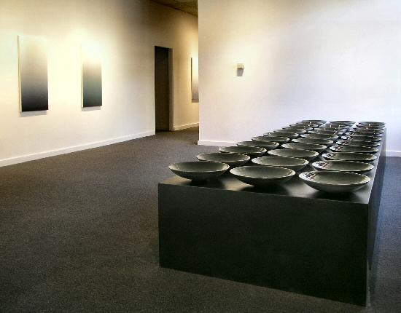

Eric Tillinghast
Joan Watts
Susan York

April 16-May 8 2004
Quiet becomes a palpable presence in the work of the three Santa Fe artists represented in The Zen of Materiality. Eric Tillinghast, Joan Watts and Susan York work in a deliberate, meditative way that produces work that draws the viewer in to an experience of dynamic stillness.
For metal sculptors, access to an environment with possibilities such as pouring 600 pounds of hot iron in eight seconds, making intricate molds, and creating finishes such as enamels and plating, is a rare and extremely valuable opportunity. Eric Tillinghast was awarded this opportunity as a resident last summer at art/INDUSTRY in Kohler, Wisconsin. Of the 200 to 300 artists who apply for these prestigious fellowships each year, only twelve to fifteen are accepted. Tillinghast brings to the April exhibition a selection of the fruit of his Kohler labors, cast iron bowls measuring two feet by five feet each. He describes the process of making the molds for these pieces as painstakingly slow, a careful development aimed at the eventual moment when glowing molten steel is poured into the forms.
In her latest series, O, Joan Watts explores the fullness that seeming emptiness can evoke. Using tall vertical canvases, Watts starts with multiple layers of white gesso and then applies oil pigments, rubbing them in with a cloth to create a blush of soft color appearing strongly at the bottom of the canvas and fading away to white at the top. The viewer's eye is led upward to the ultimate quietude and strong impact of absent color. A stunning catalogue of this series will be available for viewing at the exhibition.
Susan York wants to know exactly when a flat plane becomes form. In pursuit of this understanding, she pours, cuts and stacks shard after shard of translucent ceramic. These delicate stacks of shards are juxtaposed with the sturdiness of a metal or wooden support and hung on the wall, forming a subtle, elegant whole. "It is the quiet world in my studio where I make hundreds of shards of the same shape, over and over, that forms my work. My hope is that the viewer can taste this calm and sink into a moment of emptiness."
All three artists have used the experience of creating work in a measured, deliberate sequence to produce work that can inspire the viewer to pause and enter into a similar state of mindfulness. This particular combination of works allows the gallery to become an oasis of calm, a refuge from everyday bustle.
MAIN GALLERY:

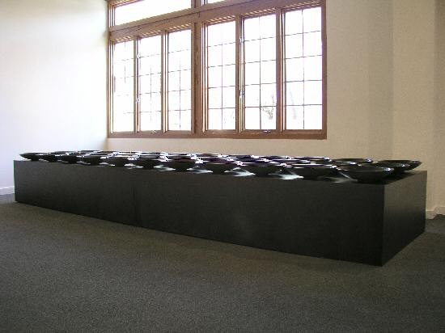

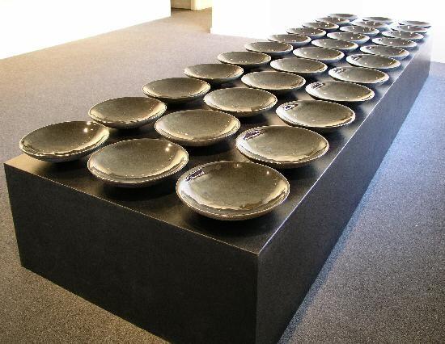
ERIC TILLINGHAST
Water Series #60, 2003 (Edition of 33)
Water, cast iron, enamel, 3” x 15”x 15” each bowl
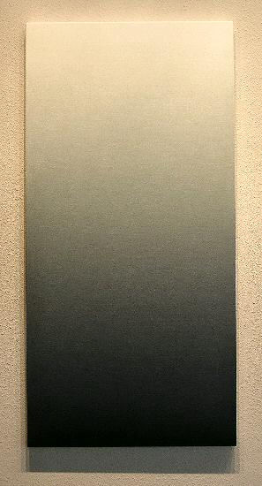
JOAN WATTS
0-33, 2003
Oil on canvas, 44 " x 22"
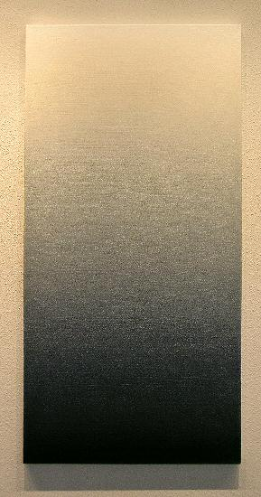
JOAN WATTS
0-38, 2003
Oil, on canvas, 44” x 22”
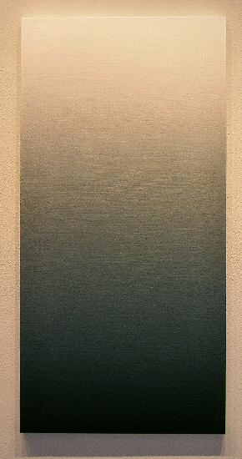
JOAN WATTS
0-37, 2003
Oil on canvas, 44” x 22”
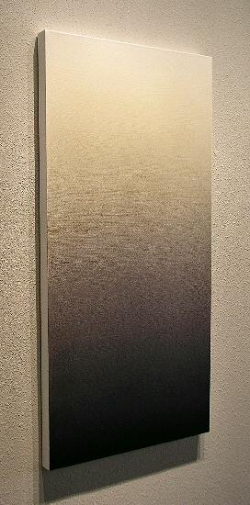
JOAN WATTS
0-36, 2003
Oil on canvas, 44” x 22”
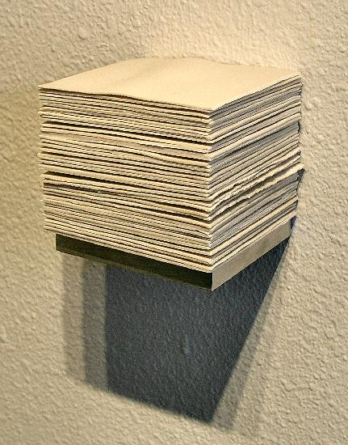
SUSAN YORK
The Color of Porcelain, no.3, 2004
Porcelain, aluminum, 4" x 4 "x 4”
GALLERY II: 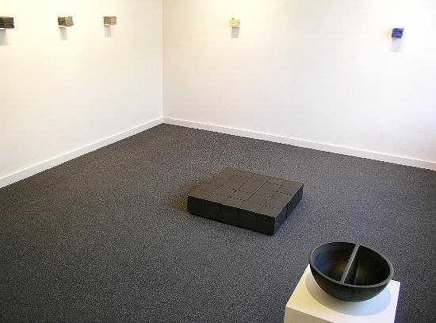
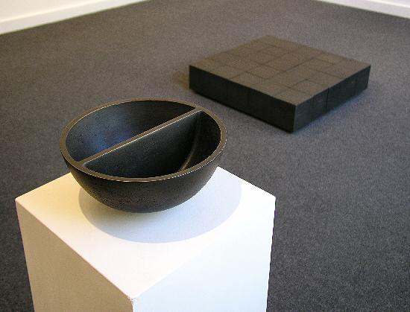
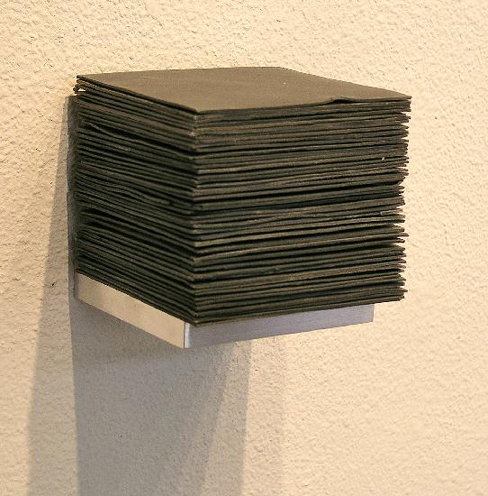
SUSAN YORK
Grey Study 3.5, no. 1, 2004
Porcelain, aluminum, 4” x 4” x 4”
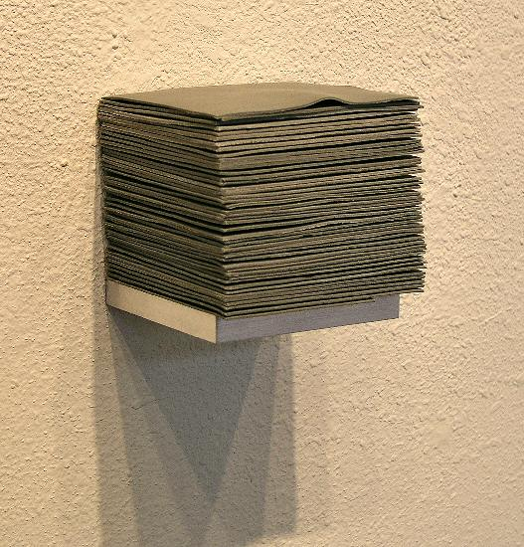
SUSAN YORK
Grey Study .75, no. 1, 2004
Porcelain, aluminum 4” x 4” x 4”
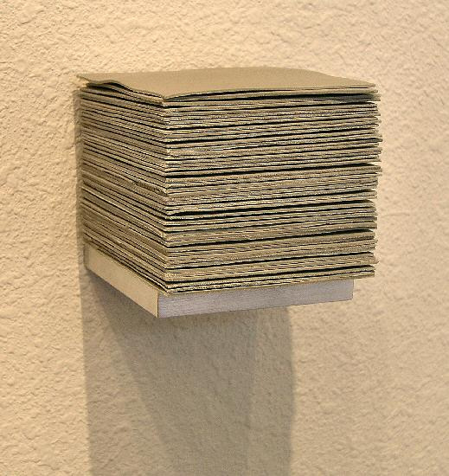
SUSAN YORK
Grey Study .5, no. 1, 2004
Porcelain, aluminum, 4” x 4” x 4”
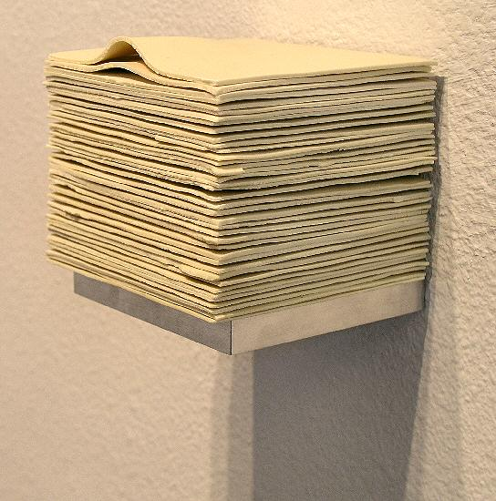
SUSAN YORK
The Color of Butter, no. 3, 2004
Porcelain, aluminum, 5 " x 4" x 4”
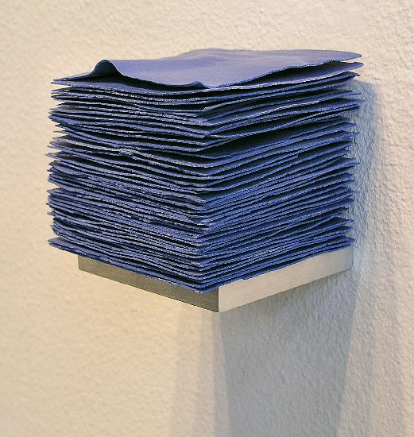
SUSAN YORK
The Color of Cobalt, no. 3, 2004
Porcelain, aluminum, 4” x 4”x 4”
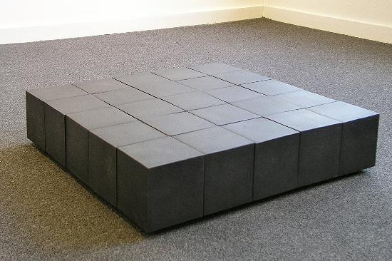
ERIC TILLINGHAST
Not Titled, 1996
Fabricated Steel, 30” x 30” x 6”

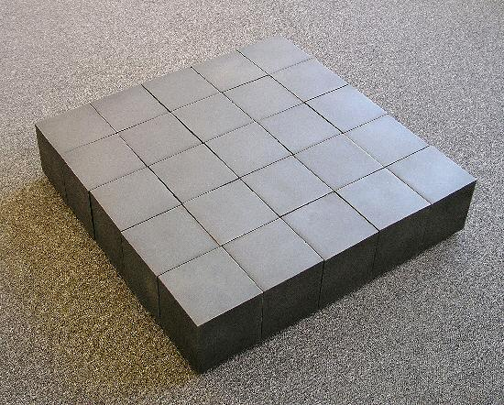
ERIC TILLINGHAST (detail view)
Not Titled, 1996
Fabricated Steel, 30” x 30” x 6”
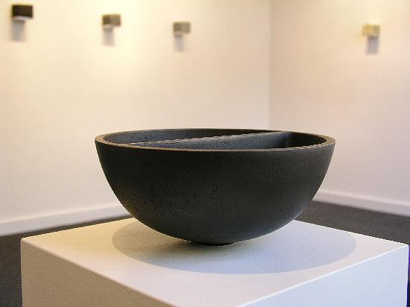
ERIC TILLINGHAST
Water Series #59, 2003 (Edition of 13)
Water, cast brass, 4” x 10” x 10”
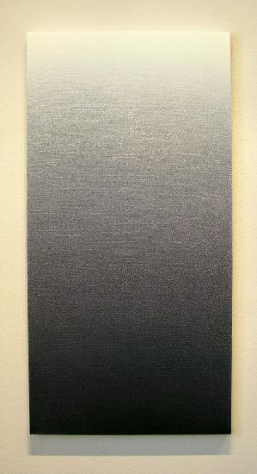
JOAN WATTS
0-35, 2003
Oil on canvas, 44” x 22”
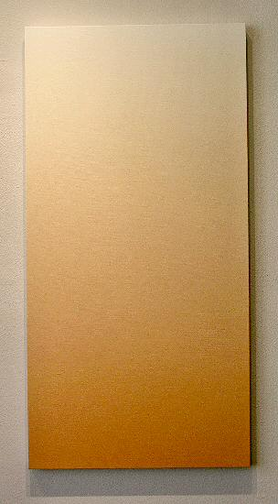
JOAN WATTS
0-24, 2003
Oil on canvas, 44” x 22”
© 2004, Charlotte Jackson Fine Art
All Rights Reserved

Charlotte Jackson Fine Art

200 West Marcy Street, Suite 101

Santa Fe, New Mexico 87501

Phone: 505.989.8688
Fax: 505.989.9898

www.charlottejackson.com

Photography and CD production – William Metcalf

