CHARLOTTE JACKSON FINE ART

PRESENTS:

JOAN WATTS / UNTITLED

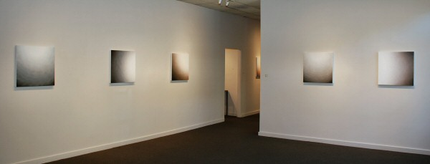

MAY 7 - JUNE 7, 2010
Light filled space. It is difficult to attempt any description of the work of Joan Watts without meditating on the nature of light - the way it makes color, creates volume, and interacts with space. The way it illuminates and creates the world we know.
Watts has painted for fifty years and this time spent mastering her art has led to reduction and refinement, a stripping away of figures and referents. Although she has often been aligned with Modernist and Minimalist artists, a better clue to the source of her work is her two decades of meditation practice. She brings a meditative focus to her painting which shows through in its persistently contemplative qualities. Watts works systematically, using canvas as her light trap-a way to study color, light, and volume in their bare essentials.
The vocabulary of this exploration has, for some time, been the slow modulation of color (saturated and dense) in a measured, almost imperceptible gradation of tones toward white. The effect of this slow interpenetration of color and white, especially with the careful techniques that Watts uses - rubbing paint into the layers of gesso she uses to prepare her canvas, and then wiping it away in a patient building of layers, is as subtle as it is profound. The canvas contains depth, flow, volume; it becomes a doorway into a light-filled domain that the viewer may step through.
The current Untitledseries was inspired by an experience Watts had while on retreat near Muir Beach, California. In the early morning hours of her first night in residence in a small isolated cottage overlooking the sea, Watts was awoken by the light of the full moon, streaming in her windows. She spent that morning, and the nights following, watching the bright disc of the moon rise and set over the Pacific. When she returned home she was inspired to return to the circle (a form she had spent years exploring in the past) in her paintings. However this time the circle is partial, a fragment emerging from the side or corner of the canvas. Watts found the use of the partial circle new ground and particularly intriguing.
The paintings in this exhibition utilize a 24x24 square format - a particularly harmonious pairing of square with circle. The forms of the partial circles exist within the ground of Watts' modulated color-light field. But it is not a case of two disparate elements brought together, these forms live within the color-white field. There are subtle undulations within the white light areas of the canvas which reach out, interact and engage with the partial circles in a quiet dialog. These quiet and meditative pieces at once contain stillness and movement, color and no-color, form and formlessness.
It is tempting to look for parable in these pieces: the fragment of the circle contains the whole, light is experienced when nuanced with shade. That the moon itself would be invisible if not for the light of the sun reflected off its surface and bounced to earth. There are a myriad of metaphors to be extracted from these ideas. However, although each of these concepts may be apt the true genius of these works is that they must be experienced, not theorized. There is something so singular in their quiet shift from color to white that they demand not thought or even just a casual perusal - they require patient, attentive experience. Watts' canvases become not just works of art, or records of the meditative act of painting, but meditations in themselves for the viewer to contemplate and engage.
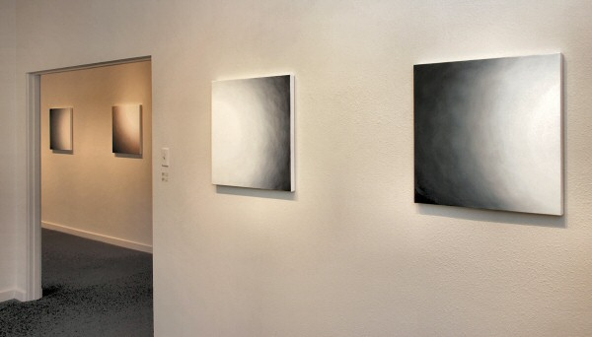

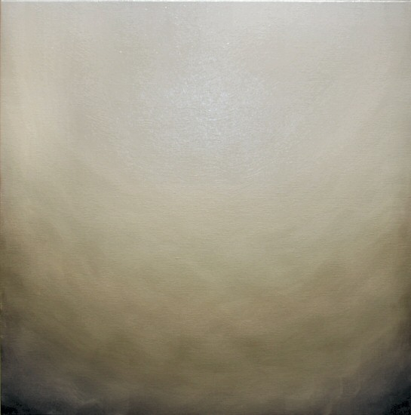
Untitled 7, 2009
Oil on canvas
24 x 24 inches, JW046
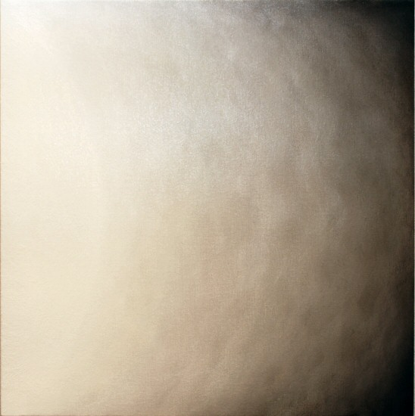
Untitled 9, 2009
Oil on canvas
24 x 24 inches, JW048
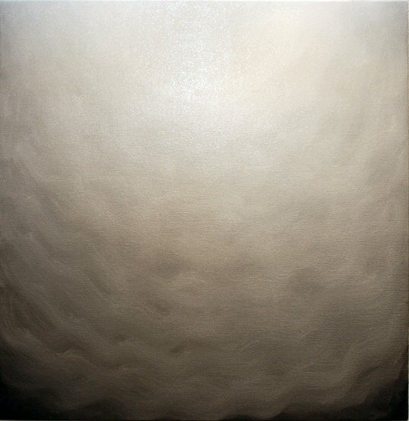
Untitled 1, 2009
Oil on canvas
24 x 24 inches, JW040
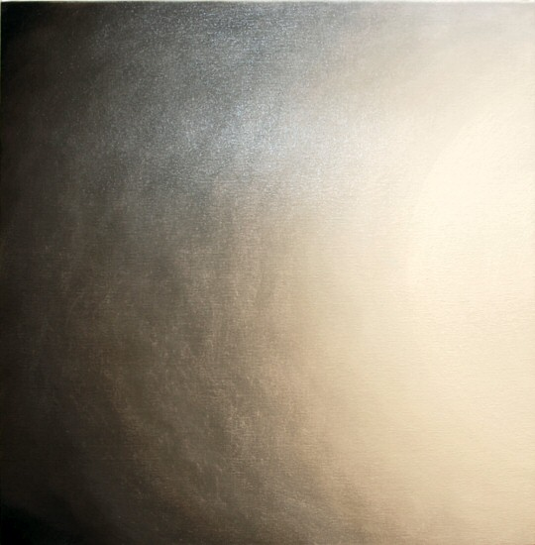
Untitled 14, 2010
Oil on canvas
24 x 24 inches, JW053
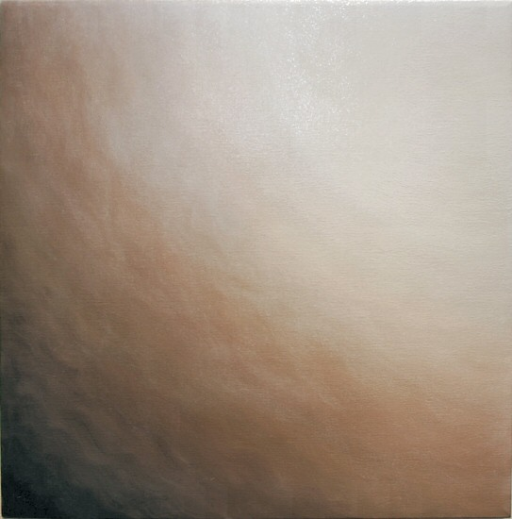
Untitled 4, 2009
Oil on canvas
24 x 24 inches, JW043
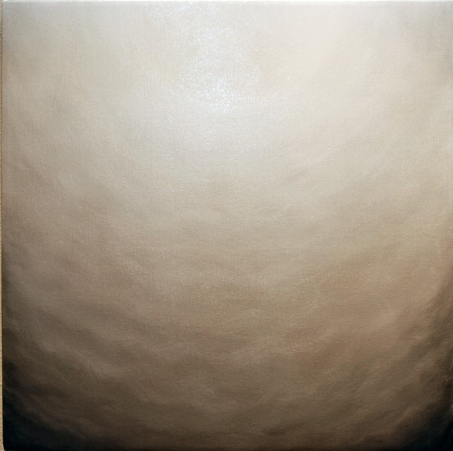
Untitled 2, 2009
Oil on canvas
24 x 24 inches, JW041
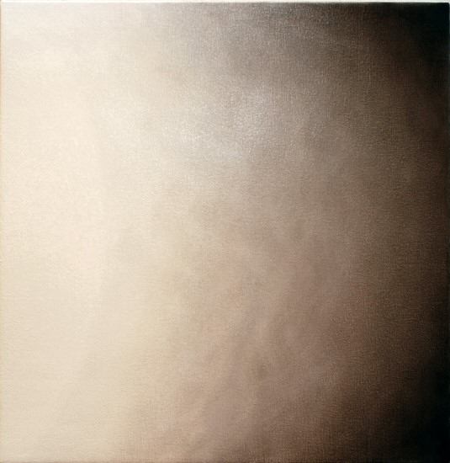
Untitled 10, 2009
Oil on canvas
24 x 24 inches, JW049
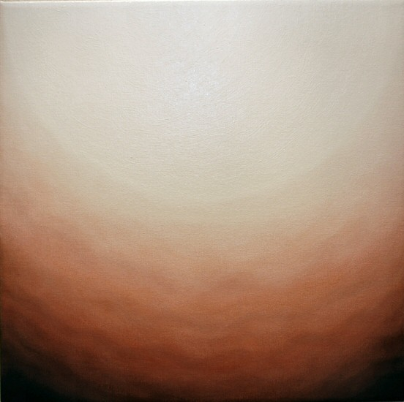
Untitled 8, 2009
Oil on canvas
24 x 24 inches, JW047
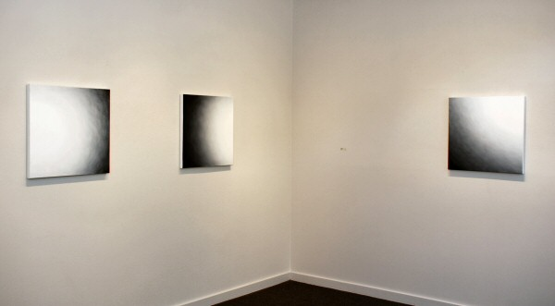

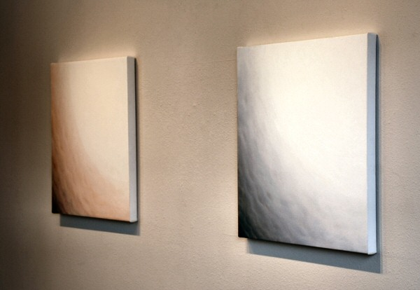
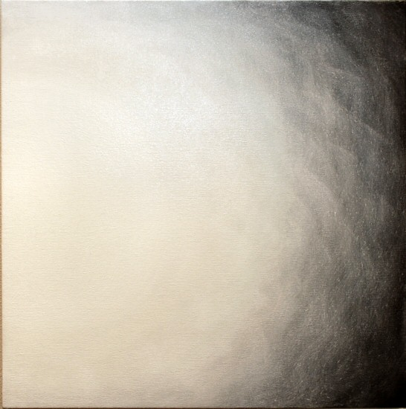
Untitled 11, 2009
Oil on canvas
24 x 24 inches, JW050
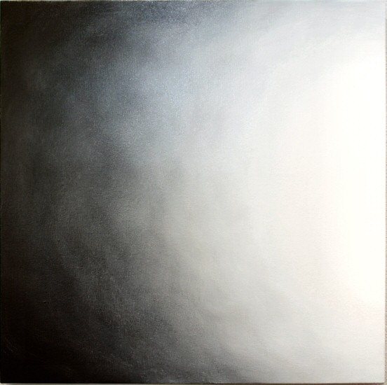
Untitled 12, 2009
Oil on canvas
24 x 24 inches, JW051
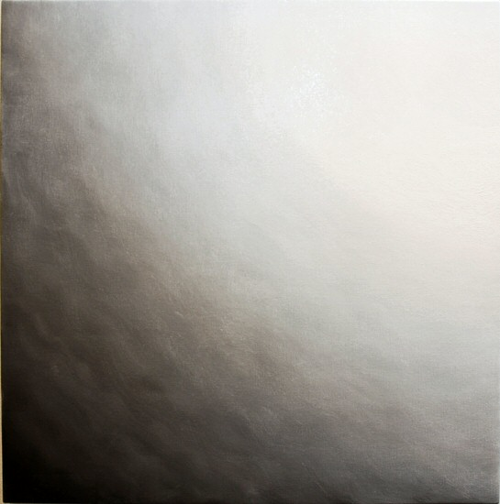
Untitled 3, 2009
Oil on canvas
24 x 24 inches, JW042
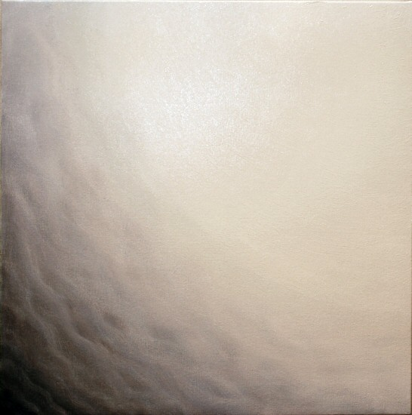
Untitled 6, 2009
Oil on canvas
24 x 24 inches, JW045
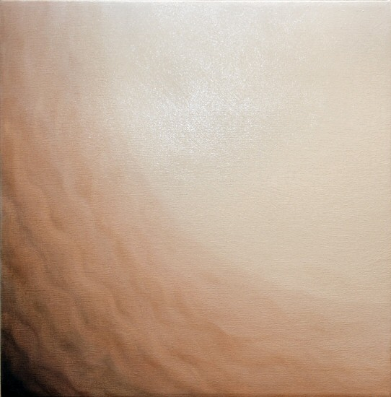
Untitled 5, 2009
Oil on canvas
24 x 24 inches, JW044

© 2010

Charlotte Jackson Fine Art, Inc.

200 West Marcy Street, Suite 101, Santa Fe, New Mexico 87501
Telephone: 505.989.8688 Fax: 505.989.9898
cjfa@charlottejackson.com - www.charlottejackson.com

