CHARLOTTE JACKSON FINE ART
PRESENTS:

CLARK WALDING
RIFT SERIES
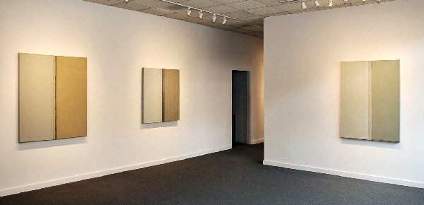
MARCH 6-31, 2009
Clark Walding’s Rift paintings reveal work that is restrained in color and structure. They are all vertically bifurcated permitting interaction between two major planes with the center element resulting from this dynamic meeting. In some of the paintings the center is a form of channel or pathway, while in others it is distinctly a forceful split or rift of the major planes. The relationship of the major planes is one of continuous, simultaneous change which is the core of this work. The paintings’ focus moves between the immediate and the infinite – equal parts intimate and distant, like change itself.
Physically the Rift paintings are multi-layered canvasses of oil paint mixed with wax medium. The paint and wax are applied in their cold state, with Japanese painting knives, in varying degrees of viscosity and density. The use of painting knives permits a packing and quieting of paint that brushes cannot achieve. Knives are pressure sensitive while keeping the process direct. Layers are sometimes open and transparent, or translucent, while others achieve a density that just stares back at the viewer. The accumulation of painted layers turns and twists color until each painting acquires its own sense of light and color context. Each of the Rift paintings is the result of a long gestation period employing many painting processes: scraping, chemical wipes, wash downs, and lines incised into the paint and wax mixture. It is the inevitable “repentances” that allow the paintings to evolve organically to realize their intent.
Walding’s Rift paintings encourage contemplation and careful perusal. The often muted and subtle color has a matter-of-fact presence that is direct in execution and develops a quiet surface tension as the work emerges with a full sense of experience. The beauty in these paintings is their haunting nature in search of a resolution. As one viewer remarked, “it was only after I had collected my thoughts and caught my breath that I realized I had a very intuitive, gut response to the work.” In most respects it is this unselfconscious interaction with the work that is its reward.
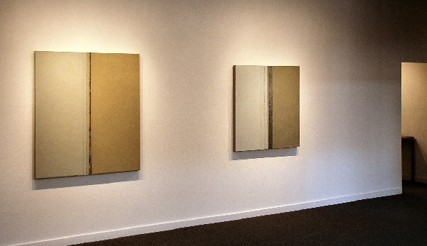

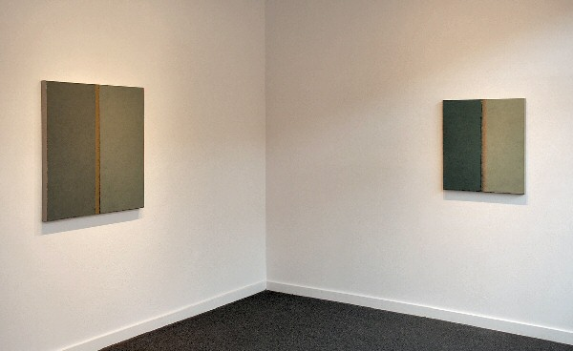
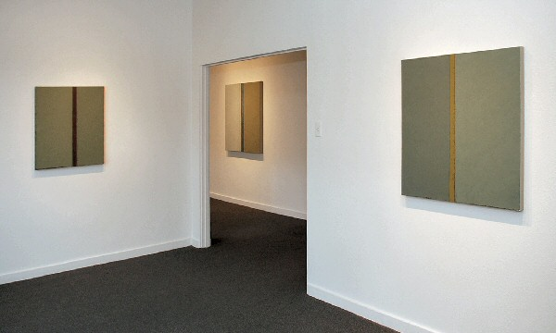

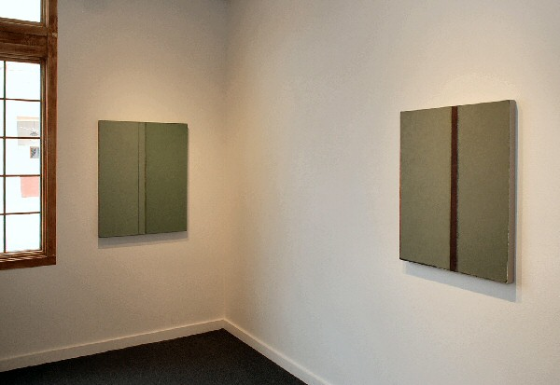
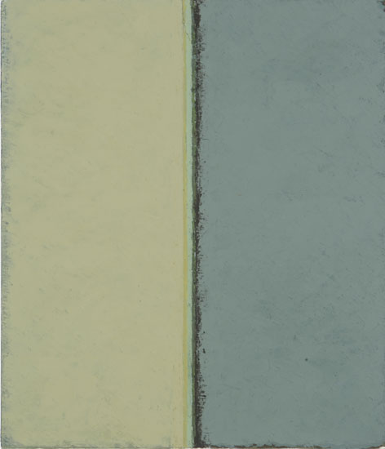
Return,
oil and cold wax on cotton duck,
21 x 18 inches, 2008-09
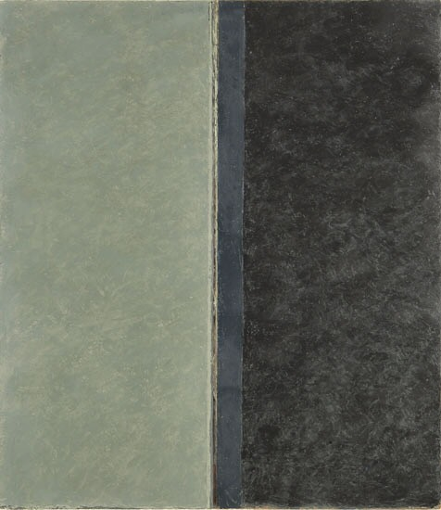
Murmer,
oil and cold wax on cotton duck,
28 x 25 inches, 2008-09
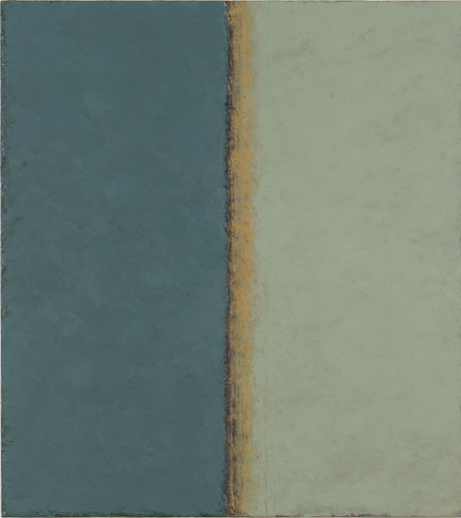
Coarse mesh,
oil and cold wax on cotton duck,
28 x 25 inches, 2008
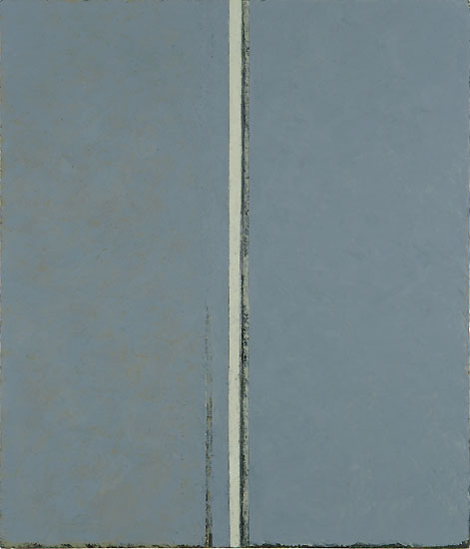
Lens,
oil and cold wax on cotton duck,
28.5 x 25 inches, 2007-08
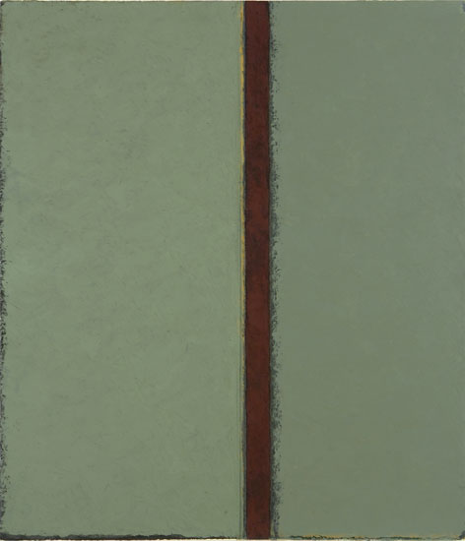
Breach,
oil and cold wax on cotton duck,
31 x 26.75 inches, 2008
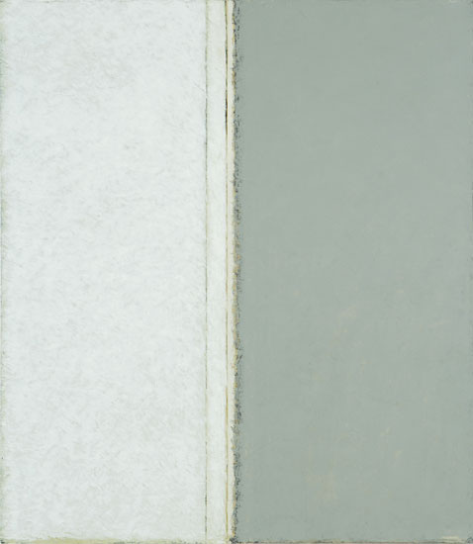
Shift,
oil and cold wax on cotton duck,
32 x 28 inches, 2008
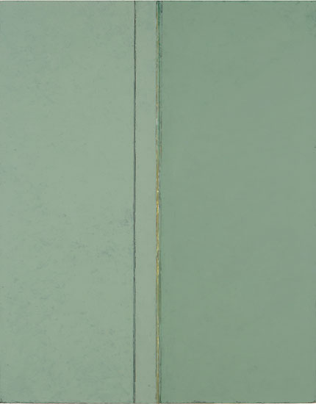
Side by side,
oil and cold wax on cotton duck,
37 x 29 inches, 2007-08
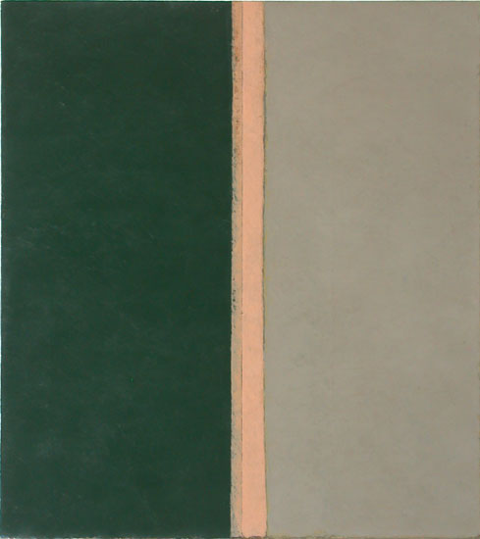
In full view,
oil and cold wax on cotton duck,
40 x 36 inches, 2007-08
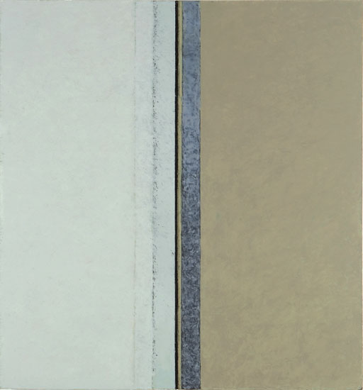
Narrow lead,
oil and cold wax on cotton duck,
42.75 x 40 inches, 2008-09
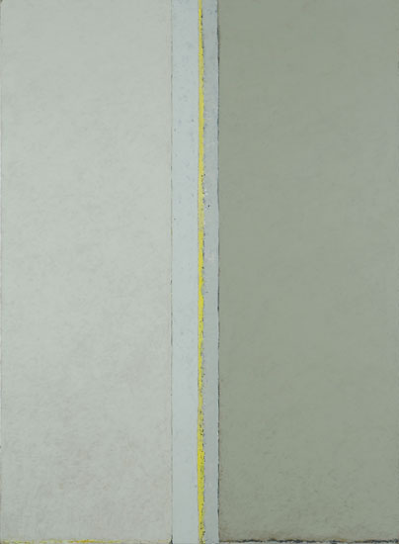
Trace,
oil and cold wax on cotton duck,
53.25 x 39.5 inches, 2006-09
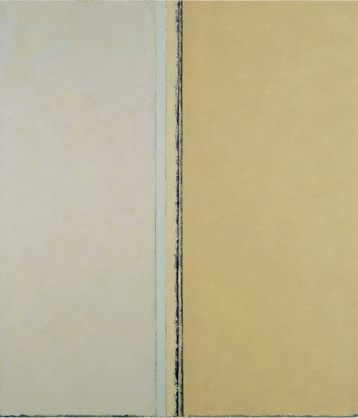
Shaky ground,
oil and cold wax on cotton duck,
52 x 45 inches, 2008
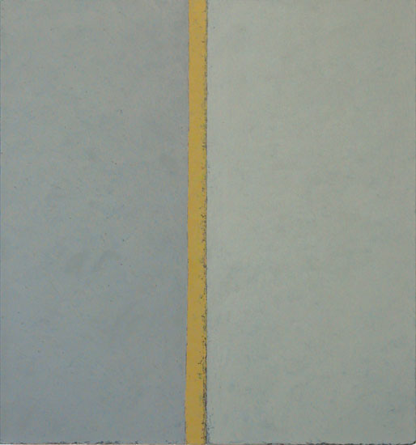
Five penny view,
oil and cold wax on cotton duck,
35 x 32 3/4 in. inches, 2007-09

© 2009

Charlotte Jackson Fine Art, Inc.

200 West Marcy Street, Suite 101, Santa Fe, New Mexico 87501

Telephone: 505.989.8688 Fax: 505.989.9898
cjfa@charlottejackson.com - www.charlottejackson.com

