CHARLOTTE JACKSON FINE ART
PRESENTS:

HEINER THIEL: The Wrily Truth of Space
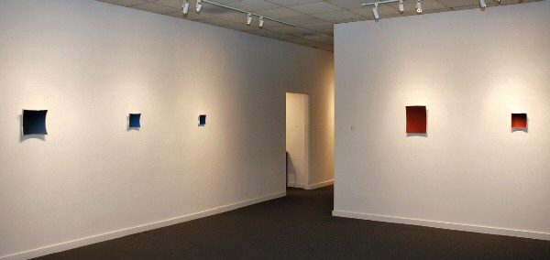
August 7 - August 29, 2009
The work of German artist, Heiner Thiel, is charged with ideas. Constructed based on mathematical formulas, part sculpture, part painting, these works of aluminum do not hang so much as emerge from the wall, seemingly arrested in the act of reforming themselves into the virtual spheres from which they’ve been cut.
There is something about the way these concave quadrangles are hung, suspended from a single point so that from an angle a viewer can see their arc outward, which suggests movement, even while the heavy aluminum seems so solidly fixed. But this fascinating curved shape does more than just suggest a movement of the piece itself; it inspires movement in the one gazing at it. Because of this curve the color, which mathematically must be the same shade throughout, does not appear uniform. Our eyes perceive it as ever shifting (bright here, shaded there) as we move. One shade of blue or red appears in a full spectrum of gradations. As Thiel states, “I’m interested in how the spatial immateriality of the color interacts with the quite visible materiality of the piece itself. The space created by the curvature and the color appears to gain a certain ‘independence’ from the aluminum body.”
It is not difficult to make a connection with the title of the show, “The Wrily Truth of Space.” The title, from a poem by German poet Ernst Meister, suggests this playful confusion of perception that occurs when humans use their limited senses to suss out the nature of the space around them. As a young man, Thiel read Albert Einstein’s layman’s book on the special and general theories of relativity and since then has had a particular fascination with the idea of “curved space.” His works are, in part, an attempt to create a model for this idea.
It is interesting to note that when asked about his inspiration and influences as an artist, his first citations are of scientists. In addition to Einstein, he credits Alexander von Humbolt’s “Kosmos” as a formative work. In the art world he feels affinity to Elsworth Kelly, David Rabinowitch, and Donald Judd, to name only a few.
However, Thiel’s pieces are anything but academic. There is an intimacy both in the size (mostly 6x6 and 8x8) and concavity of these pieces which penetrates the viewer directly. There is also something special and secretive which speaks in the revelation of bringing the inside of a sphere into the light. Perhaps in the same way that color and space dance between independence and dependence, the ideas behind Thiel’s works are both fundamental and immaterial to their powerful presence.
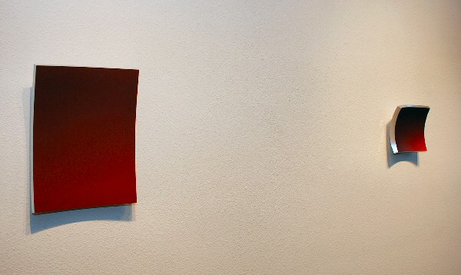WVZ506, 2009 & WVZ487, 2009
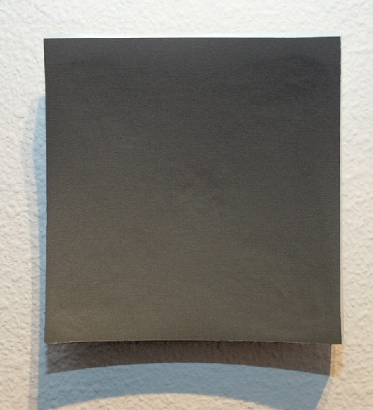
WVZ491
2009 (grey piece, right facing door)
Anodized Aluminum
5 15/16 x 5 15/16 x 1 5/8 inches HT014
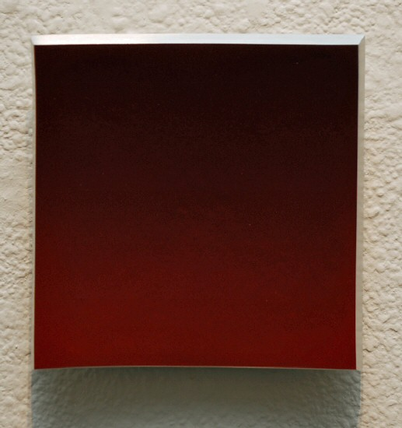
WVZ495
2009 (red piece, right facing door)
Anodized Aluminum
5 15/16 x 5 15/16 x 1 5/8 inches HT017
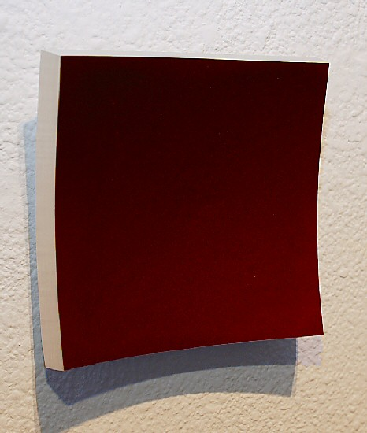
WVZ495
2009 (red piece, right facing door)
Anodized Aluminum
5 15/16 x 5 15/16 x 1 5/8 inches HT017
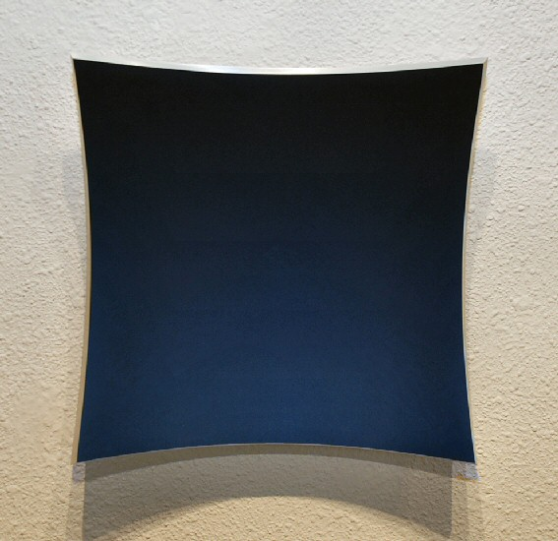
WVZ504
2009
Anodized Aluminum
12 x 12 x 3 inches HT023
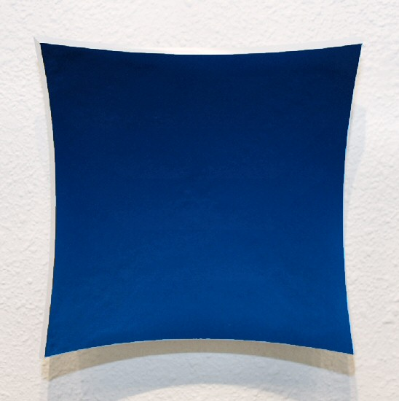
WVZ507
2009
Anodized Aluminum
7 7/8 x 7 7/8 x 2 inches HT026
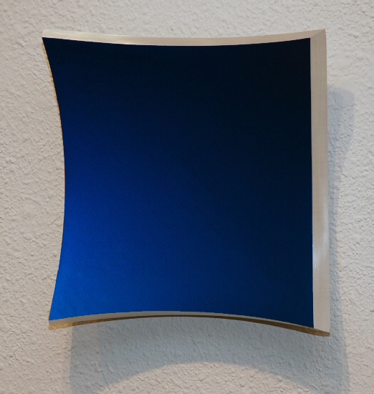
WVZ507
2009
Anodized Aluminum
7 7/8 x 7 7/8 x 2 inches HT026
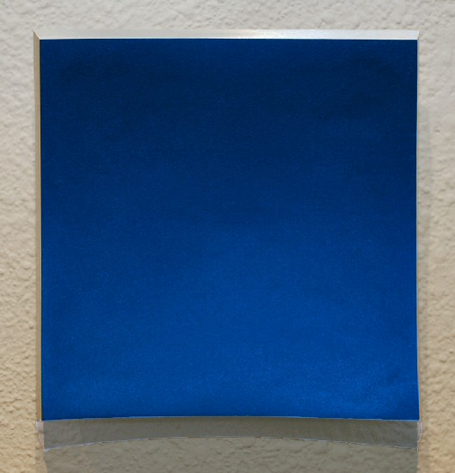
WVZ496
2009
Anodized Aluminum
5 15/16 x 5 15/16 x 1 5/8 inches HT018
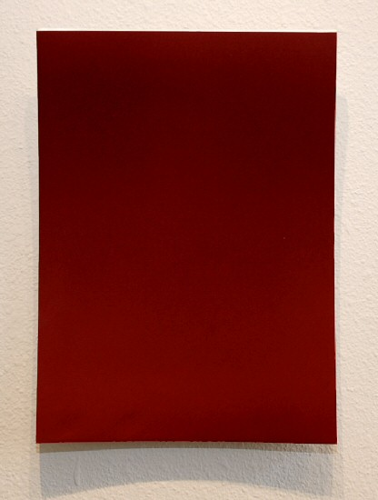
WVZ506
2009
Anodized Aluminum
15 13/16 x 12 x 2 3/8 inches HT025
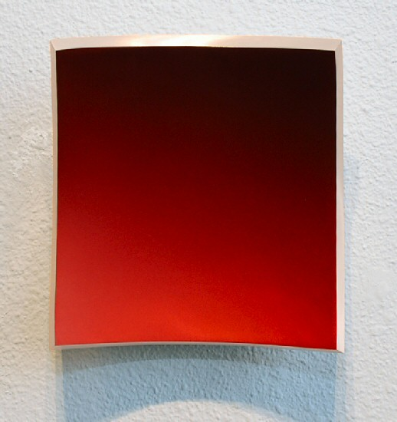
WVZ487
2009
anodized aluminum
7 7/8 x 7 7/8 x 2 3/8 inches HT010
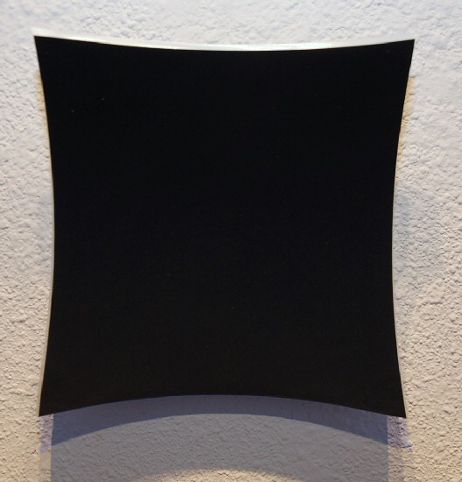
WVZ489
2009
Anodized Aluminum
7 7/8 x 7 7/8 x 2 inches HT012
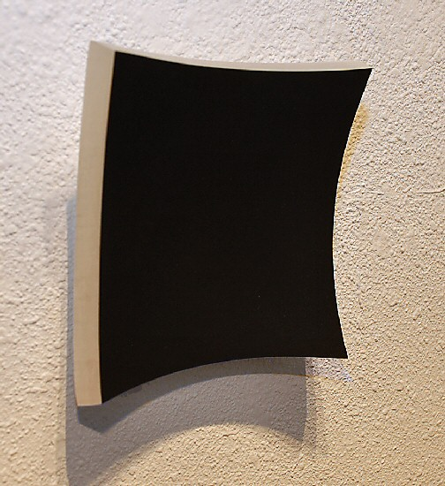
WVZ489
2009
Anodized Aluminum
7 7/8 x 7 7/8 x 2 inches HT012
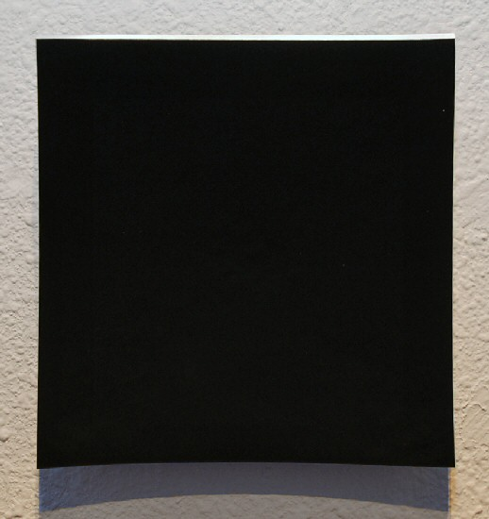
WVZ489
2009
Anodized Aluminum
7 7/8 x 7 7/8 x 2 inches HT012
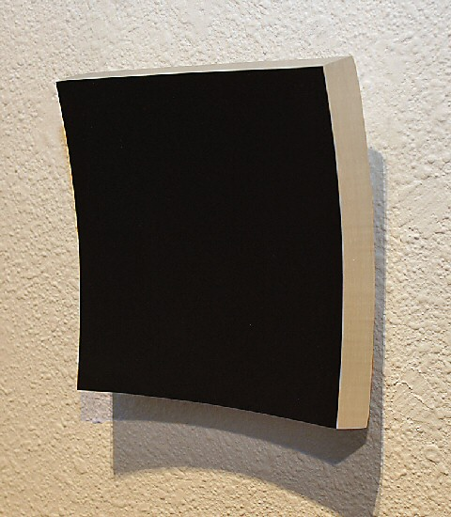
WVZ489
2009
Anodized Aluminum
7 7/8 x 7 7/8 x 2 inches HT012
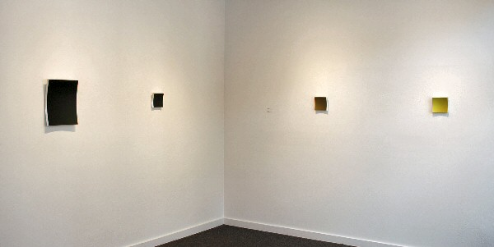

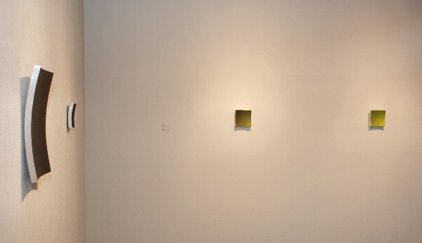
WVZ505, WVZ490, WVZ500, & WVZ494, all 2009
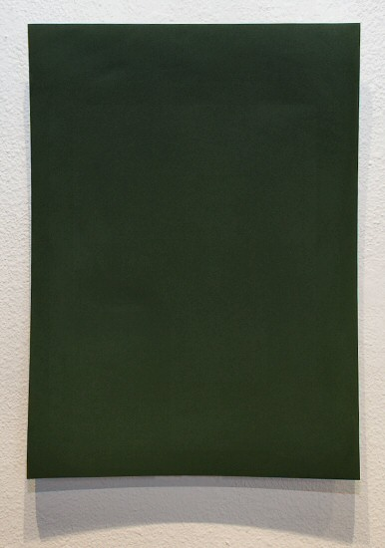
WVZ505
2009
Anodized Aluminum
15 13/16 x 12 x 2 3/8 inches HT024
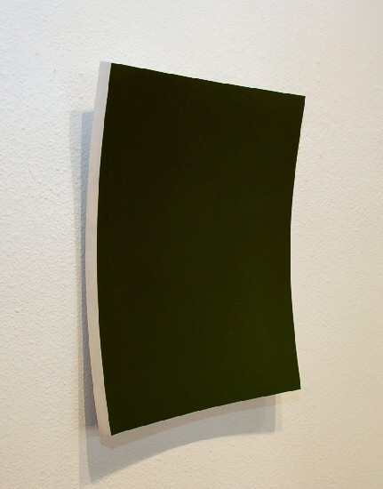
WVZ505
2009
Anodized Aluminum
15 13/16 x 12 x 2 3/8 inches HT024
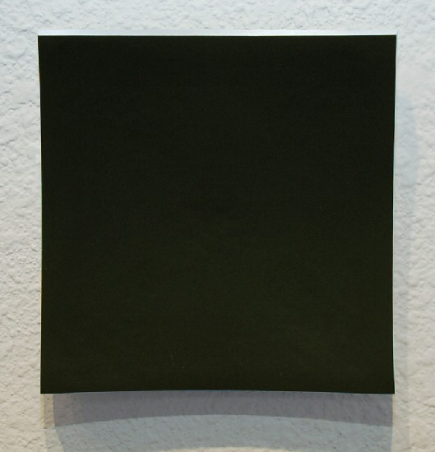
WVZ490
2009
Anodized Aluminum
5 15/16 x 5 15/16 x 1 5/8 inches HT013
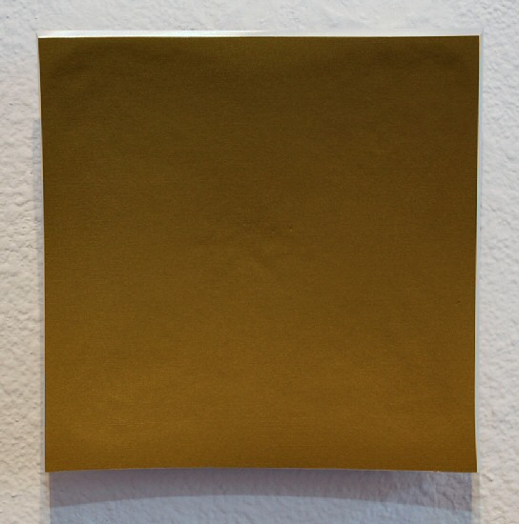
WVZ500
2009
Anodized Aluminum
5 15/16 x 5 15/16 x 1 5/8 inches HT021
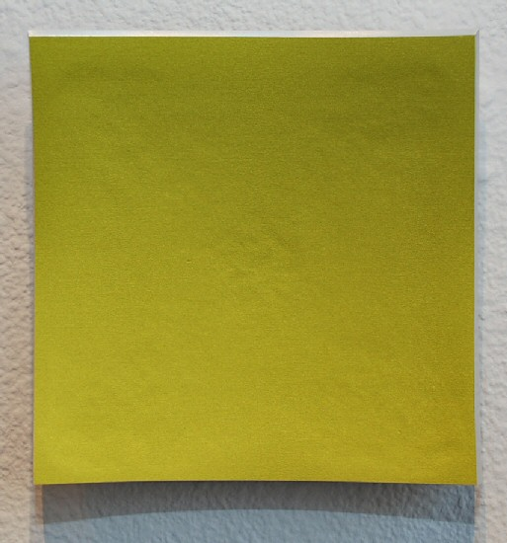
WVZ494
2009
Anodized Aluminum
5 15/16 x 5 15/16 x 1 5/8 inches HT016
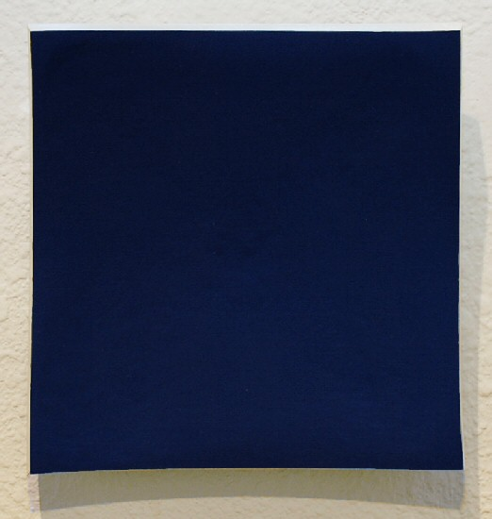
WVZ492
2009
Anodized Aluminum
5 15/16 x 5 15/16 x 1 5/8 inches HT015
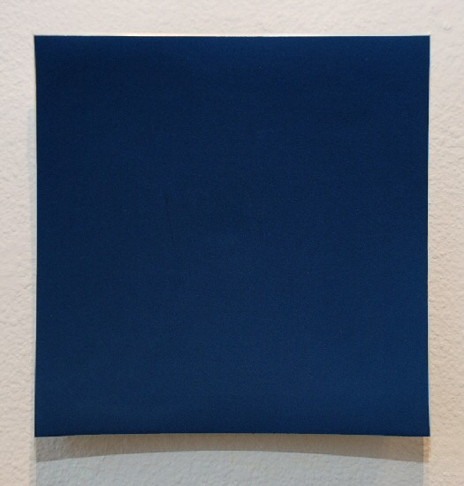
WVZ488
2009
Anodized Aluminum
7 7/8 x 7 7/8 x 1 5/8 inches HT011
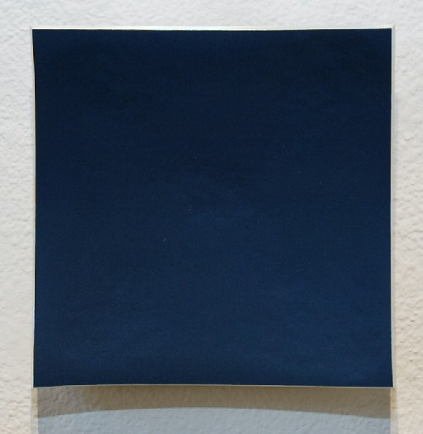
WVZ499
2009
Anodized Aluminum
5 15/16 x 5 15/16 x 1 5/8 inches HT020

© 2009

Charlotte Jackson Fine Art, Inc.

200 West Marcy Street, Suite 101, Santa Fe, New Mexico 87501
Telephone: 505.989.8688 Fax: 505.989.9898
cjfa@charlottejackson.com - www.charlottejackson.com

