CHARLOTTE JACKSON FINE ART

Presents:

That's Hot!
A Group Exhibition
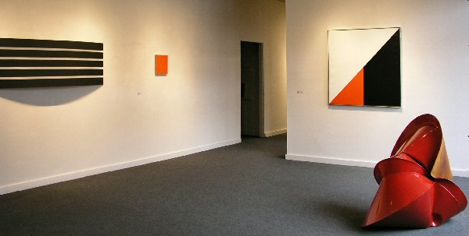

February 2006
Come feel the heat at a new group exhibition featuring a variety of work in “hot” hues by gallery artists: Alfonso Fratteggiani Bianchi, Tony DeLap, Frederick Hammersley, Scot Heywood, William Metcalf, Jeremy Thomas, Eric Tillinghast, Anne Truitt, and Susan York. Red, black, brilliant yellow, these works not only rivet the eye but create an atmosphere of sophistication with their elegance.
Tony DeLap creates three-dimensional paintings of saturated color and complex form. Alfonso Bianchi works in pure powdered pigment applied directly to Italian limestone with his hand. Anne Truitt and Frederick Hammersley, as early pioneers in color field, provide a historical reference to the show. Scot Heywood, an exciting new addition to Charlotte Jackson Fine Art, has explored the relationships between color, space, and geometry since the mid 70’s. William Metcalf's sleek sculptural paintings are constructed from translucent polyester fabric painted with acrylics. Jeremy Thomas's inflated sheet metal sculpture, a powdercoated steel arc by Eric Tillinghast, and Susan York’s lustrous solid graphite cubes round out the mix.
This month Charlotte Jackson Fine Art offers an exhibition that will make you want to put on your best black and hit the town. An excellent combination of the very latest in contemporary art executed with classic style.
MAIN GALLERY:

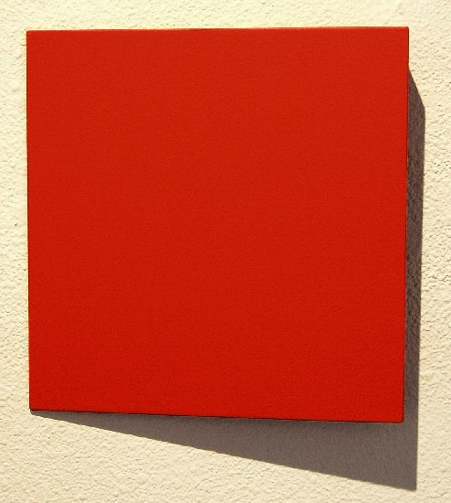
TONY DELAP
The Jumping Ace, 2002
Acrylic on aluminum, wood, 11 ¾” x 11 ½” x 2”, TD0011
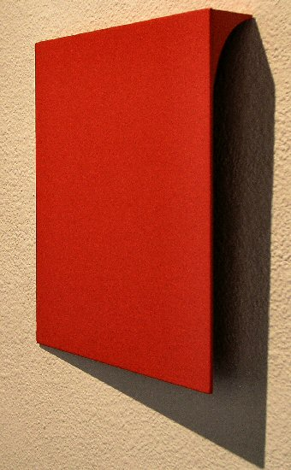
TONY DELAP
The Jumping Ace, 2002
Acrylic on aluminum, wood, 11 ¾” x 11 ½” x 2”, TD0011
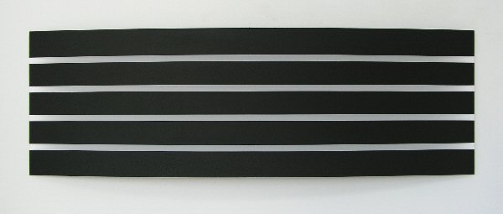
WILLIAM METCALF
Black Arc, 2006
Acrylic on polyester fabric, 24” x 72” x 6”, WM0054

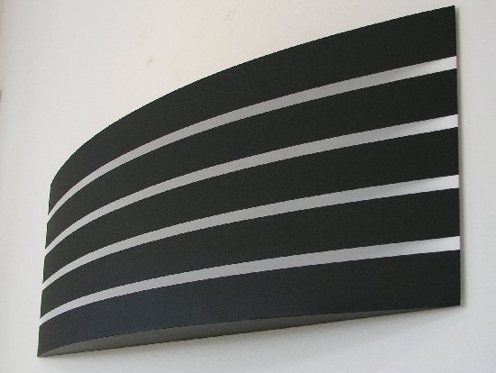
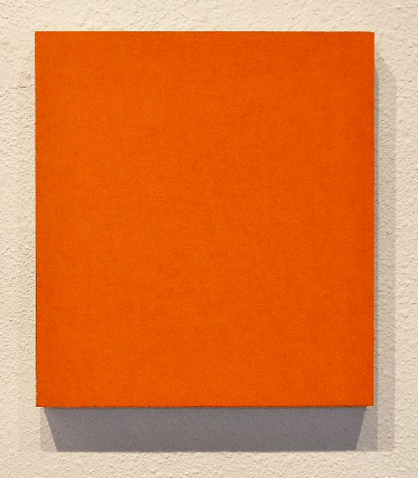
ALFONSO FRATTEGGIANI BIANCHI
#217 Rojo Arancio,
Pigment on limestone, 12” x 11”, AFB006
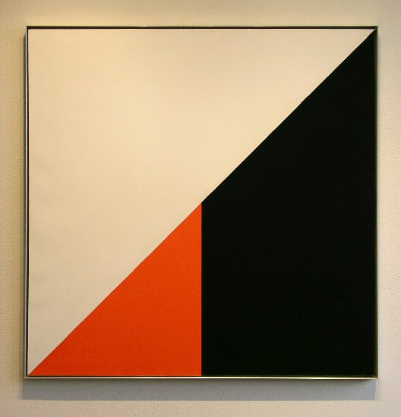
FREDERICK HAMMERSLEY
Mutual Fund, #1, 1972
Oil on linen, 44” x 44”, FH0081
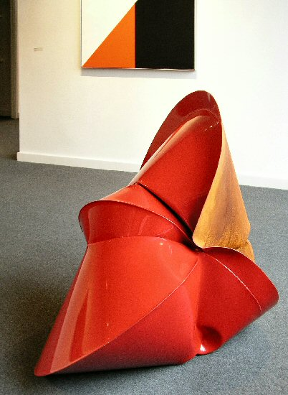
JEREMY THOMAS
Case Red, 2006
Forged mild steel and powder coat, 50” x 40” x 36”, JT0046
HALLWAY:

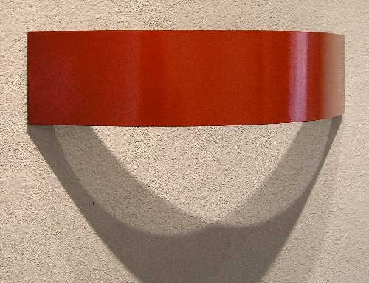
ERIC TILLINGHAST
Strawberry, 2003
Enameled Steel, 5 ½” x 22 ½” x 6”, ET001
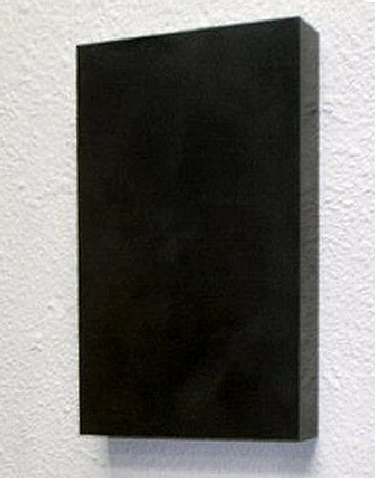
SUSAN YORK
Golden Mean Rectangle No. 3, 2005
Solid graphite, 10 ½” x 6 ½” x 1 ¼”, SY0018
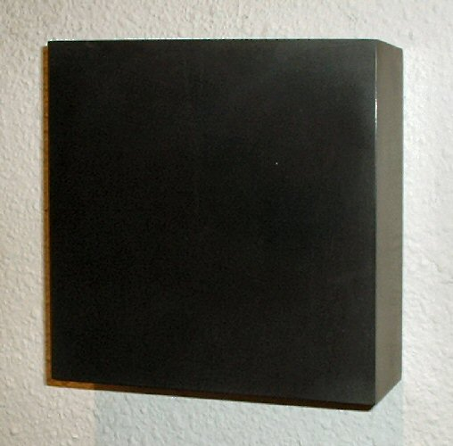
SUSAN YORK
Graphite Square No. 3, 2005
Solid graphite, 5” x 5” x 1 ½”, SY0016
GALLERY II:

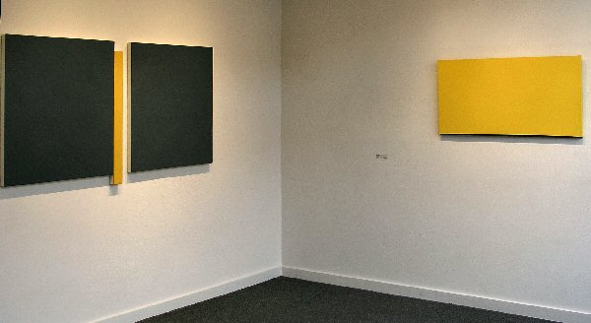

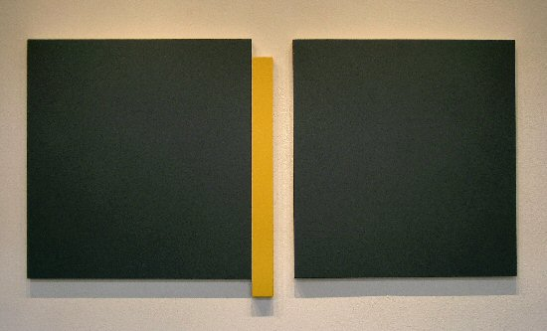
SCOT HEYWOOD
Third Movement #4, 2006
Acrylic on canvas, 37 ¾” x 72 ¼”, SH001
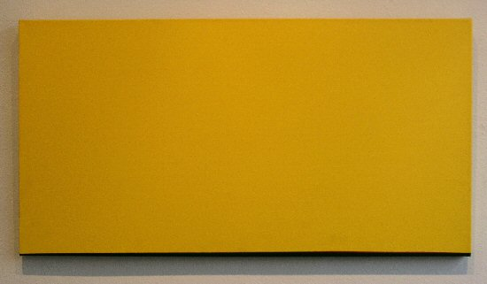
ANNE TRUITT
Quick, 1986
Acrylic on canvas, 22” x 42”, RO-AT2

ALFONSO FRATTEGGIANI BIANCHI
#122 Giallo, 2005
Pigment on limestone, 14” x 12”, AFB19

© 2006

Charlotte Jackson Fine Art, Inc.

200 West Marcy Street, Suite 101, Santa Fe, New Mexico 87501
Telephone: 505.989.8688 Fax: 505.989.9898
info@charlottejackson.com - www.charlottejackson.com

