CHARLOTTE JACKSON FINE ART PRESENTS:

SUMMER SHOW: GROUP EXHIBITION

JULY 02, TO JULY 23, 2011

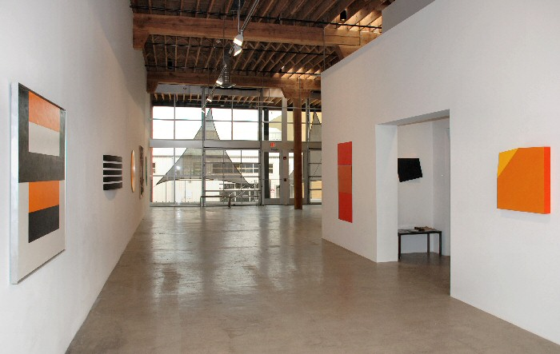
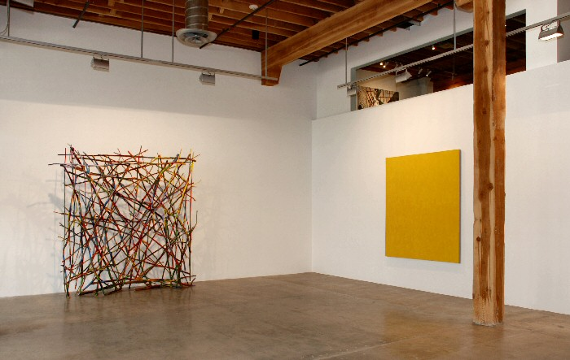

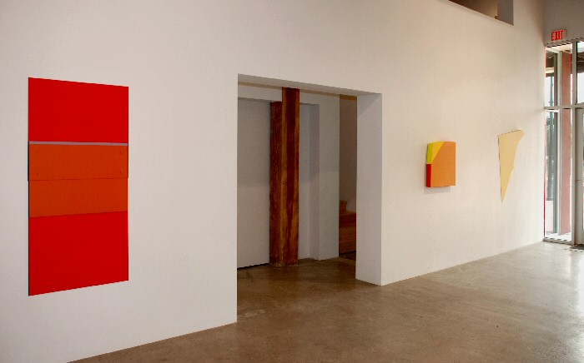
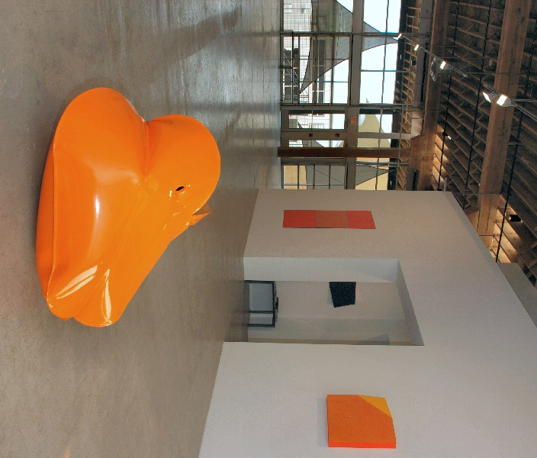
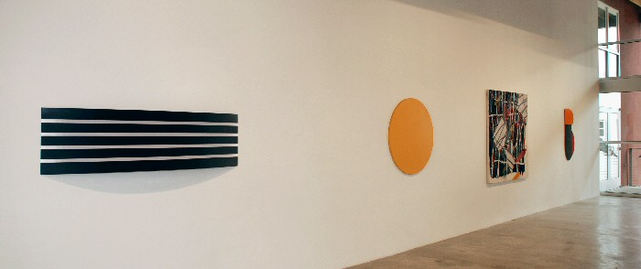

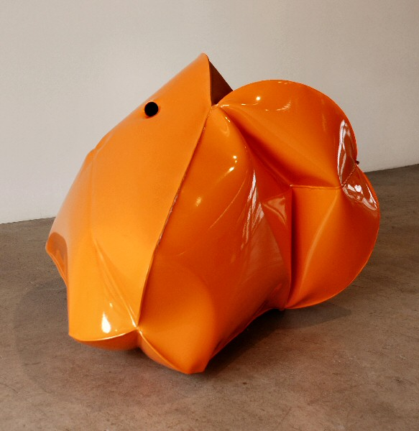
Jeremy Thomas
Flat Orange, 2010
Forged mild steel and powder coat
22 1/2 x 33 x 28 inches
JT202
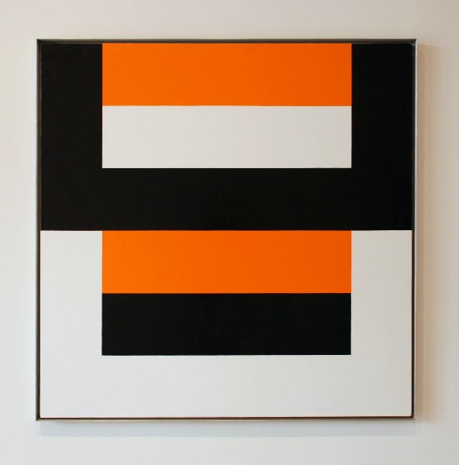
Frederick Hammersley
Cleave (#2), 1979
Oil on linen
45 x 45 inches
FH0083-SM
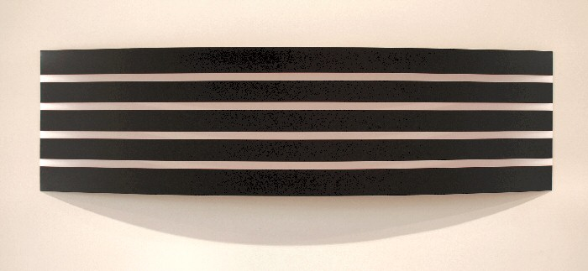

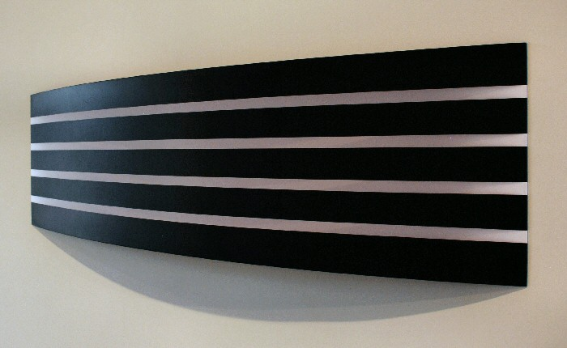
William Metcalf
Black Arc Informed by Red, 2011
Acrylic on translucent polyester fabric over wood frame
19 1/2 x 71 x 5 1/2 inches
WM19
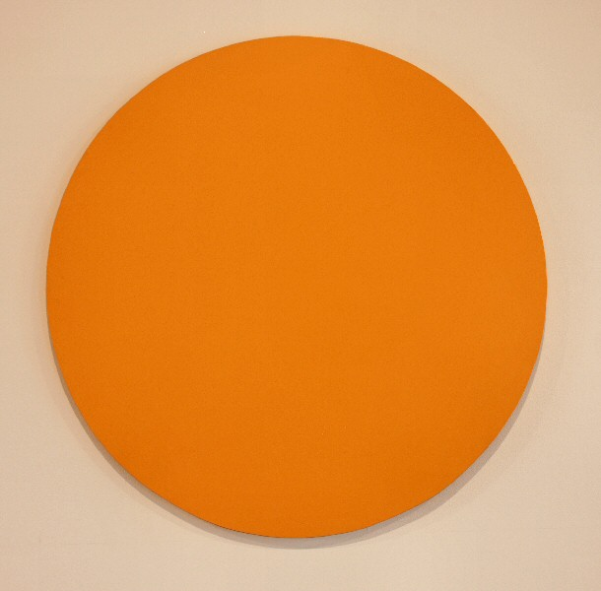
Elliot Norquist
Summer Circle, 2010
Steel and acrylic enamel
40 inches
EN0061
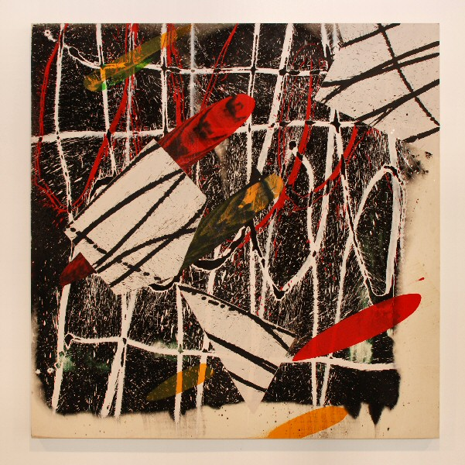
Ed Moses
Flite, 2004
acrylic on canvas
60 x 60 inches
EM0032
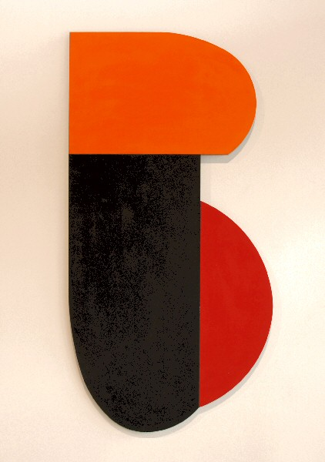
Charles Arnoldi
Ironclad (06.38), 2006
Oil on aluminum
43 1/8 x 21 7/8 inches
CA0016
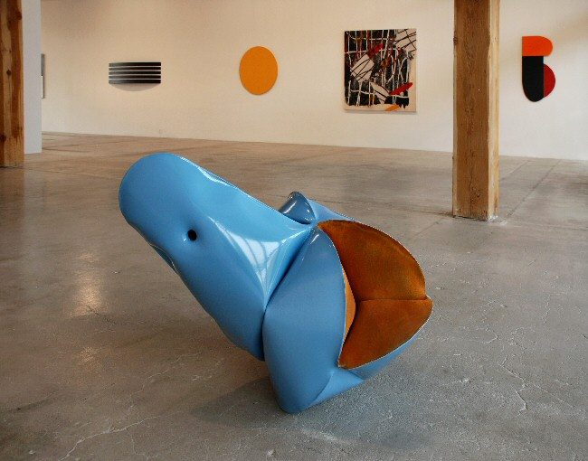
Jeremy Thomas
Eichler Blue, 2011
Forged Mild Steel & Powder Coat
29 x 39 x 28 inches
JT209
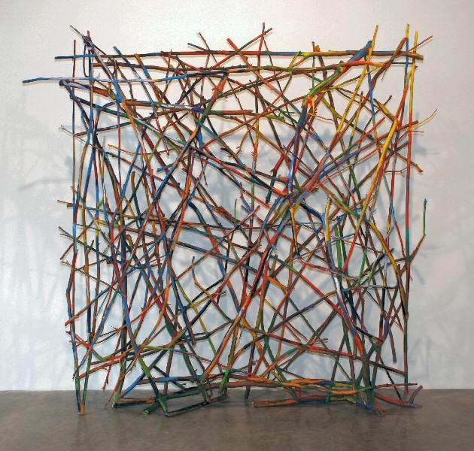
Charles Arnoldi
Untitled ("Stick Piece"), 1978-1979
Oil on tree branches
134 x 115 x 27 inches
No signature
CA0047
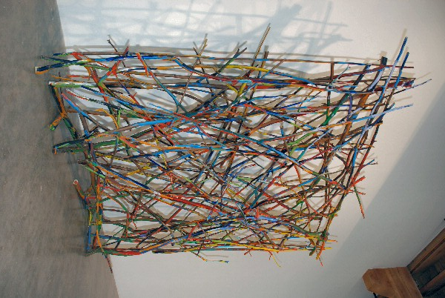
Charles Arnoldi
Untitled ("Stick Piece"), 1978-1979
Oil on tree branches
134 x 115 x 27 inches
No signature
CA0047 (detail view)
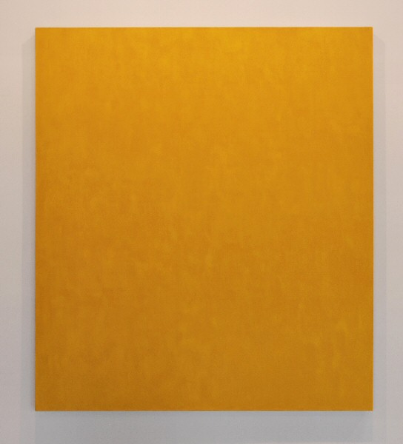
Phil Sims
Untitled (Yellow), 1999
Oil on linen
80 x 70 inches
PS0017
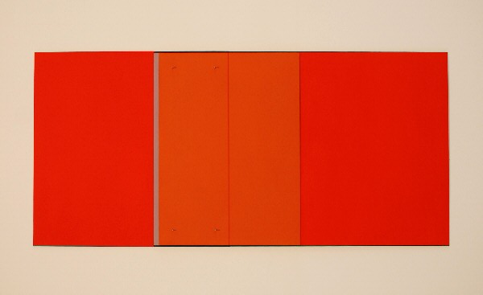
Michael Rouillard
Addendum, 2008
Oil and oil stick on aluminum
61 x 28 7/8 inches
MR018
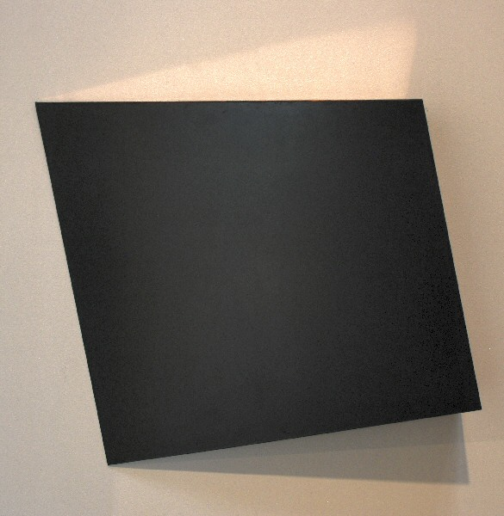
Constance DeJong
Square 18/4 R, 2007
Copper, wood
18 x 18 x 4 inches
CD032
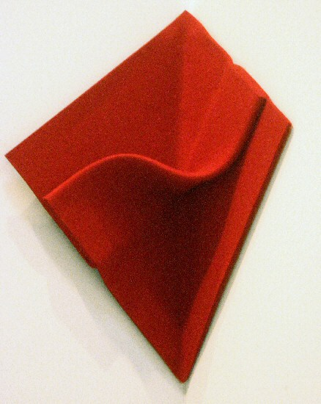
Peter Weber
Corner Folding, 2008
felt
15 3/4 x 15 3/4 inches
PW026

© 2011

Charlotte Jackson Fine Art, Inc.

In the Railyard at:

554 S. Guadalupe, Santa Fe, New Mexico 87501
Telephone: 505.989.8688 Fax: 505.989.9898
cjfa@charlottejackson.com - www.charlottejackson.com

