CHARLOTTE JACKSON FINE ART PRESENTS:

Summer Group Exhibition
July 3 - July 5, 2012

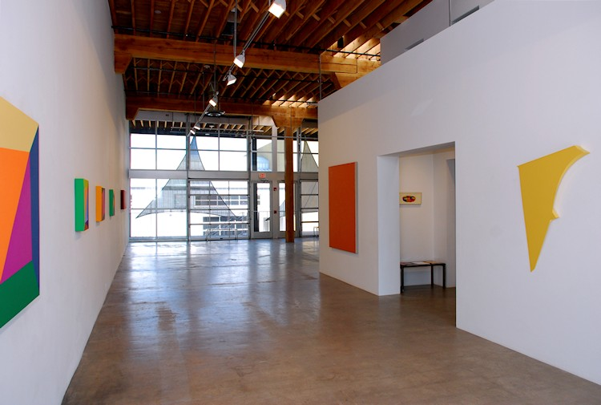
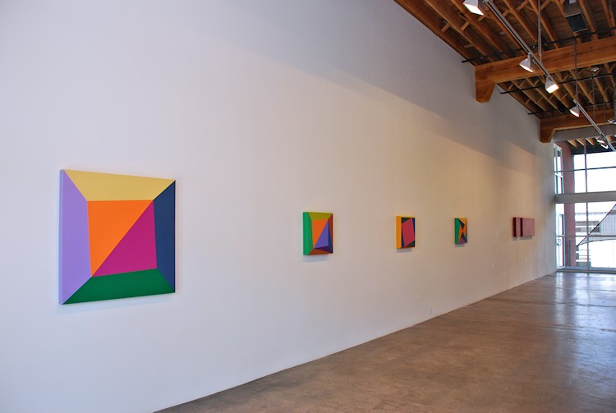

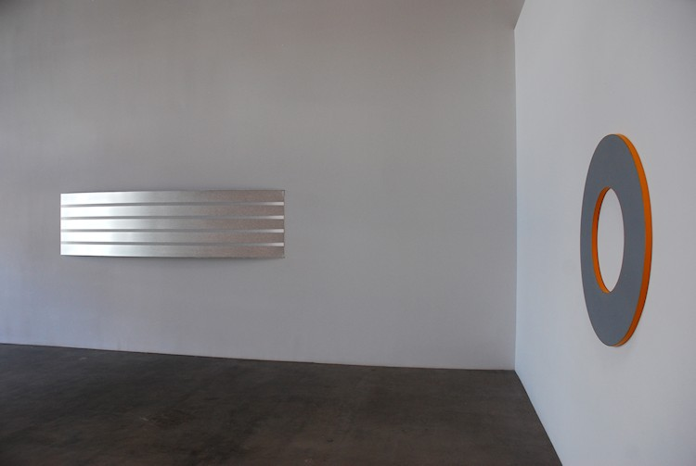
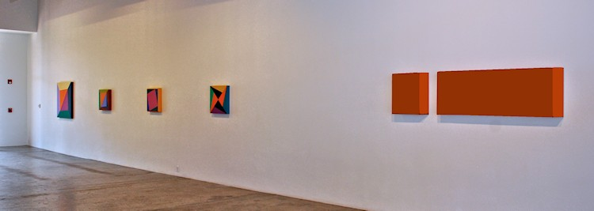

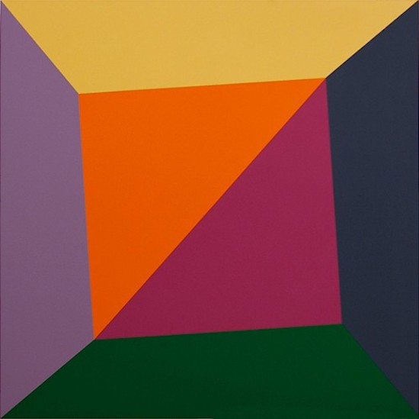
Ronald Davis
Large Diagonal Twist, 2010
Acrylic on expanded PVC
39 3/4 x 40 x 2 1/2 inches
ROND0043
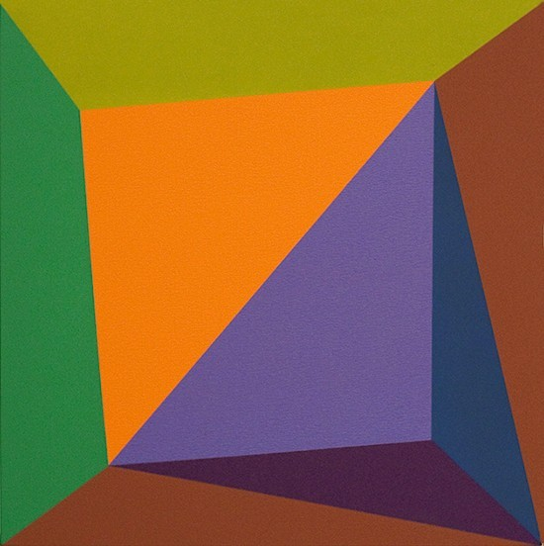
Ronald Davis
Tetra Un-Square, 2009
Acrylic on expanded PVC
20 x 20 x 2 1/2 inches
ROND075
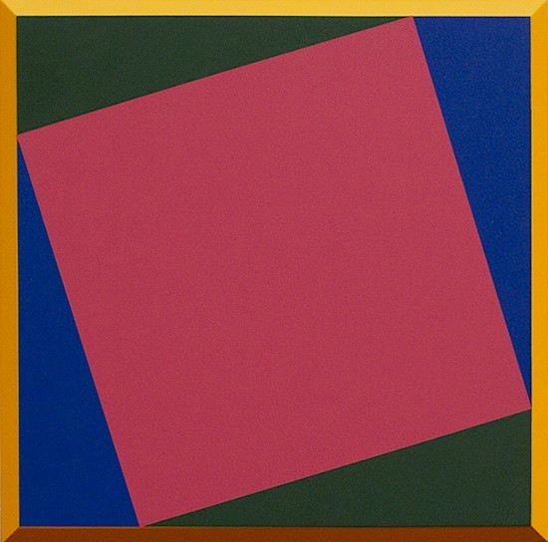
Ronald Davis
Raspberry Square Twist Bevel, 2010
Acrylic on expanded PVC
20 x 20 x 3 inches
ROND0021
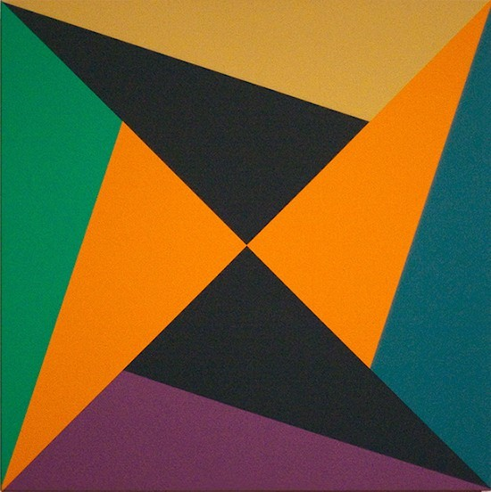
Ronald Davis
Twenty-Four Triangles, 2009
Acrylic on expanded PVC
20 x 20 x 2 1/2 inches
ROND0025
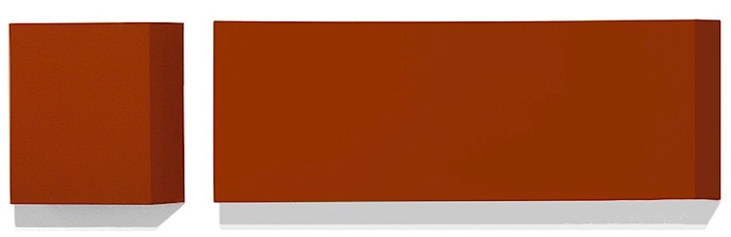
Ronald Davis
Double Burnt Orange, 1966
Liquatex Acrylic on Canvas
20 5/8 x 84 x 4 inches
ROND056
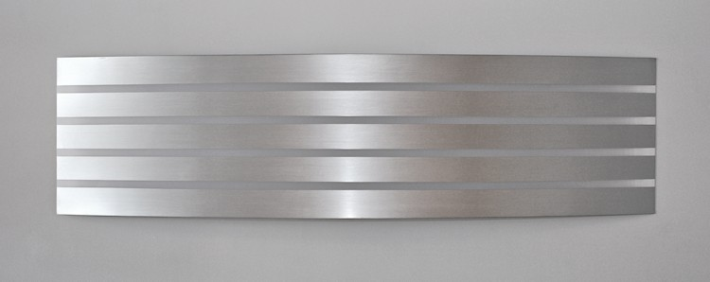
William Metcalf
Stainless Steel Arc, 2007
Acrylic on polyester fabric, wood
31 x 120 x 8 1/2 inches
WM0080
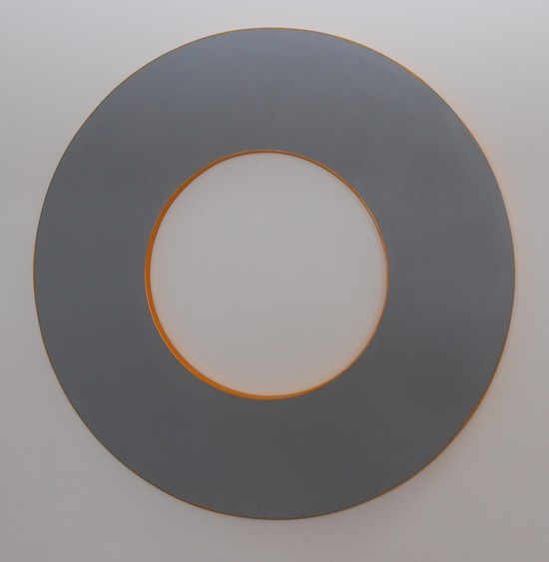
Elliot Norquist
Boost Dose, 2012
painted steel
40 x 40 x 1 1/8 inches
EN0072
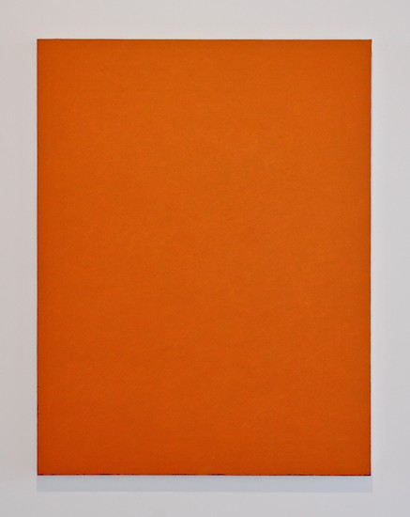
Clark Walding
Painting of Orange (Mayday),
2001-2003
Oil, alkyd, wax on canvas
65 x 51 inches
CW0013
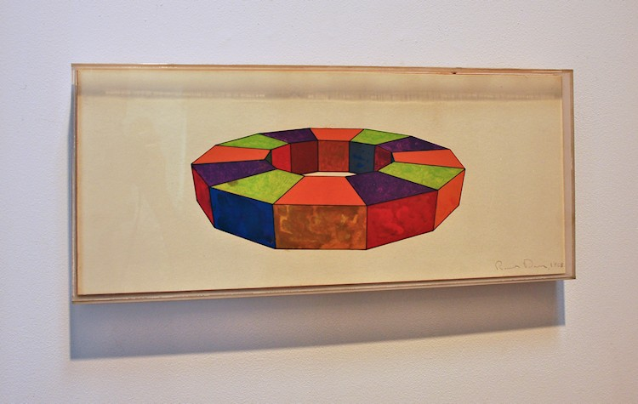
Ronald Davis
Dodecagon, 1968
Cel-Vinyl on Acetate
20 1/4 x 8 3/4 x 1 1/2 inches
ROND0053
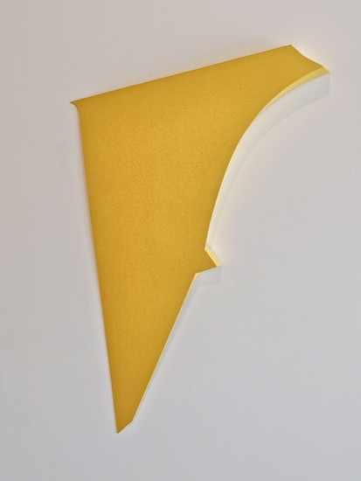
Tony DeLap
Zinger II, 2003
acrylic on aluminum, wood
46 1/2 x 33 1/2 x 3 inches
TD002

© 2012

Charlotte Jackson Fine Art, Inc.

In the Railyard at:

554 S. Guadalupe, Santa Fe, New Mexico 87501
Telephone: 505.989.8688 Fax: 505.989.9898
cjfa@charlottejackson.com - www.charlottejackson.com

