CHARLOTTE JACKSON FINE ART PRESENTS:

DAVID SIMPSON
Interference Blues

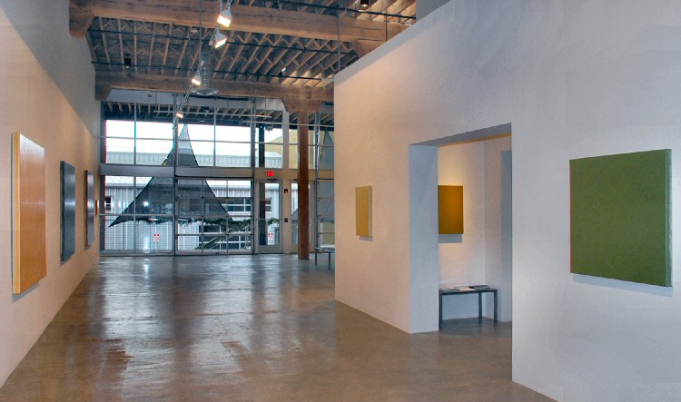
December 17 - January 16 2010
For one moment the painting might appear entirely as a shock of pure blue, but in the next instant, because of the tiniest of movements, the smallest shift of the light, the blue starts to shiver away into a cascade of color: blues bleeding into purples and pinks, resolving into pale straw gold. As you walk back and forth, following these falling colors across the canvas, the effect can feel similar to the play of light over the surface of water—the way it almost crackles as it glints and refracts off of tiny waves in ever-changing patterns.
There is perhaps no other painter who distills color to its essential nature as harmoniously as David Simpson. These square canvases with their taut surfaces gleam and shift over the spectrum, inviting the active engagement of the viewer and invoking questions about the relationship between color and light. In the case of Simpson’s work, the interference comes from the paint, which contains suspended micro-particles coated with mica, which affects the light like a prism, or a random network of mirrors, refracting the light which then bounces and twists off each successive layer of the interference paint. These refractions are what create the startling spectrum shifts in Simpson’s work.
This random effect is not so simple to achieve, however. Simpson has spent years experimenting and perfecting his work with interference paints and the process of creating the paintings is painstaking and arduous. After multiple layers of gesso are applied and sanded down to a velvet finish, Simpson applies as many as 30 layers of interference paint, using a brush and a specially designed metal trowel. It is the careful layering of the paint which gives depth to the paintings and allows the light to penetrate them, creating the array of colors within in each piece.
Simpson knew he wanted to be an artist at an early age and left his home in Pasadena, California to move to the Bay Area and study at the Art Institute. From the beginning his interests lay in the movements of abstract art and he sites Rothko as one of his most pervasive early influences. In the early 1960’s his work was included in ground-breaking shows in New York and Los Angeles, including Clement Greenberg’s celebrated “Post Painterly Abstraction” exhibition at the Los Angeles County Museum of Modern Art.
In Interference Blues, Simpson’s paintings bring the mystery and the science of light, color, and perception together with a deceptively simple straightforwardness and minimal intrusion from the artist. However, to the viewer, seeing the arpeggio-like shift of a copper painting deepen into rust and descend into purple, what comes across most notably will be their beauty.
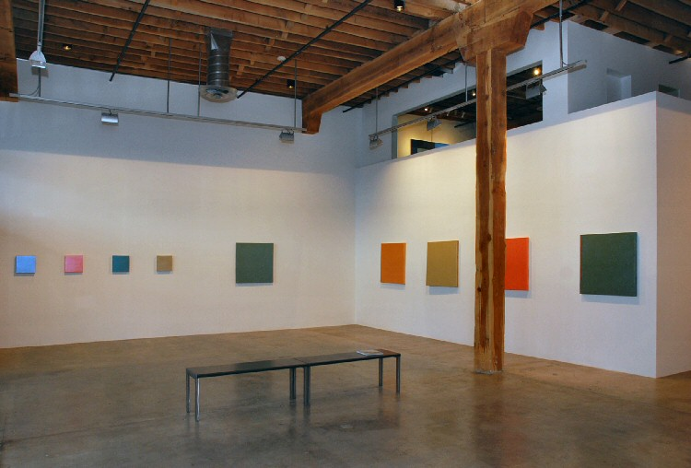v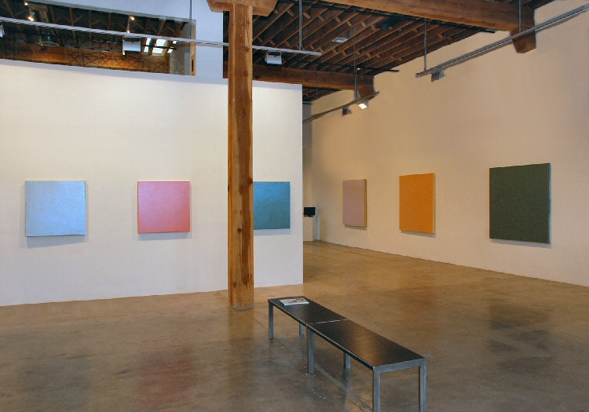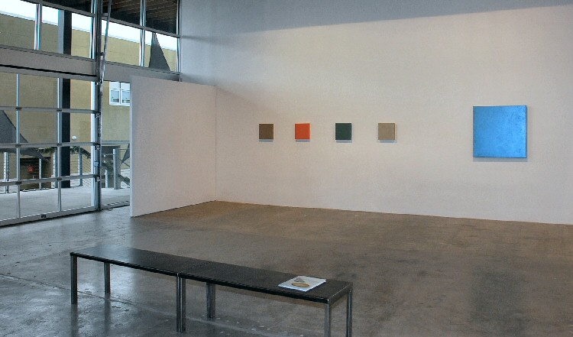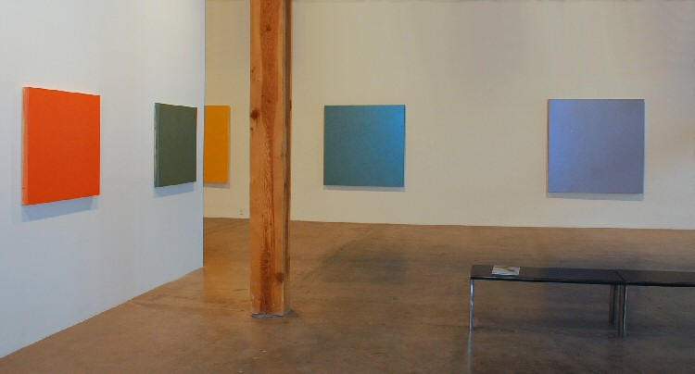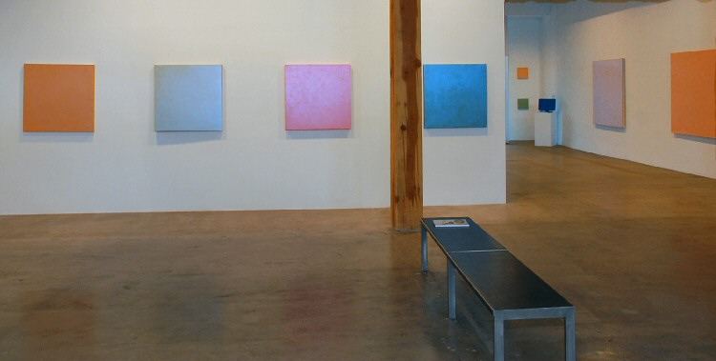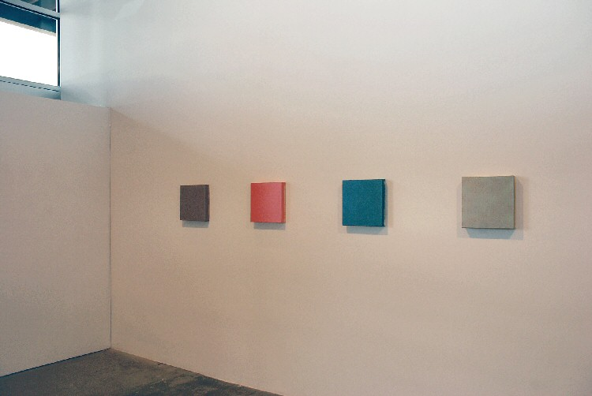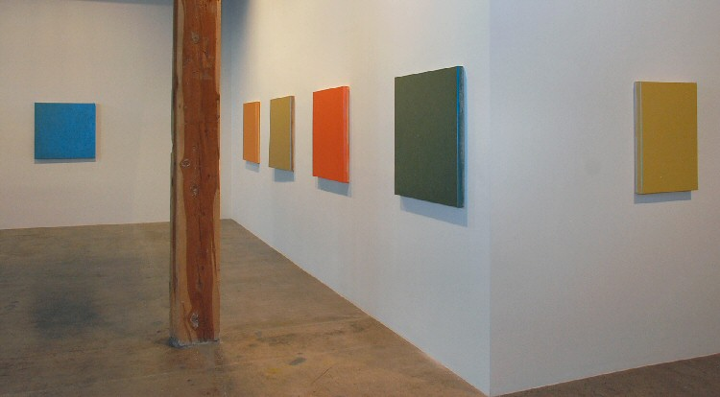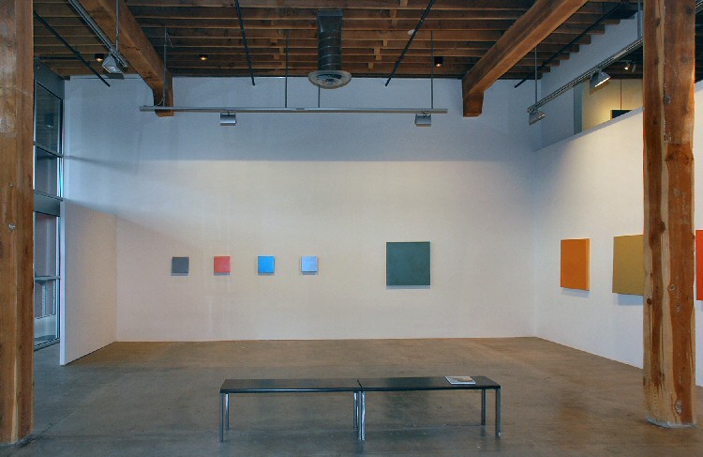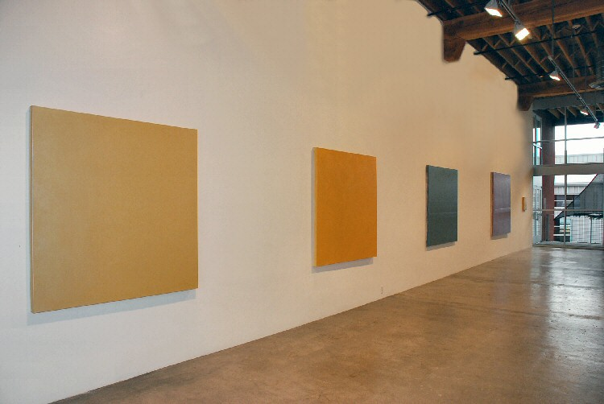
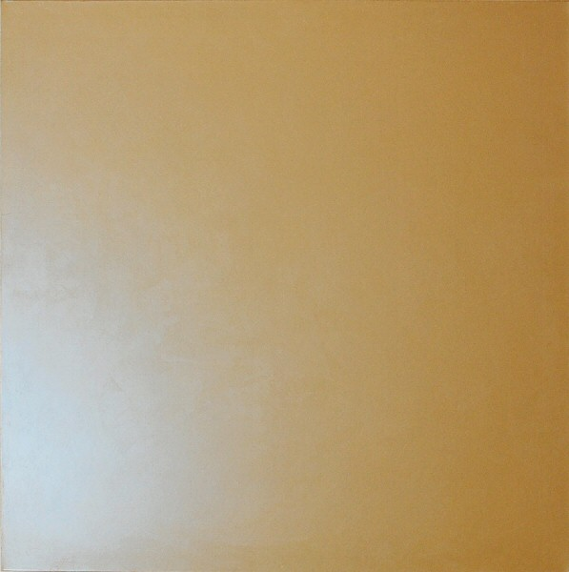
Pie in the Sky, 2010
Acrylic on canvas (interference pigment)
60 x 60 in. (152.4 x 152.4 cm) DS0088
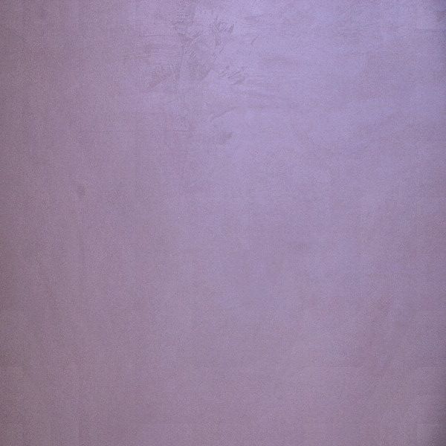
Pie in the Sky, 2010
Acrylic on canvas (interference pigment)
60 x 60 in. (152.4 x 152.4 cm) DS0088
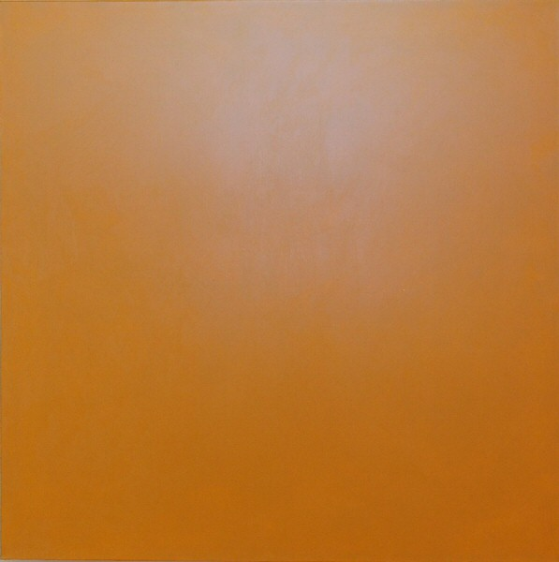
Sky in the Pie, 2010
Acrylic on canvas (interference pigment)
60 x 60 in. (152.4 x 152.4 cm) DS0089
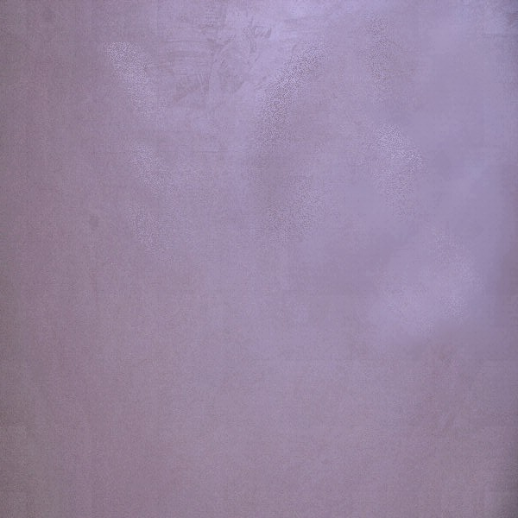
Sky in the Pie, 2010
Acrylic on canvas (interference pigment)
60 x 60 in. (152.4 x 152.4 cm) DS0089
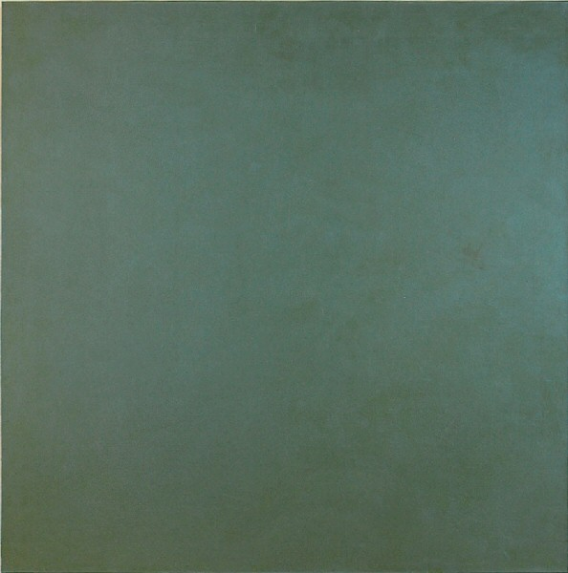
Tides, 2010
Acrylic on canvas (interference pigment)
60 x 60 in. (152.4 x 152.4 cm) DS0090
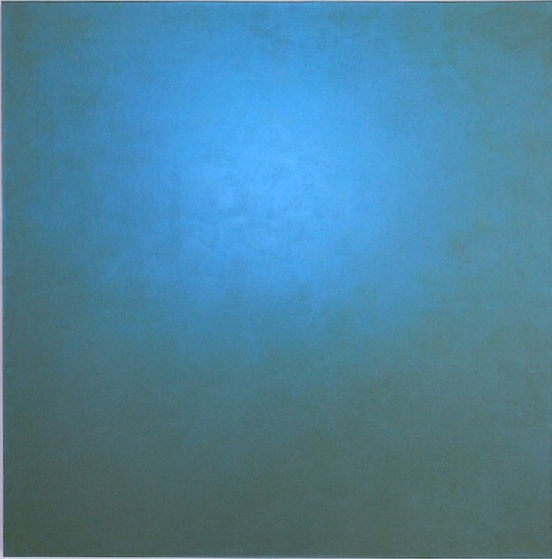
Tides, 2010
Acrylic on canvas (interference pigment)
60 x 60 in. (152.4 x 152.4 cm) DS0090
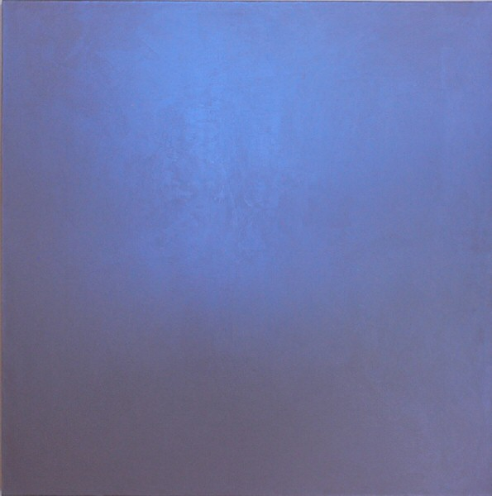
Equinox Blue, 2010
Acrylic on canvas (interference pigment)
66 x 66 in. (167.64 x 167.64 cm) DS0087
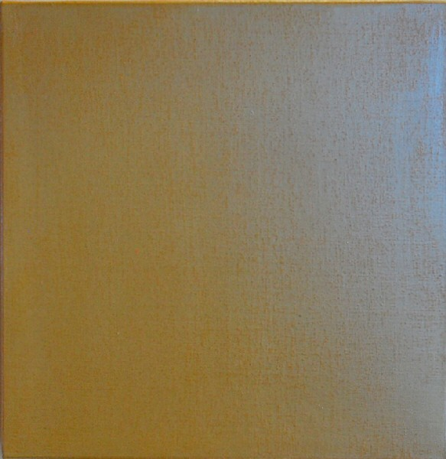
Synthesis, 2010
Acrylic on canvas (interference pigment)
16 x 16 x 2 in. (40.64 x 40.64 x 5.08 cm) DS119
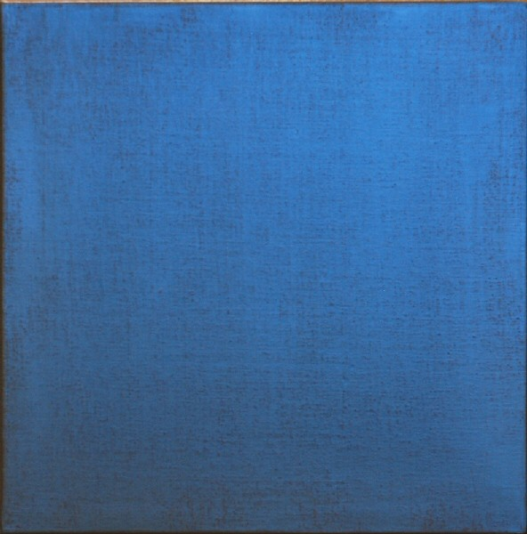
Synthesis, 2010
Acrylic on canvas (interference pigment)
16 x 16 x 2 in. (40.64 x 40.64 x 5.08 cm) DS119
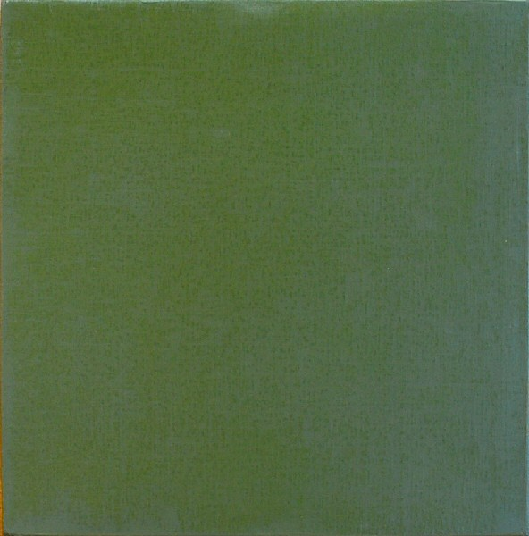
Inner Sea, 2010
Acrylic on canvas (interference pigment)
16 x 16 x 2 in. (40.64 x 40.64 x 5.08 cm) DS120
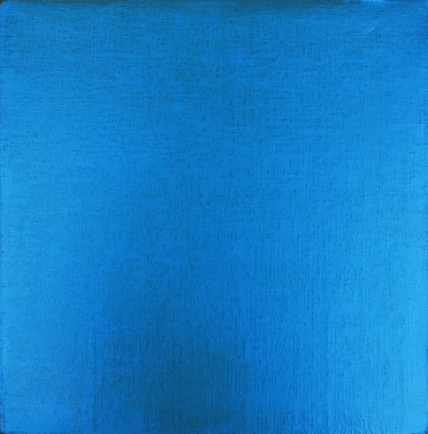
Inner Sea, 2010
Acrylic on canvas (interference pigment)
16 x 16 x 2 in. (40.64 x 40.64 x 5.08 cm) DS120
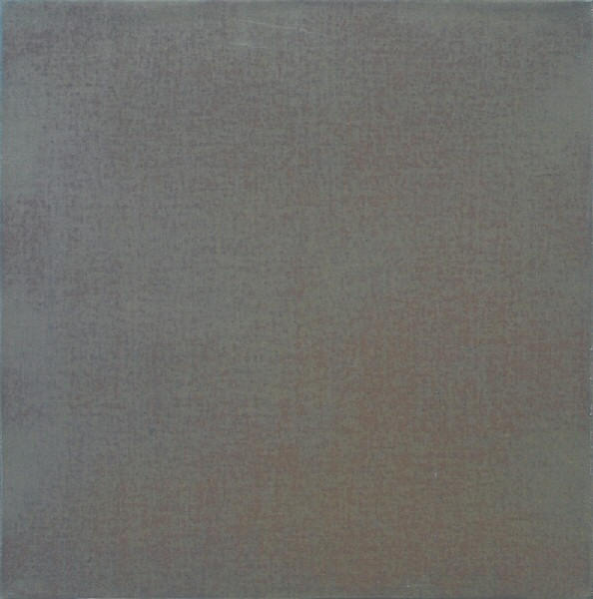
Untrue Blue #1, 2010
Acrylic on canvas (interference pigment)
12 x 12 x 2 in. (30.48 x 30.48 x 5.08 cm) DS115
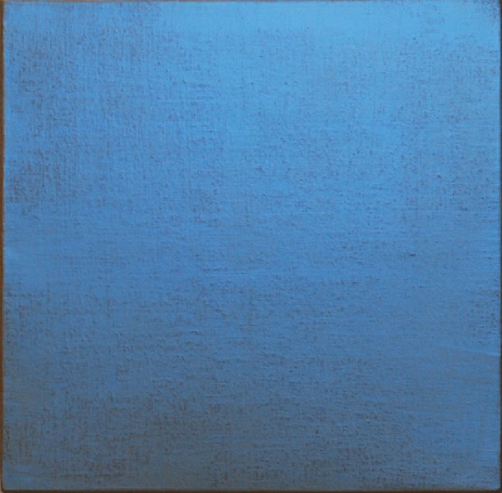
Untrue Blue #1, 2010
Acrylic on canvas (interference pigment)
12 x 12 x 2 in. (30.48 x 30.48 x 5.08 cm) DS115
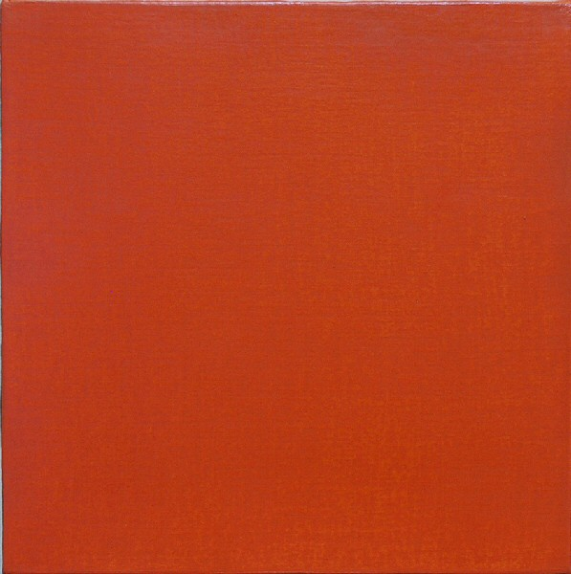
Untrue Blue #2, 2010
Acrylic on canvas (interference pigment)
12 x 12 x 2 in. (30.48 x 30.48 x 5.08 cm) DS116
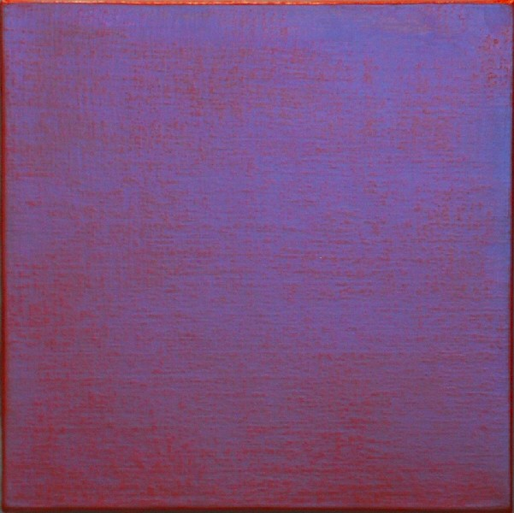
Untrue Blue #2, 2010
Acrylic on canvas (interference pigment)
12 x 12 x 2 in. (30.48 x 30.48 x 5.08 cm) DS116
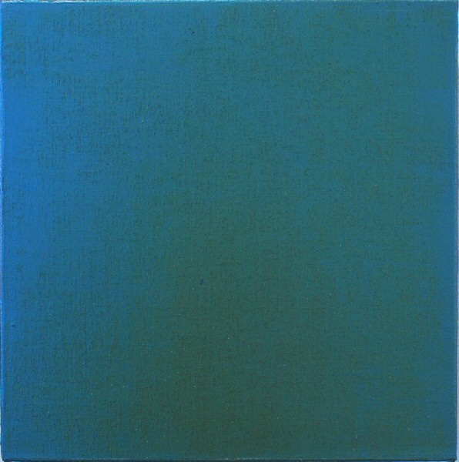
Untrue Blue #3, 2010
Acrylic on canvas (interference pigment)
12 x 12 x 2 in. (30.48 x 30.48 x 5.08 cm) DS117
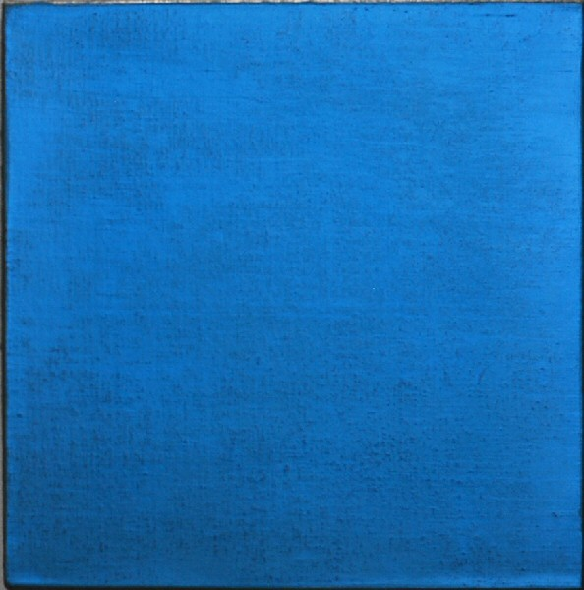
Untrue Blue #3, 2010
Acrylic on canvas (interference pigment)
12 x 12 x 2 in. (30.48 x 30.48 x 5.08 cm) DS117
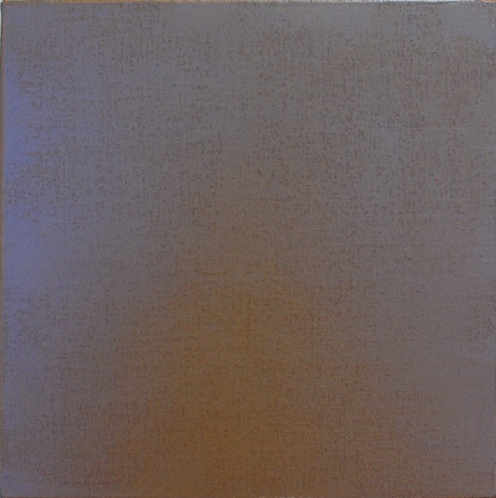
Untrue Blue #4, 2010
Acrylic on canvas (interference pigment)
12 x 12 x 2 in. (30.48 x 30.48 x 5.08 cm) DS118
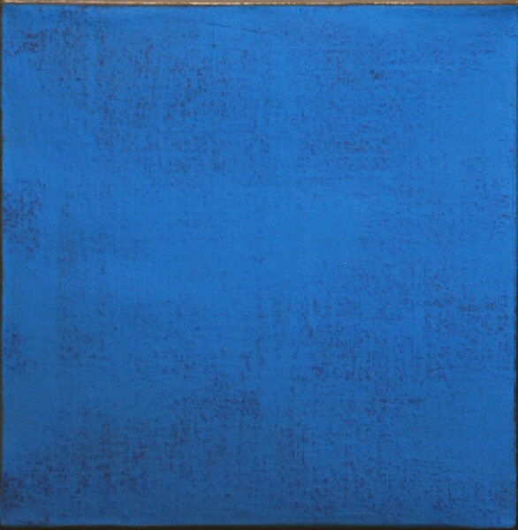
Untrue Blue #4, 2010
Acrylic on canvas (interference pigment)
12 x 12 x 2 in. (30.48 x 30.48 x 5.08 cm) DS118
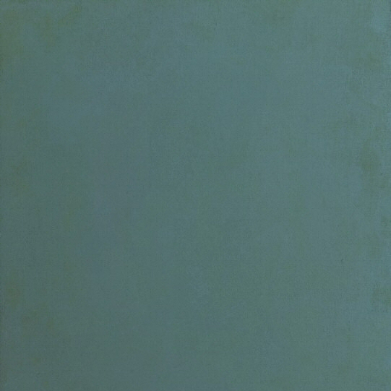
Off the Coast, 2010
Acrylic on canvas (interference pigment)
34 x 34 in. (86.36 x 86.36 cm) DS0096
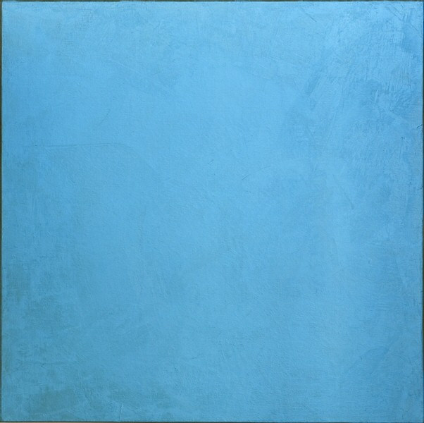
Off the Coast, 2010
Acrylic on canvas (interference pigment)
34 x 34 in. (86.36 x 86.36 cm) DS0096
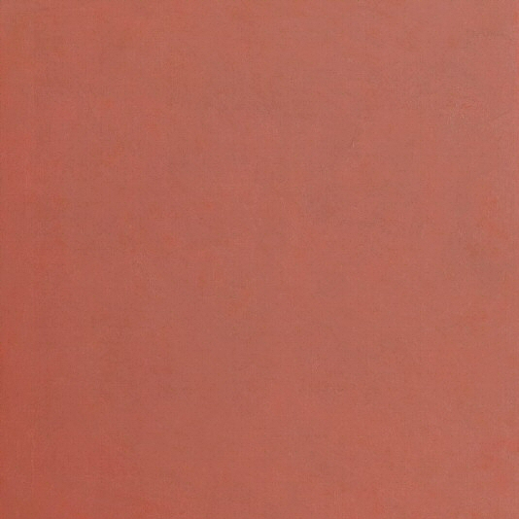
Sunday, 2010
Acrylic on canvas (interference pigment)
34 x 34 in. (86.36 x 86.36 cm) DS0092
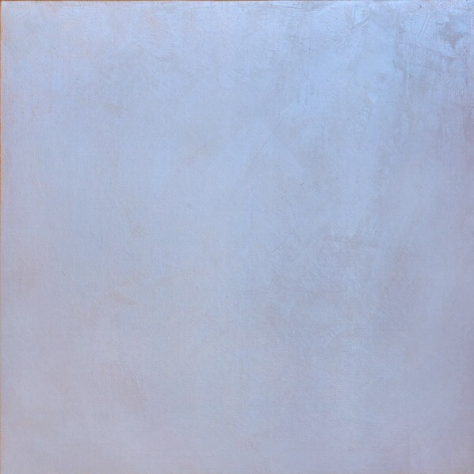
Sunday, 2010
Acrylic on canvas (interference pigment)
34 x 34 in. (86.36 x 86.36 cm) DS0092
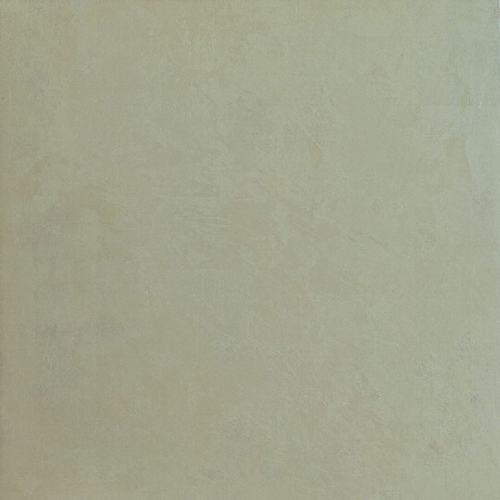
Shifting Sands, 2010
Acrylic on canvas (interference pigment)
34 x 34 in. (86.36 x 86.36 cm) DS0091
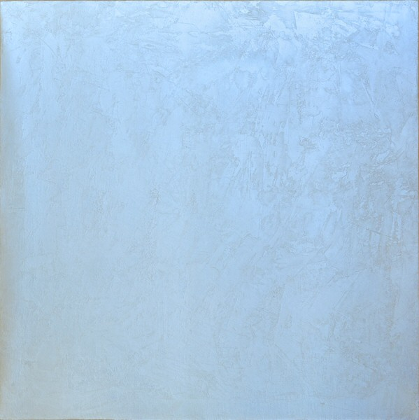
Shifting Sands, 2010
Acrylic on canvas (interference pigment)
34 x 34 in. (86.36 x 86.36 cm) DS0091
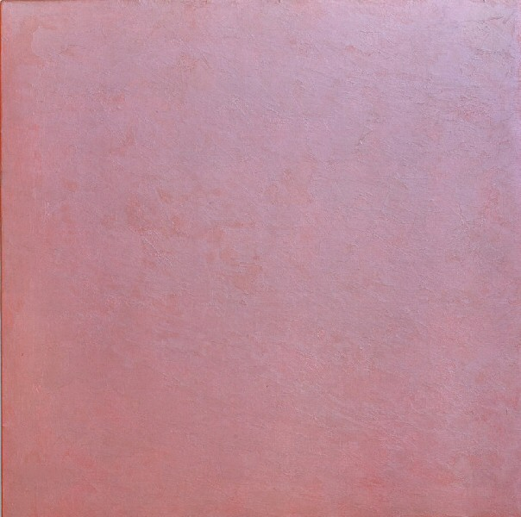
Tangerine, 2009
Acrylic on canvas (interference pigment)
34 x 34 in. (86.36 x 86.36 cm) DS0095
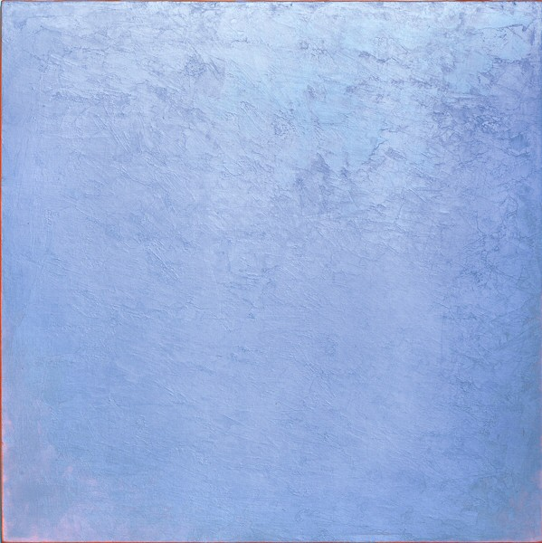
Tangerine, 2009
Acrylic on canvas (interference pigment)
34 x 34 in. (86.36 x 86.36 cm) DS0095
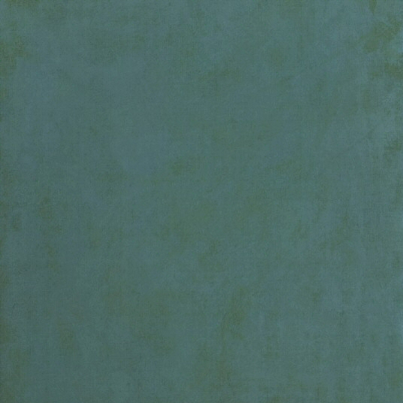
Reflection, 2009
Acrylic on canvas (interference pigment)
34 x 34 in. (86.36 x 86.36 cm) DS0093
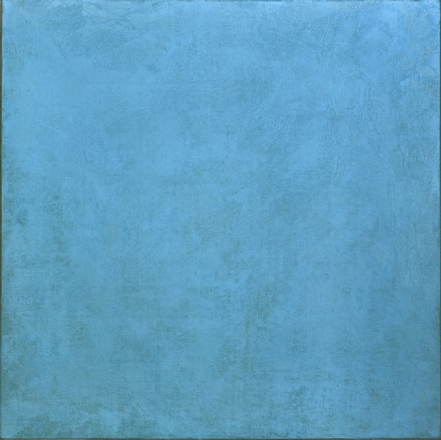
Reflection, 2009
Acrylic on canvas (interference pigment)
34 x 34 in. (86.36 x 86.36 cm) DS0093
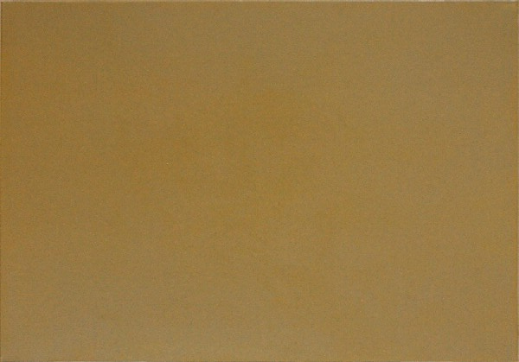
Light of Day, 2010
Acrylic on canvas (interference pigment)
28 x 20 in. (71.12 x 50.8 cm) DS0097
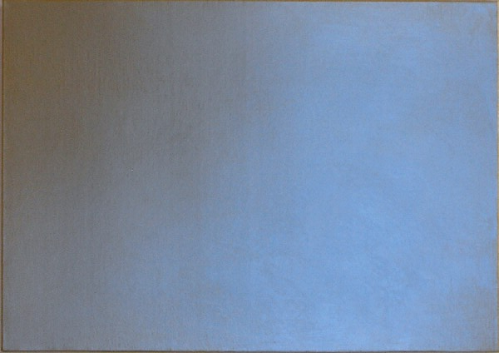
Light of Day, 2010
Acrylic on canvas (interference pigment)
28 x 20 in. (71.12 x 50.8 cm) DS0097
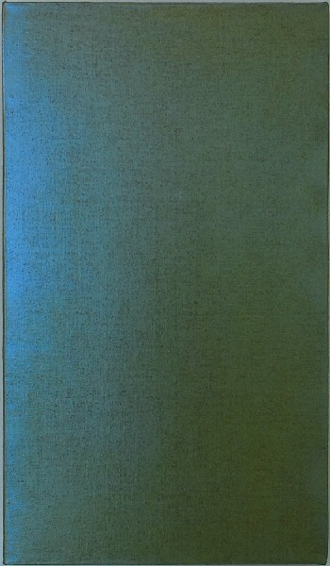
Sweet Pea #2, 2010
Acrylic on canvas (interference pigment)
26 x 15 in. (66.04 x 38.1 cm) DS0099
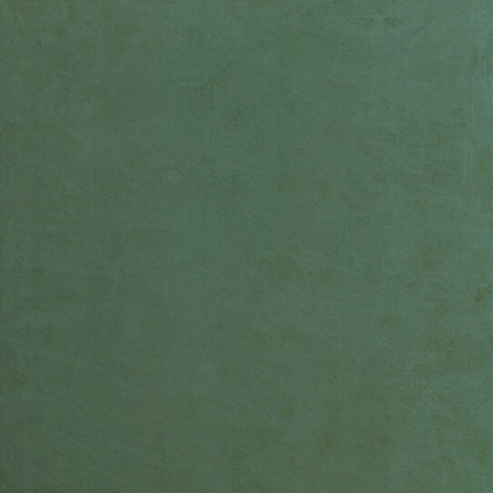
Beneath the Sea, 2010
Acrylic on canvas (interference pigment)
34 x 34 in. (86.36 x 86.36 cm) DS0094
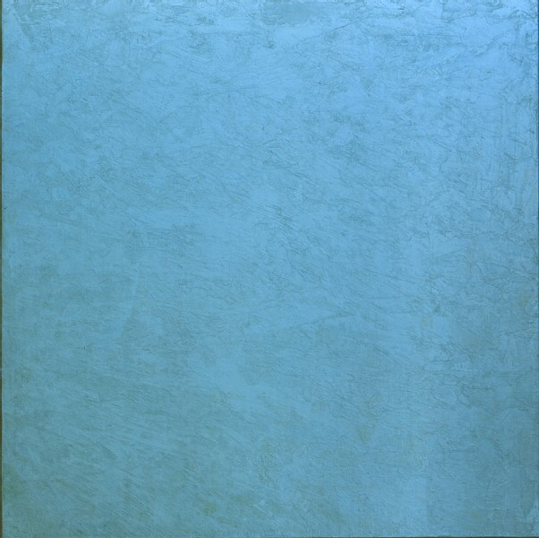
Beneath the Sea, 2010
Acrylic on canvas (interference pigment)
34 x 34 in. (86.36 x 86.36 cm) DS0094
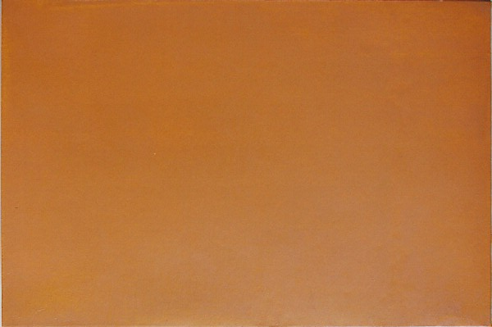
Noon, 2010
Acrylic on canvas (interference pigment)
28 x 19 in. (71.12 x 48.26 cm) DS0098

© 2011

Charlotte Jackson Fine Art, Inc.

In the Railyard at:

554 S. Guadalupe, Santa Fe, New Mexico 87501
Telephone: 505.989.8688 Fax: 505.989.9898
cjfa@charlottejackson.com - www.charlottejackson.com

