CHARLOTTE JACKSON FINE ART
PRESENTS:

Inaugural Railyard Exhibition

SELF AND FAMILY... A RECENT LOOK
Guest Curated by Bobbie Foshay

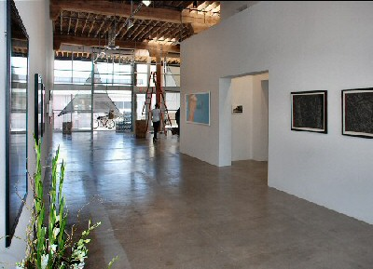

Monika Bravo / Ellen Harvey / Alex Katz / Hendrik Kerstens Coke Wisdom O'Neal / Sandra Scolnik / Kiki Smith

July 9 - August 8, 2010
An exhibition entitled "Self and Family... a Recent Look" inaugurates the unveiling of the new gallery for Charlotte Jackson Fine Art located in the heart of Santa Fe's thriving contemporary art magnet milieu, the Railyard. The light-filled, expansive interior of the remodeled space is well-suited to the variety and breadth of this initial exhibit. A variegated sampling of self and family portraiture-in its broadest sense-by a handful of its distinctive practitioners at work today, the show is conceived and guest curated for the Gallery by Bobbie Foshay

Ms. Foshay is well-known as a committed collector, in addition to being an extremely active promulgator of contemporary art in Santa Fe and New York for many years, including a long stint on the Board of SITE Santa Fe, as President and Chairman. She has previously curated exhibitions in both cities as well. She has elected to organize this particular portraiture show, as the Gallery's debut, because she has long been struck by how cutting edge artists continue to turn to that timeless genre within the long history of art. "Charlotte requested that I do a show with works entirely different than the work she normally exhibits... portraiture seemed to fill this bill rather nicely," Foshay added.

The riveting mummy portraits of Egyptian "Fayum," the hyper-realistic portrait busts of Imperial Rome are just a few of the stellar examples of the genre from ancient times. In the Middle Ages, the Netherlandish painters, like the Van Eycks brought gimlet-eyed exactitude to their portraits-most of them commissioned by private or church patrons. Portraiture reached a place of huge privilege in the Renaissance (Leonardo's mesmerizing, self-portrait drawing comes to mind) and in the Baroque era, we recall Velasquez' "Las Meninas" and Rembrandt's many penetrating self-depictions

In early modern times, the portrait genre flourished among the Impressionists-think of Renoir and Degas, alone-but, for the first time in the evolution of the genre, portraits began, increasingly, to serve as pretexts for experimentation, as much as they were to be accurate representations of the artist himself or his sitters. A prime example of this new, intellectually distanced concept of the portrait was Whistler's famed portrait of his mother, a sedate and contemplative figure in an empty room.

That painting signaled a very "modern" concept of portraiture, indeed, of painting in general, in that the artist, very typically for him, entitled the work not "dear mama" but, instead, "Arrangement in Gray and Black, Number Two," positioning his painting as somehow parallel to the state and condition of musical (i.e. abstract) composition.

Abstraction in portraiture, both of himself and others, is most vividly embodied in Pablo Picasso's long painterly output; we can recollect the artist seeing himself as a satyr prancing with nymphs, or his wives and mistresses as shattered, sometimes weeping apparitions. Foshay has mentioned her admiration for such striking portraits as those of DeKooning, Cindy Sherman, Jeff Koons and, building on those precedents, she has settled upon a group of seven living artists who variously enter this realm of portraiture with an often very idiosyncratic sensibility.

“Self and Family...a Recent Look" is kicked off by the portraits-most often of his wife, Ada-of Alex Katz. Katz's whole painterly enterprise has been a quest "to reconcile the intangible realm of abstract art," as Foshay says, "with the everyday stuff of living," i.e. with his very signature, representational style.

Painter/sculptor/printmaker Kiki Smith is represented in the exhibition with a series of three, shadowy woodcuts, entitled "Mortal," wherein the artist's well-known grappling with hoary themes of life, death, and resurrection is focused expressly on ghostly images of her mother's head, feet and hands.

Perhaps the most riveting and direct reference to historical precedents in portraiture in this show are the staged portraits of Dutch artist, Hendrik Kerstens. In his several cool, still images of his daughter Paula, made without technical aids, Kerstens evokes the tremulous portraits of his fellow countryman, Johannes Vermeer (for example, "The Girl with the Pearl Earring") or earlier Flemish Primitives. The twist in these images consists in Kerstens' fanciful headdresses devised for his sitter, outré concoctions of, say, aluminum foil, or bubble wrap!

Humor also informs the "portraits"--that is, the C-print, photo depictions of the contents of medicine cabinets-by Coke Wisdom O'Neal. The artist allows the interiors of those cabinets--his parents' prescription drugs, his sister's holistic and feminine products-to speak, in an uncanny fashion, for their respective owners.

In hand-engraved, plexiglass mirror and fluorescent light, Ellen Harvey creates her series of "Invisible Portraits," wherein she effaces her own image (in a hanging assemblage of framed pictures) by a "flash-out" tactic, i.e. obliterating her own face by the reflected flash of the camera. We are left to ponder what the artist wishes to convey by this strategy of self-abnegation.

Sandra Scolnik's paintings-in the very medieval technique of oil on wood panel-links her endeavor to the evocations of old portraiture by Kerstens. It is not to the old, Dutch masters, however, that Scolnik turns, but rather, her crowds of melancholy figures, often including herself, in strange, death-related dream-sequences, seem to hark back to Edvard Munch, or, still further back in time, to the more menacing, proto-Surreal paintings of the great Hieronymus Bosch.

Including the complex video installation piece,"Timepiece: Be Here Now," by Monika Bravo, might seem a bit of a stretch, within the concept of contemporary "portraiture" posited for this exhibition. However, Foshay points out that for we viewers, "the act of looking in a mirror, shaped like a medicine cabinet, and contemplating "time" in texts brings all of us to think about "who we are," "where we came from," and "of whom we are a part...ourselves, and our families."

The eccentric and provocative group of artists presented in this show, illustrates rather well what the great Futurist painter, Boccioni, had to say about the depiction of "Self and Family": "A portrait, to be a work of art, neither must nor may resemble the sitter... to depict a figure one must not paint that figure; one must paint its atmosphere."

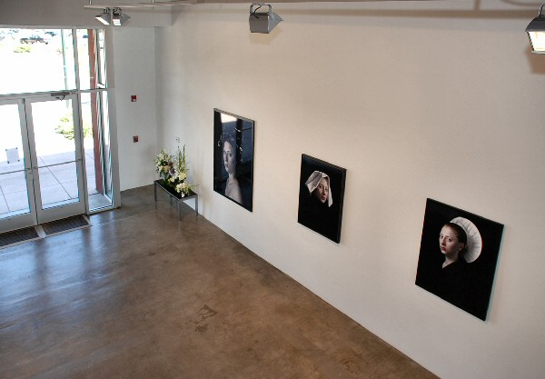
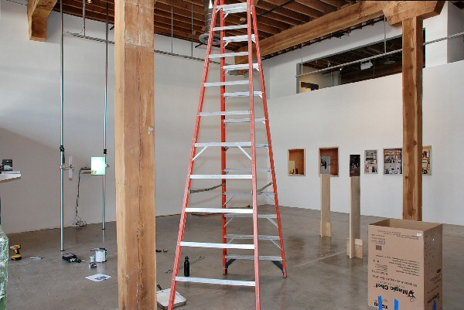

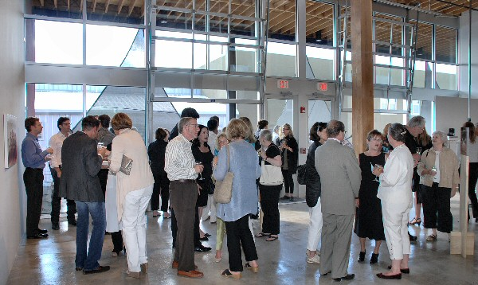
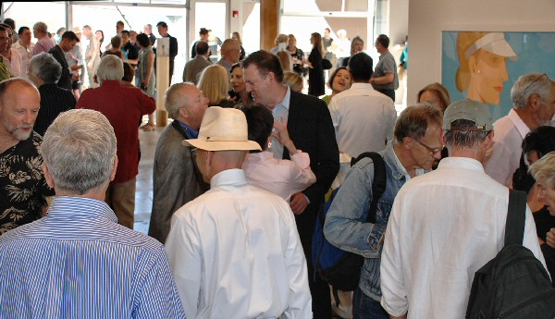

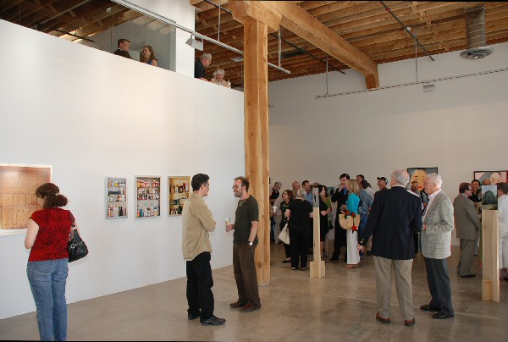

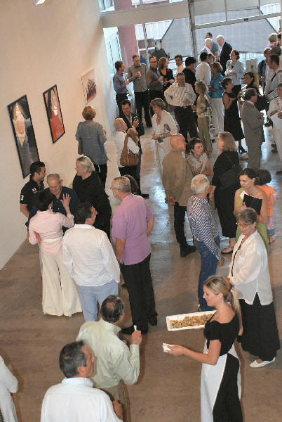

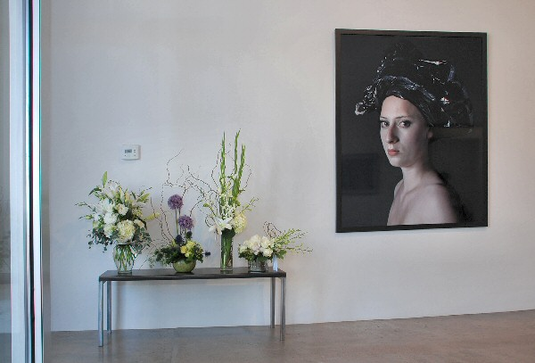

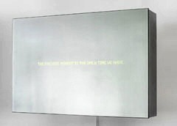 | 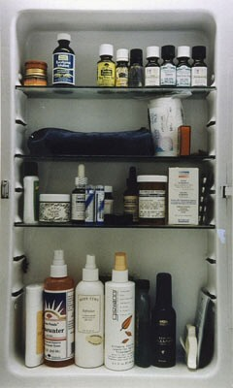
Monika Bravo | Coke Wisdom O'Neal; Courtesy of Mixed Greens Gallery, NY
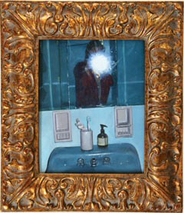 | 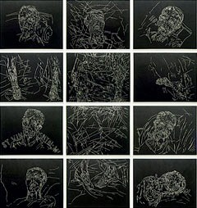
Ellen Harvey; Courtesy of Stephan Stoyanov Gallery, NY | Kiki Smith; Courtesy Kornelia Tamm Fine Art, NM
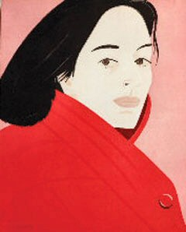 | 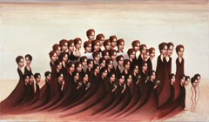
Alex Katz; Courtesy Kornelia Tamm Fine Art, NM | Sandra Scolnik; Courtesy of CRG Gallery, NY

© 2010

Charlotte Jackson Fine Art, Inc.

In the Railyard at:

554 S. Guadalupe, Santa Fe, New Mexico 87501
Telephone: 505.989.8688 Fax: 505.989.9898
cjfa@charlottejackson.com - www.charlottejackson.com

