CHARLOTTE JACKSON FINE ART PRESENTS:

MICHAEL ROUILLARD
Framed Light 2005-2011

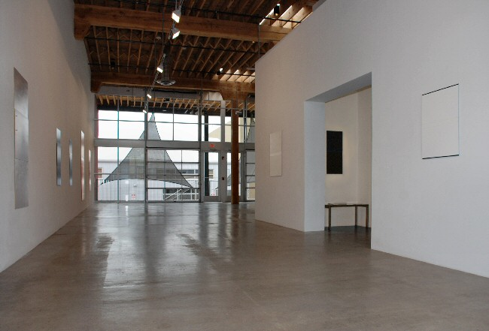

April 29 - May 31, 2011
At first glance the viewer might register four paintings, hanging almost impossibly flat against the wall, with colors that seem to burst forth in their brilliance: Sun-gold orange, red underplayed with pink, dark deep blue, and a shocking red highlighted by currents of orange. But soon they will realize that the gallery is filled with pieces.
Space itself has shifted. Where at first there was only white gallery wall, paintings emerge: light-catching white framed by fine black lines. Their very subtlety acts as a kind of magnet on the viewer, pulling them inexorably deeper into the gallery for a closer look.
Two major themes that run through Michael Rouillard's artwork come together in these pieces: the exploration of light framed by line and the interchange between the seen and the unseen. These ideas can be seen in other mediums of Rouillard's work, including architectural pieces which use recessed or cut lines in wall and ceiling to frame light itself as it enters a structure.
The works in this exhibition are constructed of thin aluminum panels painted with oil or oil stick. In the multi-panel works these panels are layered and the pieces are mounted directly to the wall on pins. The layered panels are cut in order to reveal tiny hints of what lies beneath. Color, hidden below, is suggested in the merest line. The latest pieces are made with only a single panel and here the element of the line and layering is created through a process of painting and incising, rather than through the physical construction.
There is a temptation to put the colored works into a different category altogether from the white and black pieces, however, in practice the pieces work in tandem. In the colored works Rouillard explores the tensions between color's direct emotive qualities and the analytic and linear elements of the paintings' construction. The white and black pieces allow for much finer nuance which emphasizes the fundamental space of light defined by line. Each body of work suggests and refines the other.
The largest of the pieces, up to 9 feet, are mounted so that they begin at floor level. Because of their size and the way they sit against the wall they become architectural, suggesting a doorway perhaps in the way that other paintings suggest windows.
There is no escaping here into something easy or familiar (those markers of traditional painting that can, at times, allow us to lazily breeze by a work because all the normal 'art' boxes have been ticked). Rather we are left with the object itself, brought right up to the moment of interaction between ourselves and the painting. What we are left with, in that moment, is deceptively simple: the hairsbreadth line that marks off the artist's space from the wall, the place where light becomes an event, rather than a ubiquitous phenomena. This is the artist's space, which means, simultaneously, that it is the space that belongs to the viewer's eye.
This is a quiet exhibition. In its silence it asks the viewer to slow down and engage one-on-one with each piece. And yet its stillness should not be confused with simplicity, because here - in a gallery of elegantly constructed paintings, many of which nearly vanish into the walls, there are a multiplicity of complex elements acting all at once, asking us to see.

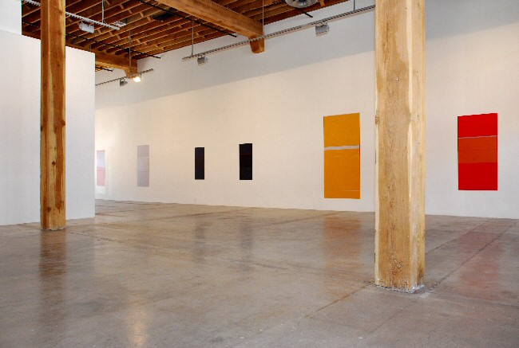

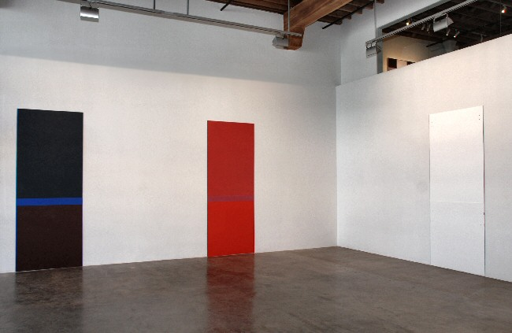

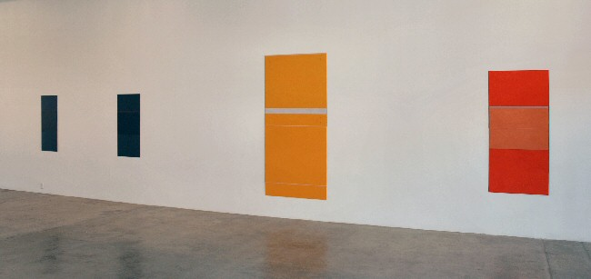
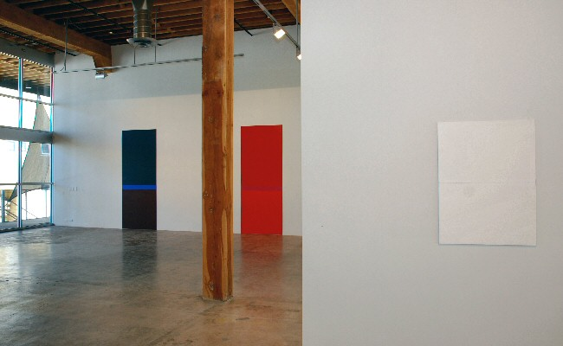

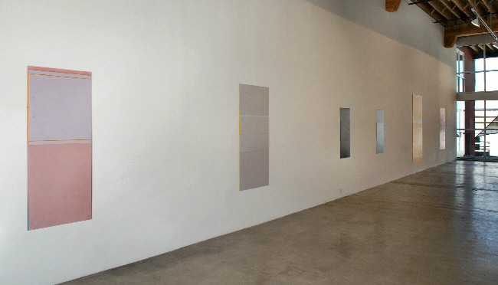
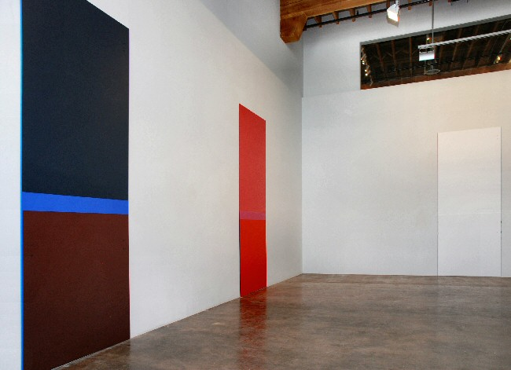

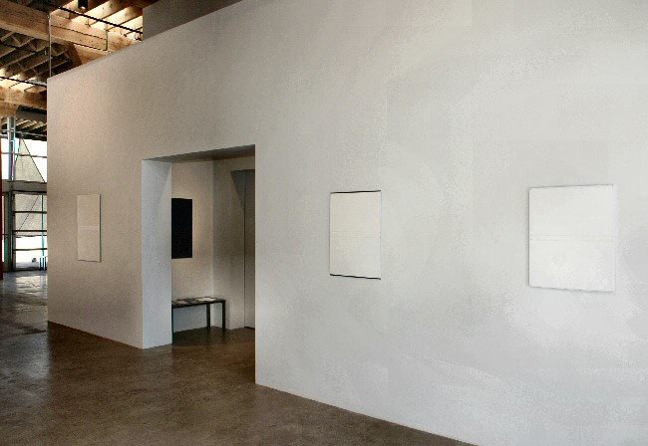
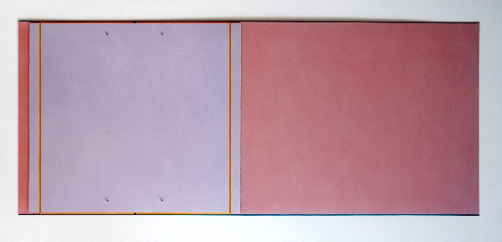
Untitled, 2006
Oil on aluminum
59 1/4 x 25 1/2 inches
MR0037
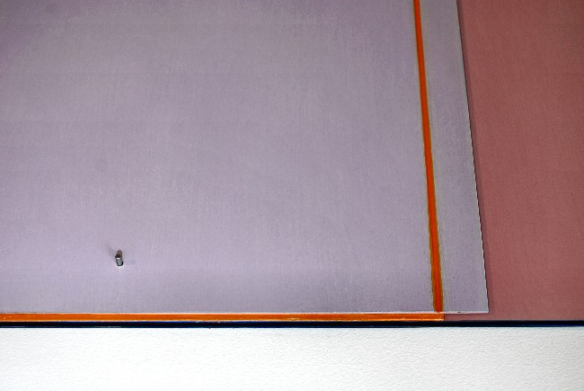
Untitled, 2006
Oil on aluminum
59 1/4 x 25 1/2 inches
MR0037 (detail)
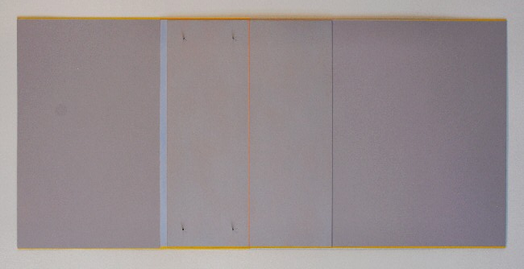
Refrain, 2008
Oil on aluminum
61 x 28 1/3 inches
MR0036
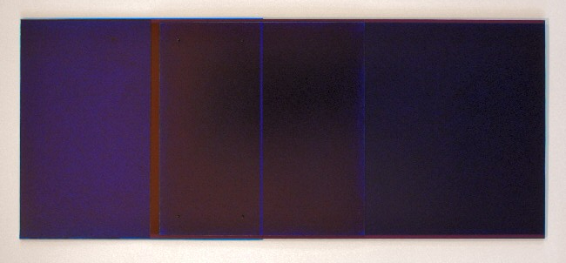
Ion, 2007
Ballpoint pen on paper mounted on aluminum
41 3/8 x 17 inches
MR0041
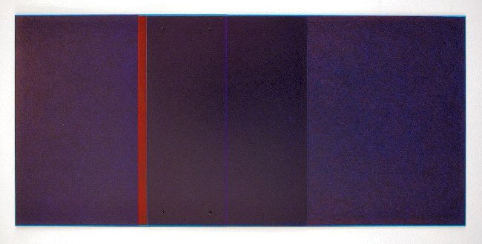
Moment, 2008
Ballpoint pen on paper mounted on aluminum
42 3/8 x 20 inches
MR022
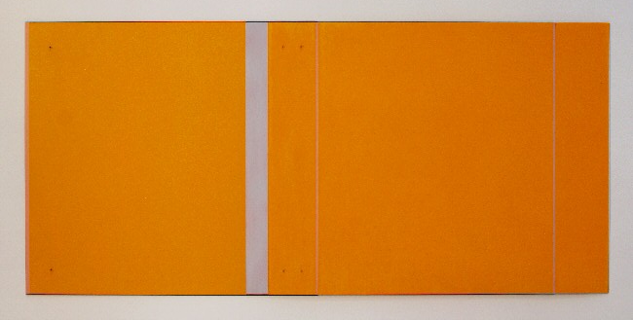
Chroma, 2005
Oil stick on aluminum
82 ½ x 38 7/8 inches
MR017
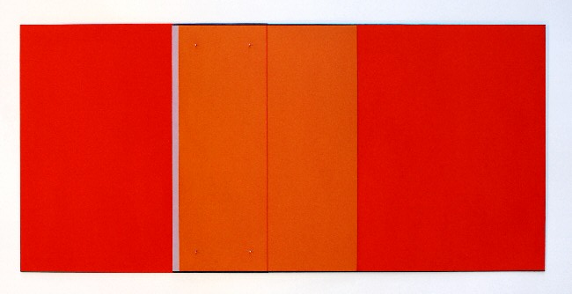
Addendum, 2008
Oil and oil stick on aluminum
61 x 28 7/8 inches
MR018
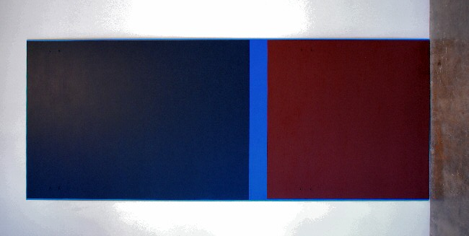
Untitled, 2007
Oil on aluminum
108 x 43 1/4 inches
MR0034
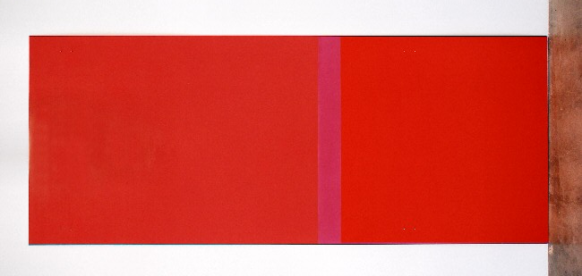
Red Rise, 2007
Oil on aluminum
108 x 43 1/4 inches
MR0035
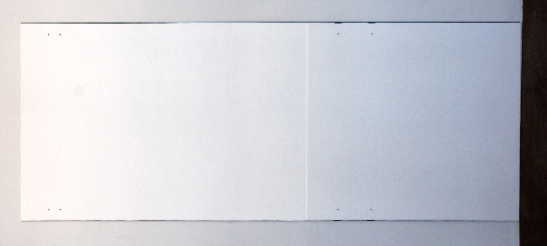
Lighter Still, 2010
Oil on aluminum
108 x 43 1/4 inches
MR0033
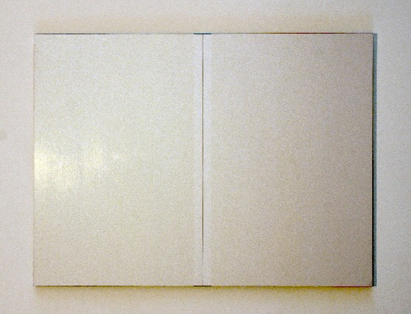
Untitled, 2011
Oil on aluminum
36 x 27 inches
MR0038
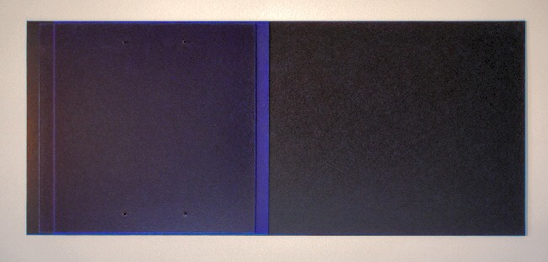
Sequence, 2005-2006
Oil on aluminum
33 ½ x 14 1/2 inches
MR011
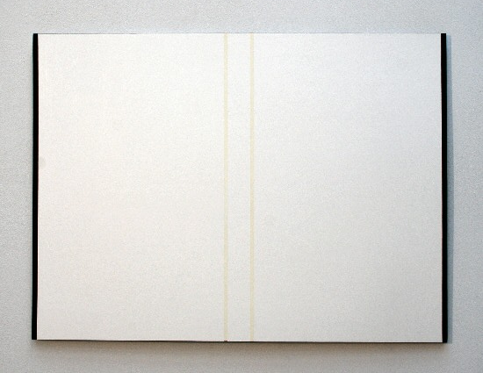
Untitled, 2011
Oil on aluminum
27 1/2 x 20 5/8 inches
MR0042
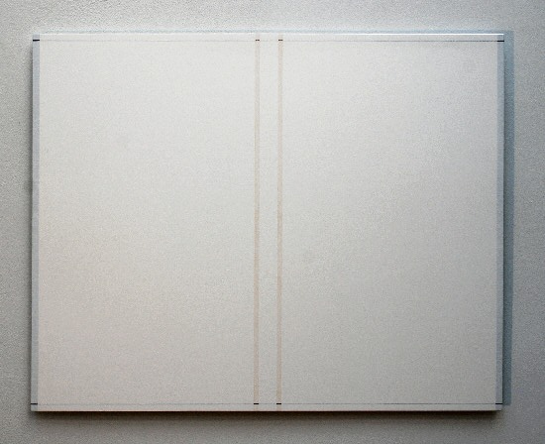
Untitled, 2011
Oil on aluminum
25 1/4 x 20 inches
MR0040

© 2011

Charlotte Jackson Fine Art, Inc.

In the Railyard at:

554 S. Guadalupe, Santa Fe, New Mexico 87501
Telephone: 505.989.8688 Fax: 505.989.9898
cjfa@charlottejackson.com - www.charlottejackson.com

