CHARLOTTE JACKSON FINE ART
PRESENTS:

MICHAEL ROUILLARD
LAYERED COMPOSITIONS: PAINTINGS AND DRAWINGS
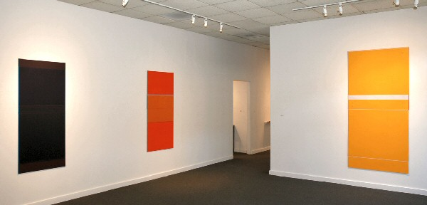
September 5-27

2008
Michael Rouillard has long been fascinated by the relationship of the seen to the unseen. He recalls painting both the backs and the fronts of his early paintings, and his installations have sometimes featured light emanating from behind walls or parts of paintings hidden behind architectural elements. His more recent work, including the new work in his upcoming exhibition at Charlotte Jackson Fine Art, reflects this interest through the technique of layering.
Each Rouillard painting is composed of a number of thin, painted aluminum panels that overlap each other; the entire composition hangs flat against the wall. The parts of each panel hidden by the layers in front of it are as important as the parts that are visible, according to Rouillard. He refers to a "dialogue between elements seen and unseen" and speaks of creating a situation in which the viewer is led to speculate on what lies hidden behind the outer layers.
The works in the September show will feature a new medium for Rouillard: oil stick on aluminum panel. Rouillard cites 13th and 14th Century panel painters as an important inspiration for his current work and notes the similarity of texture between the tempera used in the early Renaissance and the oil stick used in his paintings. Rouillard's new works achieve a richness of color and softness of surface that are reminiscent of these early masters of panel painting. Colors in the September exhibition will be a subtle range of light and medium grays and off white, combined with pieces in the red range.
Rouillard's work has been shown in major galleries in New York, Los Angeles and Chicago, as well as in academic settings and museums in Europe and the United States. His work is represented in major collections such the Panza Collection in Italy; he has also completed residencies at the Sirius Project in Ireland, Riverhouse Editions in Colorado, and the Santa Fe Art Institute.
Repeating a successful formula has never appealed to Rouillard. Rather he always seems to be looking around the next corner to see what may be possible in a different combination of materials or color. For the viewer, his work stimulates a similar fascination with the interplay between what is seen and what is hidden.
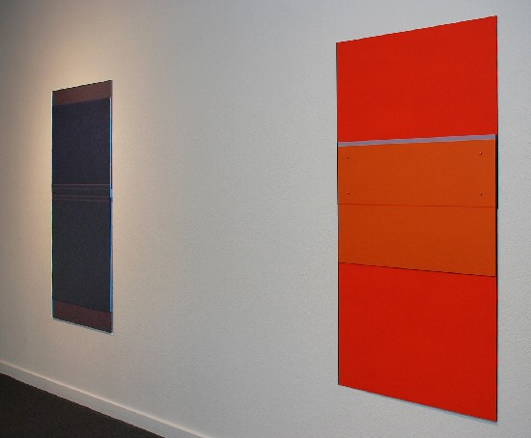
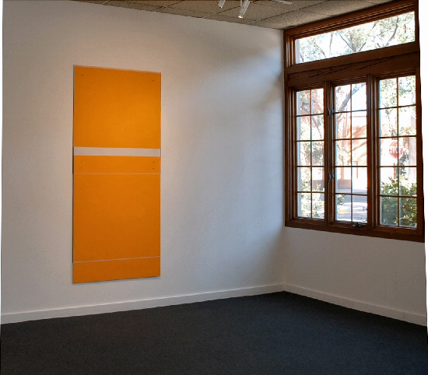
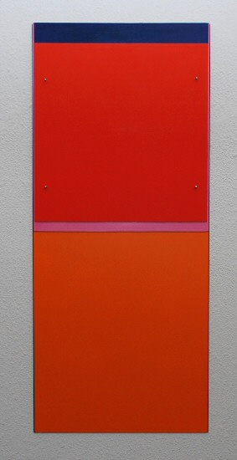
Red Shift, 2005/2007
oil and oil stick on aluminum
36 1/8 x 15 1/2 inches MR020
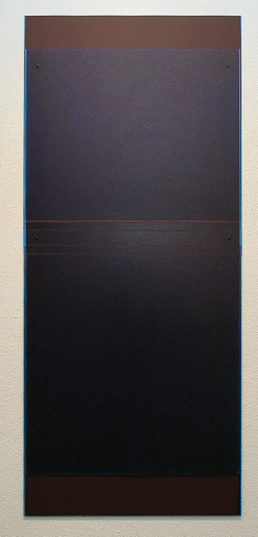
Beginner, 2007/2008
ballpoint pen and brushed ink on paper mounted on aluminum
62 1/4 x 27 1/4 inches MR021
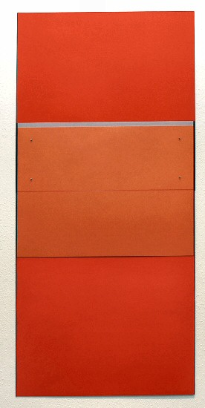
Addendum, 2008
oil and oil stick on aluminum
61 x 28 7/8 inches MR018
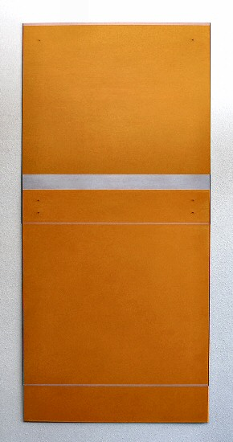
Michael Rouillard
Chroma, 2005
oil stick on aluminum
82 1/2 x 38 7/8 inches MR017
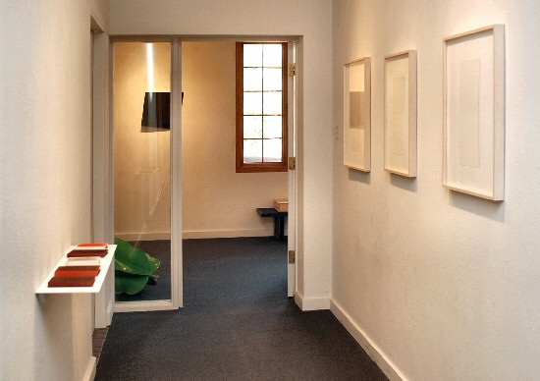
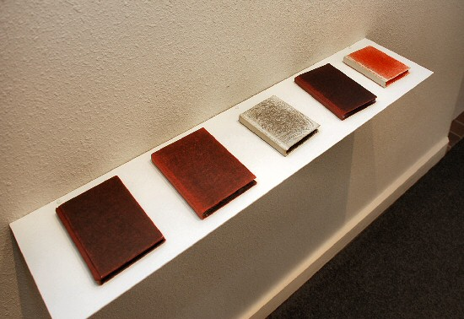
Five Books, 1995-96
ballpoint pen on books MR027

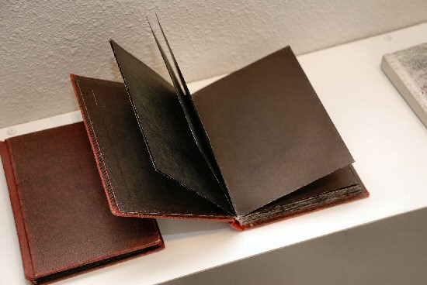
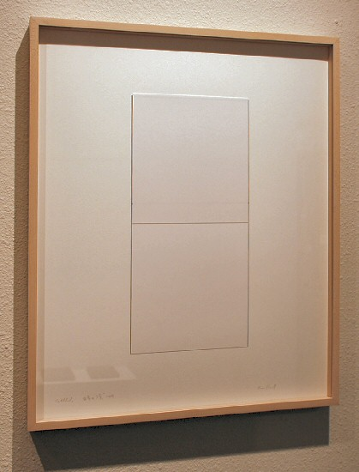
Untitled, 2008
ink on paper
16 3/4 x 7 3/8 inches MR024
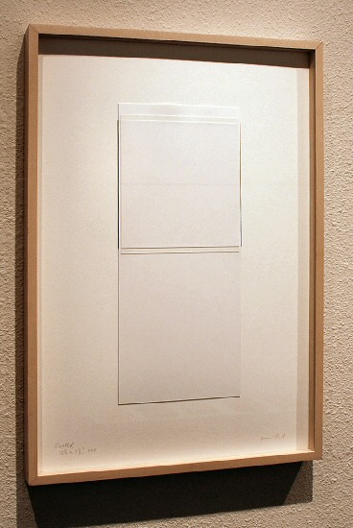
Untitled, 2008
ink on paper
16 3/4 x 7 1/8 inches MR025
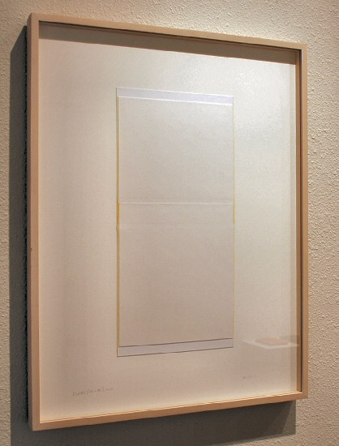
Untitled, 2008
ink on paper
18 1/2 x 8 7/8 inches MR026
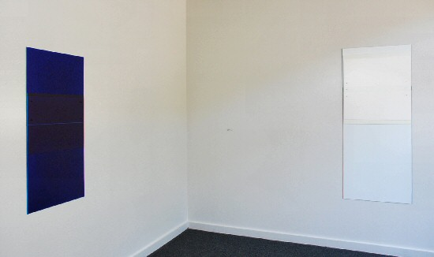
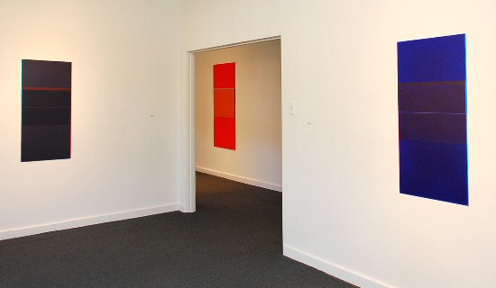
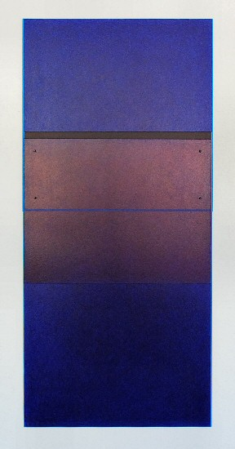
Portal, 2008
ballpoint pen and paper mounted on aluminum
42 2/5 x 20 inches MR023
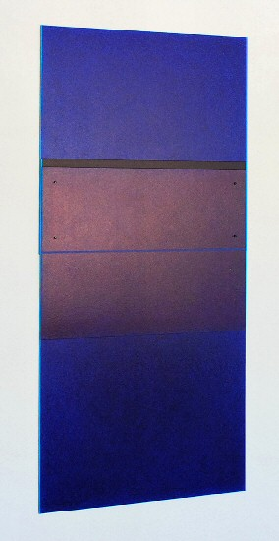
Portal, 2008
ballpoint pen and paper mounted on aluminum
42 2/5 x 20 inches MR023
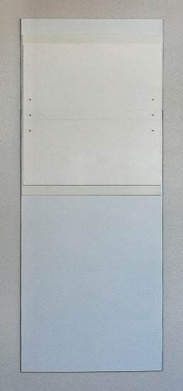
Mediator, 2005/2008
oil and oil stick on aluminum
60 1/3 x 25 inches MR019
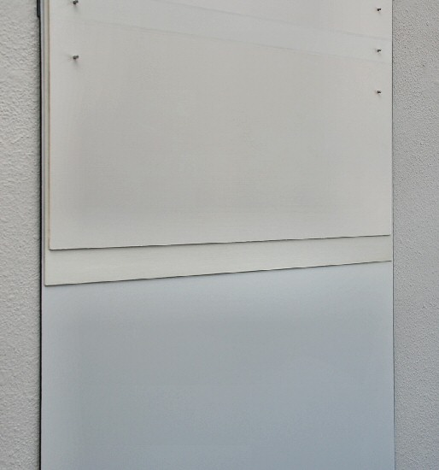
Mediator, 2005/2008
oil and oil stick on aluminum
60 1/3 x 25 inches MR019
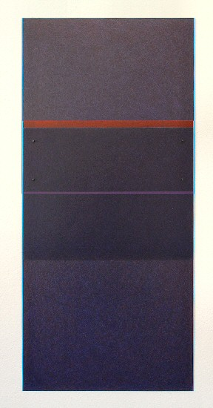
Sequence, 2005-2006
Ball point pen on paper mounted on aluminum
33 1/2 x 14 1/2 inches MR011
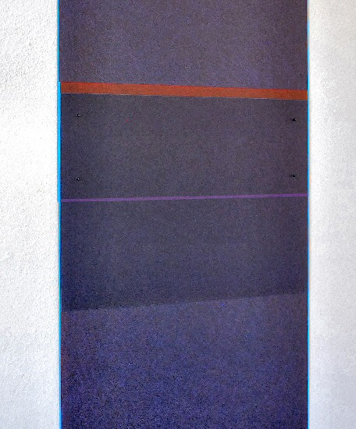
Sequence, 2005-2006
Ball point pen on paper mounted on aluminum
33 1/2 x 14 1/2 inches MR011
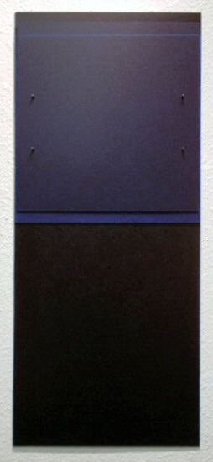
Moment, 2008
ballpoint pen and paper mounted on aluminum
42 2/5 x 20 inches MR022

© 2008

Charlotte Jackson Fine Art, Inc.

200 West Marcy Street, Suite 101, Santa Fe, New Mexico 87501
Telephone: 505.989.8688 Fax: 505.989.9898
cjfa@charlottejackson.com - www.charlottejackson.com

