CHARLOTTE JACKSON FINE ART PRESENTS:

RED, WHITE, & BLACK
A GROUP EXHIBITION

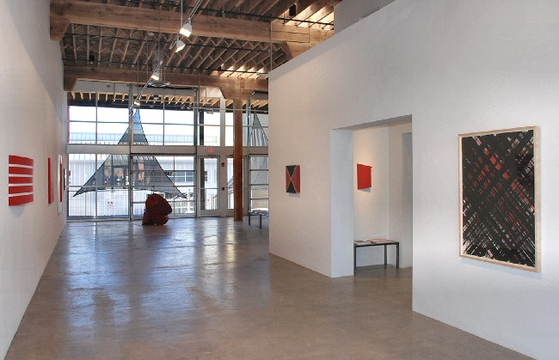

FEBRUARY 4 - MARCH 20, 2011
Color startles, it stimulates. Color flashes before our eyes and reels us backward into memories; it teases out emotions. Color, like almost nothing else, has the power to move us in unknown ways.

Each year Charlotte Jackson Fine Art provides the opportunity for the public to explore raw color on its own terms—either a single color or a significant color grouping. This year the gallery presents a show focused on the dynamic combination of Red, White & Black featuring an engaging array of works from artists Charles Arnoldi, Joe Barnes, Ronald Davis, Constance DeJong, Tony DeLap, Frederick Hammersley, William Metcalf, Ed Moses, Elliot Norquist, Phil Sims, Jeremy Thomas, and Clark Walding.

Walk into a winter wood: bare black branches contrast with stark white snow. And then a flash of red: a berry, a bird’s wing. There is something very fundamental in this color combination—the trio goes back to the pre-history of painting. They were among the very first pigments ever used by man: white chalk, black charcoal, and red ochre. Even beyond their symbolic resonances, these three colors form a unique triad. Black, absorber of light, sits in contrast with white, reflecting light. The strain and dissonance caused by the opposing forces of black and white are charged by the warmth and force of red, pulsing at the far end of the visible spectrum.

Allegory is left far behind in the minimalist works of Red, White, & Black, but a walk through this exhibition is no less dramatic. Clark Walding’s Thin Ice (2nd Lead) is an arresting black painting composed of oil, wax, and alkyd on canvas which offers a subtly of texture that defies its one-color surface. Ronald Davis’ offers a work of acrylic on expanded PVC, Red-Black Quarters, which draws the eye inward to where alternating triangles of red and black meet. Viewers will pause at Joe Barnes’ Untitled (Cadmium Red, medium hue) which uses acrylic on canvas to create a striking study of red. They may then compare this painting with Phil Sims’ large oil on linen meditation on red. Elliot Norquist also explores red, but his vibrant version is painted onto a forty inch steel circle. Jeremy Thomas’ sculptures of twisted, elaborated forms also utilize steel as a medium for powder coated, high gloss color and William Metcalf’s sculptural Red Arc lifts off the wall in stripes of acrylic red on translucent polyester fabric. The interlocking blocks of tonal reds in Charles Arnoldi’s Possession successfully possess the viewer’s attention and hold it.

The viewer of Red, White, & Black will be tempted to circumambulate the gallery over and over again to view each piece individually, pausing perhaps in front of Frederick Hammersley’s oil on linen Mutual Fund #1, in which he masterfully challenges the dichotomy of black and white with the up-thrust of red wedge, and then moving on to explore the ways these pieces interact with one another. For example, Tony DeLap’s black and white, skew-shaped piece The Real Secret finds an interesting counterpoint in Constance DeJong’s quietly mysterious copper and wood, Square 18/3.5 R. Finally, Ed Moses’ twin untitled works of acrylic and masking tape on Strathmore board create a summary statement for the entire exhibition with their energetic composition of crossing black and white lines with their flashes of red bleeding through from beneath.

Red, White, & Black offers a chance for the viewer to be startled and entranced by color.

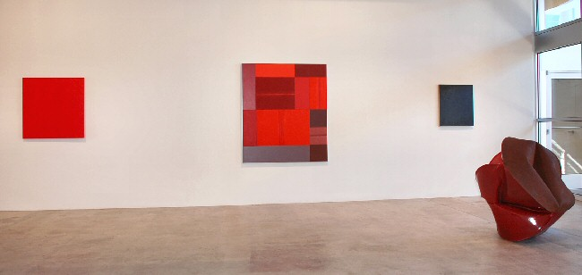

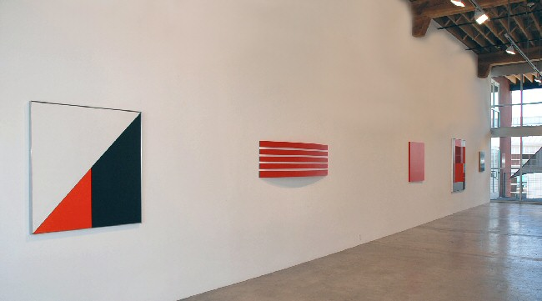
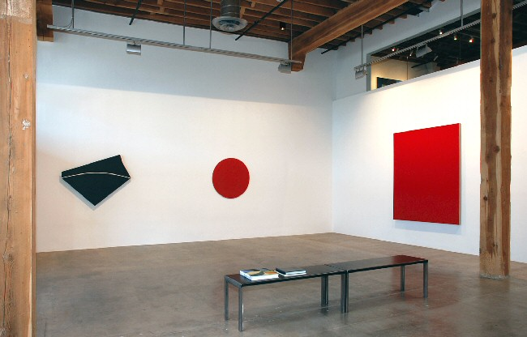

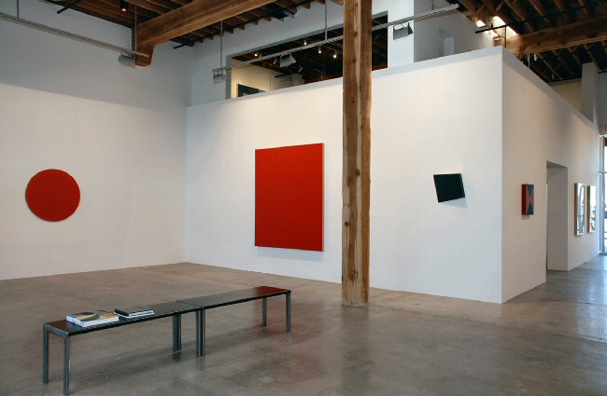
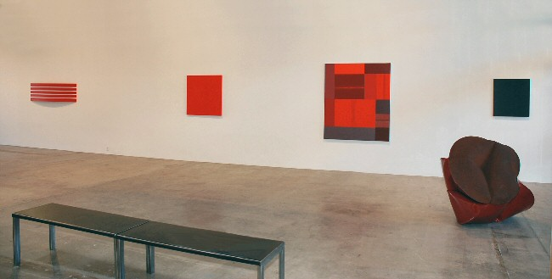

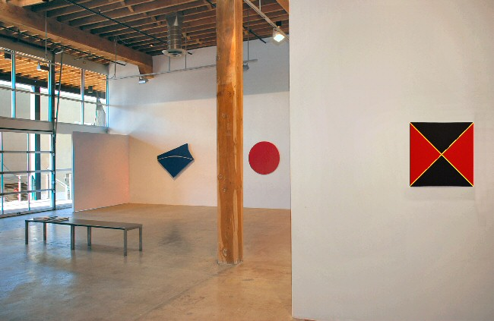
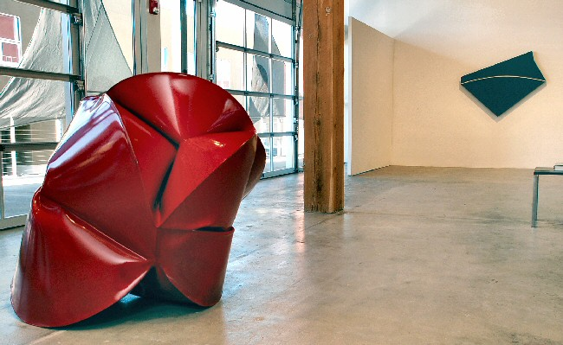

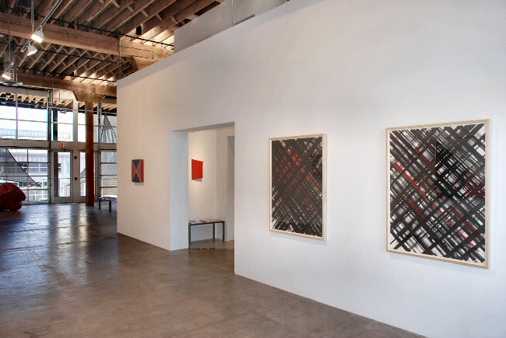
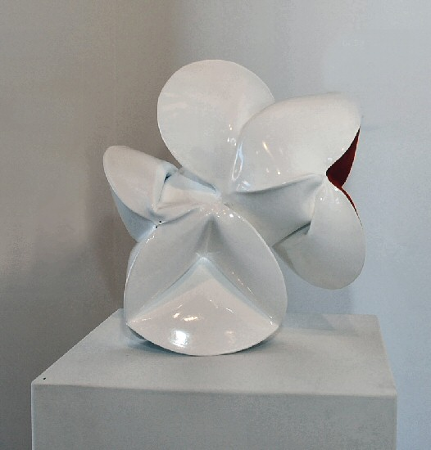
Jeremy Thomas
Oliver White, 2010
Forged mild steel and powder coat
17.00 x 16.00 x 12.00 inches JT200
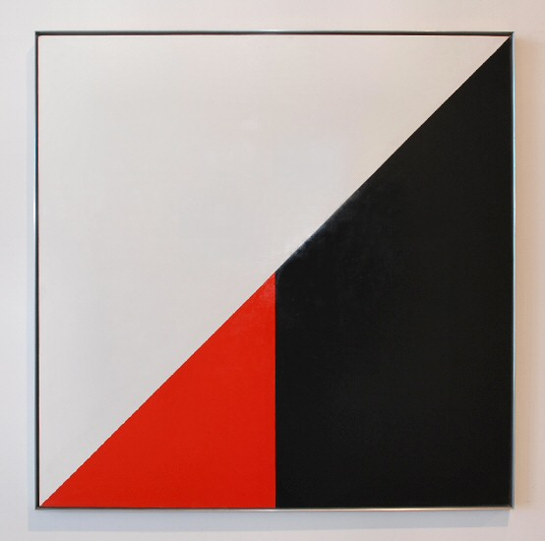
Frederick Hammersley
Mutual Fund (#1), 1972
Oil on linen
44.00 x 44.00 inches FH0081-SM
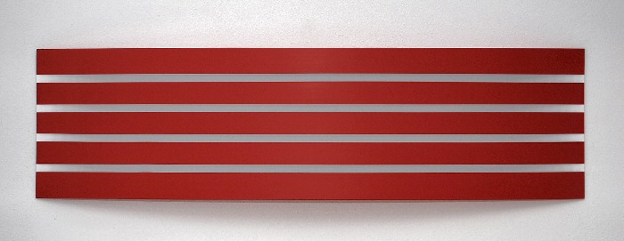

William Metcalf
Red Arc (181WM), 2010
Acrylic on polyester fabric over wood frame1
9.00 x 72.00 x 5.00 inches WM0186
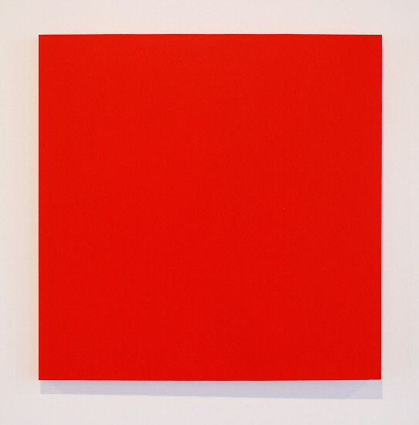
Joe Barnes
Untitled (Cadmium red, medium hue), 2007
acrylic on canvas
36.00 x 36.00 x 1.00 inches JBAR0018
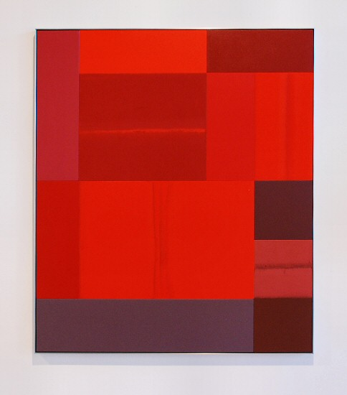
Charles Arnoldi
Possession, 2009
Acrylic on canvas
60.00 x 52.00 inches CA0100
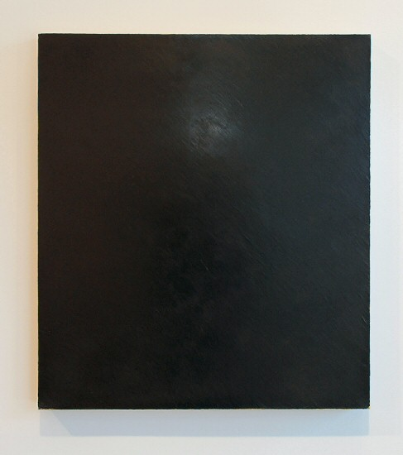
Clark Walding
Thin Ice (2nd Lead), 2005
Oil, wax and alkyd on canvas
28.00 x 25.00 inches CW0036
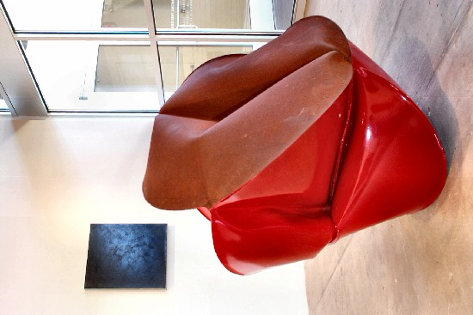
Jeremy Thomas
Cotton Picker Red, 2009
Forged mild steel and powder coat
42.00 x 32.00 x 45.00 inches JT204
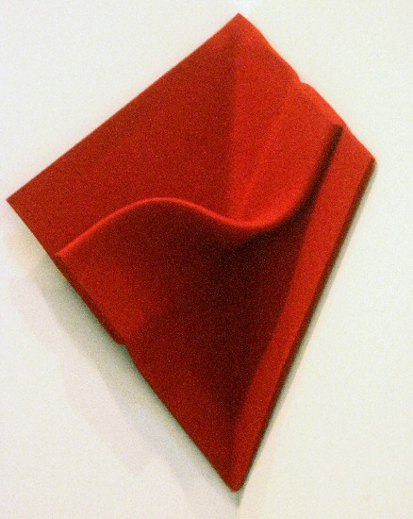
Peter Weber
Corner Folding, 2008
felt
15 3/4 x 15 3/4 inches PW026
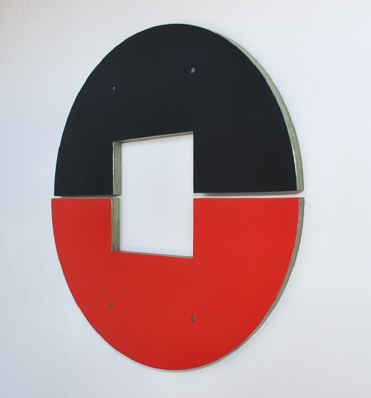
Elliot Norquist
Divided Mind, 2011
Steel, bondo & cardboard
24.00 x 3/4 inches EN0064
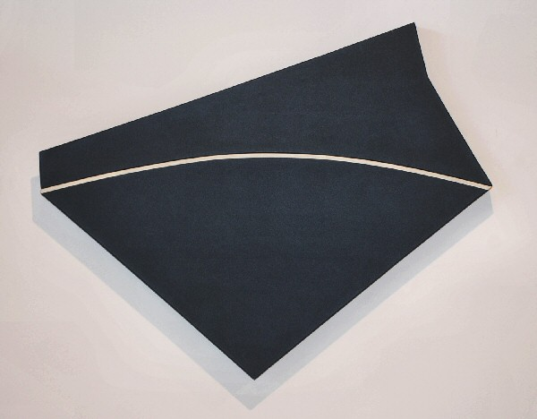
Tony DeLap
The Real Secret, 2009
Acrylic on canvas
45.00 x 56.00 x 3.00 inches TD0078
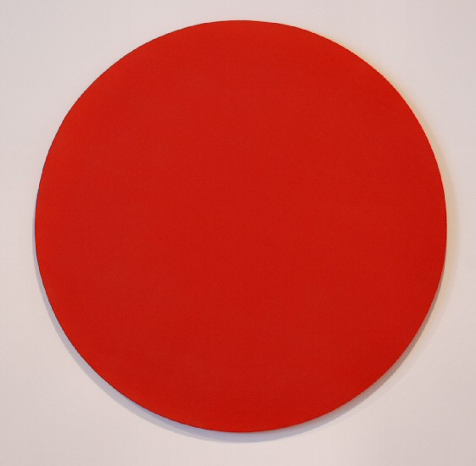
Elliot Norquist
40 Inch Red Circle, 2010
Painted steel
40.00 x 5/8 inches EN0063
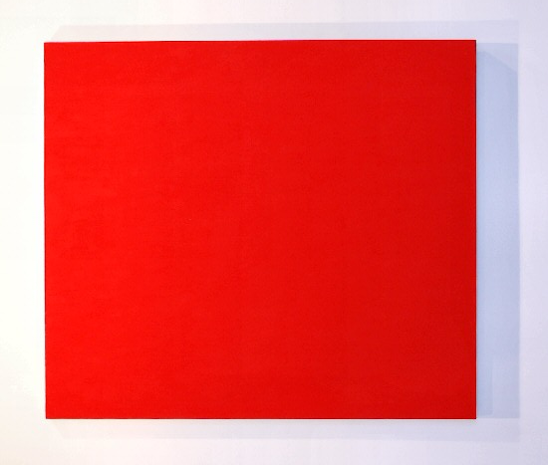
Phil Sims
Untitled (Red), 1999
Oil on linen
80.00 x 70.00 inches PS0016
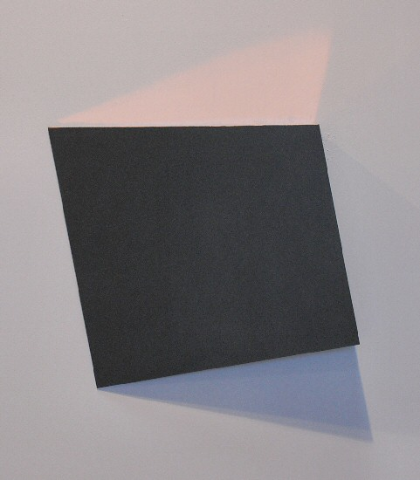
Constance DeJong
Square 18/3.5 R, 2007
Copper, wood
18.00 x 18.00 x 3.00 inches CD91
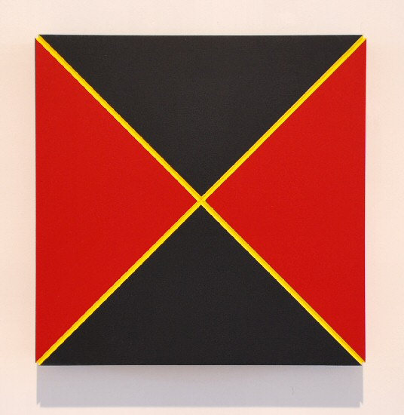
Ronald Davis
Red-Black Quarters, 2009
Acrylic on Expanded PVC
20.00 x 20.00 inches ROND0011
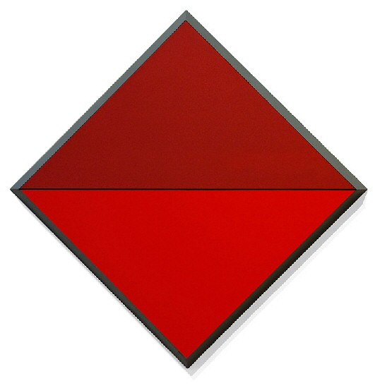
Ronald Davis
Shaped Painting - PTN 1226 - Red Diamond Horizon, 2009
(Shaped) Acrylic on Expanded PVC.
49 1/2 x 49 1/2 x 3 inches
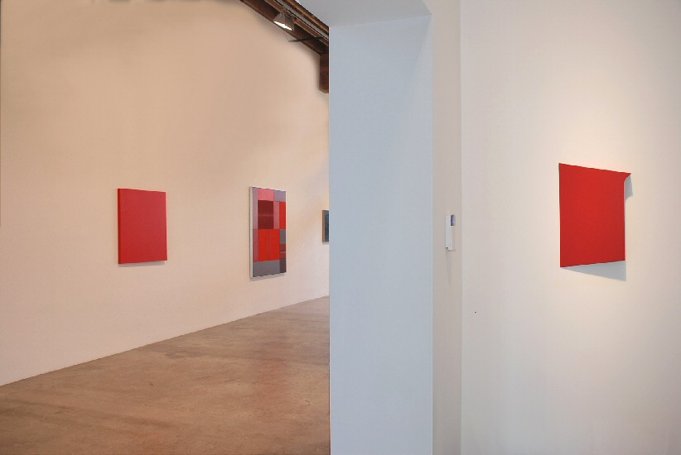
Tony DeLap
Read Allover, 2010
Acrylic on canvas
18.00 x 10.00 x 2.00 inches TD0079
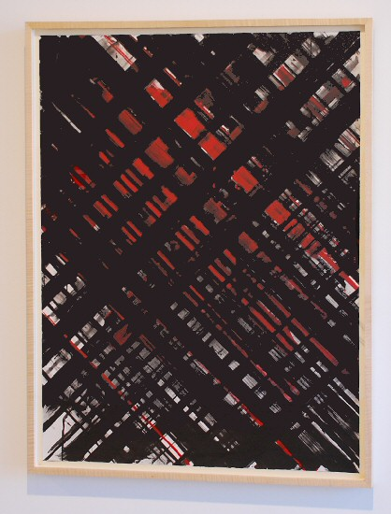
Ed Moses
Untitled, 1976-2008
Acrylic & Masking Tape on Strathmore Board
49.00 x 37.00 inches EM29
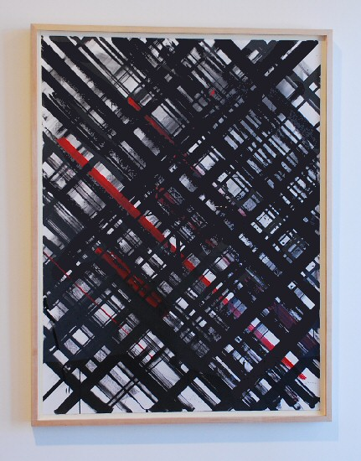
Ed Moses
Untitled, 1976-2010
Acrylic & Masking Tape on Strathmore Board
49.00 x 37.00 inches EM30

© 2011

Charlotte Jackson Fine Art, Inc.

In the Railyard at:

554 S. Guadalupe, Santa Fe, New Mexico 87501
Telephone: 505.989.8688 Fax: 505.989.9898
cjfa@charlottejackson.com - www.charlottejackson.com

