Charlotte Jackson Fine Art
Presents:

PRIMARY INTENTIONS
A GROUP SHOW
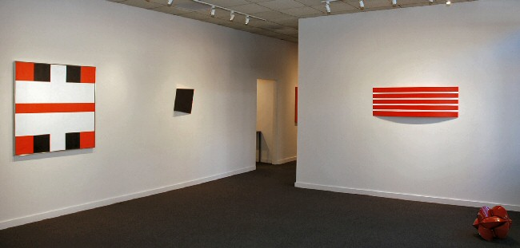

Featuring:
Joe Barnes, Karl Benjamin, Alfonso Fratteggiani Bianchi, Ronald Davis
Constance DeJong, Frederick Hammersley, William Metcalf, Elliot Norquist, Jeremy Thomas
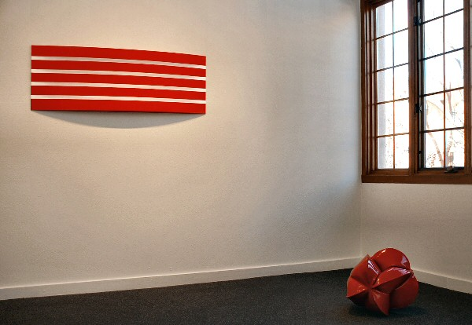

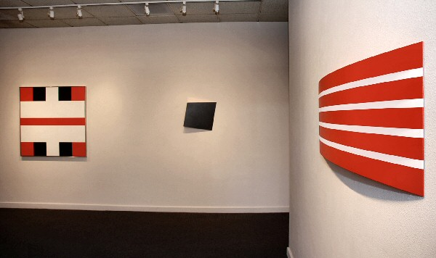
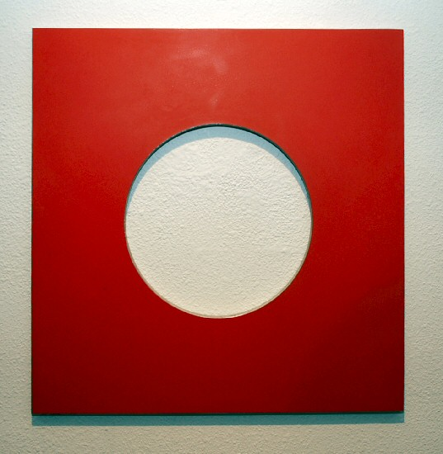
Elliot Norquist
Cookie Cutter, 2009
steel, bondo, cardboard
24 x 24 x 5/8 inches
EN0043
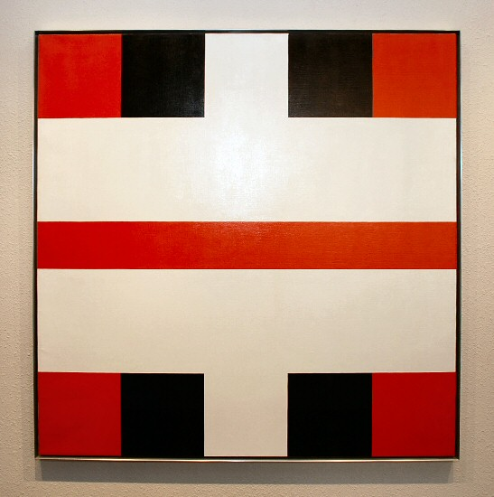
Frederick Hammersley
To Plus Two (#3), 1973
Oil on linen
45 x 45 inches
FH0353
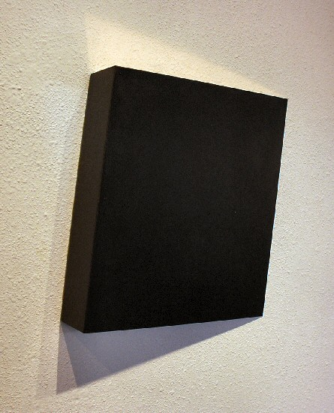
Constance DeJong
Square 18/3, 2007
copper, wood
18 x 18 x 3 inches
CD023
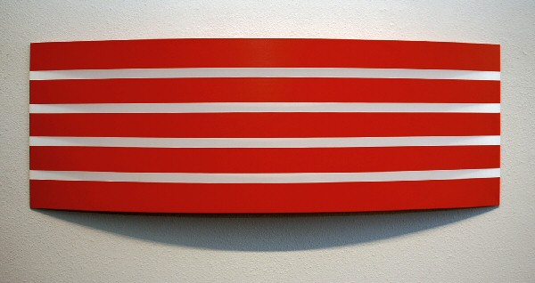
William Metcalf
Red Arc, 2008
acrylic, polyester fabric, wood, DiBond
18 x 53 x 3 1/5 inches
WM0105
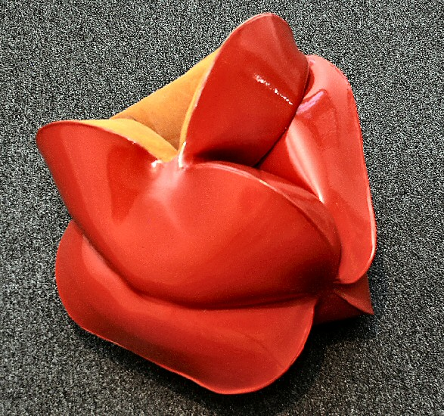
Jeremy Thomas
Module Red, 2009
Forged Mild Steel & Powder Coat
15 x 17 x 16 inches
JT177
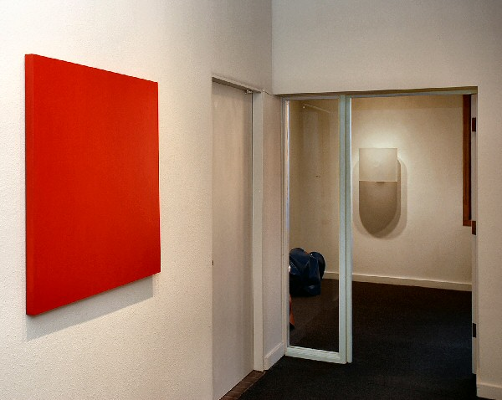
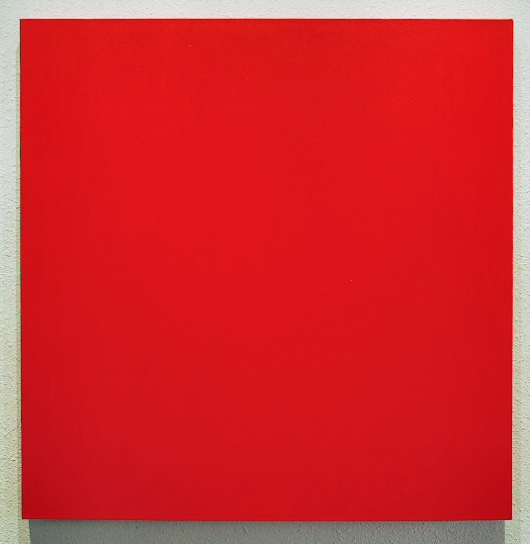
Joe Barnes
Untitled (Cadmium red, medium hue), 2007
acrylic on canvas
36 x 36 x 1 1/2 inches
JBAR0018
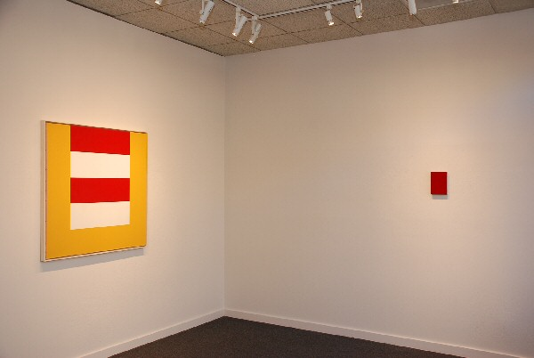

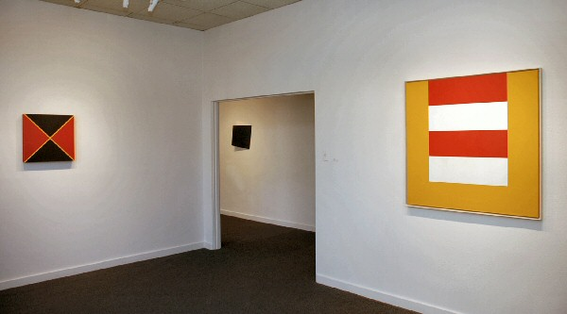
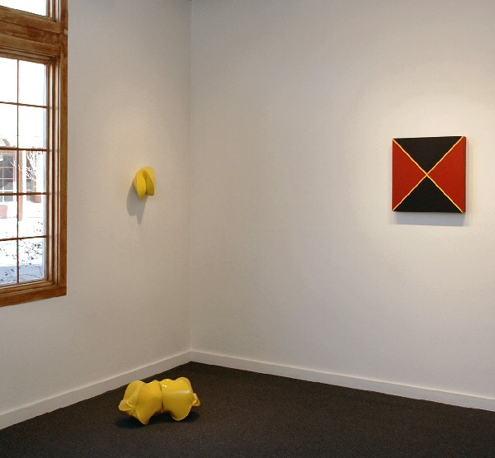
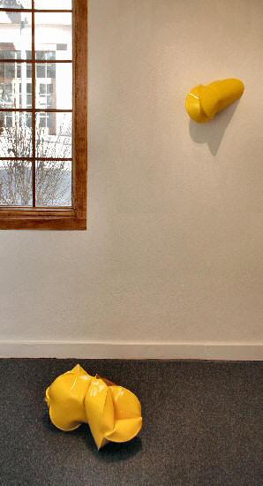
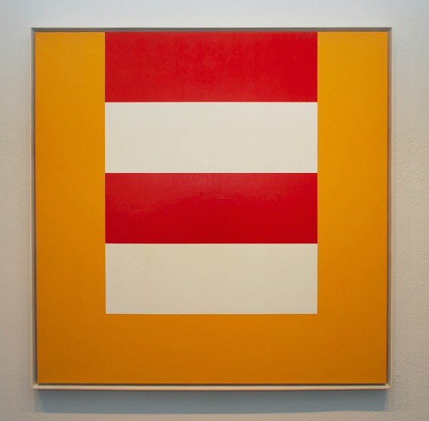
Karl Benjamin
Untitled (#14), 1965
oil on canvas
42 x 42 inches
MMKB001
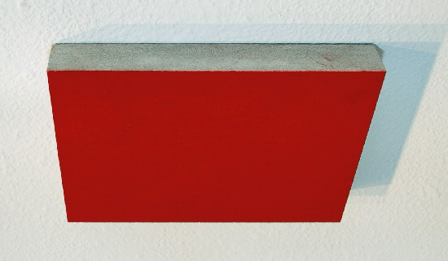
Alfonso Fratteggiani Bianchi
Pigmento su carta,
Pigment on paper
8 1/4 x 5 7/8 inches
AFB53
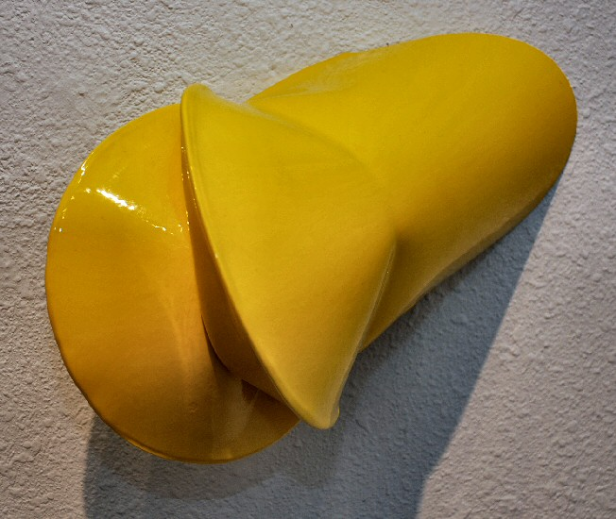
Jeremy Thomas
Superbird Yellow, 2007
Forged Mild Steel & Powder Coat
15 x 9 1/2 x 9 inches
JT112
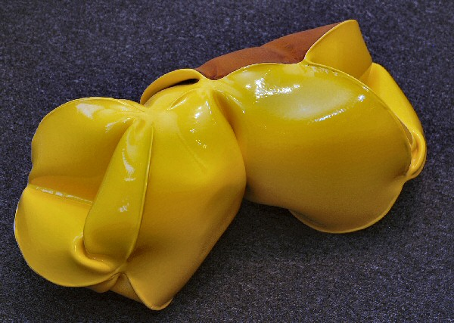
Jeremy Thomas
Module Builder Yellow, 2009
Forged Mild Steel & Powder Coat
10 x 22 x 9 1/2 inches
JT178
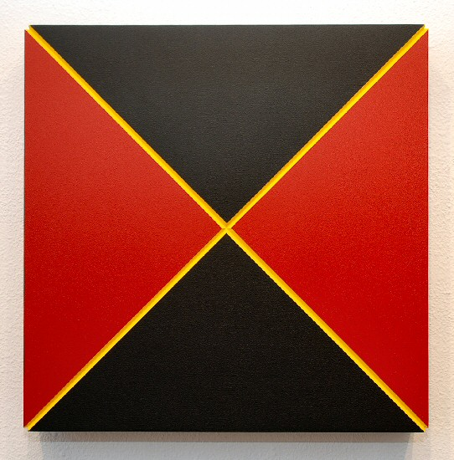
Ronald Davis
Red-Black Quarters, 2009
Acrylic on Expanded PVC
20/ x 20 x 1/2 inches
ROND0011
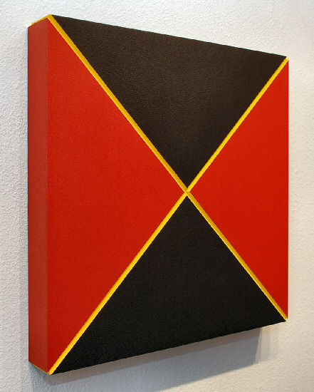

© 2010

Charlotte Jackson Fine Art, Inc.

200 West Marcy Street, Suite 101, Santa Fe, New Mexico 87501
Telephone: 505.989.8688 Fax: 505.989.9898
cjfa@charlottejackson.com - www.charlottejackson.com

