CHARLOTTE JACKSON FINE ART
PRESENTS:

Elliot Norquist
FULL CIRCLE
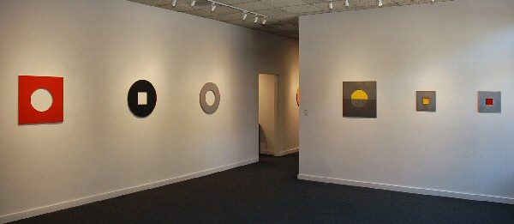
May 1 through May 31, 2009
To write about the work of Elliot Norquist is to be endlessly tempted to use the word irony. Ironic that a man passionate about nature (skiing, mountaineering—living on a former dairy farm 45 miles from the nearest store where you can stare at a 100 miles horizon with nothing man-made to be seen) creates works of high sophistication and abstraction. Ironic that someone with Norquist’s infectious exuberance makes works of quiet, contemplative minimalism.
But irony isn’t a useful concept. Step beyond simple polarity and you see that Norquist’s work and life lie squarely in the province of art: paradox. William Blake wrote, “Without Contraries is no progression,” echoing an idea posited by the Taoists that the very universe itself would not exist if not for the meeting of opposites. Norquist’s work dances between a series of contraries: the circle in the square, the simple in the complex, the personal in the abstract, the natural in what is man-made
Full Circle plays not only on Norquist’s new exploration of the circle form but on his return to color. At the time his son was born, Norquist created a series of brightly colorful pieces in joyous response to fatherhood. Now he returns to color in celebration of his son’s imminent adulthood in a way that is playful and yet thoughtful. The pieces continue with the process and materials he has been working with for decades. Layers of sheet metal, cardboard, and bondo are carefully cut, sanded, and primed into shapes which hang on the wall, not quite painting, not quite sculpture. While the edges are sanded they remain uncovered, an archeological layering which shows his process and that is allowed to remain readable by the viewer.
Shape and color are all important. A square with a circle cut from the center, a circle with a square cut. A brilliant orange and a vibrant red meet at the axis of a circle. Norquist uses the sparest of visual vocabularies. Color and shape must retain their integrity and yet merge to become art. Contraries again and again.
Norquist describes this precarious walk through contraries in an elegant way. Speaking again of his son, a competitive extreme skier, he remarks that in a race the best line is often closet to no line at all, closest also to disaster. For Norquist resolution lies in the work itself. Where the no-line exists, the place where ideas like irony or contrary are meaningless, is in the circle itself, common yet somehow magical, in color itself, personal yet eternal. In Elliot Norquist’s “Full Circle” we find works that ride that dangerous line where opposites meet and beauty happens.
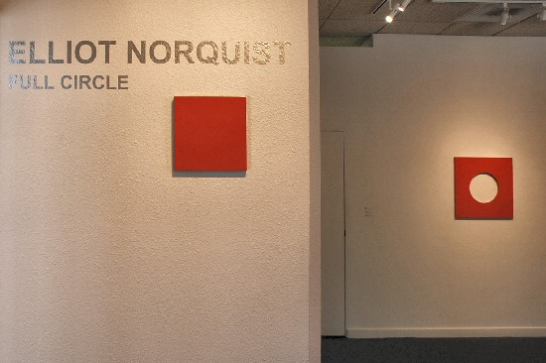
Spanish Square, 2007
steel, Bondo, cardboard
8 x 8 x 5/8 inches
EN0037
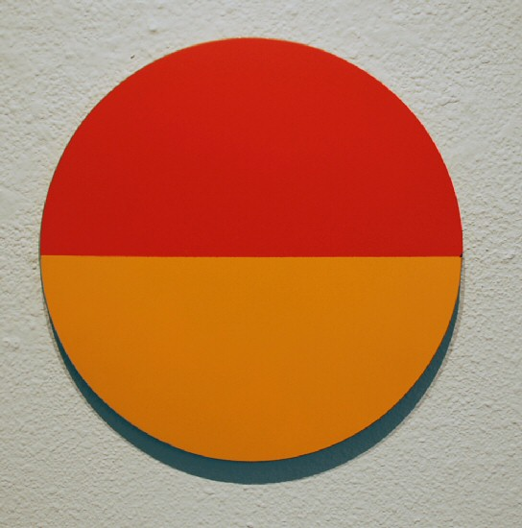
Summer Sunset, 2009
steel, Bondo, cardboard
12 x 12 x 5/8 inches EN0022
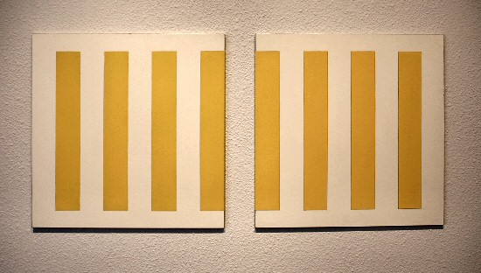
Barcode, 2008
steel, Bondo, cardboard
34 x 16 x 1/2 inches EN0045
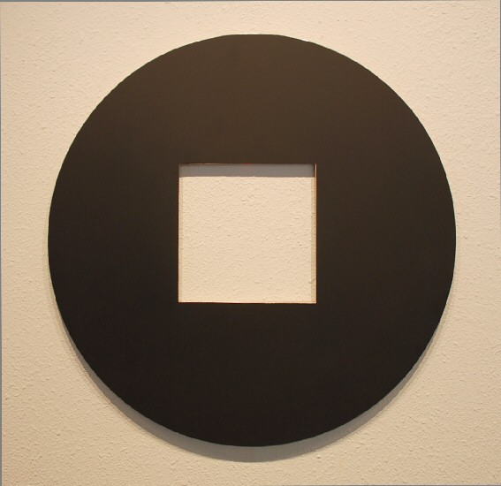
Black Circle, 2009
steel, Bondo, cardboard
24 x 24 x 5/8 inches EN0041
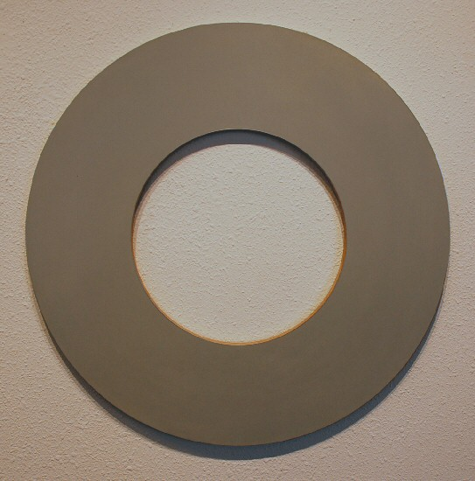
Grey Circle, 2007
steel, Bondo, cardboard
24 x 24 x 5/8 inches EN0039
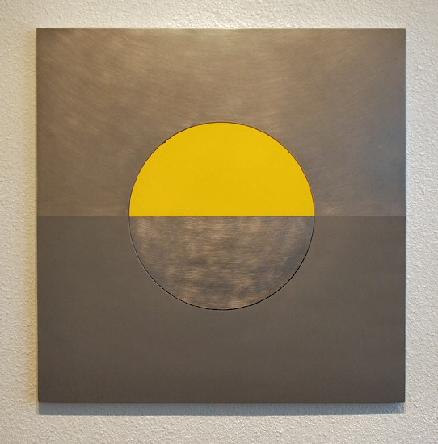
Yellow Patch, 2009
steel, Bondo, cardboard
24 x 24 x 5/8 inches EN0042
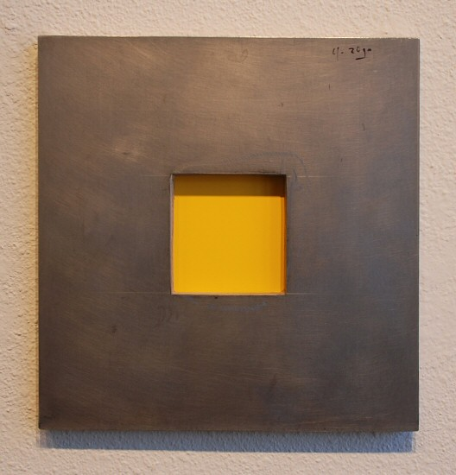
Yellow Inset, 2009
steel, Bondo,cardboard
12 x 12 x 5/8 inches EN0024
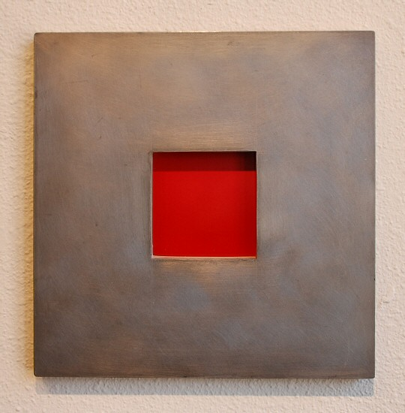
Red Inset, 2009
steel, Bondo, cardboard
12 x 12 x 5/8 inches EN0023

Eclipse, 2009
steel, Bondo, cardboard
24 x 24 x 5/8 inches EN0038
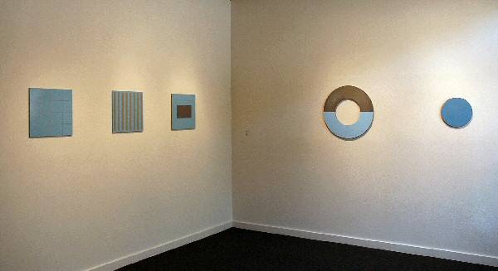

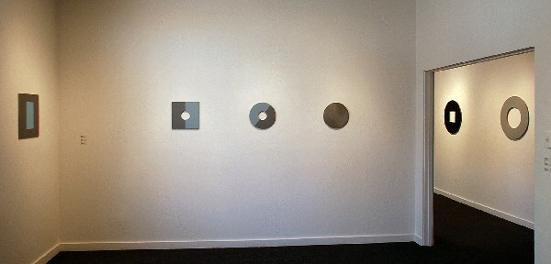
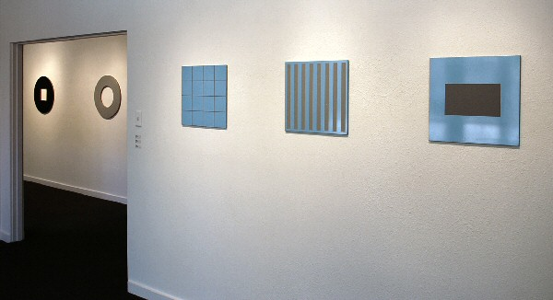
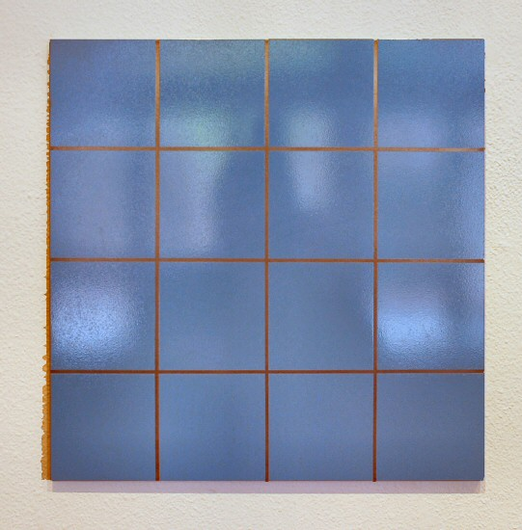
Winter Grid,2007
steel, Bondo, cardboard
16 x 16 x 1/2 inches EN0034
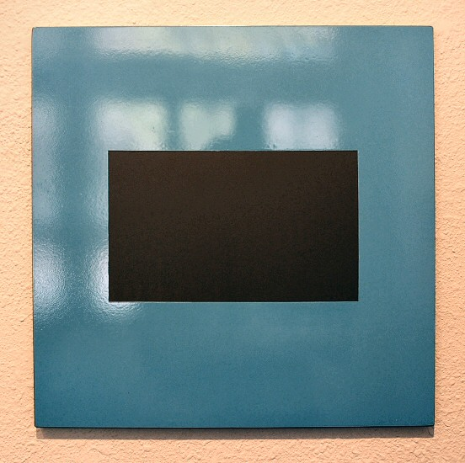
Winter Rectangle, 2007
steel, Bondo, cardboard
16 x 16 x 1/2 inches EN0035
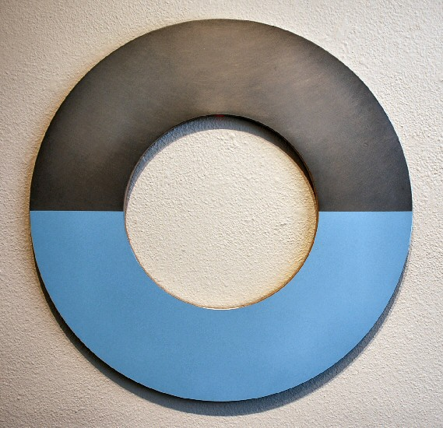
Blue Horizon, 2009
steel, Bondo, cardboard
24 x 24 x 5/8 inches EN0040

The Blues, 2009
steel, Bondo, cardboard
12 x 12 x 5/8 inches EN0044
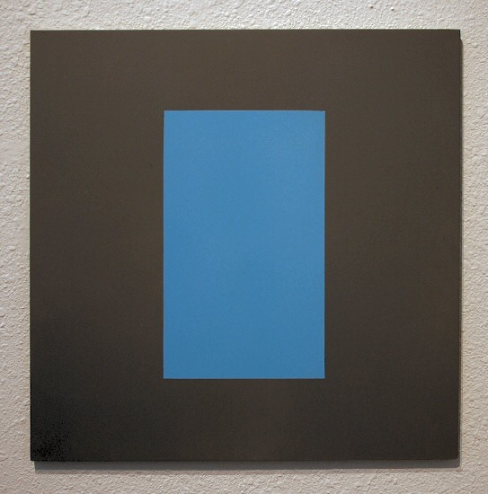
Winter Surround, 2007
steel, Bondo, cardboard
16 x 16 x 1/2 inches EN0036
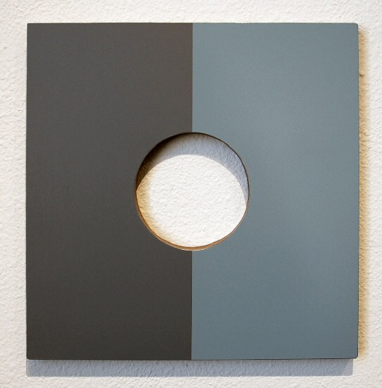
Blue Grey Square, 2008
steel, Bondo, cardboard
12 x 12 x 5/8 inches EN0029
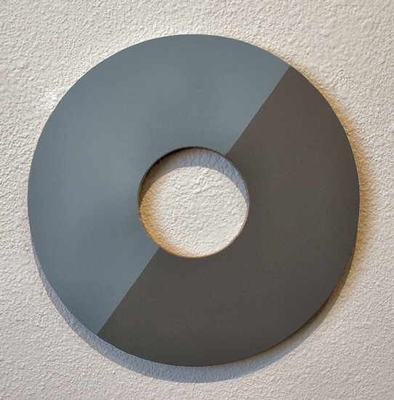
Blue Green Circle, 2008
steel, Bondo, cardboard
12 x 12 x 5/8 inches EN0028
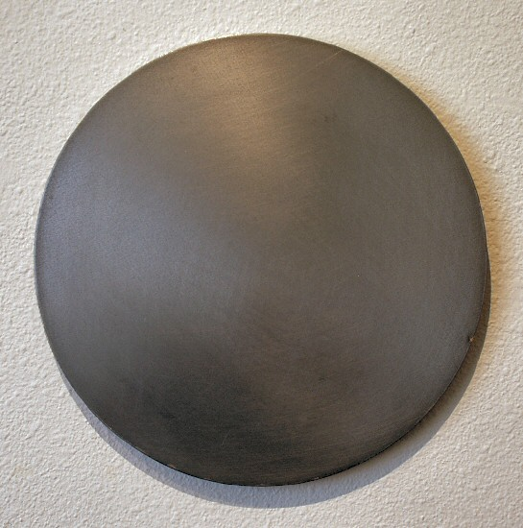
Circle Concept, 2009
steel, Bondo, cardboard
12 x 12 x 5/8 inches EN0033

© 2009

Charlotte Jackson Fine Art, Inc.

200 West Marcy Street, Suite 101, Santa Fe, New Mexico 87501
Telephone: 505.989.8688 Fax: 505.989.9898
cjfa@charlottejackson.com - www.charlottejackson.com

