CHARLOTTE JACKSON FINE ART PRESENTS:

NICK TERRY
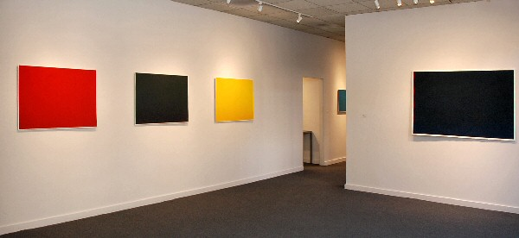
FEB 6 - FEB 28, 2009
Upon first glance the watercolors in Nick Terry’s first solo exhibition at the Charlotte Jackson gallery, appear monochromatic. But once the eyes adjust it becomes clear that there are subtle shifts in color and value occurring.
The ‘history’ of each painting, how the composition was arrived at, is revealed along the borders, and in them one sees that there are many layers comprising these seemingly ‘monochromatic’ bodies of color.
Terry says, “When I start with one color and build up the surface layer by layer to develop a rich field, the result looks flat, un-engaging, not interesting. I have faith that the color in question is interesting, but often introducing a contrasting color, or value shift, even the smallest amount, seems to make the ‘main body’ color more alive; there is a sense of expansiveness as other qualities express themselves.“
The color and value shifts, from warm to cool tones, from deep darks to a sense of light, are very subtle, and one must get beyond the presumption that these are ‘monochrome’ paintings. In his catalog essay Interest and Openness, Jose Munoz writes of the watercolors, “These paintings can shift us from a point of everyday obliviousness to a position of interest in not only the routines of our everyday life, our predictable lines of sight, but also to a place of contemplation and meditation. All the components in his art, including the actual paint he creates himself, the carefully selected stock of paper, and his painterly method of layering colors, move us towards this other way of being in and feeling the world. Each image permits the viewer access to a level of interestedness that is most importantly a mode of openness.”
Nick Terry received his BA from Sarah Lawrence College, New York, in 1989. He lives and works in Marfa, Texas, with his wife, painter Maryam Amiryani.
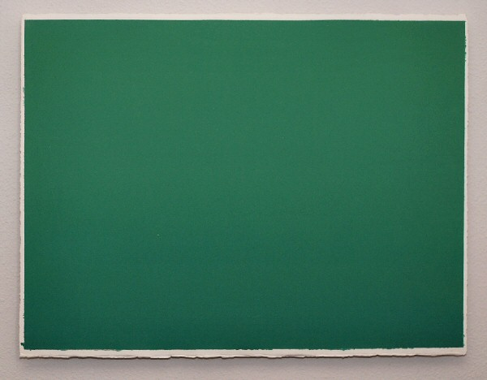
Untitled, 2008
Watercolor on paper
22” x 30” NT003

Untitled, 2008
Watercolor on paper
30” x 40” NT005

Untitled, 2008
Watercolor on paper
30” x 40” NT010
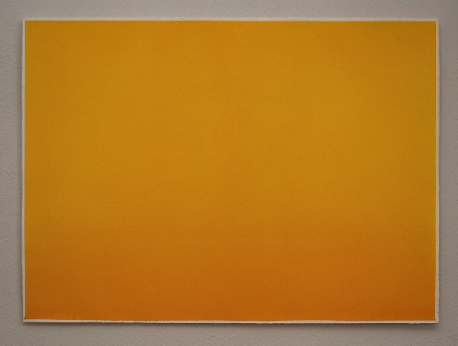
Untitled, 2008
Watercolor on paper
30” x 40” NT007
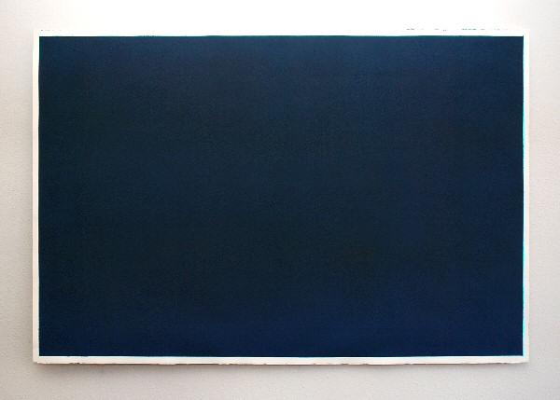
Milori
2008
Watercolor on paper
40” x 60” NT006
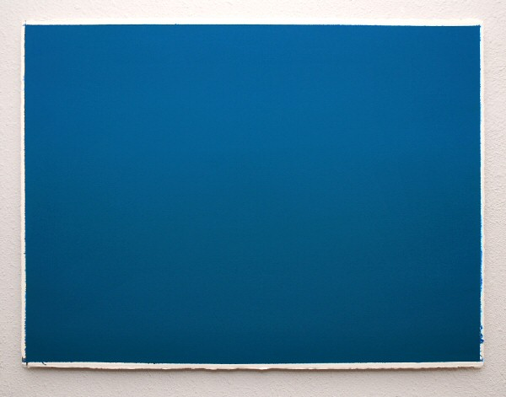
Untitled, 2008
Watercolor on paper
22” x 30” NT014

Untitled, 2008
Watercolor and Graphite on paper
22” x 30” NT011
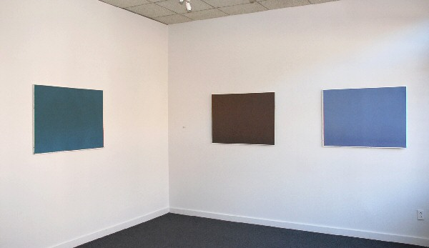

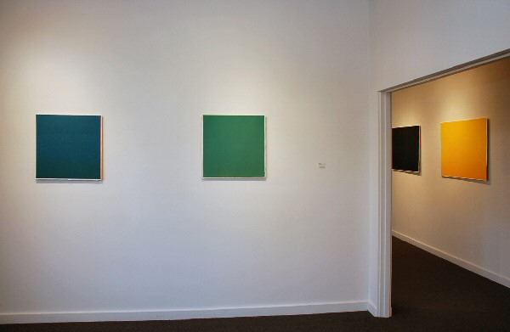
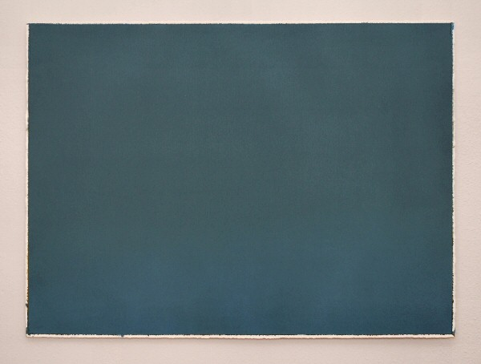
Untitled, 2008
Watercolor on paper
29 1/2” x 39 1/2” NT013

Untitled, 2008
Watercolor on paper
29 1/2” x 39 1/2” NT009
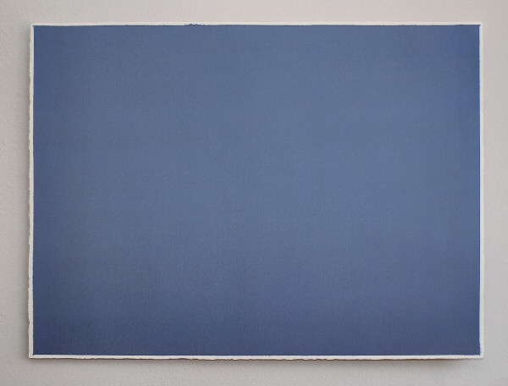
Untitled, 2008
Watercolor on paper
29 1/2” x 39 1/2” NT004

Untitled, 2007
Watercolor on paper
22 1/4” x 22 1/4” NT008
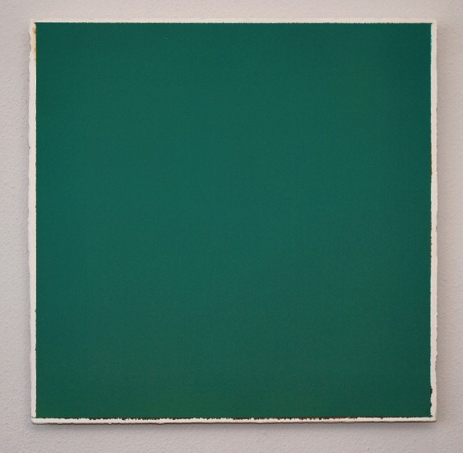
Untitled, 2007
Watercolor on paper
22 1/4” x 22 1/4” NT012

© 2009

Charlotte Jackson Fine Art, Inc.

200 West Marcy Street, Suite 101, Santa Fe, New Mexico 87501
Telephone: 505.989.8688 Fax: 505.989.9898
cjfa@charlottejackson.com - www.charlottejackson.com

