CHARLOTTE JACKSON FINE ART PRESENTS:

WILLIAM METCALF: MINDSPACE

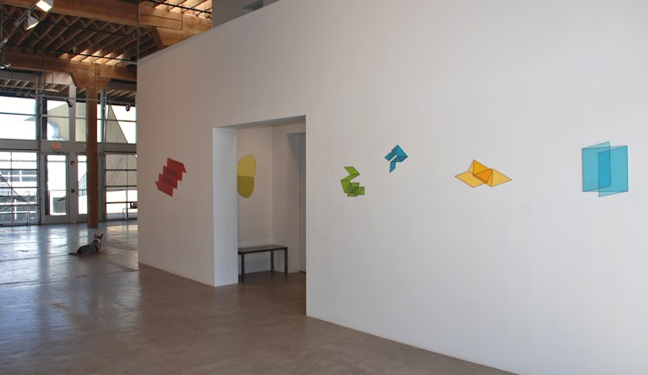

March 29 - April 30, 2013
You are in a changed space. The intricately folded transparent planes of color could very well be drawn directly onto the gallery walls, erasing the notion of "a painting." The white of the walls ceases to appear flat while the drawings hover in the space in front of or sink into the depths of the wall itself. With utterly deceptive simplicity, William Metcalf's new series of works, Mindspace, defy the eye-triggering alternating shifts of perception within the viewer.
The aptly named Mindspace pieces are a departure from Metcalf's earlier work using sculptural forms projecting from the wall to explore three-dimensionality and shifts in perspective. With this new series Metcalf has returned to the two-dimensional - but without sacrificing his exploration of perception-shifts. The pieces, graphite and acrylic on DiBond cut out to the shape of their drawn perimeters, are relentlessly flat in their form. However, the drawn geometrical shapes (interlocking, transparent planes) clearly suggest three-dimensionality, though without the use of perspective. The pieces present a sort of visual conundrum - simultaneously it is clear to us that the piece is entirely flat and yet the look of the lines and shapes imply three-dimensionality. The blinking shift which happens when the viewer looks at a piece, seeing flatness and then seeing depth, takes place entirely inside the mind of the viewer.
For Metcalf, the questions which emerged and engaged artists from the Modernist era are essential principles which continue to inform and direct his work. Issues of non-objectivity, flatness, and figure-ground relationships form the architecture around which Metcalf has explored what he terms his, "career-long quest," to answer one question: "What else can I do with painting?" With the Mindspace paintings Metcalf has returned to drawing and to the conscious flatness which is quintessential to painting as a medium.
In fact it is a paradox of these works that the flatness actually works as a part of the shivering illusion of three-dimensionality. Standing in front of one of the Mindspace pieces, something relaxes in the eye and suddenly the flat drawn planes appear to unfold, to unpack themselves, accordioning out into space. But with another moment that illusion winks out of existence and the eye clearly sees flat lines on flat space. The viewer's mind is not allowed to rest comfortably in either position and this insistence is a key to what is so arresting about the pieces. As Metcalf says of his work, "the medium has always been the message." The sense of insistence in these works involves more than just the notion of space and surface, there is a demand inherent within the works themselves that the viewer sees and understands these pieces for exactly what they are, which is to say - paintings.
Finally there is a fresh cleanness of line and form that defines these new works. The forms and colors are elegant, simple, and yet deeply alluring. Part of this may be linked to Metcalf's return to his early love, drawing, though he now uses an iPad to sketch, rather than a pad of paper. As Metcalf says, "There is a great deal of love inherent in the creation of an interesting line."
Just as the title suggests, Mindspace demands that viewers come ready to engage. Each piece, a small paradox of its own, offers the viewer the opportunity to explore not only line, color, surface, space - but to investigate the relationship between eye and mind, object and subject, art and perception.
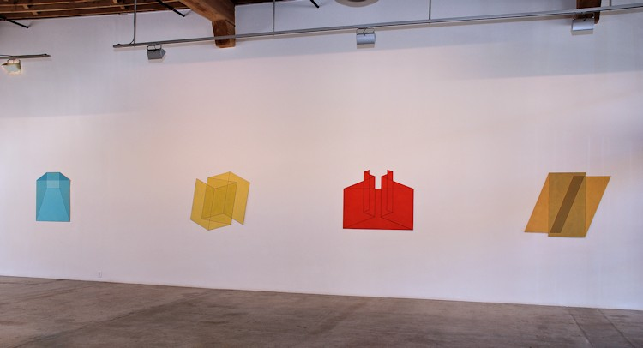

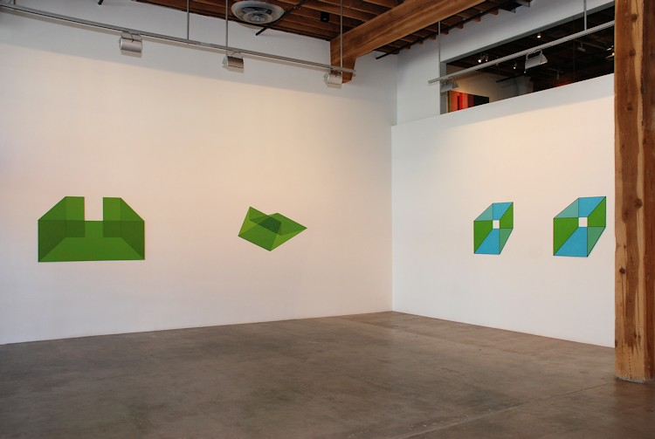
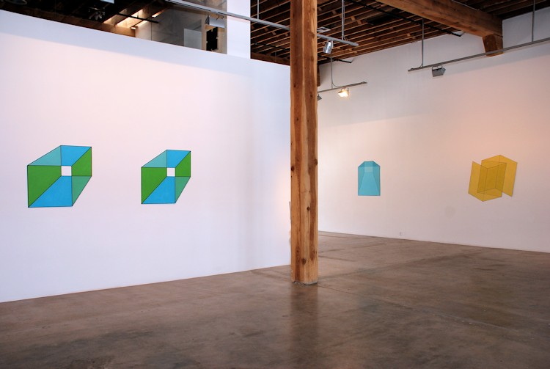

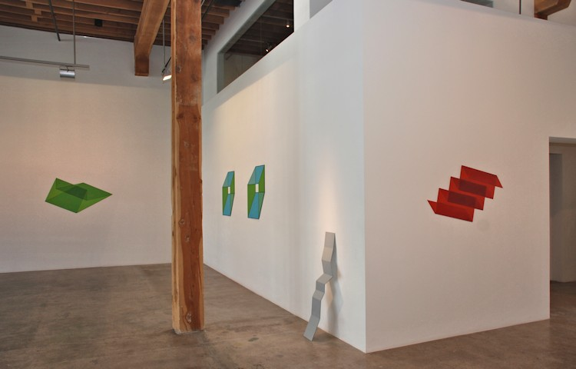
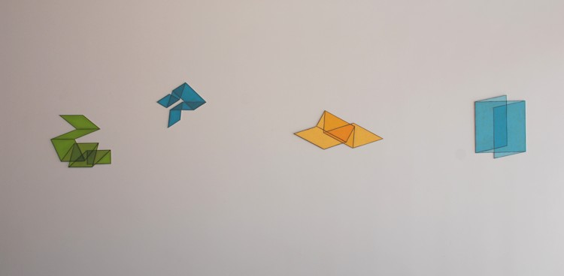

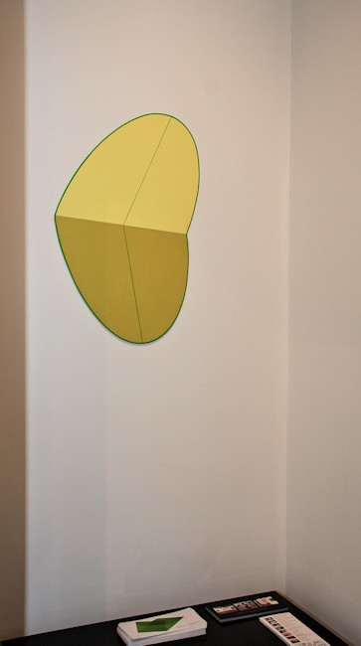
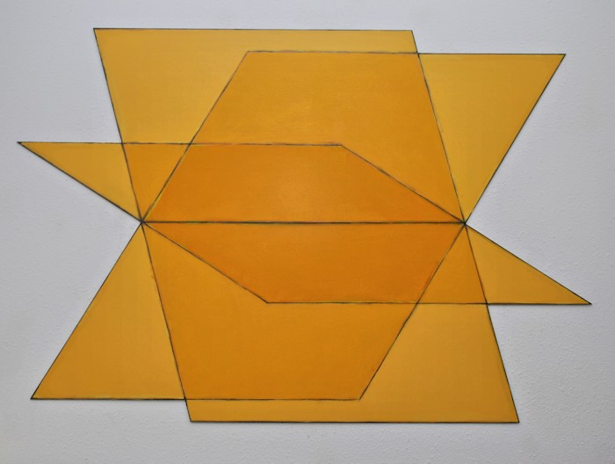
Mindspace #57, 2013
Acrylic, graphite, india ink, on AluPanel
32 x 45 inches
WM306
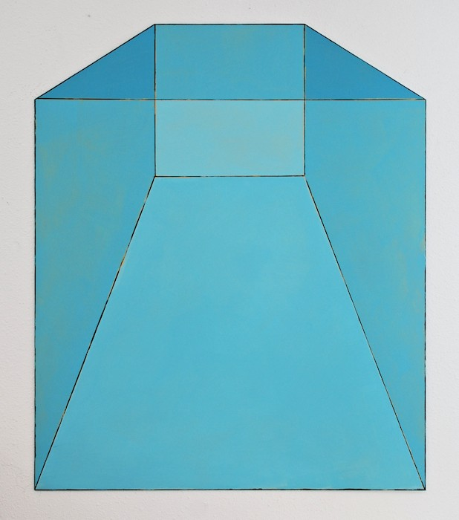
Mindspace #44, 2013
Acrylic on AluPanel
40 x 34 inches
WM294
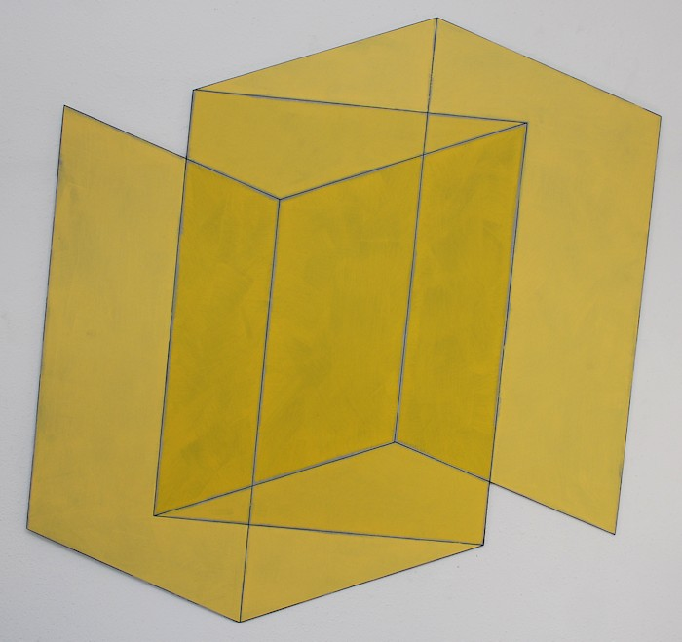
Mindspace #48, 2013
Acrylic, graphite on AluPanel
44 x 44 inches
WM298
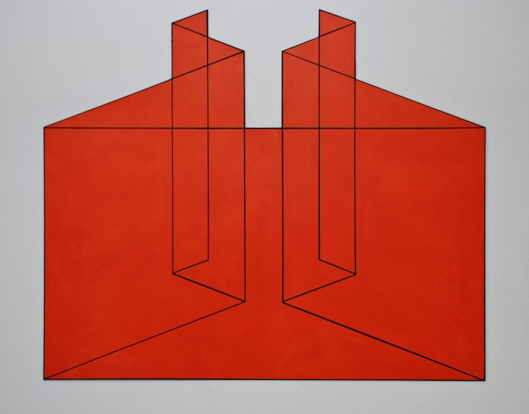
Mindspace #54, 2013
Acrylic on AluPanel
40 x 48 inches
WM303
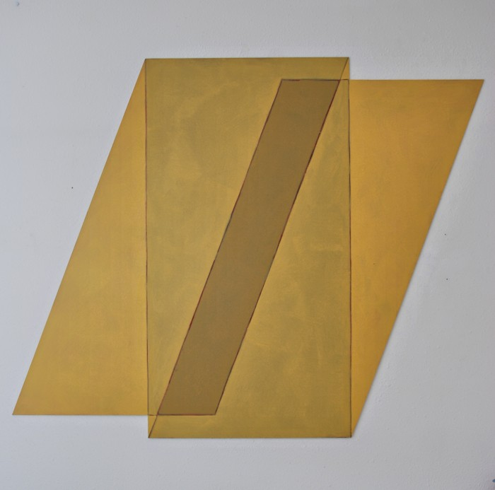
Mindspace #53, 2013
Acrylic, graphite on AluPanel
40 x 50 inches
WM302
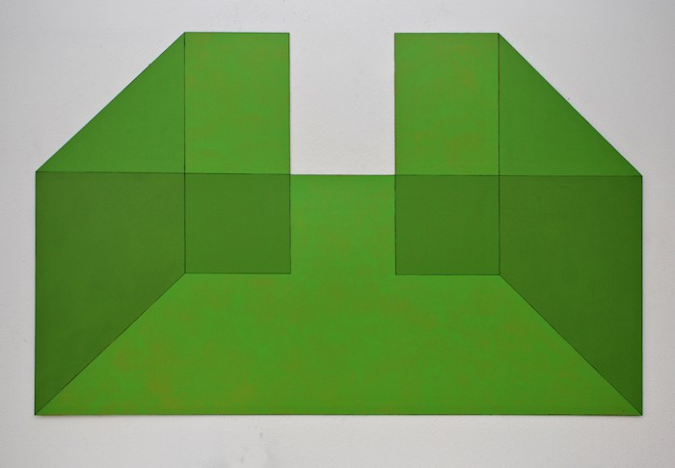
Mindspace #55, 2013
Acrylic, india ink,on AluPanel
38 x 60 inches
WM304
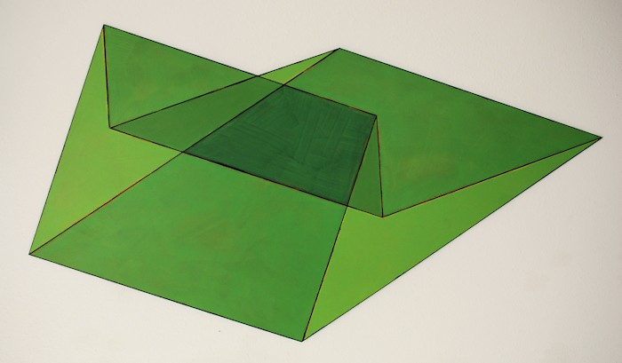
Mindspace #45, 2013
Acrylic on AluPanel
30 x 54 inches
WM295
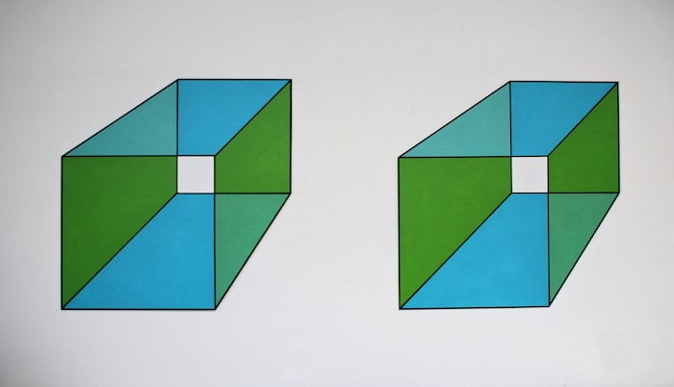
Mindspace #47, 2013
Acrylic on AluPanel
34 x 34 in. each panel
WM297
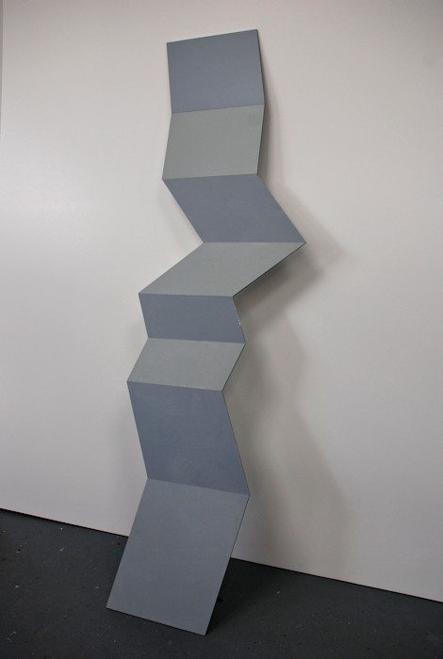
Mindspace #58, 2013
Acrylic on AluPanel
48 x 14 inches
WM307
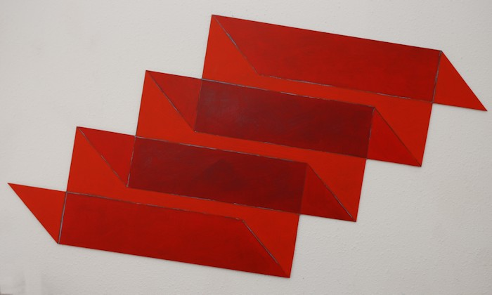
Mindspace #46, 2013
Acrylic, graphite, india ink on AluPanel
25 x 46 inches
WM296
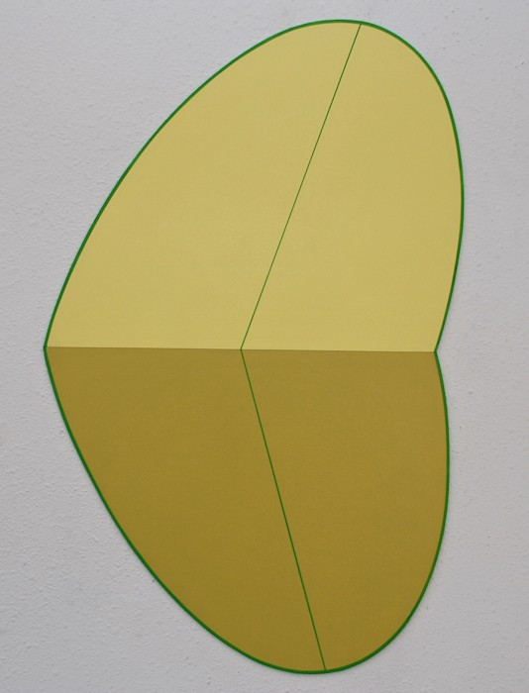
Mindspace #61, 2013
Acrylic on AluPanel
28 x 19 inches
WM310
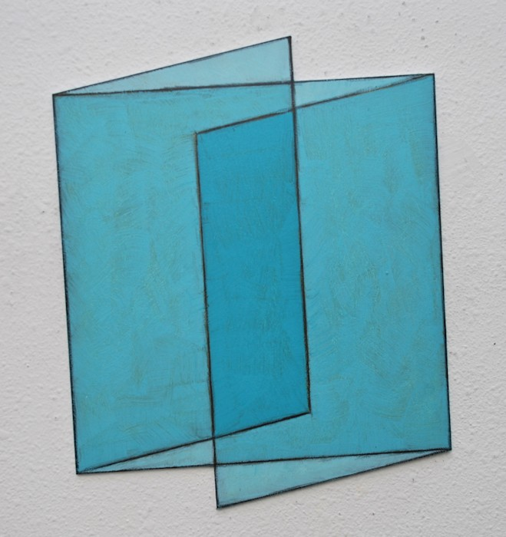
Mindspace #59, 2013
Acrylic on AluPanel
16 x 13 inches
WM308
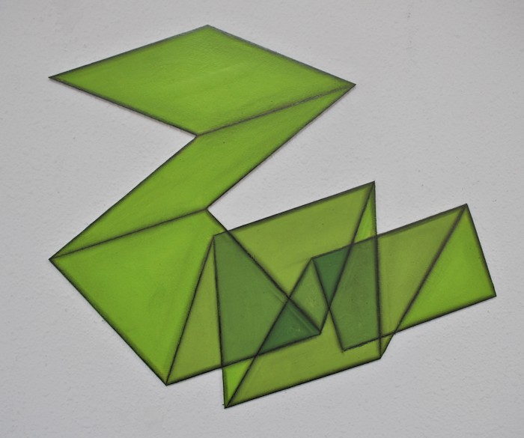
Mindspace #11, 2012
Acrylic, graphite, Di Bond
14 x 15 inches
WM259
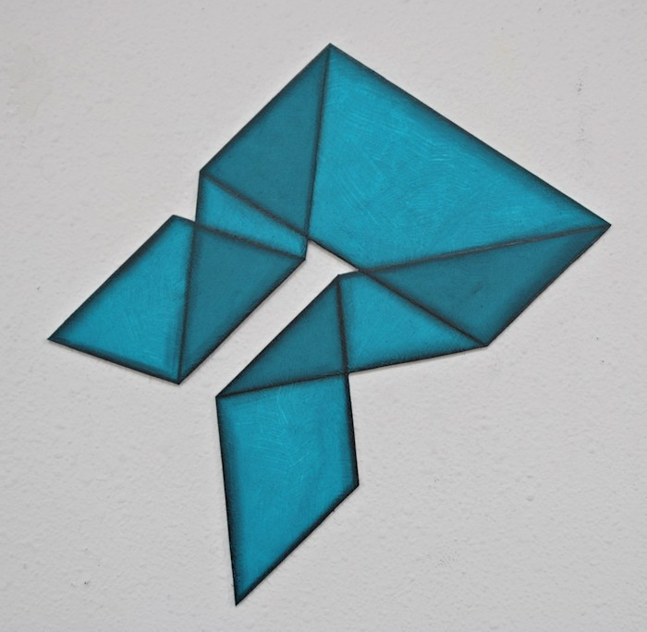
Mindspace #23, 2012
Acrylic, graphite, Di Bond
8 x 12 inches
WM254
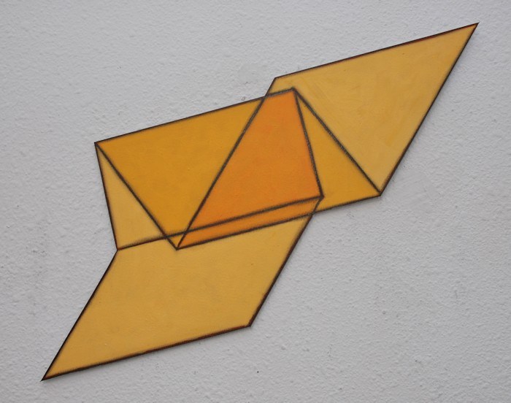
Mindspace #23, 2012
Acrylic, graphite, Di Bond
8 x 12 inches
WM254
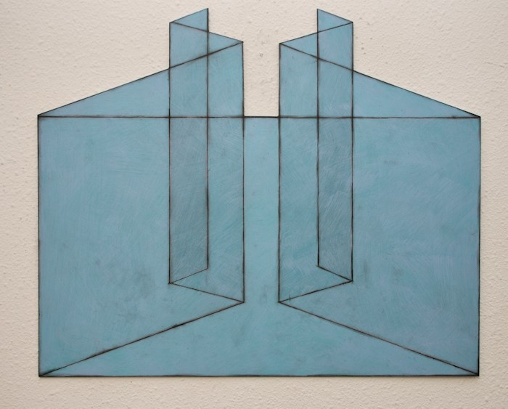
Mindspace #60, 2013
Acrylic on AluPanel
20 x 24 inches
WM309

© 2013

Charlotte Jackson Fine Art, Inc.

In the Railyard at:

554 S. Guadalupe, Santa Fe, New Mexico 87501
Telephone: 505.989.8688 Fax: 505.989.9898
cjfa@charlottejackson.com - www.charlottejackson.com

