CHARLOTTE JACKSON FINE ART
PRESENTS:

Max Cole: Beyond

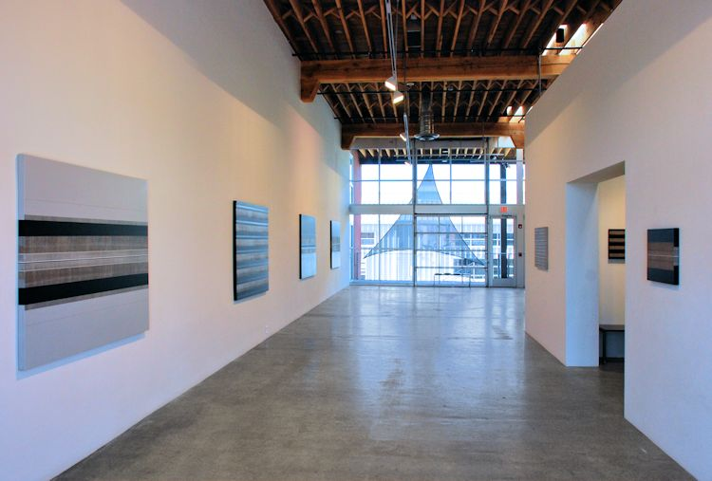

Nov 30 - Dec 30, 2012
There is room for the viewer to exist inside of these paintings. It is not only that the heavy black horizontal lines with their egg-shell smooth surfaces are laced together across the painting by verticals—hundreds of hair’s breadth lines that lift and open up each piece like breathing opens up the ribcage. It is not just the subtle scale of their tonality, ranging only through blacks, grays, white, and browns which gives them this sense of interspace.
Each line is perfect—which is to say, somehow exactly as it should be. Not mechanical, ruled, or fabricated—each line is individual, unique, and clearly imbued with a distinct character by the hand that made it. These lines are woven together, thick and thin, horizontal and vertical, in a harmonious balance which suggests the intricate structures of weaving, and sometimes even the texture of textiles. In a way this comparison is apt because, as in a tapestry, so much of what goes on in Max Cole’s paintings is behind, beyond, the marks on the canvas. The most important part of the paintings’ architecture is somehow not in the lines themselves but in the space each line creates and inhabits. Just as a sculpture simultaneously creates both positive and negative space—Cole’s lines, despite their two-dimensionality, act in a similar way, carving out and filling up space.
The longer that one spends with one of Max Cole’s paintings, the more the painting’s inherent depth and presence settles in and becomes recognizable to the viewer. The effect is less like revelation (a veil being lifted to show you what is there) and more like the action of a leaf, slowly sinking down into the depths of a pond until it finally becomes a part of the mosaic pattern at the bottom. The paintings sink into us. Or perhaps we sink into them.
One thing clearly apparent in these pieces is the precision and skill necessary in their creation, although the viewer may not realize just how much time in the studio Cole commits to each piece. Crafted of acrylic on linen, the bands of horizontal lines are painted with up to eighty layers in order to achieve their supple smoothness. The thin vertical lines, made with brush or with a paint-loaded technical pen, require painstaking concentration. Such clear presence of the human hand, in all its fallibility and distinctiveness, illuminates a link back to something fundamental, ancient: the human urge toward mark making. As Cole says, “The line is the most universal and abstract art element. The most direct contact between the hand and brain.” Max Cole has spent decades mastering this quintessentially human art of mark making.
Over the years Max Cole’s work and aesthetic have often been linked with nature and the environment. Some have gone so far as to connect the horizontal orientation of her pieces with horizon lines, and the verticals with distant fence posts, or rows of corn and wheat. Yet, as Cole says, “I am not a realistic painter and don’t make landscapes. However, I believe that humanity is not separated from nature and the life presence in nature is also the same force in the human spirit and will be a part of human expression. I am not interested in the ‘look’ of nature but in the force of essence of it.”
In this statement we begin to unlock the intriguing sense of there being something more to Cole’s work than what is immediately apparent. Cole says, “It is well to remember that most of reality is not visible….” From molecules to sub-atomic structures, what we see is only a fraction of what makes our world—and yet its presence becomes visible in the large-scale. Cole’s work seems to draw its source from the energy of the world beyond the world we see, and to make it visible. Her lines tremble, vibrate, with the basic and essential resonances of the world around us.
Beyond technique. Beyond time. Beyond color. Beyond geometry, form, and paint. Beyond what the eyes that see, the ears that hear, the hands that place brush onto canvas there is something which makes art. An energy, an essence, that goes beyond the checklist of skills and accomplishments of the artist, but that undeniably exists in the best works of art. This is where Max Cole resides.
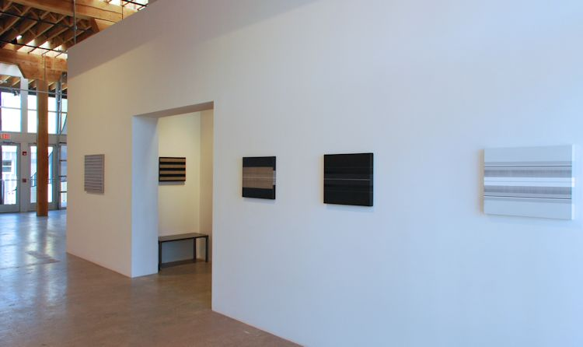

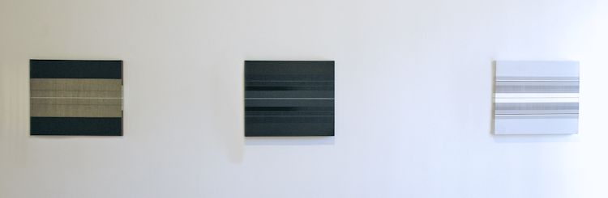

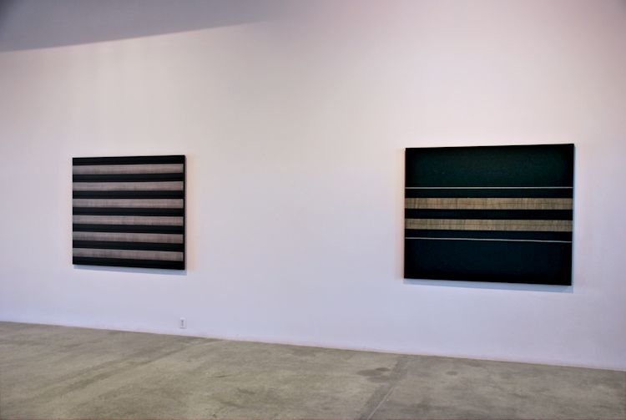

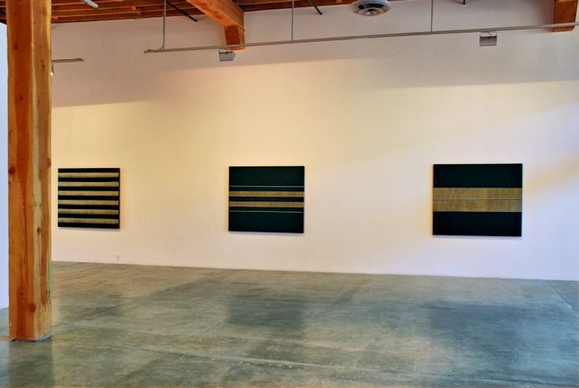
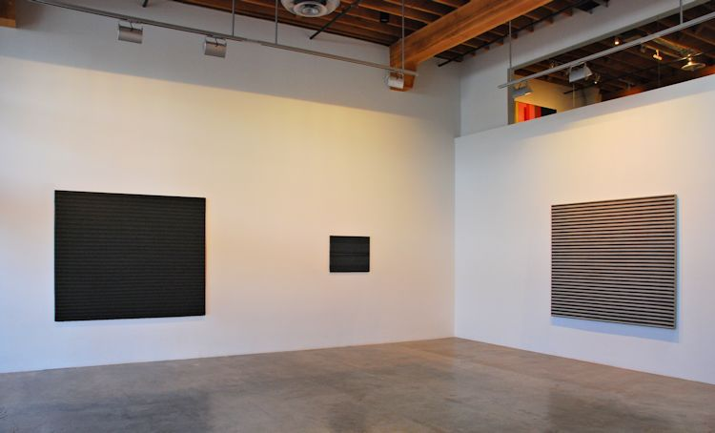
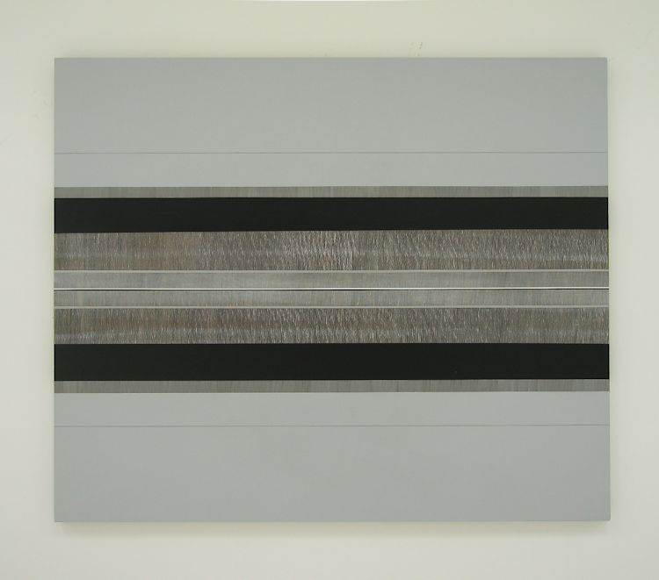
Somerset Fall IV, 2012
Acrylic on linen
52 x 62 inches
MAXC006
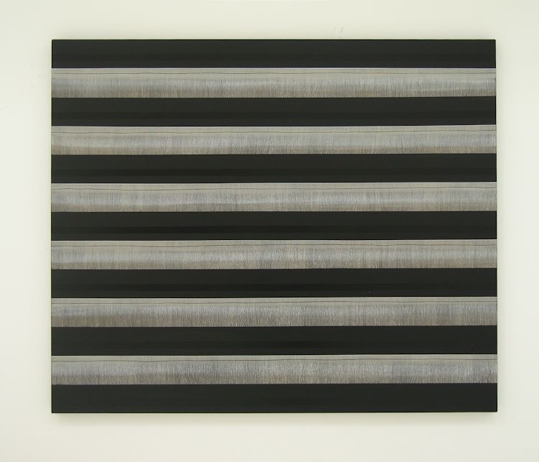
Somerset Fall III, 2012
Acrylic on linen
52 x 62 inches
MAXC005
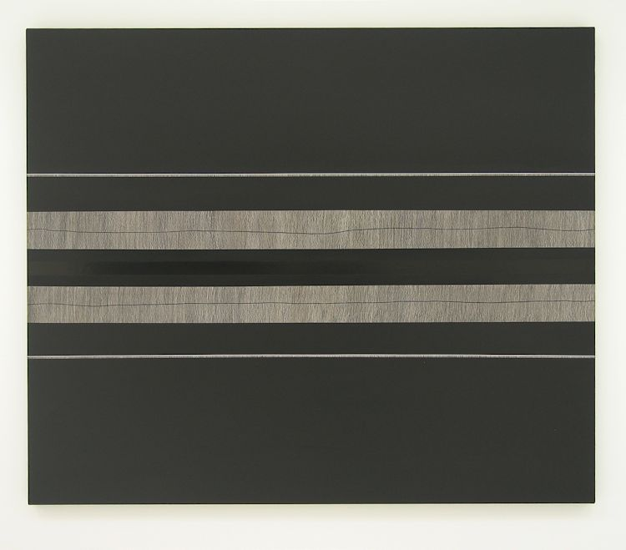
Somerset Fall II, 2012
Acrylic on linen
52 x 62 inches
MAXC004
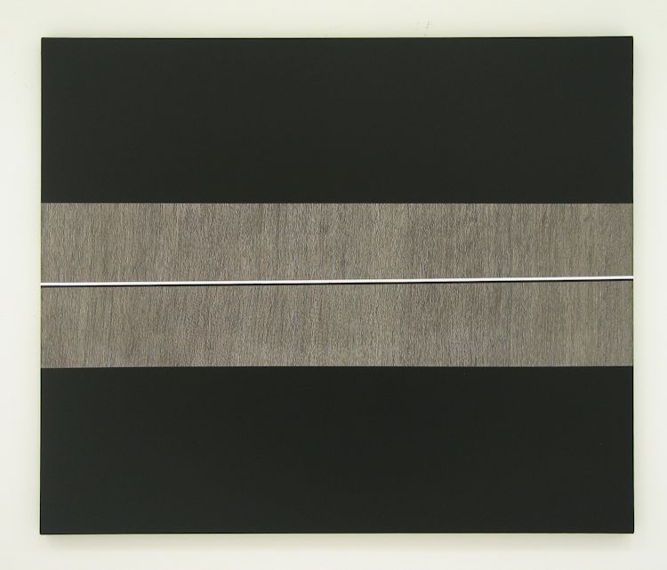
Somerset Fall I, 2012
Acrylic on linen
52 x 62 inches
MAXC003
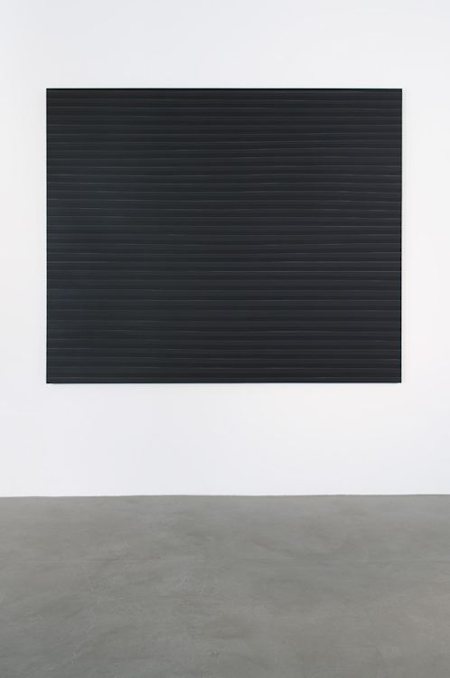
Wolf Trap, 2006 ,
Acrylic on linen, 68 x 80 inches
MAXC0010
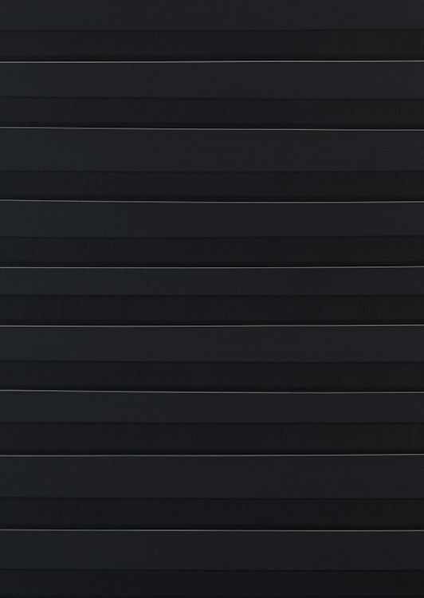
Wolf Trap, 2006
Detail
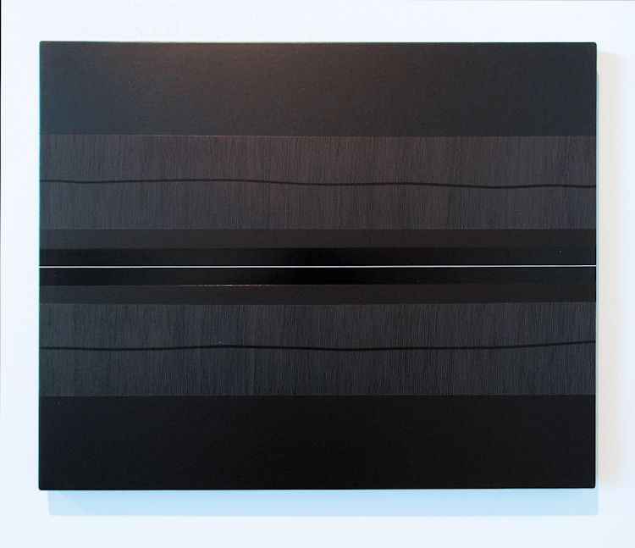
Perry Creek, 2012
Acrylic on linen
24 x 30 inches
MAXC0014
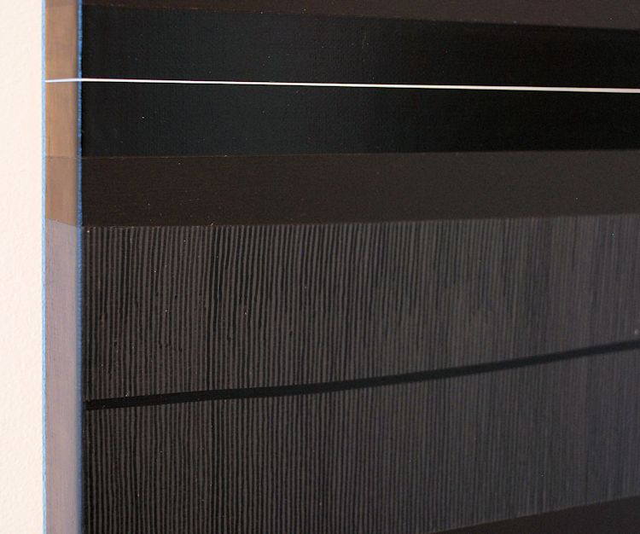
Perry Creek, 2012
Detail
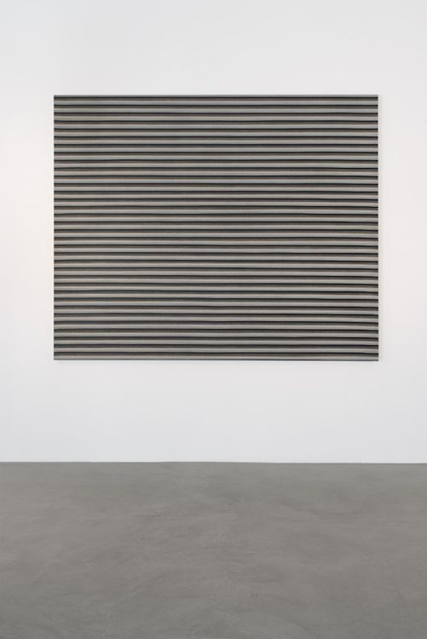
Transvaal, 2006
Acrylic on linen
68 x 80 inches
MAXC0011
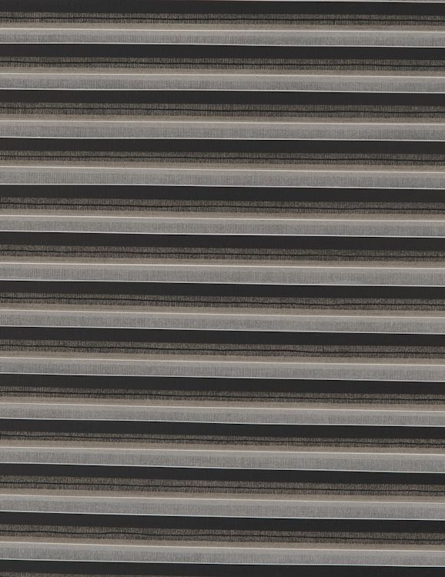
Transvaal, 2006
Detail
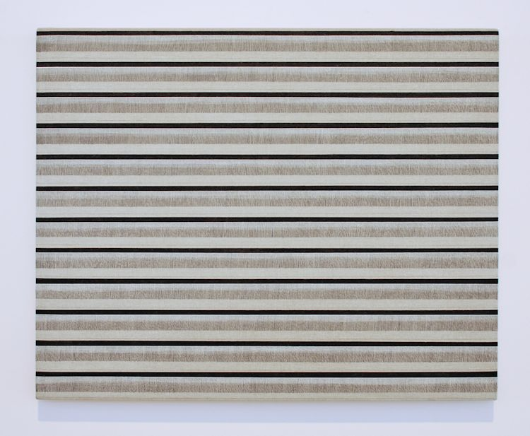
Caddo Camp, 2012
Acrylic on linen
24 x 30 inches
MAXC0013
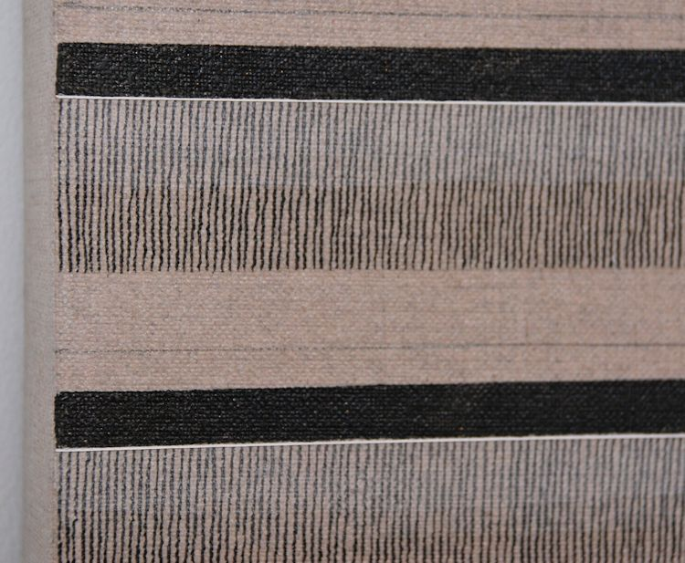
Caddo Camp, 2012
Detail
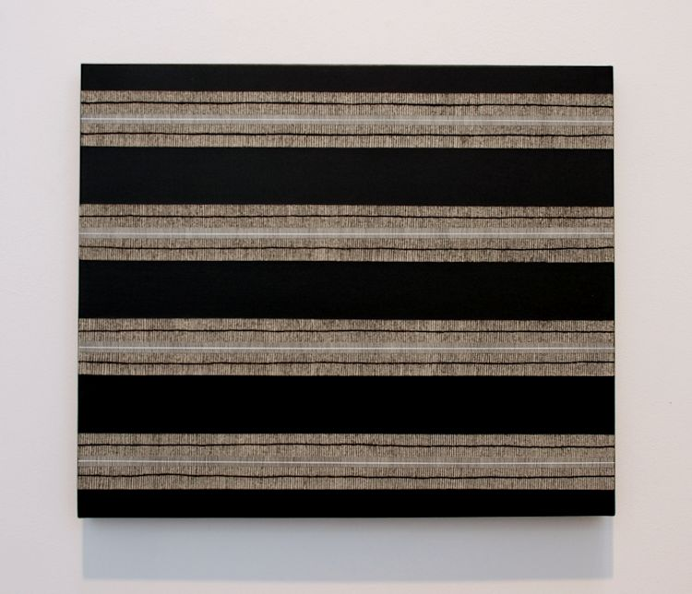
Lacuna, 2012
Acrylic on linen
16 x 19 inches
MAXC0018
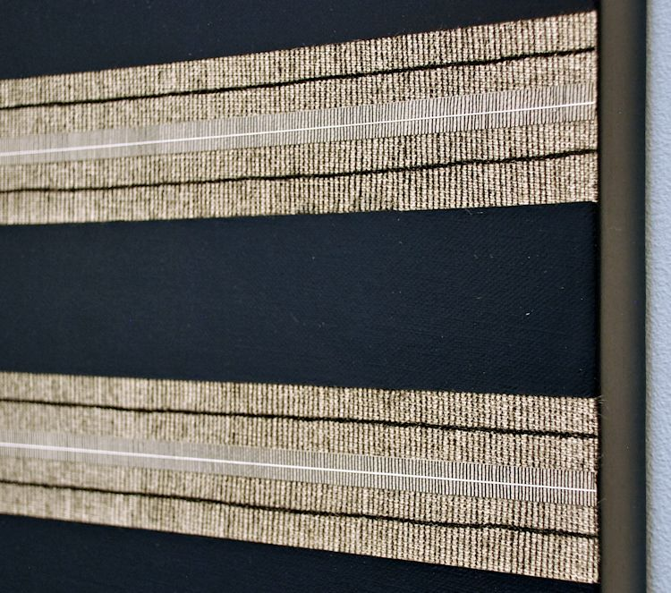
Lacuna, 2012
Detail
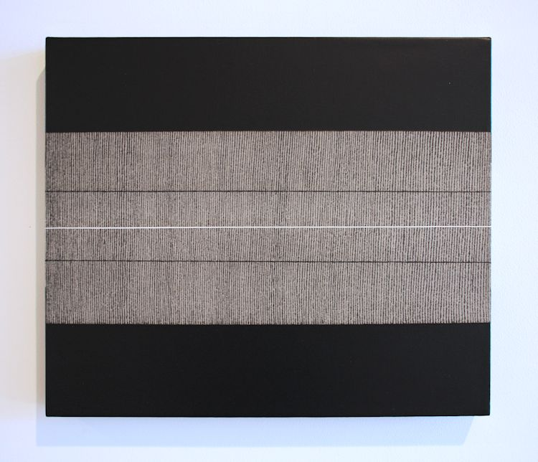
Soloman's Split, 2012
Acrylic on linen
16 x 19 inches
MAXC0017
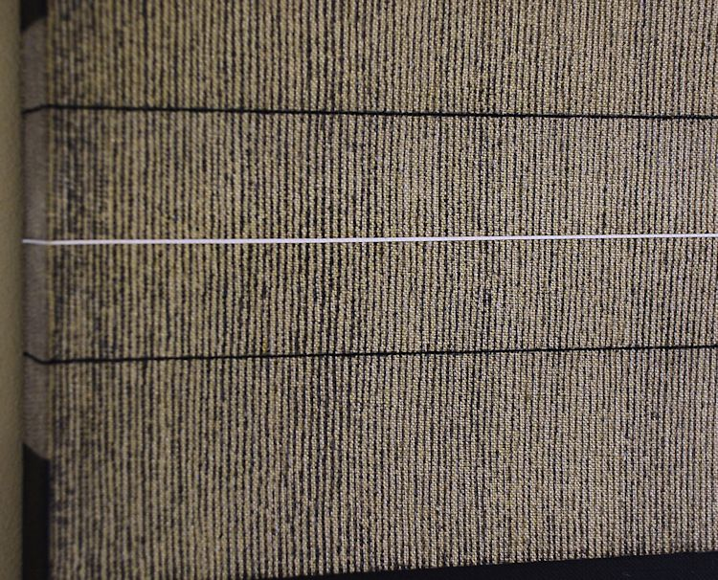
Soloman's Split, 2012
Detail
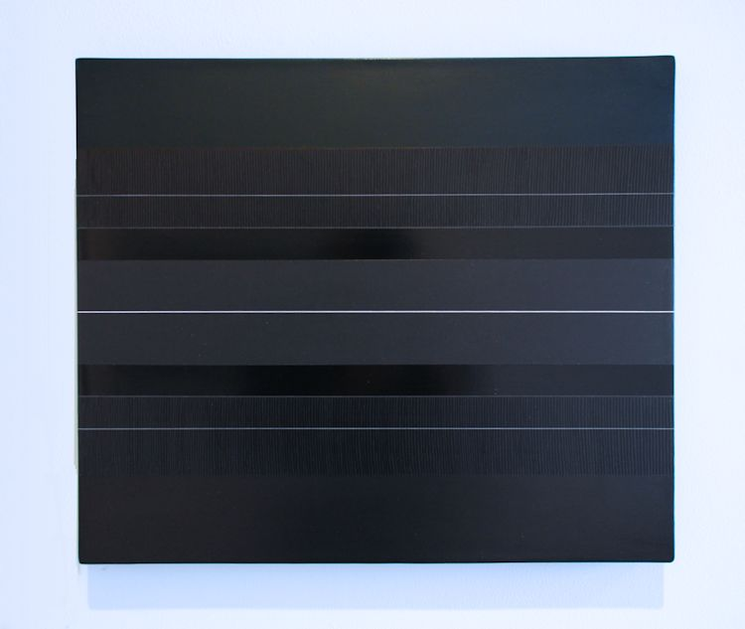
Bucks Bar, 2012
Acrylic on linen
16 x 19 inches
MAXC008
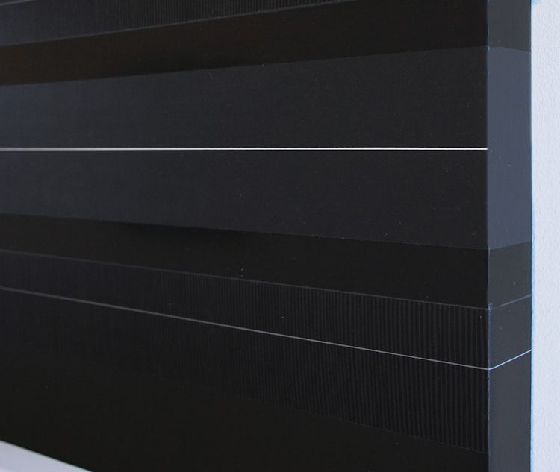
Bucks Bar, 2012
Detail
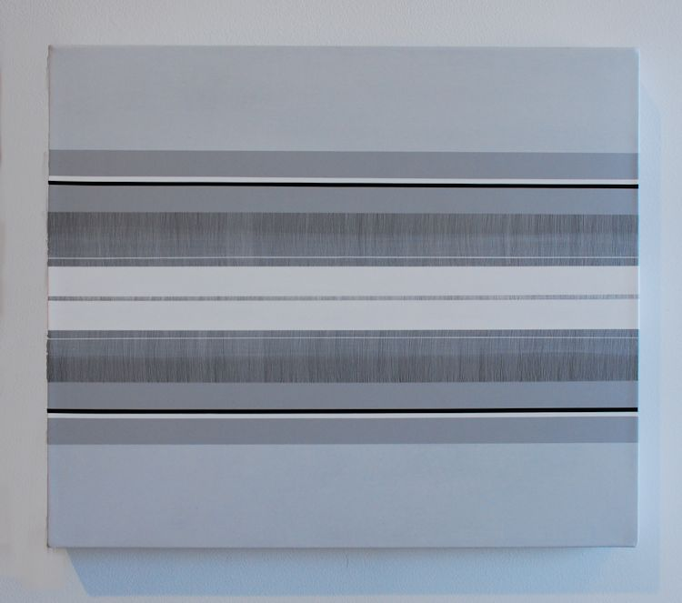
Plume, 2012
Acrylic on linen
16 x 19 inches
MAXC0016
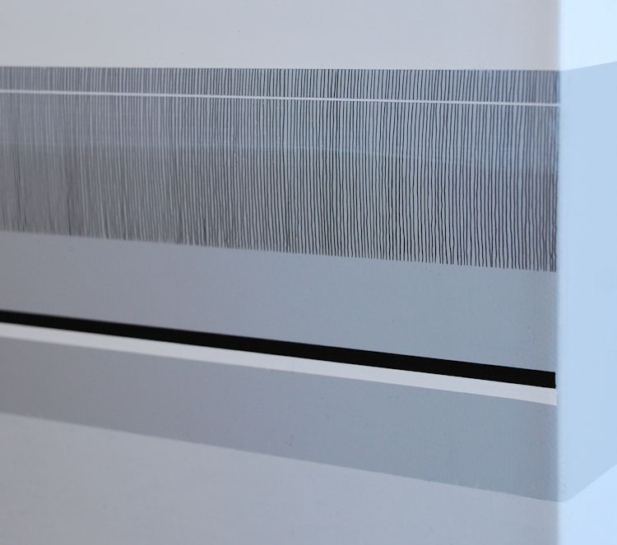
Plume, 2012
Detail
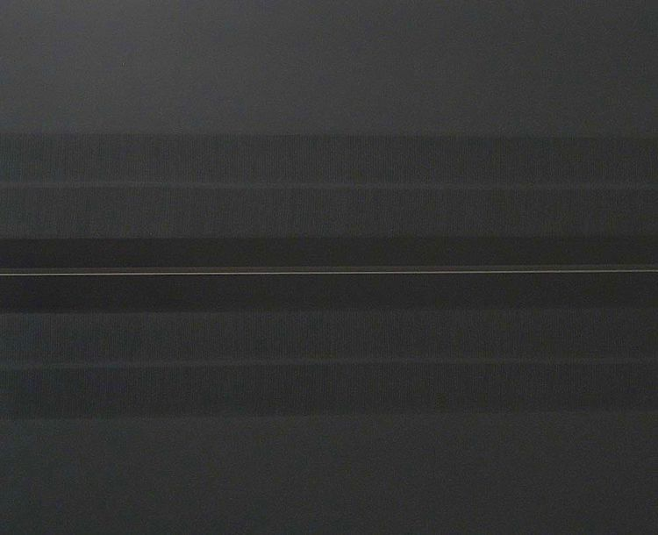
Arcanum, 2012
Acrylic on l i n e n
16 1/2 x 19 1/4 inches
MAXC002
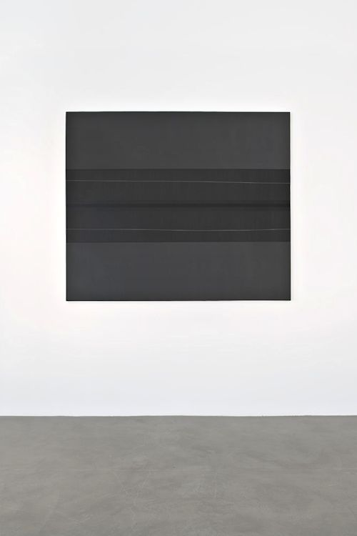
Dusk, 2010
Acrylic on linen
52 x 62 inches
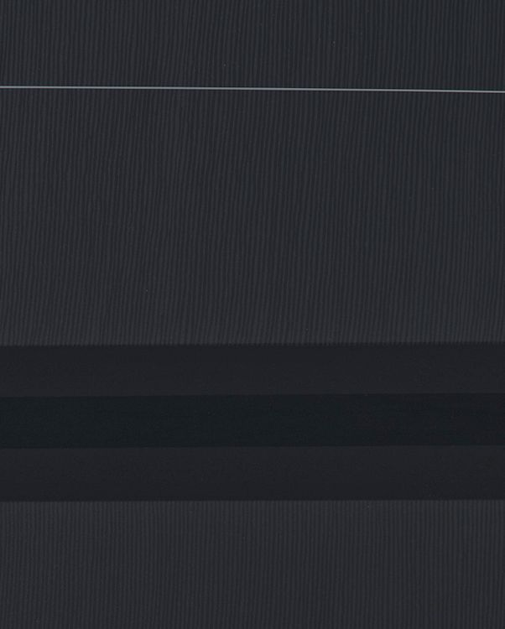
Dusk, 2010
Detail
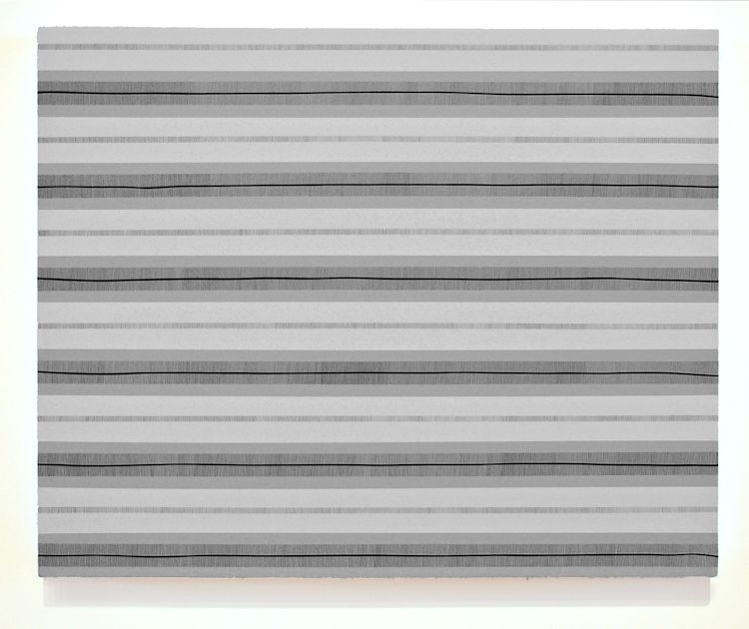
Amador, 2012
Acrylic on l i n e n
24 x 30 inches
MAXC0015
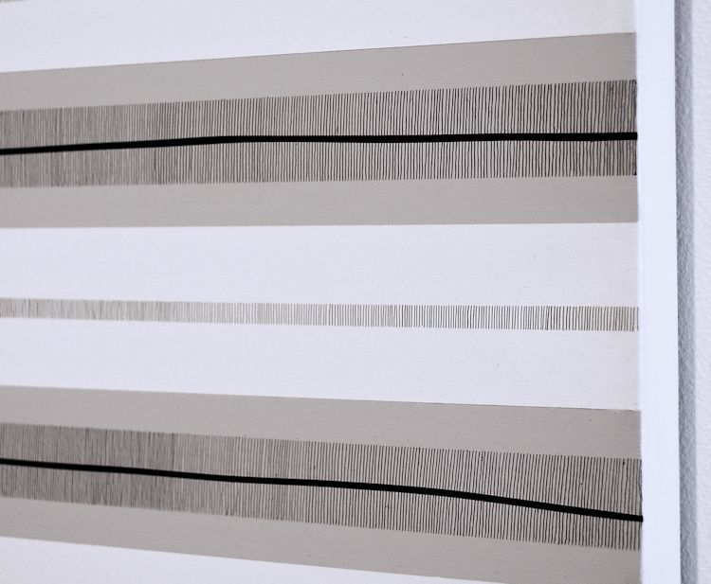
Amador, 2012
Detail
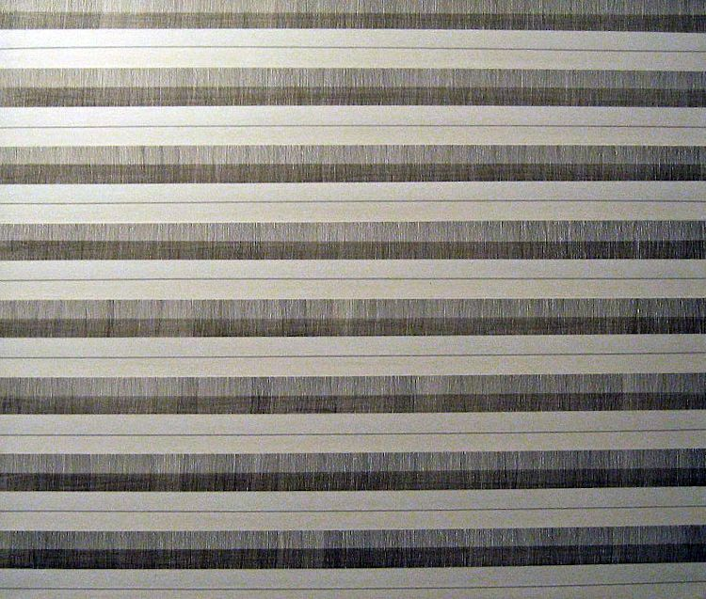
Ivory Field, 2012
Acrylic on l i n e n
16 1/4 x 19 1/4 inches
MAXC001
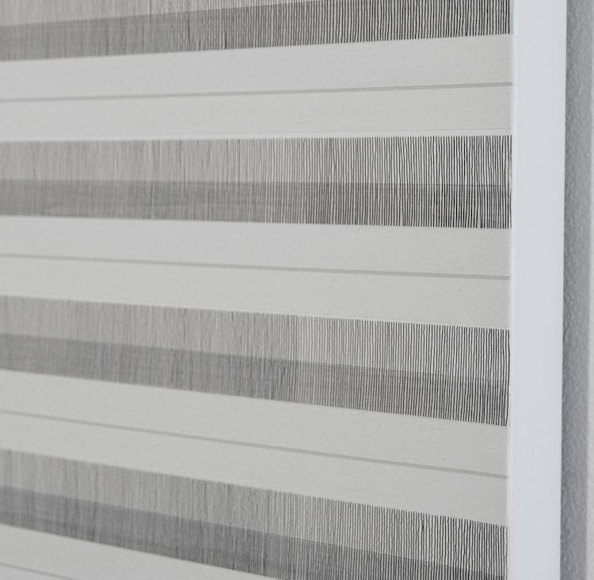
Ivory Field, 2012
Detail

© 2012

Charlotte Jackson Fine Art, Inc.

In the Railyard at:

554 S. Guadalupe, Santa Fe, New Mexico 87501
Telephone: 505.989.8688 Fax: 505.989.9898
cjfa@charlottejackson.com - www.charlottejackson.com

