CHARLOTTEJACKSON FINE ART
PRESENTS

JOSEPH MARIONI:
PAINTER

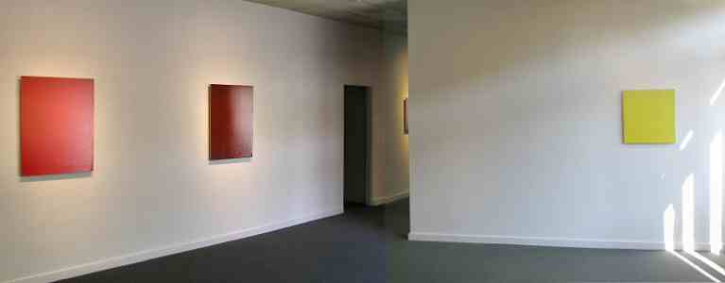Red Painting, Orange Painting, Yellow Painting - Installation View

July 4 - August 1 2003

Opening Reception, Saturday, July 5 from 2-4 p.m.
Joseph Marioni is an acknowledged international leader among monochrome painters. A member of the Radical Painting Group of New York, artists who pioneered the monochrome painting movement in the United States, Marioni has been instrumental in establishing color-based painting as a strong and viable current in the stream of contemporary art. His own career has seen a steady rise in the number and stature of museum exhibitions throughout the world.
Each Marioni painting is concerned with defining the particular character of a specific color. Every aspect of a painting's material body - size, layering, texture - is determined by the color itself, which makes each painting a unique object. The support is linen on stretcher, in vertical formats ranging from 24" x 20" to 72" x 60". Marioni uses a long-handled roller to apply layers of acrylic paint from bottom to top of the support; paint drips back down the surface, sometimes exposing parts of the layers underneath. The eventual surface may appear as one color or may reveal hints of the undercoats, but complex layering determines the overall sense of the color in all of Marioni's work.
Careful examination of a Marioni painting reveals the precision with which the artist applies the paint. Allowing the paint to drip back down over the surface creates the opportunity for chance to work its wonders, but the thick carpet of linen on Marioni's studio floor (the back side of paintings that did not meet his exacting standards) testifies to the degree to which he exercises control over the final result.
Marioni's command of technique is impressive in itself, but what makes his work riveting for the viewer is the intensity and mystery that these works express. They are entirely non-representational, but the viewer often has his or her own associations with a given color - the deep green of piñon in bright moonlight, or the white of an aged ivory carving - that multiply the impact of a given piece. These associations are in some cases subliminal, but the result is the same: strong emotional impact, which in the end must be attributed to the painter's ability to perceive and portray a specific color with equal measures of exactitude and passion.
Museums all over the world have recognized Marioni's achievements. Over the past several years, his work has been included in "Claude Monet...Up to Digital Impressionism" in Basel, Switzerland; a solo exhibition at the Brisbane Art Museum in Australia; and most recently at the Amarillo Museum of Art in Texas. The Brisbane and Amarillo shows were accompanied by stunning catalogs. Upcoming venues include a major exhibition of monochrome painting at the Museo Nacional Centro Reina Sofía Museum in Madrid, to be curated by Barbara Rose in 2004.

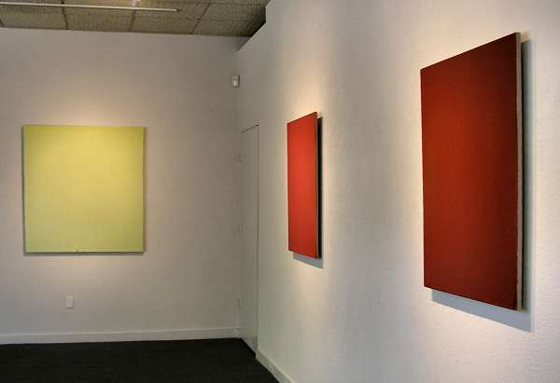
Yellow Painting, Red Painting, Orange Painting - Installation View
MAIN GALLERY

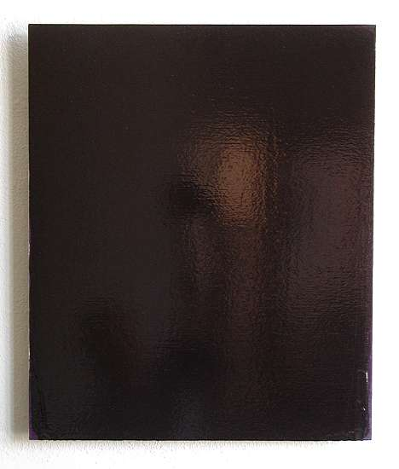

Black Painting
Acrylic on linen on stretcher, 2003
24" x 20"


Yellow Painting
Acrylic on linen on stretcher, 2003
48" x 46"
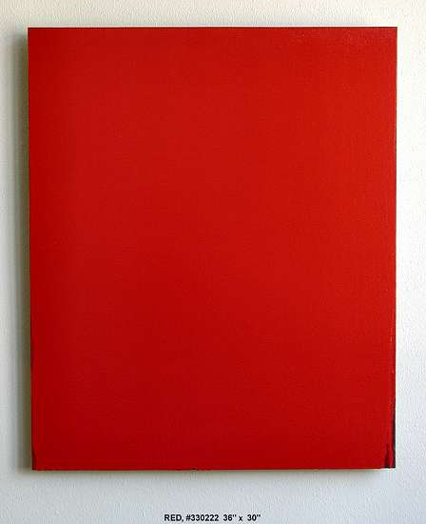

Red Painting
Acrylic on linen on stretcher, 2002
36" x 30"
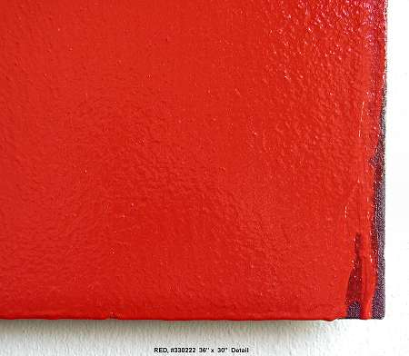

Red Painting (detail)
Acrylic on linen on stretcher, 2002
36" x 30"

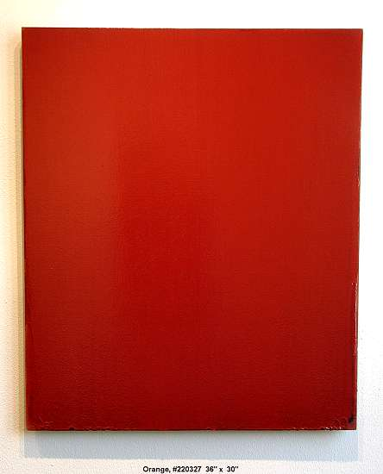

Orange Painting
Acrylic on linen on stretcher, 2003
36" X 30"
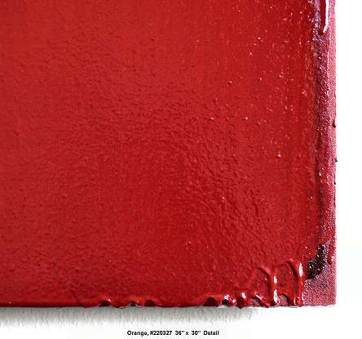

Orange Painting (detail)
Acrylic on linen on stretcher, 2003
36" X 30"
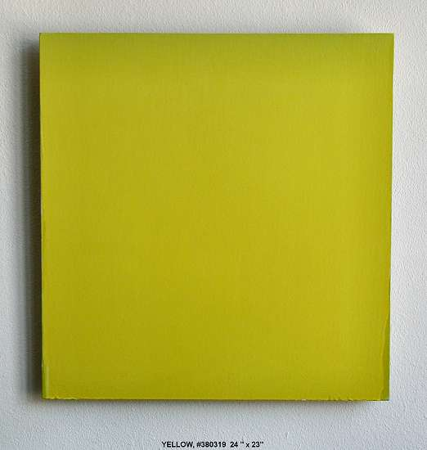

Yellow Painting
Acrylic on linen on stretcher, 2000
24" x 23"
HALLWAY

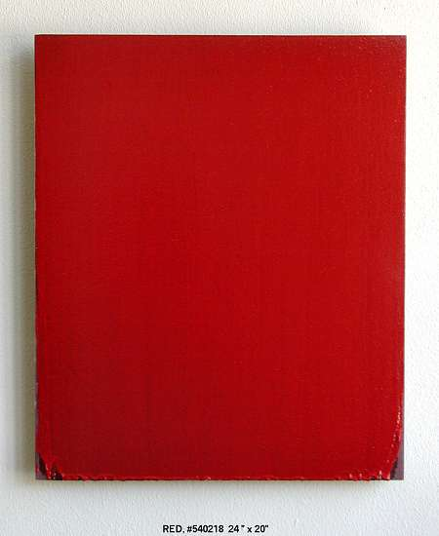

Red Painting
Acrylic on linen on stretcher, 24" x 20"
2002
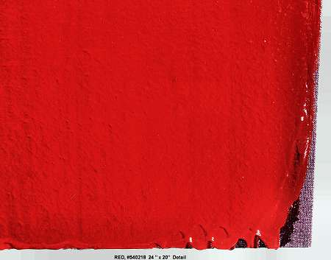

Red Painting (detail)
Acrylic on linen on stretcher, 24" x 20"
2002

GALLERY II
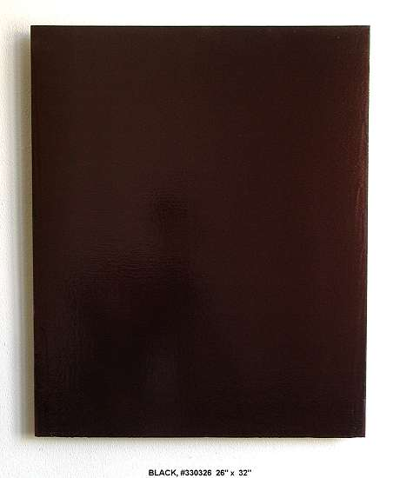

Black Painting
Acrylic on linen on stretcher, 2003
32' x 26"
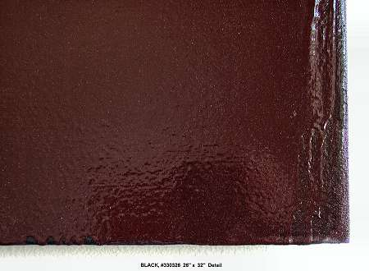

Black Painting (detail)
Acrylic on linen on stretcher, 2003
32' x 26"
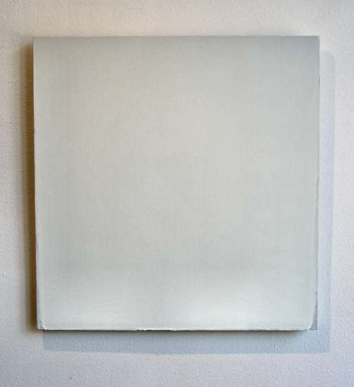

White Painting
Acrylic on linen on stretcher, 2002
28" x 27"
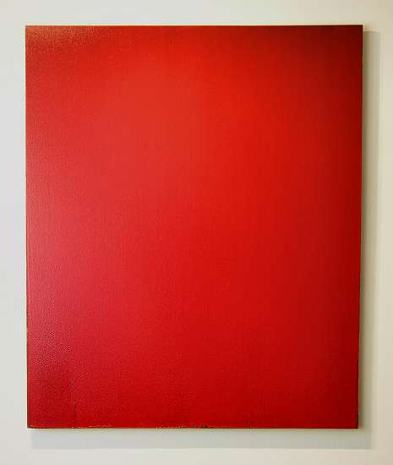

Red Painting
Acrylic on linen on stretcher, 2001
72" x 60"
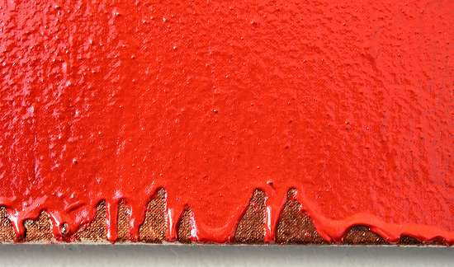

Red Painting (detail)
Acrylic on linen on stretcher, 2001
72" x 60"
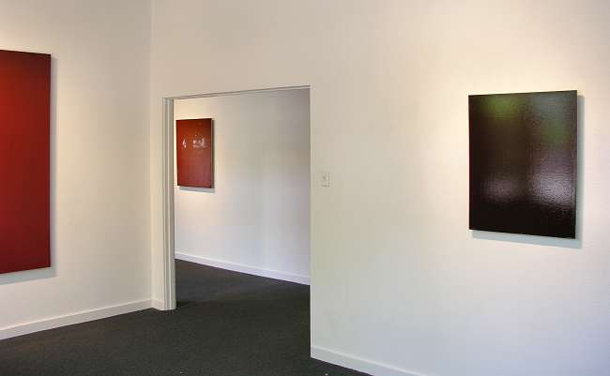

Red Painting, Orange Painting, Black Painting - Installation View
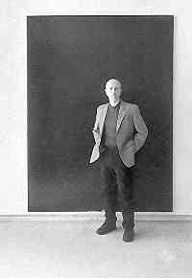
Joseph Marioni
Asked when he decided to become a painter, Joseph Marioni replies, “It was always there.” He recounts memories from earliest childhood, when he could barely reach the lowest shelf in his father’s library. On that shelf were kept books with illustrations of Renaissance art, and Joseph would pull the books down and spend hours looking at the vibrant colors in the paintings.
“This was in the early 50s,” he recalls. “Color printing was fairly new, and the quality was excellent. I was looking at the work of da Vinci, Michaelangelo, Bellini, Cellini and the great Renaissance architect Brunellischi. The colors were absolutely beautiful.”
Marioni went on to acquire strong academic training at the Cincinnati Art Academy and Museum, and completed graduate studies at the San Francisco Art Institute. Although he received training in a wide variety of subjects, including music, sculpture and printmaking, his early love for color persisted and led him inexorably toward the choice of painting as his medium. He was also drawn to painting by the fact that it was “quiet” and allowed him to create his own world. By his early twenties, he had settled into painting, and by his late twenties had found his identity as a painter.

Inspired by the work of New York painters and discouraged by the lack of serious interest in painting in California, Marioni made the decision to live and paint in New York. There his painting and his career received encouragement and support from some of the most important painters of the day. He met Robert Ryman in 1971 and thereafter had access to Ryman’s studio. In 1974 he met Brice Marden, who came to Marioni’s studio to look at his work.
“After about 15 minutes, Marden remarked, ‘Oh, these are literal paintings,’” recalls Marioni. “I felt confirmed in my decision to live in New York – as difficult as it was – I felt as if I had come home.” He notes that Marden was the first to recognize what he was doing. A year later, Marden chose Marioni’s work for a solo show he was curating at the Artist Space, an exhibition space in Soho that still exists with the purpose of introducing promising young artists.
The monochromatic painting of Marioni and a handful of other painters began to be recognized and exhibited in Europe. The movement gained prominence on the American art scene in Radical Painting, a group exhibition at Williams College in 1984. The artists in this exhibition became known as the Radical Painting Group – radical in the sense of the original Latin meaning, root. It was an attempt to get back to the roots of painting and to make art that was about color and painting itself.
In the meantime, Marioni's work has achieved considerable stature all over the world. Museums as diverse and far-flung as the Beyeler Foundation in Basel, the University Art Museum in Queensland, Australia and the Amarillo Museum of Art in Texas have all exhibited his paintings over the past two years alone. Through all these developments, color has remained Marioni’s central focus. “It’s always been about color,” he says.
© 2003, Charlotte Jackson Fine Art
All Rights Reserved

Charlotte Jackson Fine Art

200 West Marcy Street, Suite 101

Santa Fe, New Mexico 87501

Phone: 505.989.8688
Fax: 505.989.9898

www.charlottejackson.com

