CHARLOTTE JACKSON FINE ART
PRESENTS:

A LIGHTER SHADE OF PALE

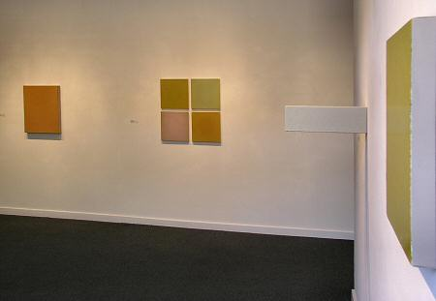

ANNE APPLEBY
JOHN BEECH
MARK COLE
MARCIA HAFIF
MATT MCCLUNE
DAVID SIMPSON
JEREMY THOMAS
CLARK WALDING

May/June 2005
MAIN GALLERY:

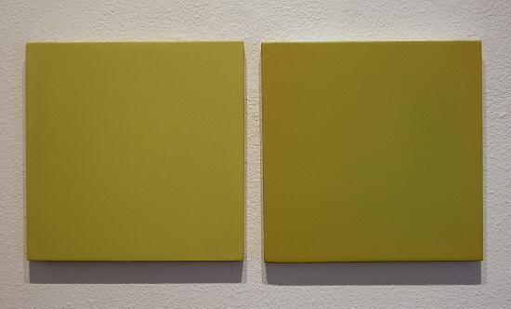
ANNE APPLEBY
May, 2005
Oil and wax on gesso panel, 12” x 25”, AA002
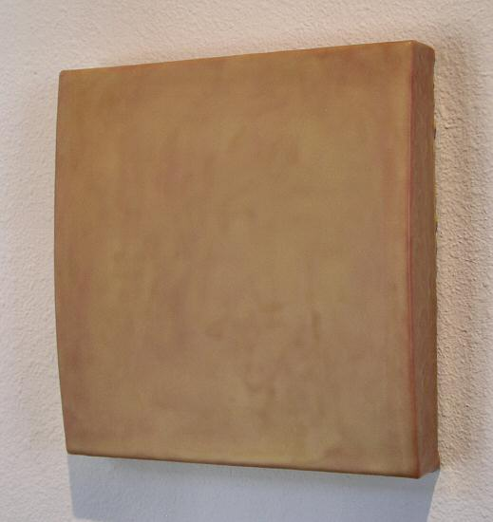
JOHN BEECH
Glue Painting #71, 2004
Plasterweld, Elmer's original wood glue, plywood, linen, 11 ½” x 11 ½” x 1 ¾”, JB0026
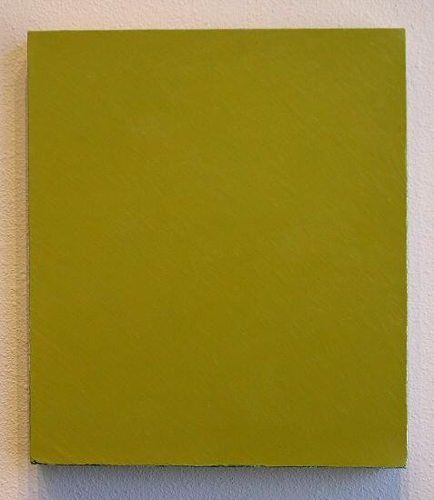
CLARK WALDING
Untitled, 2004
Oil, alkyd, wax on canvas, 24” x 20”, CW0010
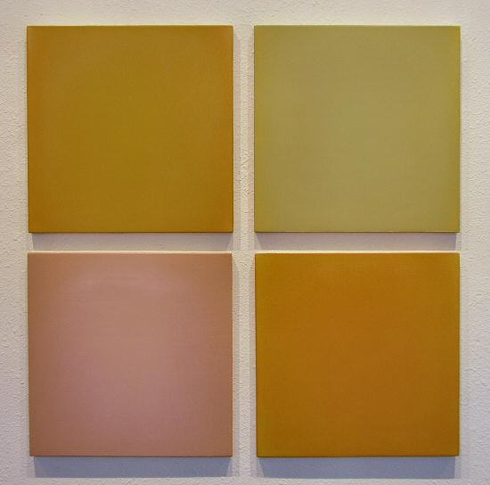
ANNE APPLEBY
Winter Into Spring II, 2005
Oil and wax on gesso panel, 29” x 29”, AA001
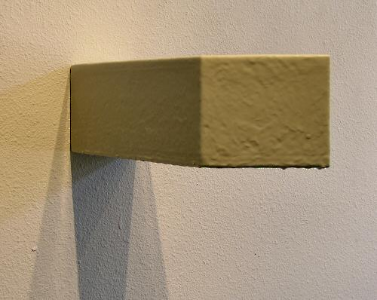
JOHN BEECH
Glue Painting # 83, 2004
Latex tinted Titebond original woodglue, MDF, 5 ¾” x 5” x 17 ½”,
JB0022
CLARK WALDING
Untitled, 2004-2005
Oil, alkyd, wax on canvas, 19” x 16 ½”, CW0011
HALLWAY:

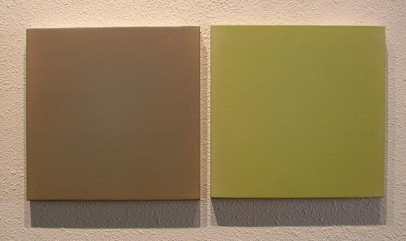
ANNE APPLEBY
March, 2005
Oil and wax on gesso panel, 12” x 25”, AA003
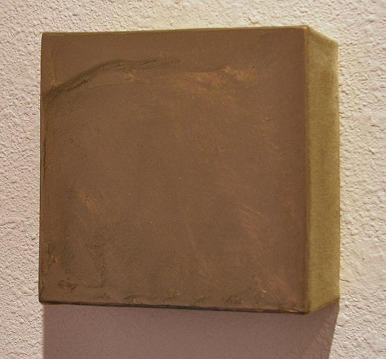
DAVID SIMPSON
Thick #6, 1995
Acrylic on canvas on board, 6” x 6” x 2 ½”, FDS1
GALLERY II:

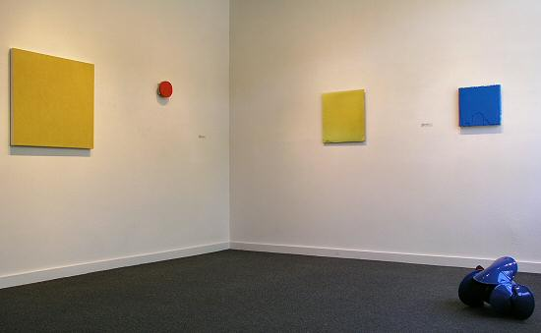
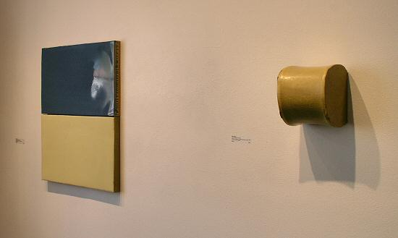
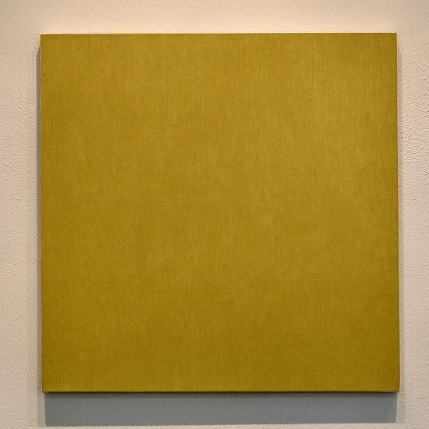
MARCIA HAFIF
Indian Yellow Tint 2, 1998
Oil on canvas, 29” x 29”, MH004
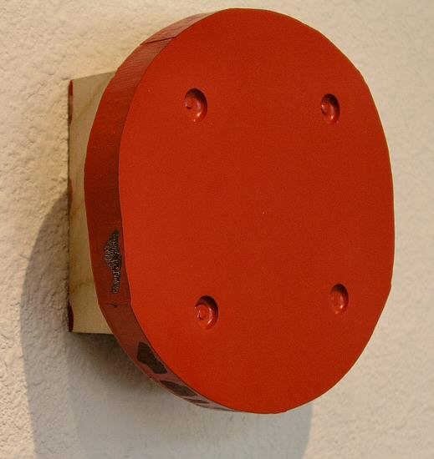
JOHN BEECH
Rotating Painting #106, 2002
Plexiglas, enamel, plywood, rotating hardware, 6 ½” x 6 ½” x 3”,
JB0013
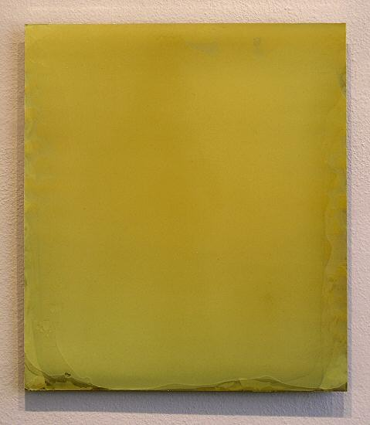
MATT MCCLUNE
Yellow Painting, 2002
Acrylic on aluminum, 20” x 18”, MM007
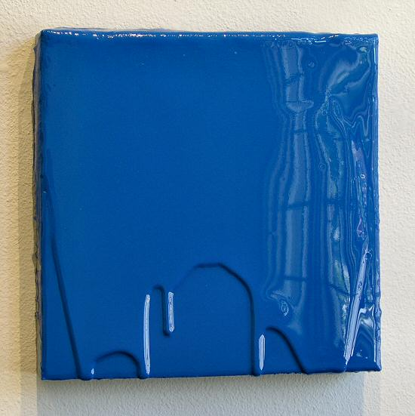
MARK COLE
The Little One has a Day Off, 2004
Polyurethane plastic with pigment, 14” x 14”, MC0017
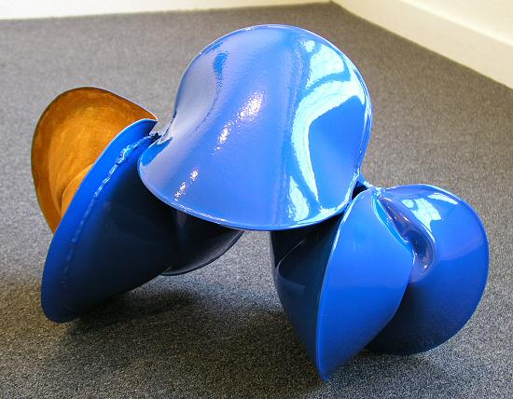
JEREMY THOMAS
New Holland Blue 5/05, 2005
Forged mild steel and powder coated enamel, 22” x 13” x 9”, JT0031
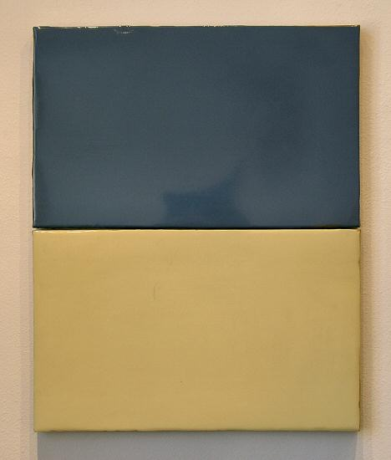
MARK COLE
The Best New Myths, 2003
Polyurethane plastic with pigment, 36” x 26”, MC002
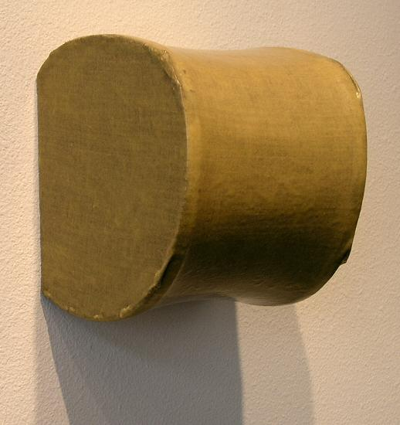
JOHN BEECH
Glue Painting #79, 2004
Titebond original wood glue, linen, plywood, MDF, 9 ½” x 8” x 8 ½”
JB0027
© 2005, Charlotte Jackson Fine Art
All Rights Reserved

Charlotte Jackson Fine Art

200 West Marcy Street, Suite 101

Santa Fe, New Mexico 87501

Phone: 505.989.8688
Fax: 505.989.9898

www.charlottejackson.com

Photography and CD production – William Metcalf

