CHARLOTTE JACKSON FINE ART PRESENTS:

JOAN WATTS: BOUNDLESS

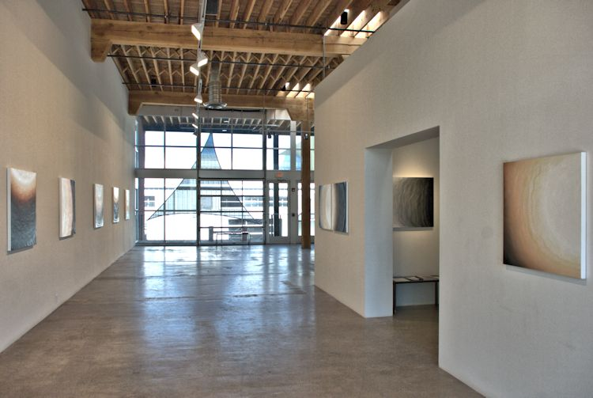

May 16 - June 21, 2014
Boundless: without limits, infinite. The title of this exhibition of new work by Joan Watts speaks directly to the experience of the viewer and to the nature of these paintings. It’s not that these works are literally uncontained, without borders: There is the regular square or diamond format of the paintings themselves; the overlapping yet distinct waves of color; the perfect curve of the partial white circle which appears in every piece. Nevertheless, Boundless, is a perfect designation for the way in which these paintings take the viewer beyond, how they suggest that there is more to them than what appears at first sight.

What makes these paintings breathe? What makes them unfold before the viewer? One of the keys may be the gradual shift in color value in Watt’s paintings, from dark to light, black to white, which has been a hallmark of her work for many years. The slow modulation of tone across the spectrum (from say, the darkest of midnight blue-black to palest shell-blue to pristine white) has the effect of opening up the canvas, creating a sensation of depth and volume into which the viewer is immersed. In the earlier explorations, white-tints moved up the canvas evenly in a careful and seamless movement in which all presence of the artist’s hand was meticulously erased in a process of continual application and wiping away of the paint. The process created an amorphous landscape of light and dark.

In more recent series, Watts added a partial circle along one edge of the canvas, all white, which seemed to push into the color, pressing it back toward the opposing edge of the canvas. The circle determined the shape of the deepening color as it flowed across or down the canvas and it added a focal point to the pieces. But rather than this focus tethering the viewer, the suggestiveness of the unfinished circle added a sense of space and dimension, of potential—the hint of more beyond

The current work continues to utilize this tantalizing sliver of circle and the exploration of color saturation shifting from light to dark; however, these new works have changed dramatically. Unlike the previous works where all trace of the artist’s hand had been wiped away, the pieces in Boundless are painterly. The viewer is allowed to see the undulating lines of the paint as it was applied. Rather than a seamless shift, the works in Boundless are complexified by the inclusion of interwoven waves of color. Warm tones of earth: sienna, sepia, burnt umber, and rust weave, overlap, and then open up into muted striated creams which give way to the thick and wavy white of the incomplete circle

The waves do not directly refer to anything specific, although as Watts says, “Everything is a particle and a wave.” However, the gentle roll of a wave-line is intensely suggestive, as essential and basic a form as the square or circle. If in the cooler works (blue, green, purple) these waves of color suggest water, in the warmer pieces (where the colors are earth, orange, rust) these waves feel more like the ancient geological strata of canyon walls or the dramatic roiling of smoke from a forest fire. The coiling lines are not planned, but spontaneous. Watts’ process involves a basic set of parameters: the format (size and shape of the canvas), the orientation of the partial circle which is drawn in with an old drafting compass, and the choice of warm or cool color. After these choices are made the painting emerges organically. Watts says, “There is a sense of allowing … Why is only just emerging—I didn’t ask myself why. I am freer than I ever have been in my life.”

This idea of allowing and spontaneity may also be a clue to understanding the boundless quality of these works. Watts says: “The process begins, moves spontaneously, and usually ends rather suddenly when it has somehow arrived. It seems the spontaneity of this work has evolved out of long practice both physical and meditative.” A relationship to the Japanese meditative practices of Shodo (calligraphy) and Enso (circle drawing) can be drawn, in which the practitioner both meditates and practices their art for years in order to develop the skill to successfully create one spontaneous form in a matter of a few seconds. The goal is to find the place where thought and intent disappear into seamless act, where body and mind, paint and canvas, hand and form become one.

It seems that by bringing the elements of light and dark, space and form, hand and eye together, the paintings in Watts’ Boundless elicit a visceral response in the viewer, a multifaceted experience which transcends each disparate element to create something beyond them all.
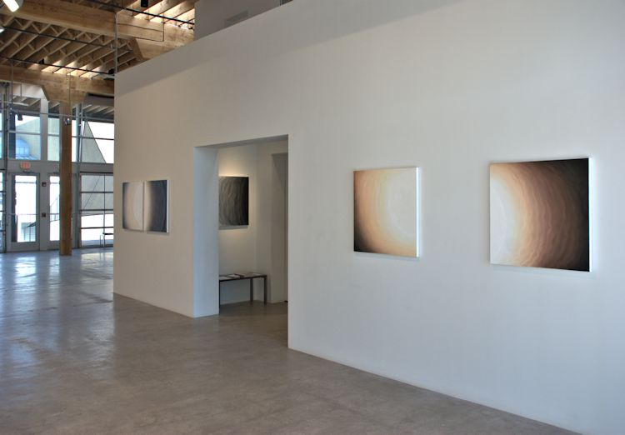

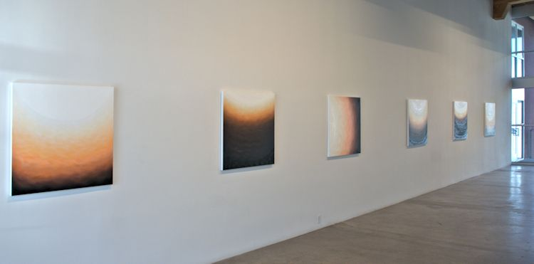
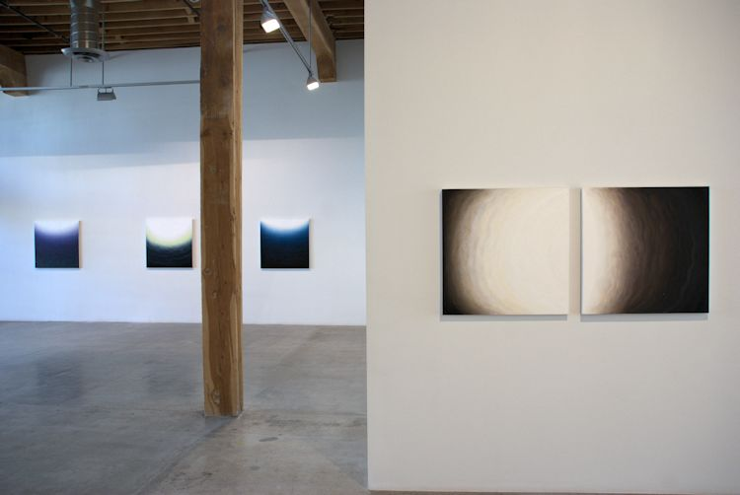

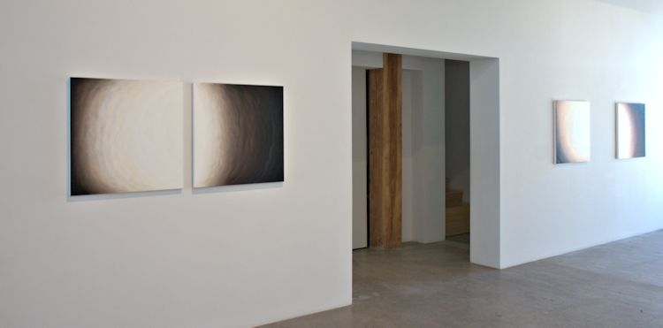
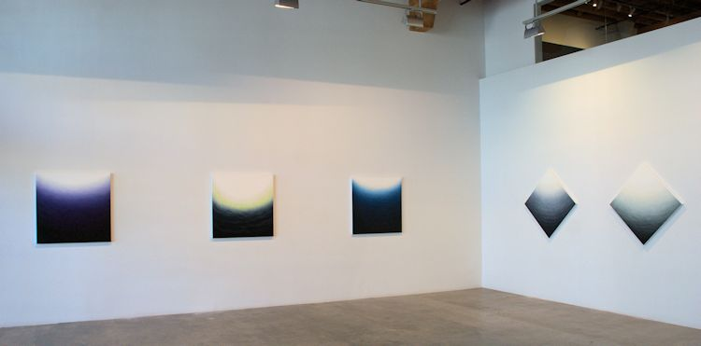

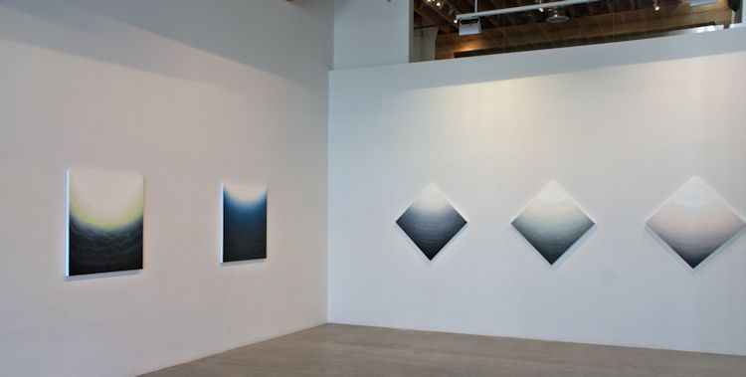
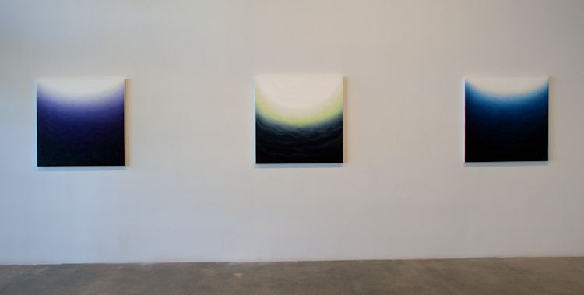

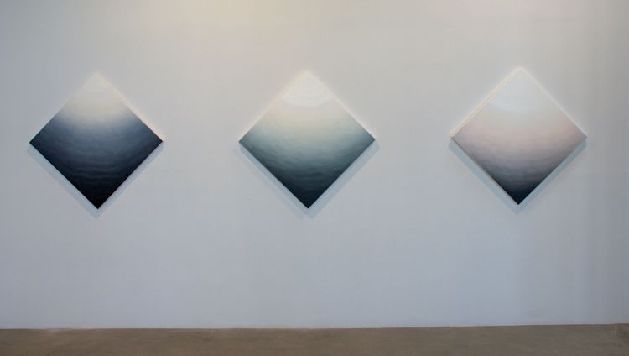
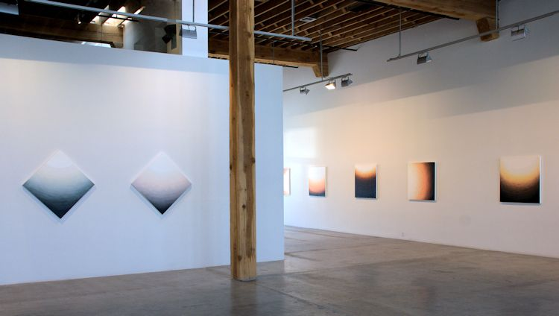

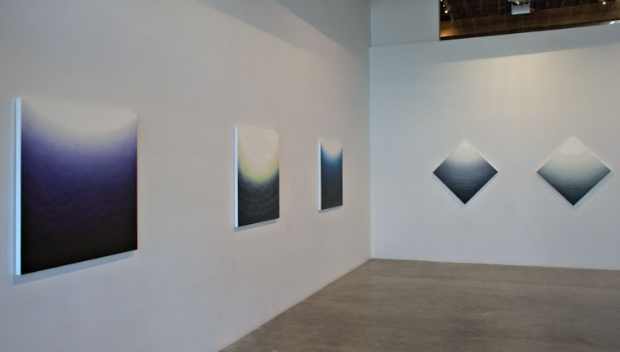
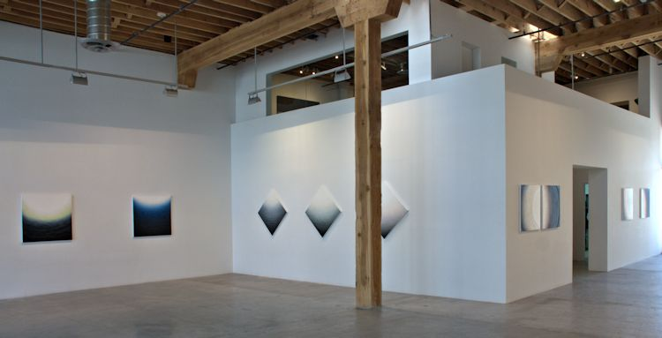

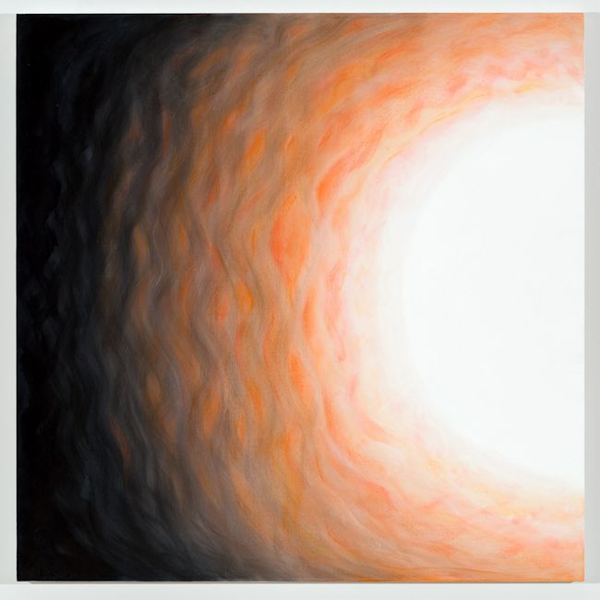
Untitled 34, 2013
oil on canvas
36 x 36 inches
JW101
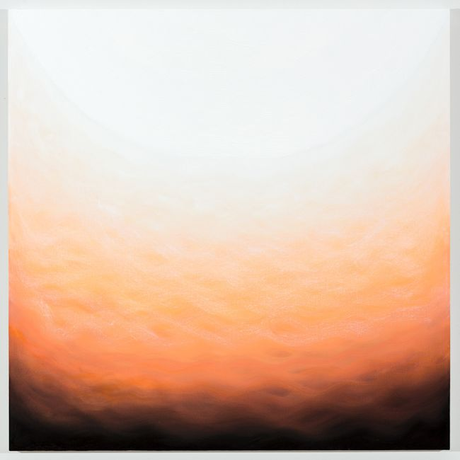
Untitled 36, 2013
oil on canvas
36 x 36 inches
JW103
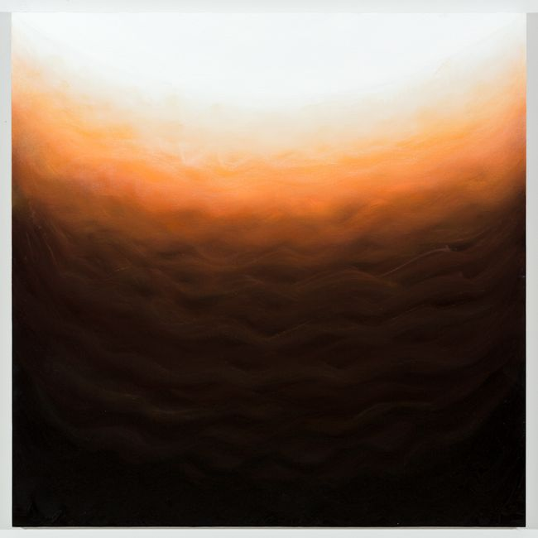
Untitled 37, 2013
oil on canvas
36 x 36 inches
JW104
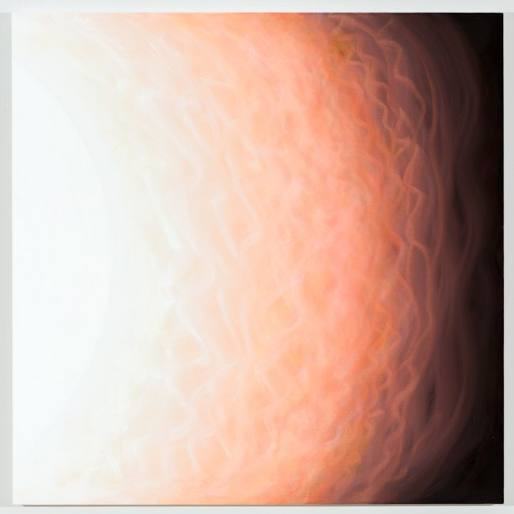
Untitled 35, 2013
oil on canvas
36 x 36 inches
JW102
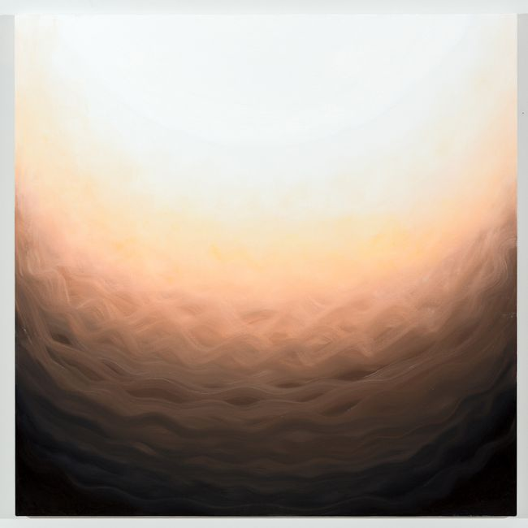
Untitled 32, 2013
oil on canvas
36 x 36 inches
JW099
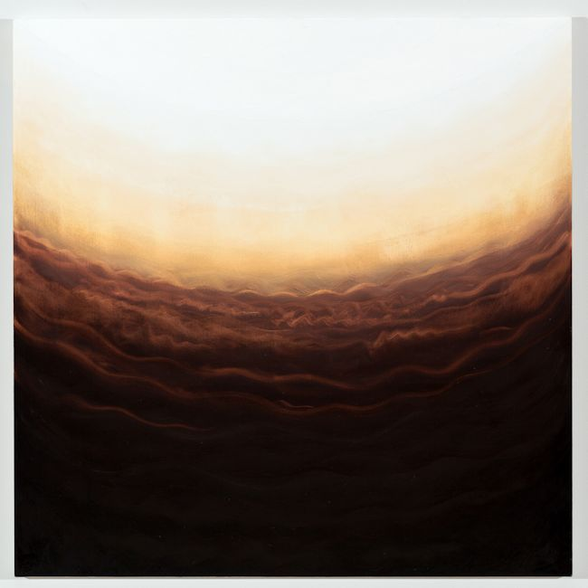
Untitled 33, 2013
oil on canvas
36 x 36 inches
JW100
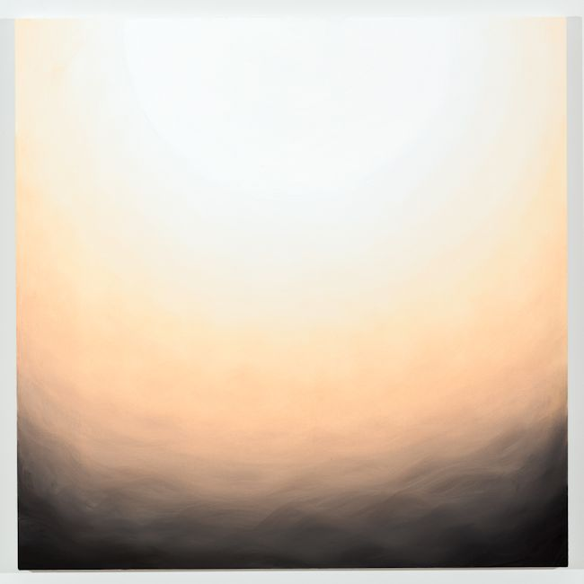
Untitled 31, 2013
oil on canvas
36 x 36 inches
JW098
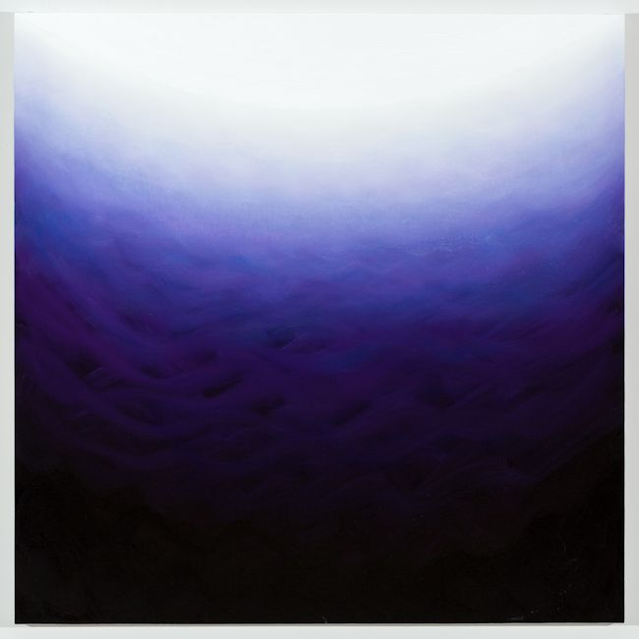
Untitled 39, 2013
oil on canvas
36 x 36 inches
JW106
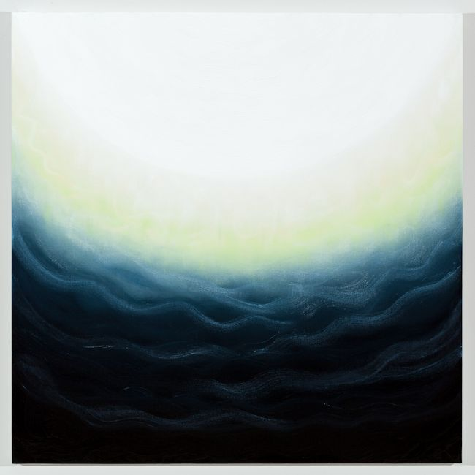
Untitled 40, 2013
oil on canvas
36 x 36 inches
JW107
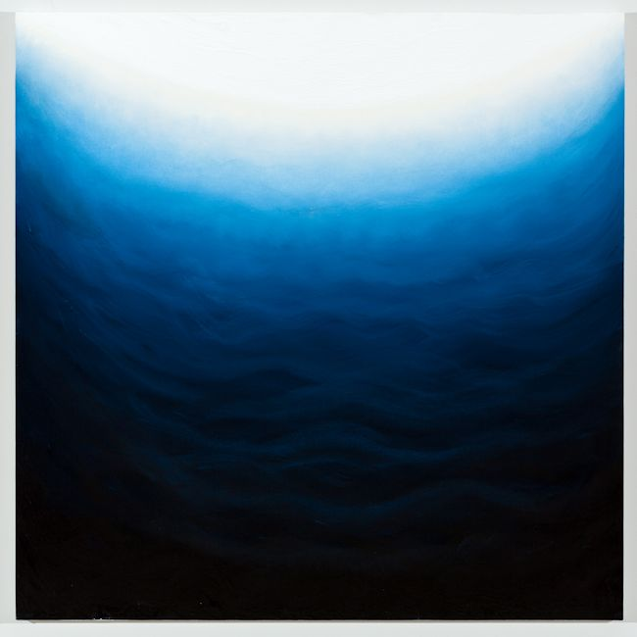
Untitled 38, 2013
oil on canvas
36 x 36 inches
JW105
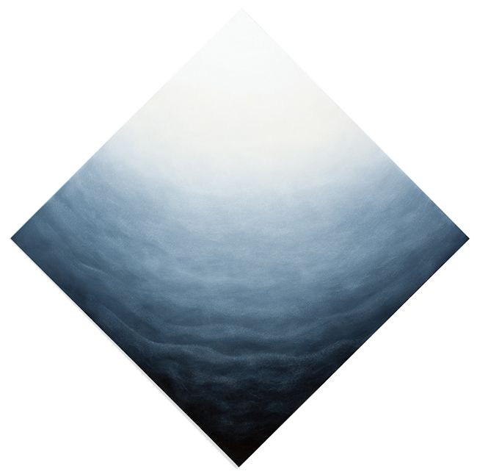
Diamond 4, 2013
oil on canvas
42 1/2 x 42 1/2 inches
JW108
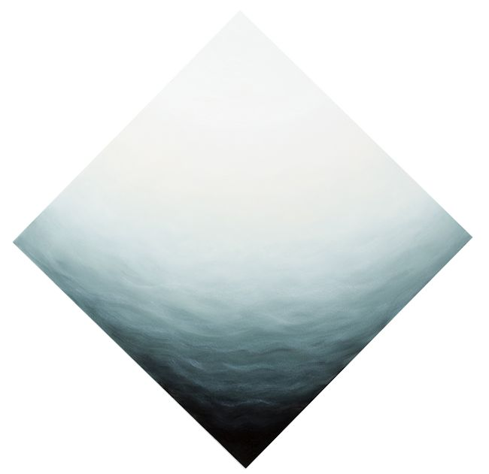
Diamond 5, 2013
oil on canvas
42 1/2 x 42 1/2 inches
JW109
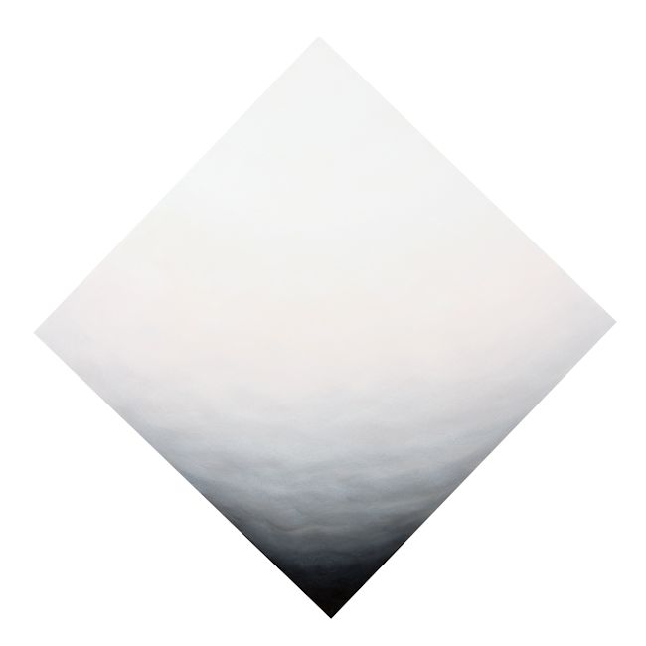
Diamond 6, 2013
oil on canvas
42 1/2 x 42 1/2 inches
JW110
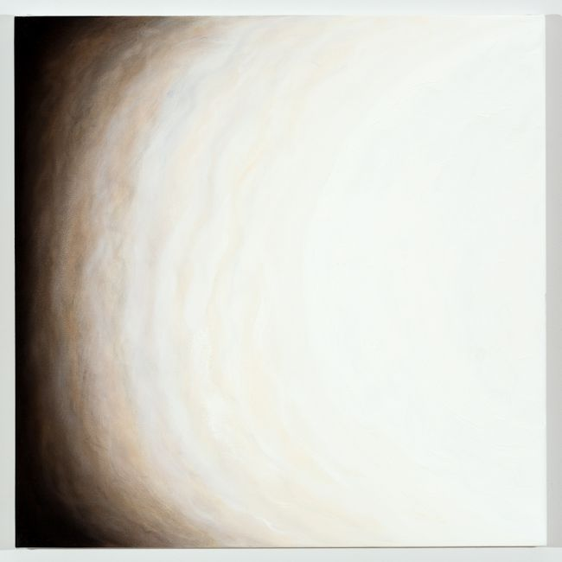
Untitled 28 Duo, 2013
oil on canvas
30 x 30 inches
JW095
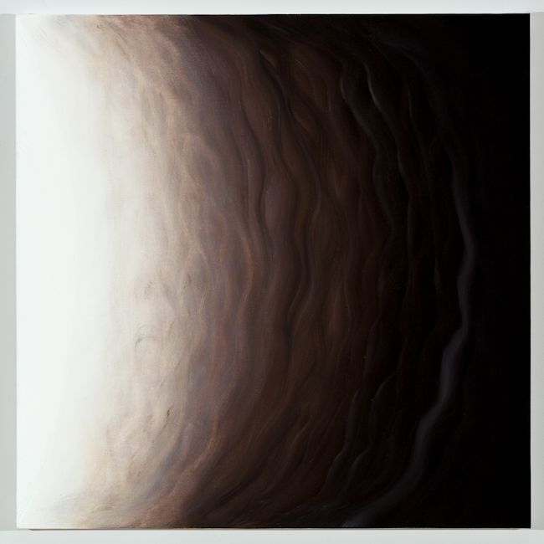
Untitled 27 Duo, 2013
oil on canvas
30 x 30 inches
JW094
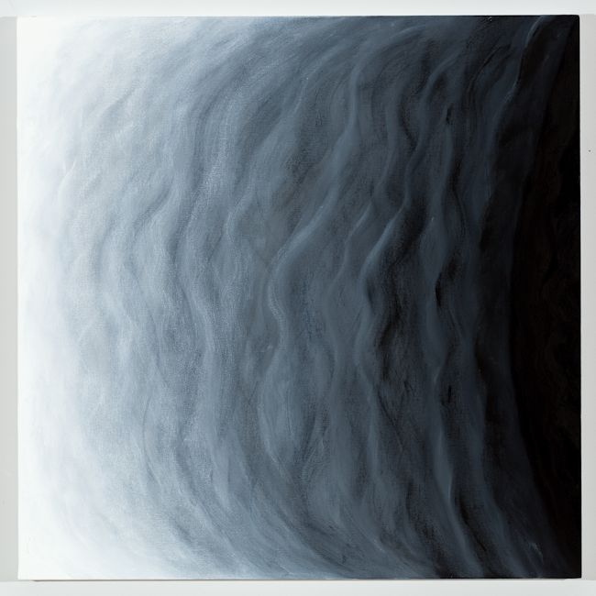
Untitled 24, 2013
oil on canvas
30 x 30 inches
JW091
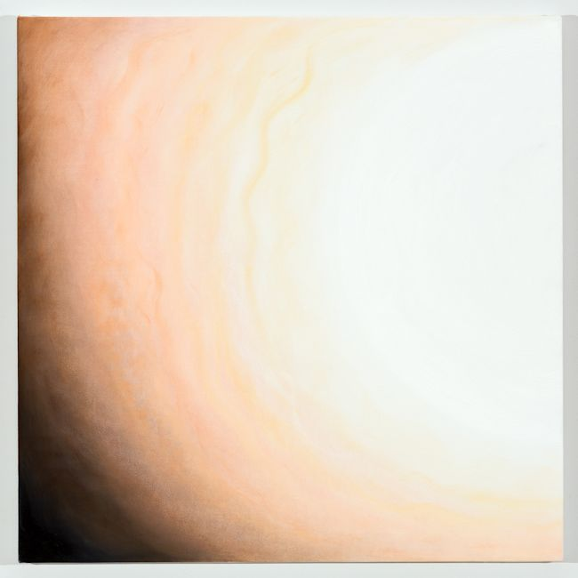
Untitled 30, 2013
oil on canvas
30 x 30 inches
JW097
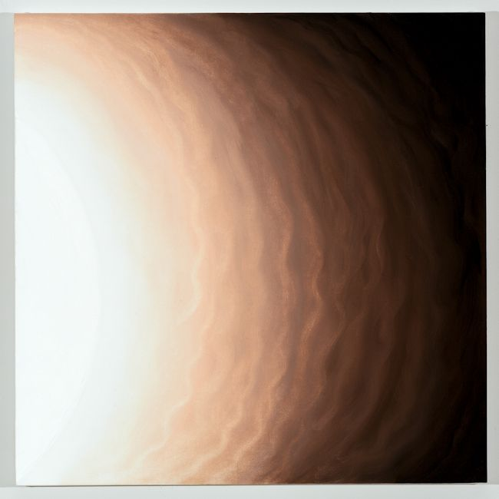
Untitled 29, 2013
oil on canvas
30 x 30 inches
JW096

© 2014

Charlotte Jackson Fine Art, Inc.

In the Railyard at:

554 S. Guadalupe, Santa Fe, New Mexico 87501
Telephone: 505.989.8688 Fax: 505.989.9898
cjfa@charlottejackson.com - www.charlottejackson.com

