CHARLOTTE JACKSON FINE ART

PRESENTS

JOAN WATTS
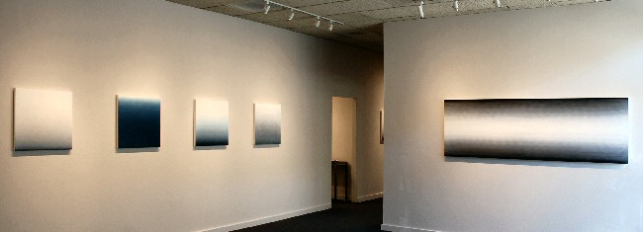
JUNE 6 - June 30, 2008
In New Mexico, the notion that our light is sublime is so evident that it has become a cliché: to state that a painter has been deeply influenced by the light of northern New Mexico seems trite. In the case of Joan Watts' paintings, to look at her art is to understand that clichés are born out of truth.
Watts will show a series of square and long rectangular canvases in cool tones that range from nearly black to grays, blues, purples, and turquoise hues-all of which graduate to white, as if infused with their own unimaginably brilliant light source.
Watts' work has always been about light, but when she moved to New Mexico over 20 years ago, "I became enveloped in light. The work [of the recent past] could not have been done anywhere else." Originally painting the landscape, she reduced her subject matter down to its essence: light. Radiant, pristine, and meditative, Watts considers her works to be objects of contemplation rather than minimalist paintings. For her, they represent the logical reductionist tendencies of a Buddhist practitioner, as was the case with Taos painter Agnes Martin. Watts' fascination with light as dimensional is similar also to James Turrell's skyscapes that cause our seemingly flat sky to pop, suddenly and perceptibly, into a third dimension-just as Watts uses color on canvas to "illustrate" light on a two-dimensional surface, creating the illusion of spaciousness through her process.
That process is simplified and direct, and extremely effective for the results she desires to achieve. First, Watts applies several layers of gesso onto her canvas, leaving horizontal brush strokes on the surface. Then she embeds oil paint onto the canvas in waves with rags, daubing and deleting pigment so that her colors seem to effortlessly run a scale of hue and saturation. Subtly gestural, the paintings shimmer with vitality.
Radius Books premiers its latest offering, a powerfully beautiful book on the life and works of Joan Watts since the 1960s, with text by Art in America writer Lilly Wei and a foreword by SITE Santa Fe's first director, Louis Grachos.
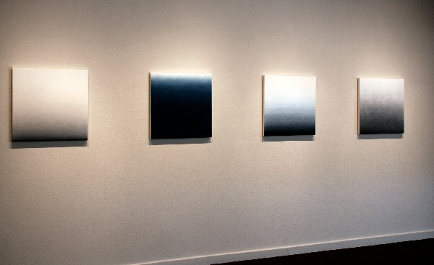
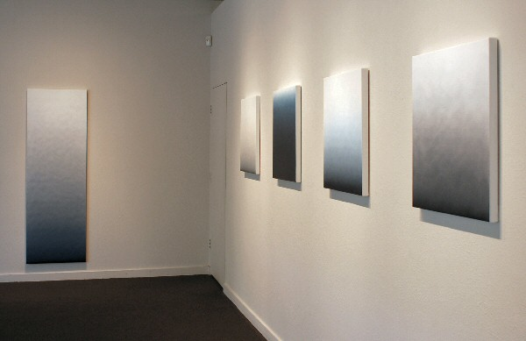
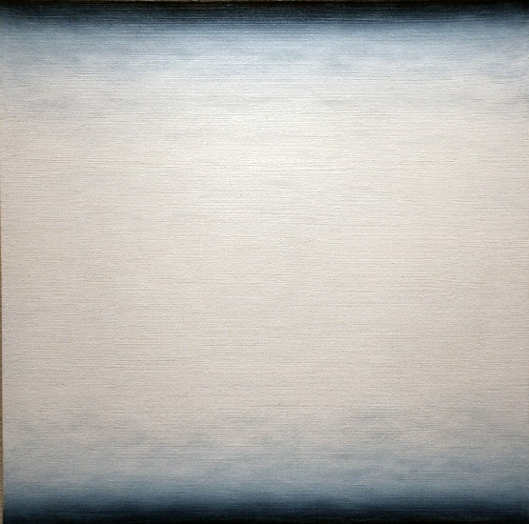
One-10, 2008
oil on canvas 24 x 24 inches JW028
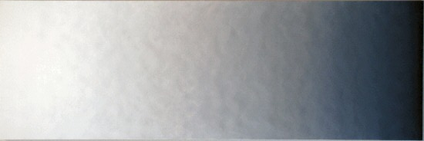
X-11, 2006
oil on canvas 72 x 24 inches JW031
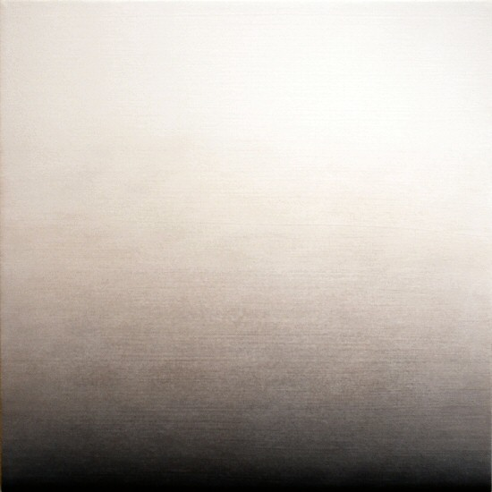
One-5, 2008
oil on canvas 24 x 24 inches JW024
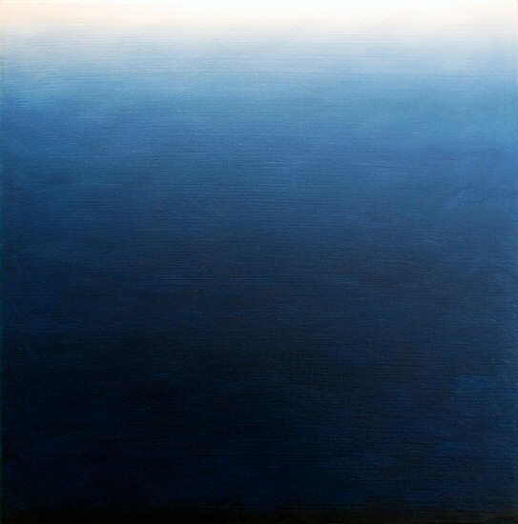
One-6, 2008
oil on canvas 24 x 24 inches JW025
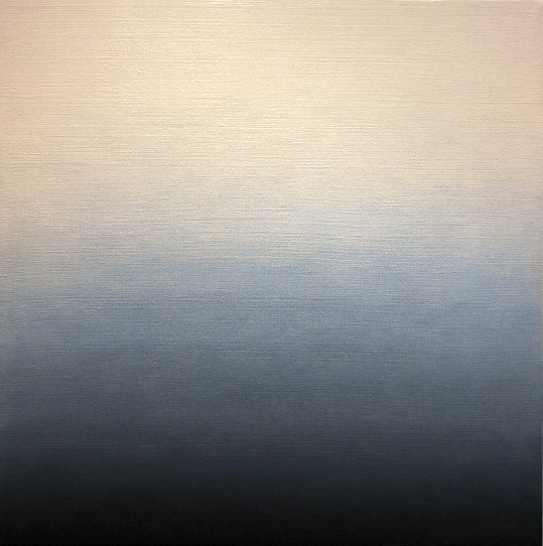
One-2, 2008
oil on canvas 24 x 24 inches JW021
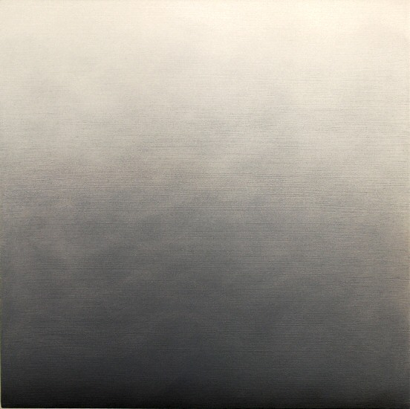
One-7, 2008
oil on canvas 24 x 24 inches JW019
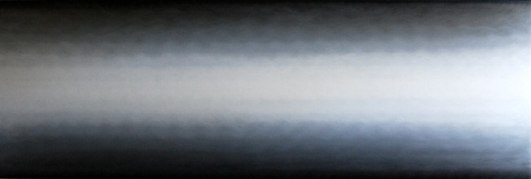
Channel 10, 2007
oil on canvas 30 x 90 inches JW029

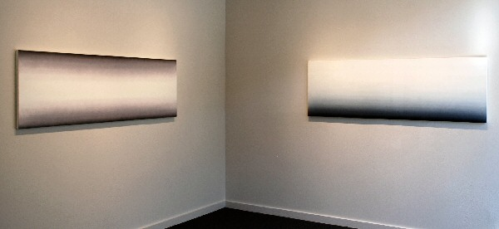

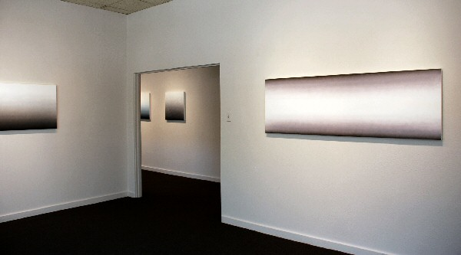

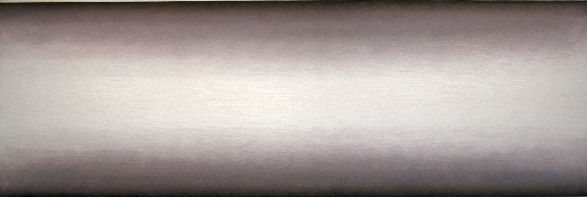
Channel 5, 2007
oil on canvas 24 x 72 inches JW030
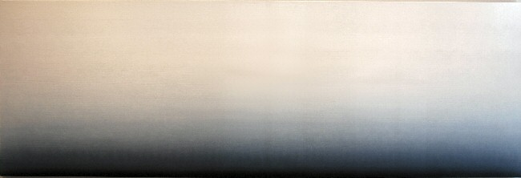
X-16, 2006
oil on canvas 24 x 72 inches JW033

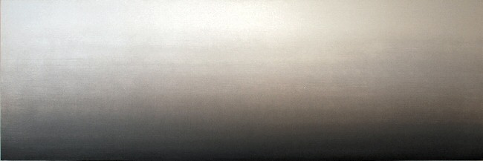
X-15, 2006
oil on canvas 24 x 72 inches JW032

© 2008

Charlotte Jackson Fine Art, Inc.

200 West Marcy Street, Suite 101, Santa Fe, New Mexico 87501
Telephone: 505.989.8688 Fax: 505.989.9898
cjfa@charlottejackson.com - www.charlottejackson.com

