CHARLOTTE JACKSON FINE ART
PRESENTS:

JOAN WATTS

Poems and More

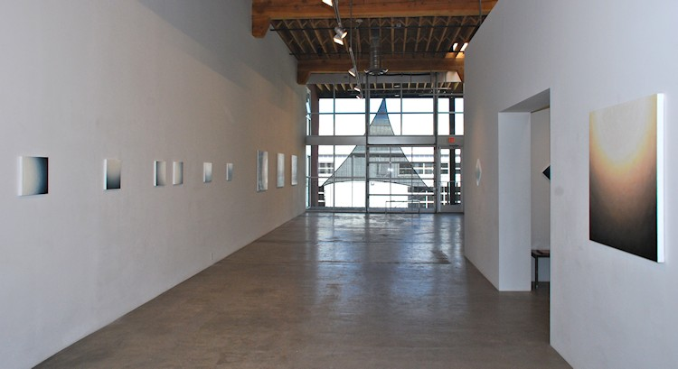

June 1 - June 30, 2012
Artist Statement:
The body of work featured in the exhibition, poems and more, continues my ongoing exploration of painting as process and meditation.
Luminosity has been central to my work with its various fluctuations of waves that offer constant change. These streams of light/dark offer infinite possibilities for reflection within embodied form. The partial circle also reflects light and appears to continue into space beyond the confines of the canvas.
The small paintings called “poems” represent the most intimate experience. The larger paintings allow more space to enter. The square shapes suggest equilibrium and equanimity. The diamond shapes move dynamically. All are different ways to give form to the formless.
Joan Watts 4-2012
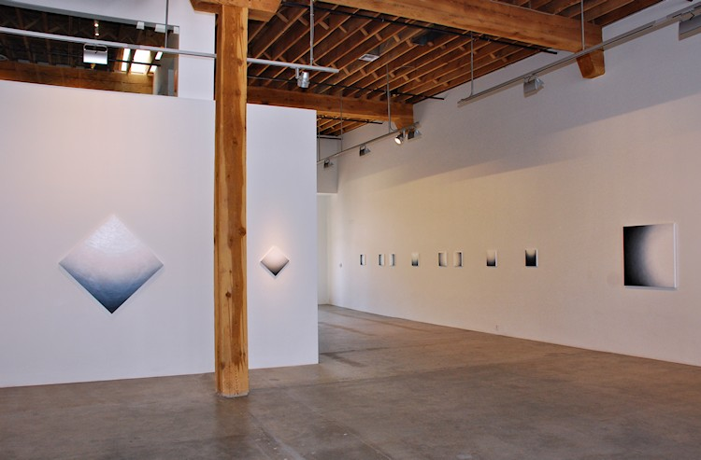
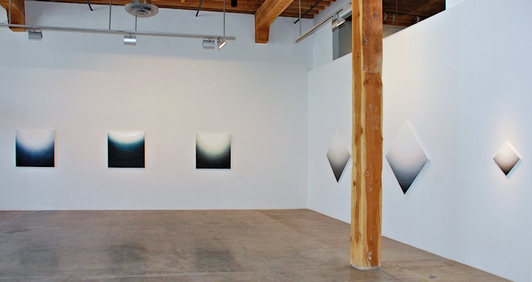

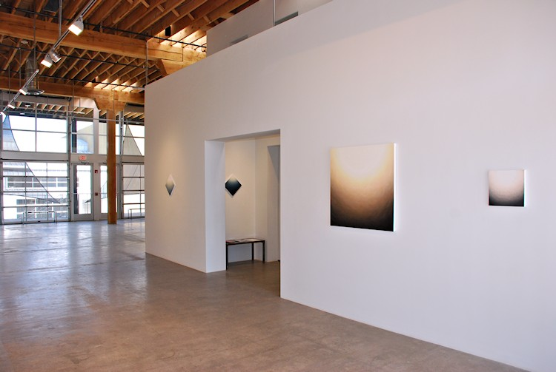
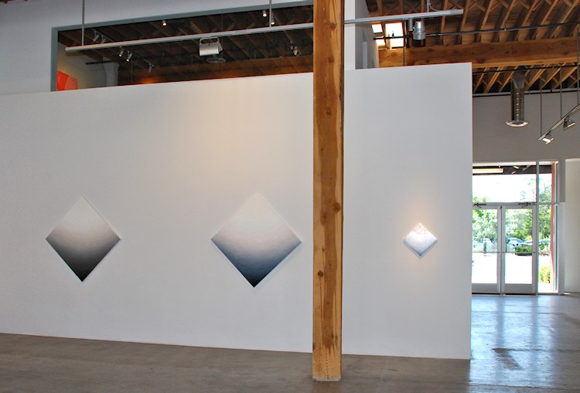
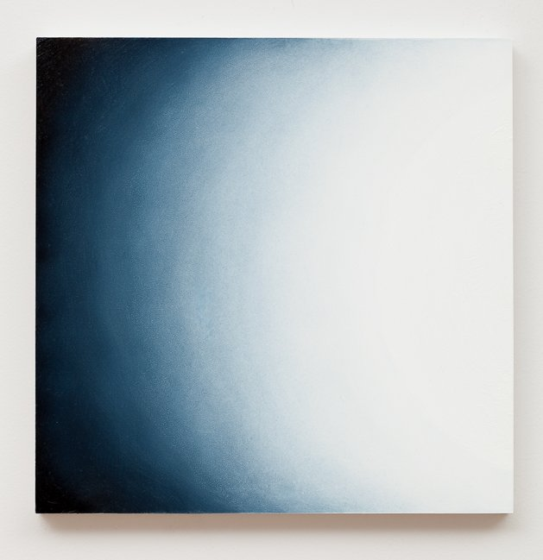
poem 3, 2010
oil on board
12 x 12 inches
JW071

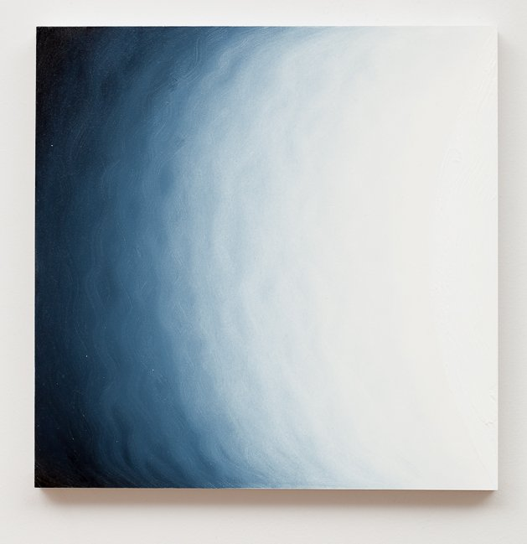
poem 17, 2011
oil on board
12 x 12 inches
JW082
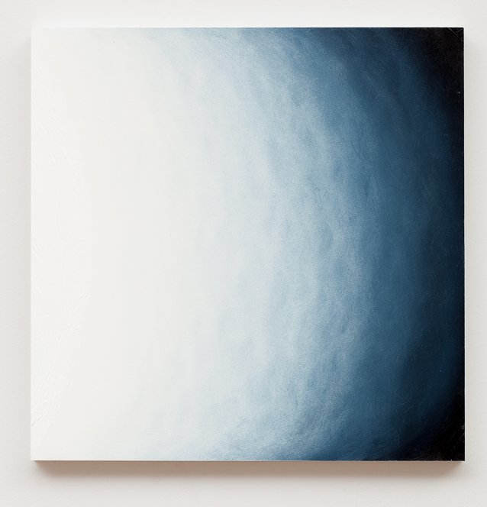
poem 18, 2011
oil on board
12 x 12 inches
JW083

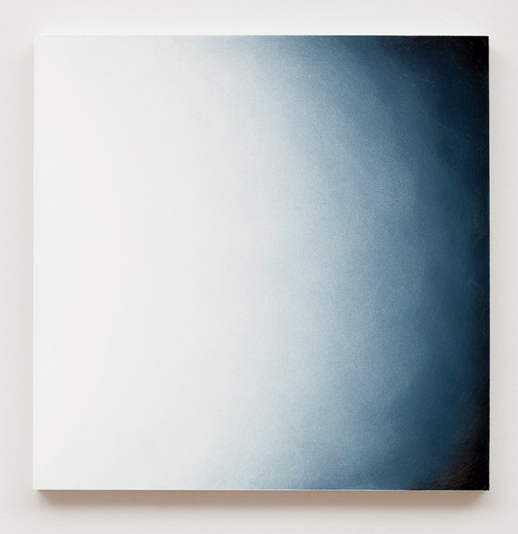
poem 2, 2010
oil on board
12 x 12 inches
JW070
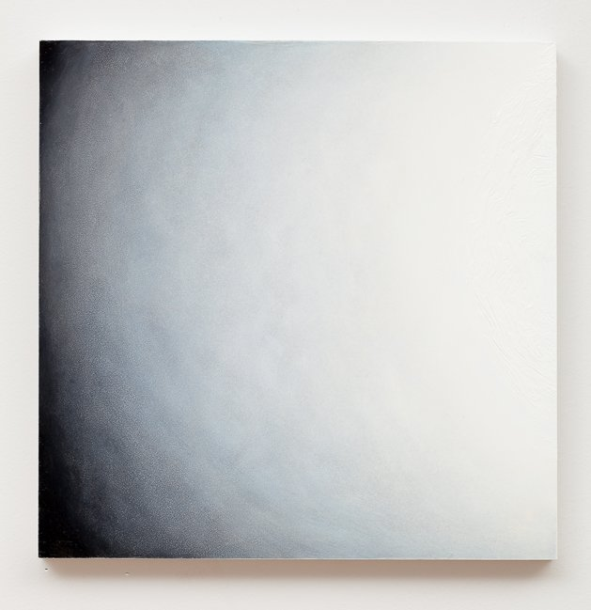
poem 4, 2010
oil on board
12 x 12 inches
JW072

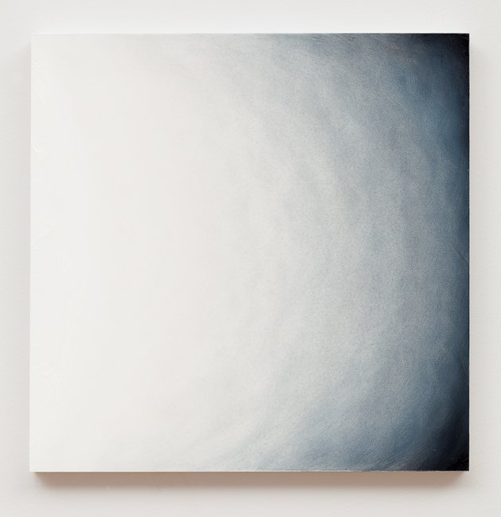
poem 5, 2011
oil on board
12 x 12 inches
JW073
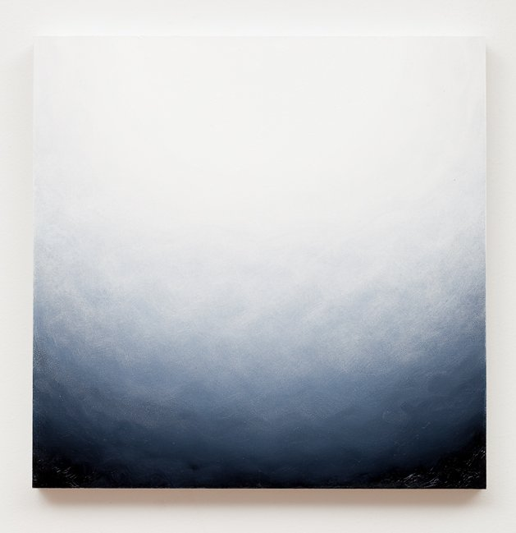
poem 1, 2010
oil on board
12 x 12 inches
JW069

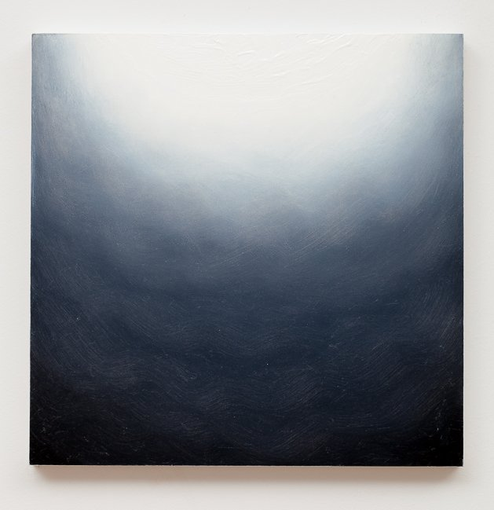
poem 7, 2011
oil on board
12 x 12 inches
JW075
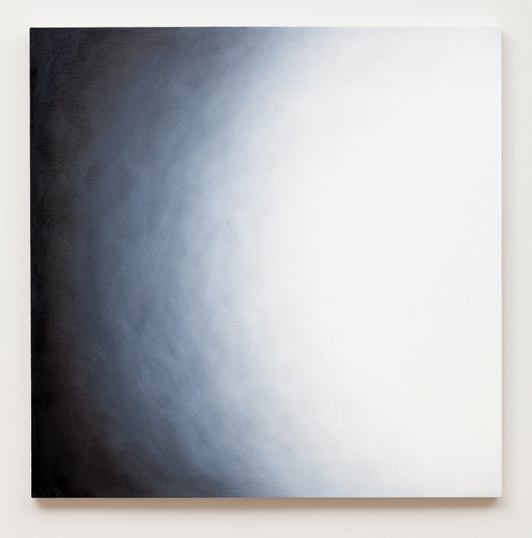
Untitled 19, 2010
oil on canvas
36 x 36 inches
JW064

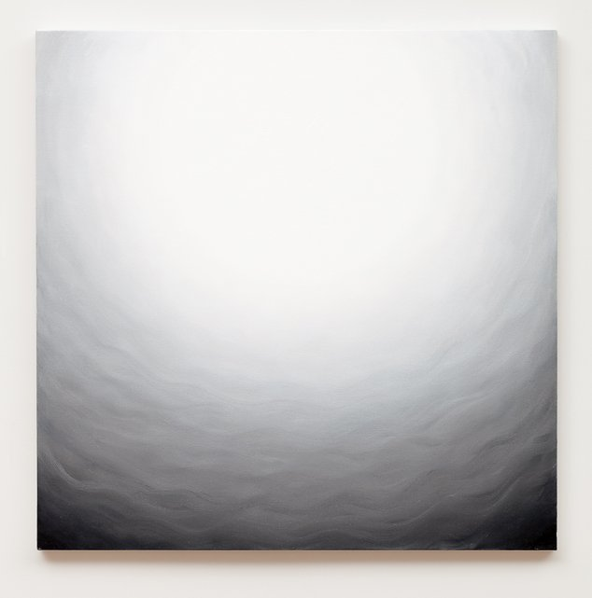
Untitled 18, 2010
oil on canvas
36 x 36 inches
JW063
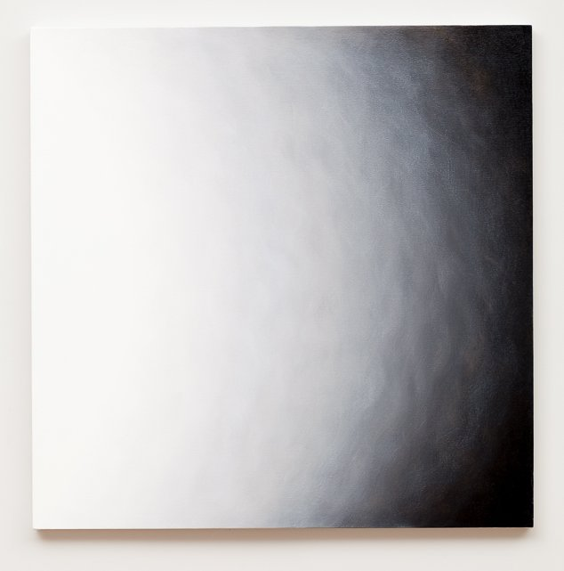
Untitled 17, 2010
oil on canvas
36 x 36 inches
JW062

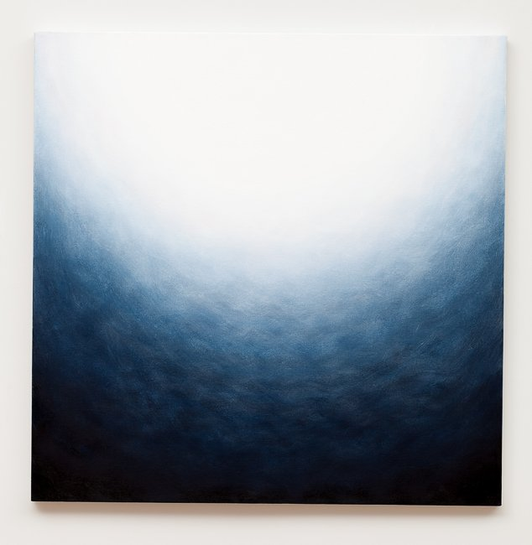
Untitled 21, 2011
oil on canvas
36 x 36 inches
JW066
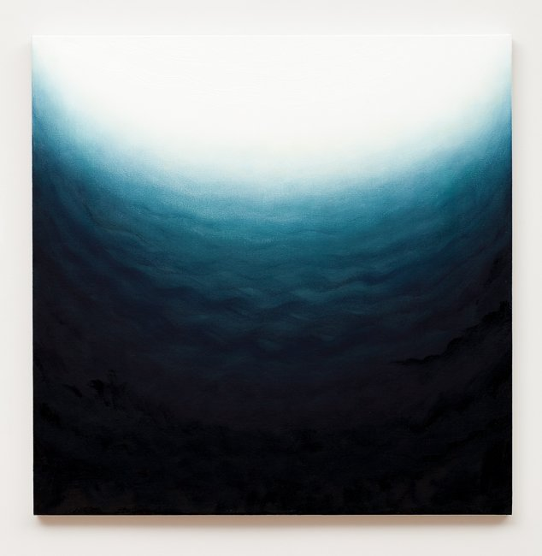
Untitled 23, 2011
oil on canvas
36 x 36 inches
JW068

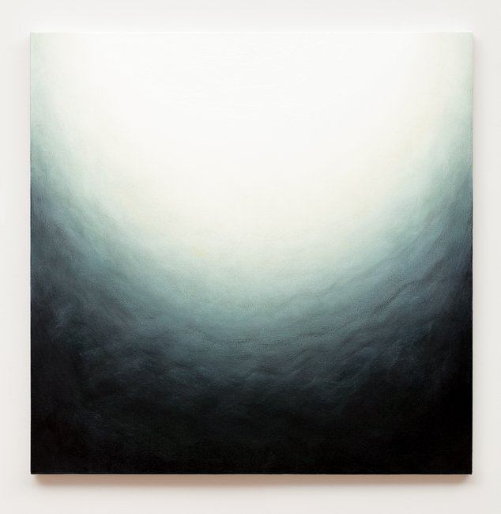
Untitled 22, 2011
oil on canvas
36 x 36 inches
JW067
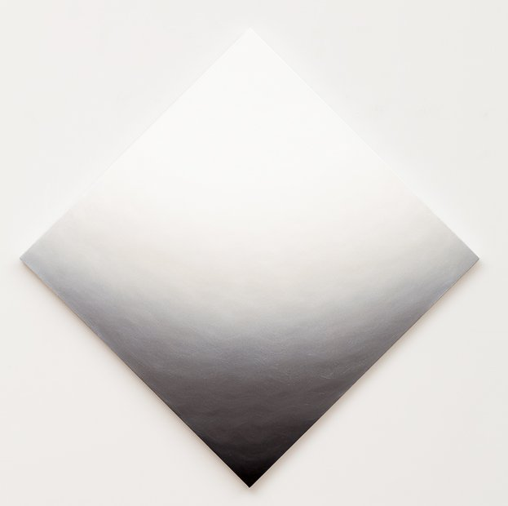
Diamond 1, 2010
oil on canvas
51 x 51 inches
JW059

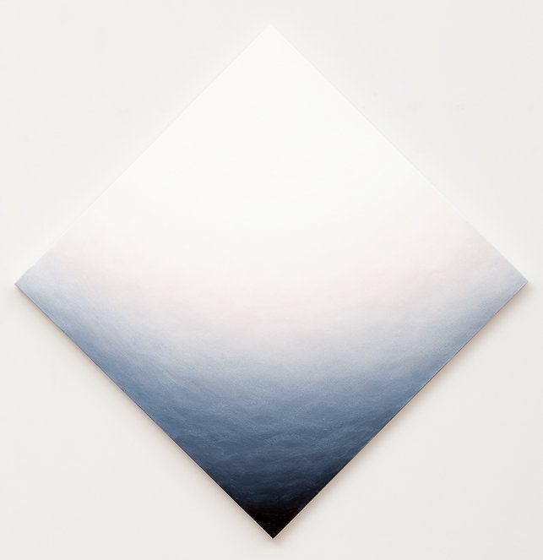
Diamond 2, 2010
oil on canvas
51 x 51 inches
JW060
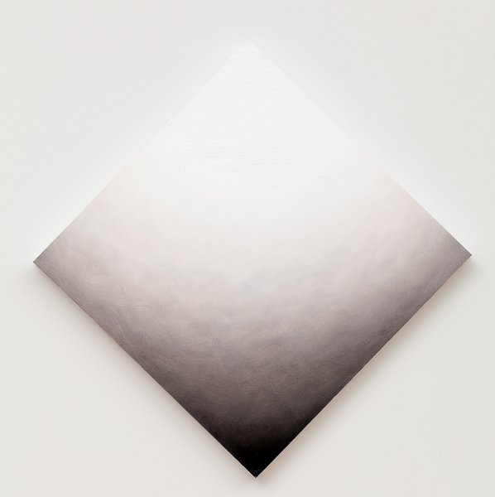
poem 13, 2011
oil on board
17 x 17 inches
JW086

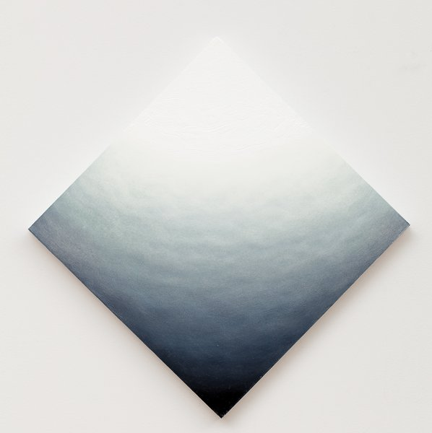
poem 16, 2011
oil on board
17 x 17 inches
JW087
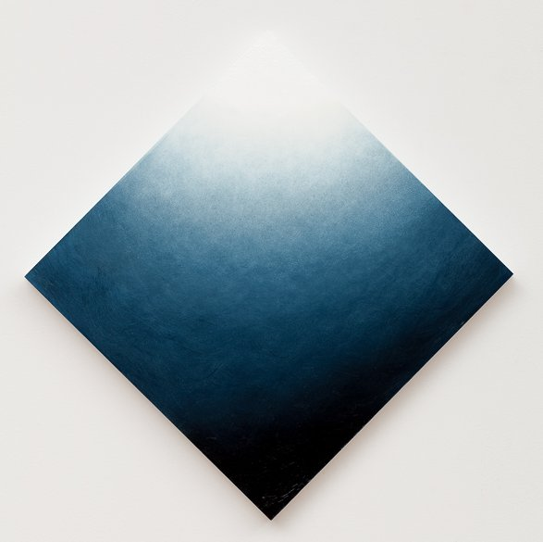
poem 19, 2011
oil on board
17 x 17 inches
JW088

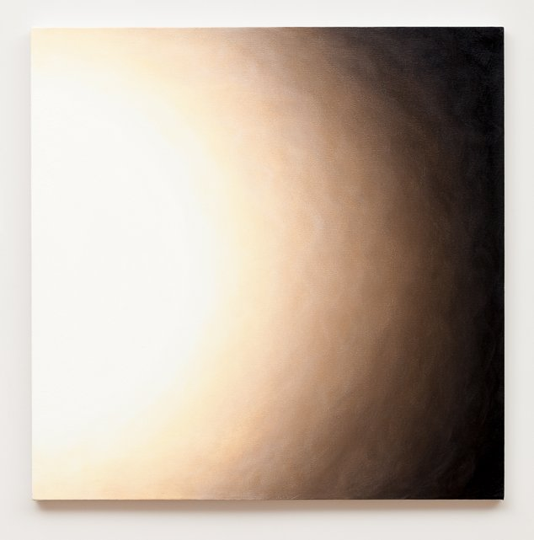
Untitled 20, 2010
oil on canvas
36 x 36 inches
JW065
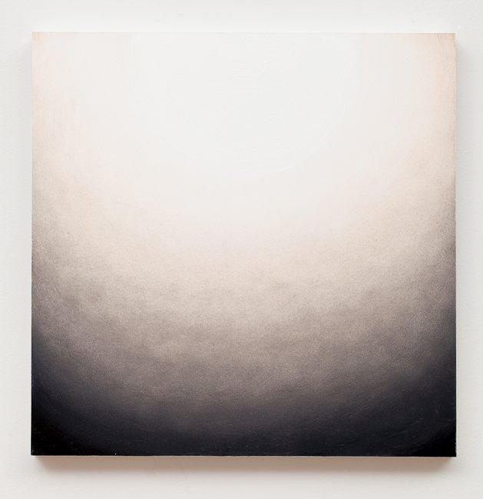
poem 11, 2011
oil on board
12 x 12 inches
JW078

© 2012

Charlotte Jackson Fine Art, Inc.

In the Railyard at:

554 S. Guadalupe, Santa Fe, New Mexico 87501
Telephone: 505.989.8688 Fax: 505.989.9898
cjfa@charlottejackson.com - www.charlottejackson.com

