CHARLOTTE JACKSON FINE ART PRESENTS:

JAMES HOWELL: Survey

June 3 - June 30, 2011

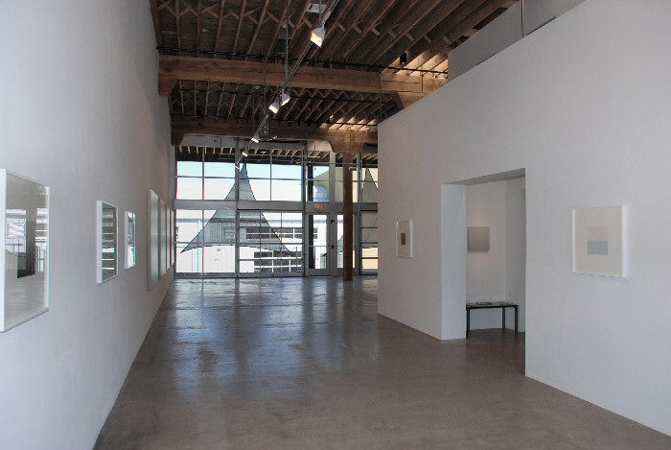
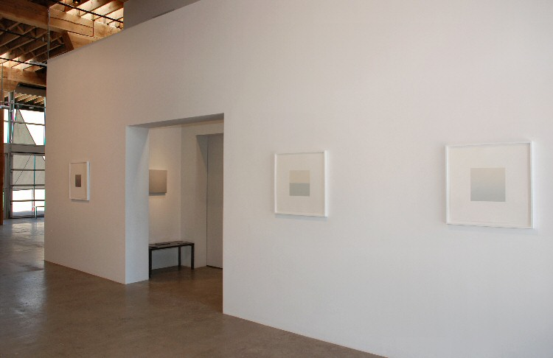

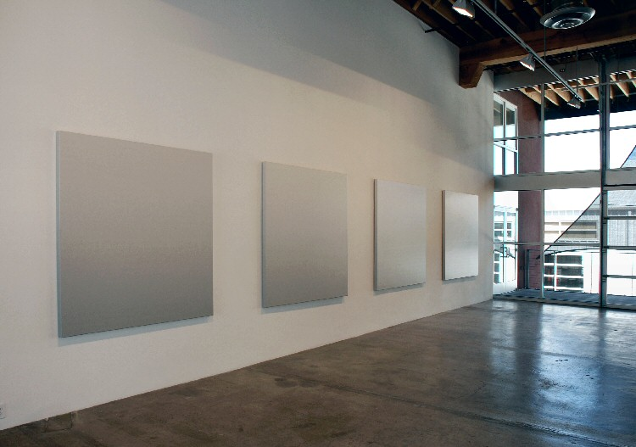
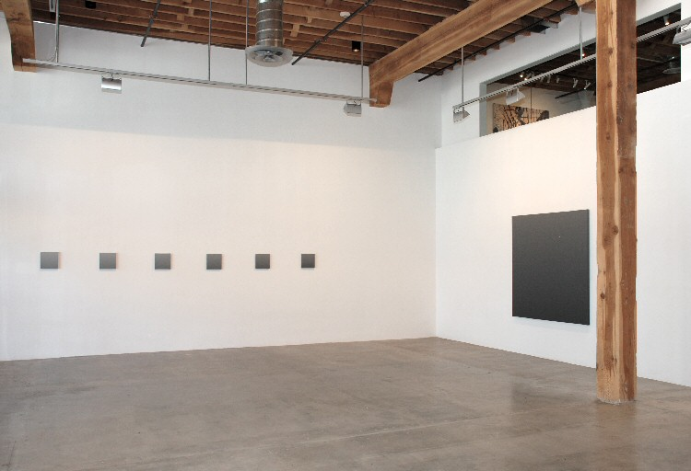

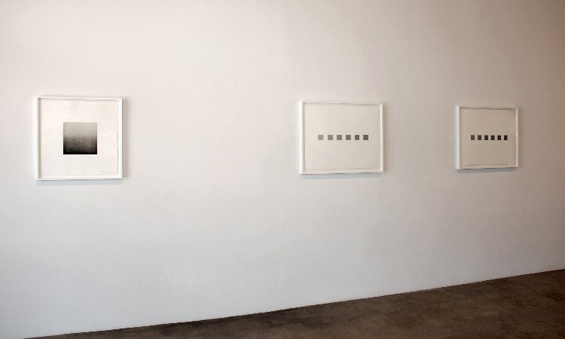
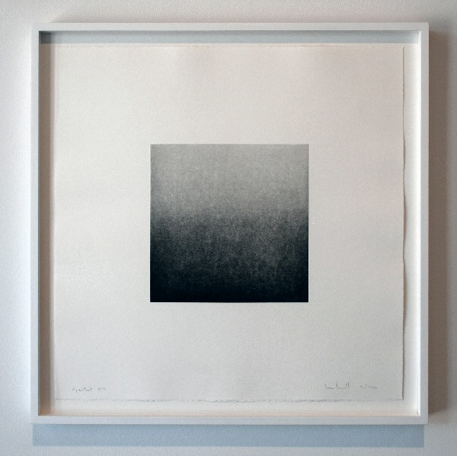
Aquatint 6/10 Nov. 1990, 1990
Aquatint- steel plated zinc plate;
Rives BFK hwt paper 22 x 22 in. Framed: 25 x 25 in. Image Size: 10 x 10 in.
JH0018
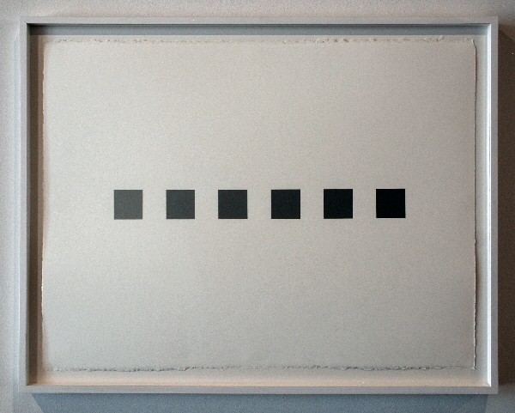
71.68-88.84 09 Sept. 2010, Progression Tops, 2010
Acrylic on Lanaquarelle hp 640 G/m2 paper
Framed: 25 x 32 in.
Image Size: 23.5 x 30 in.
Signed on Verso: 88.84
85.01 to 71.68
JH0020
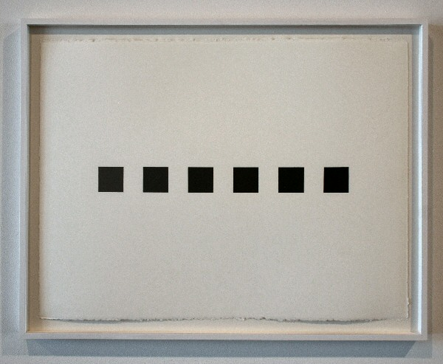
71.68-88.84 24 Oct. 2010, Progression Bottoms, 2010
Acrylic on Lanaquarelle hp 640 G/m2 paper
Framed: 25 x 32 in.
Image Size: 23.5 x 30 in.
Signed on Verso: 88.84
85.01 to 71.68
JH0021
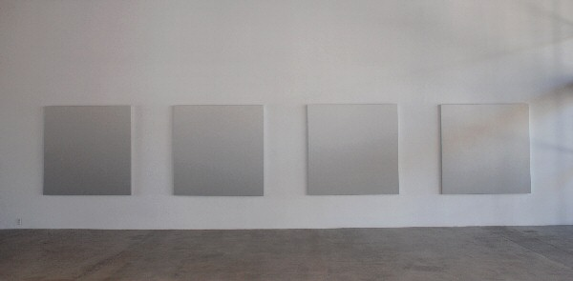
93.47-96.66 10 Nov. 2001, Four-Part Progression, 2001
Acrylic on CVI Canvas
Four Canvases, 66 x 66 in. each
JH0025

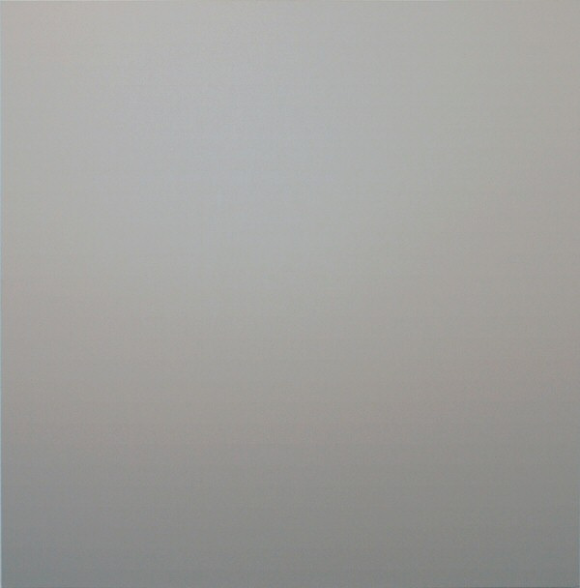
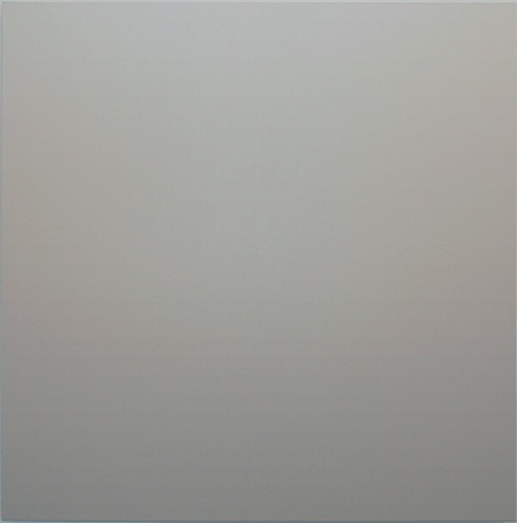
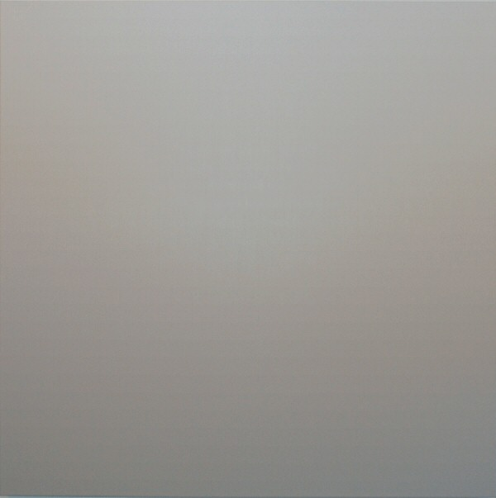
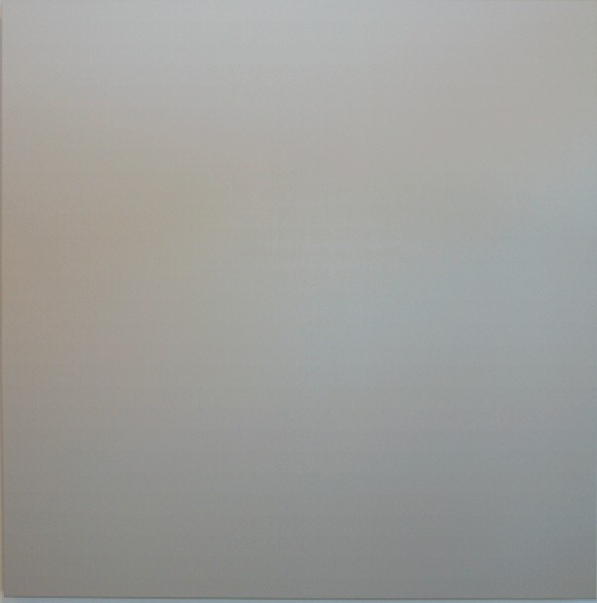
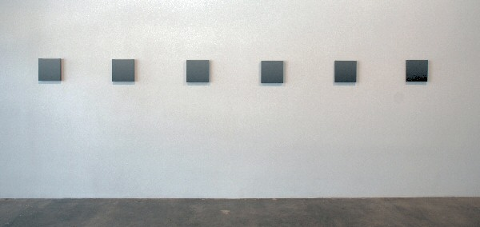
49.16-67.46 21 Dec. 2006- 6 Part Progression, 2006
Acrylic on Canvas
10 x 10 x 1.15 in. each
JH0026
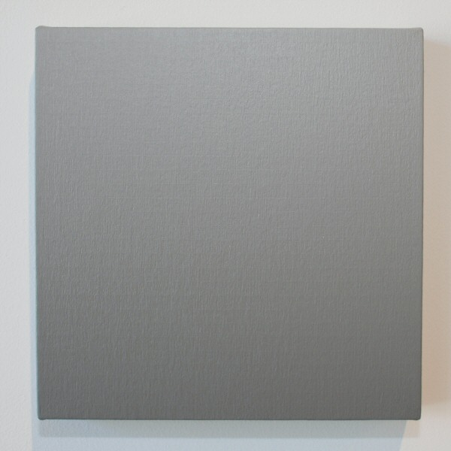
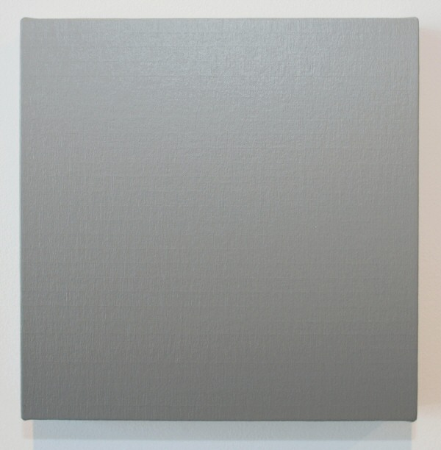
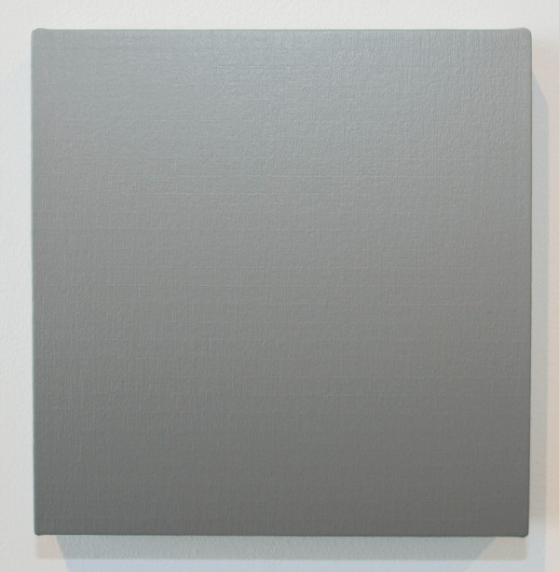
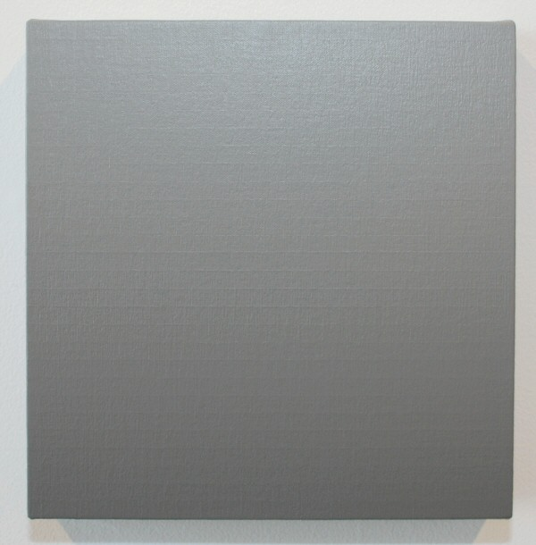
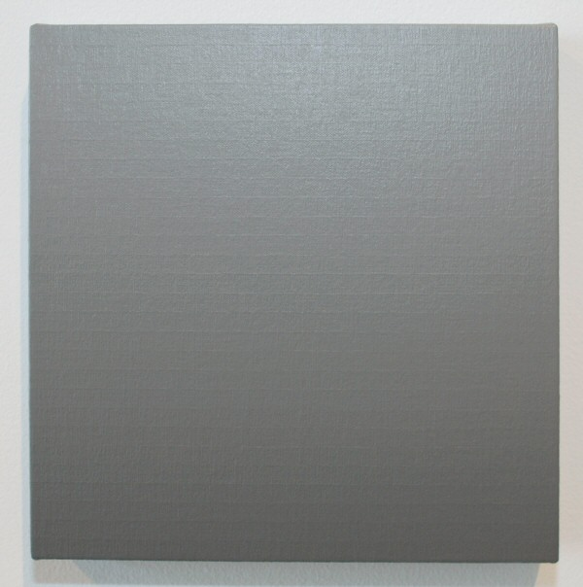
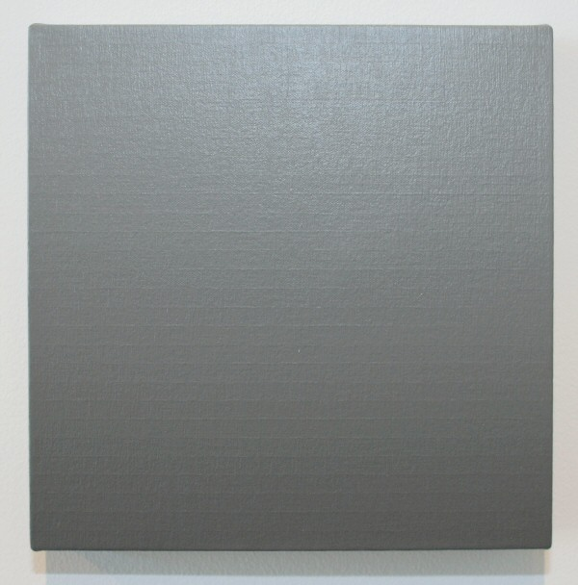
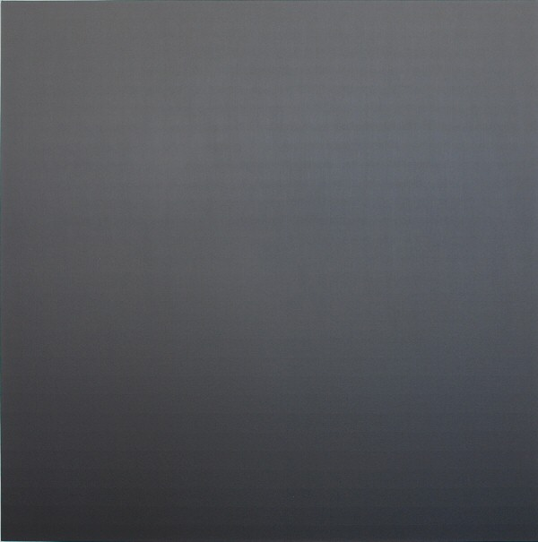
33.25 11 June 2000, 2000
Acrylic on CVI Canvas
66 x 66 x 2 inches
JH0027
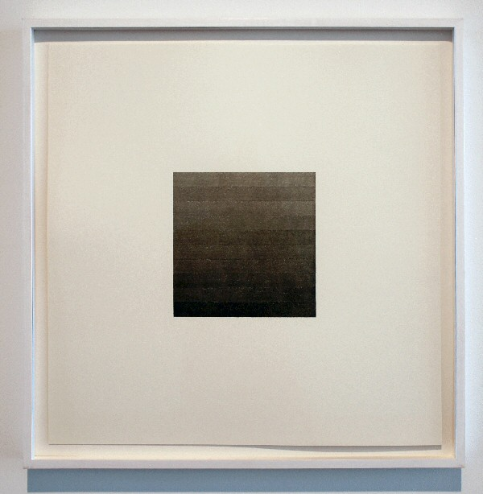
Ink Gradation 14 June 2003, 2003
Ink and Water, Lanaquarelle 22 x 22 in.
Framed: 25 x 25 in.
Image Size: 8 x 8 in.
Signed on Verso: Ink/ 10 water start 50 gms to 134.76 gms
JH0022
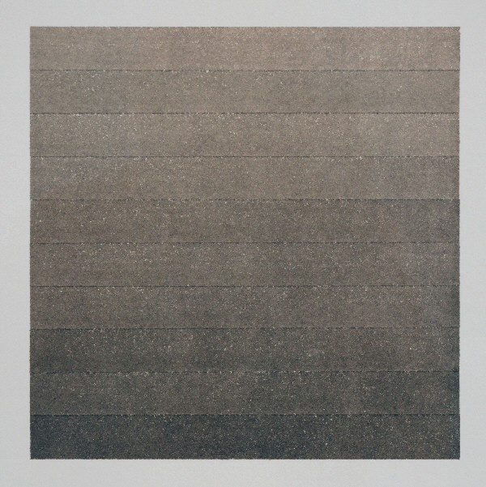
Detail View
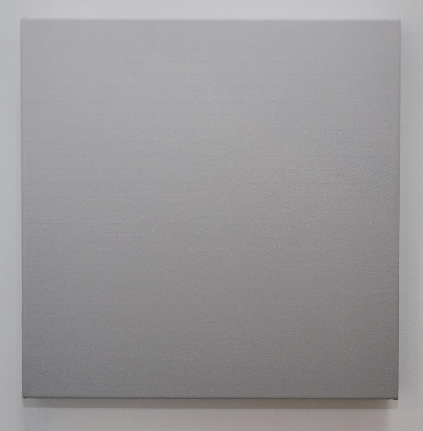
Ink Gradation 14 June 2003, 2003
Ink and Water, Lanaquarelle 22 x 22 in.
Framed: 25 x 25 in.
Image Size: 8 x 8 in.
Signed on Verso: Ink/ 10 water start 50 gms to 134.76 gms
JH0022
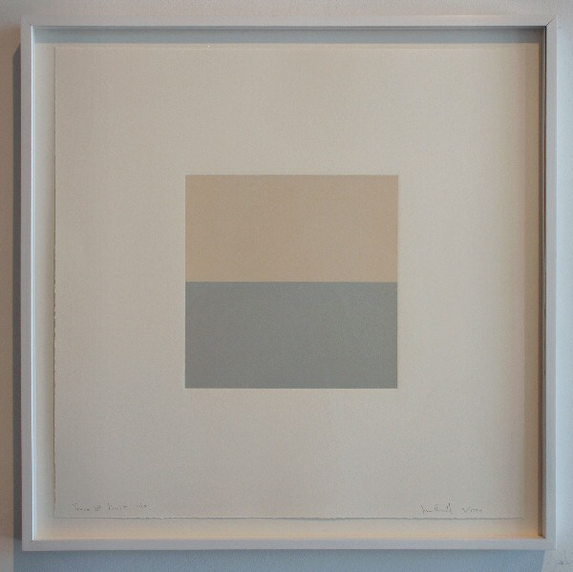
Trace III Limit 1/10 Sept. 1990 (pictured on right-top & bottom of blend)
Trace III 1/10 Sept. 1990 (pictured on left-blend), 1990
Monotype- Lithograph Ink; Rives BFK hwt paper 22 x 22 in.
Framed: 25 x 25 in. each
Image Size: 10 x 10 in.
JH0019
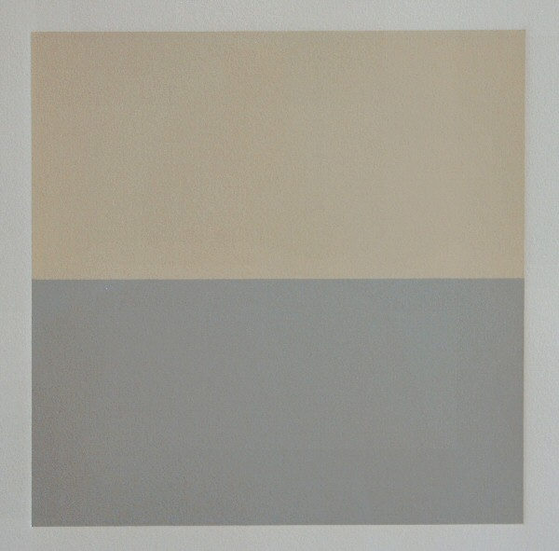
Detail View
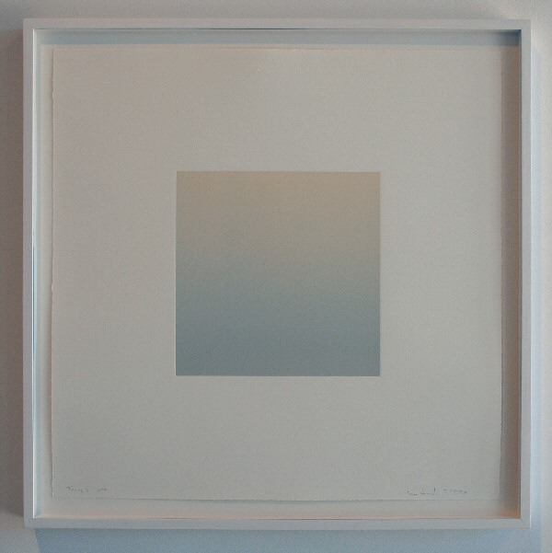
Trace III Limit 1/10 Sept. 1990 (pictured on right-top & bottom of blend)
Trace III 1/10 Sept. 1990 (pictured on left-blend), 1990
Monotype- Lithograph Ink; Rives BFK hwt paper 22 x 22 in.
Framed: 25 x 25 in. each
Image Size: 10 x 10 in.
JH0019
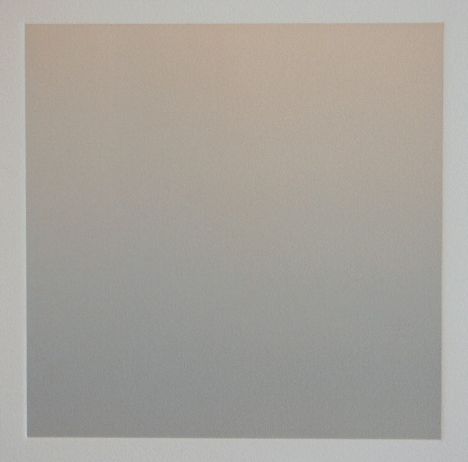
Detail View

© 2011

Charlotte Jackson Fine Art, Inc.

In the Railyard at:

554 S. Guadalupe, Santa Fe, New Mexico 87501
Telephone: 505.989.8688 Fax: 505.989.9898
cjfa@charlottejackson.com - www.charlottejackson.com

