CHARLOTTE JACKSON FINE ART
PRESENTS

FREDERICK HAMMERSLEY

PAINTINGS

March 13-April 10
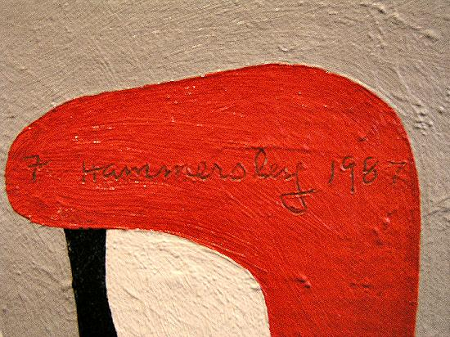

Opposites attract Frederick Hammersley. He speaks of a moment, much earlier in his life, when he realized that everything around him had to do with what he calls “the marriage of opposites.” Far more than a passing philosophical fancy, this observation was to provide the basis for an approach to painting in which contrasting colors and mirror-image or interlaced geometric forms lead the viewer to examine the way opposites interact.
Hammersley is quick to point out that this approach is not an intellectual one. Rather, intuition determines the entire content of his paintings. Trained in the classical tradition, Hammersley’s mastery of drawing and eye for color are so developed that they appear instinctive, and he notes that technical considerations rarely play a conscious role in making a painting. He describes the process as a series of discoveries about what is “right” for the next step. Until he can see the next color, the next shape, he waits. When the right color/form appears with certainty in his mind’s eye, down it goes on the canvas. After that, changes are rarely necessary.
One is reminded of Charlie Parker’s admonition: “First master your instrument. Then forget all that **** and just play.” Hammersley’s virtuosity as a draftsman and colorist allow him to approach painting with a sense of joy and playfulness that is palpable to the viewer of his work. Colors talk back to each other; forms lead the viewer’s eye on a merry chase. His whimsical titles ("Likewise," "All in Favor," "Company Policy," etc.) reinforce the sense that serious work need not be ponderous, preachy or self-consciously intellectual.
This is not to say that Hammersley’s paintings lack emotional depth. On the contrary, these seemingly simple, direct geometric forms and straightforward colors carry a clear sense of emotional intensity to the viewer, inspiring a California critic to refer to Hammersley’s hard edge paintings as “emotional works that wear the clothes of classical restraint.”
Hammersley’s work has been exhibited throughout the United States (including the Museum of Modern Art and the Whitney in New York, and the Corcoran in Washington DC); his education included the Jepson Art School and Chouinard in Los Angles, and the Ecole des Beaux Arts in Paris. His distinguished teaching career included Jepson, Chouinard, Pomona College and the University of New Mexico. A self-described “Westerner by birth and by choice,” he currently resides in Albuquerque.
Work in the upcoming exhibition at Charlotte Jackson Fine Art will include examples of Hammersley’s hard edge paintings (familiar to those who saw his work in the 2001 SITE Santa Fe biennial, curated by Dave Hickey) and his “organic” paintings, which feature non-geometric (“biomorphic”) shapes and more complex colors.
MAIN GALLERY:

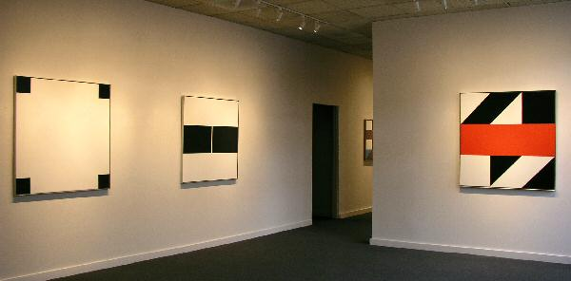

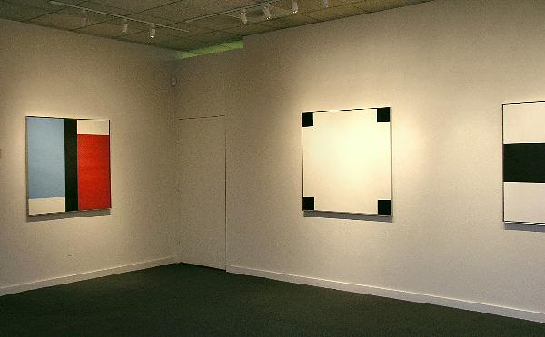
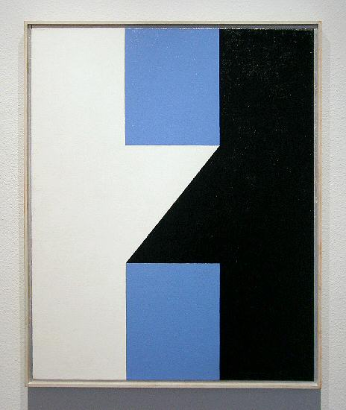
JOIN, #11, 1961
Oil on linen, 30” x 24”
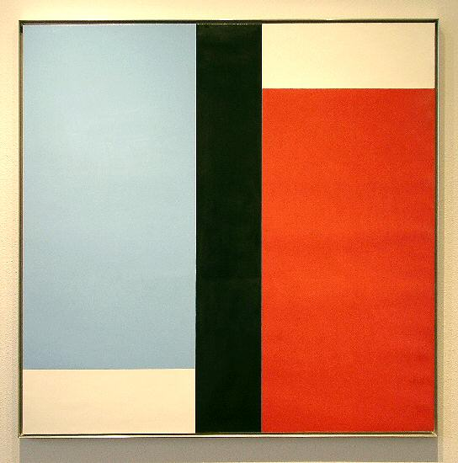
ADAM AND EVE, #2, 1970
Oil on linen on Masonite, 44” x 44”
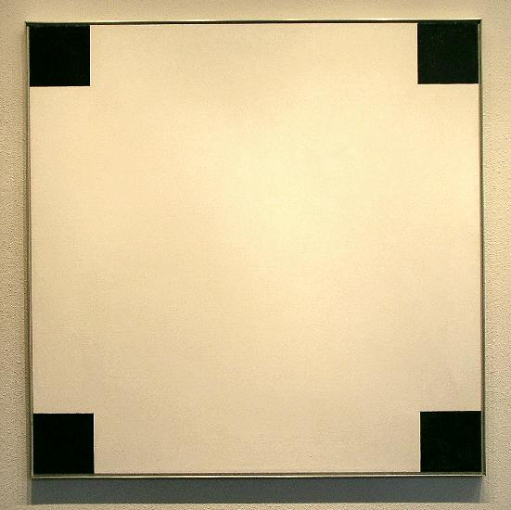
ADD LESS, #1,1966
Oil on linen, 44” x 44”
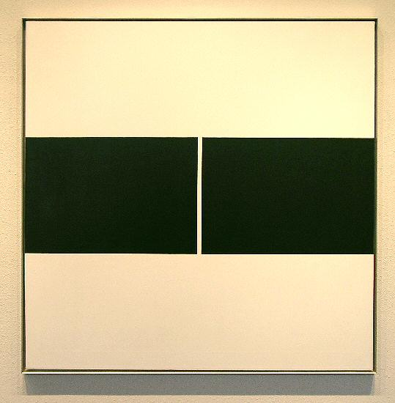
DO YOU DO, #6, 1970
Oil on linen, 44” x 44”
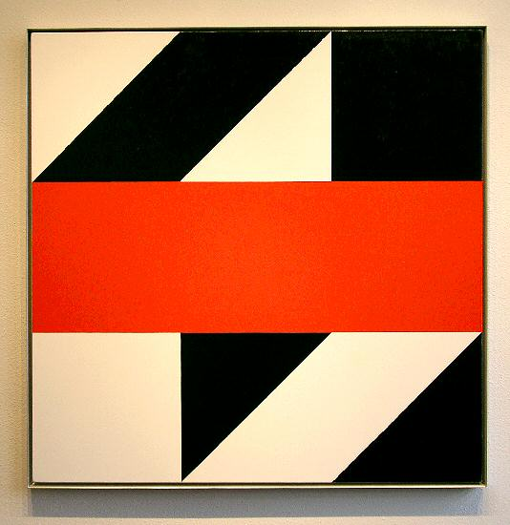
COME PAIR, #1, 1979
Oil on linen, 45” x 45”
HALLWAY:

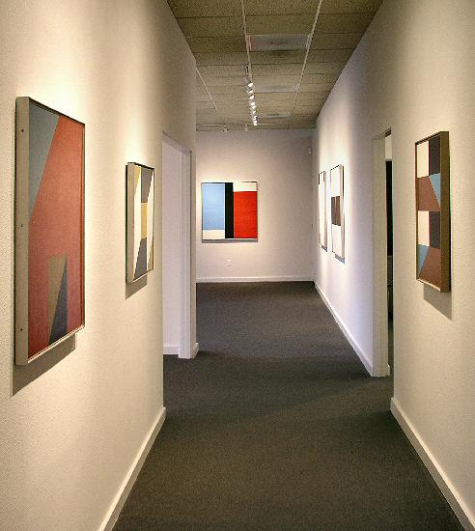
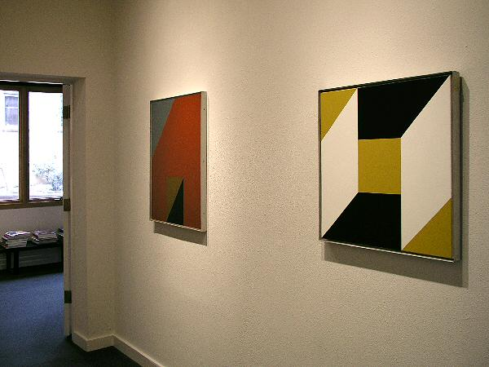

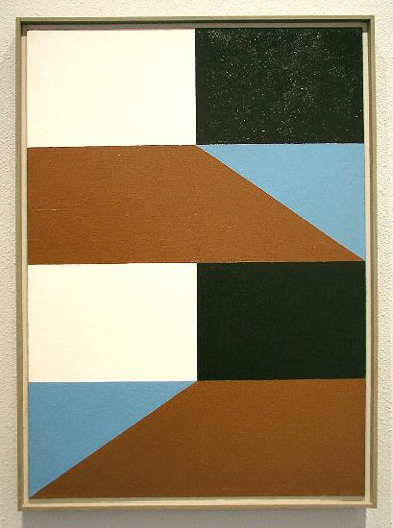
SAME CHANGED, #14, 1960
Oil on linen, 30” x 21 ”
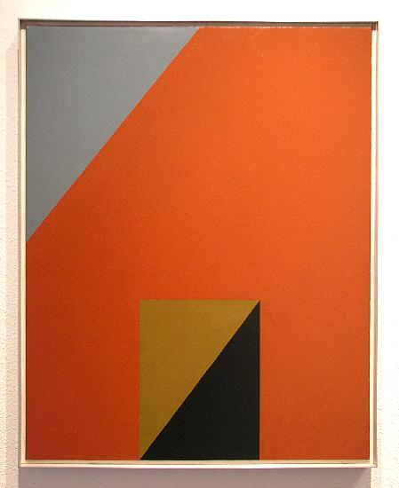
BESIDE, #7, 1962
Oil on linen, 30 ” x 24 ”
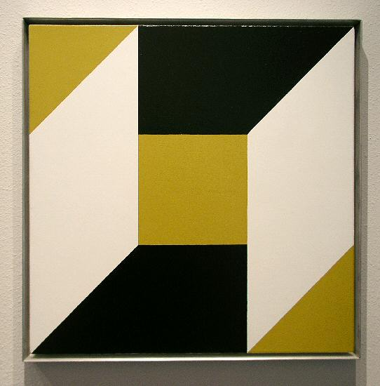
BATTERY INCLUDED, #9, 1992
Oil on linen, 24” x 24”
GALLERY II:

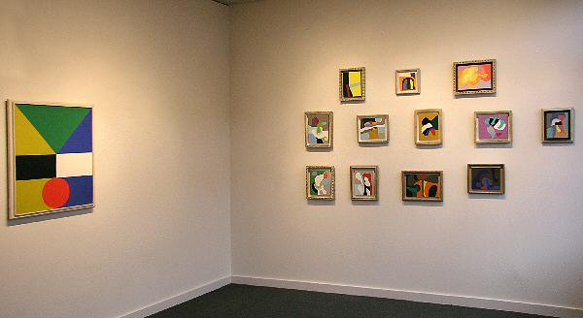

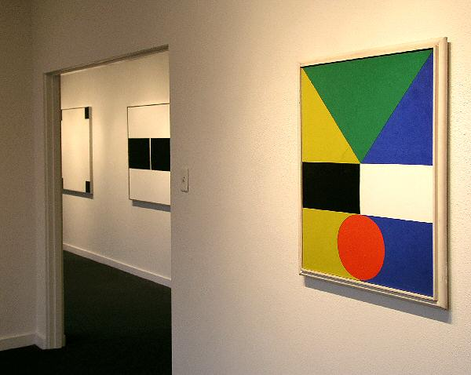
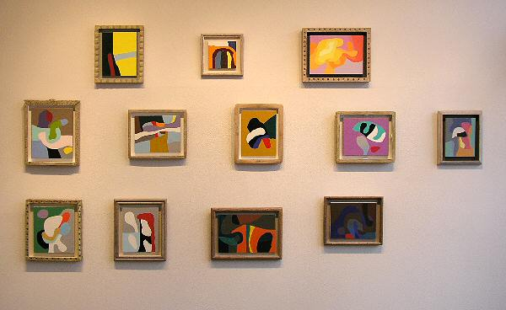

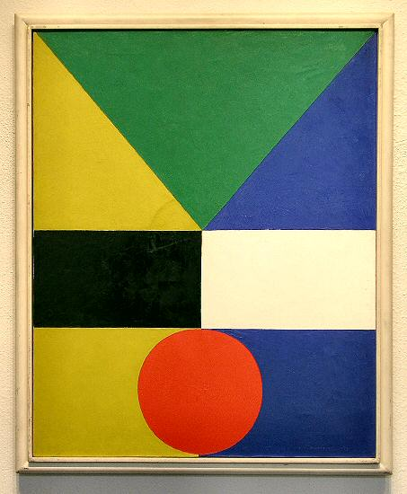
OPPOSING, #15,1959 (finished Aug 3, 1959)
Oil on linen, 30” x 24”
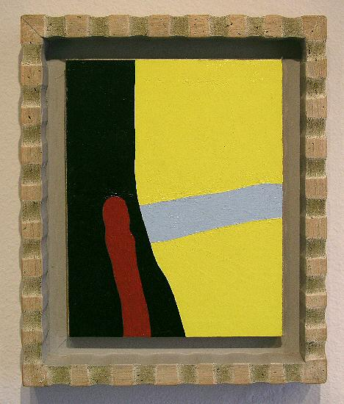
ONE ON ONE, #17, 1987
Oil on rag paper on linen on wood, 9 ½ ” x 7 ½ ”
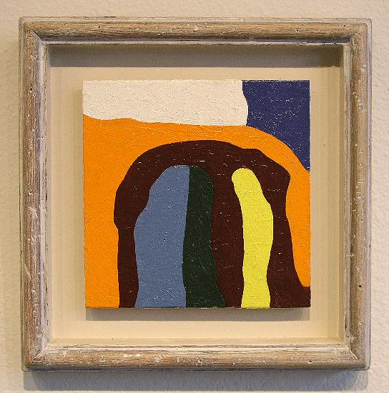
ANNIVERSARY, #4, 1985
Oil on 3 ply birch, 6” x 6”
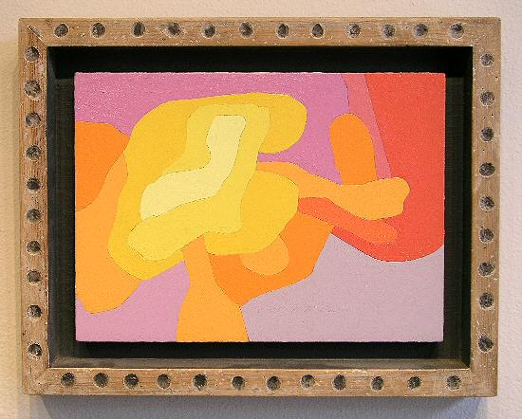
FAMILY TREE, #2, 1991
Oil on linen on 3 ply oak, 8 3/8 ” x 11 ½ ”
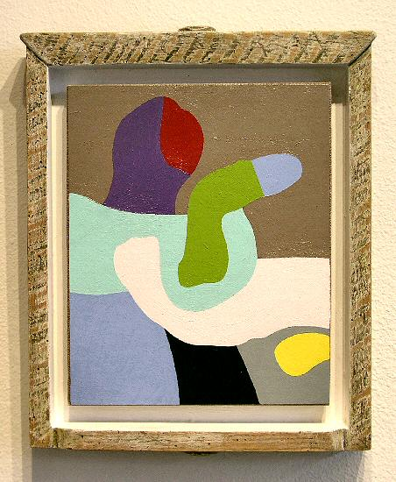
NEW MEMBER, #7, 1989
Oil on rag paper on linen, 11” x 9”
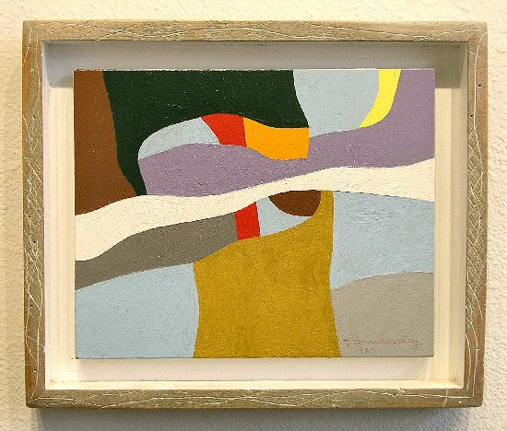
ONE ON ANOTHER, #9, 1986
Oil on hard wood, 8” x 10”
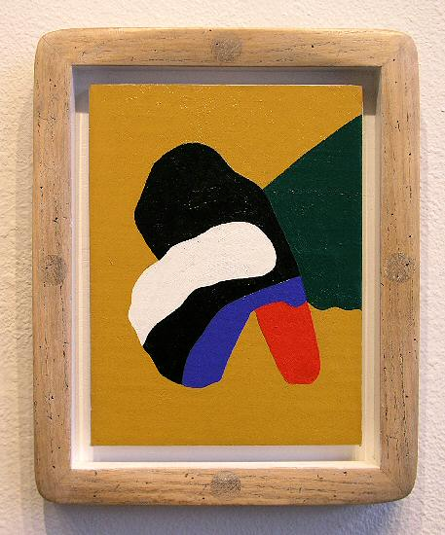
HAND AND GLOVE, #15, 1987
Oil on rag paper on linen, 10” x 7 ½ ”
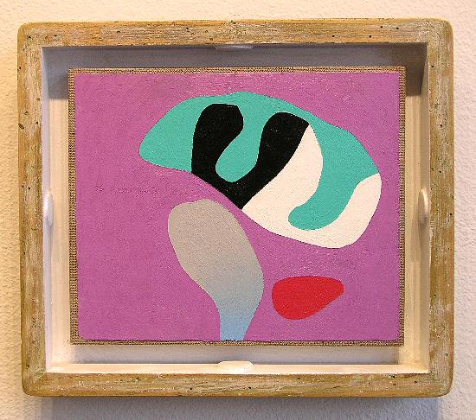
STEAK AND ALE, #6, 1989
Oil on rag paper on linen, 8” x 9 5/8 ”
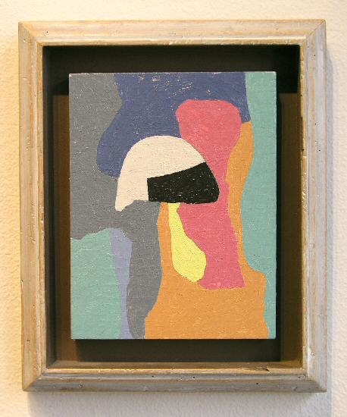
UNDERWATER, #14, 1984
Oil on oak, 8 ½” x 6 ½”
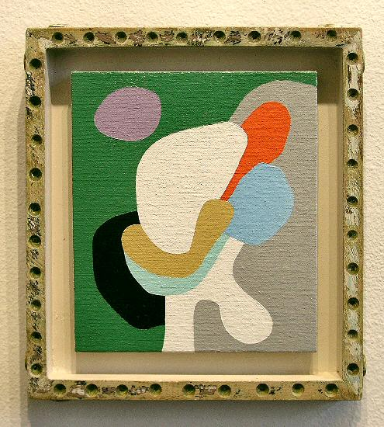
SPIT AND POLISH, #2, 1989
Oil on linen on birch ply, 10 1/8” x 8 7/8”
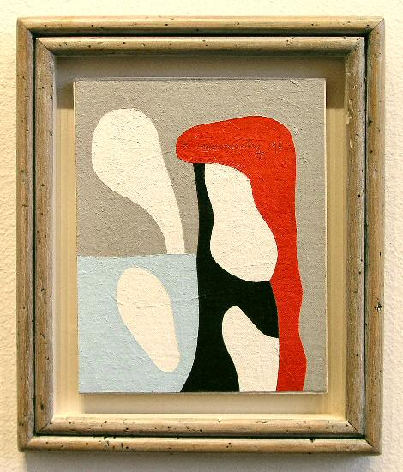
FOUR WAYS, #18, 1987
Oil on linen on Masonite, 9 7/8” x 7 7/8”
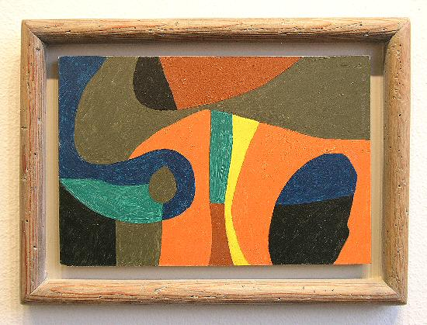
THURSDAY, #7, 1984
Oil on 3 ply wood, 8 ½” x 12 ½”
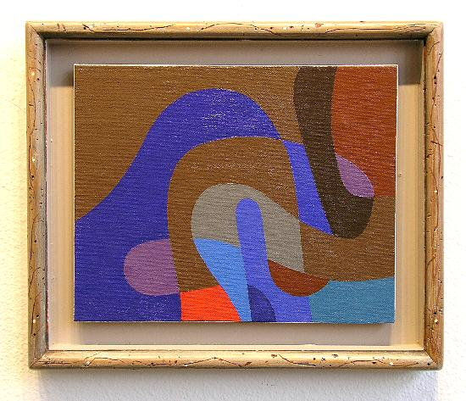
RHYMING, #12, 1986
Oil on linen on Masonite, 7 7/8” x 10”
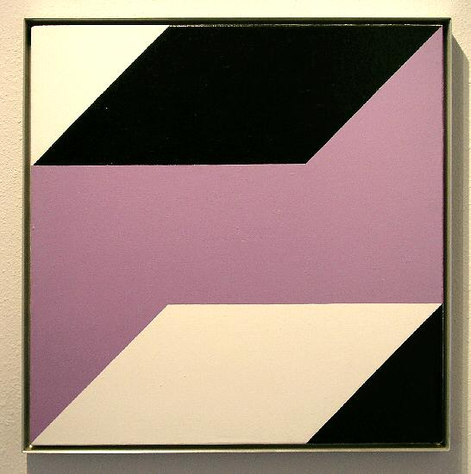
TURN OF MIND, #3, 1981
Oil on linen, 24” x 24”
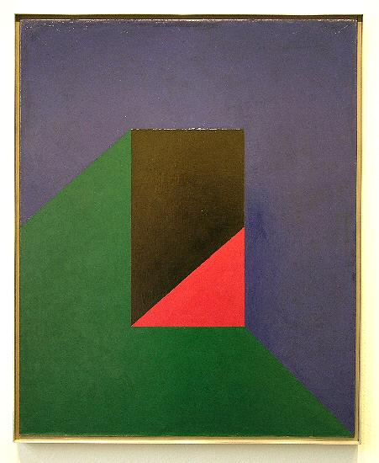
TOWARD, #17, 1961
Oil on linen, 30” x 24”
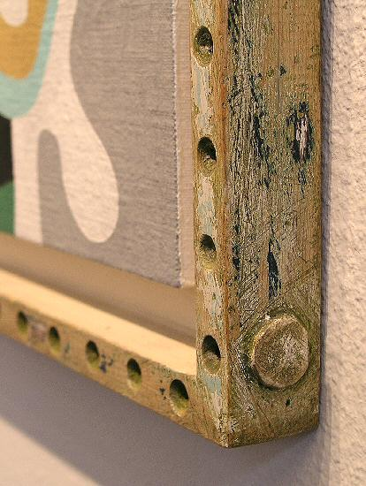
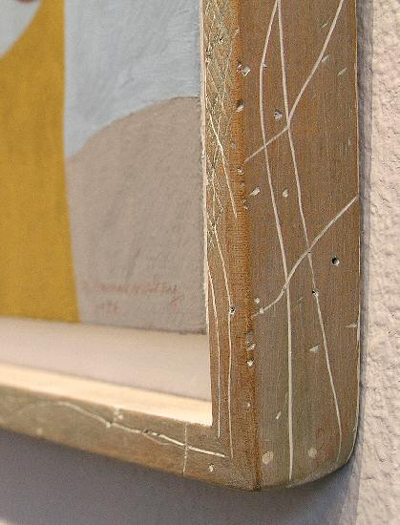
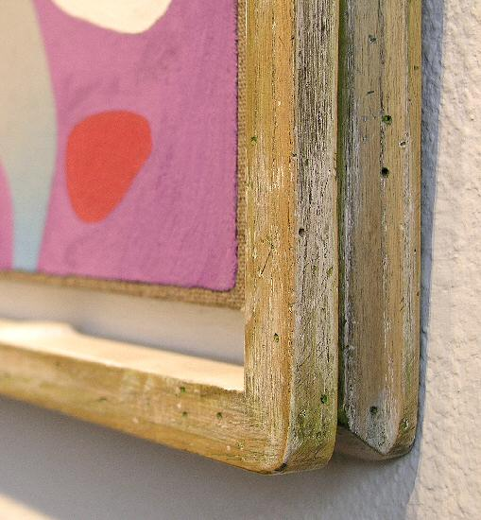
ADDITIONAL WORKS:

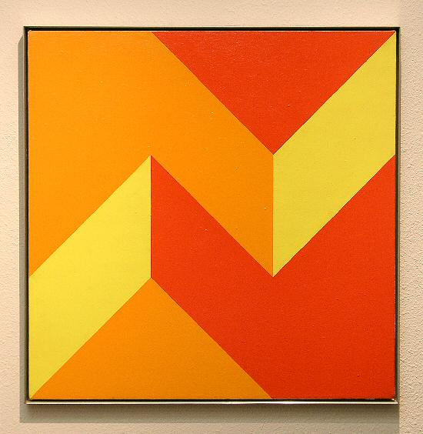
Oath of Office, #6, 1973
Oil on linen, 30” x 30”
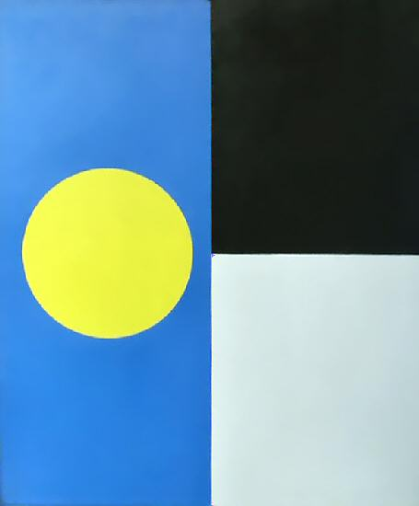
Side With, #6, 1962
36" x 30", oil on linen
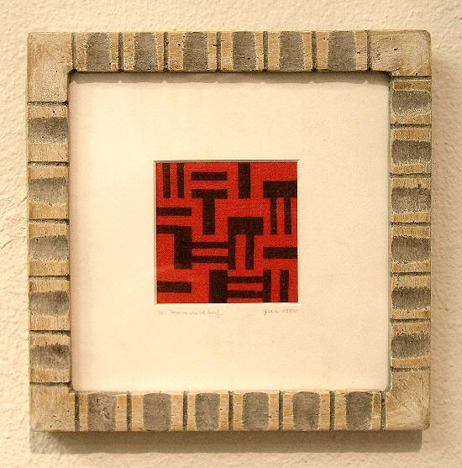
Act One, 15 January, 1950
Lithograph, 3” x 3”
FREDERICK HAMMERSLEY 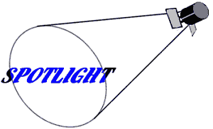

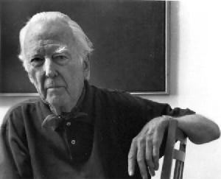

"Painting is just like living. After you make the first move, every other move is related to it," Frederick Hammersley once remarked. In his life, as in his work, one thing has just seemed to lead to another. He describes the beginning of his artistic career, when he was still in his teens, as a stint painting signs for a movie theater, for the princely sum of a dollar for an afternoon's work. After he received encouragement for this work, art school was the logical next step.
Hammersley subsequently attended Chouinard and Jepson in Los Angeles, and the Ecole des Beaux Arts in Paris, with time out in between to run the art department of the Information and Education Section Office of Military Government in Frankfurt and Berlin, during and immediately following World War II. The combination of classical art training and the opportunity to study at first hand the great works housed in the museums of Europe developed both his hand and his eye. It only remained for Hammersley to find his own individual vision. "I was painting art school studies, but I didn't really know why. At a certain point I just couldn't do it any more."
The resolution to this dilemma came about quite by accident, to hear Hammersley tell it. In fact it was a prime example of his willingness and ability to wait for the next "move" to appear, and to grasp the opportunity when it arose. He had decided to paint a self-portrait and had divided the canvas into 16 rectangles as a basis for the composition. Then, as he considered the next step, a solid blue shape presented itself to his mind as the "right" thing for one of the rectangles -- a shape and color having nothing to do with the painting of his face that he had planned. He vacillated, unsure of which course to pursue, but ultimately decided to paint the square as he saw it in his imagination. As soon as the new shape and color (or colorform, as the elements in his paintings later came to be called) were down on the canvas, an adjacent square attracted his attention. With less hesitation, he followed his impulse and filled in the "right" color and shape; before long, the empty canvas had become a painting and Hammersley had found the direction he had been seeking.
This direction has provided a rich field of inquiry. Hammersley has been particularly interested in resolving oppositions between contrasting colors and shapes. In pursuing this goal, he has developed a process that involves a notebook of initial ideas with rudimentary drawings and another notebook with more detailed drawings of ideas that appear promising; these notebooks are in themselves works of art. Once he has settled on an idea, Hammersley applies one colorform at a time to the canvas, waiting as long as it takes for the next one to appear clearly in his imagination as "right" for the painting. He calls these "hunch paintings" and compares the process to the structure of a pinecone, in which the shape and placement of each element is dependent on those that surround it.
This analogy applies equally to the course of his career. By paying attention to the immediate next step in developing his art, Hammersley has created a body of work that has been exhibited in major museums and is represented in important collections. He takes it all in stride, confident that his intuition will continue to supply him with the right next move.
FREDERICK HAMMERSLEY

Born 1919 Salt Lake City, Utah

Education

1936-38 University of Idaho, Pocatello, ID
1940-42 Chouinard Art School, Los Angeles, CA
1945 Ecole des Beaux Arts, Paris, France
1946-47 Chouinard Art School, Los Angeles, CA
1947-50 Jepson Art School, Los Angeles, CA

SOLO EXHIBITIONS

2000 Visual Puns and Hard-Edge Poems, Laguna Beach Art Museum, Laguna Beach, CA
1999-02 I've Been Here All the While, L.A. Louver, Venice, CA
1999 Visual Puns and Hard-Edge Poems, University of New Mexico, Albuquerque, NM
1999 Visual Puns and Hard-Edge Poems, Museum of Fine Arts, Santa Fe, NM
1995 Modernism, San Francisco, CA
1993 The Mulvane Art Museum, Washburn University, Topeka, Kansas
1993 Richard Levy Gallery, Albuquerque, NM
1992 Owings-Dewey Fine Art, Santa Fe, NM
1990 Modernism, San Francisco, CA
1989-90 Paris, Berlin, Albuquerque, California State University, Northridge, CA
1989 Graham Gallery, Albuquerque, NM
1988 Statement 88, New Mexico State Fair, Albuquerque, NM
1987 Modernism, San Francisco, CA
1986 Hoshour Gallery, Albuquerque, NM
1984 Hoshour Gallery, Albuquerque, NM
1981 L.A. Louver, Venice, CA
1978 L.A. Louver, Venice, CA
1977 Middendorf/Lane Galleries, Washington, DC
1975 University of New Mexico, Albuquerque, NM
1969 University of New Mexico, Albuquerque, NM
1966 Hollis Galleries, San Francisco, CA
1965 Santa Barbara Museum of Art, Santa Barbara, CA
1963 La Jolla Art Museum, La Jolla, CA
Heritage Gallery, Los Angeles, CA
1962 California Palace of the Legion of Honor, San Francisco, CA
Occidental College, Los Angeles, CA
1961 Heritage Gallery, Los Angeles, CA
Pasadena Art Museum, Pasadena, CA

INVITATIONAL EXHIBITIONS

1998 Cedar Rapids Museum of Art, Cedar Rapids, IA
1993 The Mulvane Art Museum, Washburn University, Topeka, KS
Miniatures, Albuquerque Museum, Albuquerque, NM
1992 Miniatures, Albuquerque Museum, Albuquerque, NM
1991 Miniatures, Albuquerque Museum, Albuquerque, NM
1989-90 The Alcove Show, Museum of Fine Arts, Santa Fe, NM
1989 Roswell Museum and Art Center, Roswell, NM
1987 Artists Space Gallery, New York, NY
1986 Four Abstract Classicists, R.C. Erpf, Gallery, New York, NY
American Academy and Institute of Arts and Letters, New York, NY
1985-86 Potential Acquisitions, Museum of New Mexico, Santa Fe, NM
1980-81 Here and Now, 35 Artists in New Mexico, Albuquerque Museum, Albuquerque, NM
1977 35th Biennial, Corcoran Gallery of Art, Washington, DC
Private Images: Photographs by Painters, L.A. County Museum, Los Angeles, CA
California: Five Footnotes to Modern Art History, L.A. County Museum, Los Angeles, CA
1968 Computer Drawings, University of Illinois
1965 The Responsive Eye, Museum of Modern Art, New York, NY
1964 California Hard Edge, Balboa Pavilion, Balboa, CA
1962 Fifty California Artists, Whitney Museum, New York, NY
Geometric Abstraction in America, Whitney Museum, New York, NY

NATIONAL AND INTERNATIONAL TRAVELING EXHIBITIONS

1994-96 Still Working, Corcoran Gallery of Art, Washington, DC
1990-92 Turning the Tide: Early Los Angeles Modernists 1920-1956
1979-80 The First Western States Biennial Exhibition
1974 Geometric Abstraction
1970-72 The Drawing Society National Exhibition, American Federation of Arts
1969-70 Computer Drawings, Institute of Contemporary Art
1965-67 Art Across America, Meade Corporation
1960-61 Purist Painting, American Federation of the Arts
1959-60 Four Abstract Classicists
1957-58 California Drawings

SELECTED GROUP EXHIBITIONS

M. Knoedler Gallery
J. B. Speed Museum
Smithsonian Institute
Houston Museum of Art
Corcoran Gallery of Art
Butler Institute of American Art
Albright-Knox Museum
San Francisco Museum of Modern Art
Walker Art Center
University of California at Los Angeles
Los Angeles County Museum of Art
International Art Fair L.A. 1987, 1988, 1989
Dallas Museum of Fine Arts
Richard Levy Gallery
Snyder Fine Art

PUBLIC AND PRIVATE COLLECTIONS

Corcoran Gallery of Art
Mr. Harry Bellafonte
San Francisco Museum of Modern Art
Mr. Vincent Price
Mr. Howard Ahmonson
L.A. County Museum of Art
Mr. David E. Bright
Butler Institute of American Art
Dr. Seymour Slive, Fogg Museum
University Art Museum, Berkeley
Dr. H.P. Widdup
The Oakland Museum
Mr. Nicholas Wilder
The Washington Post
Santa Barbara Museum of Art
Petersburg Press, London
La Jolla Museum of Art
United States Navy
University of New Mexico
Museum of Fine Arts, Santa Fe
Foote Cone and Belding
Mr. Gerald E. Buck
Albuquerque Museum
Mr. Jeffrey Rhodes
University of Nebraska
Roswell Museum and Art Center

AWARDS

1991 Guest Artist, Tamarind Institute, Albuquerque, NM
1988 Guest Artist, Tamarind Institute, Albuquerque, NM
1977 National Endowment for the Arts in Painting
1975 National Endowment for the Arts in Painting
1973 Guest Artist, Tamarind Institute, Albuquerque, NM
John Simon Guggenheim Fellowship in Painting
1966 Purchase, All City Art Annual, Los Angeles, CA
1965 Purchase, Los Angeles Printmaking Society, CA
1964 Purchase, All City Art Annual, Los Angeles, CA
1963 1st Purchase, 18th Annual Newport Harbor, CA
1961 Purchase, Butler Institute of American Art, Ohio
1960 1st Purchase, City of Claremont, CA

TEACHING

1968-71 University of New Mexico, Albuquerque, NM
1964-68 Chouinard Art School, Los Angeles, CA
1953-62 Pomona College, Claremont, CA
1956-61 Pasadena Art Museum, Pasadena, CA
1948-51 Jepson Art School, Los Angeles, CA

PUBLICATIONS

1991 "Painting from Left Field," by Kathleen Shields, Art in America, January
1989 "Personal Abstract Language of F. Hammersley," by Sandy Ballatore, Artspace, Nov.-Dec.
The California Art Survey, Les Krantz, American References
1985 Art in Your Environment, 2nd edition, Brommer and Horn, Davis Publishing
Art in Your World, 2nd edition, Brommer and Horn, Davis Publishing
1979 Visual Art, Mathematics and Computers, Malina Pergamon
Who's Who in the West, 17th edition
1977 Art News, January, May
1974 Archives of American Art, Smithsonian Institute, Washington, DC
International Who's Who in Art and Antiques, England
Dictionary of International Biography, Cambridge, England
Who's Who in Contemporary Art, New York
1973-present Who's Who in American Art
1970 "My Geometrical Paintings," by F. Hammersley, Leonardo, Vol. 3, Pergamon Press
1969 "My First Experience with Computer Drawings," by F. Hammersley, Vol. 2, Pergamon Press
1965 Das Kunstwerk, 10-2 XVII, April-June
Vogue, February
Artforum
1964 West Coast Hard-edge, by Lawrence Alloway, Institute for Contemporary Art, London/U.S.I.S.
1963 Artforum, Vol. 1, #8
1962 Abstract Painting, by Michel Seuphor, Abrams
Artforum, Vol. 1, #7
Art News, February, May
1960 Art International
Art News, September
1959 Four Abstract Classicists, by Jules Langsner, San Francisco Museum of Modern Art and the L.A. County Museum of Art
Art in America, nominated, "New Talent for 1959"
Arts, December
Art News, September

TELEVISION

1994 "Still Working," Curator Stuart Shedletsky and artists F. Hammersley, Florence Pierce, Louise Falkenstein, Mala Breuer and others, Sunday Morning with Charles Kurault, CBS, June
1990 "The Art of Growing Older," F. Hammersley, Wilson Hurley and Charles Mattox, Colores, KNME, Public Broadcasting System, February

© 2004, Charlotte Jackson Fine Art
All Rights Reserved

Charlotte Jackson Fine Art

200 West Marcy Street, Suite 101

Santa Fe, New Mexico 87501

Phone: 505.989.8688
Fax: 505.989.9898

www.charlottejackson.com

Photography and CD production – William Metcalf

