CHARLOTTE JACKSON FINE ART
PRESENTS:

Frederick Hammersley: Drawing Closer, Works on Paper 1940-1980
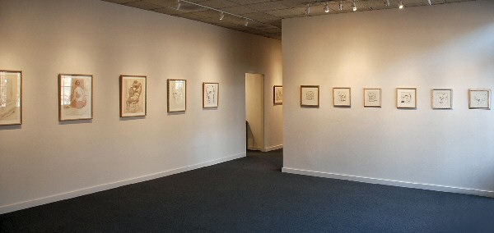
December 12 through January 12, 2008
Art historian, writer, and curator Dave Hickey has called Frederick Hammersley’s paintings “the best-kept secrets in the art world and easily the most ravishing.” Associated since the 1950s with the California “Abstract Classicists,” the artist is known and respected as one of hard-edged abstraction’s leading practitioners.
Thus it may seem almost antithetical to organize an exhibition of Hammersley’s mostly figurative drawings, along with a small series of clay sculptures of variations on the female nude. But that’s exactly the content of Charlotte Jackson Fine Art’s exhibition titled Frederick Hammersley: Drawing Closer, Works on Paper 1940-1980. A high percentage of the works on paper, and all of the sculptures, have never before been publicly exhibited.
Upon revelation of Hammersley’s declaration that drawing is “the power behind the throne,” however, and that he has continued to draw since his school days mid-century at Chouinard Art Institute and at various night classes that featured a live model for what Hammersley recalls was a five-dollar fee, it is no surprise that such an exhibition has at long last been planned. In fact, a quick comparative look at what the artist calls the “cliché of representation” in the self-portrait (above) and the sense of “winging it” in Outward (below) reveals the artist’s significant moment, which occurred in the ’60s, of breaking away from illusionist work to something that felt like a huge relief to him—and is key to the methodology of his work. Whether drawing or painting, Hammersley works by hunches, pushing himself past what is expected to the next right step.
Hammersley holds the power of draftsmanship in high regard, and cites Michelangelo, Leonardo (“next to God,” he says), and Degas as inspirations for his own art. In fact, maintains Hammersley, “any giant [in art history] is a marvelous draftsman, but you don’t always see it [in their paintings].” He is close to celebrating his 90th birthday, and still wishes he could spend more time drawing.
ART Santa Fe Presents announces the upcoming publication of Frederick Hammersley: Works From 1938 through 2001, with over 100 color plates, and essays by Hickey, David Pagel, Arden Reed, and Joseph Traugott. Also included in the monograph is an interview with the artist conducted by Sarah S. King in the spring of 2008.

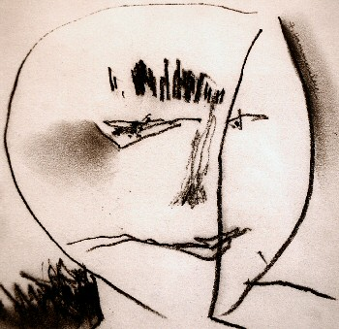
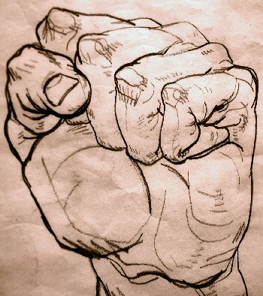

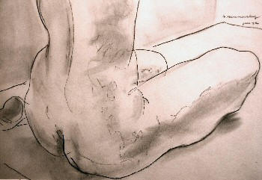
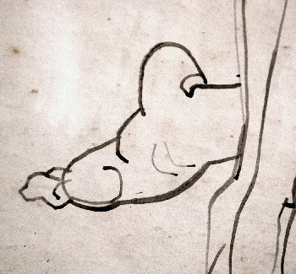

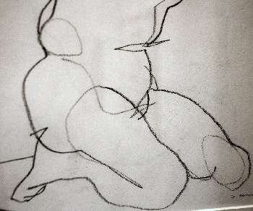
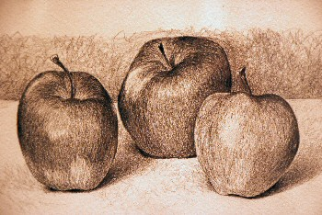

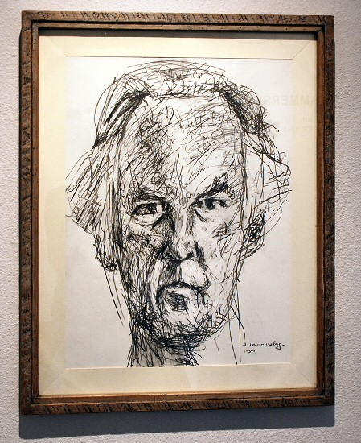
Frederick Hammersley
Start (Self Portrait), 1980
Pencil on paper
24 x 18 inches
FH177
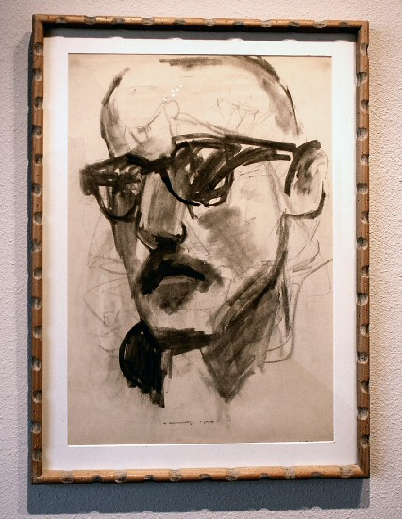
Frederick Hammersley
Great Dane, 1966
charcoal
17 1/2 x 11 inches
FH268
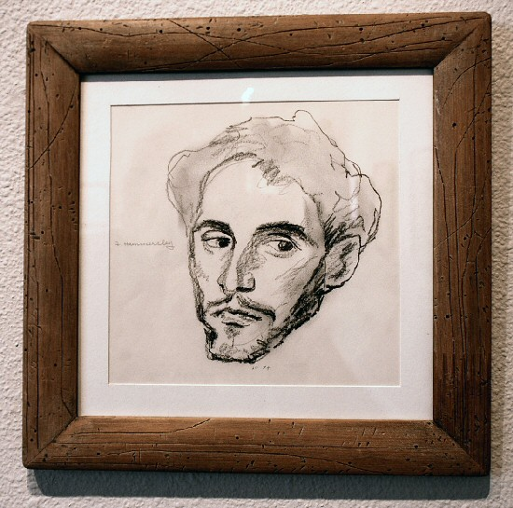
Frederick Hammersley
Watching El Greco, 1974
Pencil
7 1/2 x 7 1/2 inches
FH310
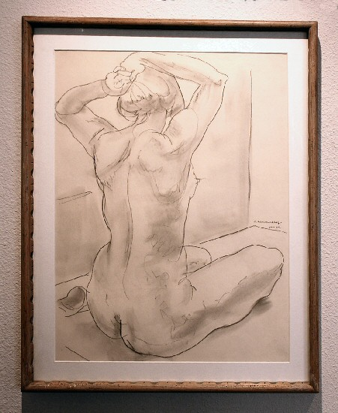
Frederick Hammersley
Hair Do,
Charcoal Pencil
24 x 18 inches
FH340
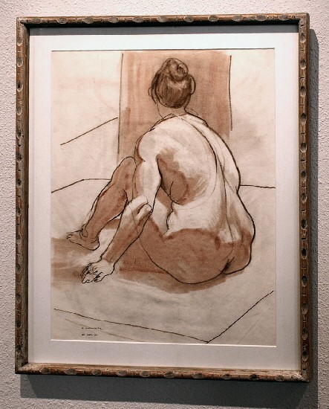
Frederick Hammersley
Well Grounded, 1961
Conte Crayon
23 7/8 x 18 7/8 inches
FH339
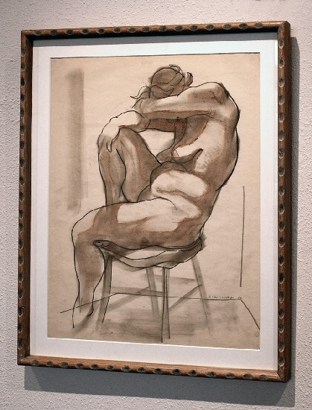
Frederick Hammersley
Well Rounded, 1954
Charcoal pencil and conte
24 x 18 3/4 inches
FH332
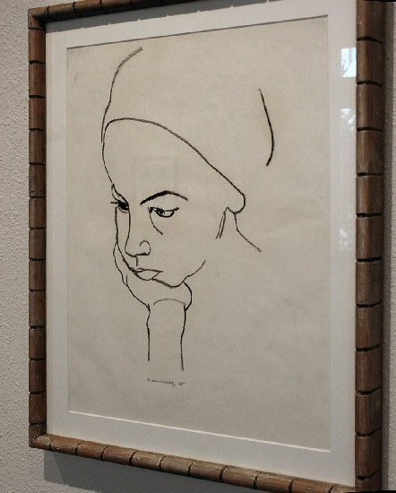
Frederick Hammersley
Angelica, 1965
Pressed charcoal
21 x 16 1/2 inches
FH328
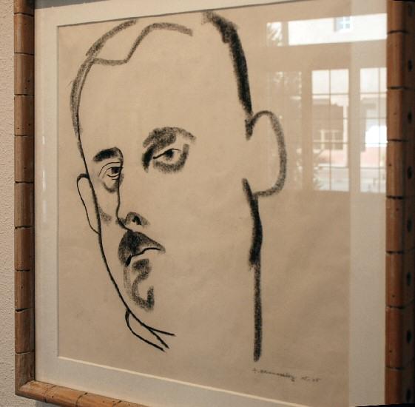
Frederick Hammersley
Tom, 1965
Pressed charcoal
17 1/2 x 17 inches
FH337
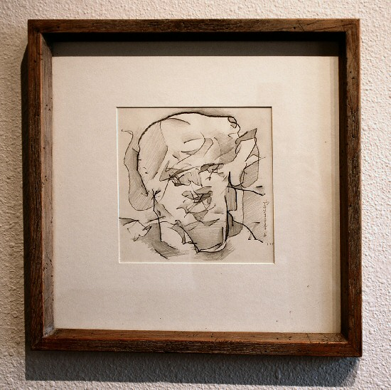
Frederick Hammersley
Outward, 1965
pencil on paper
7 1/2 x 7 1/2 inches
FH251
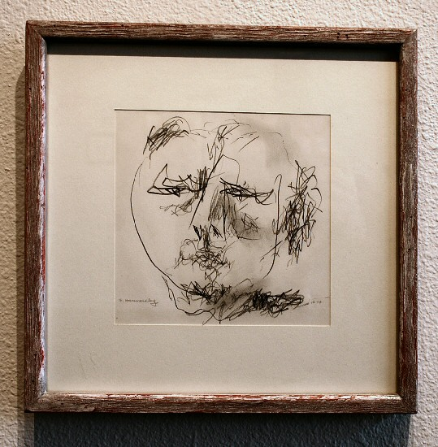
Frederick Hammersley
Yes, 1974
Pencil
7 1/2 x 7 1/2 inches
FH311
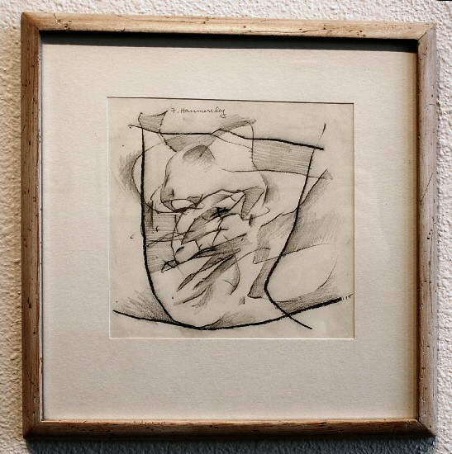
Frederick Hammersley
Agreed, 1975
Pencil
7 1/2 x 7 1/2 inches
FH322
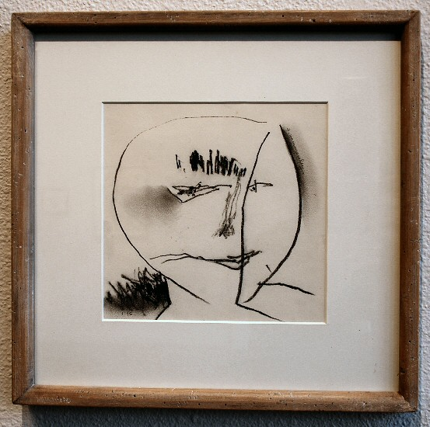
Frederick Hammersley
Succinct, 1975
Charcoal Pencil
7 1/2 x 7 1/2 inches
FH312
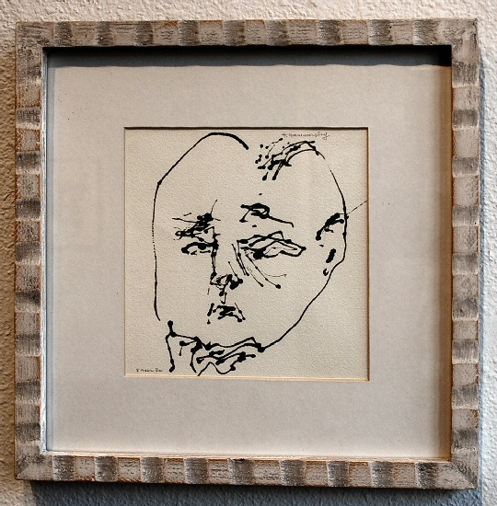
Frederick Hammersley
Stuffed Shirt, 1980
Ink
6 3/4 x 7 inches
FH313
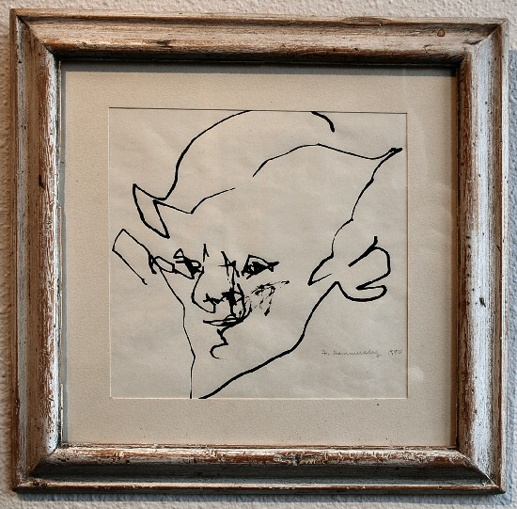
Frederick Hammersley
Madam, 1975
Pencil
7 1/2 x 7 1/2 inches
FH316
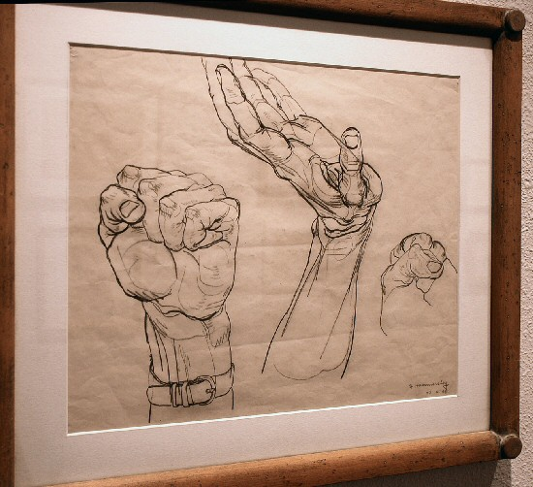
Frederick Hammersley
Hands, 1948
Pencil on paper
14 x 7 inches
FH178
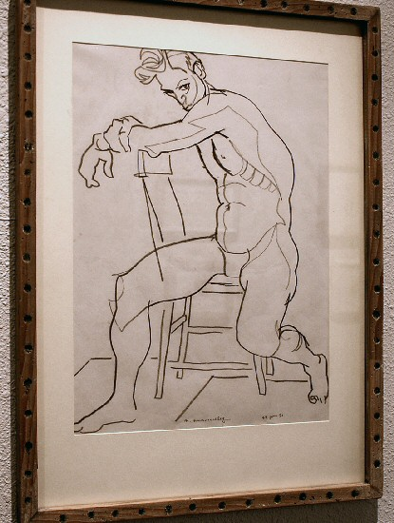
Frederick Hammersley
Chair Man, 23 June, 1953
Pencil on paper
17 x 14 inches
FH179
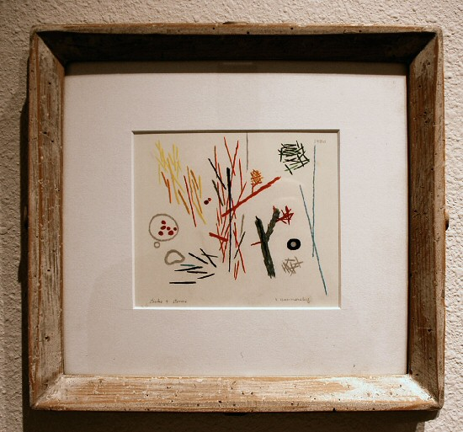
Frederick Hammersley
Sticks and Stones, 1950
Colored pencil
4 3/4 x 5 5/8 inches
FH325
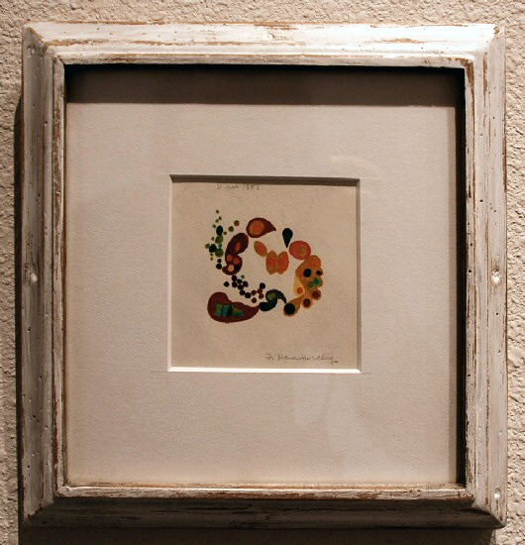
Frederick Hammersley
Poly Wog, 1951
Colored pencil
3 1/2 x 3 1/2 inches
FH161
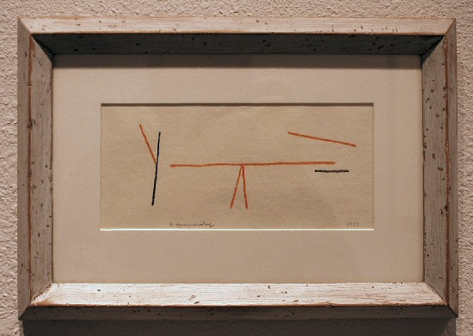
Frederick Hammersley
Balancing Act, 1951
Pencil
3 1/2 x 7 1/2 inches
FH321
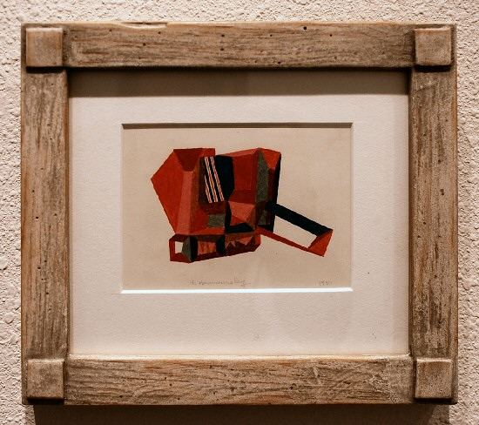
Frederick Hammersley
Soap Opera, 1951
colored pencil
3 1/2 x 5 inches
FH256
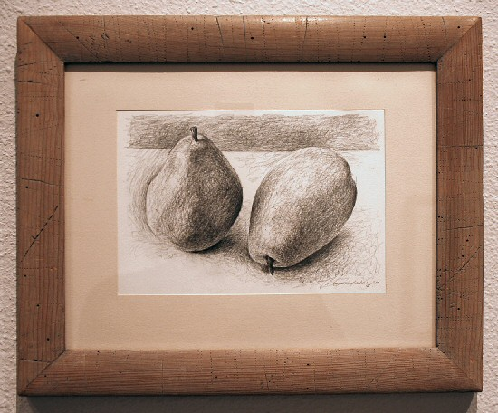
Frederick Hammersley
Separate Checks,
Pencil on rag paper
5 1/8 x 8 inches
FH314
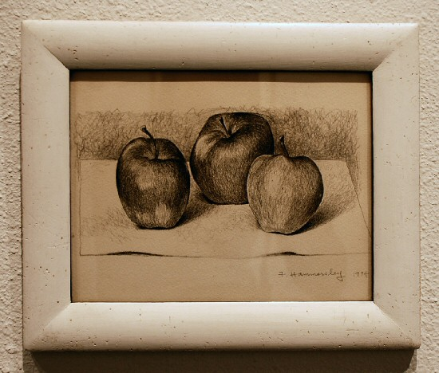
Frederick Hammersley
Untitled, 1974
pencil
6 1/2 x 8 1/2 inches
FH258
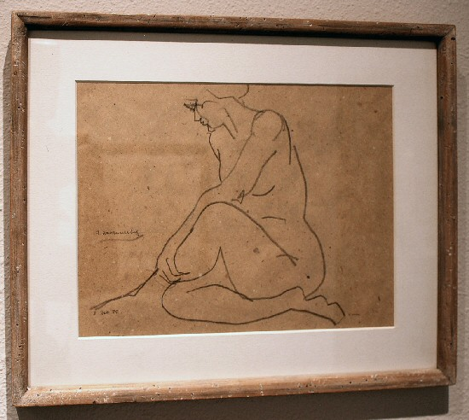
Frederick Hammersley
Seated, 1988
pencil on paper
10 1/2 x 13 1/2 inches
FH252
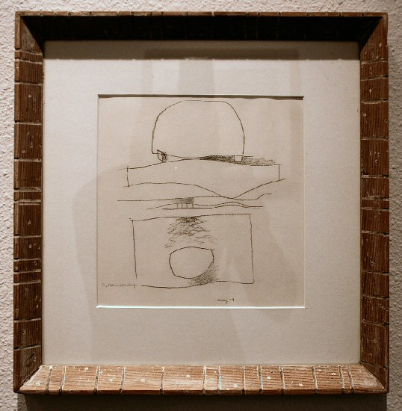
Frederick Hammersley
Ahead, 1979
graphite, charcoal on paper
7 1/4 x 7 1/4 inches
FH342
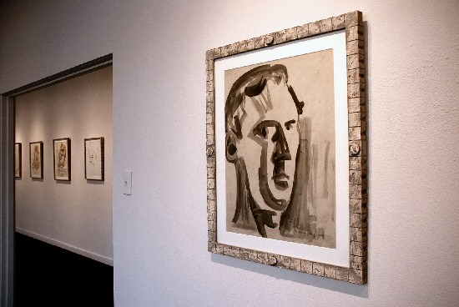
Frederick Hammersley
Self Portrait, 1956
Ink on paper
24 x 18 inches
FH176
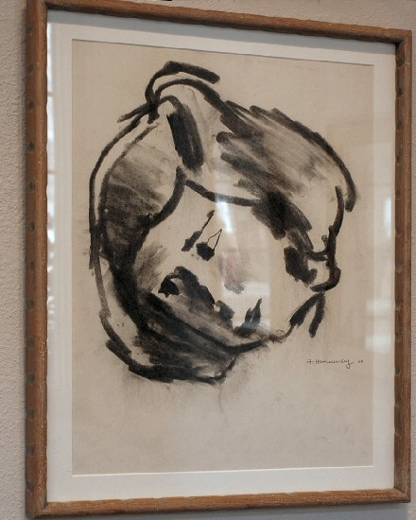
Frederick Hammersley
Benton Way- Head, 1966
Charcoal
22 x 17 inches
FH334
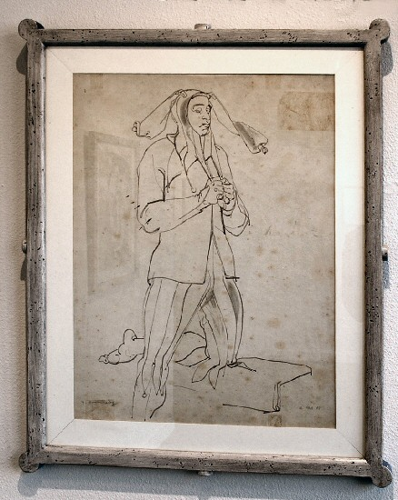
Frederick Hammersley
Standing Jester, 1948
Ink
24 x 19 inches
FH336
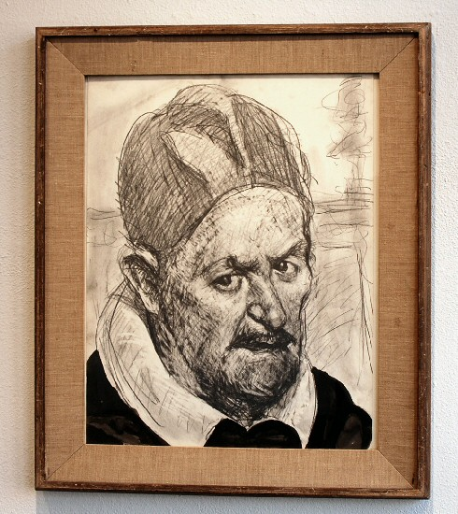
Frederick Hammersley
Back Again . . . Seated Man, 1987
charcoal pencil
22 1/2 x 17 1/2 inches
FH335
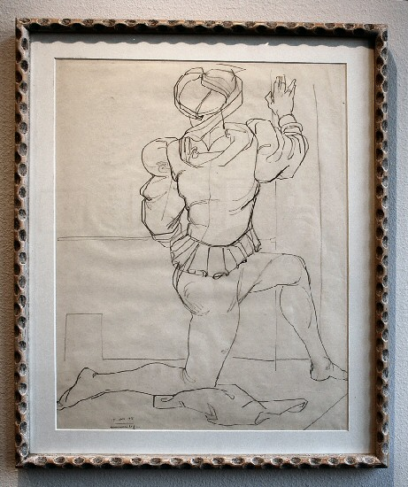
Frederick Hammersley
Period Costume, 1948
Pencil
23 3/4 x 18 3/4 inches
FH329
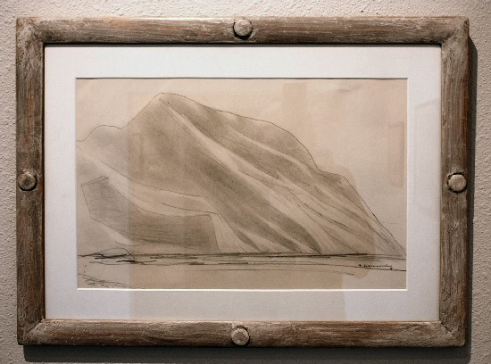
Frederick Hammersley
Sandia Profile, 1907's
Pencil
11 7/8 x 17 7/8 inches
FH326
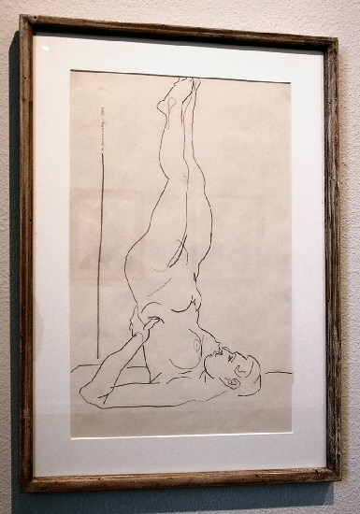
Frederick Hammersley
Shoulder Stand, 1984
pencil
17 1/2 x 11 inches
FH267
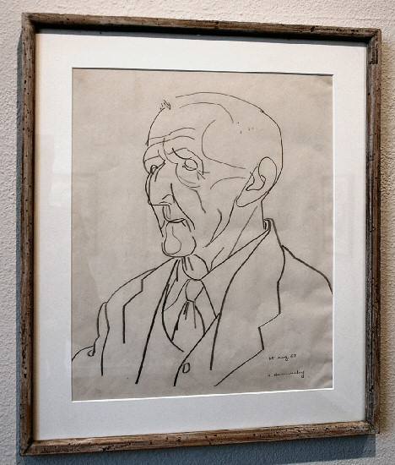
Frederick Hammersley
Long Day, 1953
Pencil
16 x 13 inches
FH327
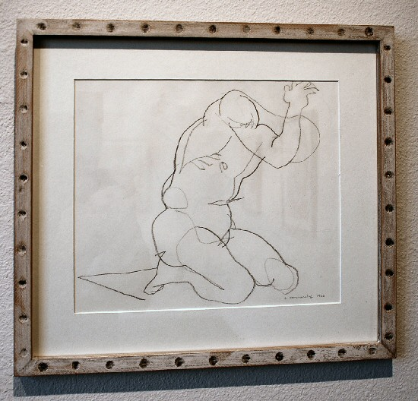
Frederick Hammersley
Short Prayer, 1986
pencil on paper
13 7/8 x 10 1/2 inches
FH254
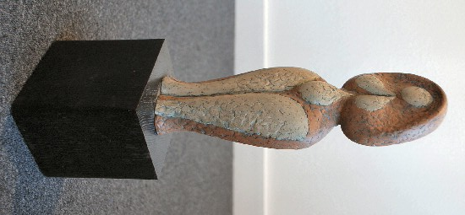
Frederick Hammersley
Untitled (female figure),
red clay
17 x 5 x 4 inches
FH344
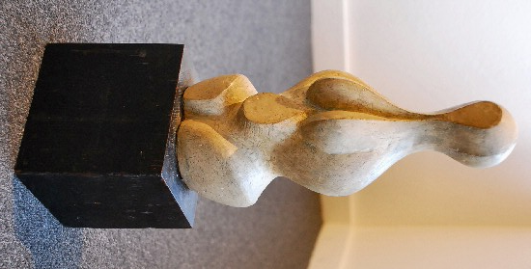
Frederick Hammersley
Untitled (female figure),
clay
15 1/4 x 5 x 4 inches
FH345
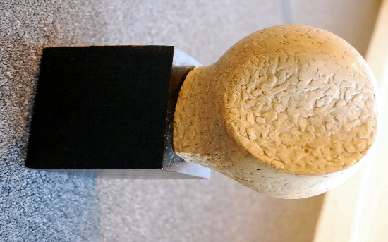
Frederick Hammersley
Untitled (round form),
clay
9 1/2 x 5 x 5 inches
FH346

© 2008

Charlotte Jackson Fine Art, Inc.

200 West Marcy Street, Suite 101, Santa Fe, New Mexico 87501
Telephone: 505.989.8688 Fax: 505.989.9898
cjfa@charlottejackson.com - www.charlottejackson.com

Photography & CD Production:
William Metcalf

