THE GRASS IS (NOT) GREENER
A Group Exhibition
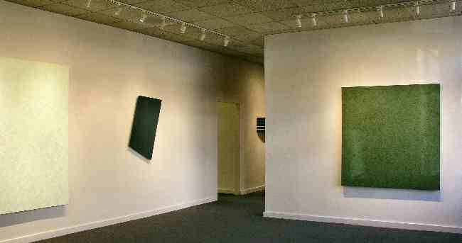
ALAN EBNOTHER
JAMES HAYWARD
ELLSWORTH KELLY
JOSEPH MARIONI
WILLIAM METCALF
JEREMY THOMAS
ERIC TILLINGHAST
CLARK WALDING
January 15, 2004
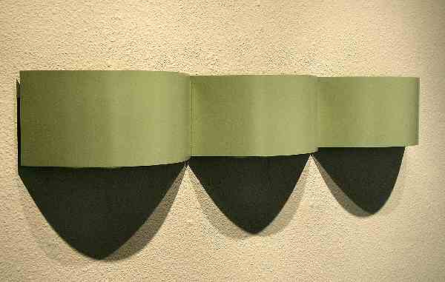
ERIC TILLINGHAST
Crème de Menthe, 2003
Enameled steel, 5” x 33” x 3 ”
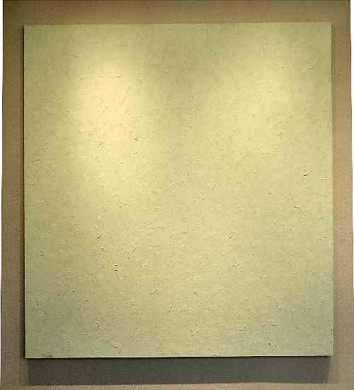
ALAN EBNOTHER
August 19th, 2003, Green, 2003
Oil on Linen, 75" x 70"
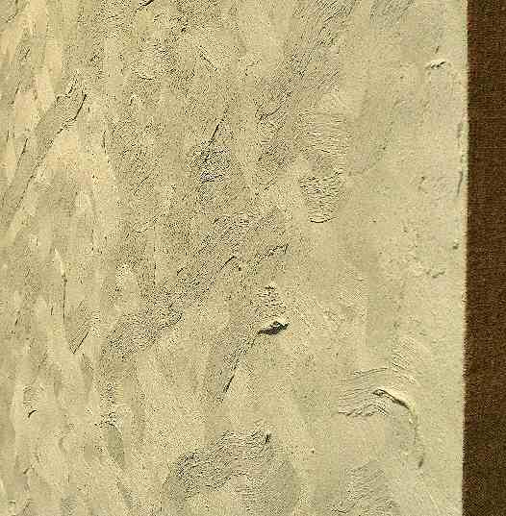
ALAN EBNOTHER
August 19th, 2003, Green, 2003
Oil on Linen, 75" x 70"
(Detail)
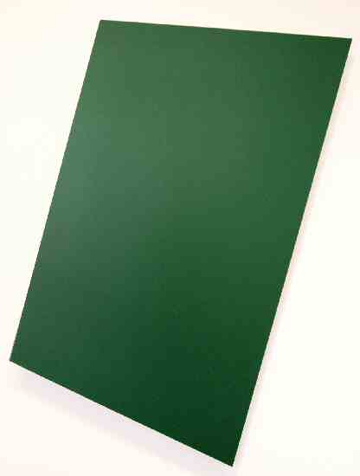
ELLSWORTH KELLY
Dark Green Panel # 1, Edition 3/9, 1982
Painted Wall Sculptures Series, 42 1/8” x 31 ¾”
Published by Gemini Editions
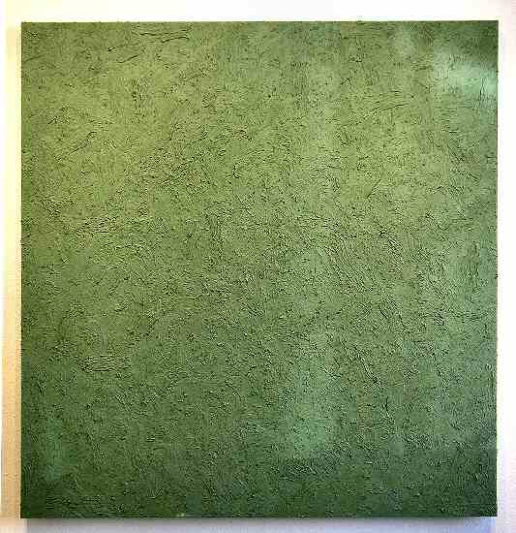
ALAN EBNOTHER
January 4th, 2004, Green, 2004
Oil on Linen, 59" x 57"
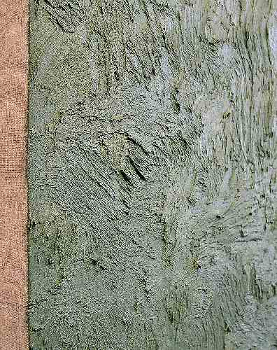
ALAN EBNOTHER
January 4th, 2004, Green, 2004
Oil on Linen, 59" x 57"
(detail)
HALLWAY:
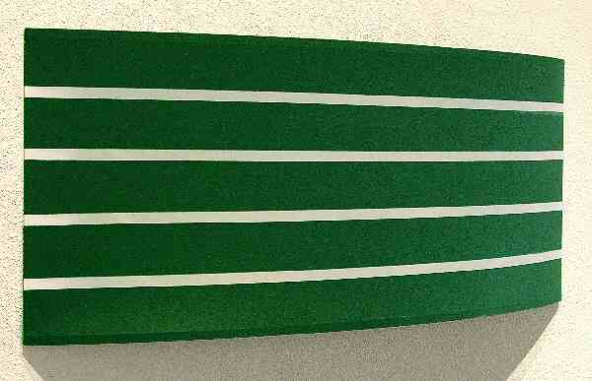
WILLIAM METCALF
Green arc, 2002
Acrylic on polyester fabric, 14” x 34.5” x 4.5”
GALLERY II:
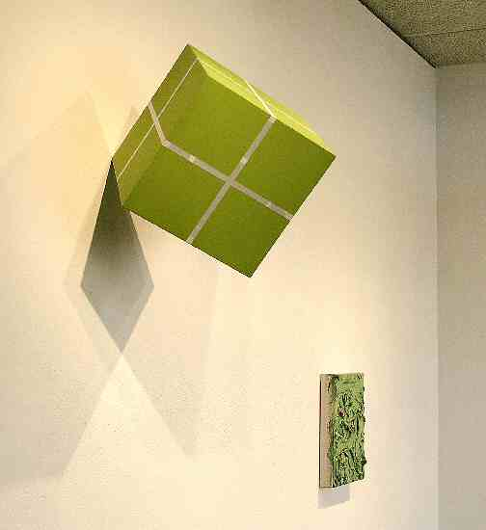
WILLIAM METCALF
Cube Suspended from a Point, 2003, green
Acrylic on polyester on wood structure,
12” x 12” x 12”
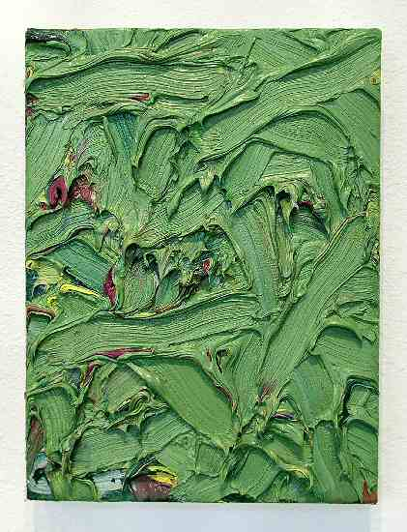
JAMES HAYWARD
Chromachord #92, 2001, Green
Oil on canvas on board, 13 7/8" x 10 3/8"
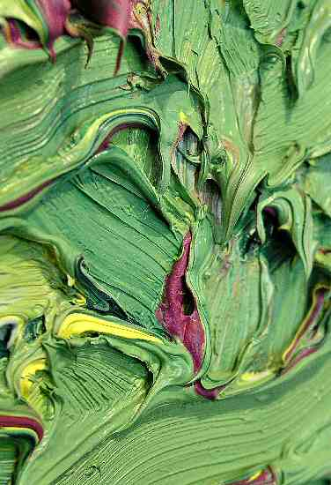
JAMES HAYWARD
Chromachord #92, 2001, Green
Oil on canvas on board, 13 7/8" x 10 3/8"
(detail)
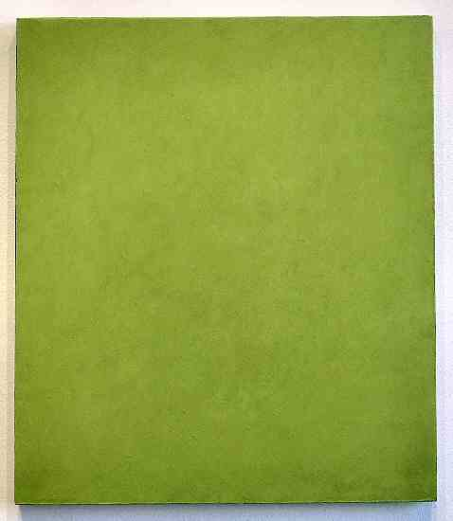
CLARK WALDING
Painting of Green, 2001-2002 Oil,
alkyd, wax on canvas on panel, 40” x 35”
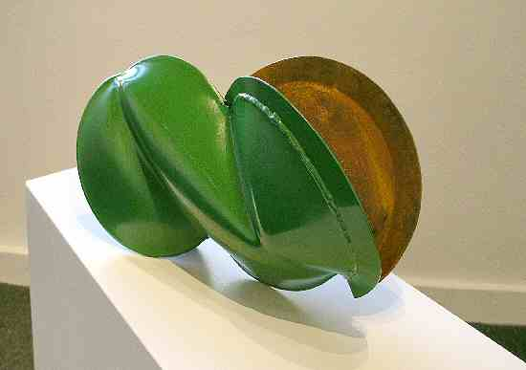
JEREMY THOMAS
John Deere Green, 2003
Forged Milled Steel & Enamel, 8 ½” x 15” x 5”
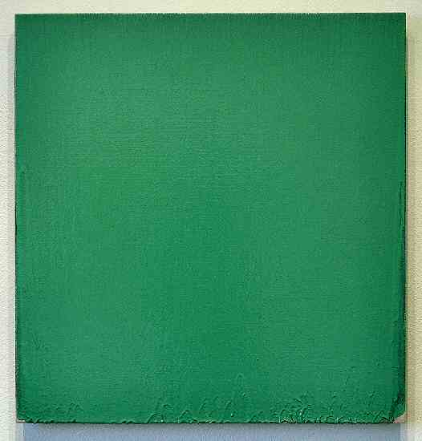
JOSEPH MARIONI
Green Painting, 2000
Acrylic and linen on stretcher, 28" x 27"
© 2004 Charlotte Jackson Fine Art
All Rights Reserved

CHARLOTTE JACKSON FINE ART
200 West Marcy Street, Suite 101
Santa Fe, New Mexico 87501

505-989-8688

Fax: 505-989-9898

www.charlottejackson.com

Photography and CD Development, William Metcalf

