CHARLOTTE JACKSON FINE ART
PRESENTS:

GET AWAY
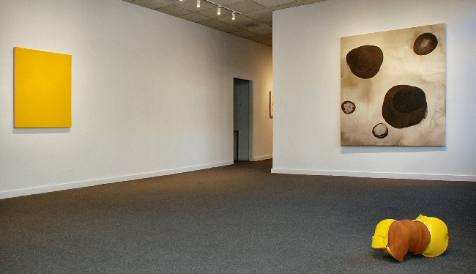
Nov 6 - 30, 2009
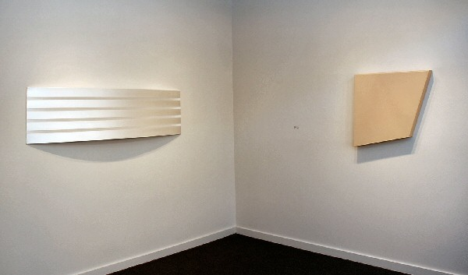

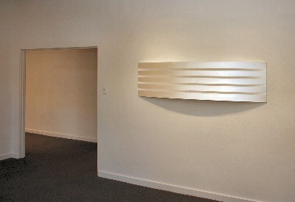
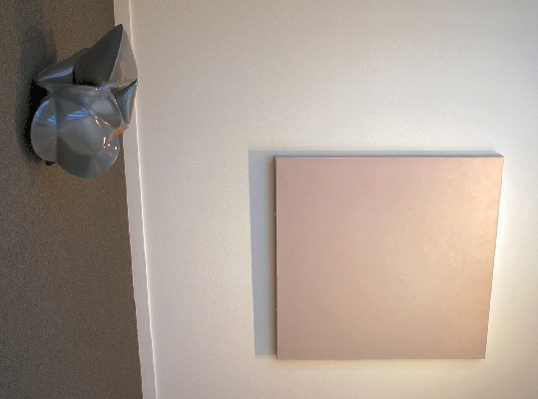
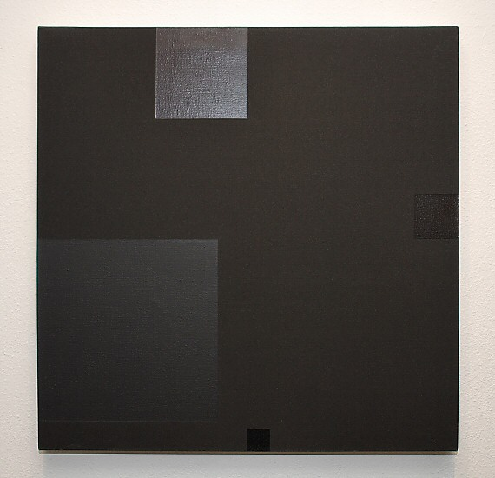
David Simpson
For Ad (Four Square Series)
1980
Acrylic on canvas
32 5/ x8 32 5/8 x 1 ½ in
(82.87 x 82.87 x 3.81 cm) DS0085
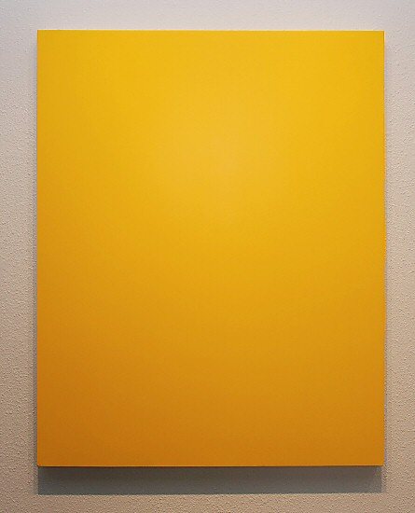
Ed Moses
Untitled (Yellow)
1975
Acrylic on canvas
42 x 34 in. (106.68 x 86.36 cm) EM0024
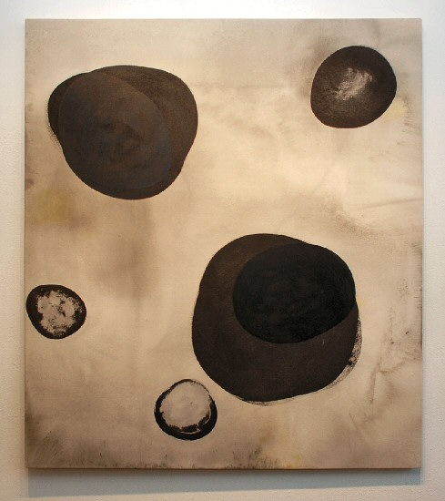
Charles Arnoldi
Get Away
1999
Acrylic on canvas
72 x 64 in. (182.88 x 162.56 cm) CA0076
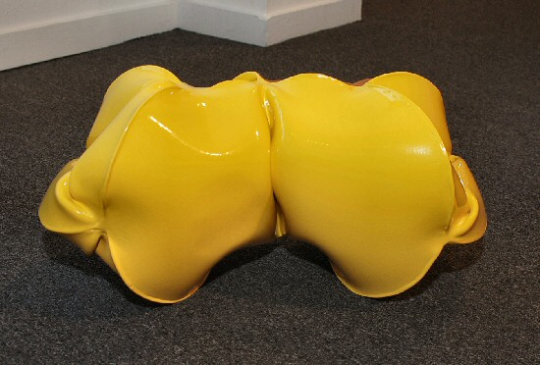
Jeremy Thomas
Module Builder Yellow
2009
Forged mild steel and powder coat
10 x 22 x 9 ½ in.
(25.4 x 55.88 x 24.13 cm) JT178
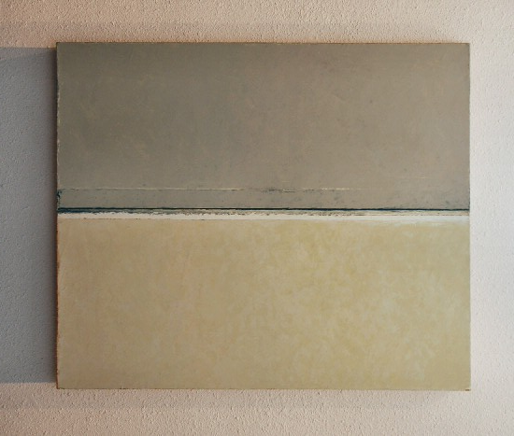
Clark Walding
Rift Series - Exchange, 2008-2009
Oil and cold wax on cotton duck
32 x 26 3/4 x 2 2/8 inches CW0035

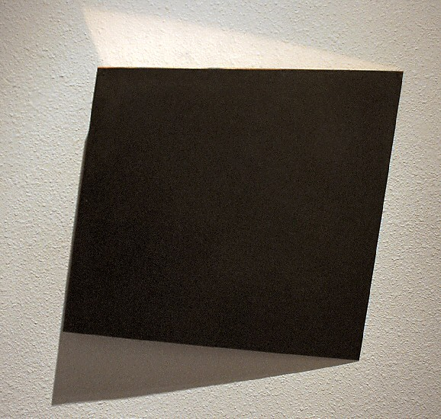
Constance DeJong
Square 18/3
2007
Copper, wood
18 x 18 x 3 in.
(45.72 x 45.72 x 7.62 cm) CD023
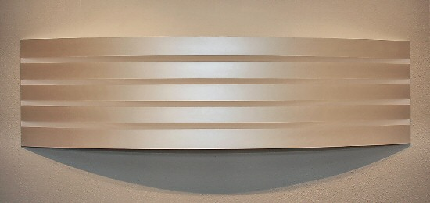
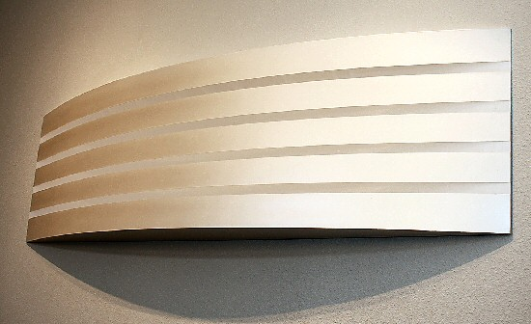
William Metcalf
Pearlescent Gold Arc
2009
Acrylic, polyester fabric, wood
19 x 71 x 5 ¾ in
(48.26 x 180.34 x 14.61 cm) WM0179
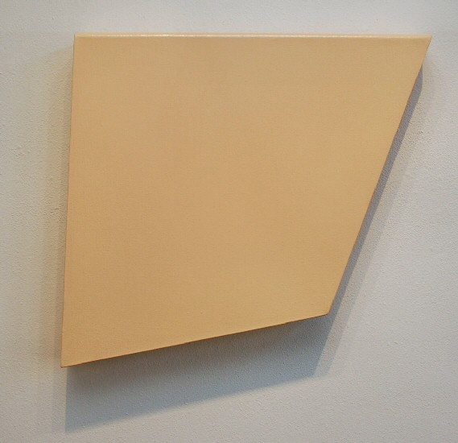
Ron Davis
Small Beige
1966
Liquatex acrylic on canvas
30 3/8 x 28 ¾ x 3 5/8 in overall
(77.47 x 73.66 x 10.16 cm approx.) ROND007
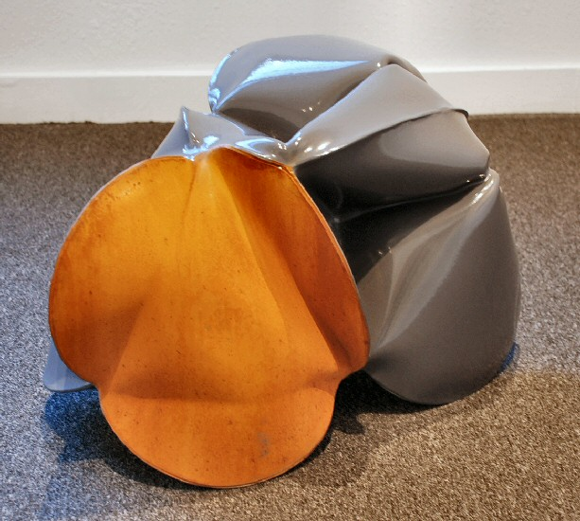
Jeremy Thomas
Module Grey
2009
Forged mild steel and powder coat
12 ½ x 20 x 15 ½ in.
(31.75 x 50.8 x 36.83 cm) JT176
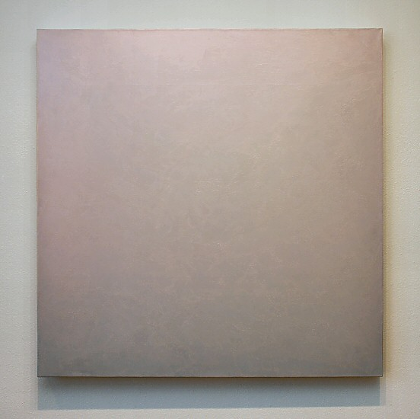
David Simpson
Any Day Now
2000
Acrylic on canvas (interference pigment)
48 x 48 in. (121.92 x 121.92 cm) DS0065
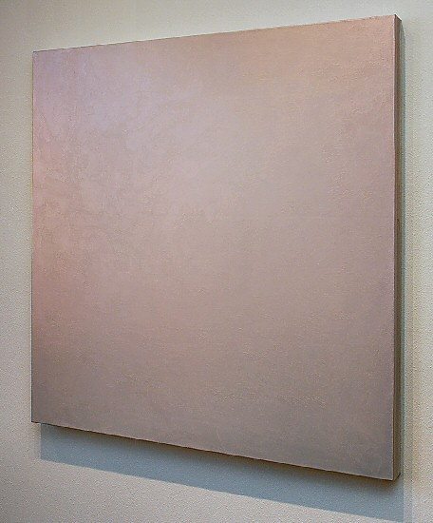
David Simpson
Any Day Now
2000
Acrylic on canvas (interference pigment)
48 x 48 in. (121.92 x 121.92 cm) DS0065

© 2009

Charlotte Jackson Fine Art, Inc.

200 West Marcy Street, Suite 101, Santa Fe, New Mexico 87501
Telephone: 505.989.8688 Fax: 505.989.9898
cjfa@charlottejackson.com - www.charlottejackson.com

