CHARLOTTE JACKSON FINE ART PRESENTS:

FRIENDS AND FAMILY
Mala Breuer, Lawrence Fodor, Florence Pierce

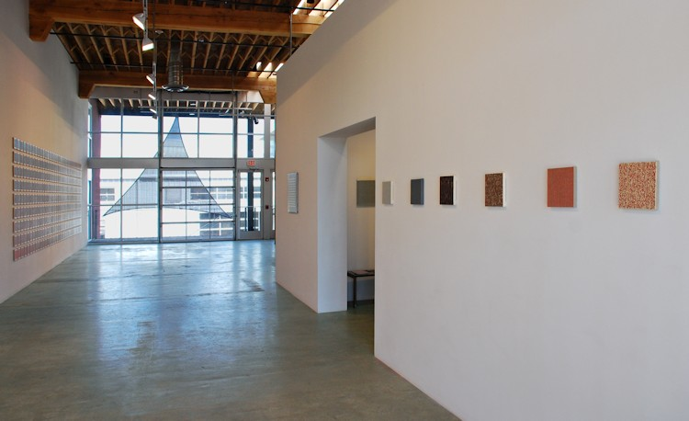

Friends and Family features work by artists, including Florence Pierce and Mala Breuer, who have been a part of Charlotte Jackson Fine Art since its very beginning, as well as work by long-time friend of the gallery, artist Lawrence Fodor. Fodor’s epic installation, Holding Light 4, provided the inspiration for the exhibition. A collection of 315 individual 7 x 7 inch watercolors on archival recycled paper mounted on maple wood, the pieces are arranged to shift along the chromatic scale from all directions (horizontally, vertically and diagonally). The corner pieces provide the key color origins, with the remaining pieces formulated into specific gradations. The very center piece is a perfect mix of the four colors. In counterpoint to this chromatic pattern each individual watercolor is a unique, intuitive expression. Fodor’s works strike up a strong dialogue with a selection of Mala Breuer’s small early canvases. These works highlight her distinctive “mark making”, finding roots in her early experience as a student of Clyfford Still. Weaving in and out of this dialogue are the strong punctuation marks of Florence Pierce’s resin reliefs. Her pristine works both shift in color and hold light as the viewer moves around them. The overall effect of Friends and Family is one of harmonious balance, careful precision, and fascination with the nature and experience of light.
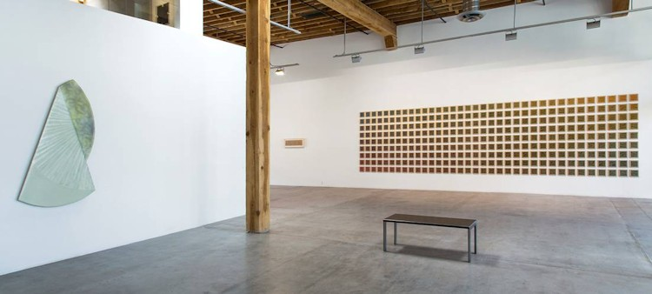

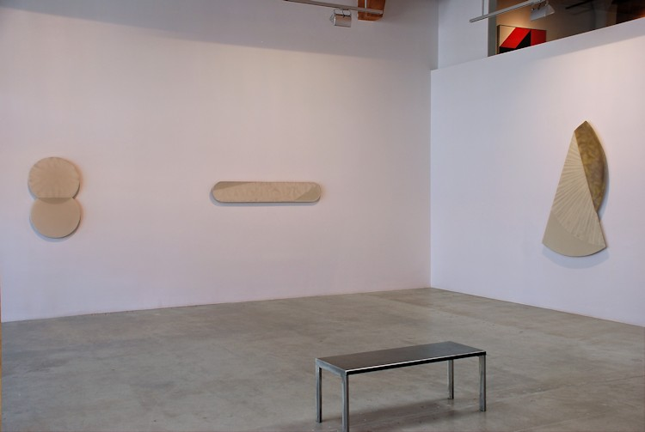

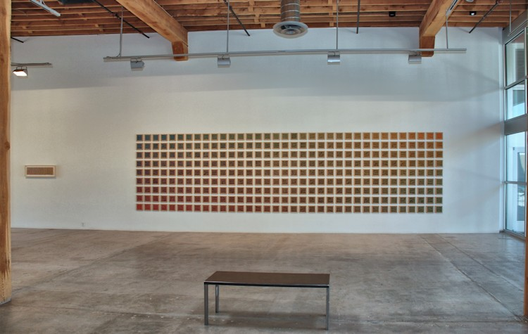

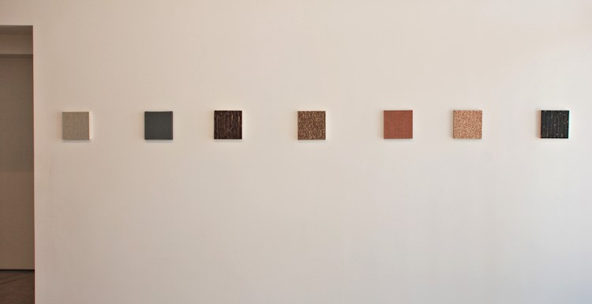

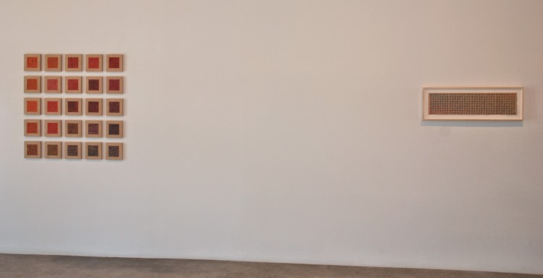

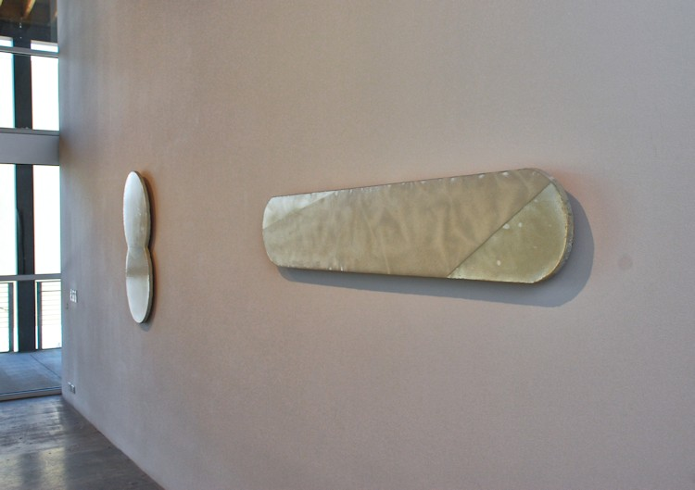

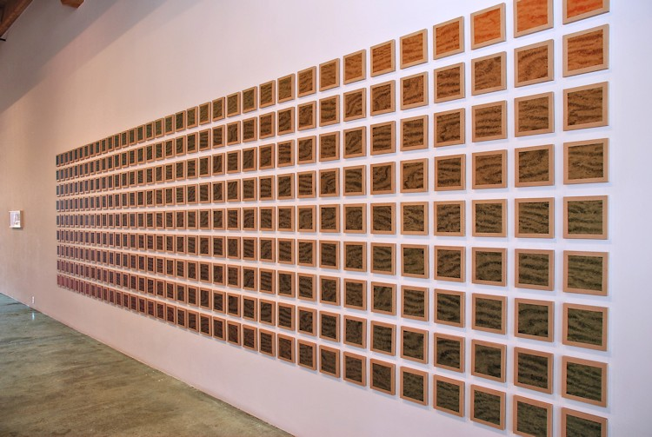

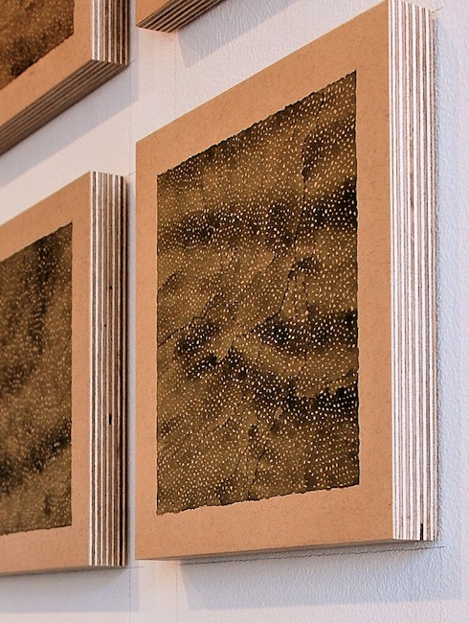

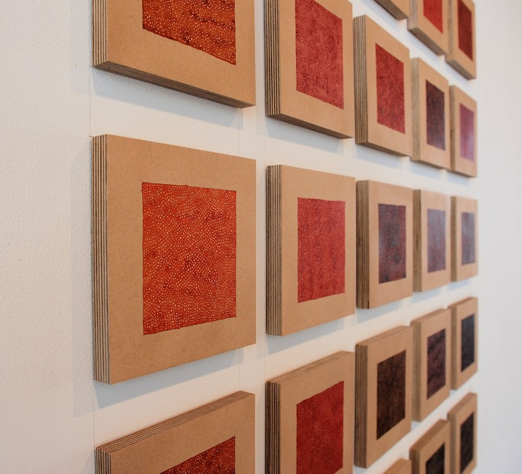
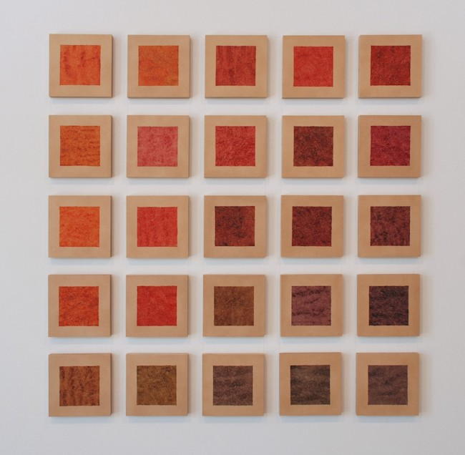
Lawrence Fodor, Holding Light 7 (Orange/Red-Violet 25), 2012-2013
watercolor on paper on maple wood
42 x 41 inches LAF02
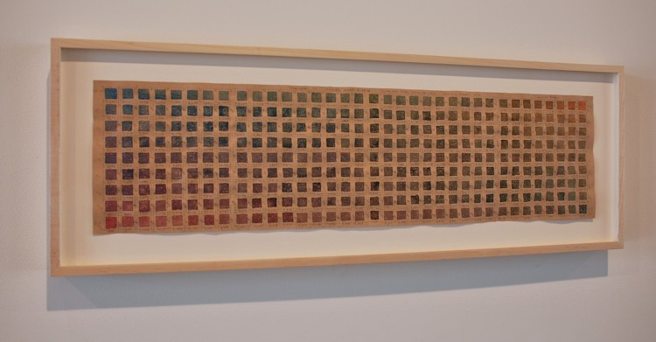

Maquette for Holding Light 4
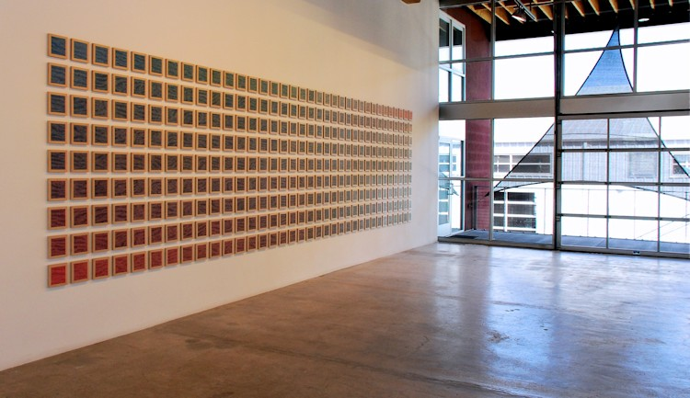
Lawrence Fodor, Holding Light 4, 2012
watercolor on paper on maple wood
79 x 312 inches LAF01
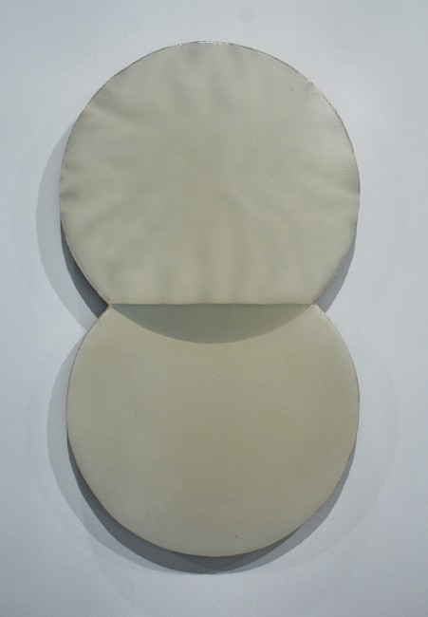
Florence Pierce, Untitled, 09/19/1986
Resin Relief
42 x 24 inches FPE030
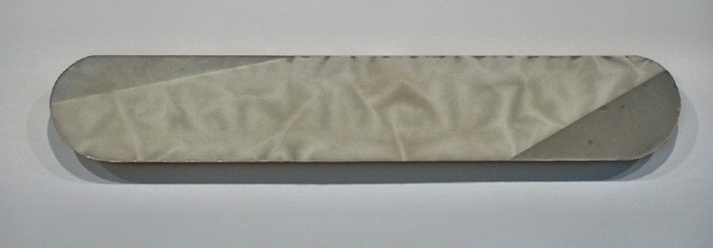

Florence Pierce
Horizontal Cylinder, 10.1986
Resin Relief
72 x 12 inches
FP0089
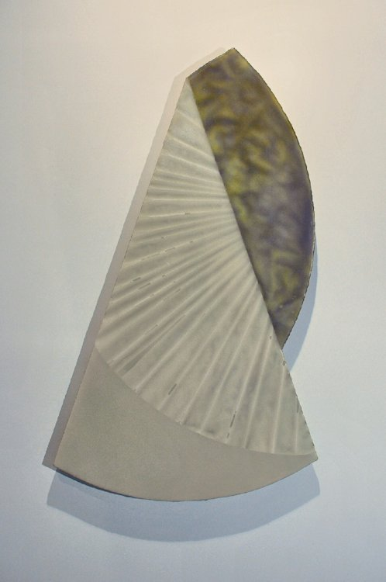
Florence Pierce, Untitled, 1985
Resin Relief, 70 x 30 inches
FP0086
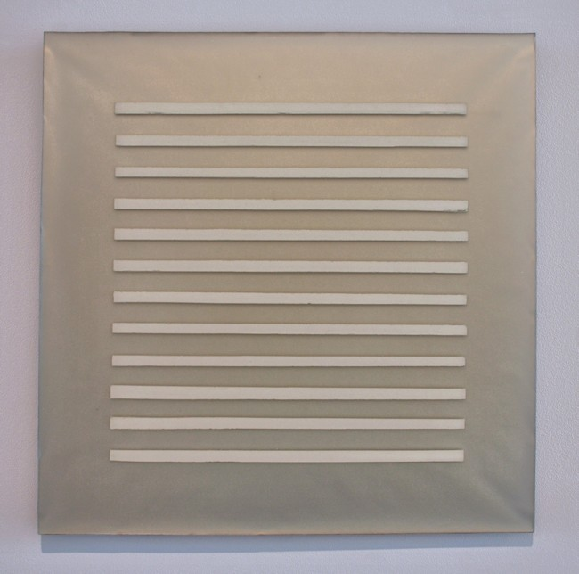
Florence Pierce, Untitled # 16, 9-12-94
Resin Relief, 24 x 24 inches
Signed on Verso: F2003-95 FP179-SM_GF
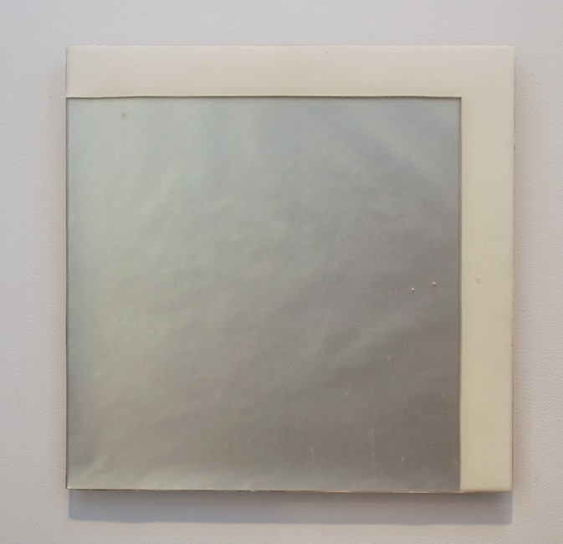
Florence Pierce, Untitled #57, 1995
Resin Relief
16 x 16 inches FP-JB03
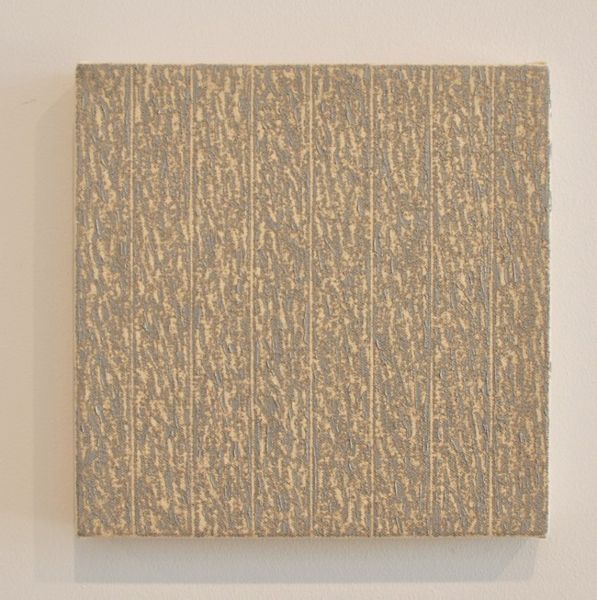
Mala Breuer, Untitled( 9.2.92), 1992
Oil and wax on canvas
8 x 8 inches MB088
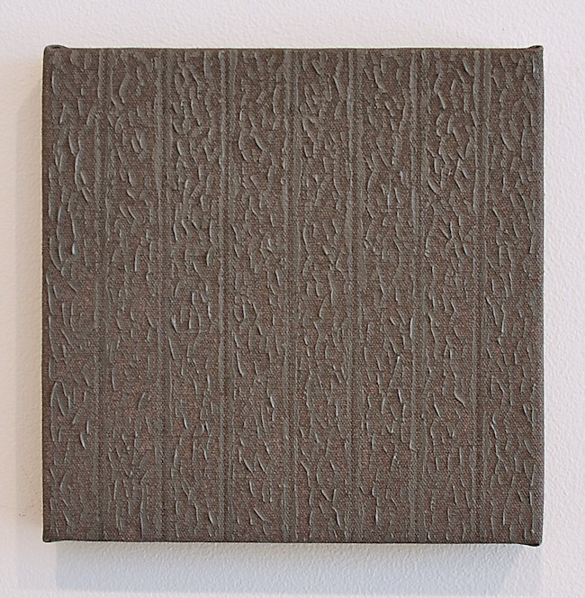
Mala Breuer, Untitled(7.12.94), 1994
Oil and wax on canvas
8 x 8 inches MB089
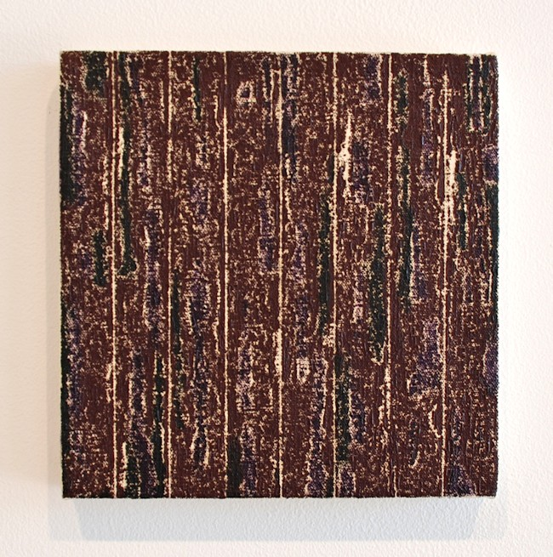
Mala Breuer,Untitled(2.9.92), 1992
Oil and wax on canvas
8 x 8 inches MB090
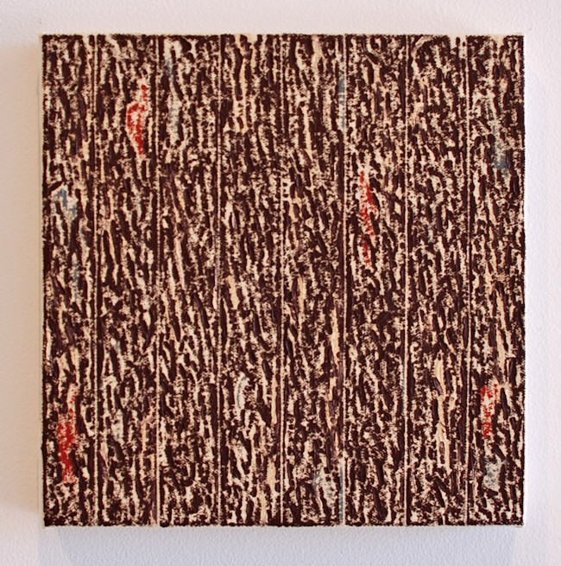
Mala Breuer, Untitled (9.22.92), 1992
Oil and wax on canvas
8 x 8 inches MB091
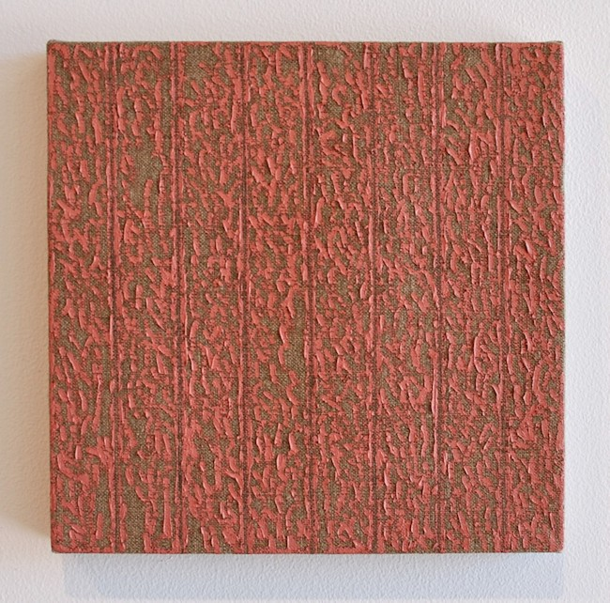
Mala Breuer, Untitled (12.26.93), 1993
Oil and wax on canvas
8 x 8 inches MB092
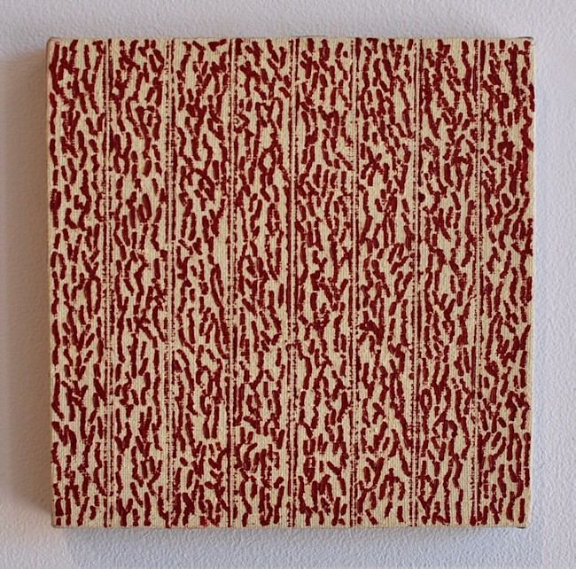
Mala Breuer, Untitled (4.20.95), 1995
Oil and wax on canvas
8 x 8 inches MB093
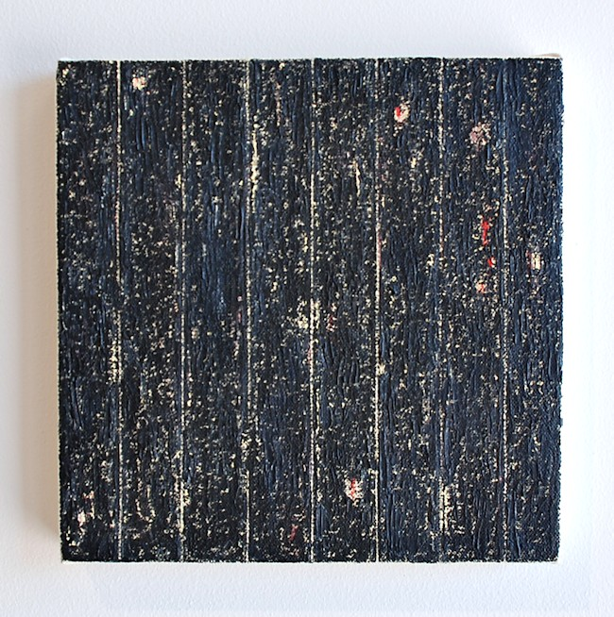
Mala Breuer, Untitled (4.20.95), 1995
Oil and wax on canvas
8 x 8 inches MB093

© 2013

Charlotte Jackson Fine Art, Inc.

In the Railyard at:

554 S. Guadalupe, Santa Fe, New Mexico 87501
Telephone: 505.989.8688 Fax: 505.989.9898
cjfa@charlottejackson.com - www.charlottejackson.com

