CHARLOTTE JACKSON FINE ART PRESENTS:

FIFTY/FIFTY
Holiday Group Exhibition 2013

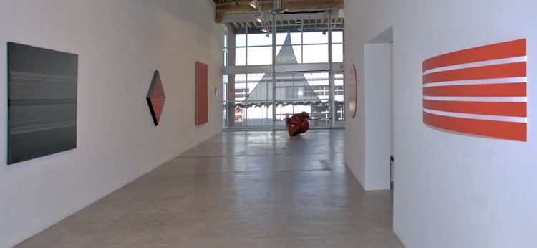
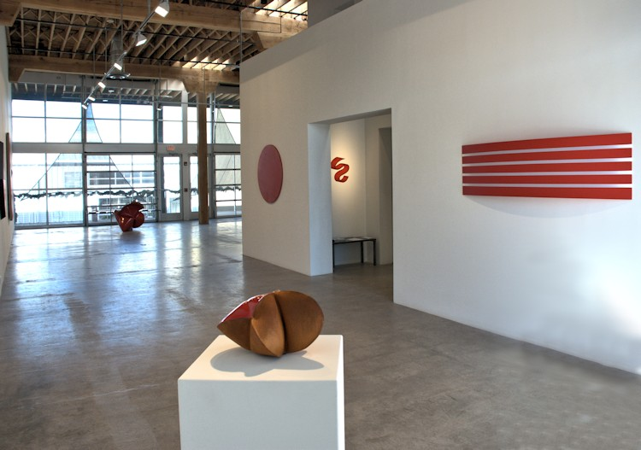

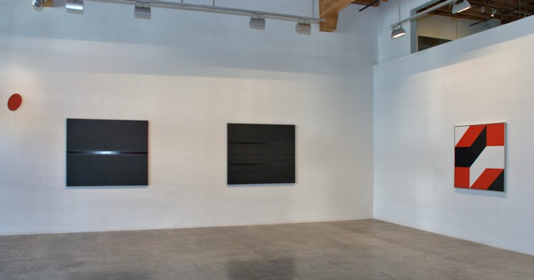
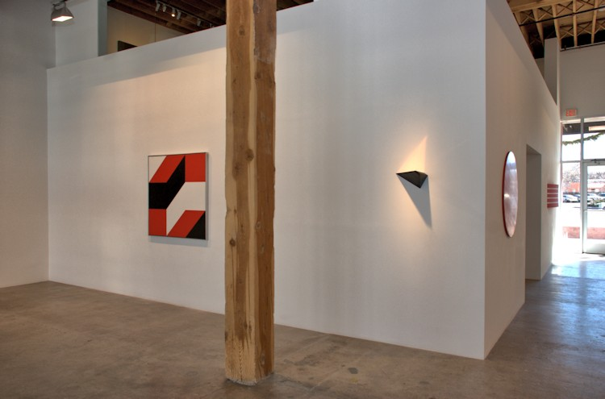

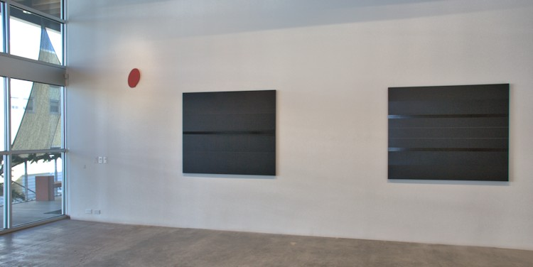
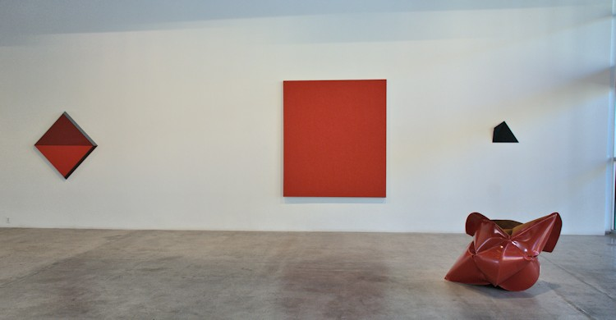

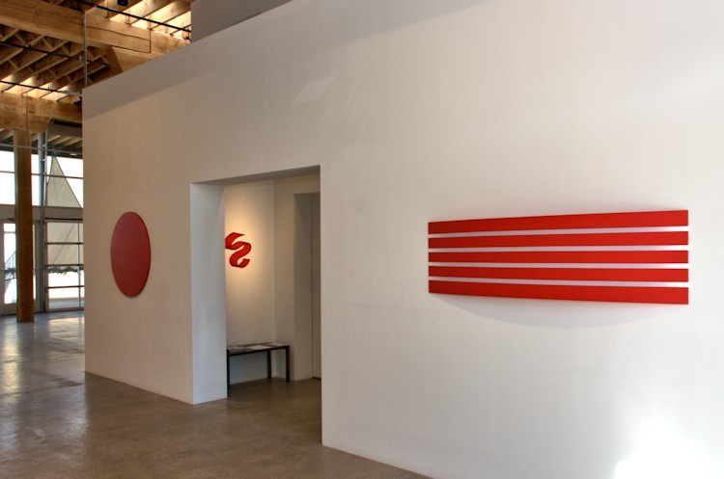
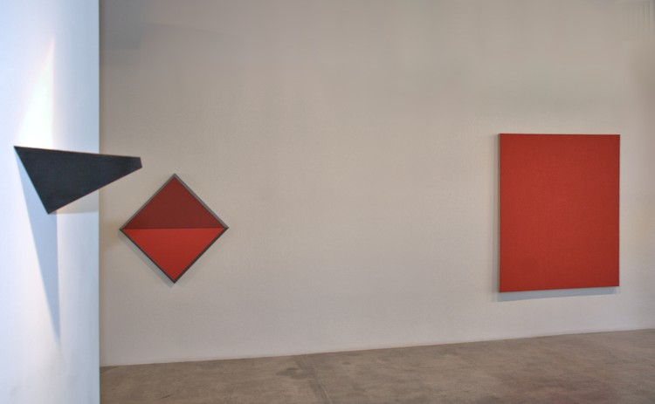

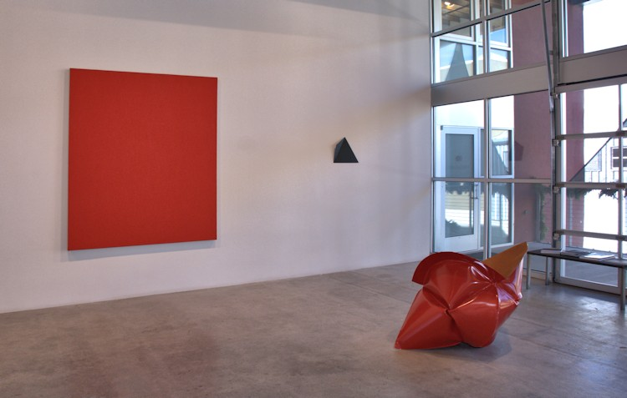
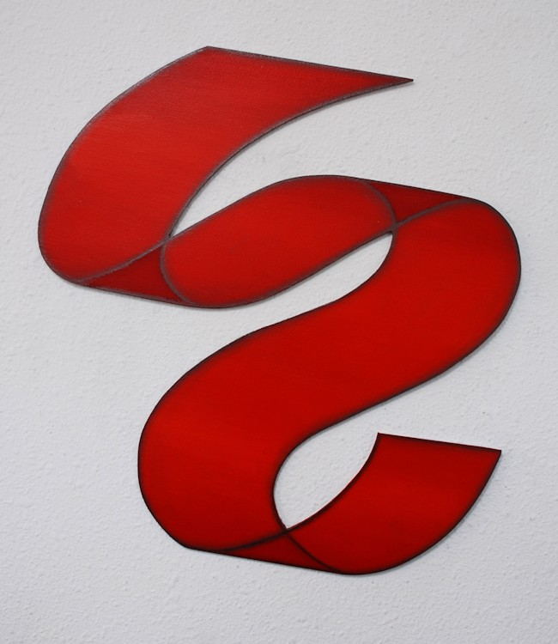

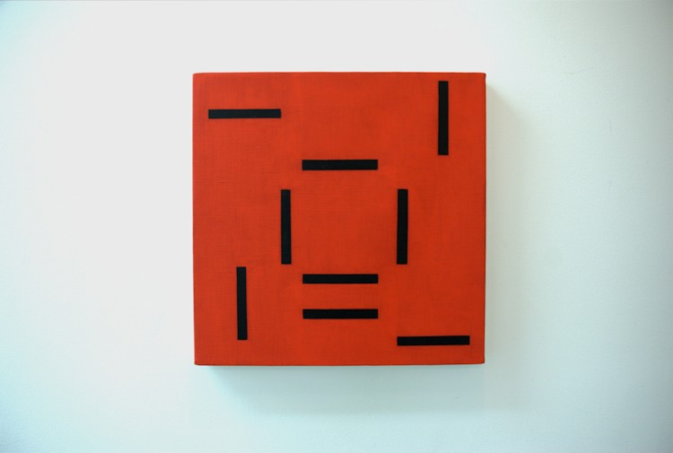
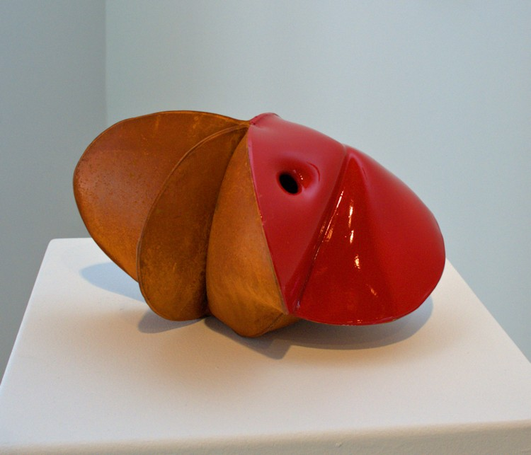

Jeremy Thomas
Sooki Red, 2013
forged mild steel and lacquer
6 1/4 x 11 x 8 1/4 inches
JT277
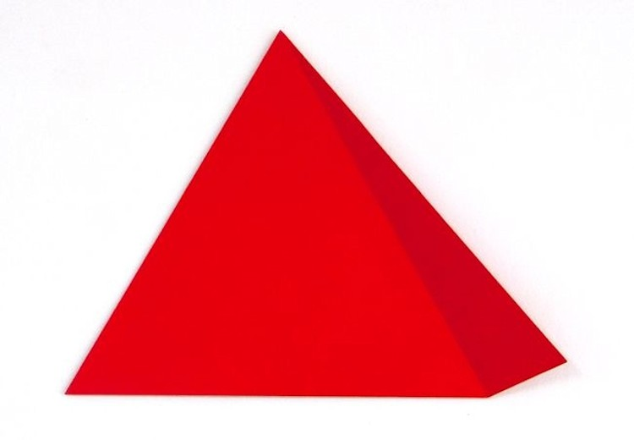
Michael Post
Untitled- wvz17, 2013
acrylic on fiberglass over steel
11.2 x 16.2 x 1.8 in.
MP015
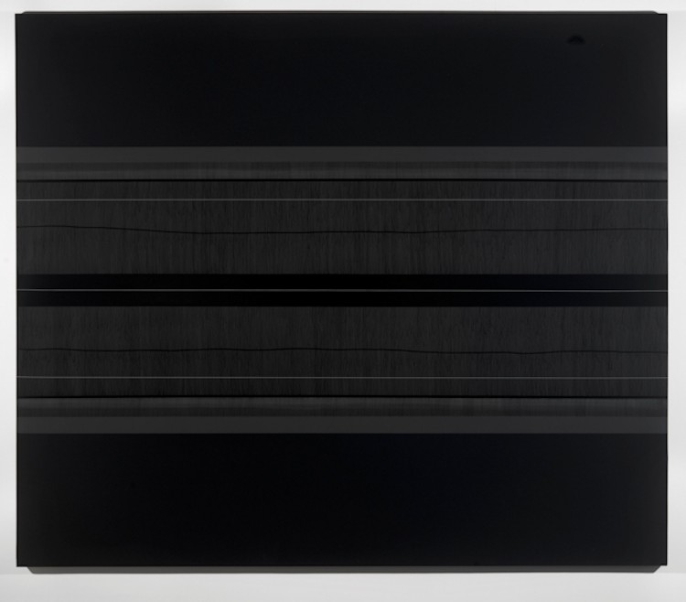
Max Cole
Line Trap, 2010
Acrylic on linen
52 x 62 inches
MAXC042
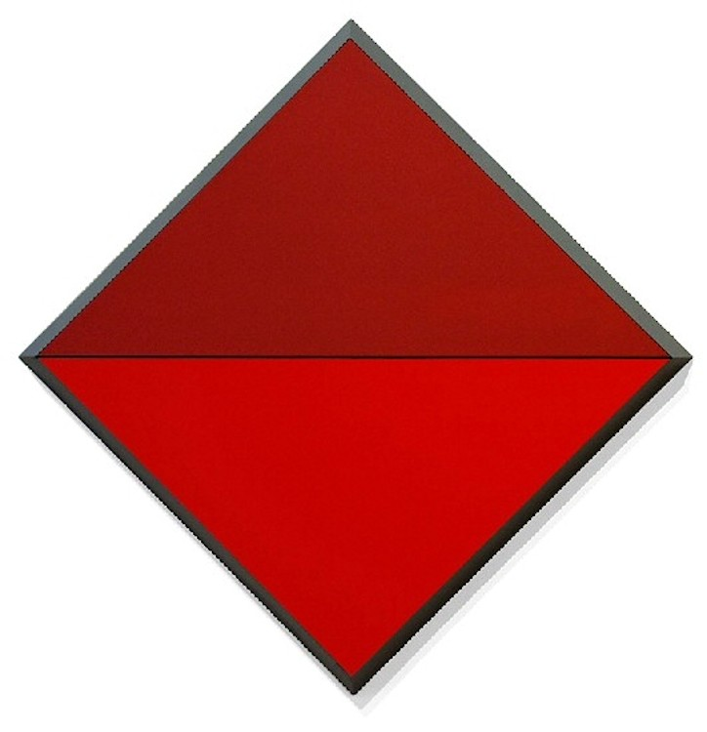
Ronald Davis
Red Diamond Horizon, 2009
Acrylic on Expanded PVC
49 1/2 x 49 1/2 x 3 inches
ROND0044
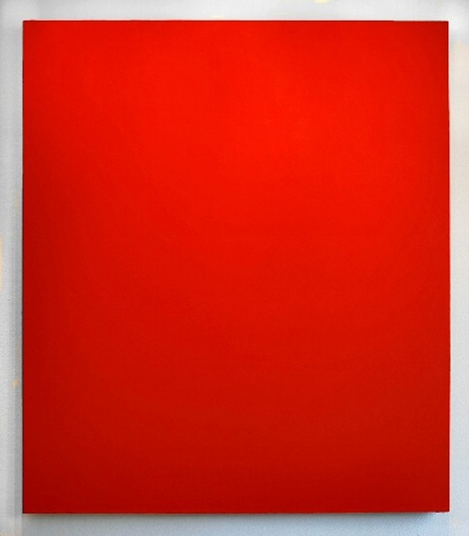
Phil Sims
Untitled (Red), 1999
Oil on linen
80 x 70 inches
PS0016
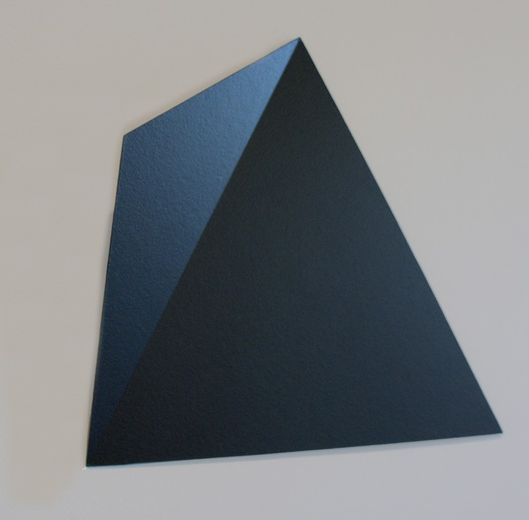
Michael Post
Untitled- wvz32, 2013
acrylic on fiberglass over steel
14.6 x 19.7 x 2 in.
MP019
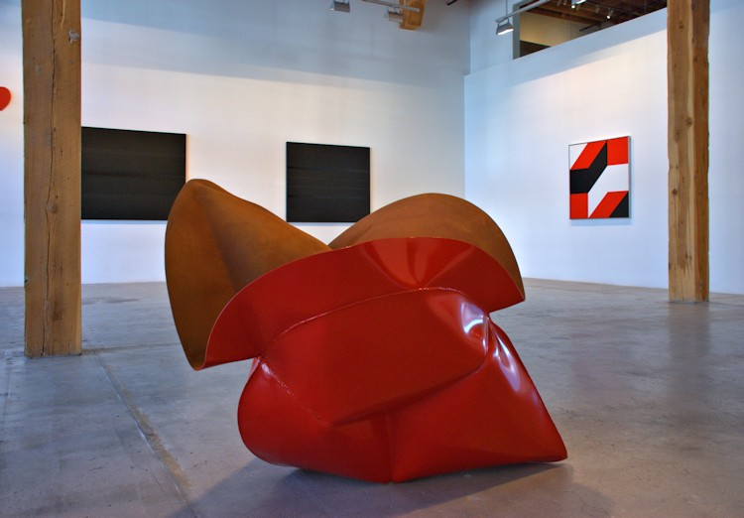
Jeremy Thomas
Cropmaster Red, 2013
forged mild steel and powder coat
34 x 46 x 38 inches
JT272
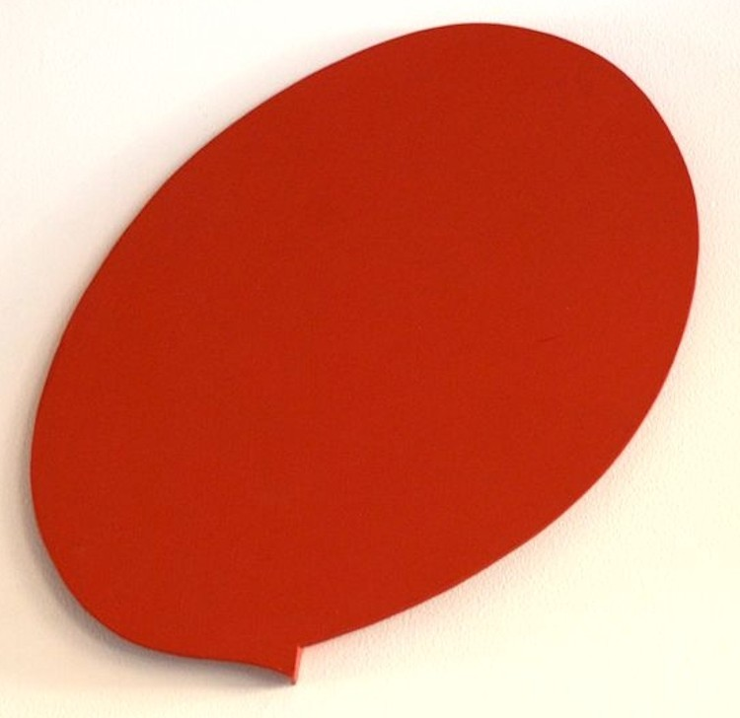
Tony DeLap
Jumping Pulse, 2009
Acrylic on aluminum
13 1/2 x 9 x 1 inches
TD0116
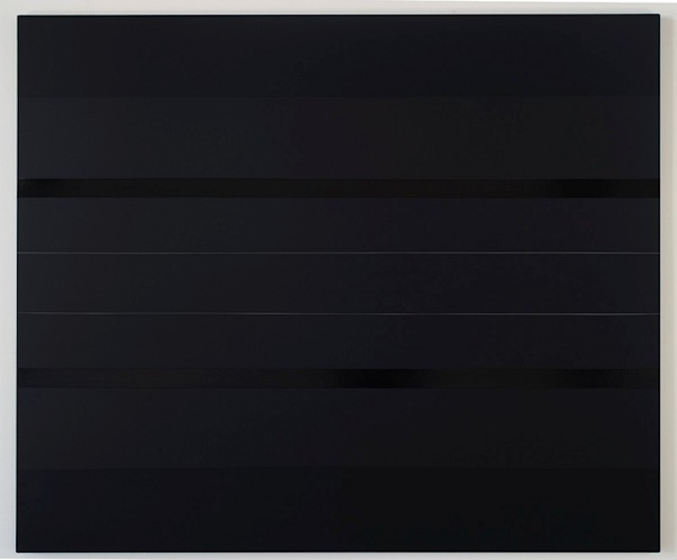
Max Cole
Somerset XIII, 2013
Acrylic on linen
52 x 62 inches
MAXC050
Max Cole
Somerset XIV, 2013
Acrylic on linen
52 x 62 inches
MAXC049
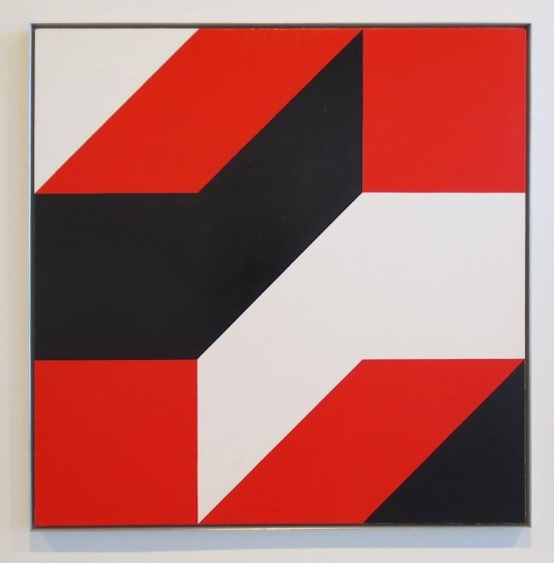
Frederick Hammersley
Come and Grow (#6), 1979
Oil on linen
45 x 45 inches
FH0107-SM
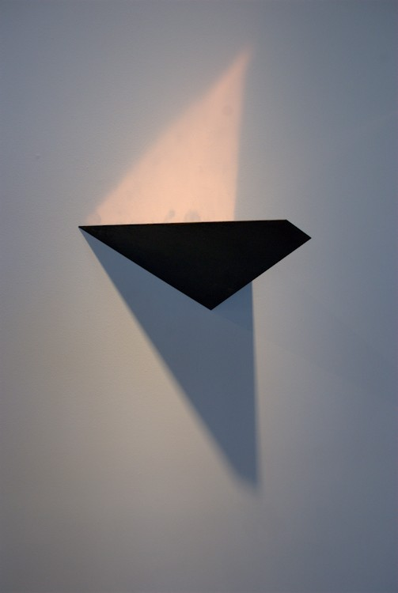
Constance DeJong
Square XV, 1991
copper and wood
7 x 14 x 10 inches
CD126
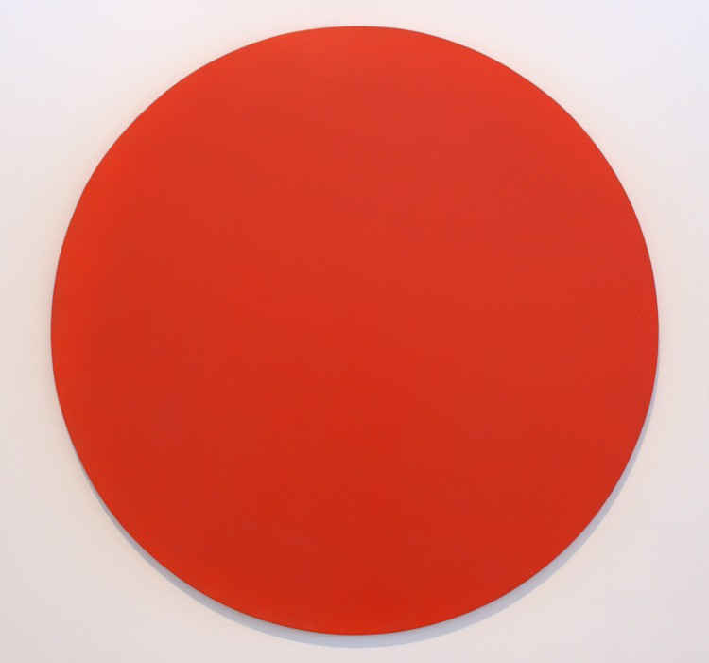
Elliot Norquist
40 Inch Red Circle, 2010
Painted steel
40 x 5/8 inches
EN0063
William Metcalf
Mindspace #35, 2012
Acrylic, graphite, Di Bond
18 x 15 inches
WM275
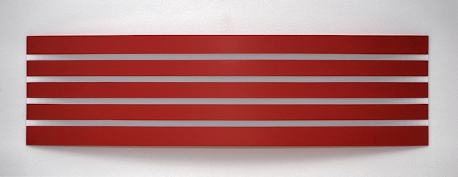

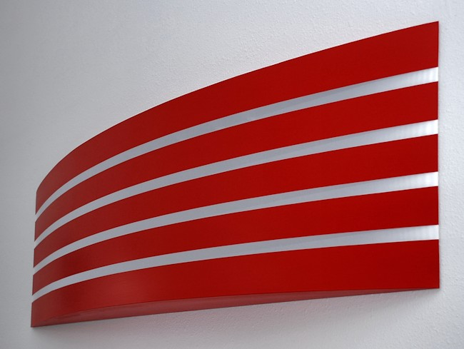
William Metcalf
Red Arc (181WM), 2010
Acrylic on polyester fabric over wood frame
19 x 72 x 5 1/2 inches
WM0186
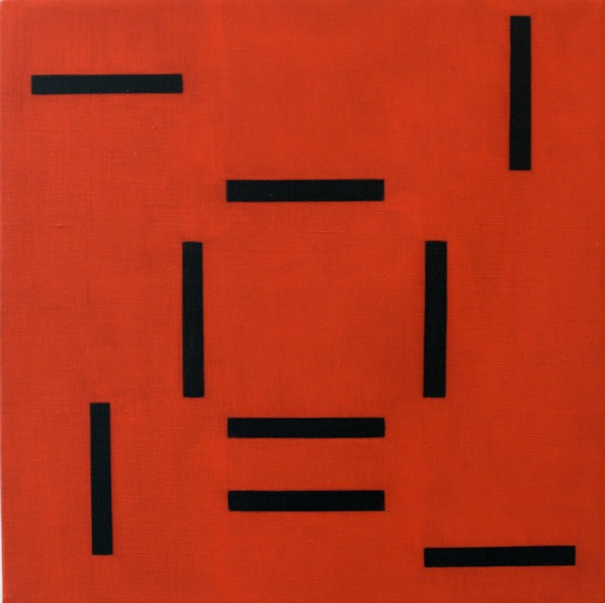
Edith Baumann
Jazz Notes #28, 2009
raw pigment on canvas
12 x 12 inches
EBA004

© 2013

Charlotte Jackson Fine Art, Inc.

In the Railyard at:

554 S. Guadalupe, Santa Fe, New Mexico 87501
Telephone: 505.989.8688 Fax: 505.989.9898
cjfa@charlottejackson.com - www.charlottejackson.com

