CHARLOTTE JACKSON FINE ART PRESENTS:

ED MOSES

GREEN/BRONZE

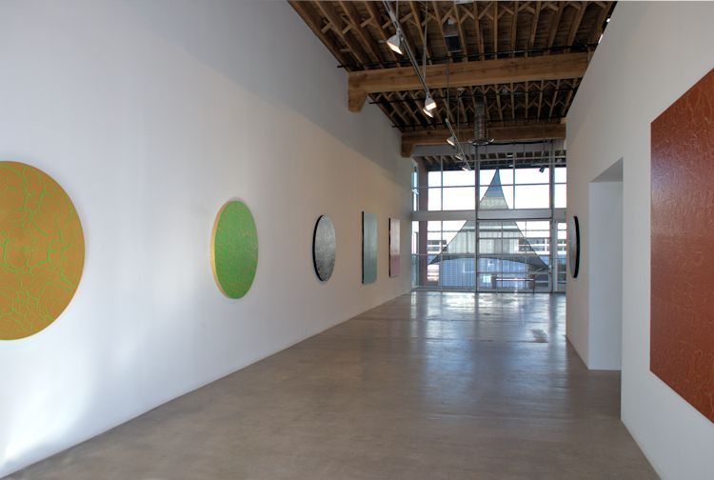

AUGUST 30 - SEPTEMBER 23, 2013
Ed Moses is one of Southern California’s preeminent abstract artists, a member of the generation that came to be known as the “cool school” in Los Angeles, alongside Larry Bell, Wallace Berman, Frank Gehry, Dennis Hopper, Robert Irwin, and Ed Ruscha, among numerous equally prominent names. His career has spanned over fifty years since his first exhibition in 1957 at the legendary Ferus Gallery in Los Angeles. Except for two brief, but important interludes (one in New York from 1958-60; the other in Europe from 1973-74) Moses has lived in Southern California and his career has been central to the history of West Coast art since the end of second World War.

In this exhibition of works by the long-time gallery artist, Charlotte Jackson Fine Art features his latest “crackle” paintings, a departure from the artist’s purely abstracted works that prompt the viewer to question the very definition of painting itself. Moses made his crackle paintings according to a formula he evolved that involves three levels of activity. In the first, a single color is laid down on the prepared canvas. To this, he adds what he calls his “secret sauce,” which causes the paint on the surface of the canvas to fracture into random crevices. Once that layer has dried, he manipulates the canvas to promote further crackling. Finally, a second color is laid down; thus follow the titles of the paintings, e.g. Green Over Gold, and its reverse,
Gold Over Green.

The crackle paintings in Green/Bronze occur in three distinct shapes: tondos, or circular paintings; rectangles in two sizes; and four individual canvases that will be mounted as one work, its shape suggesting the chevron insignia of military uniforms. When asked if the tondos referenced Italian Renaissance paintings, Moses, replied, “I decided to make circles for reasons I don’t question.”

For Moses, the crackle paintings have a certain Rorschach-like appeal that he believes to be more accessible to his viewers than the absolutely flat, paintings (referring to his monochromes from the 70’s) with no illusions to dimensionality or lines that could suggest a narrative. Just as clouds take on anthropomorphic shapes in our imaginations, this latest series of paintings offers a way for viewers to recognize forms that are familiar. “We don’t need to see bunny rabbits,” he says, but “people have a terrible time with the monochromes.” Moses poses Susan Sontag’s Against Interpretation - a brilliant essay from 1964, in which she argues that we have a need to define what an artwork “means” in order to accept or reject it as good or bad - alongside the Buddhist teaching that “you don’t interpret, you just view,” as Moses put it. For him, art and Buddhism are complementary disciplines; each offers a practice that reveals what it will. As Moses gets older, he says, he is “less interested in putting ’me’ out there with my attitude and my
personality. I let it happen. I watch it happen.”

Moses paints every day in Venice, California, beginning early in the morning. The painter revels in the rigors of his chosen discipline, “chasing something with no shape and no reference.” A student of Buddhism since 1971, Moses is able to state with absolute serenity that he does not know what he is doing. “I am a painter. I’m not an artist. I don’t like the word ’create.’ I invent them as I proceed on the path of confusion and ambition.”

On Saturday, August 31, from 2 to 3 pm, Ed Moses will appear in a dialog with Rani Singh of the Getty Research Institute. Singh is internationally known for her work as the co-curator of the Getty Center’s highly acclaimed Pacific Standard Time: Crosscurrents in LA Painting and Sculpture, a broad-spectrum initiative of exhibitions that took place throughout the Los Angeles area in 2011.

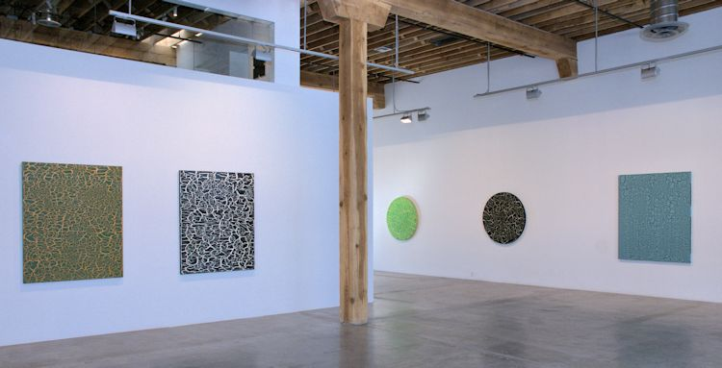
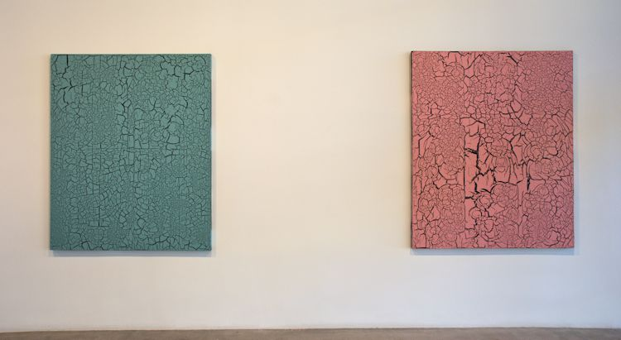

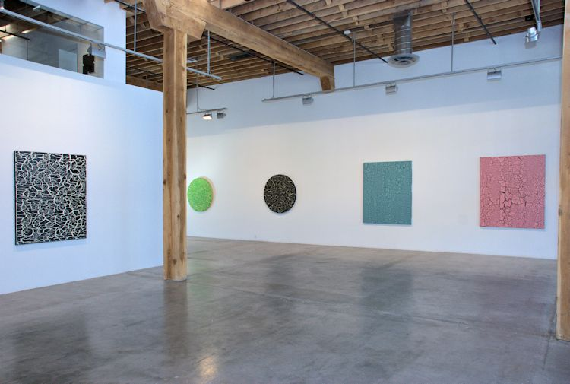
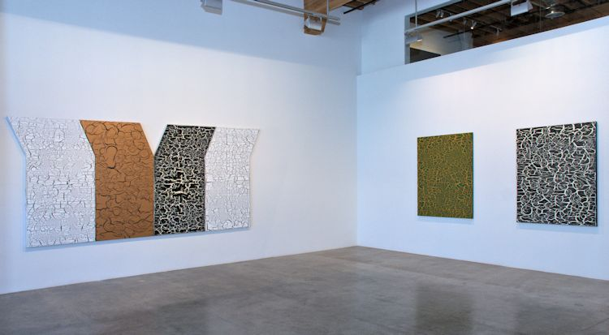

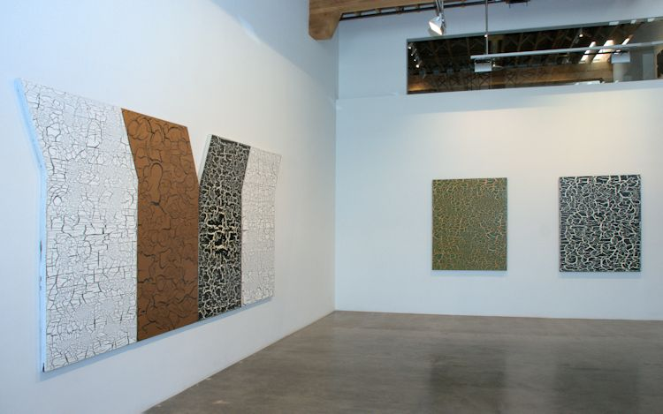
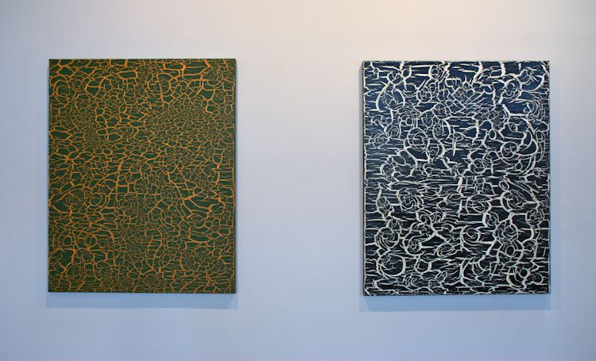

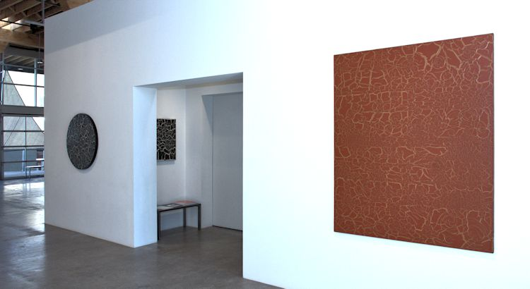
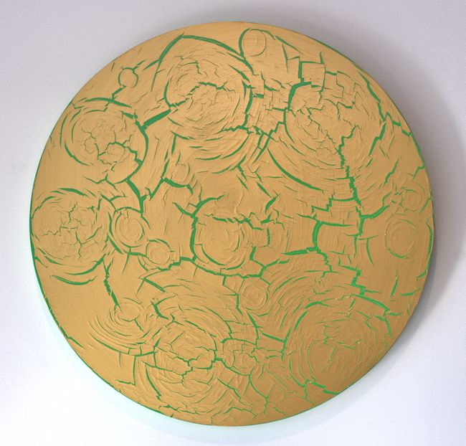
Gold Over Green, 2013
mixed media on canvas
48" diameter
EM057
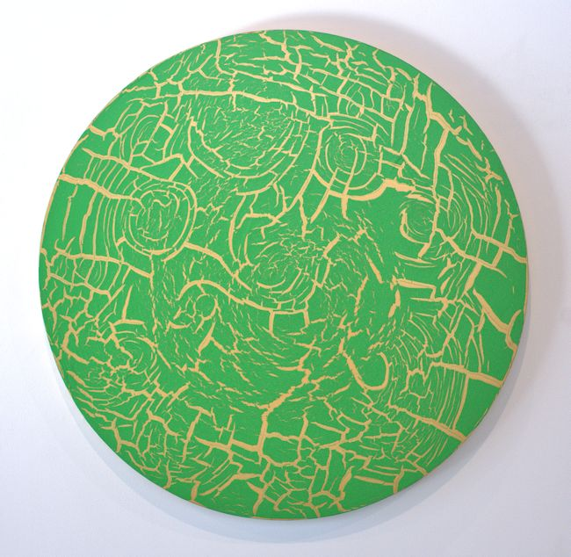
Green Over Gold, 2013
mixed media on canvas
48" diameter
EM056
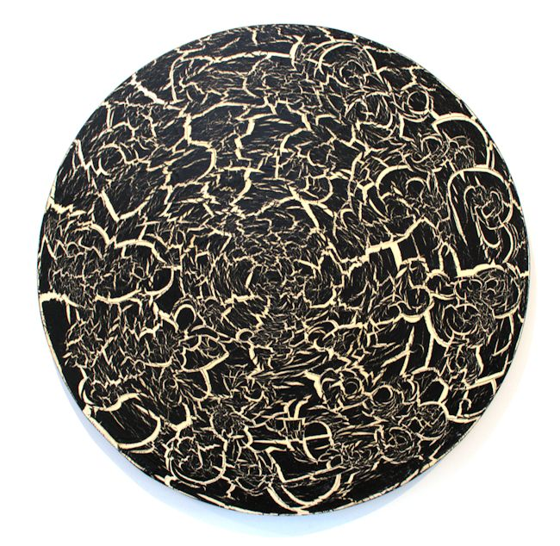
B/W, 2013
mixed media on canvas
48" diameter
EM058
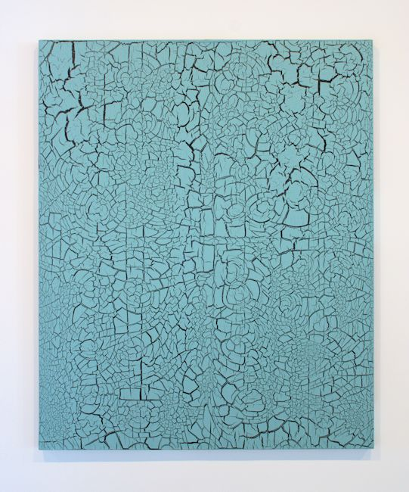
Institutional Green/Black, 2013
mixed media on canvas
66 x 54 inches
EM062
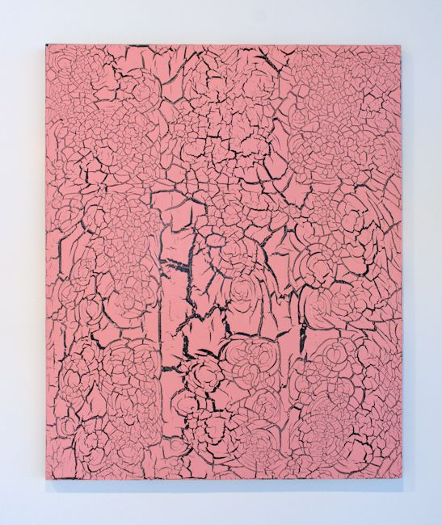
Pink Over Black, 2013
mixed media on canvas
66 x 54 inches
EM064
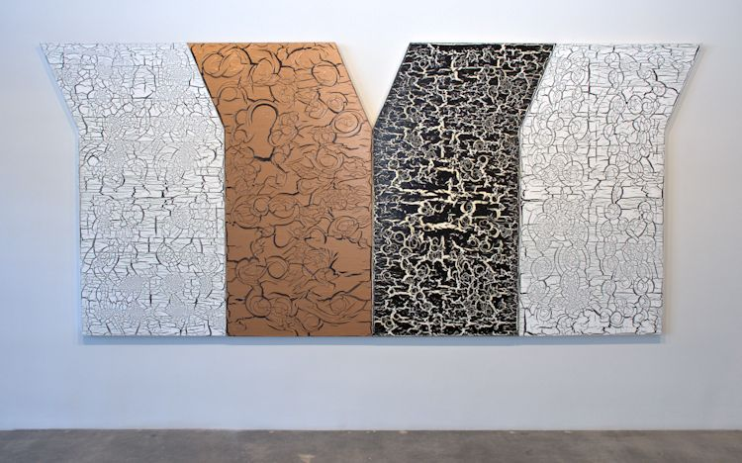
Y? Copper, 2013
mixed media on canvas
4 panels 72" x 45" each
EM065
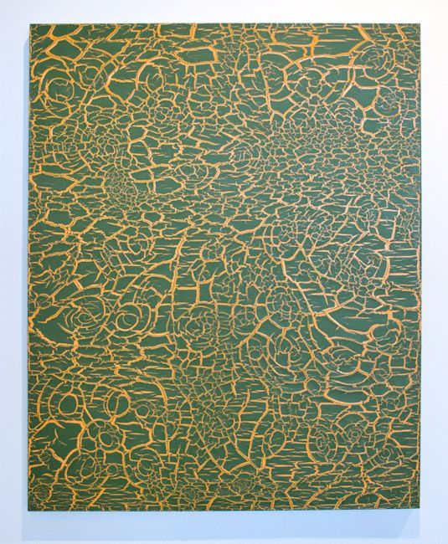
Plant Desert Must, 2013
mixed media on canvas
60 x 48 inches
EM061
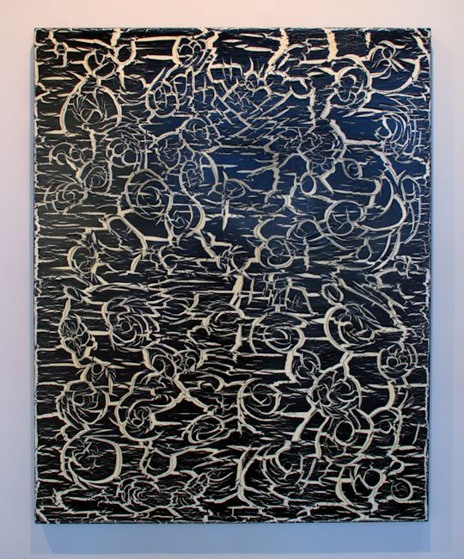
Plant Desert Must, 2013
mixed media on canvas
60 x 48 inches
EM061
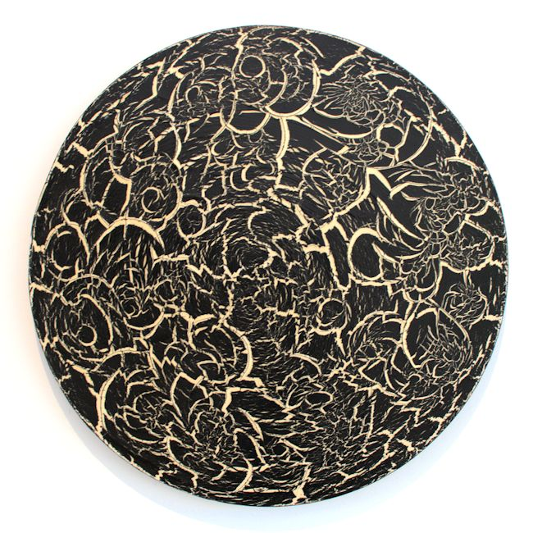
B+W, 2013
mixed media on canvas
36" diameter
EM054
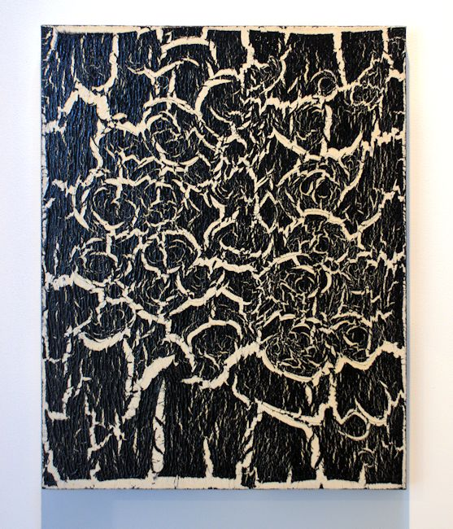
B/W, 2013
mixed media on canvas
28 x 22 x 1 3/4 inches
EM050
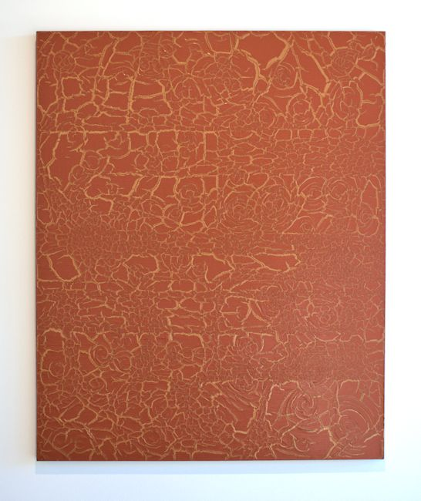
Indian Red/Gold, 2013
mixed media on canvas
66 x 54 inches
EM063

© 2013

Charlotte Jackson Fine Art, Inc.

In the Railyard at:

554 S. Guadalupe, Santa Fe, New Mexico 87501
Telephone: 505.989.8688 Fax: 505.989.9898
cjfa@charlottejackson.com - www.charlottejackson.com

