CHARLOTTE JACKSON FINE ART
PRESENTS:

DIALOGUES IN STEEL
Elliot Norquist and Jeremy Thomas

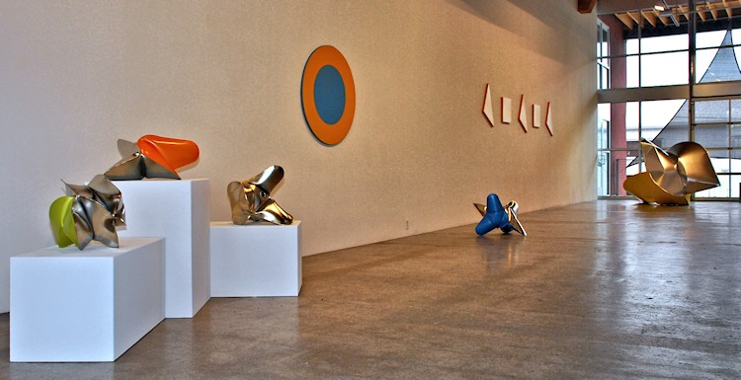
April 27, - May 27 2012

Sculptors, particularly those who work in various metals, must anticipate every bend, crease, cut and weld. That the raw material at times informs the shape of the finished piece rather than yielding to the will of the artist's hand isn't lost on Elliot Norquist or Jeremy Thomas; two artists who have spent the majority of their careers in conversation with the feral material into seemingly effortless forms. "Dialogues in Steel," is the first collaborative show between Norquist and Thomas.
Thomas is a former student of Norquist's. Each has been privy to one another's progress as artists and have reached distinctive conclusions with their respective work. In this, "Dialogues in Steel," is a moment is the lives of these two artists reconnecting in their ongoing conversation about pushing metal into broader landscapes. "Dialogues in Steel," pairs two primary architects in the world of contemporary sculpture.
Norquist creates works of high sophistication and abstraction; it is a kind of contemplative minimalism. Norquist's work dances between a series of contraries: the circle in the square, the simple in the complex, the personal in the abstract, the natural in what is man-made. Shape and color are all important. A square with a circle cut from the center, a circle with a square cut. Norquist uses the sparest of visual vocabularies. Color and shape must retain their integrity and yet merge to become art. Norquist describes this precarious walk through contraries in an elegant way.
Thomas welds forms together that he can then heat and inject with pressurized air, inflating, or "growing" them into their final shape. The final pieces contain paradox: metal molded by air, sensual forms in forceful fetish-finish primary colors gleaned from tractor manufactures. These sculptures are changeable (as one continuously finds new approaches in their creases, angles, and wrinkles); they allow a dialogue between viewer and work much in the way Thomas says he engages in an ongoing dialogue, a give and take, with his materials. As he says, "Art is the science of play," a creed that Thomas seems to take to heart, both in his work and in his life.

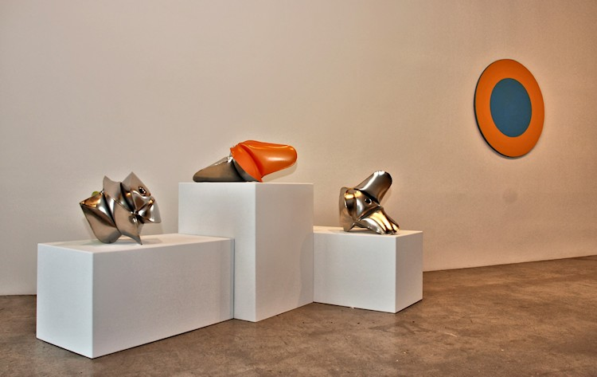

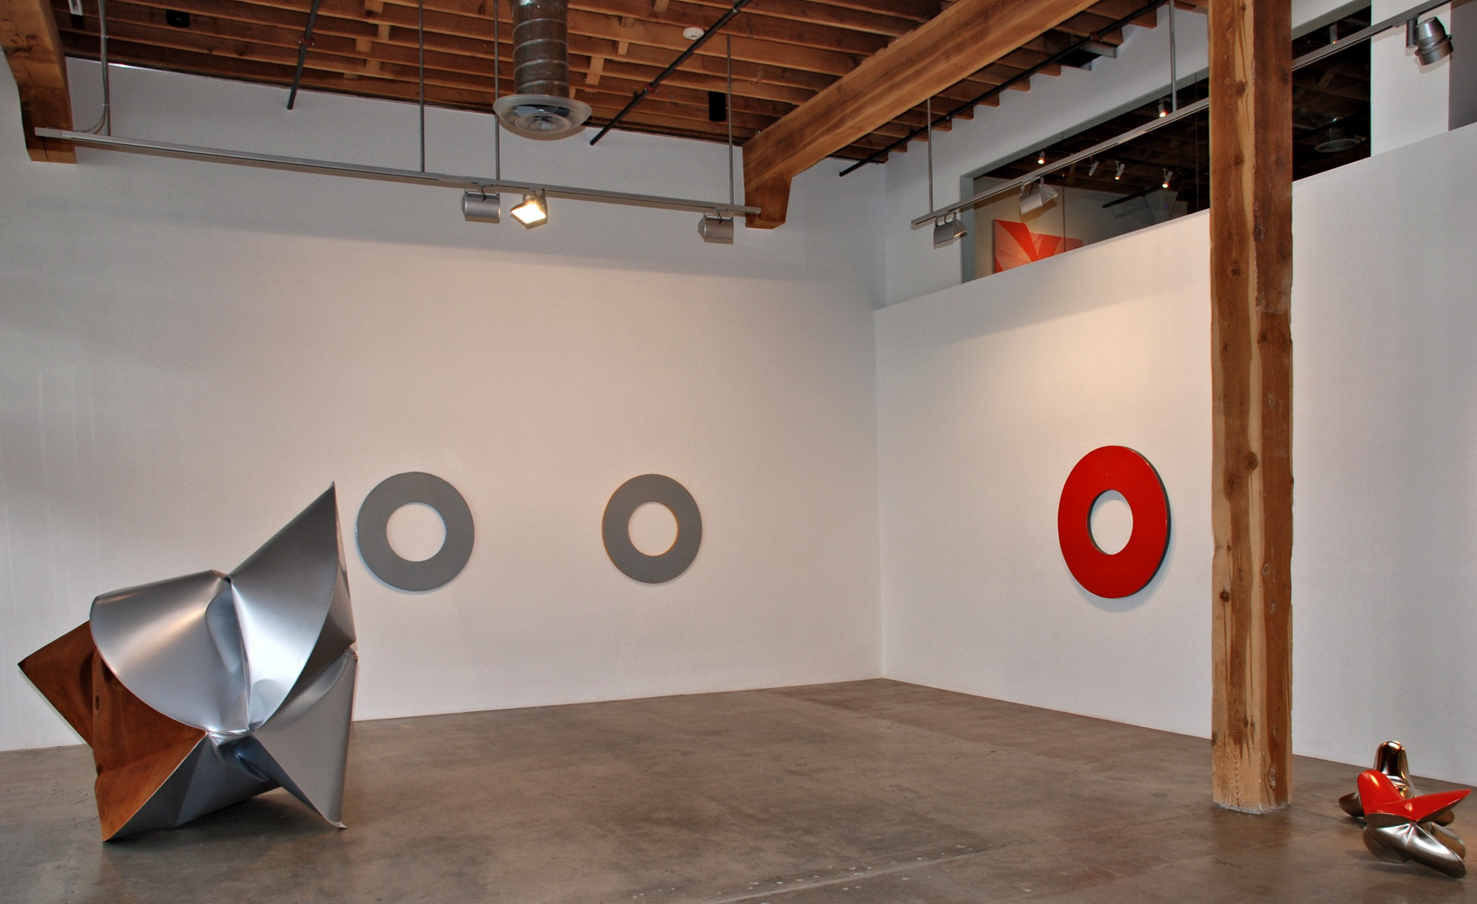
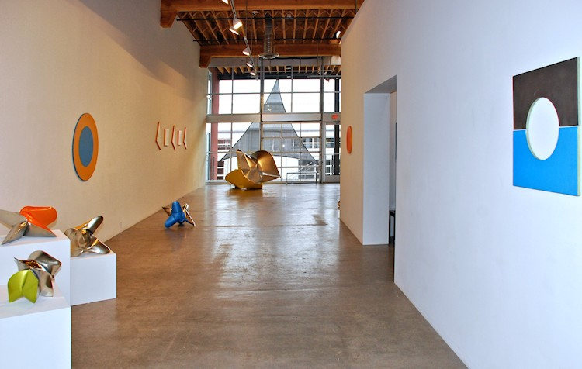

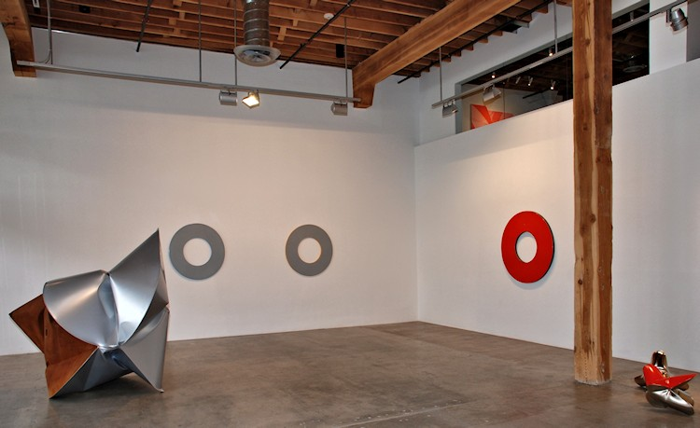
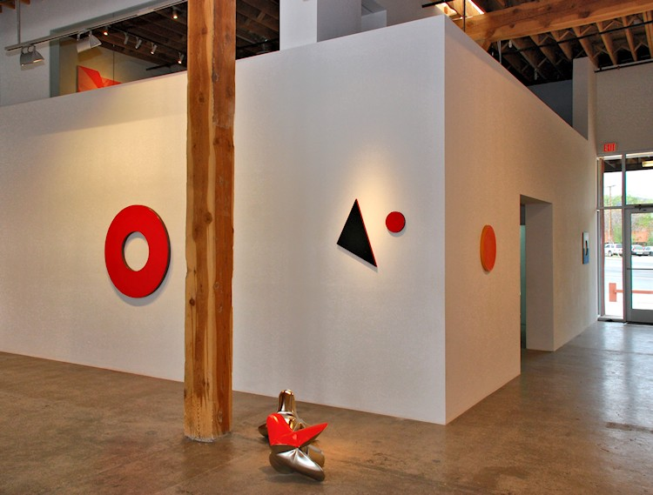

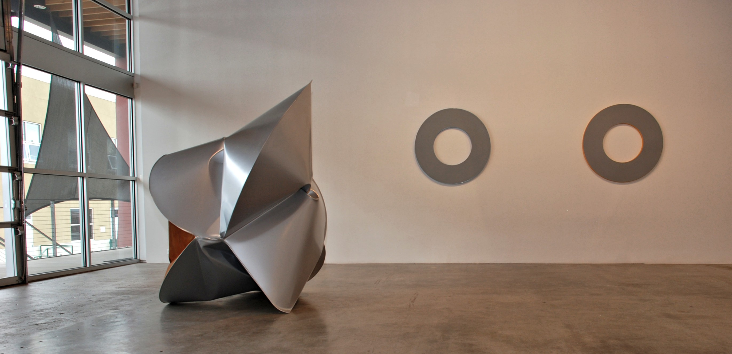
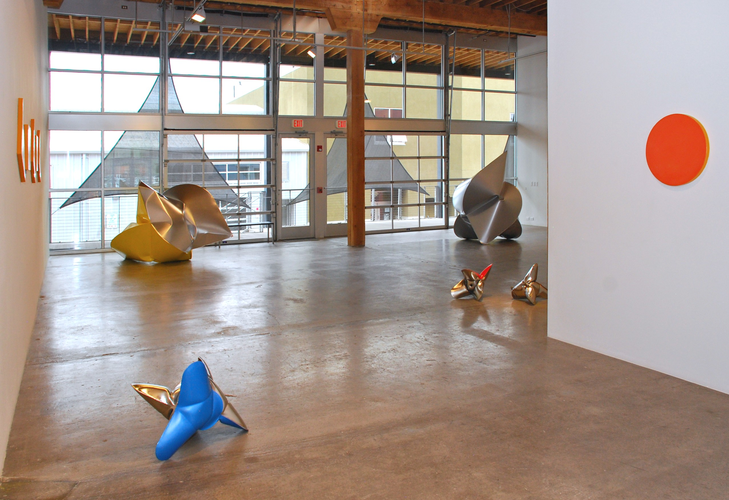
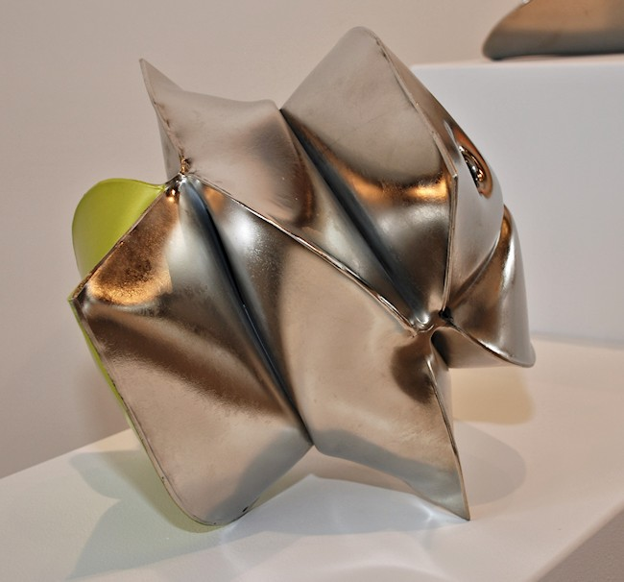
Jeremy Thomas
Soul Green, 2012
forged mild steel, nickel and acrylic
14 x 14 x 15 inches
JT242
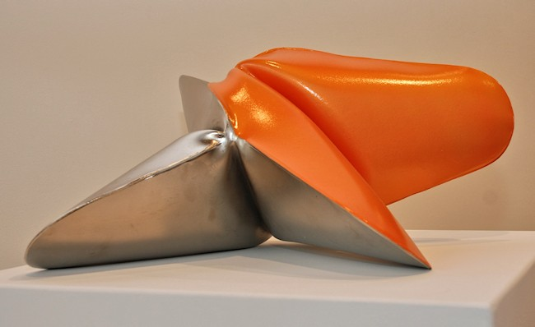
Jeremy Thomas
Aeoptolabrus Constricticallis, 2012
forged mild steel, nickel and acrylic
11 x 20 x 21 inches
JT234
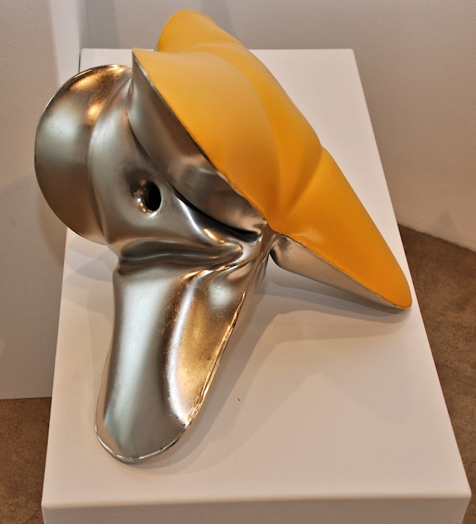
Jeremy Thomas
Southern Tailed Birdwing, 2012
forged mild steel, nickel and acrylic
15 3/4 x 14 x 18 1/2 inches
JT241
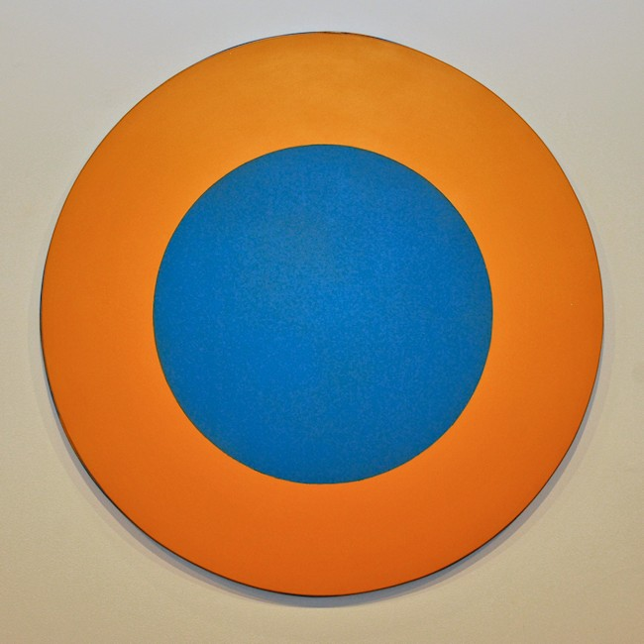
Elliot Norquist
Kansas Sunflower, 2011
painted steel
40 x 40 x 3/4 inches
EN0068
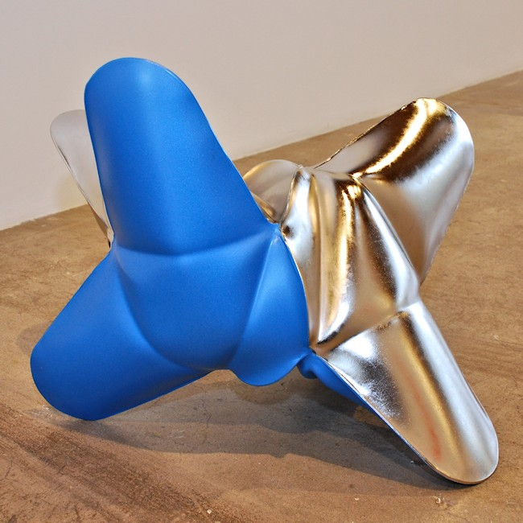
Jeremy Thomas
Morpho Didius Blue, 2012
forged mild steel, nickel and acrylic
20 x 26 x 19 1/4 inches
JT247
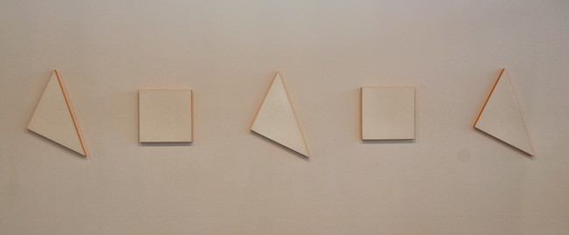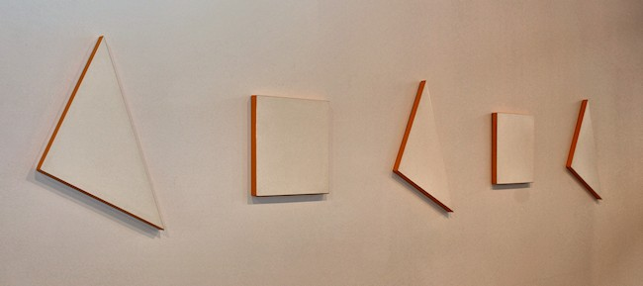
Elliot Norquist
Triangle Dance (series of 5), 2012
painted steel
18 x 18 in. square
20 x 20 x 28 in. triangle
EN0073
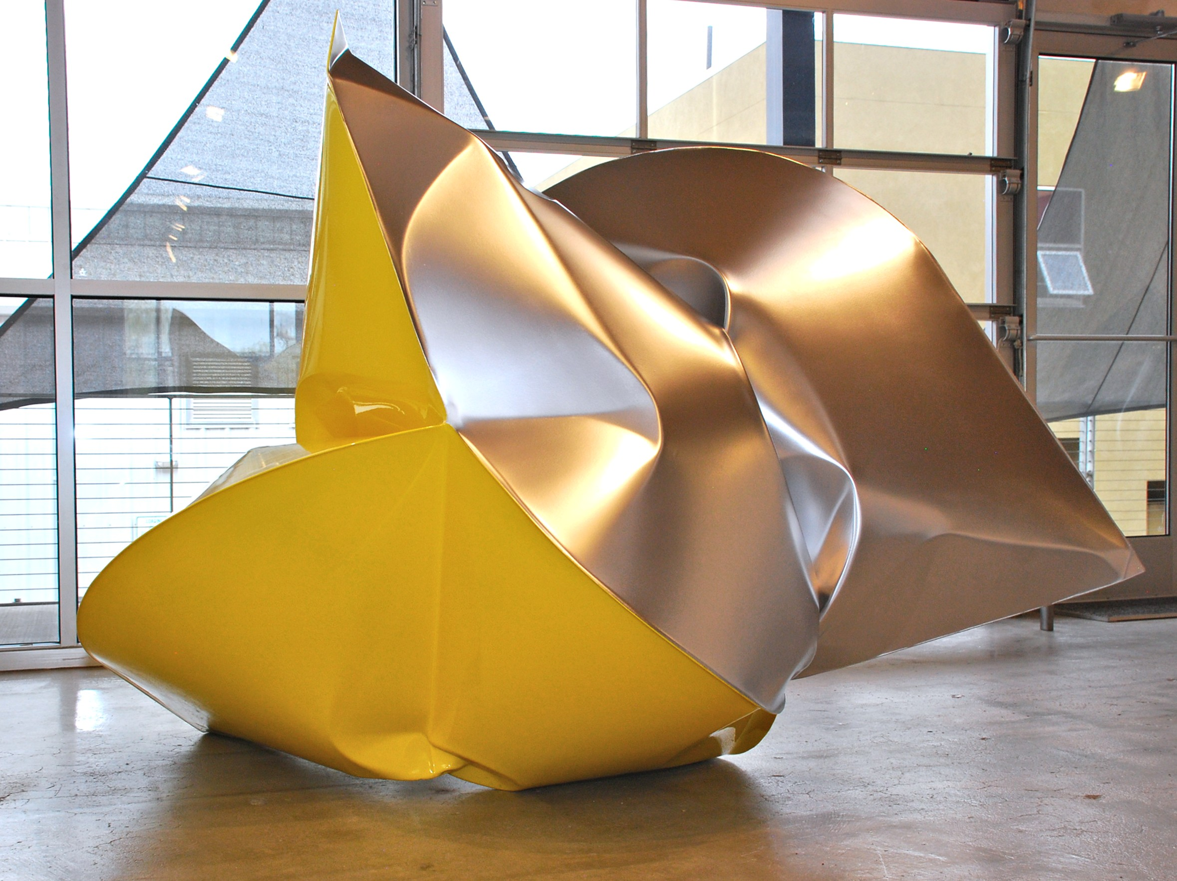

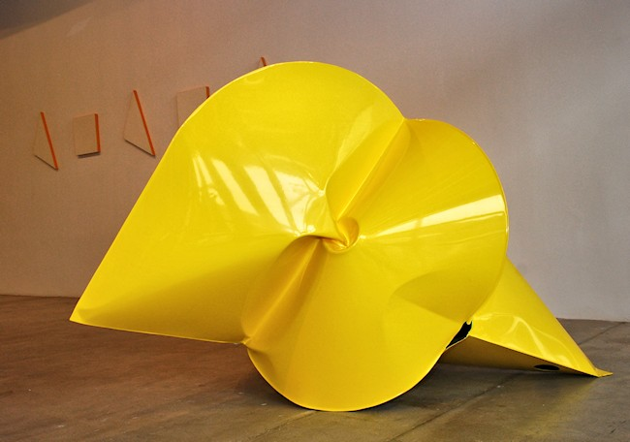
Jeremy Thomas
Bailer Yellow, 2012
forged mild steel, powder coat and oil ploymer
59 x 88 x 55 inches
JT249
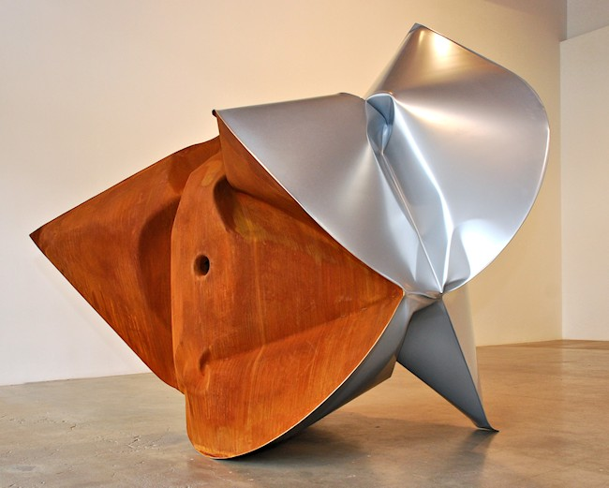
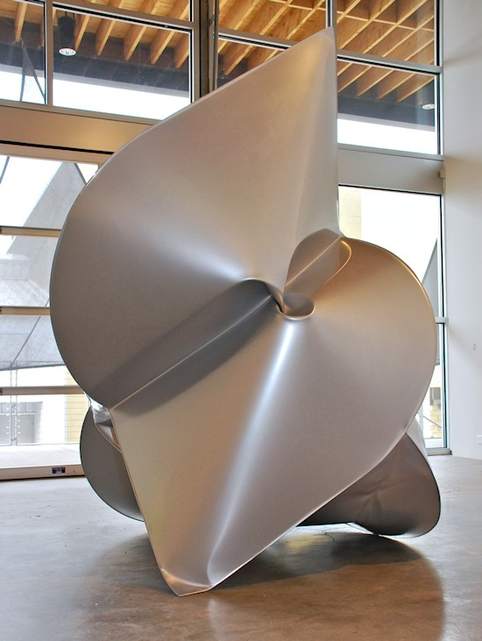
Jeremy Thomas
Gleaner, 2012
forged mild steel, and powder coat
74 x 79 x 56 inches
JT250
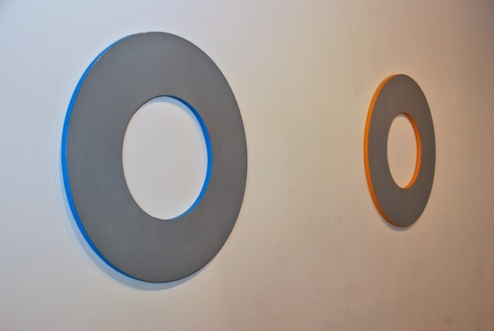

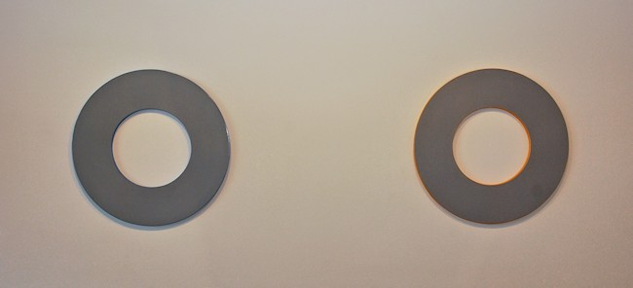
Elliot Norquist
Cat Scan, 2012, and Boost Dose, 2012
painted steel
40 x 40 x 1 1/8 inches
EN0070
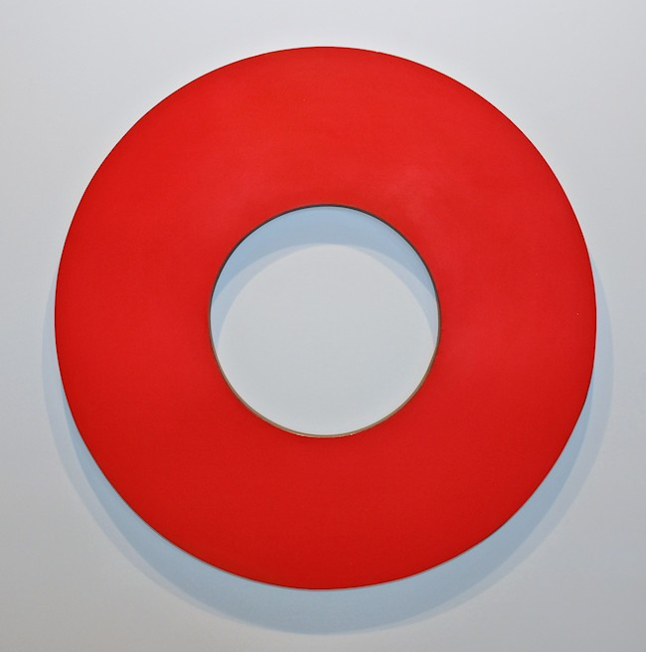

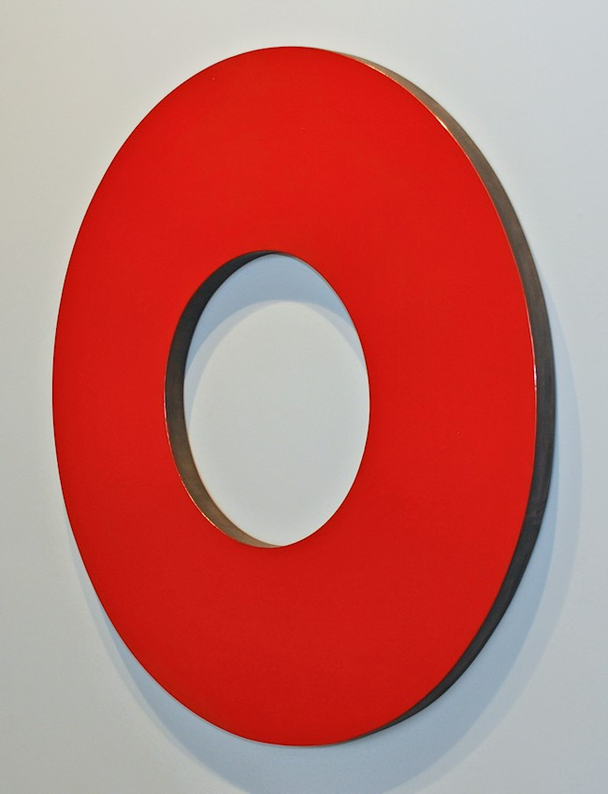
Elliot Norquist
Red Cherry Life Saver, 2012
painted steel
47 x 47 x 1 7/8 inches
EN0069
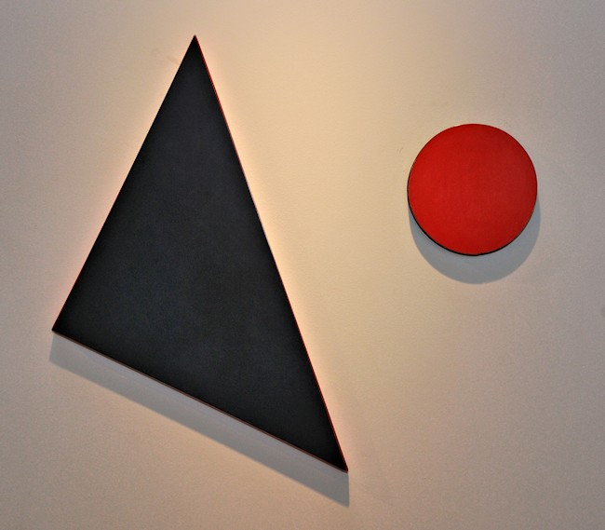
Elliot Norquist
Blackie's Triangle and Blackie's Bowl, 2012
painted steel
8 in. diameter x 1 1/8 circle
20 x 20 x 1 1/8 in. triangle
EN0074
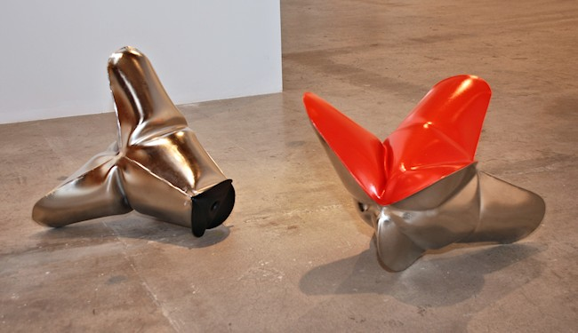
Jeremy Thomas
Liner Black, 2012
forged mild steel, nickel and acrylic
17 x 21 x 15 inches
JT248
Spitfire Red, 2012
forged mild steel, nickel and acrylic
15 x 17 1/2 x 19 inches
JT244
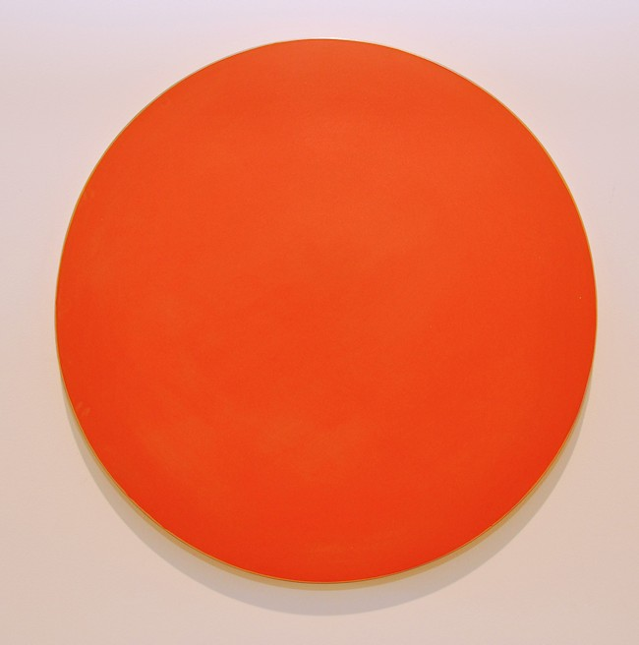

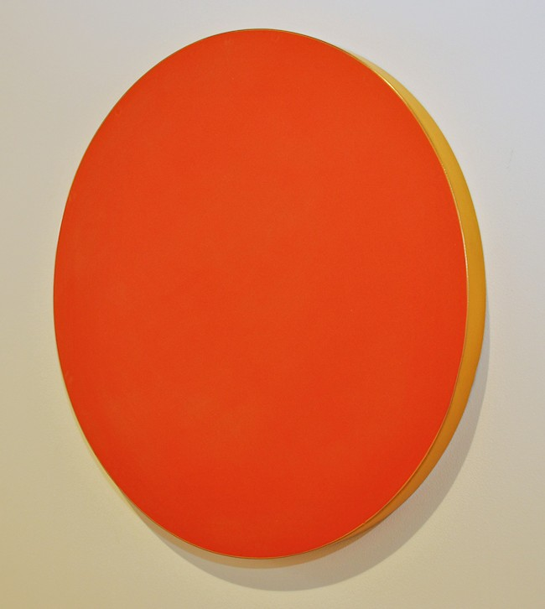
Elliot Norquist
Fire Season, 2012
painted steel
20 in. diameter x 1 3/8 circle
EN0077
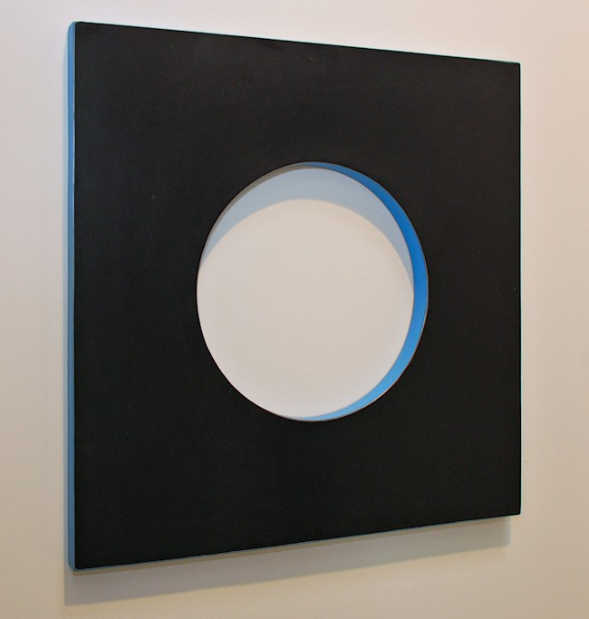
Elliot Norquist
Diagnosis, 2012
painted steel
24 x 24 x 1 inches
EN0066
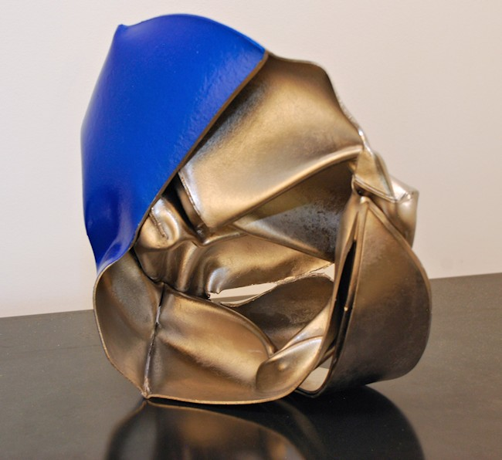
Jeremy Thomas
Sever Press, aka John Chamberlain Blues, 2011
forged mild steel, nickel and acrylic
10 1/2 x 10 1/2 x 4 inches
JT237
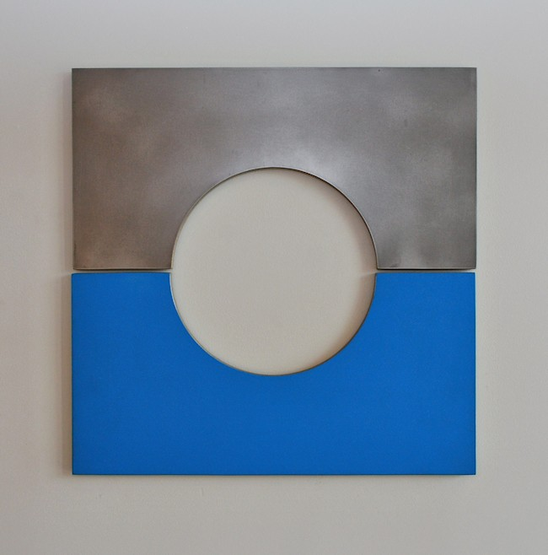

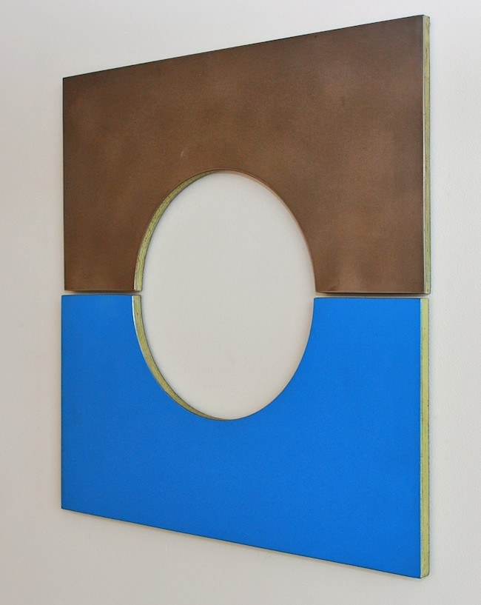
Elliot Norquist
Split Decisions, 2011
Steel, bondo & cardboard
24 x 24 x 1/2 inches
EN0067

© 2012

Charlotte Jackson Fine Art, Inc.

In the Railyard at:

554 S. Guadalupe, Santa Fe, New Mexico 87501
Telephone: 505.989.8688 Fax: 505.989.9898
cjfa@charlottejackson.com - www.charlottejackson.com

