CHARLOTTE JACKSON FINE ART
PRESENTS:

Heiner Thiel and Michael Post:
In a silent dialogue
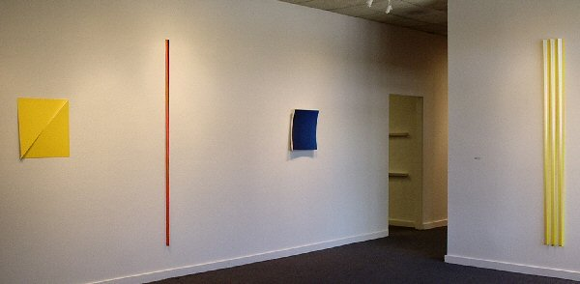
August 18 - September 10, 2006
German artists Heiner Thiel and Michael Post bring to this collaborative exhibition works that stretch the boundaries of both “traditional” painting and “traditional” sculpture. Pieces, “hung” onto the walls, reach out into space and challenge notions of surface. The title of this collaborative show, “In a silent dialogue,” is a play on the title of Miles Davis’ jazz album, In a silent way, particularly beloved by both artists. The suggestion of dialogue and silence is apt in the way that these pieces, in many ways quite different in appearance, speak to each other and command a quiet attention of the viewer.
Thiel’s current works are of anodized aluminum. Thick aluminum is formed in a gentle concave curve, based from a sphere, which is cut into various shapes and anodized with intense colors. These works, attached to the wall at a single point, appear to float off of the wall in a graceful outward arc. Head-on they can almost appear two-dimensional, but as one walks around them the concavity of the surface becomes apparent, not only from the work’s relationship to the wall, but in the shifts in color that emerge.
Post’s works are of wood, painted with acrylic. His works are made up of what he calls “modules,” each module constructed of two elongated tetrahedrons, cut to precise form by fabricators. The two wedge shapes are attached so that the thickness and width of either end are matched exactly and inversed (narrower to wider, blunt surface to narrow surface). The modules are painted with from one to three colors in ways that offset the movement and visual confusion created by the module shape. A single piece is made up of from one to several modules set on the wall in various arrangements.
As with Thiel’s pieces, Post’s works engage the wall itself, incorporating it into part of the perception process. These modules also, like the concave aluminum pieces, shift and change as the viewer moves around them. In the works of both artists, perception itself is teased by the delicate shifts that shape and color make and one quickly finds oneself on the edge of paradox: stillness requiring movement, simple forms used in complex ways, the illusions of color shift and shadow.
Although the geometric and exact nature of their works might suggest a mathematical emphasis both artists see themselves as engaging in the key questions posed by reductionist art, in particular the relationships between the second and third dimensions. As Thiel and Post write, “Whether we like it or not, the wall is the surface on which we project our thinking sight. Everything that hangs on a nail becomes a picture … The wall becomes the picture holder of the room in which we are really living, and thus is how we enter the picture.” The notion of surface itself is here called into question, for as Thiel and Post point out, in reality there is no such thing as a two-dimensional surface.
MAIN GALLERY:
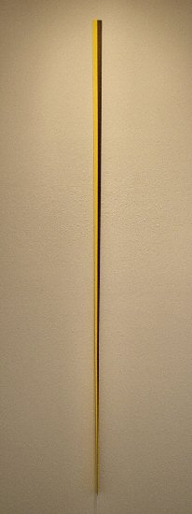
MICHAEL POST
Untitled wvz 10/06/102, 2006
Acrylic on wood, 82” x 2” x 2” MP003
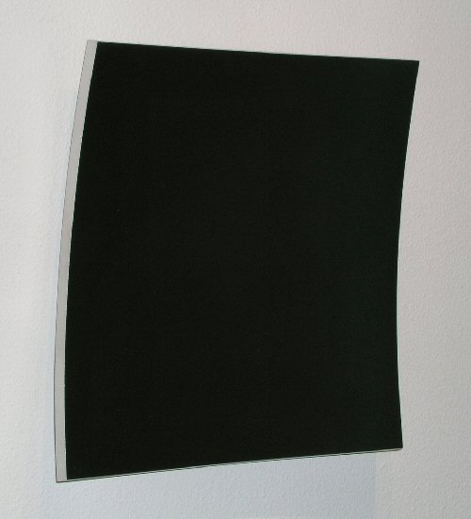
HEINER THIEL
Untitled wvz 436, 2005
Anodized aluminum, E6 S170-1, 19” x 18” x 3”, HT0011
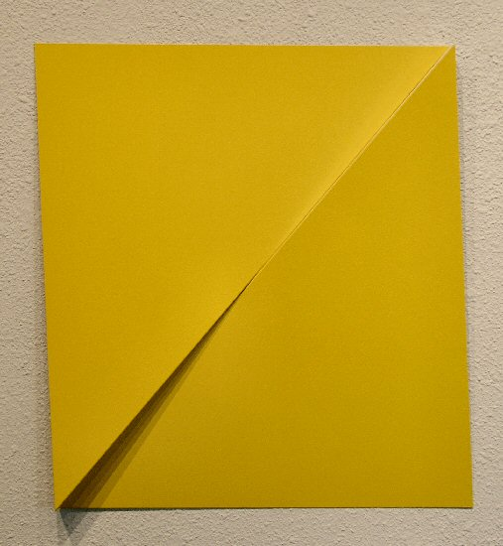
MICHAEL POST
Untitled wvz 15/06/108, 2006
Acrylic on aluminum, 19” x 19” x 2” MP007
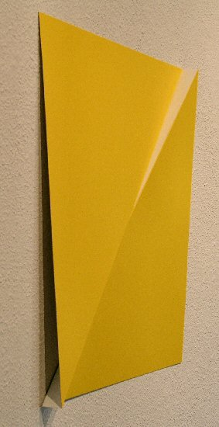
MICHAEL POST
Untitled wvz 15/06/108, 2006
Acrylic on aluminum, 19” x 19” x 2” MP007 (detail)
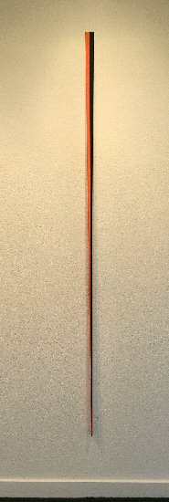
MICHAEL POST
Untitled wvz 12/06/104, 2006
Acrylic on wood, 82” x 2” x 2” MP004
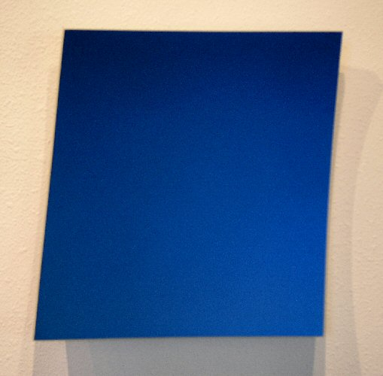
HEINER THIEL
Untitled wvz 448, 2005
Anodized aluminum, E6 C63-1, 19” x 18” x 4”, HT0018
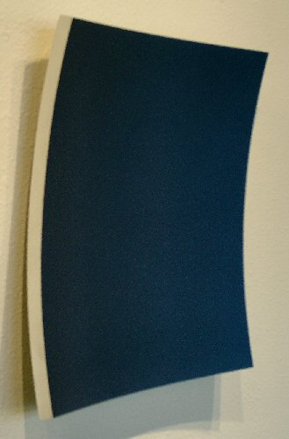
HEINER THIEL
Untitled wvz 448, 2005
Anodized aluminum, E6 C63-1, 19” x 18” x 4”, HT0018 (detail)
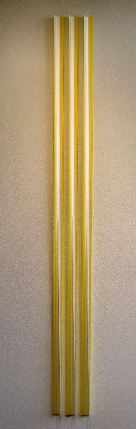
MICHAEL POST
Untitled wvz 13/05/75, 2005
Acrylic on wood, 82” x 8” x 2” MP001
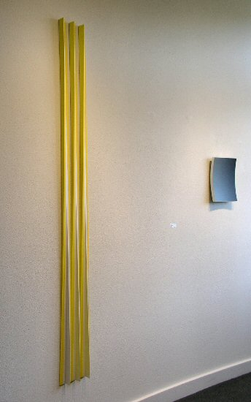
MICHAEL POST
Untitled wvz 13/05/75, 2005
Acrylic on wood, 82” x 8” x 2” MP001 (detail)
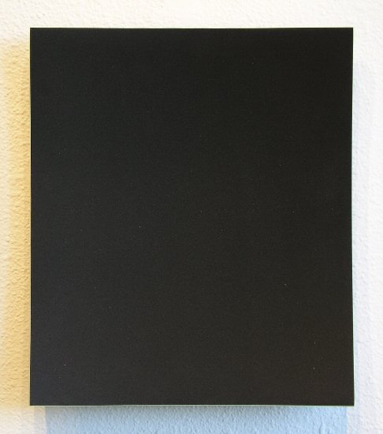
HEINER THIEL
Untitled wvz 453, 2006
Anodized aluminum, E6 C65-1, 13” x 11” x 2”, HT0012
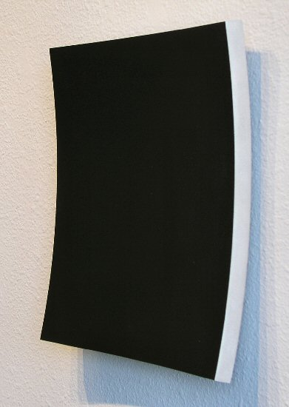
HEINER THIEL
Untitled wvz 453, 2006
Anodized aluminum, E6 C65-1, 13” x 11” x 2”, HT0012 (detail)
HALLWAY:

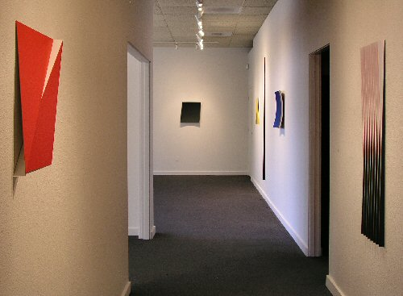
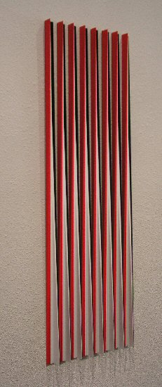
MICHAEL POST
Untitled wvz 8/05/67, 2005
Acrylic on wood, 48 ½” x 19” x 1 ½” MP0010
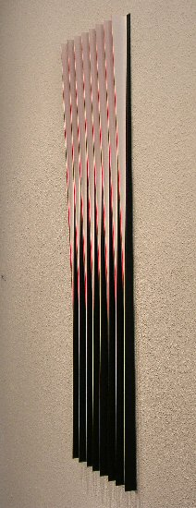
MICHAEL POST
Untitled wvz 8/05/67, 2005
Acrylic on wood, 48 ½” x 19” x 1 ½” MP0010 (detail)
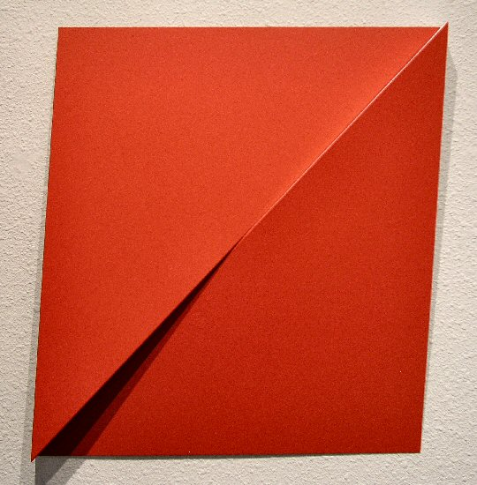
MICHAEL POST
Untitled wvz 16/06/109, 2006
Acrylic on aluminum, 19” x 19” x 2” MP008
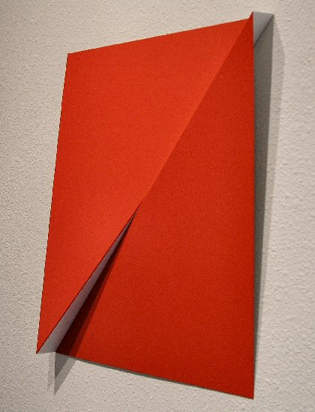
MICHAEL POST
Untitled wvz 16/06/109, 2006
Acrylic on aluminum, 19” x 19” x 2” MP008 (detail)
GALLERY II:
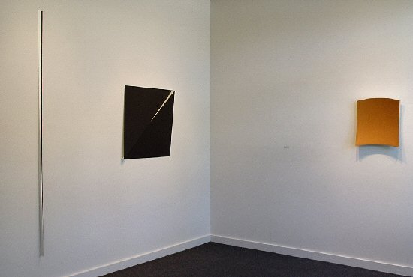
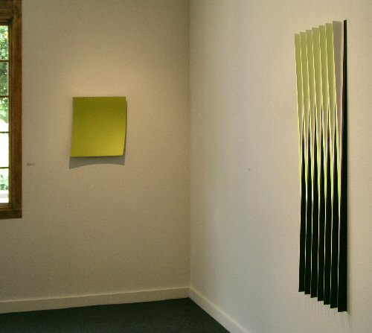
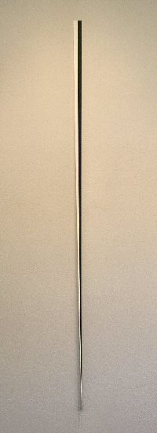
MICHAEL POST
Untitled wvz 11/06/103, 2006
Acrylic on wood, 82” x 2” x 2” MP005
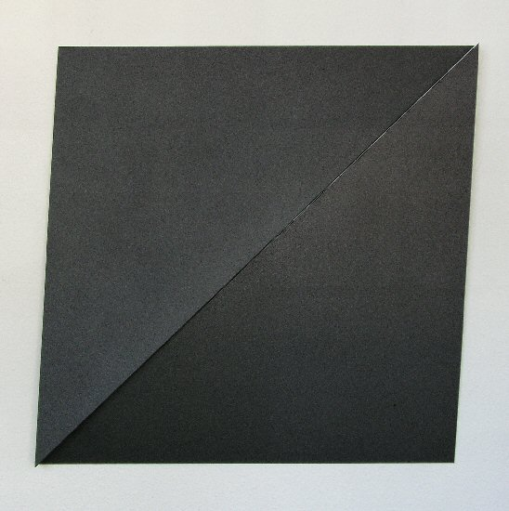
MICHAEL POST
Untitled wvz 13/06/106, 2006
Acrylic on aluminum, 31” x 31” x 2” MP0012

HEINER THIEL
Untitled wvz 444, 2005
Anodized aluminum, E6 C61-1, 18” x 17” x 3”, HT0013
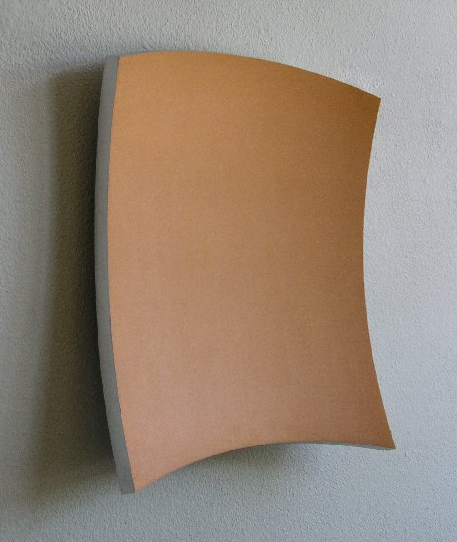
HEINER THIEL
Untitled wvz 444, 2005
Anodized aluminum, E6 C61-1, 18” x 17” x 3”, HT0013 (detail)
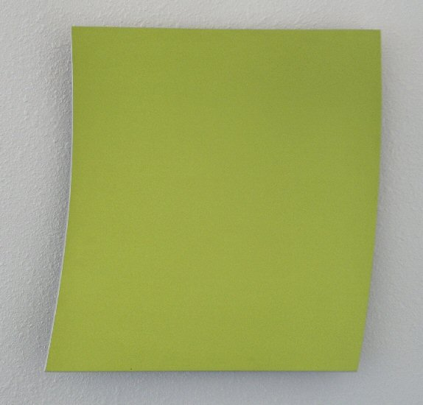
HEINER THIEL
Untitled wvz 452, 2006
Anodized aluminum, E6 C60-1, 19” x 18” x 3”, HT0016
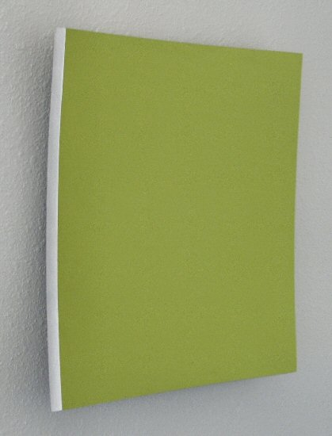
HEINER THIEL
Untitled wvz 452, 2006
Anodized aluminum, E6 C60-1, 19” x 18” x 3”, HT0016 (detail)
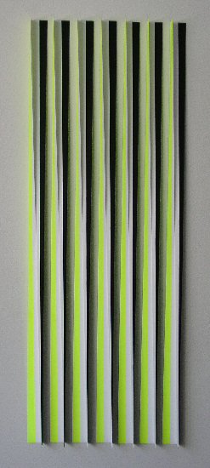
MICHAEL POST
Untitled wvz 17/04/60, 2004
Acrylic on wood, 55” x 22” x 2” MP002
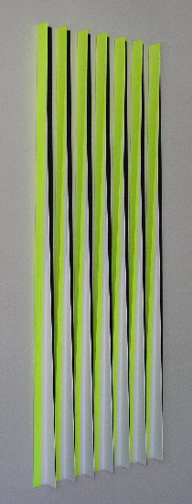
MICHAEL POST
Untitled wvz 17/04/60, 2004
Acrylic on wood, 55” x 22” x 2” MP002 (detail)

© 2006

Charlotte Jackson Fine Art, Inc.

200 West Marcy Street, Suite 101, Santa Fe, New Mexico 87501
Telephone: 505.989.8688 Fax: 505.989.9898
cjfa@charlottejackson.com - www.charlottejackson.com

