CHARLOTTE JACKSON FINE ART PRESENTS:

TONY DELAP

Paintings and Drawings

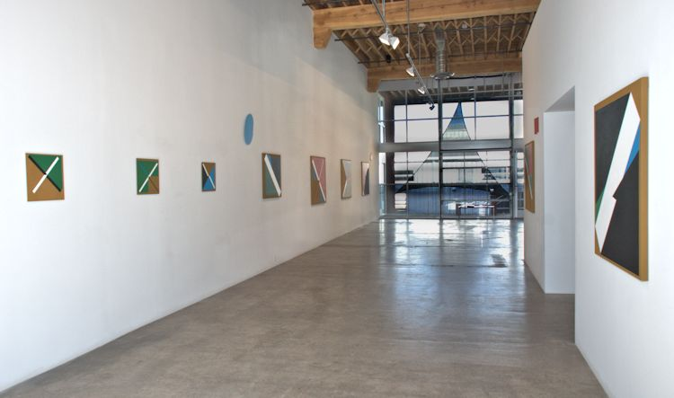

September 27 – October 27, 2013
The eye moves to the seam where white meets red, slides deep into black space and roves on, slips, and falls. The edge is unexpected. It curves away, strangely, and back. The viewer moves to follow the line of the edge, thicker and thinner, and is pulled inextricably back to the beginning as the edge curls in on itself. Edge, no edge. Like the conundrum of a Mobius band—a connecting strip which has neither an inside nor an outside edge because of a twist in the piece—DeLap manages to create edges that defy understanding. So much of the action of the pieces occurs here—behind the traditional surface, the place where “art” is thought to be.

Paintings, sculptures, pieces that are both and neither—these works present a truly unique mastery of form and color, of shape and construction. Their deceptive simplicity underscores a series of perceptual enigmas. In the paintings, the viewer cannot help but read depth and dimension into the two-dimensional shapes skillfully juxtaposed and overlapped on the surface of the canvas. But it is not the end effect so much as the process which is remarkable. The mind of the viewer understands that it is being manipulated and therefore notices itself noticing—like a form of meditation. The construction of the pieces, deceptive and challenging, is at least partially revealed by the process of showing the edges, revealing the mechanics of construction behind the surface—and yet that revelation does not make them any less of a mystery. Another paradox. It may be impossible to merely look at a painting by Tony DeLap—most viewers will find themselves actively engaged with each one.

DeLap is a veteran of the West Coast’s art scene where he was an early follower of Modernism and the Russian Constructivists, pursuing geometrical abstraction as it moved toward minimalism. He studied at the San Francisco Academy of Art and later at the Claremont Graduate school. In the early years in his studio in Oakland, DeLap had wide interests and influences, including architecture and graphic design. It is clear to see the influence of these skill sets on his work, not only in their clean lines and complex geometries, but in their distinctive and cunning construction. DeLap’s first work was mostly with glass sculpture and he received early attention, getting a cover of Artforum magazine. He taught at the California College of Arts and Crafts, then received an offer to be one of the founding members of the art department at the newly founded University of California at Irvine. DeLap’s influence on future artists included mentoring notables like Bruce Nauman, James Turrell, and John McCracken. DeLap was among those included in seminal exhibitions in the 1960’s like the “American Sculpture in the Sixties,” exhibition at the Los Angeles County Museum of Art. His pieces have been included in prestigious collections from the Metropolitan Museum of Art to the Hirshorn, the Whitney, and the Tate in London.

Though DeLap’s work has been aligned with various twentieth century art movements, including minimalism and Op Art, he seems to defy or elude most solid categories. He has always been an artist whose personal decisions and conceptions of art led him, rather than someone swayed by the latest fads. For example at a time when sculpture was moving more and more into the use of fabrication, DeLap maintained his preference for hand-making. As he says, “I enjoyed the whole process, beginning to end, that was important to me, a reason for doing it.” It is easy to see that consummate mastery, and that love, in the pieces themselves.

It is difficult to find a review or biography of DeLap that does not include his love (and skill at) magic. Though there are comparisons to be drawn between the perceptual manipulations of a slight-of-hand magician and one of DeLap’s pieces, for DeLap the connection is less philosophical than practical. He speaks about the necessity for practicing a card trick over and over, to the point where it is seamless, flawless. There is a magic in the very ability of the hands to perform such precise feats, and a satisfaction in the achievement of that mastery. Great art always reveals this exact quality. As DeLap says, “Isn’t all art magical?”
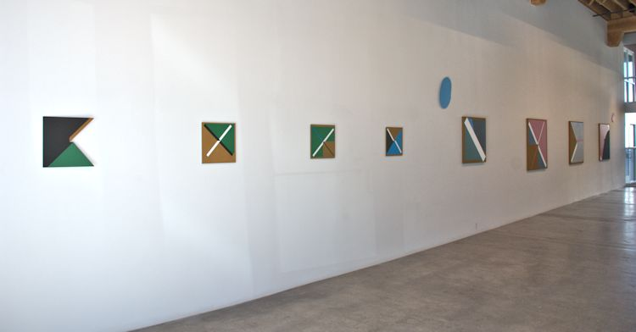
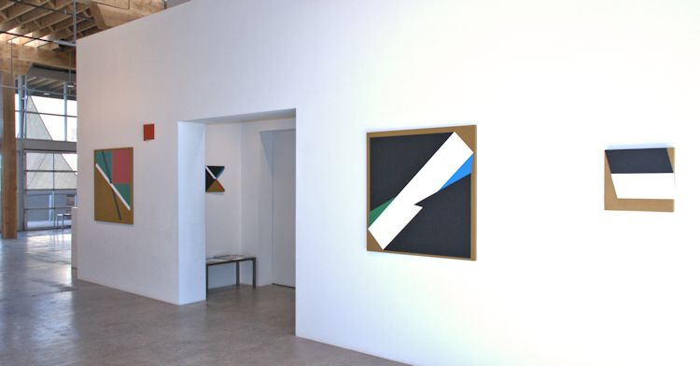

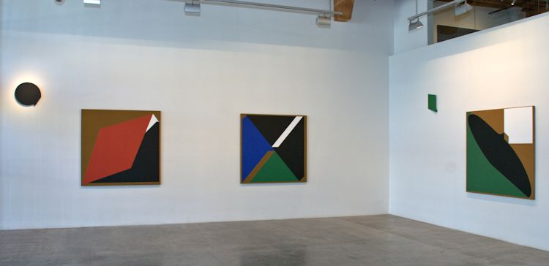
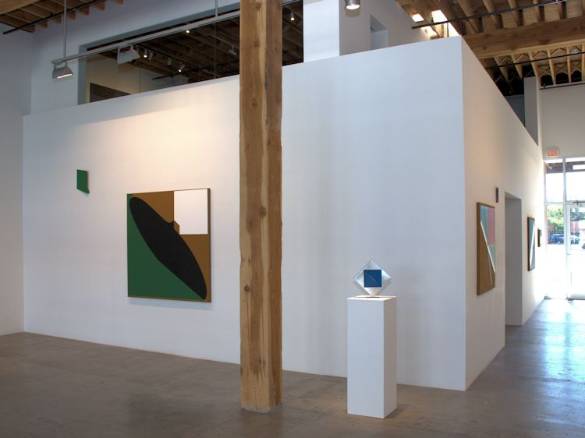

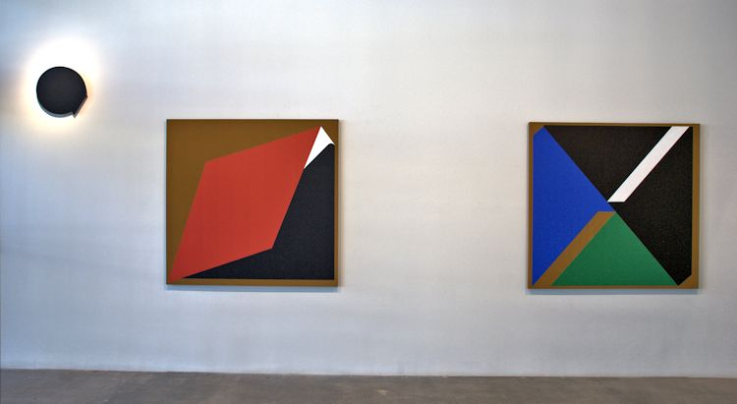
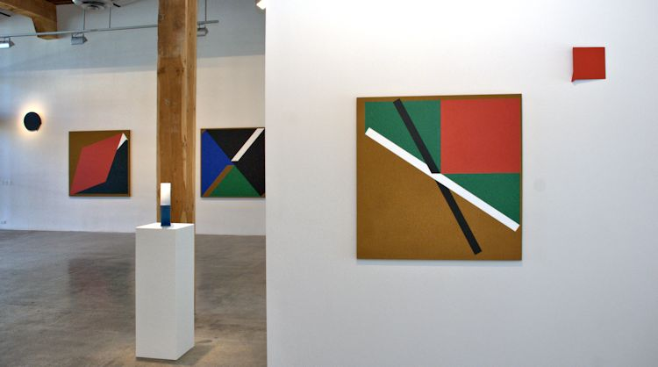

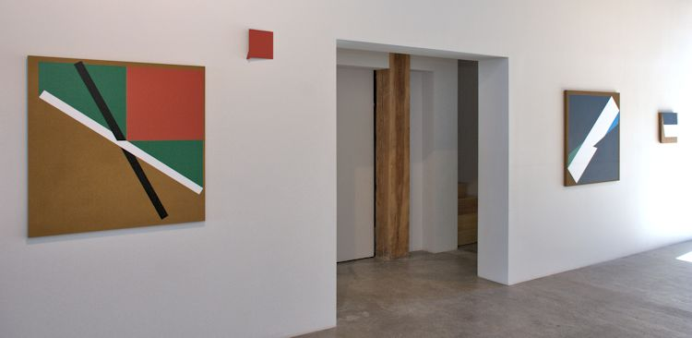
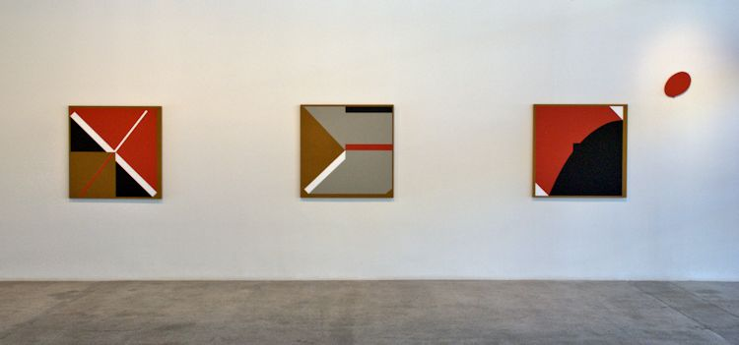

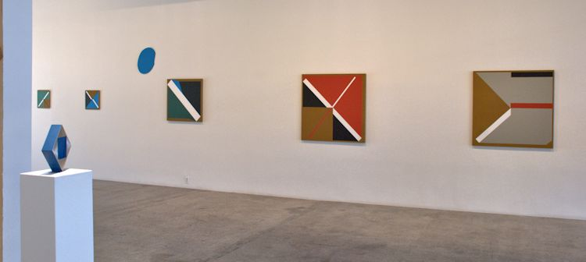
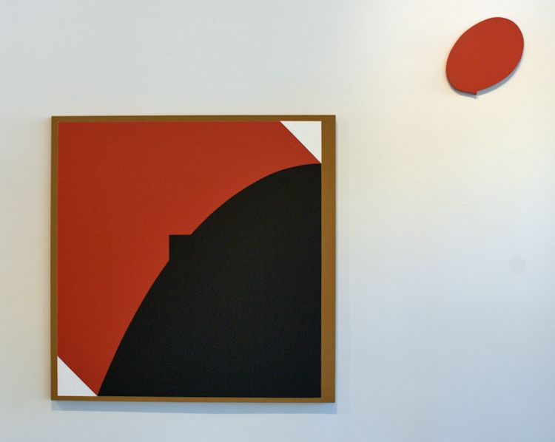
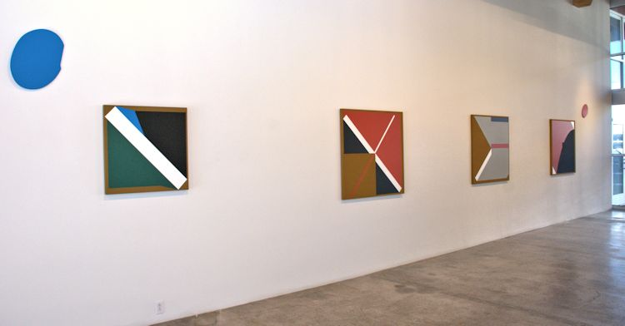

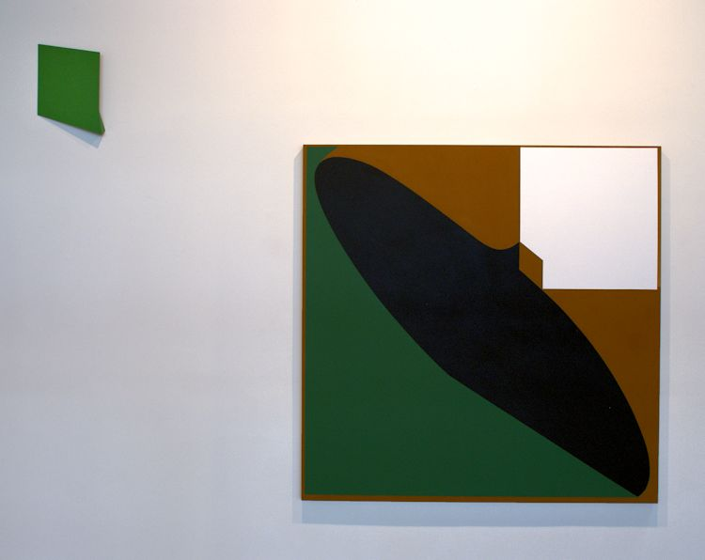

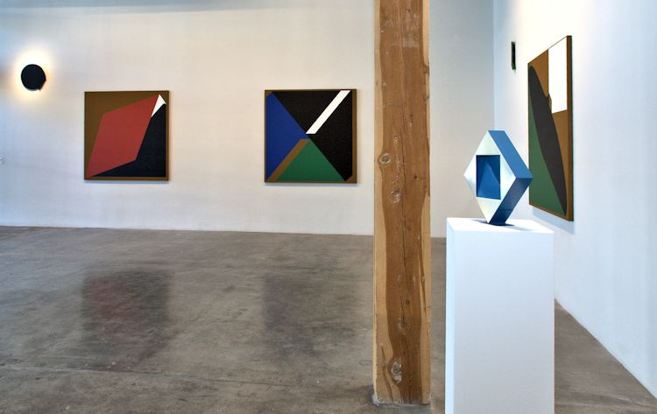

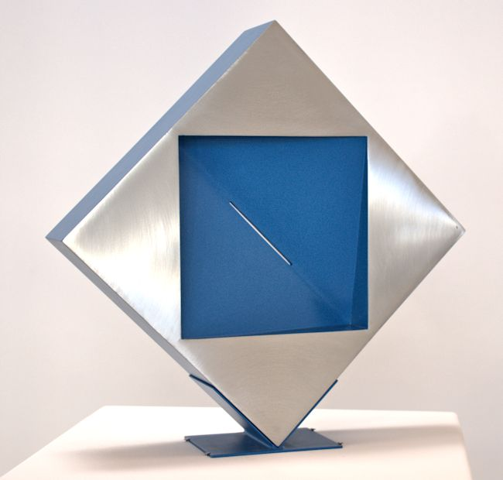
Nicola, 1968
Cast epoxy resin, aluminum, lacquer
14 x 14 x 3 inches
TD0120
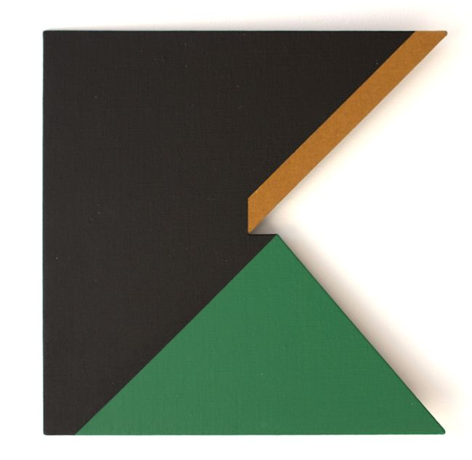
More Second Sight, 2013
Acrylic on linen, aluminum
15 x 15 inches
TD0108
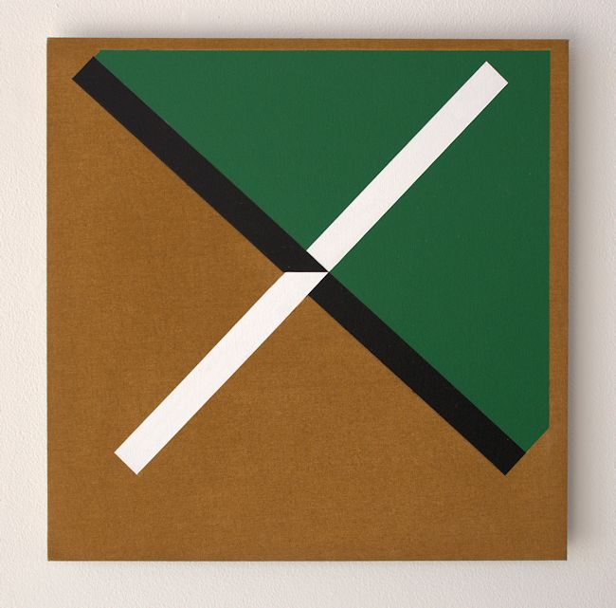
Uncanny, 2013
Acrylic on linen, aluminum
15 x 15 inches
TD0106
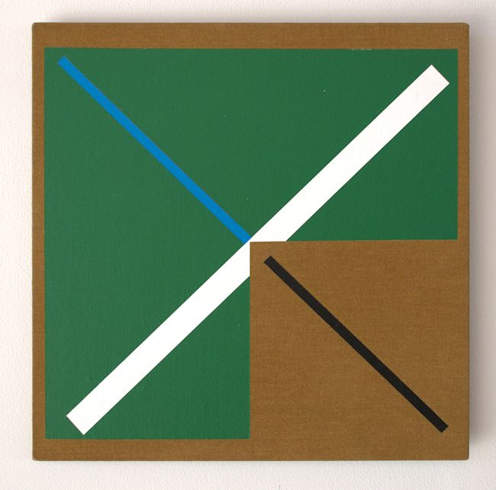
Zelo, 2013
Acrylic on linen, aluminum
15 x 15 inches
TD0105
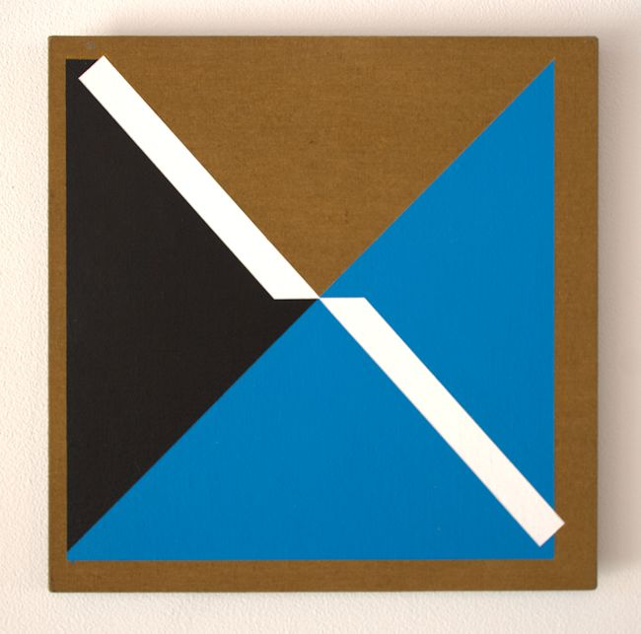
NothingTo Hide, 2013
Acrylic on linen, aluminum
15 x 15 inches
TD0107
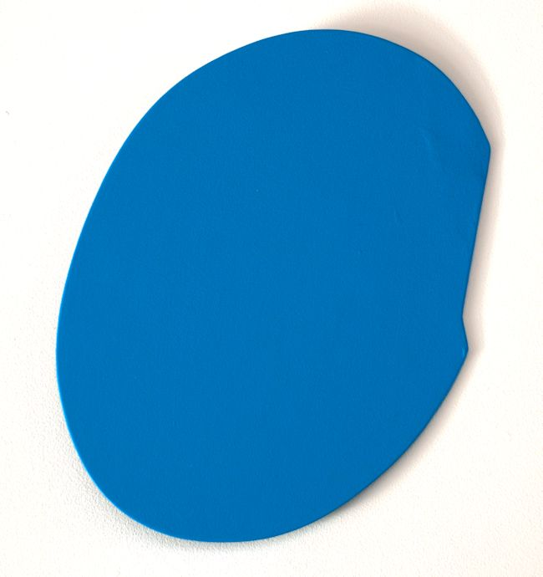
A Secret Move, 2013
Acrylic on aluminum
18 1/2 x 16 1/2 inches
TD0114
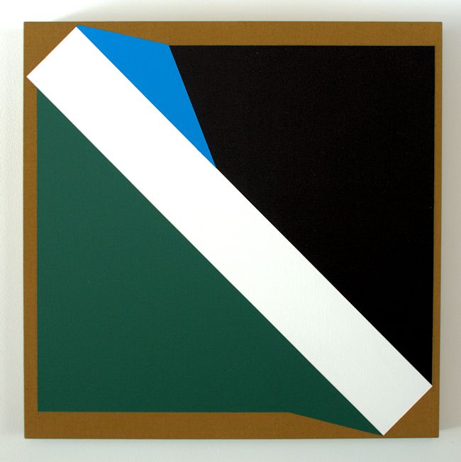
Decepto, 2013
Acrylic on linen
30 x 30 inches
TD0103
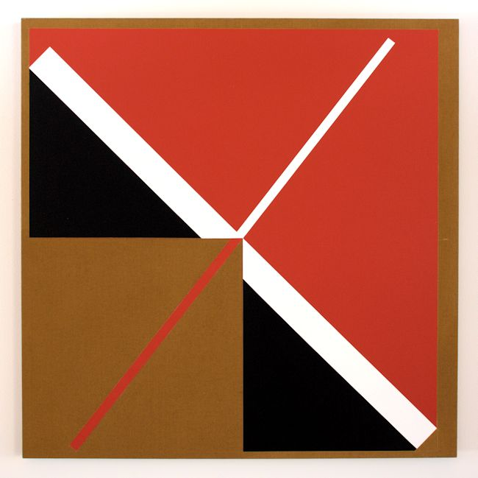
Lady In My Sleeve, 2013
Acrylic on linen
42 x 42 inches
TD0098
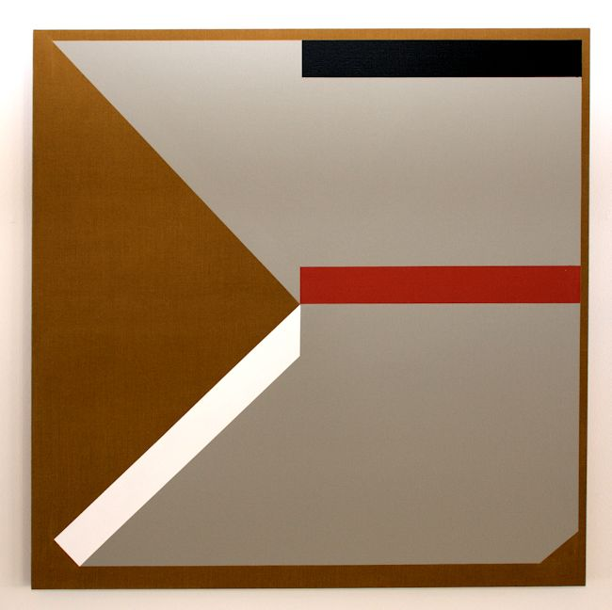
Perplexo II, 2013
Acrylic on linen
42 x 42 inches
TD0100
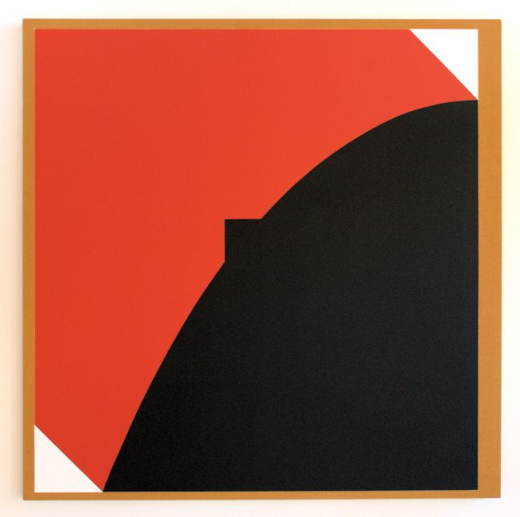
Pippin, 2013
Acrylic on linen
42 x 42 inches
TD0099
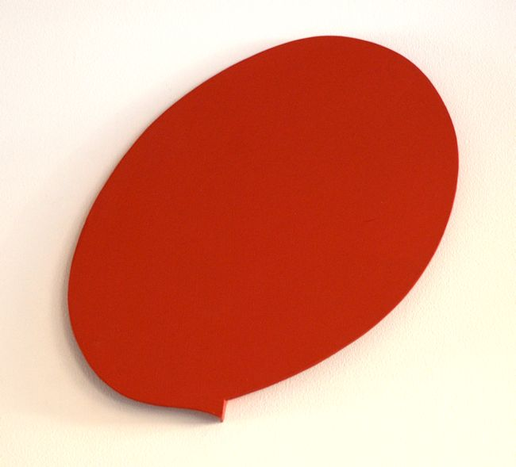
Jumping Pulse, 2009
Acrylic on aluminum
13 1/2 x 9 x 1 inches
TD0116
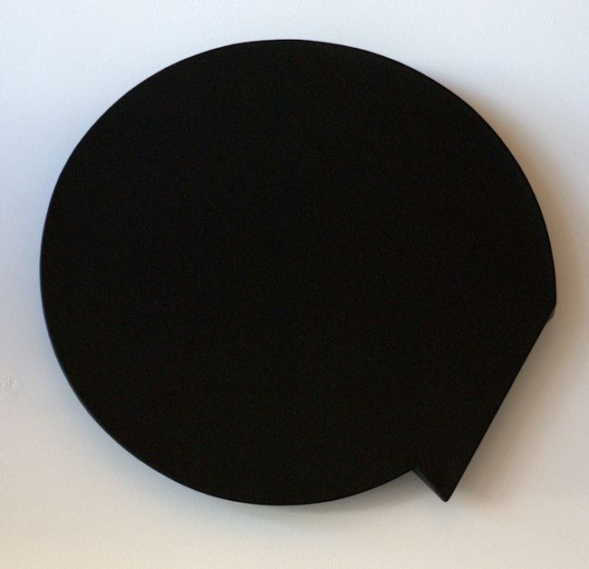
Ghost of a Chance, 1981
canvas, wood, acrylic paint
18 x 17 1/2 x 1 5/8 inches
TD0086
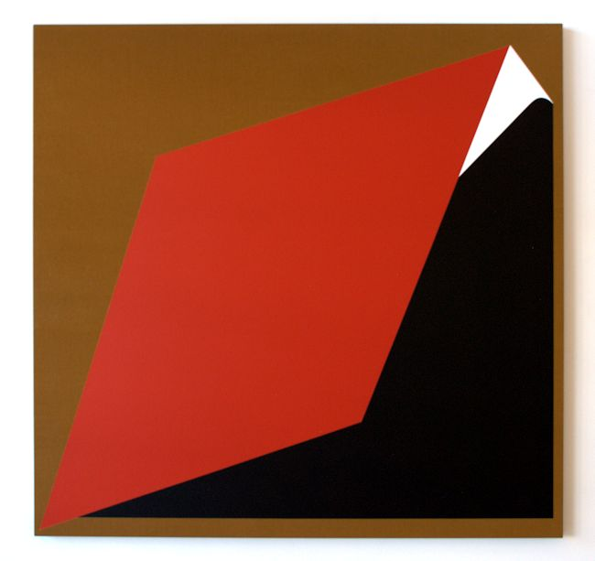

Straight Five III, 2013
Acrylic on linen
58 x 60 inches
TD0095
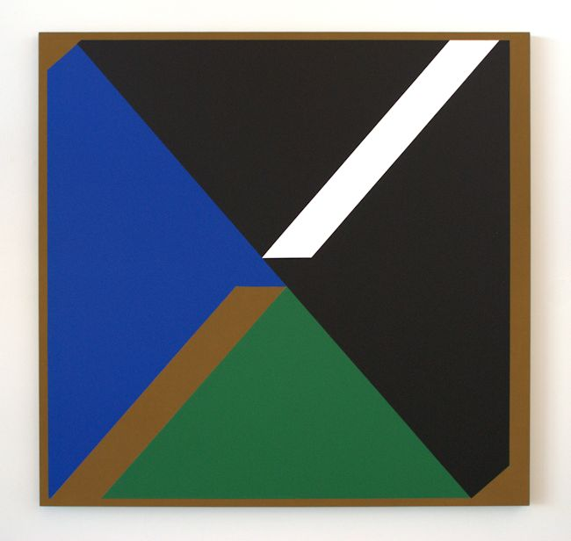
Slightly Cross, 2013
Acrylic on linen
58 x 60 inches
TD0096
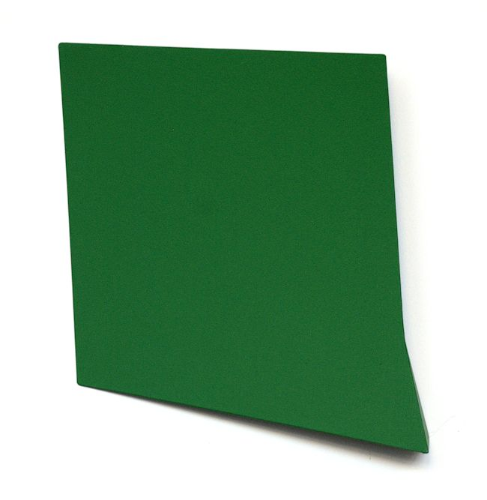
Largaud, 2011
Acrylic on aluminum
14 x 12 x 1 3/4 inches
TD0113
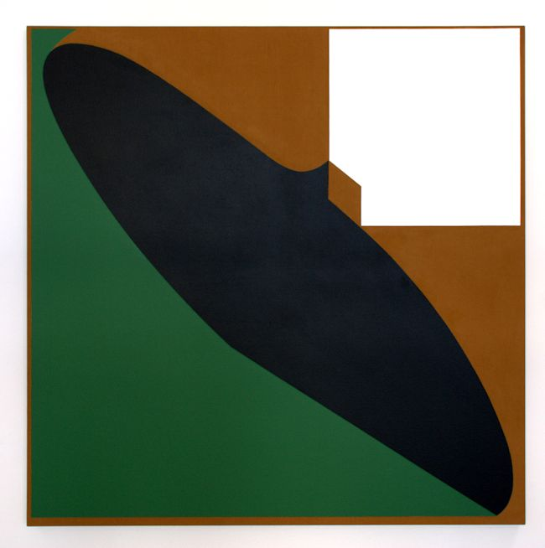
Nox-Em-All, 2010-2013
Acrylic on linen
60 x 60 inches
TD0097
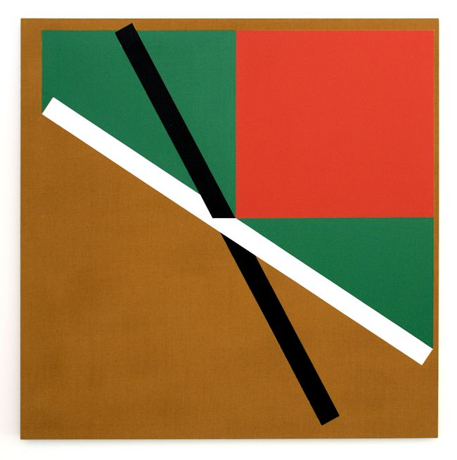
Gasparoni, 2013
Acrylic on linen
42 x 42 inches
TD0101
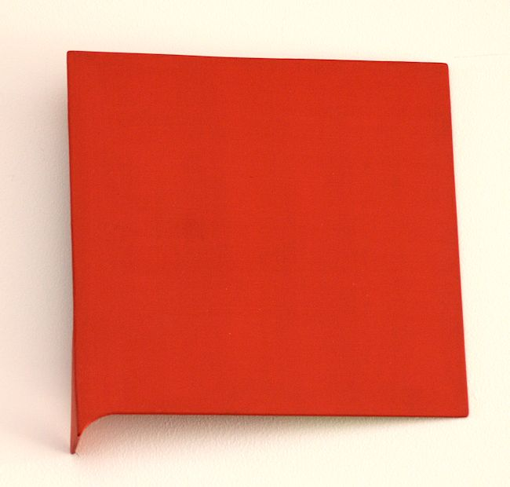
Red, 2008
Acrylic on aluminum
8 x 8 1/2 x 1 1/2 inches
TD0112
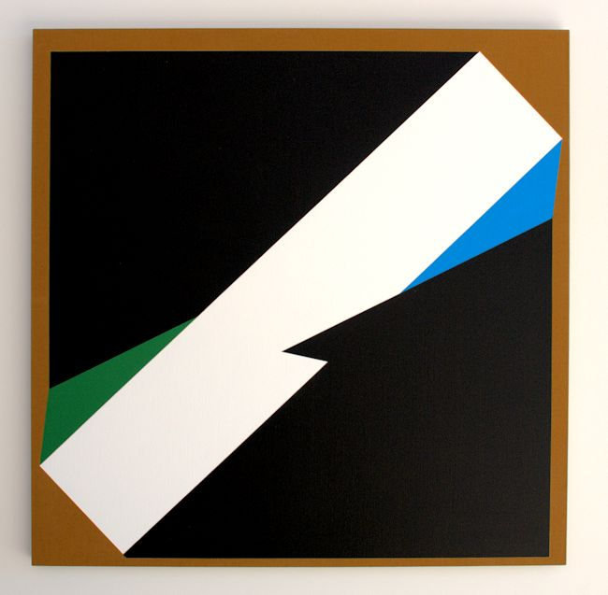
Flash Flush, 2013
Acrylic on linen
42 x 42 inches
TD0102
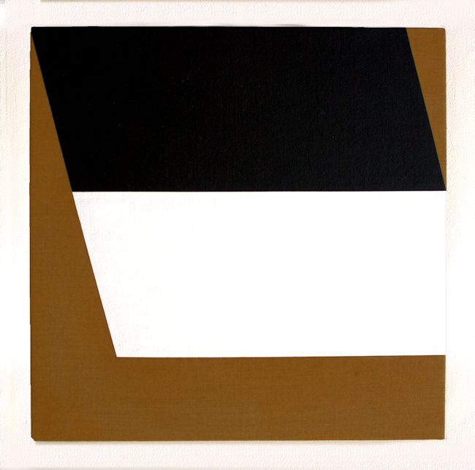
After the Riffle, 2008
Acrylic on linen, wood
16 x 16 x 2 inches
TD0104
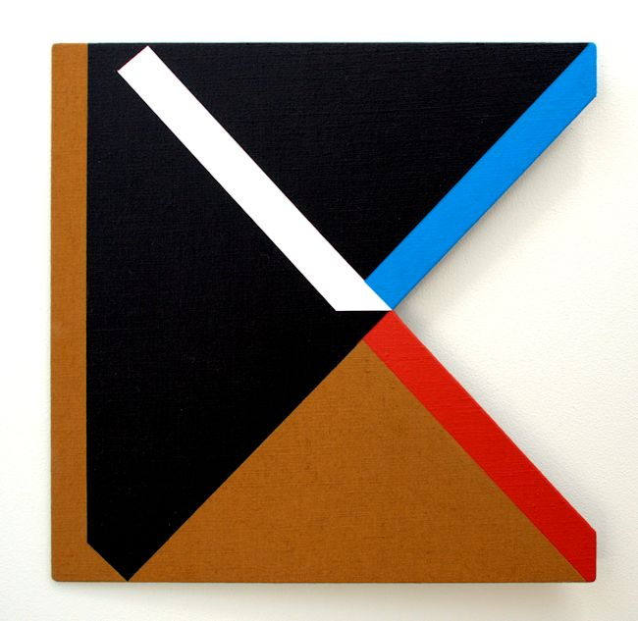
Italian Shuffle, 2013,
acrylic on linen, Aluminum,
15 x 15 inches
TD0111
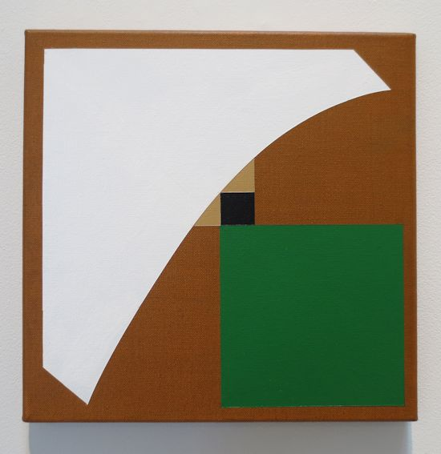
Point Roberts I, 2013
Acrylic on canvas
12 x 12 inches
TD0109
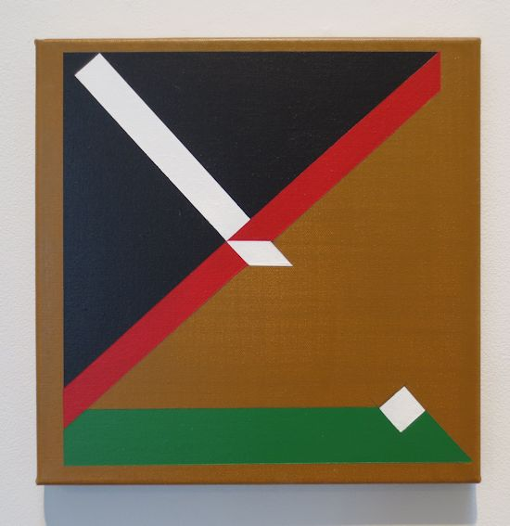
Point Roberts III, 2013
Acrylic on canvas
12 x 12 inches
TD0110

© 2013

Charlotte Jackson Fine Art, Inc.

In the Railyard at:

554 S. Guadalupe, Santa Fe, New Mexico 87501
Telephone: 505.989.8688 Fax: 505.989.9898
cjfa@charlottejackson.com - www.charlottejackson.com

