CHARLOTTE JACKSON FINE ART PRESENTS:

Ronald Davis
Squares and Diamonds 2010

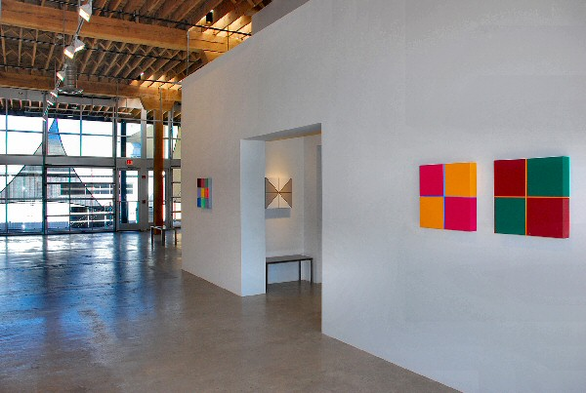
Friday, 9/3/10 – Tuesday, 09/28/10
Sat., September 4, 3pm: Gallery talk with Thom Andriola, New Gallery, Houston, TX
Art was Ronald Davis’ third choice; he wanted to be a race car driver. But after a few crashes and near misses, the young Davis realized that racing was both expensive and dangerous. He switched to painting, leaving the wide-open spaces of Wyoming for the fog-shrouded San Francisco Art Institute though, as he says, “Later I found out that being an artist is much more dangerous – and just as expensive.”
The paintings he brings to this exhibition of new work, Squares and Diamonds 2010, may be a bit dangerous for the viewer. They are highly charged, vibrating with energy—something unexpected in paintings of geometrical abstraction. In Interlocked Square a golden knot is suspended precariously over a quickly-receding blue void. In Black Diamond the viewer stares into a twisting diamond of black space through an off-kilter frame of interlocking pastel polygons. Orange Bevel Square simultaneously pops inward and outward at the viewer, writhing uncomfortably off center and out of perspective.
There are illusions within the illusions here; some of the optical effects of the paintings are created strictly by the manipulation of form and color on a square piece of expanded PVC. However, in some pieces what seems to be another perfect square or diamond is not: there are bevels and bends in the PVC skillfully incorporated into the composition to add to the perceptual distortions. Both the optical illusions (a hallmark of Davis’ career) and the palette are unsettling, engaging the viewer in a visual and visceral dance.
While in art school in San Francisco in the early 1960’s, Davis made a life-changing trip to an exhibition of the Ben Heller Collection of Abstract Expressionism in the Palace of the Legion of Honor. There he saw Jackson Pollock’s Blue Poles. His gut response to the piece was so intense that it made him physically ill. “Churned up,” as he puts it, by the work of Pollock and Clyfford Still, Davis struggled to discover his own way of expressing the raw power latent in these works of abstract expressionism.
His answer was to find a unique line between several of the popular movements of the time, incorporating aspects of Object Art, Minimalism, Op Art, Pop Art, and Abstract Expressionism with Geometrical Abstraction. He felt he would like to make a Mondrian in the style of a Pollock, a Pollock like a Mondrian. He strove to combat the movement toward flatness by reintroducing the theorems of three-dimensional Renaissance mathematical perspective to his works.
The combination was a clear success. Davis rose to prominence in the late 1960’s, moved to Los Angeles and continued his ride to stardom through the 80’s. By now he has shown his work in nearly 70 solo exhibitions and is represented in important collections at museums like the Tate, MoMA, LACMA, and the Art Institute of Chicago. In the early 90’s Davis left the frenzy of Los Angeles to build a studio in Arroyo Hondo, near Taos. After nearly a decade of quiet (though he continued to work, particularly on 3D computer modeling and drawing), Davis reemerged in 2002 with a retrospective exhibition at the Butler Institute of American Art.
The freshness of the new works in Squares and Diamonds 2010 belie Davis’ long and venerable career. These pieces burst with vitality and an impressive energy heightened by the limits imposed on them by the precision of their hard-edged style. This conflict adds to the charge, and for the viewer it is an experience of witnessing two forces meeting head-on, of unruly passion pushing up against strict geometry

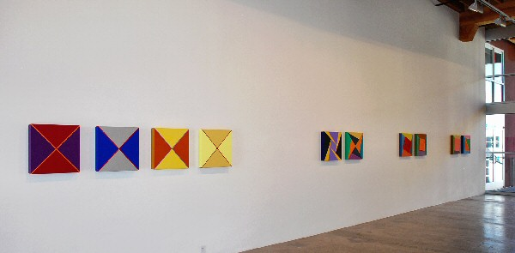

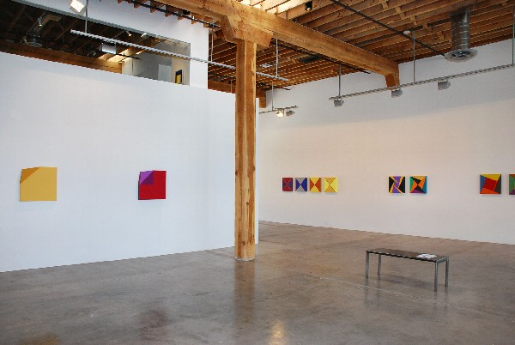
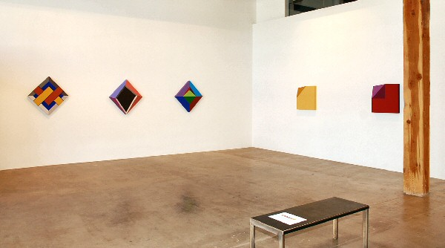

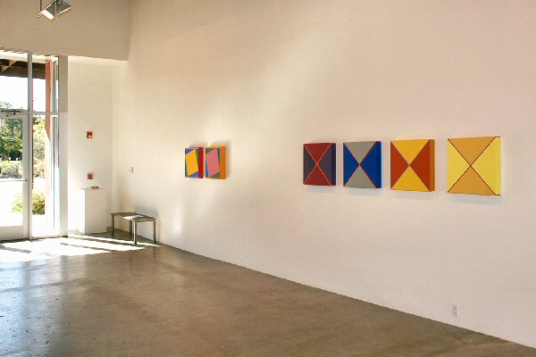
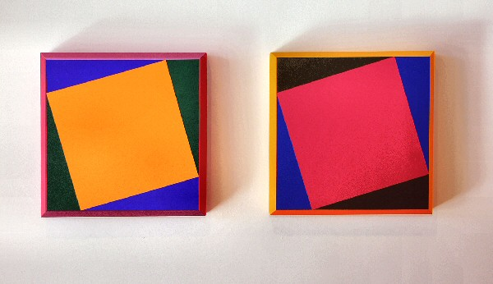

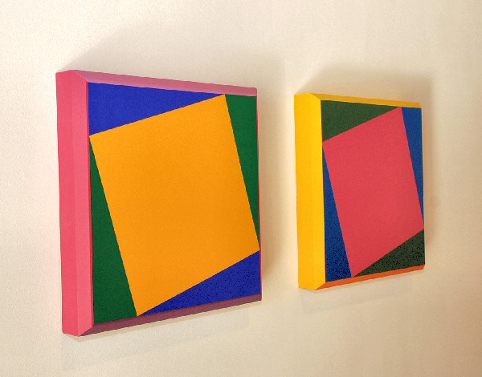
Yellow Square Twist Bevel, 2010 and Raspberry Square Twist Bevel, 2010
Acrylic on Expanded PVC, 20 x 20 x 3 inches ROND0020 and ROND0021
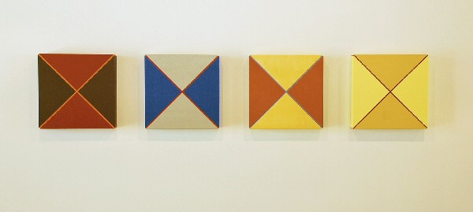

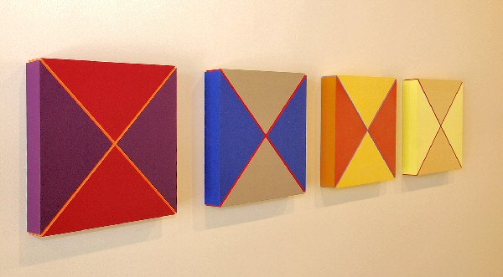

Purple-Plum Quarters, 2010
Acrylic on Expanded PVC
20 x 20 x 3 inches ROND0016

Blue-Silver Quarters II, 2010
Acrylic on Expanded PVC
20 x 20 x 3 inches ROND0018

Burnt Orange-Yellow Quarters, 2010
Acrylic on Expanded PVC
20 x 20 x 3 inches ROND0017

Yellow-Gold Quarters II, 2010
Acrylic on Expanded PVC
20 x 20 x 3 inches ROND0019
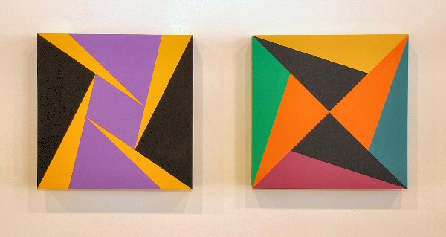

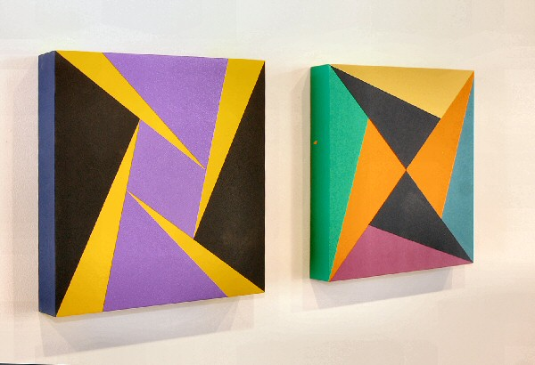

Four Yellow Triangles, 2010
Acrylic on Expanded PVC
20 x 20 x 3 inches ROND0026
Twenty-Four Triangles, 2009
Acrylic on Expanded PVC
20 x 20 x 2 ½ inches ROND0025
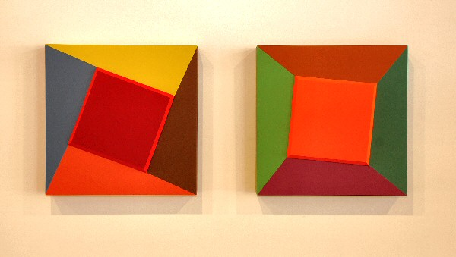

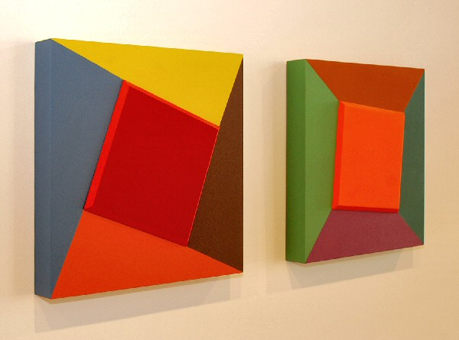

Red Bevel Square, 2009 and Orange Bevel Square, 2009
Acrylic on Expanded PVC
20 x 20 x 3 inches ROND0027 and ROND0028

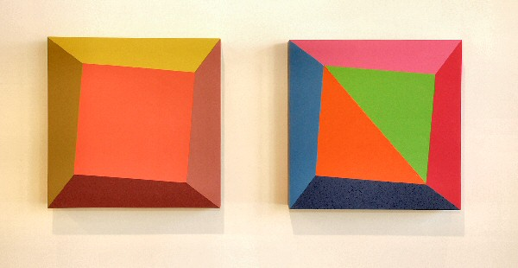

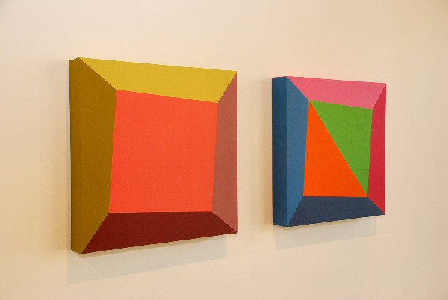

Pink Square Twist, 2009
Acrylic on Expanded PVC
20 x 20 x 3 inches ROND0002

Diagonal Square Twist, 2009
Acrylic on Expanded PVC
20 x 20 x 3 inches ROND0001
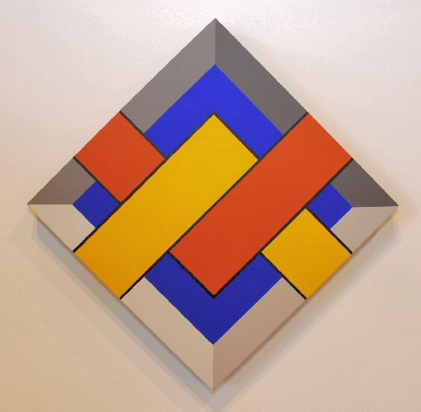

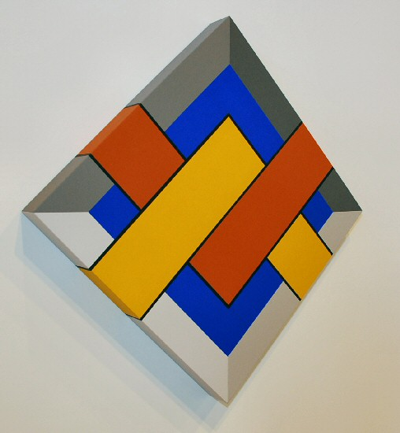

Interlocked Square, 2010
Acrylic on Expanded PVC
33 5/8 x 33 5/8 x 3 inches ROND0013
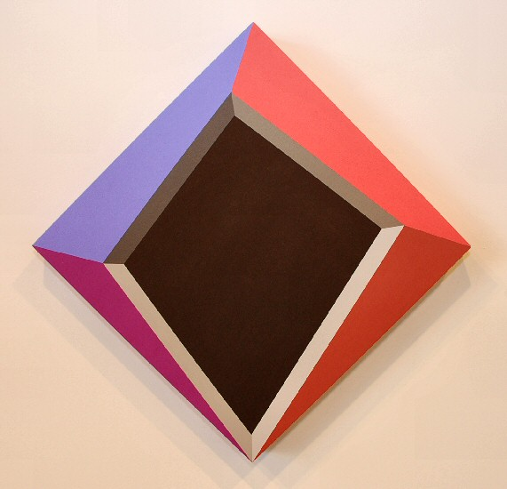

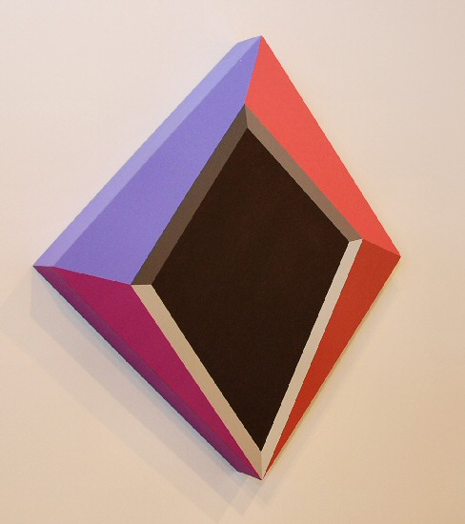

Black Diamond, 2010
Acrylic on Expanded PVC
33 5/8 x 33 5/8 x 3 inches ROND0015
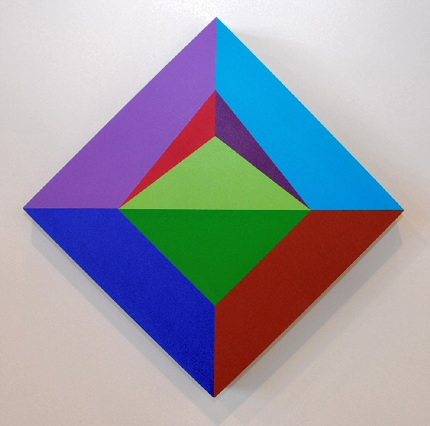

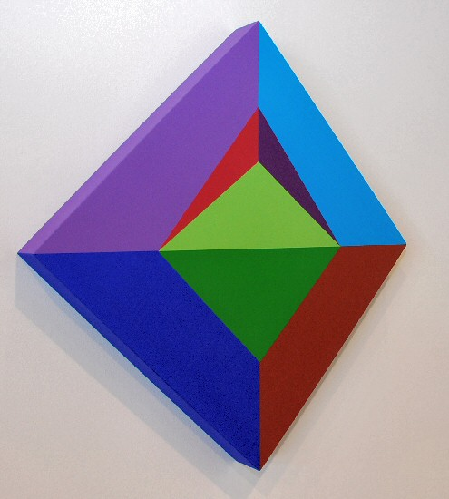

Yellow-Green Diamond, 2010
Acrylic on Expanded PVC
33 5/8 x 33 5/8 x 3 inches ROND0014
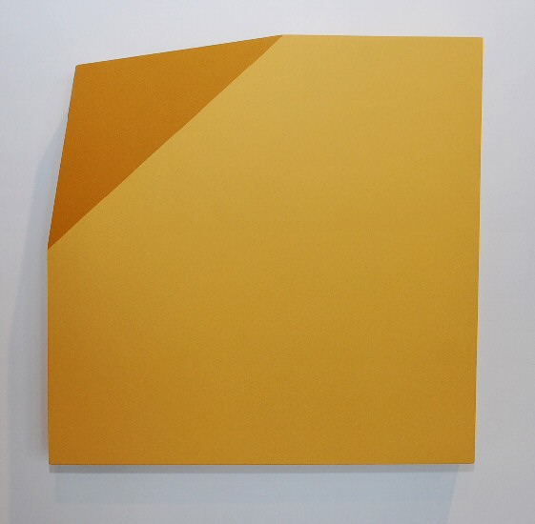

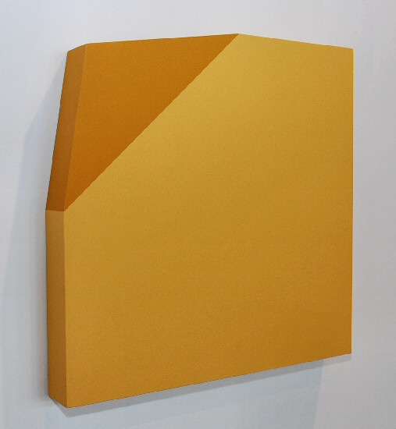

Bent Corner Slab, 2009
Acrylic on Expanded PVC
24 x 24 x 3 inches ROND0029
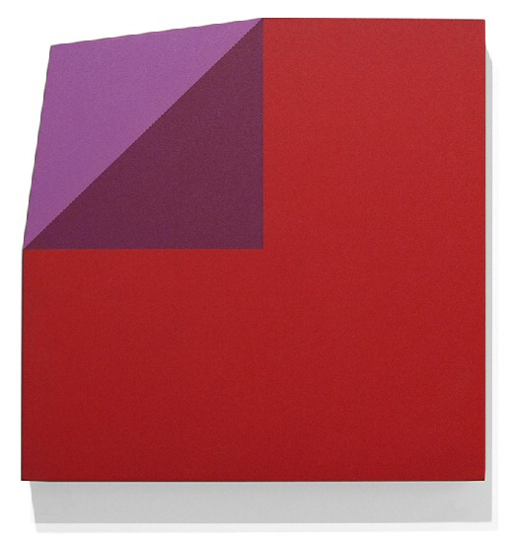

Red and Violet Bent Corner Square, 2010
Acrylic on Expanded PVC
24 x 24 x 3 inches ROND0030
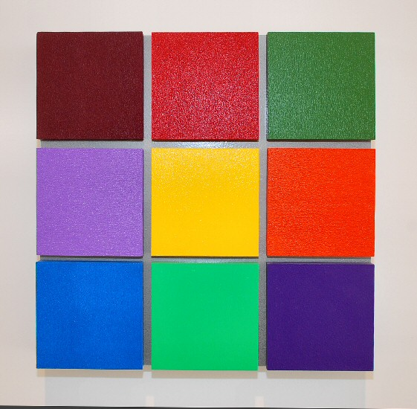

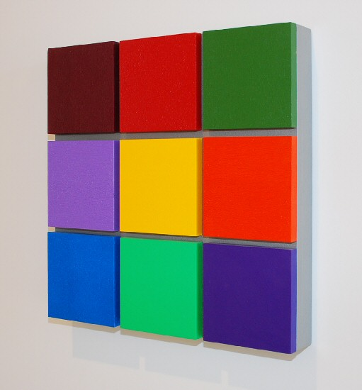

Three by Three Grid, 2009
Acrylic on Expanded PVC
20 x 20 x 3 inches ROND0031
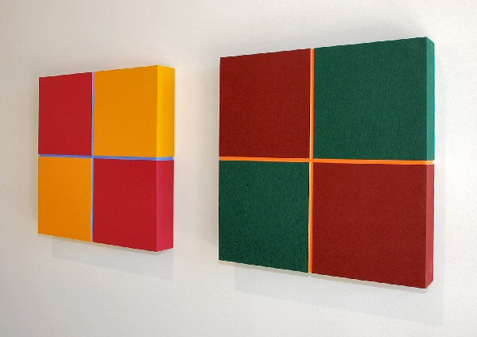

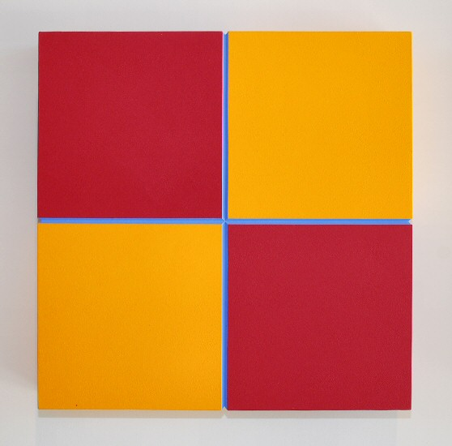

Yellow-Rust-Blue Quarters, 2010
Acrylic on Expanded PVC
20 x 20 x 3 inches ROND0023
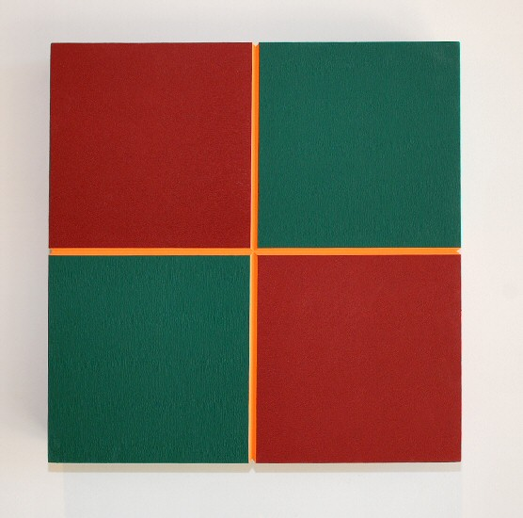

Maroon-Green Quarters, 2010
Acrylic on Expanded PVC
20 x 20 x 3 inches ROND0024
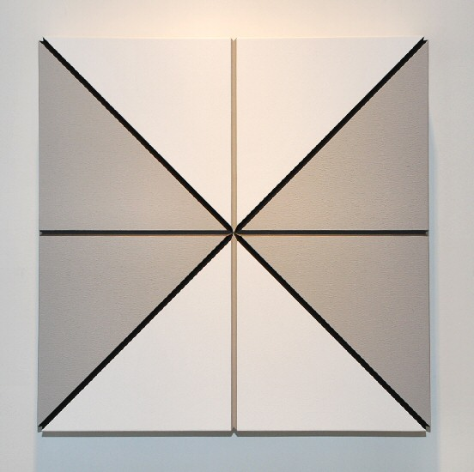

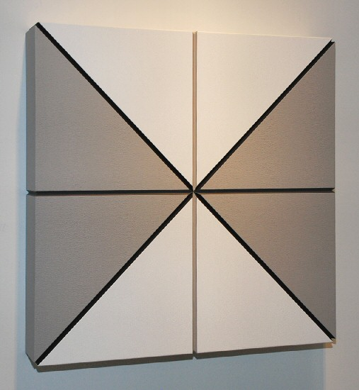

Gray and White Eights, 2010
Acrylic on Expanded PVC
20 x 20 x 3 inches ROND0022

© 2010

Charlotte Jackson Fine Art, Inc.

In the Railyard at:

554 S. Guadalupe, Santa Fe, New Mexico 87501
Telephone: 505.989.8688 Fax: 505.989.9898
cjfa@charlottejackson.com - www.charlottejackson.com

