CHARLOTTE JACKSON FINE ART

PRESENTS:

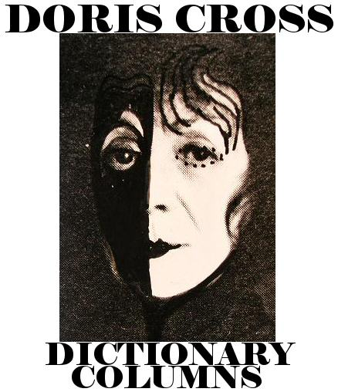

May 21 - June 12
2004
Charlotte Jackson Fine Art continues its series of historical exhibitions related to important artists of the older generation. Doris Cross: Dictionary Columns, honors the work of an important figure in the history of the Santa Fe art community. At the end of the 60s, Cross left a burgeoning career in New York City, where her work was being shown in galleries and museums, to follow her own artistic vision away from the pressures of city life. She chose Santa Fe as her new home and was a central part of the town's art community until her death in 1994.
Starting life as the daughter of Russian immigrants in New York City, Cross soaked up the diverse influences of the culture that was to become the cradle of American Abstraction. At the end of World War II, she studied with Hans Hoffman, at Pratt Institute and at the Art Student's League.
In 1965 Cross began developing what was to be the most important work of her long and distinguished career. Using a 1913 edition of Webster's dictionary, she took entire pages as her material and worked them in a subtractive manner, crossing out or covering up what she felt was unnecessary to the finished work. In a later series, "Excerpts," she photocopied sections of a page. These images were then enlarged and printed either in positive (black on white) or negative (white on black). Some pieces were spare, resembling the patterns seen in computer circuitry. Others included illustrations such as an octopus or raven, as they appeared on the dictionary page. All of them provoked the viewer's fascination with the interplay of deliberately fragmented words, definitions and images. The literary community regarded them as a new version of concrete poetry, but Cross herself insisted that "the word itself is the mark. It is the image."
Cross settled in Santa Fe against the advice of friends in the New York art world, who feared it would mean the end of her blossoming career; but Cross was determined to work apart from the commercial and competitive pressures of the city.
Cross's importance to the Santa Fe art community was considerable. The city's contemporary art community was then in the very earliest stages of development, and the presence of a committed artist with a New York reputation was an inspiration to the artists and art professionals who were struggling to establish an abstract beachhead in a sea of representational painting and sculpture. Cross continued to develop her dictionary works; her work also included sculpture, video, film and writing. She exhibited not only in the museums and galleries of Santa Fe and the Southwest, but also continued to present work in New York and Europe.
Work by Cross is included in public collections such as the Museum of Modern Art Library in New York, the Paul Getty Museum Archives in Los Angeles, the International Concrete Poetry Archives in Oxford, England, and the Museum of Fine Arts in Santa Fe, among others. She received the Governor’s Award for Contribution to the Visual Arts in New Mexico in 1986 and the Turner Award of the National Association of Women Artists in New York in 1983.
Doris Cross: Dictionary Columns, includes examples of Cross’s early series of works created directly on the dictionary pages, as well as the larger “Excerpts.”
MAIN GALLERY:
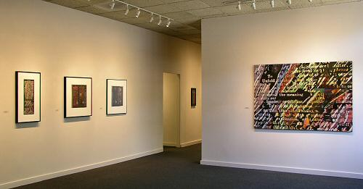

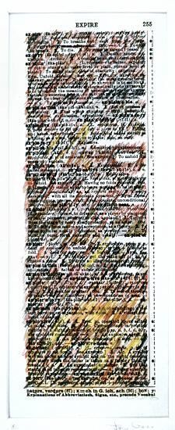
EXPIRE, Date unknown
Mixed media on paper, 12 ½” x 5”
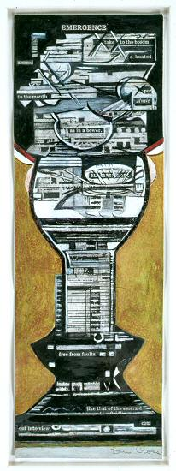
EMERGENCE, 1987
Mixed media on paper, 15” x 5”
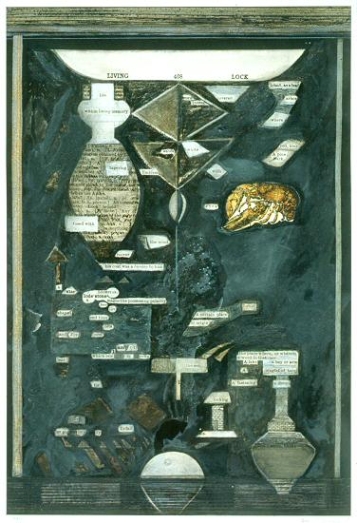
LIVING LOCK, 1982
Mixed media on paper, 25” x 17”
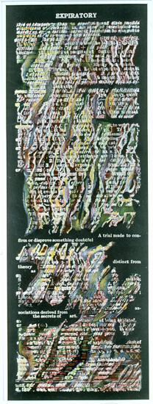
EXPIRATORY, Date unknown
Mixed Media on paper, 22” x 8 ”
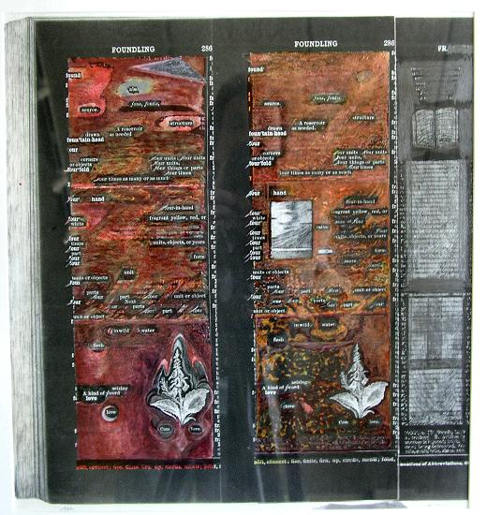
FOUNDLING, 1982
Mixed media on paper, 16” x 17 ¼”
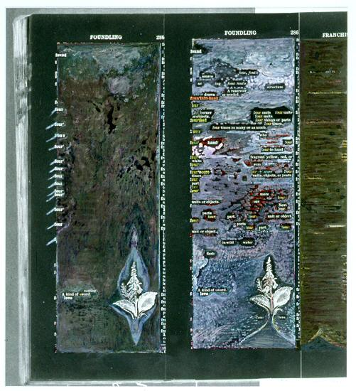
FOUNDLING, 1989-90
Mixed media on paper, 15 ½” x 17”
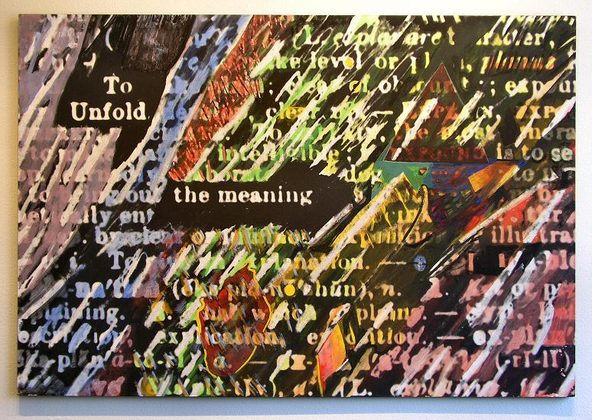
TO UNFOLD THE MEANING, 1991
Mixed media, 70” x 48”
HALLWAY:

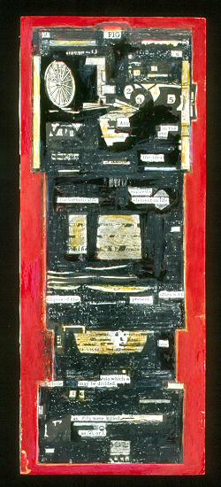
FIG, c. 1972-81
Mixed media on paper, 15 ½” x 6 ¼ ”
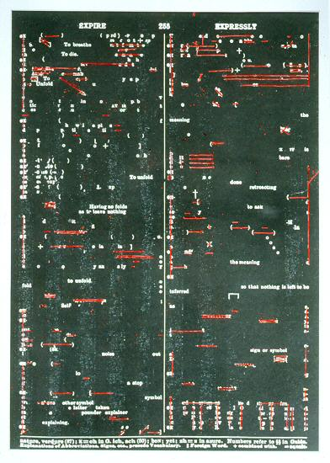
EXPIRE EXPRESSLY, Date unknown
Mixed media on paper, 13 ½” x 19”
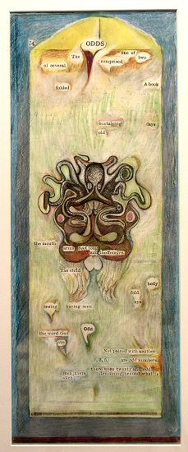
ODDS, Date unknown
Mixed media on paper, 9 ” x 22 ½ ”
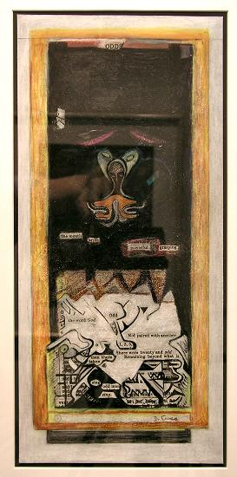
ODDS, 1987
Mixed media on paper, 17” x 8”
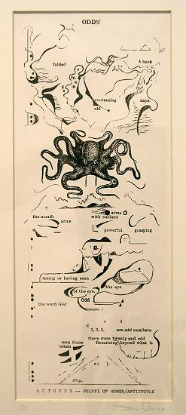
ODDS, c. 1982
Photostat, 13” x 5”
GALLERY II:

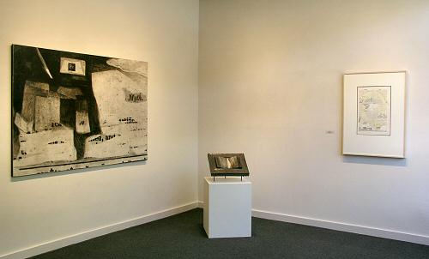

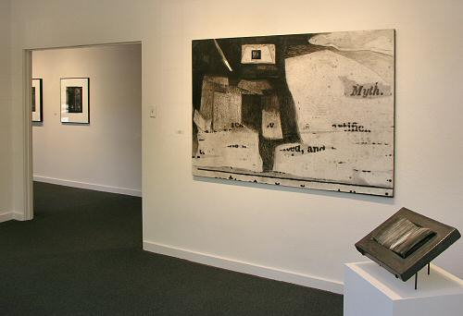
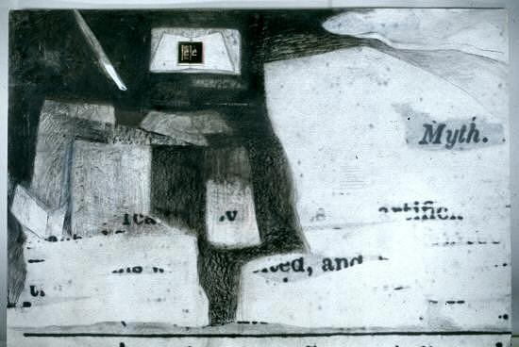
MYTH SERIES #3, 1990
Mixed media, 70” x 48”
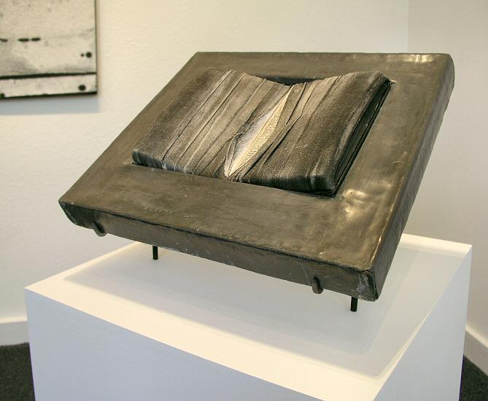
THE WRAPPED BOOK, c.1972-80
Mixed media, 17” x 14 ¼” x 2”
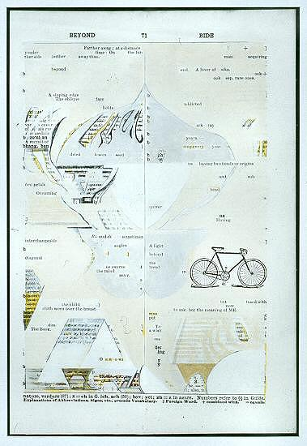
BEYOND BIDE, 1980
Mixed media on paper, 21 ¼ ” x 14 ½”
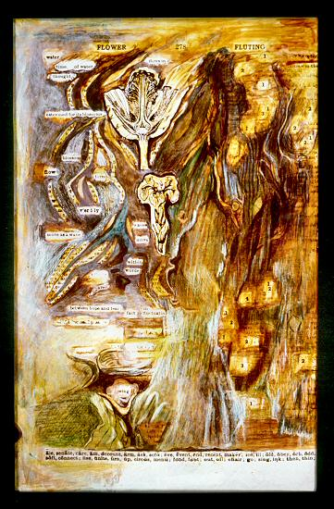
FLOWER FLUTING, 1988
Mixed media on paper, 13 ½” x 8”
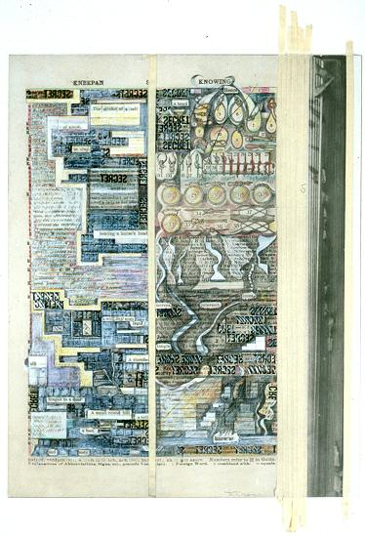
KNEEPAN KNOWING, 1980
Mixed media on paper, 16 ¼” x 13”
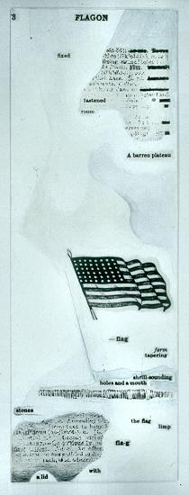
FLAGON, 1972
Mixed media on paper, 8” x 23”
© 2004, Charlotte Jackson Fine Art
All Rights Reserved

Charlotte Jackson Fine Art

200 West Marcy Street, Suite 101

Santa Fe, New Mexico 87501

Phone: 505.989.8688
Fax: 505.989.9898

www.charlottejackson.com

