CHARLOTTE JACKSON FINE ART
PRESENTS:

Common Ground: Color
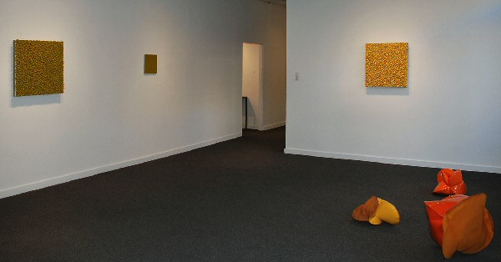
Oct 2, 2009
Featuring:
Charles Arnoldi, John Beech, Alfonso Bianchi, Ronald Davis,
Robert Sagerman, Heiner Theil, Jeremy Thomas
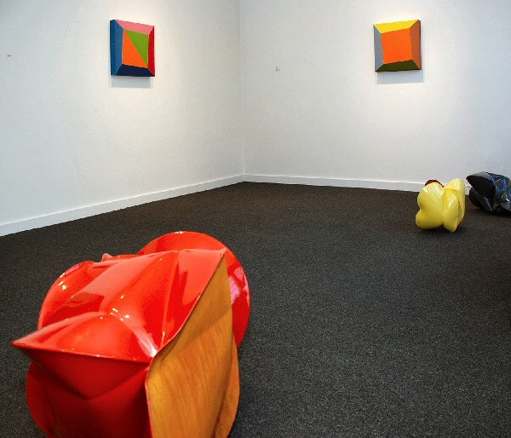
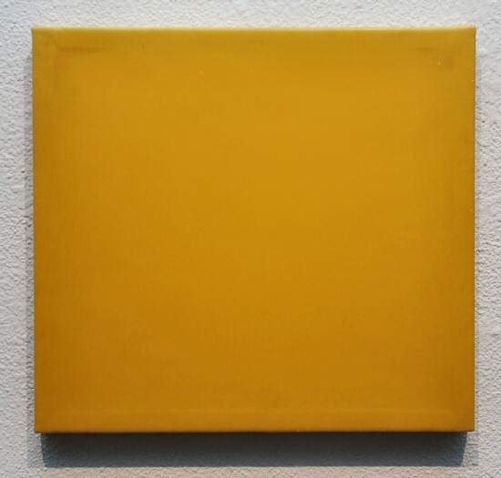
John Beech
Glue Painting # 55, 2003-04 DAP Weldwood, linen, plywood
14 x 15 ½ x 1 inches JB0019
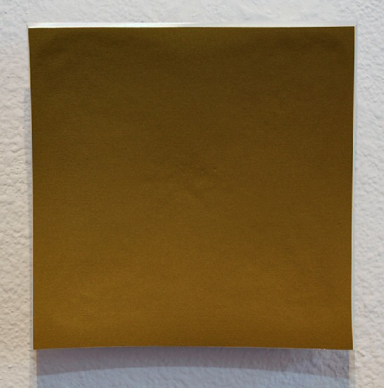
Heiner Thiel
WVZ500, 2009 anondized aluminum
5 15/16 x 5 15/16 x 1 5/8 inches HT021
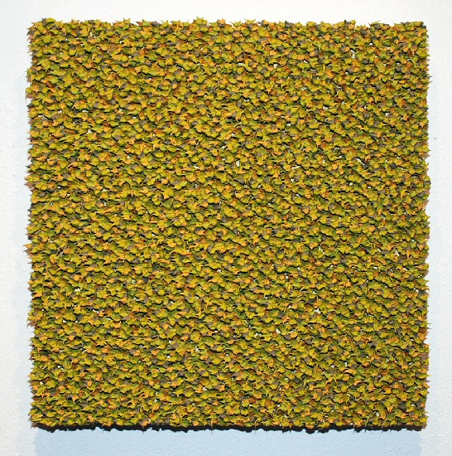
Robert Sagerman
7,757, 2009 oil on canvas
26 x 25 inches RS002
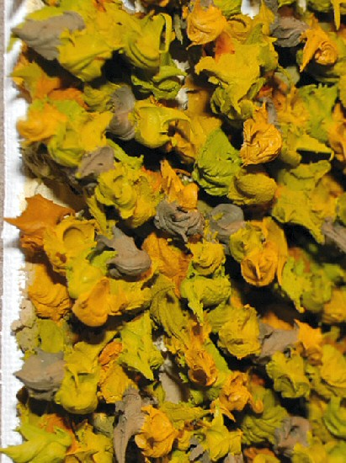
Robert Sagerman
7,757, 2009 oil on canvas
26 x 25 inches RS002
Detail
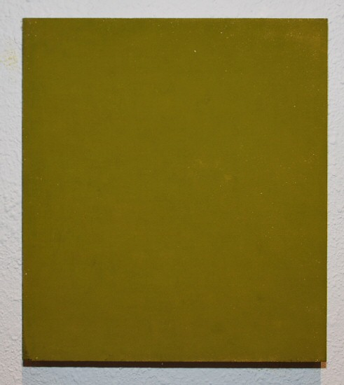
Alfonso Bianchi
#293 Verde chiaro, 2007 pigment on stone
30.9 x 27.7 centimeters AFB64
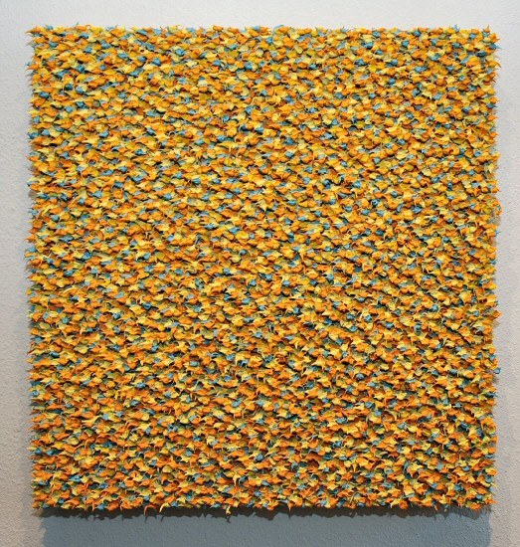
Robert Sagerman
8,207, 2009 oil on canvas
26 x 25 inches RS003
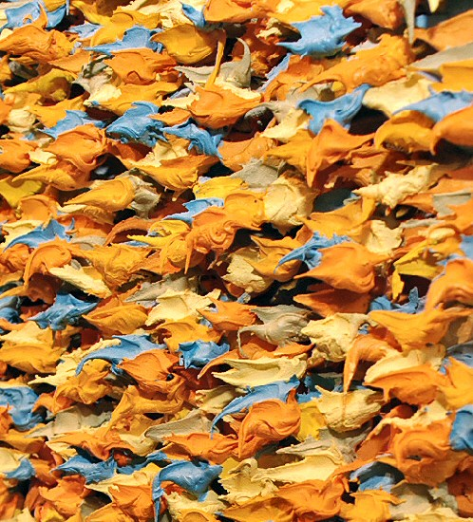
Robert Sagerman
8,207, 2009 oil on canvas
26 x 25 inches RS003
Detail
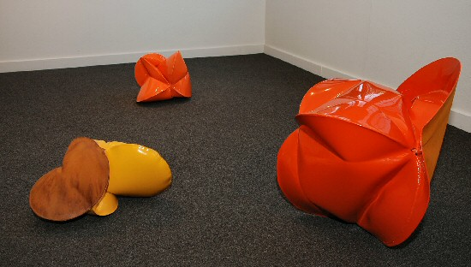

Jeremy Thomas
Boll Buggy Orange, 2009 forged mild steel and powder coat
22 x 22 x 24 inches JT172
Jeremy Thomas
Boll Buggy Deep Yellow, 2009 forged mild steel and powder coat
10 x 19 x 12 inches JT179
Jeremy Thomas
DU-AL Orange, 2009 forged cold roll and powder coat
13 x 15 x 14 ½ inches JT180
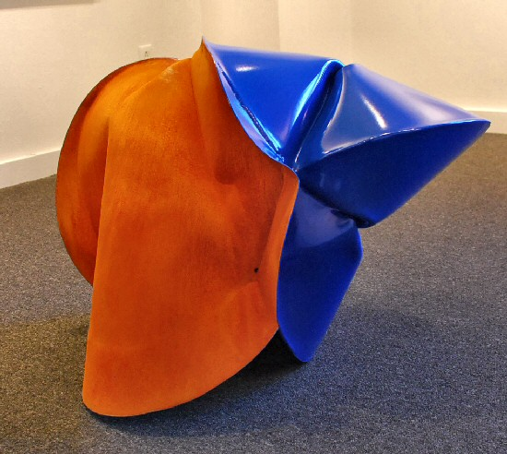
Jeremy Thomas
Boll Buggy Blue, 2009 forged mild steel and powder coat
21 x 30 ½ x 21 inches JT190
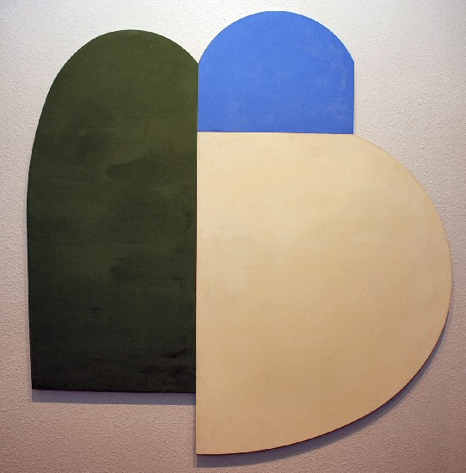
Charles Arnoldi
Submarine, 06.79, 2009 oil on aluminum
30 5/8 x 38 inches CA008
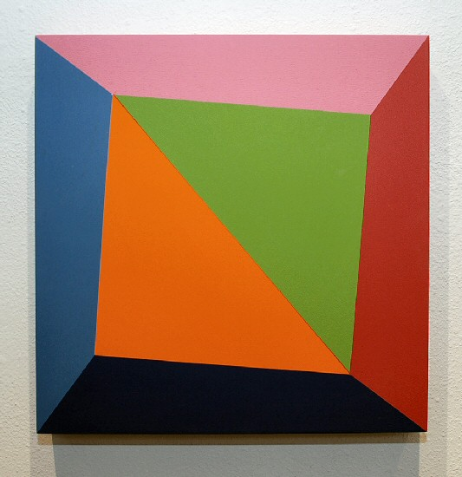
Ronald Davis
Diagonal Square Twist, 2009 acrylic on expanded PVC
20 x 20 x 3 inches ROND001
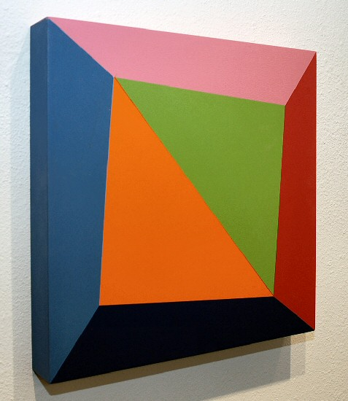
Ronald Davis
Diagonal Square Twist, 2009 acrylic on expanded PVC
20 x 20 x 3 inches ROND001
Detail
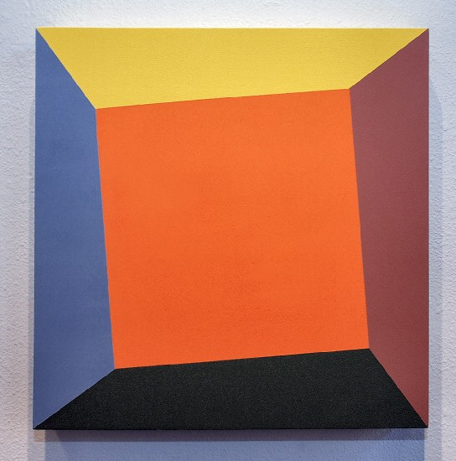
Ronald Davis
Orange Square Twist, 2009 acrylic on expanded PVC
20 x 20 x 3 inches ROND004
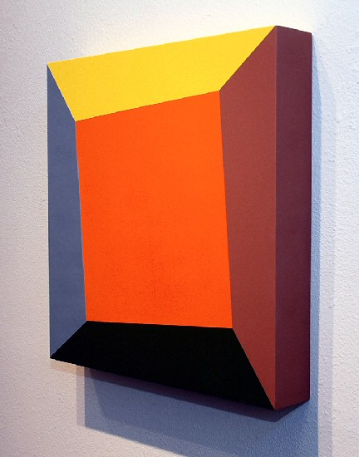
Ronald Davis
Orange Square Twist, 2009 acrylic on expanded PVC
20 x 20 x 3 inches ROND004
Detail
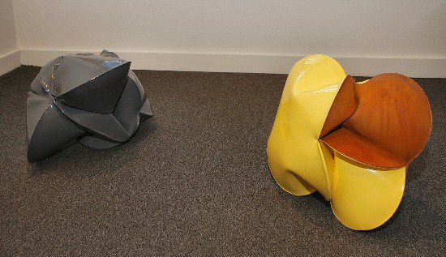
Jeremy Thomas
Module Grey, 2009 forged mild steel and powder coat
12 ½ x 20 x 15 ½ inches JT176
Jeremy Thomas
Module Builder Yellow, 2009 forged mild steel and powder coat
14 ½ x 12 x 14 ½ inches JT182
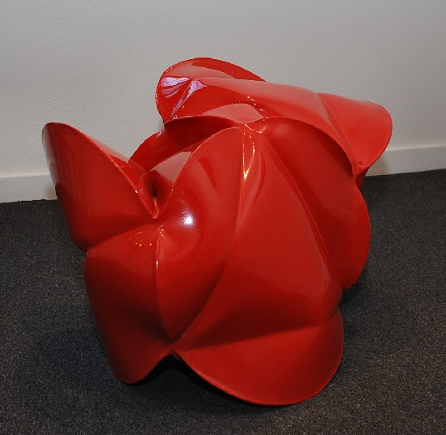
Jeremy Thomas
Module Builder Red, 2009 forged mild steel and powder coat
21 x 31 x 20 inches JT189
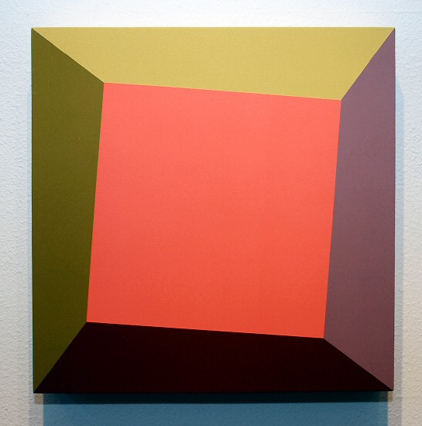
Ronald Davis
Pink Square Twist, 2009 acrylic on expanded PVC
20 x 20 x 3 inches ROND002
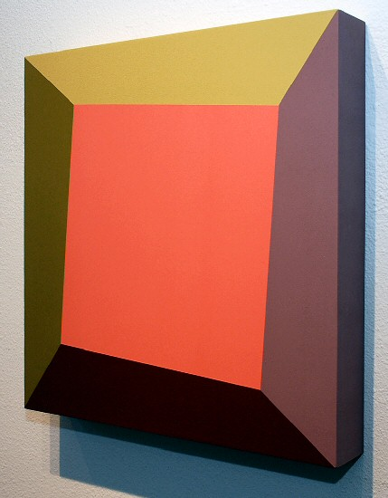
Ronald Davis
Pink Square Twist, 2009 acrylic on expanded PVC
20 x 20 x 3 inches ROND002
Detail
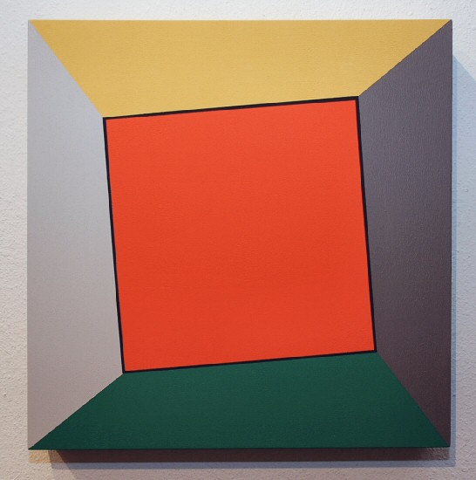
Ronald Davis
Orange Red Square Twist, 2009 acrylic on expanded PVC
20 x 20 x 3 inches ROND003

© 2009

Charlotte Jackson Fine Art, Inc.

200 West Marcy Street, Suite 101, Santa Fe, New Mexico 87501
Telephone: 505.989.8688 Fax: 505.989.9898
cjfa@charlottejackson.com - www.charlottejackson.com

