CHARLOTTE JACKSON FINE ART

PRESENTS

MARK COLE

NEW PAINTINGS

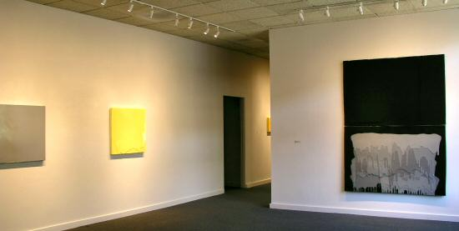

August 13 - September 4, 2004

According to Mark Cole, anything can be a legitimate source for art. "Everything's open right now," he observes. "You can easily cross boundaries." He finds as much inspiration in the "low design" of plexi displays in shop windows as he does in "high design" like that of Paul Rand. He has commented on his desire to "raise the mundane to the heroic" and cites the little things of life (small plastic religious icons and the like), which we often ignore, as important visual and theoretical stimuli.
Cole's present work grew out of just such a source. A week after curiosity had drawn him to a friend's factory, where concrete replicas of old statues, garden urns and other such objects were made, an idea popped into his head for an entirely new way of making paintings. He still has the original post-it note with a rough sketch of how it could be done. "It seemed to be a convergence of a lot of things I liked about painting," he says. Since then he has used and developed this method in a number of ways.
The process begins with stretching a canvas in the most traditional way. At that point, however, the word "traditional" ceases to apply. Instead of painting on the canvas, Cole uses it to construct a mold and then pours polyurethane plastic into the mold, creating an exact replica of the canvas in solid plastic. He then pours one or more layers of plastic, pigmented with the same color as the cast, over it. The result is a piece that looks for all the world like a painted canvas but is in fact solid plastic. Cole's vivid colors add to the high-spirited, striking look of his paintings.
Cole's latest work is concerned with the artist's touch on a painting. These paintings have a very finished, manufactured look, a style that he feels captures the present -- the things we buy today don't look handmade unless they are specifically configured that way -- and at the same time refers to the past, especially work of Donald Judd and California finish fetishists such as John McCracken.
Cole's paintings can be seen as an astute comment on painting, on the state of design in today's marketplace, or on our need to be more aware of the multitude of interesting objects around us. They can also be enjoyed in and of themselves, as paintings that draw our attention and fascinate us with their beauty and distinctiveness.
MAIN GALLERY:

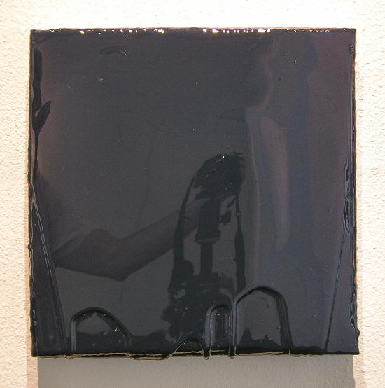
THE NIGHT FEAST, 2004
Polyurethane plastic with pigment, 14” x 14”, MC0012
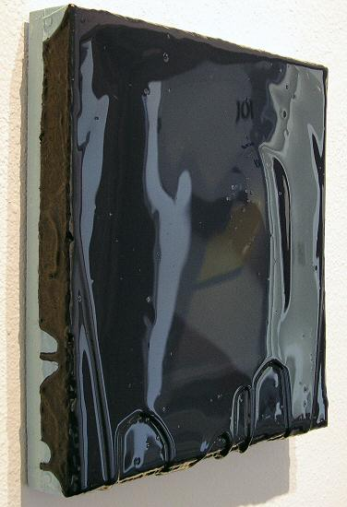
THE NIGHT FEAST, 2004
Polyurethane plastic with pigment, 14” x 14”, MC0012
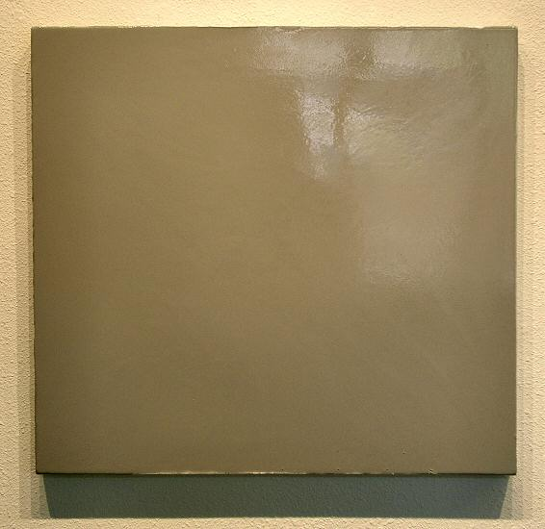
PARK OF IDOLS, 2004
Polyurethane plastic with pigment, 28” x 30”, MC0010
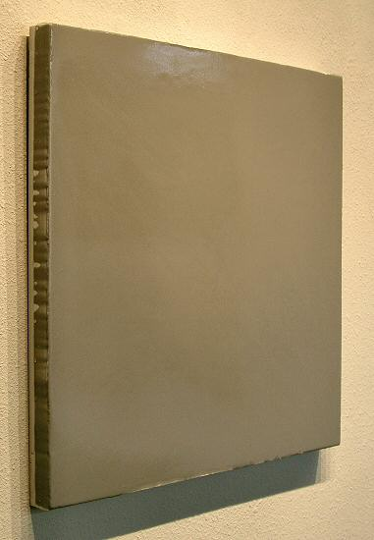
PARK OF IDOLS, 2004
Polyurethane plastic with pigment, 28” x 30”, MC0010
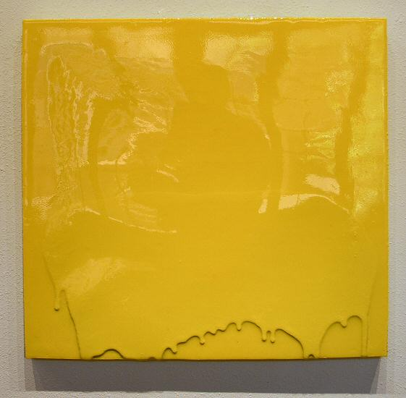
IN THE CURRENT SIX THRESHOLDS, 2004
Polyurethane plastic with pigment, 28” x 30”, MC0011
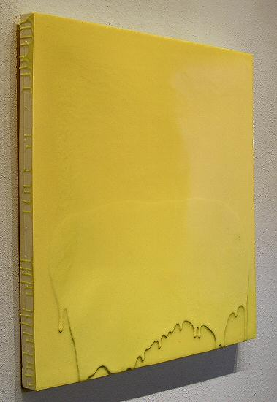
IN THE CURRENT SIX THRESHOLDS, 2004
Polyurethane plastic with pigment, 28” x 30”, MC0011
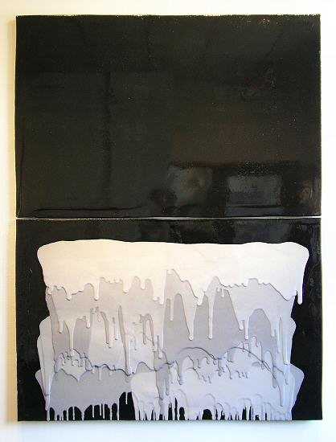
SIX MILE BOTTOM, 2004
Polyurethane plastic with pigment, 79” x 60” (diptych), MC009
HALLWAY:

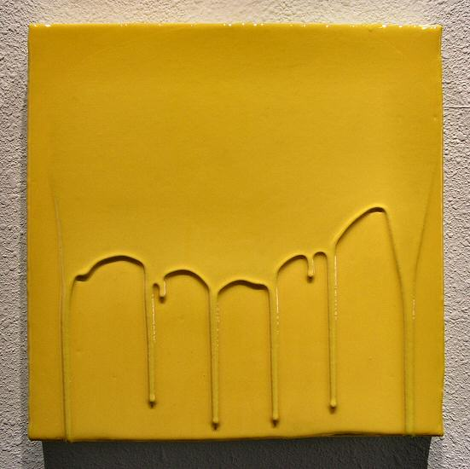
THE LETTER, 2004
Polyurethane plastic with pigment, 14” x 14”, MC0013
GALLERY II:

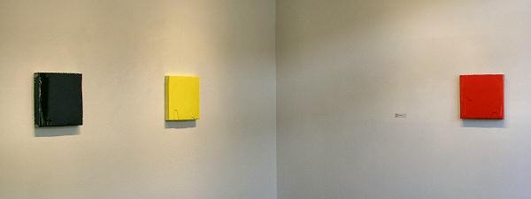

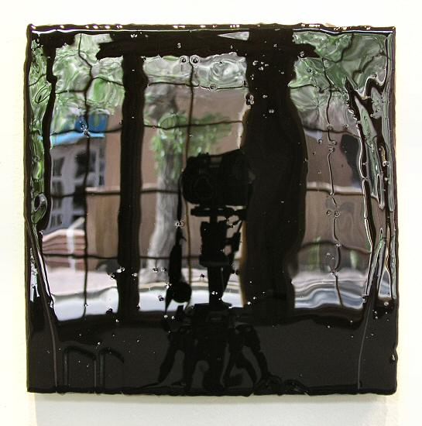
THE TILLED FIELD, 2004
Polyurethane plastic with pigment, 14” x 14”, MC0014
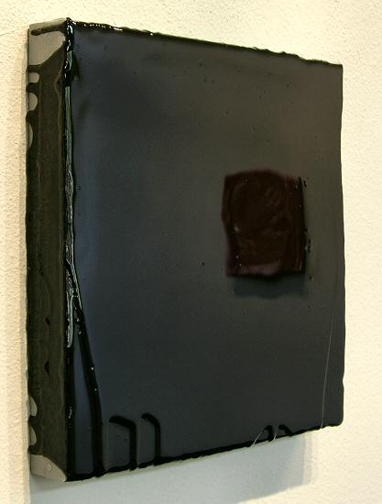
THE TILLED FIELD, 2004
Polyurethane plastic with pigment, 14” x 14”, MC0014
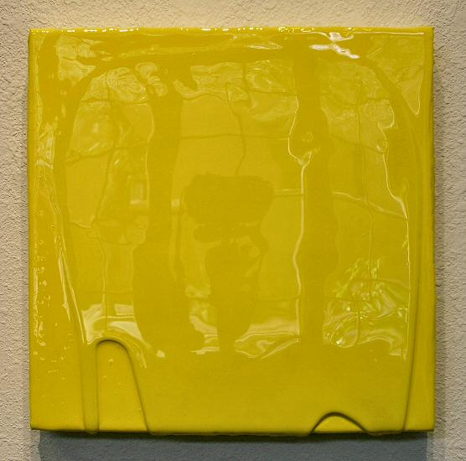
THE HARE, 2004
Polyurethane plastic with pigment, 14” x 14”, MC0016
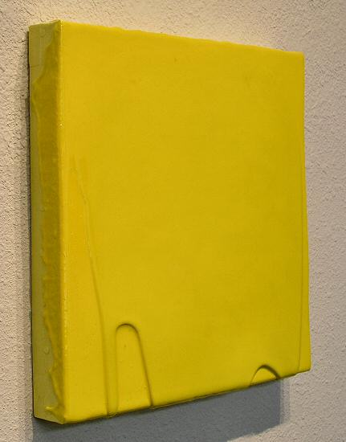
THE HARE, 2004
Polyurethane plastic with pigment, 14” x 14”, MC0016
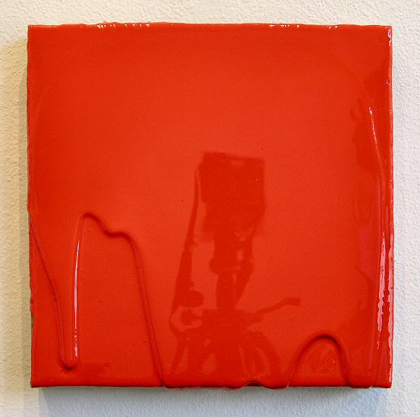
THE RETURN, 2004
Polyurethane plastic with pigment, 14” x 14”, MC0015
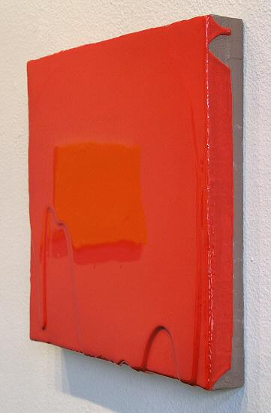
THE RETURN, 2004
Polyurethane plastic with pigment, 14” x 14”, MC0015
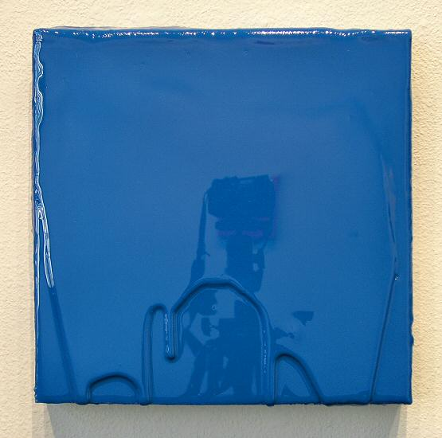
THE LITTLE ONE HAS A DAY OFF, 2004
Polyurethane plastic with pigment, 14” x 14”, MC0017
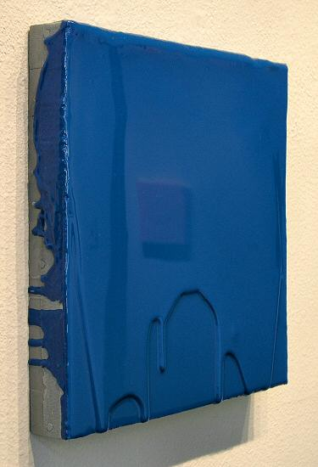
THE LITTLE ONE HAS A DAY OFF, 2004
Polyurethane plastic with pigment, 14” x 14”, MC0017
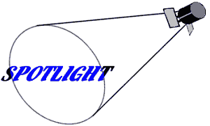

MARK COLE

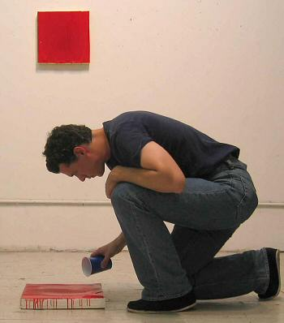
Mark Cole remembers vividly the first time he felt a strong connection to contemporary art. At the age of ten, attending an exhibition at the Rijksmuseum in Amsterdam, he caught sight of a video of a window curtain blowing in the wind. "I froze," he recalls, "because I remembered seeing a similar curtain blowing in the wind, and making up stories about why it was happening. It was such a personal connection that it made me realize the power and idiosyncratic nature of contemporary art."
Cole has "always" made art, even auditing art classes during his years in law school; but he never actually considered it as a profession until his early years as an attorney, when he began to have opportunities to exhibit his work. As his art career has developed, Cole has brought it into balance with his law practice, alternating project-based work as an attorney with months of concentrated studio time.
Cole's fascination with everything around him, his alertness to multiple associations, and his ability to pursue more than one interest at a time have grown out of a particularly rich and varied cultural background. Born in Houston, he moved with his family at the age of seven to Europe. He attended international schools in England, Holland and Canada, where the entire class for a given grade might number 20 students, representing as many as 15 different countries. The great museums of Europe were available to him at an early age, and he soon developed an appreciation for and interest in painting.
The son of an engineer father and a ballerina mother, Cole has chosen to pursue a form of painting that shows the influence of both parents. His use of industrial material (polyurethane plastic) and process (casting), and the precise, "finish fetish" look of his surfaces, combine with bright, delicate colors that could grace any stage. The resulting work impresses the viewer both with its directness and its subtlety, its practicality and its whimsy.
This kind of paradox is an important element in Cole's work. "Paradox makes us realize that things aren't black and white," he says. "There is always a fine line when a thing shifts from one side the other. That opening in the middle points to the fact that labeling is always an arbitrary exercise. It makes the work open-ended, so that there is always something left for the viewer to explore."
© 2004, Charlotte Jackson Fine Art
All Rights Reserved

Charlotte Jackson Fine Art

200 West Marcy Street, Suite 101

Santa Fe, New Mexico 87501

Phone: 505.989.8688
Fax: 505.989.9898

www.charlottejackson.com

Photography and CD production – William Metcalf

