CHARLOTE JACKSON FINE ART PRESENTS:

California Past and Present
Charles Arnoldi, Ron Davis, Tony Delap, Ed Moses

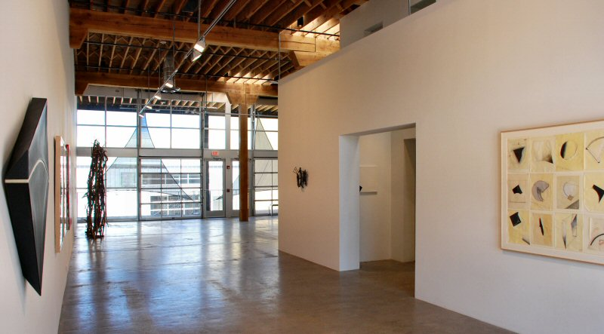
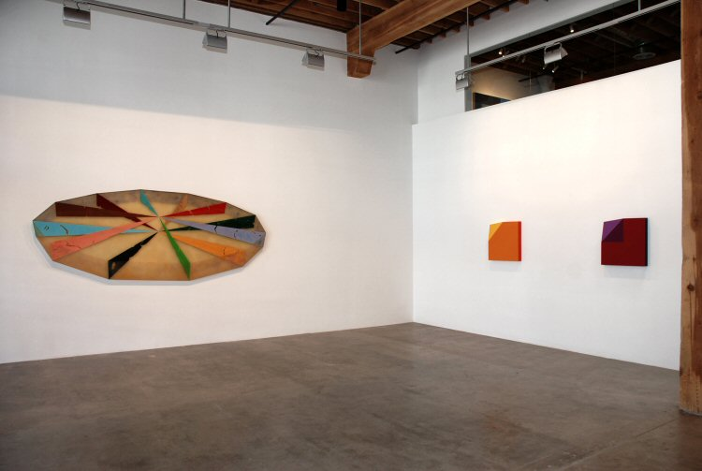

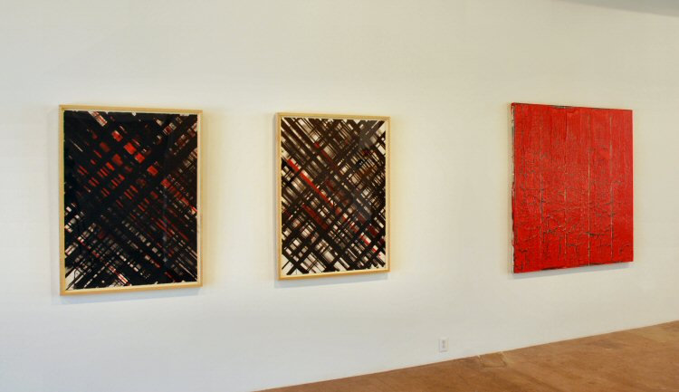

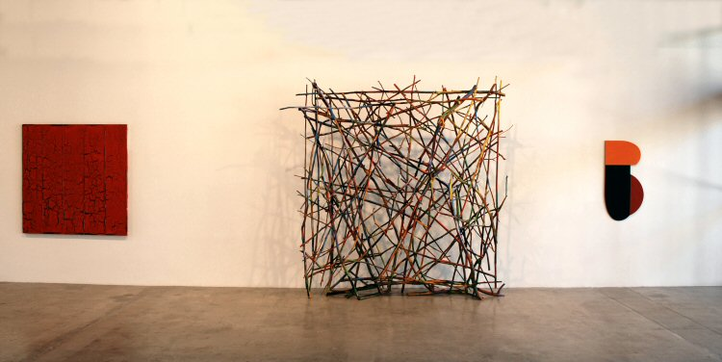

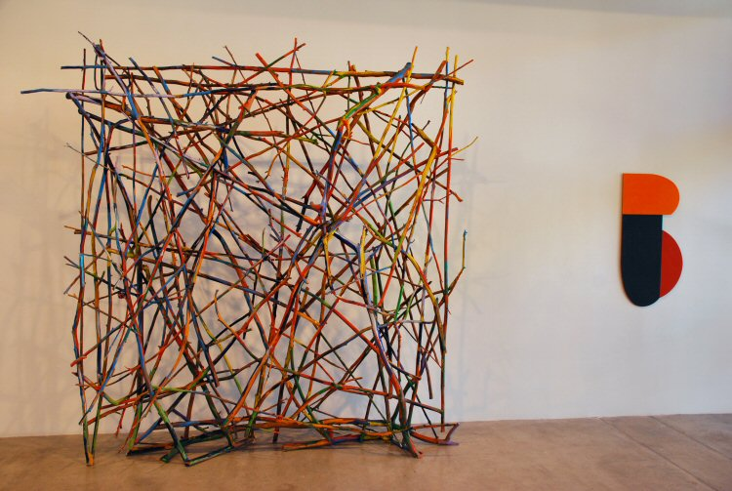

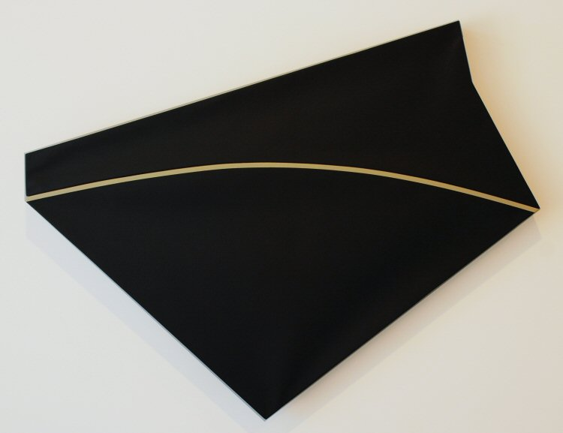
Tony DeLap
The Real Secret, 2009
Acrylic on canvas
45 x 56 1/2 x 3 3/8 inches
TD0078

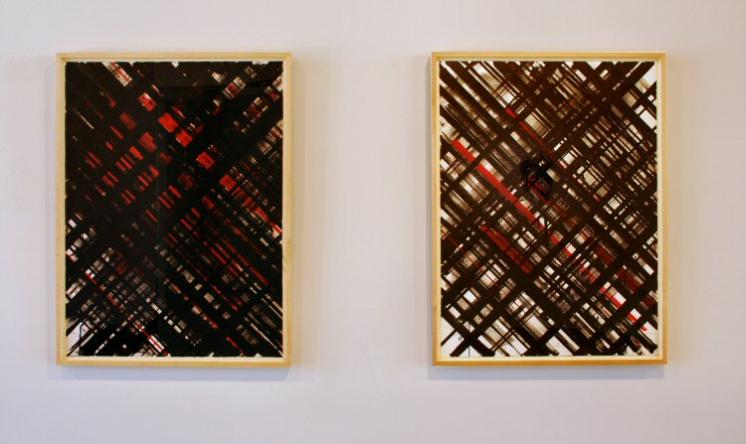

Ed Moses
Untitled, 1976-2008
Acrylic & Masking Tape on Strathmore Board
49 x 37 1/2 inches
EM29

Ed Moses
Untitled, 1976-2010
Acrylic & Masking Tape on Strathmore Board
49 x 37 1/2 inches
EM30
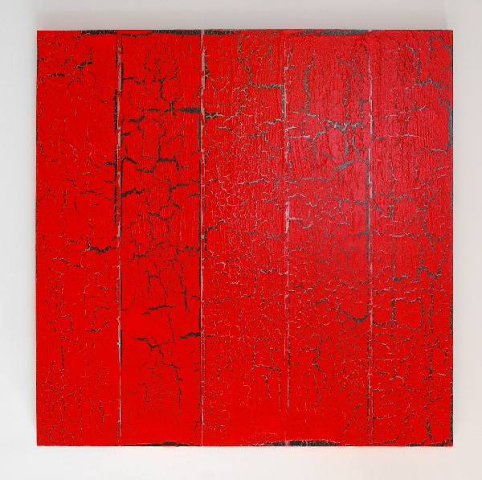

Ed Moses
ACM #2, 2011
acrylic and glue on canvas
60 x 60 inches
EM044

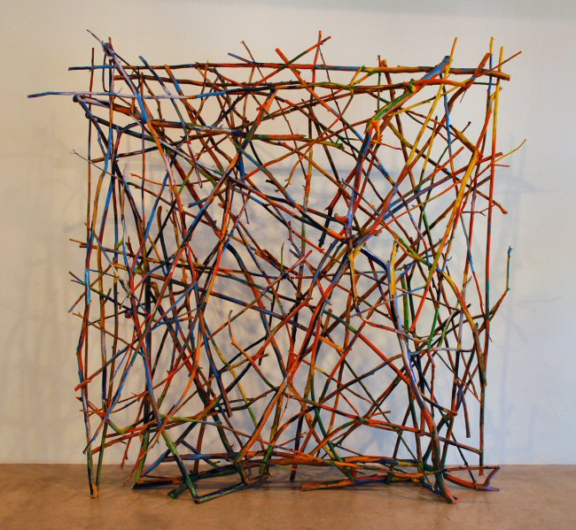

Charles Arnoldi
Untitled ("Stick Piece"), 1978-1979
Oil on tree branches
134 x 115 x 27 inches
No signature
CA0047

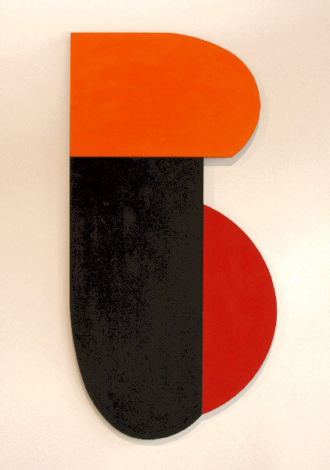
Charles Arnoldi
Ironclad (06.38), 2006
Oil on aluminum
43 1/8 x 21 7/8 inches
CA0016

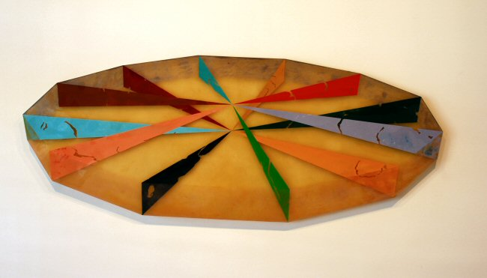
Ronald Davis
Spindle, 1968
Moulded Polyester Resin and Fiberglass
50 1/2 x 132 inches
ROND0052
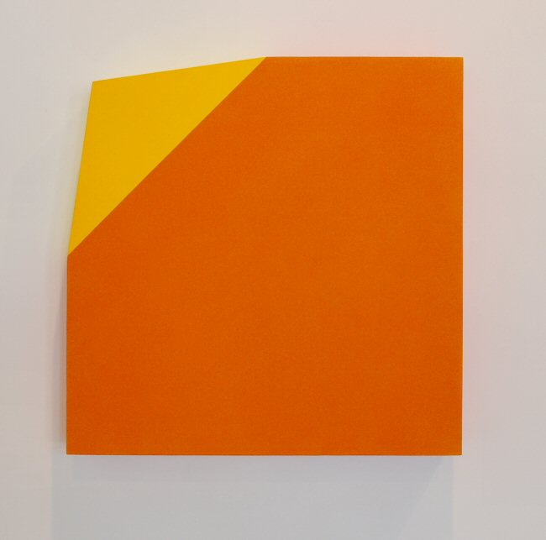
Ronald Davis
Orange Bent Corner Square, 2010
Acrylic on Expanded PVC
24 x 24 x 3 inches
ROND0051
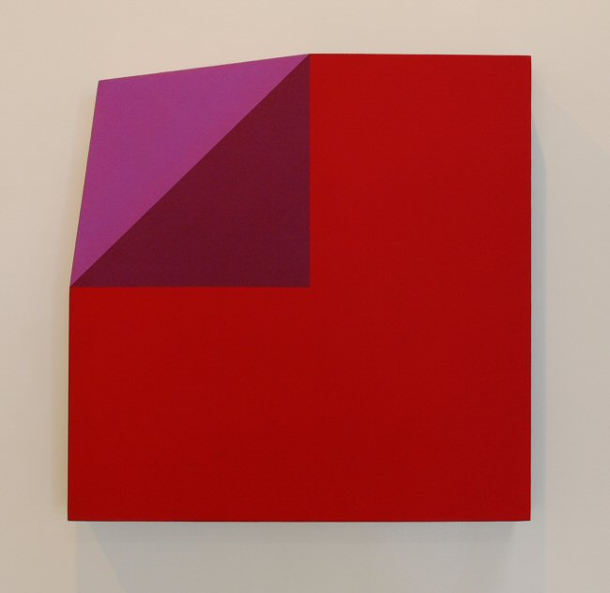
Ronald Davis
Red and Violet Bent Corner Square, 2010
Acrylic on expanded PVC
24 x 24 x 3 inches
Signed by the artist
ROND0030
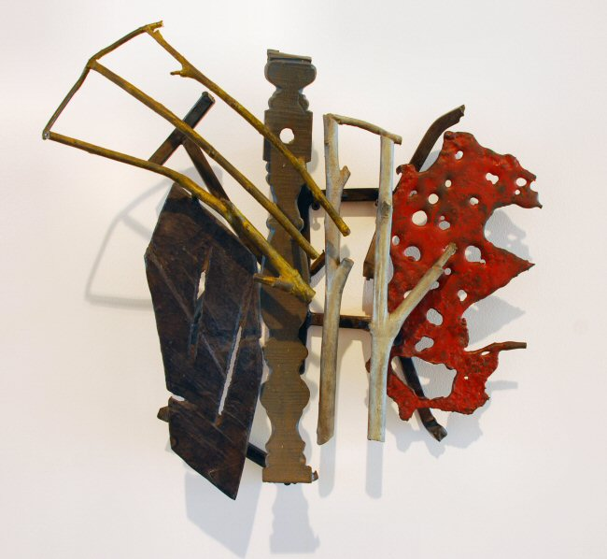
Charles Arnoldi
Untitled, 1988
cast and welded bronze
19 x 18 x 5 inches
CA133-RO
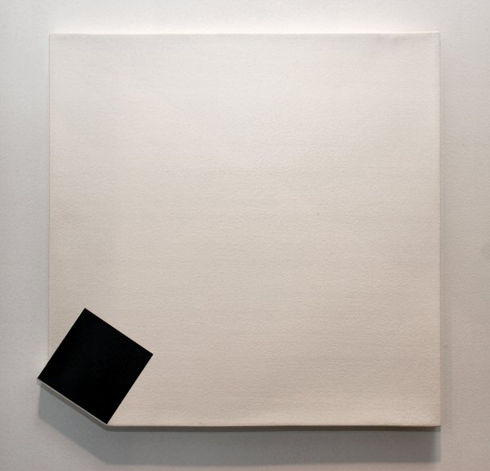
Tony DeLap
The Whim of Tituba, 1979
Acrylic on Canvas
19/ x 19 5/8 x 1 inches
TD0081
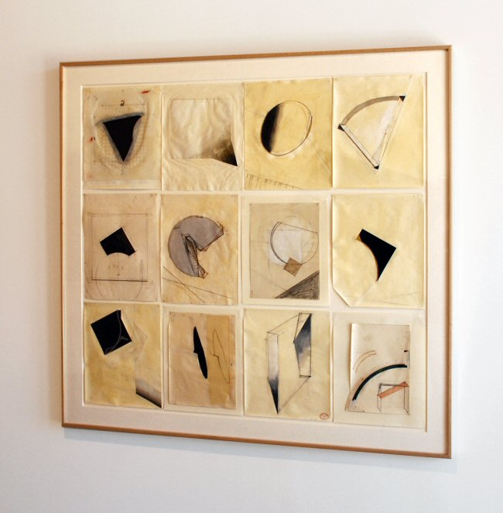
Tony DeLap
Twelve Drawings II, 1978-2003
collage, gouache, graphite, watercolor, colored pencil, ink, paper
49 x 51 inches
TD0020

© 2011

Charlotte Jackson Fine Art, Inc.

In the Railyard at:

554 S. Guadalupe, Santa Fe, New Mexico 87501
Telephone: 505.989.8688 Fax: 505.989.9898
cjfa@charlottejackson.com - www.charlottejackson.com

