CHARLOTTE JACKSON FINE ART PRESENTS:

BLACK MAGIC:

**Max Cole Constance DeJong**

Oct 16 - Nov 16, 2015

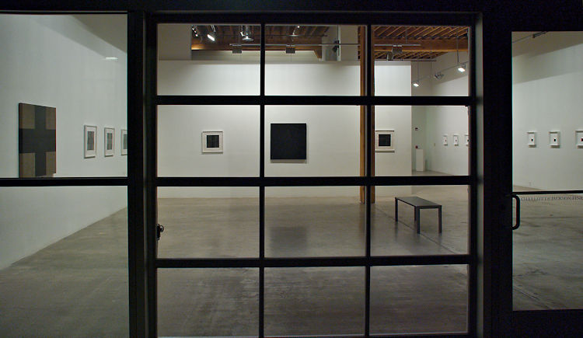

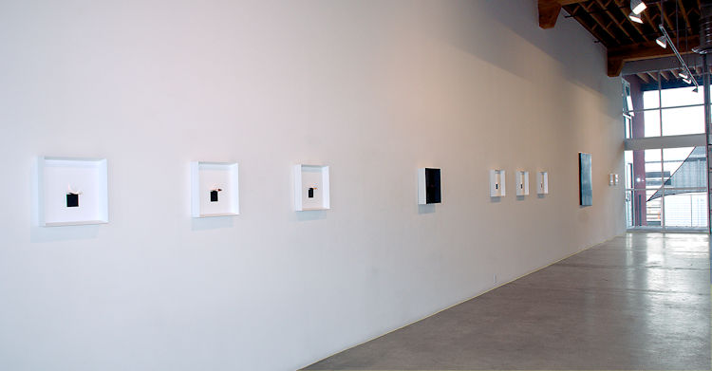

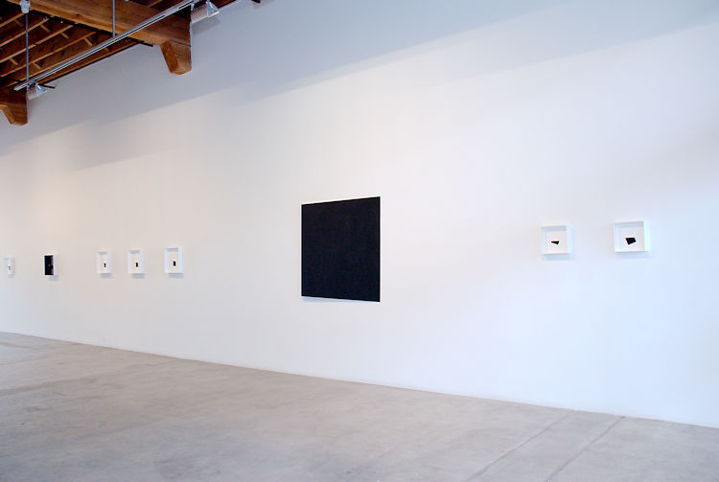

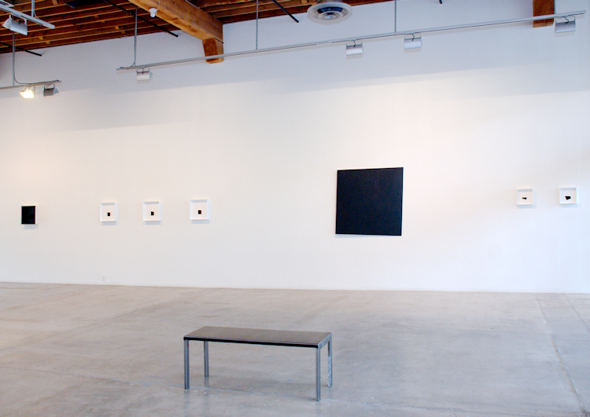

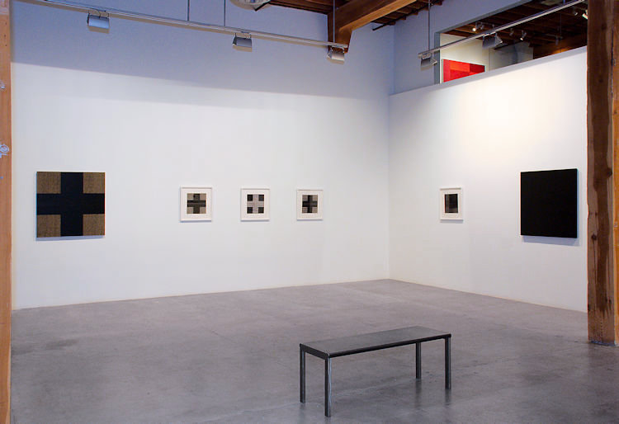

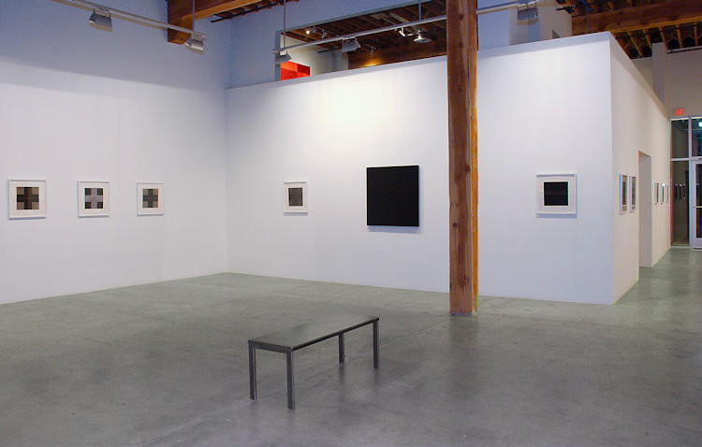

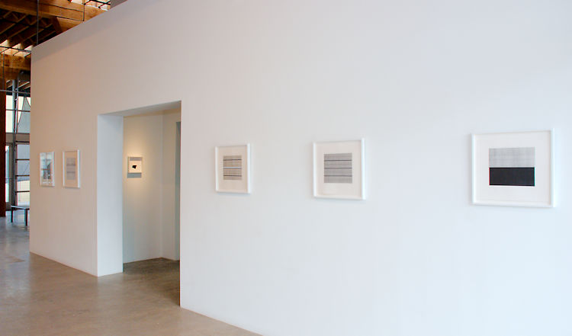

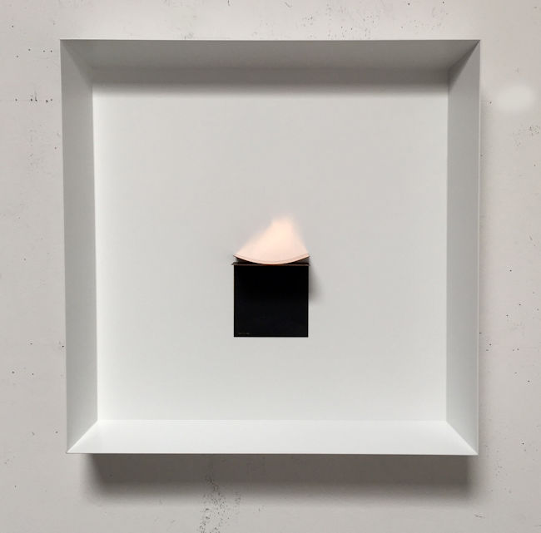

Constance DeJong  
Arc/r49, 2015  
copper and maple  
15 1/2 x 15 1/2 x 3 in.   
CD135

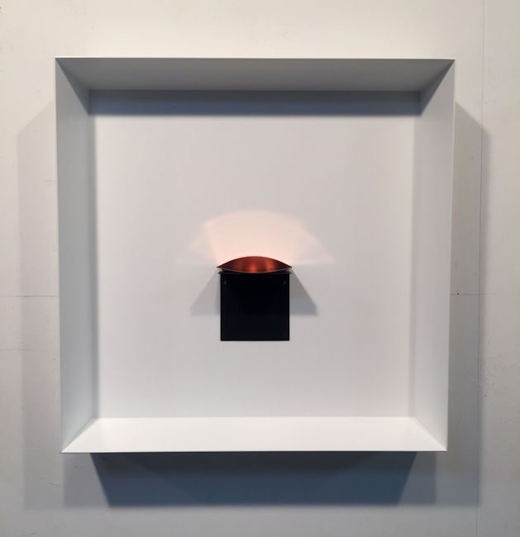

Constance DeJong  
Ellipse/h11, 2005-2015  
copper and maple  
15 1/2 x 15 1/2 x 3 in.   
CD136

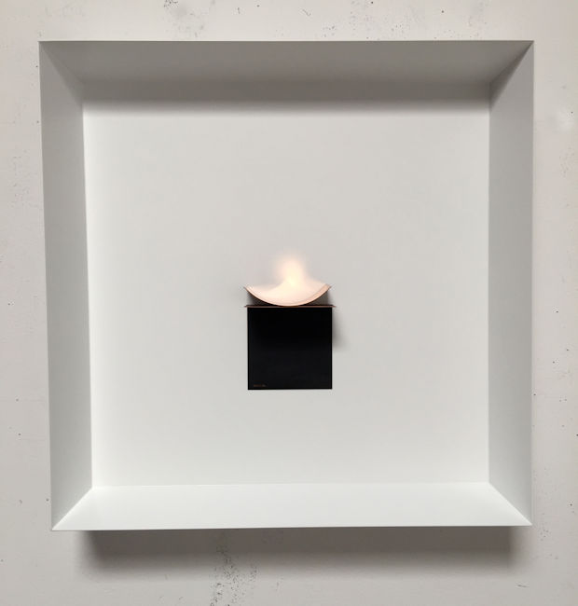

Constance DeJong  
Arc/r33, 2015  
copper and maple  
15 1/2 x 15 1/2 x 3 in.   
CD134

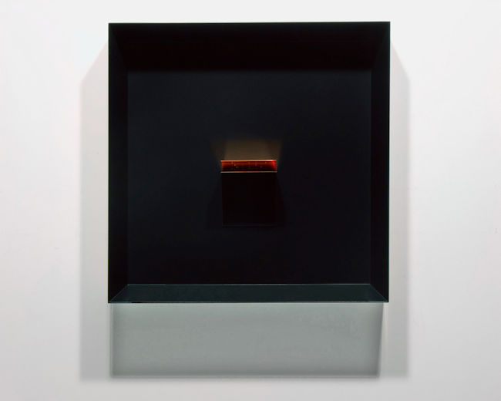

Constance DeJong  
Split Cube 1.618/4, 2015  
copper and maple  
16 1/2 x 16 1/2 x 4 in.   
CD137

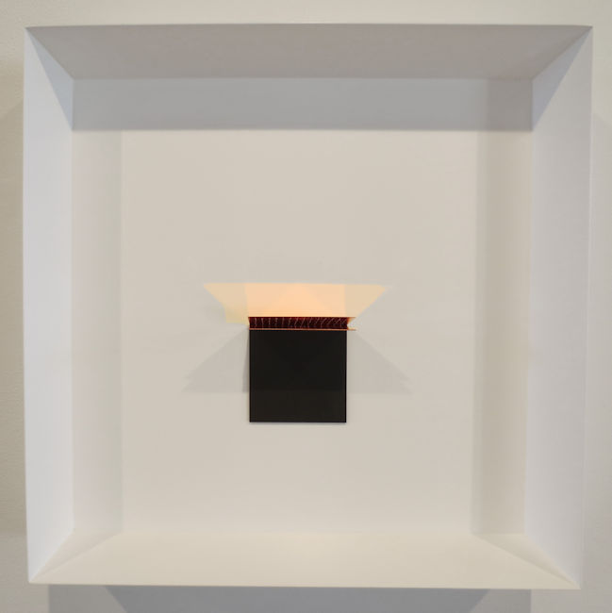

Constance DeJong  
Grid/Floating Square, 2015  
copper and maple  
15 1/2 x 15 1/2 x 3 in.   
CD132

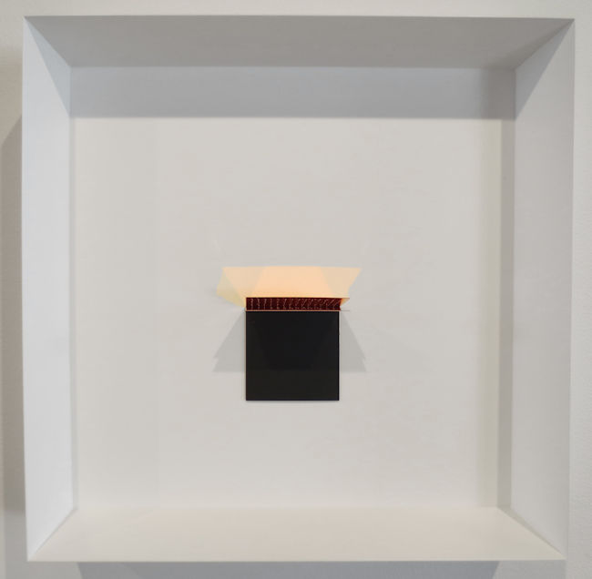

Constance DeJong  
Grid/Floating Rectangle, 2015  
copper and maple  
15 1/2 x 15 1/2 x 3 in. (39.37 x 39.37 x 7.62 cm)   
CD133

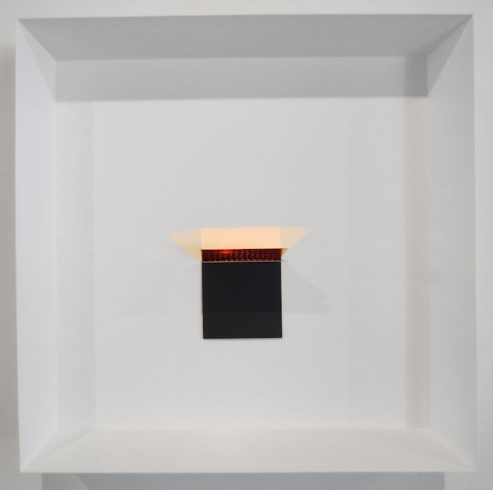

Constance DeJong  
Grid/Triangulated, 2015  
copper and maple  
15 1/2 x 15 1/2 x 3 in.   
CD131

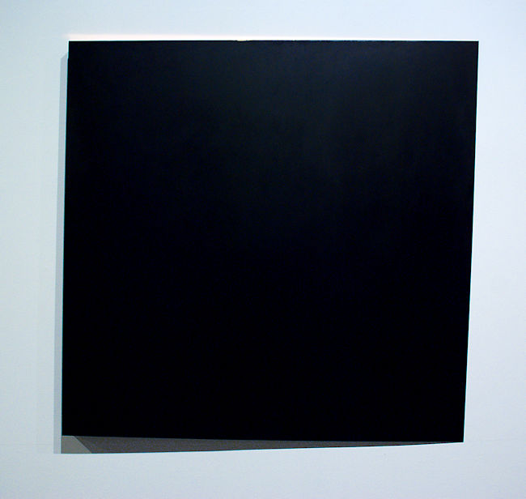

Constance DeJong  
Square 48/2, 2004  
copper, wood  
48 x 48 x 2 in.   
CD138

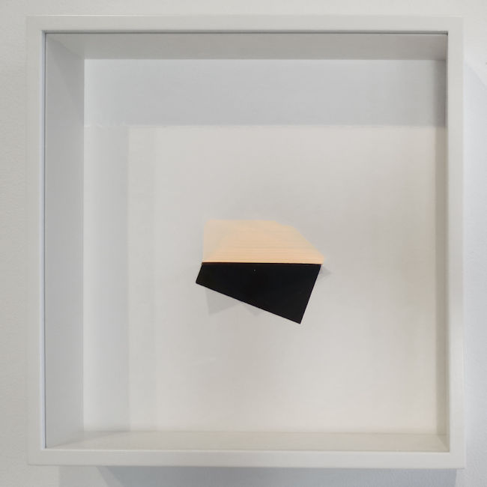

Constance DeJong  
Golden/Grid, 2015  
copper and conte on museum board  
10 1/2 x 10 1/2 x 2 1/4 in.   
CD130

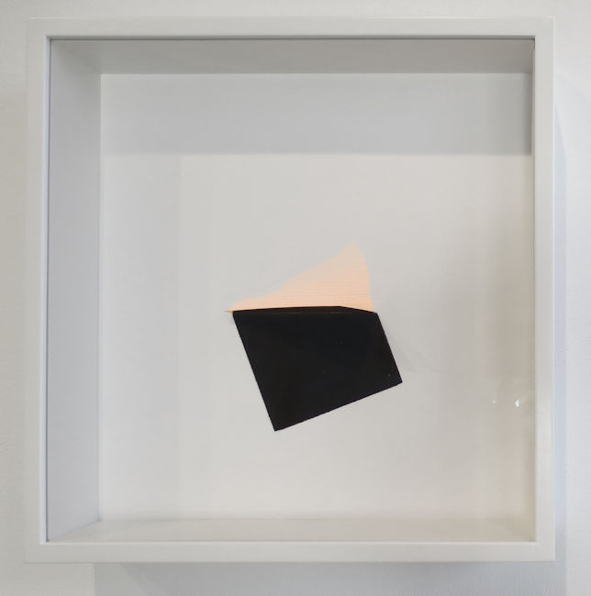

Constance DeJong  
Square/Grid, 2015  
copper and conte on museum board  
10 1/2 x 10 1/2 x 2 1/4 in.   
CD128

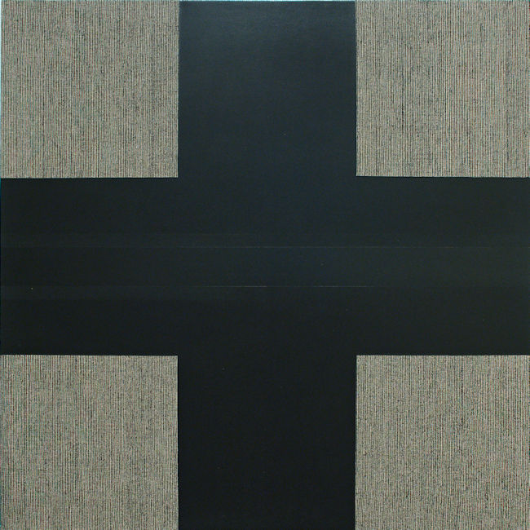

Max Cole  
Greek Cross II, 2015  
acrylic on jute canvas  
39 x 39 in.   
MAXC087

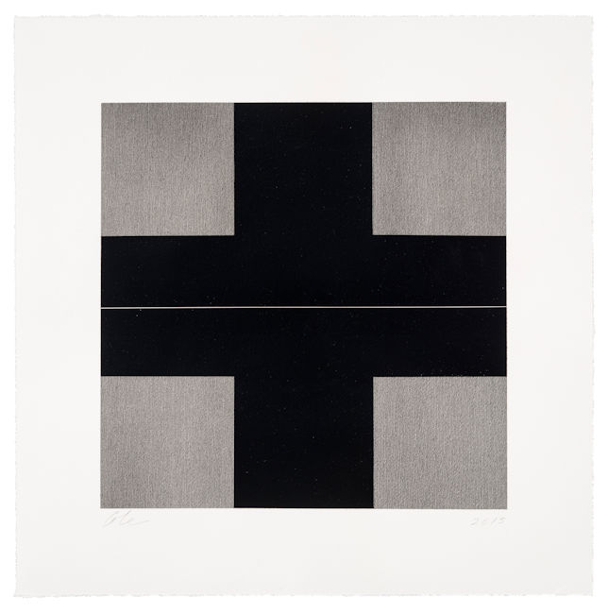

Max Cole  
Untitled, Greek Cross Series 2, 2015  
acrylic and acrylic washes on rag paper  
13 3/4 x 13 3/4 in. Sheet size: 20x20 inches  
MAXC080

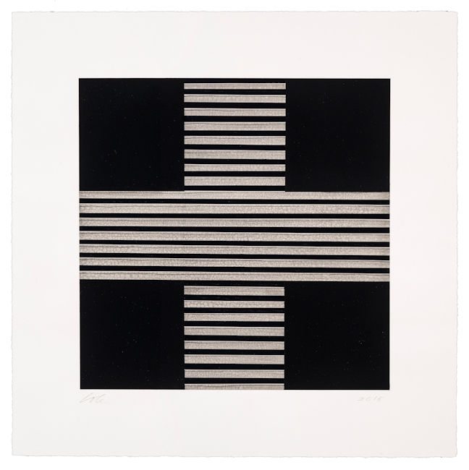

Max Cole  
Untitled, Greek Cross Series 5, 2015  
acrylic and acrylic washes on rag paper  
13 3/4 x 13 3/4 in. Sheet size: 20x20 inches  
MAXC083

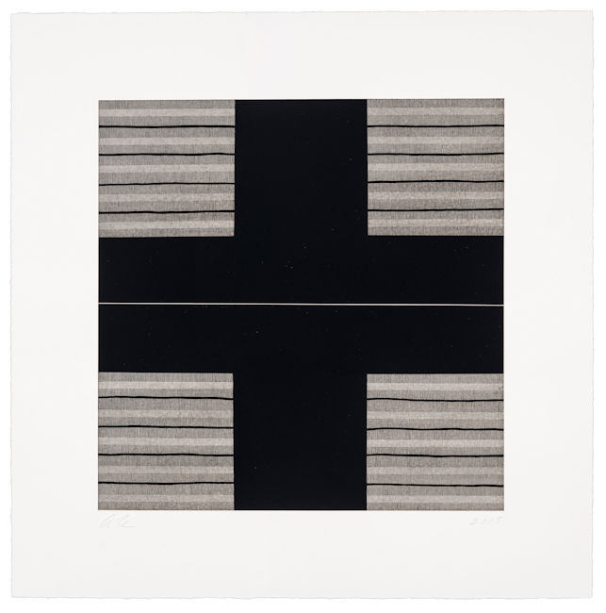

Max Cole  
Untitled, Greek Cross Series 5, 2015  
acrylic and acrylic washes on rag paper  
13 3/4 x 13 3/4 in. Sheet size: 20x20 inches  
MAXC083

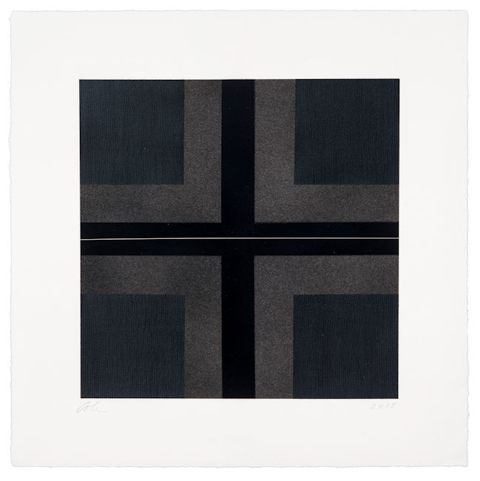

Max Cole  
Untitled, Greek Cross Series 1, 2015  
acrylic and acrylic washes on rag paper  
13 3/4 x 13 3/4 in. Sheet size: 20x20 inches  
MAXC079

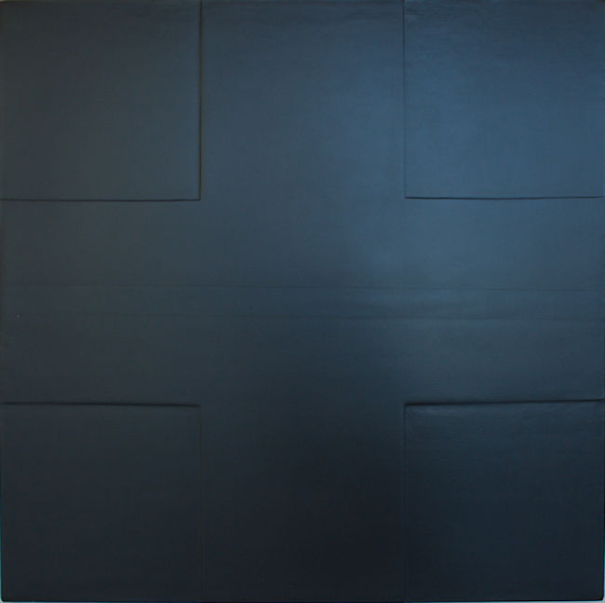

Max Cole  
Greek Cross I, 2015  
acrylic on jute canvas  
39 x 39 in.   
MAXC086

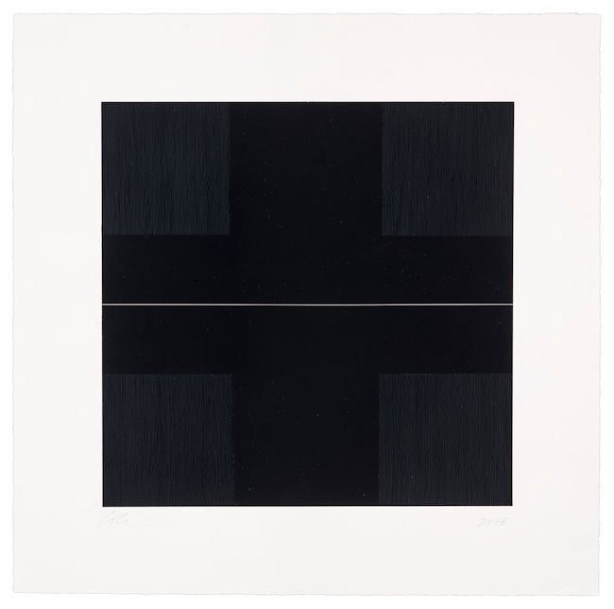

Max Cole  
Untitled, Greek Cross Series 6, 2015  
acrylic and acrylic washes on rag paper  
13 3/4 x 13 3/4 in. Sheet size: 20x20 inches  
MAXC084

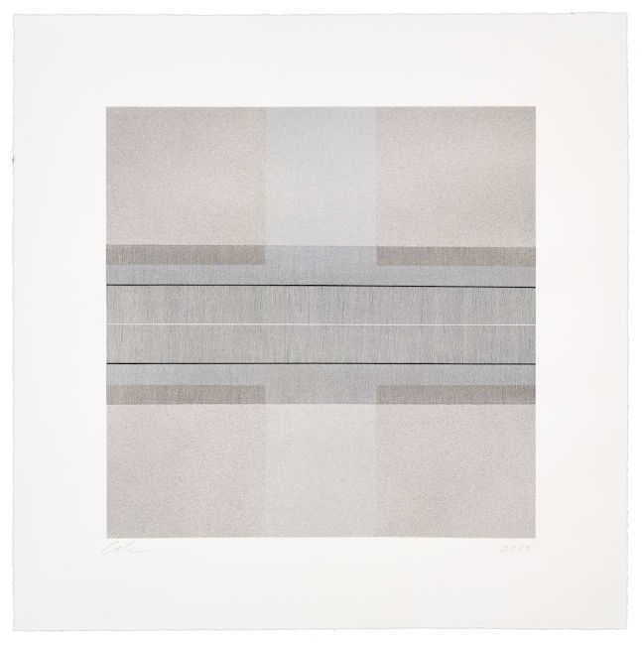

Max Cole  
Untitled, Greek Cross Series 4, 2015  
acrylic and acrylic washes on rag paper  
13 3/4 x 13 3/4 in. Sheet size: 20x20 inches  
MAXC082

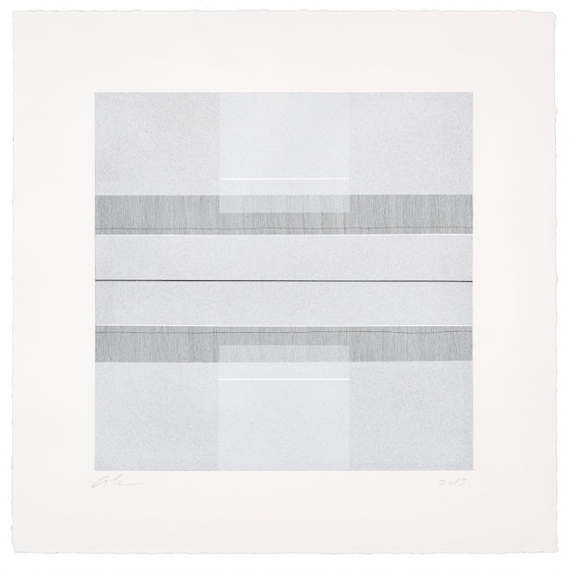

Max Cole  
Untitled, Greek Cross Series 7, 2015  
acrylic and acrylic washes on rag paper  
13 3/4 x 13 3/4 in. Sheet size: 20x20 inches  
MAXC085

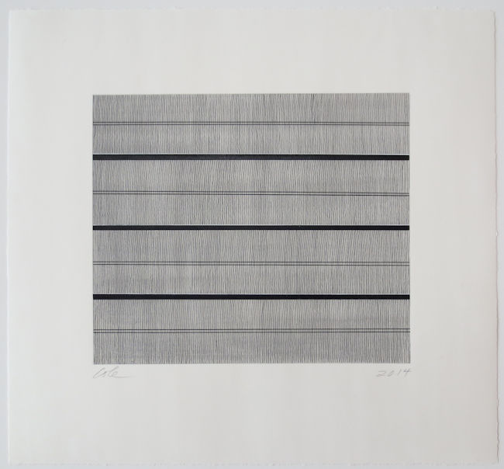

Max Cole  
Untitled (#11), 2014  
Ink and acrylic on Arches paper  
18 x 19 in.  
MAXC067

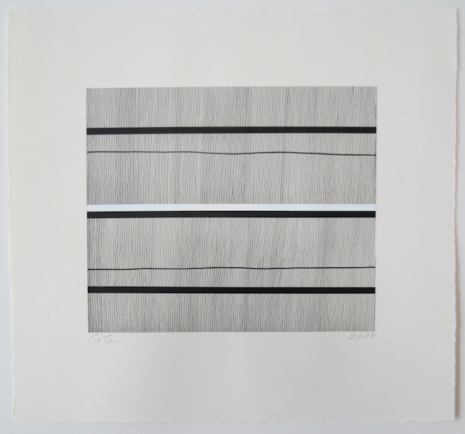

Max Cole  
Untitled (#5), 2014  
Ink and acrylic on Arches paper  
18 x 19 in.  
MAXC061

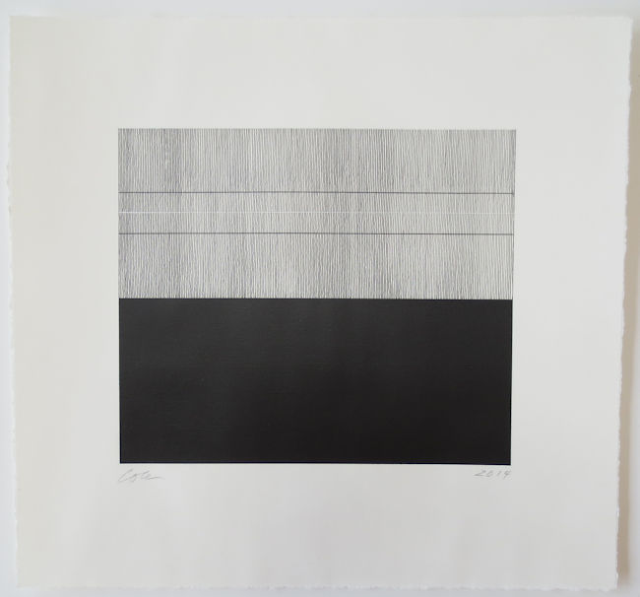

Max Cole  
Untitled (#22), 2014  
Ink and acrylic on Arches paper  
18 1/2 x 19 1/2 x 1 1/2 in.   
MAXC078

# © 2015

# Charlotte Jackson Fine Art, Inc.

## In the Railyard at:

## 554 S. Guadalupe, Santa Fe, New Mexico 87501

Telephone: 505.989.8688 Fax: 505.989.9898

cjfa@charlottejackson.com - www.charlottejackson.com