CHARLOTTE JACKSON FINE ART

PRESENTS

BACK TO BASICS
A Group Show
October, 2005
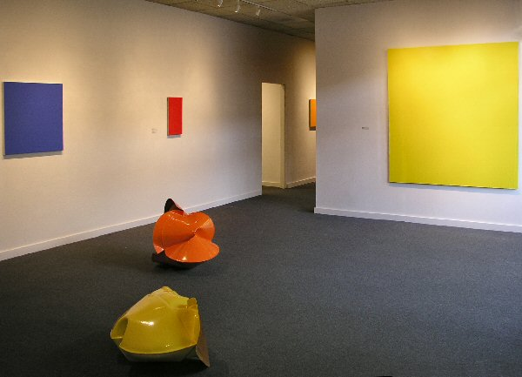
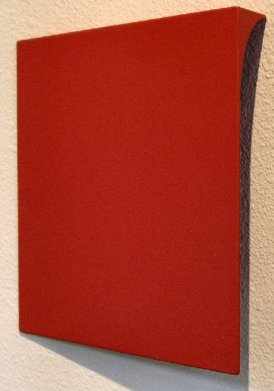
Tony Delap
The Jumping Ace, 2002
Acrylic on aluminum and wood
11 3/4" x 11 1/2" x 2"
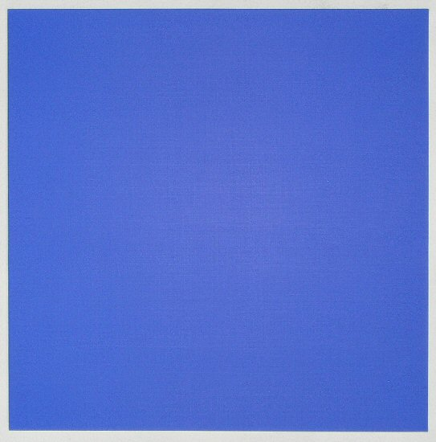
Rudolf de Crignis
Painting #01-34, 2001
Oil on canvas
30" x 30"
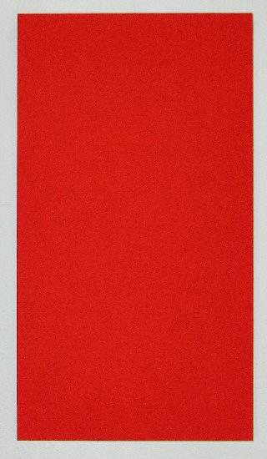
Alfonso Fratteggiani Bianchi
#177 Rosso Ve, 2003
Pigment on limestone
54 x 30.1 x 3 cm.
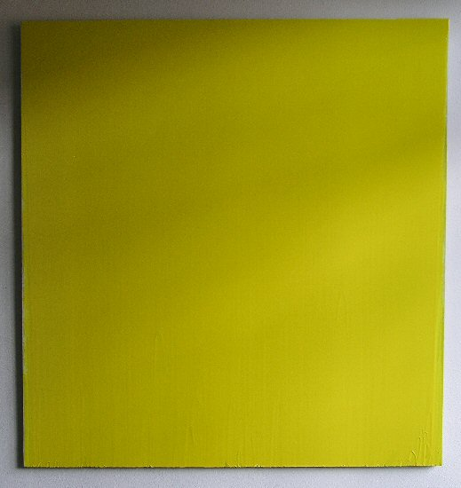
Joseph Marioni
Yellow painting #43, 1999
Acrylic on linen on stretcher
72" x 68"
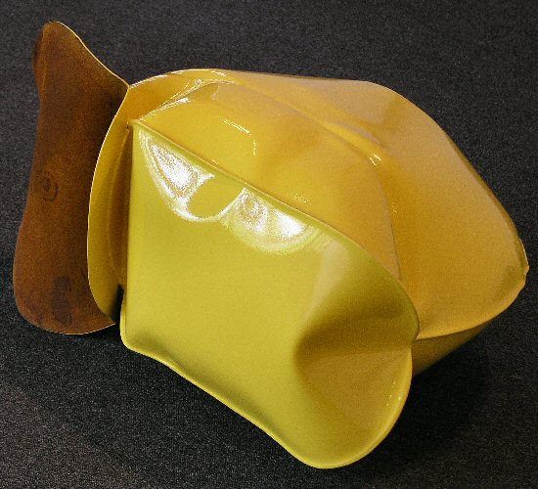
Jeremy Thomas
New Holland Yellow, 2004
Forged mild steel and powder-coated enamel
30" x 16" x 21"

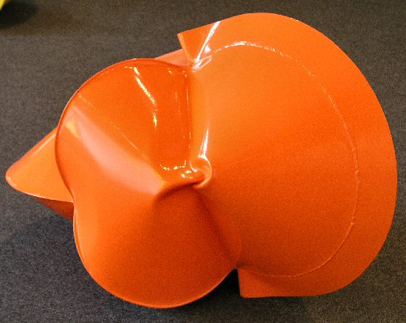
Jeremy Thomas
Olde Dixon Land Imprinter Orange, 2005
Forged mild steel and powder-coated enamel
28" x 25" x 28"
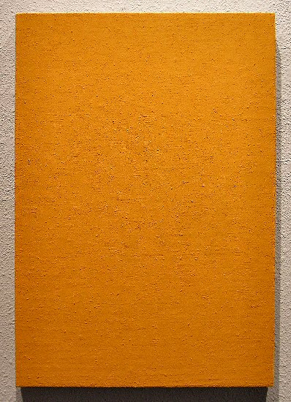
Phil Sims
Untitled Orange, #500, 2003
Oil on linen on stretcher
23" x 16"
Gallery II:

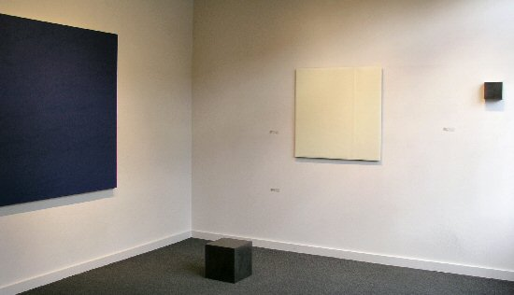
Marcia Hafif, Florence Pierce, Susan York

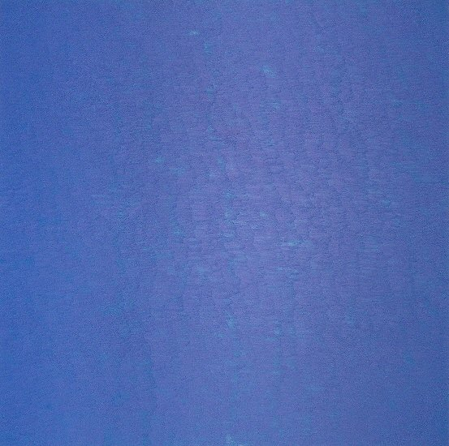
Marcia Hafif
Heliogen Blue, 2000
Oil on canvas
58" x 58"
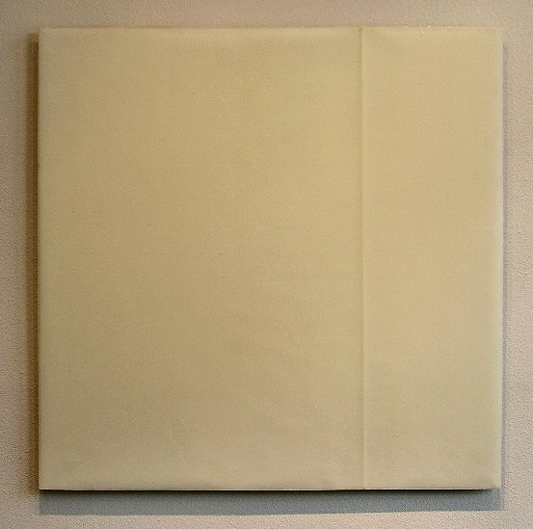
Florence Pierce
Untitled #100B, 05/13/94
Resin relief
36" x 36"
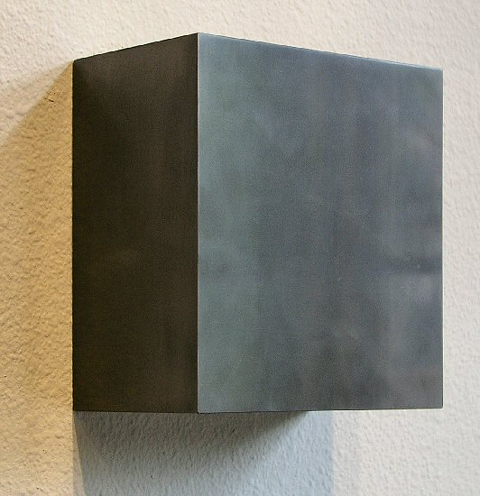
Susan York
Graphite square, 2005
Solid graphite, aluminum
5" x 6" x 3"
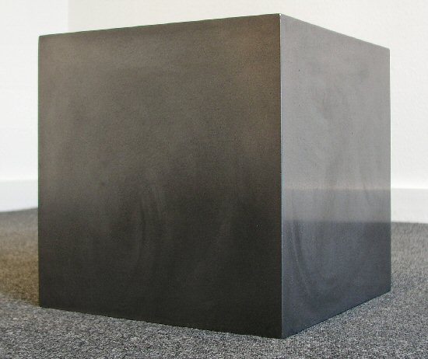
Susan York
Graphite cube #2, 2005
Solid Graphite
12" x 12" x 12"
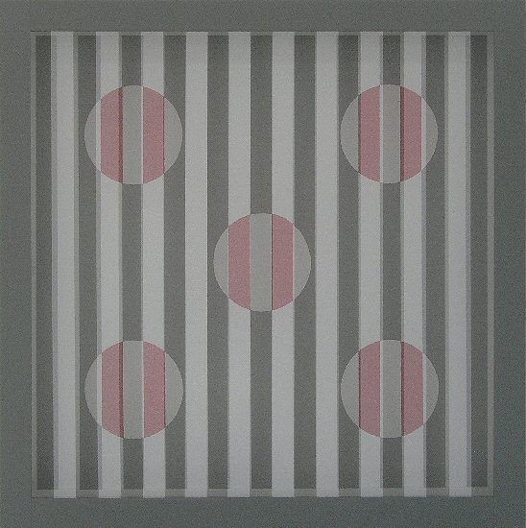
William Metcalf
Infinity Series #13, 2005
Acrylic, Polyester fabric, wood, Gatorfoam
23 3/4" sq. x 2 3/4"
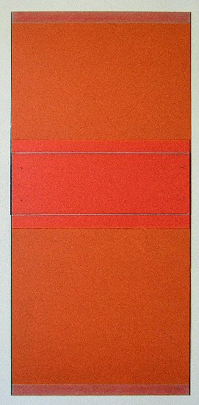
Michael Rouillard
Red One, 2003
Oil stick on aluminum
57" x 26 7/8"
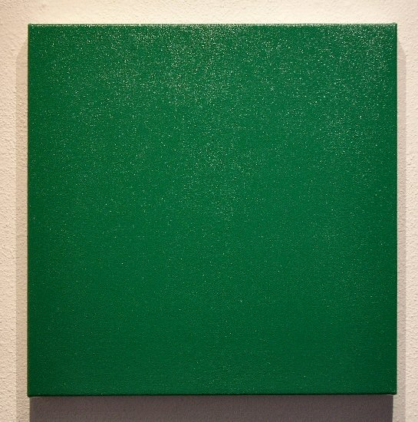
Olivier Mosset
Untitled, 2004
Oil on canvas
19" x 19"
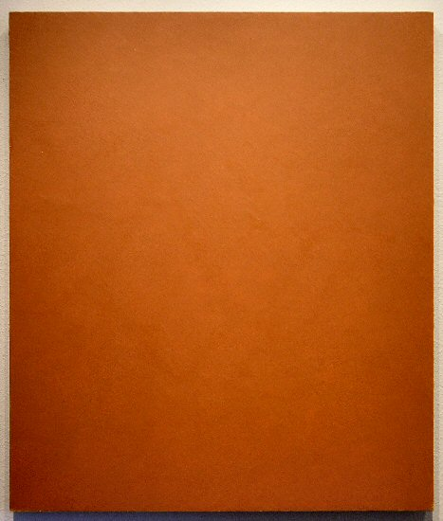
Clark Walding
Orange, 2005
Oil, alkyd, wax, and clay, on canvas
33 1/2" x 28 1/2" x 2 1/2"

ADDITIONAL WORKS:
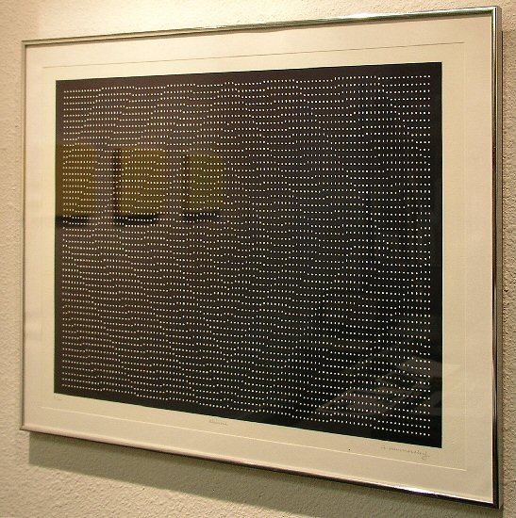
Frederick Hammersley
Chinese, 1974
Lithograph, 2/20
17 1/2" x 22"
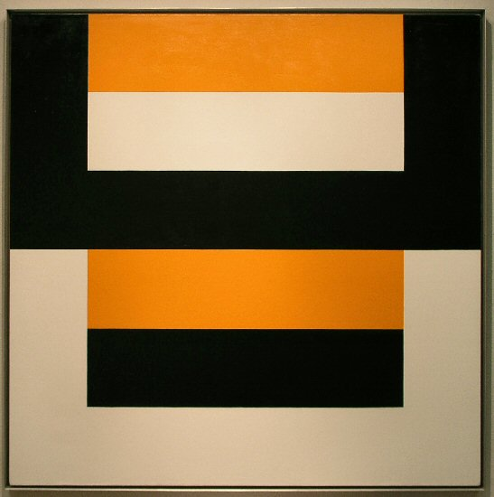
Frederick Hammersley
Cleave #2, 1979
Oil on canvas
45" x 45"
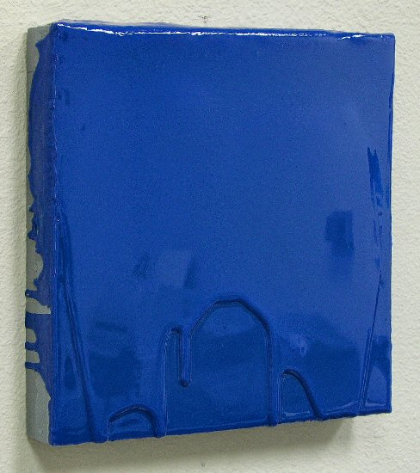
Mark Cole
The Little One Has a Day Off, 2004
Polyurethane plastic with pigment
14" x 14"
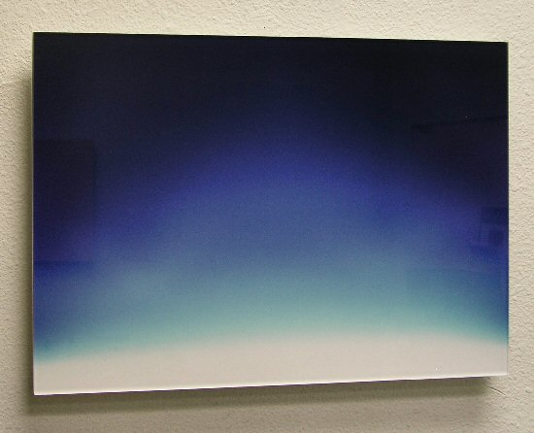
Erika Blumenfeld
Fractions of Light and Time, 05/27/2005 1:58pm
Cibachrome, Plexiglas
13 1/2" x 19"
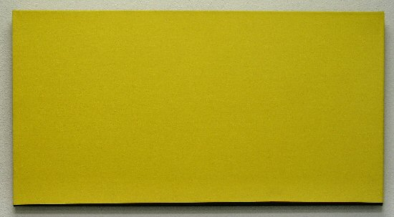
Anne Truitt
Quick, 1986
Acrylic on canvas
22" x 42"
© 2005, Charlotte Jackson Fine Art
All Rights Reserved

Charlotte Jackson Fine Art

200 West Marcy Street, Suite 101

Santa Fe, New Mexico 87501

Phone: 505.989.8688
Fax: 505.989.9898

www.charlottejackson.com

Photography and CD production – William Metcalf

