CHARLOTTE JACKSON FINE ART
PRESENTS:

CHARLES ARNOLDI: CASE STUDY

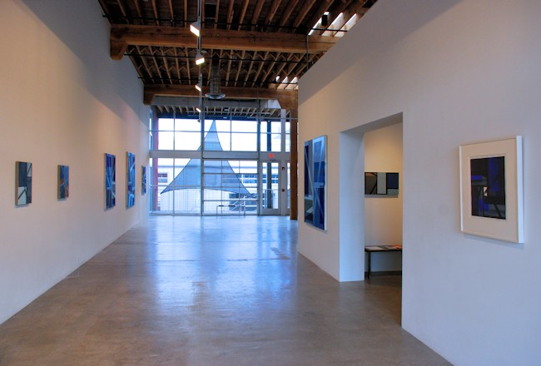

JULY 27 THROUGH AUGUST 27, 2012

You might want to walk into one of them – touch a black line, slide your hand down a plane of Ultramarine blue, duck your head under a beam of Payne’s gray. The deeper you move into a piece from Arnoldi’s Case Study series, the more you may have to contort and bend within its intricate and interlocking structures. These paintings defy two-dimensionality, teasing out a sense of space, not through use of the tricks of perspective, but through their complex layers of geometric form. The tightly controlled and balanced palette of blues, whites, grays, with some rare hints of sienna, successfully suggests space and depth, but perhaps more importantly is utterly satisfying to the eye.

With their layered interaction of planes and lines, it isn’t difficult to make a link between these works and architecture. But the titling of the exhibition for the Post World War II program of Case Study homes sponsored by Arts and Architecture magazine is more a case of synchronicity than of conscious planning. Arnoldi didn’t set out to create a series inspired by the Case Study homes, the connection came after the fact when he’d completed a number of the larger canvases and was thinking of what to title them. Having just visited a Case Study home in Los Angeles, his admiration of its clean lines and use of glass were still fresh in his mind and he decided to name the new pieces after Case Study architects.

And yet, coincidence or not, a deeper study of these pieces can lead to some very interesting comparisons. The lines of the Case Study houses are clean and the structures are full of intersecting geometric planes: walkways, connecting patios, cantilevered structures, flat roofs, deep flat overhangs. Arnoldi’s paintings not only capture the structural dynamics of this architecture, but their palette is suggestive of their materials: glass, steel, stucco.

The one thing you always know you will get when you go to an exhibition of work by Charles Arnoldi is authenticity. He doesn’t stand still—and that is what makes Arnoldi’s art continually fresh. Though the visual vocabulary may change from series to series, a student of Arnoldi’s art will begin to see the underlying patterns, the continuity from piece to piece that expresses so much of Arnoldi’s passions, obsessions, and curiosity. Though the works in this exhibition are in some ways an organic evolution or hybrid of his recent series Grids and Windows, as well as his interest in Mondrian and respect for Diebenkorn, subconsciously his passion for architecture was at play as well. One of the things that fascinates Arnoldi most in construction is the “framing” stage, before the walls are done. In a painting like Nuetra, for example, you can almost imagine standing in the framed skeleton of a building, so that you are able to see several rooms simultaneously with their patterns and intersecting planes.

In Charles Arnoldi’s latest exhibition, Case Study, structure is key. Though these paintings, with their constraint and geometry, appear clean and deceptively simple, there is a complication that arises as the viewer sinks deeper into the overlapping layers of lines and planes, studies the way they fracture at the canvas edges. The paintings in Case Study, with masterful architectural technique, balance tight precision with defiant complexity.
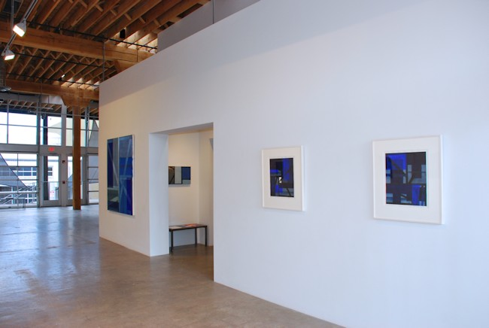

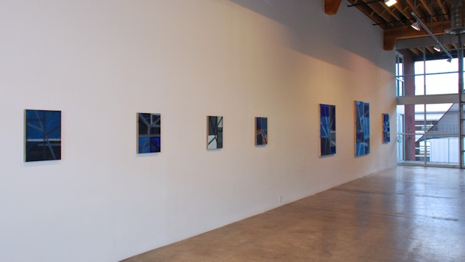
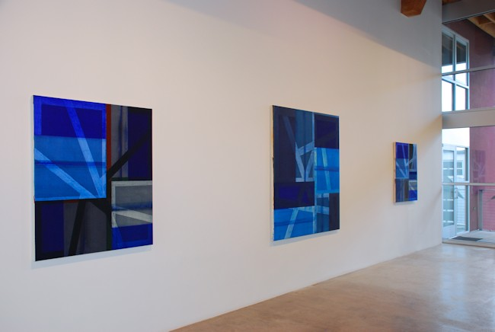

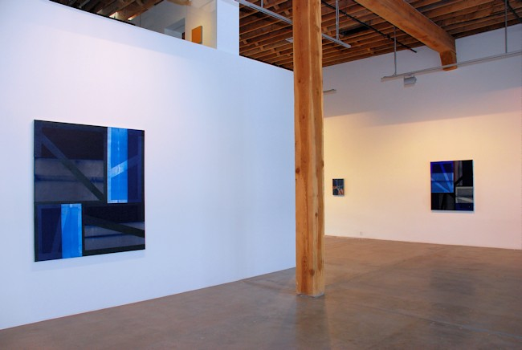
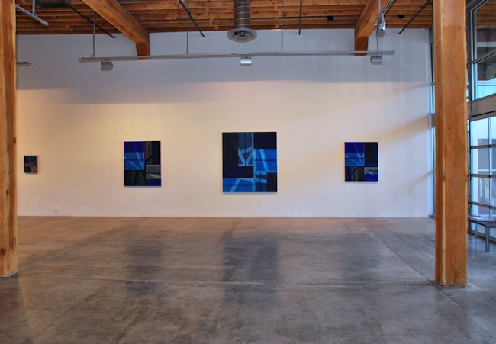

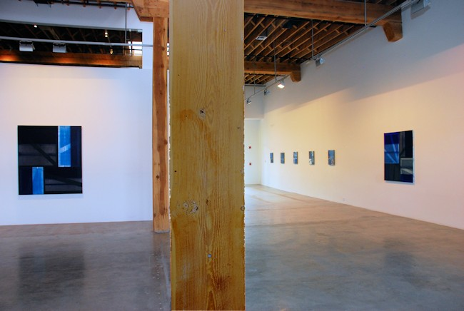
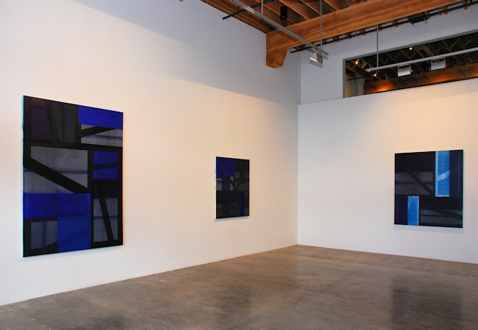
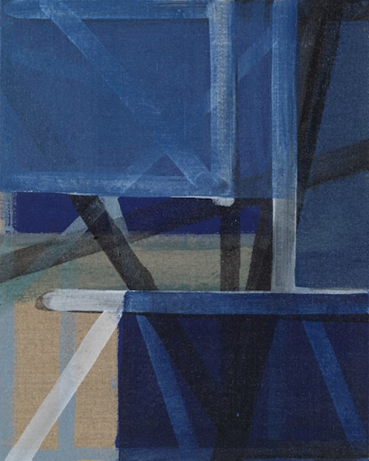
Untitled, 2012
Acrylic on linen
20 x 16 inches
CA0165
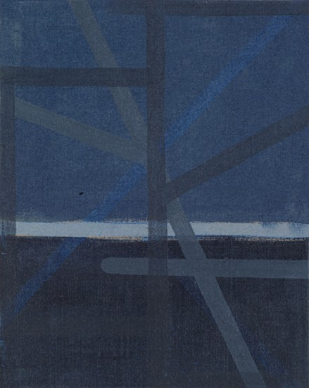
Untitled, 2012
Acrylic on linen
20 x 16 inches
CA0168
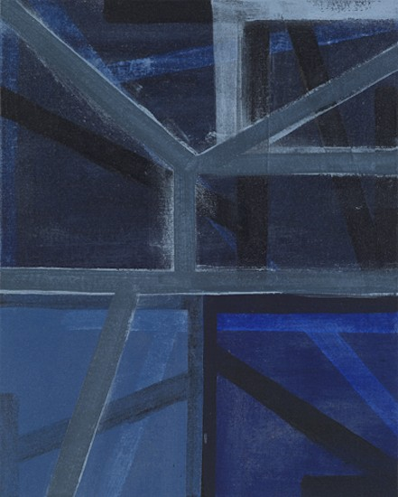
Untitled, 2012
Acrylic on linen
20 x 16 inches
CA0169
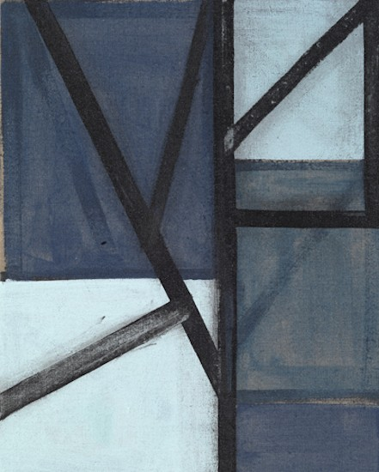
Untitled, 2012
Acrylic on linen
20 x 16 inches
CA0166
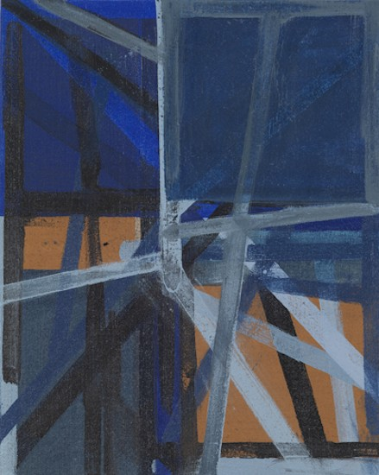
Untitled, 2012
Acrylic on linen
20 x 16 inches
CA0167
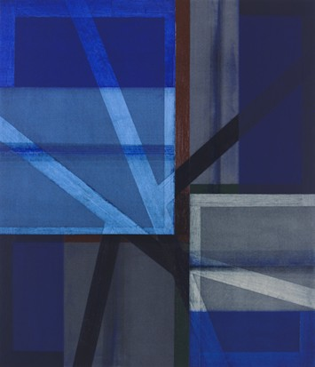
Bernardi, 2011
Acrylic on canvas
50 x 43 inches
CA0142
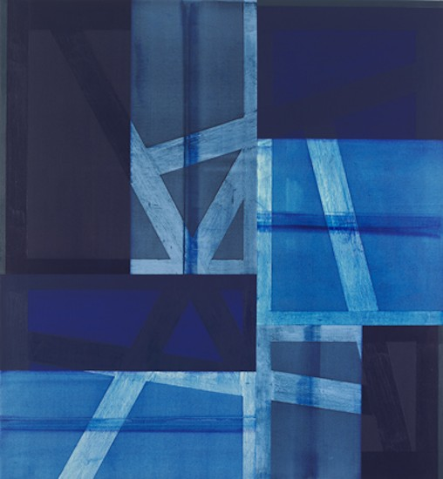
Campbell, 2012
Acrylic on canvas
65 x 60 inches
CA0146
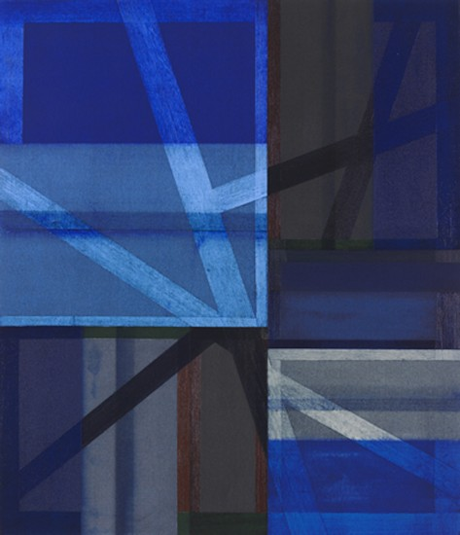
Koenig, 2011
Acrylic on canvas
42 x 36 inches
CA0140
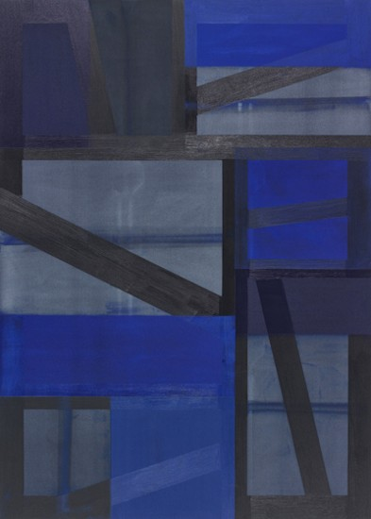
Koenig, 2011
Acrylic on canvas
42 x 36 inches
CA0140
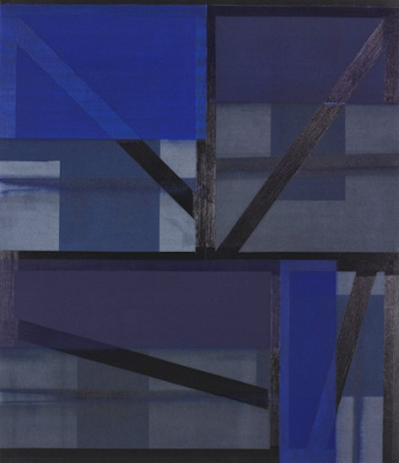
Neutra, 2011
Acrylic on canvas
50 x 43 inches
CA0141
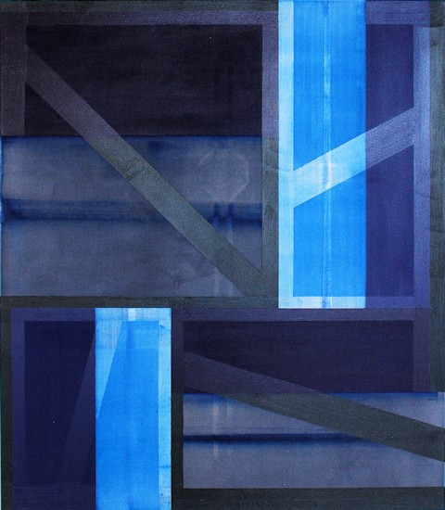
Out Thorne, 2011
Acrylic on canvas
64 x 56 inches
CA0145
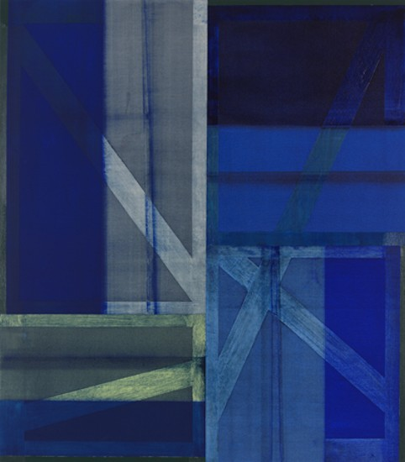
Wurster, 2011
Acrylic on canvas
64 x 56 inches
CA0144
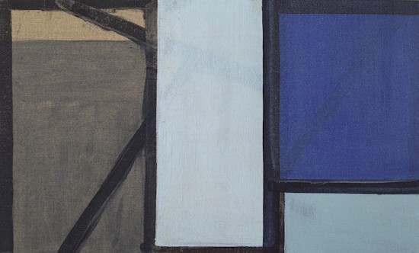
Untitled, 2012
Acrylic on linen
15 x 25 inches
CA0172
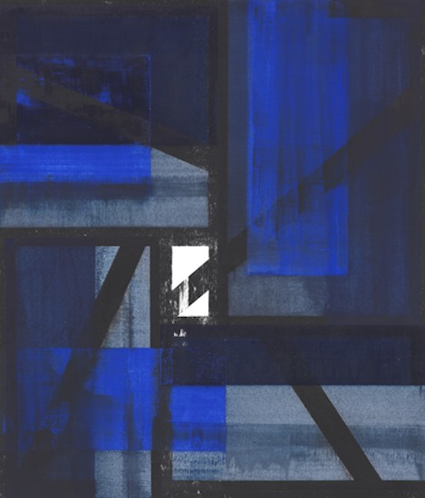
Untitled, 2011
Gouache on paper
28 1/2 x 25 1/2 inches
CA0159
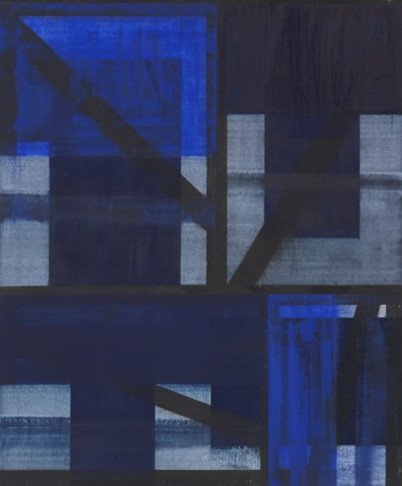
Untitled, 2011
Gouache on paper
29 x 25 1/2 inches
CA0160

© 2012

Charlotte Jackson Fine Art, Inc.

In the Railyard at:

554 S. Guadalupe, Santa Fe, New Mexico 87501
Telephone: 505.989.8688 Fax: 505.989.9898
cjfa@charlottejackson.com - www.charlottejackson.com

