CHARLOTTE JACKSON FINE ART PRESENTS:

**CHARLES ARNOLDI**

**Looking Back, Moving Forward**

Sept 11 - Oct 10, 2015

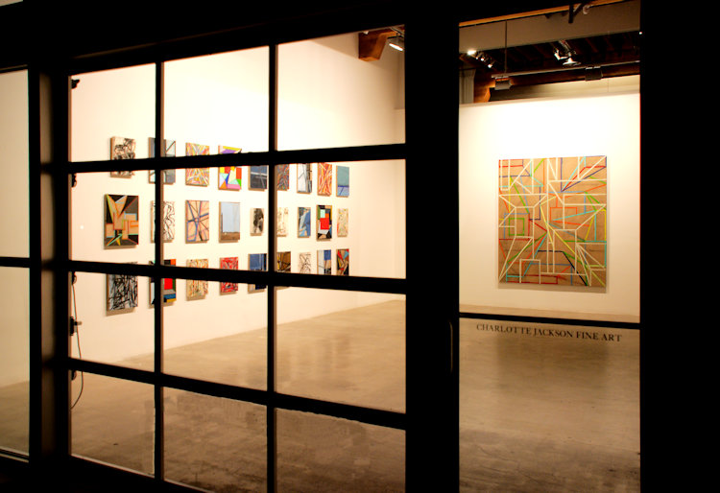

The exhibition is being curated by David Chickey, Publisher of Radius Books, in preparation for their forthcoming book: Charles Arnoldi: Paper.

If art is a continually evolving drama of creation and recognition, disruption, change, and re-creation—then Charles Arnoldi stands out as an artist who forever rides the edge of that tidal process. His work speaks with a myriad of visual languages – from burnt stick as brush stroke, to color and form as space. The dozens of small paintings and works on paper included in Looking Back, Moving Forward, span from the 1970’s to 2015 and represent a tantalizing glimpse at Arnoldi’s ongoing development.

rnoldi is perhaps best known for his very large scale paintings and constructions. For an artist who so often works at such large scale, often works on paper are used like sketches or maquettes – a way to work out issues which will be translated to the larger scale. Not so for Arnoldi. Each small piece, whether it is graphite, pastel, charcoal, gouache, or oil, is a unique work of art for Arnoldi, requiring the same level of focus and attention as other work. Each scale, Arnoldi says, requires its own set of skills. There are challenges to producing a 9 x 10 foot painting, but there is a precision and skill level required to create a 6 x 5 inch gouache on paper as well. Arnoldi will switch back and forth between large and small scale works often, and in any given period or series that he is working in, there will be some combination of larger paintings and smaller paper works. Ideas and developments flow back and forth between all of Arnoldi’s work. Even the smallest paper piece, like a fractal, holds the complexities of those larger works within itself. As Arnoldi says, it’s his job as an artist to “make inanimate objects with a life of their own.”

The role of the artist, the essence of what an artist truly is, is important to Arnoldi and a question that he continues to think about even after over forty years of making art. For Arnoldi, part of the answer to that question resides in his always evolving visual languages. A quick perusal of the diversity of works in Looking Back, Moving Forward confirms this. As Frank Gehry put it in his introduction to Charles Arnoldi 1972 – 2008, “this is an artist … who is still experimental and still willing to risk.”

Despite this diversity, it is easy to see connections, and hints of the artists and questions that inspire him come through in all his work. The spidery-fragile lines of the graphite on paper Untitled from 1973 which was made during the period when Arnoldi was making his famous Stick Paintings, is all openness and space, while the very structured blue-tone spaces of the small paintings from Arnoldi’s Case Study series of 2012 are spaces built into the canvas out of color and form. The shapes in an untitled gouache from the late 1990’s, during Arnoldi’s Potato Series, are organically bulbous and shadowed, and yet they somehow harken directly back to those early stick pieces. Cheer Up, a new work from 2015, plays with geometric forms and brilliant color palettes. Full and dense with shapes, the colors outlined in black, these new geometric paintings might at first seem too densely painted to have been made by the same person as some of the other works. However, these new pieces which paint space wouldn’t exist if Arnoldi had not once long ago used sticks to sketch lines into space, or later if he hadn’t used a chainsaw to explore negative space.

Though the perspectives change over time, the essential truth, as Arnoldi says, that of being a human maker of marks on paper, remains. Each of these small works presents a unique universe of its own. Taken together, Looking Back, Moving Forward presents a visual dialogue across time.

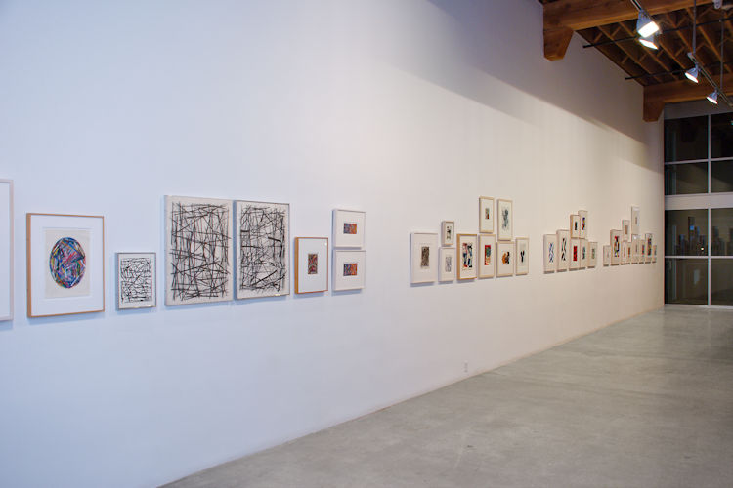

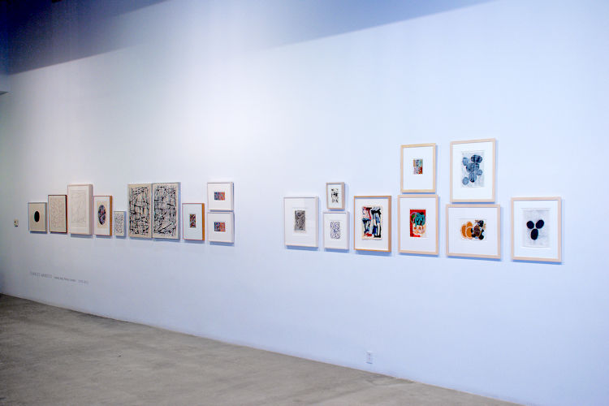

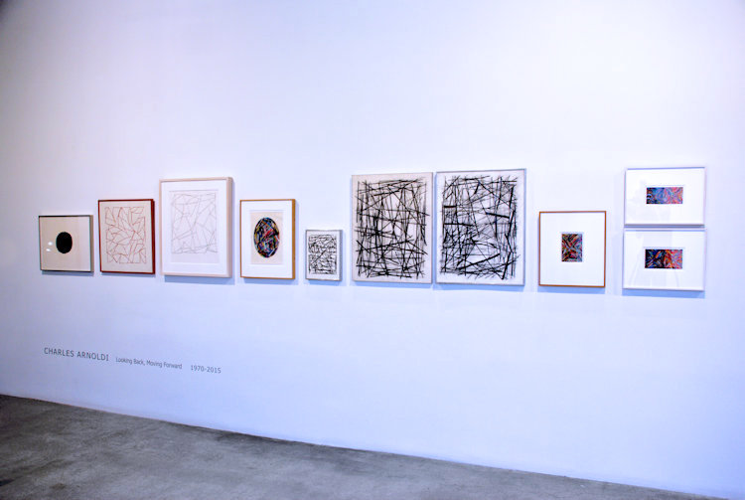

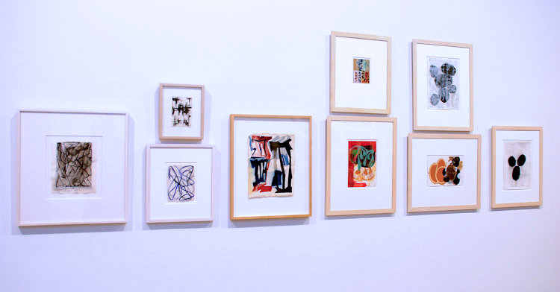

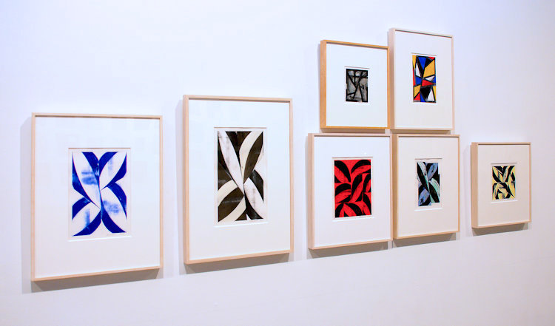

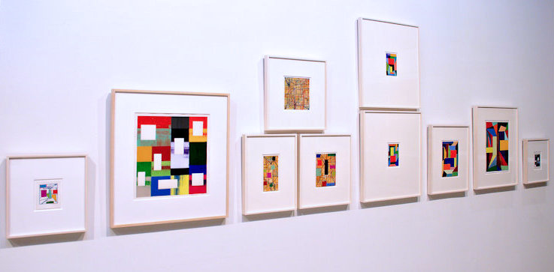

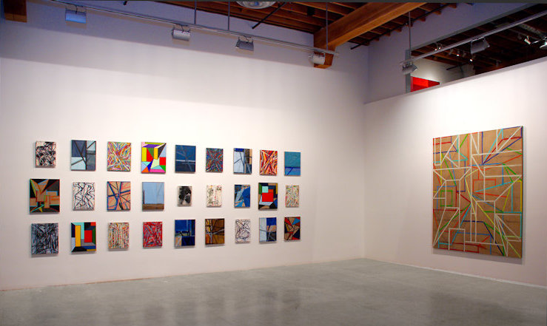

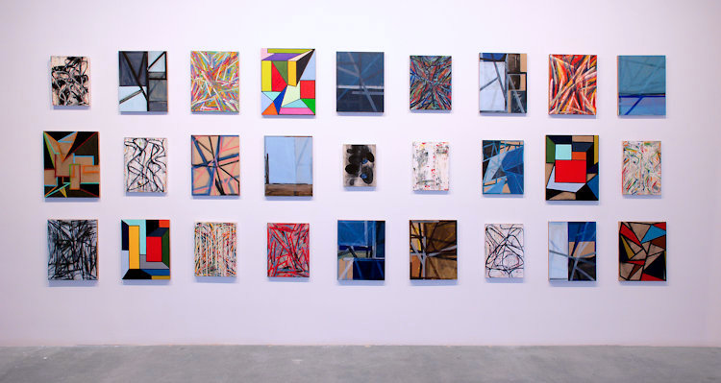

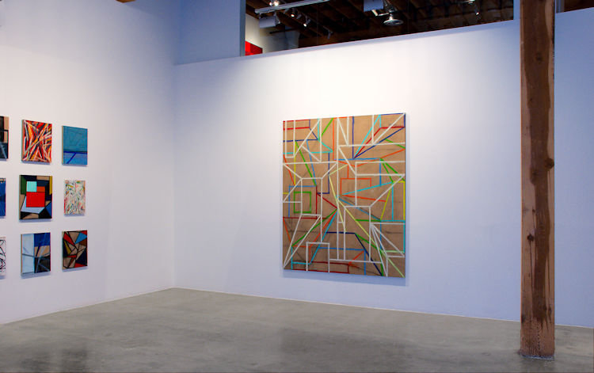

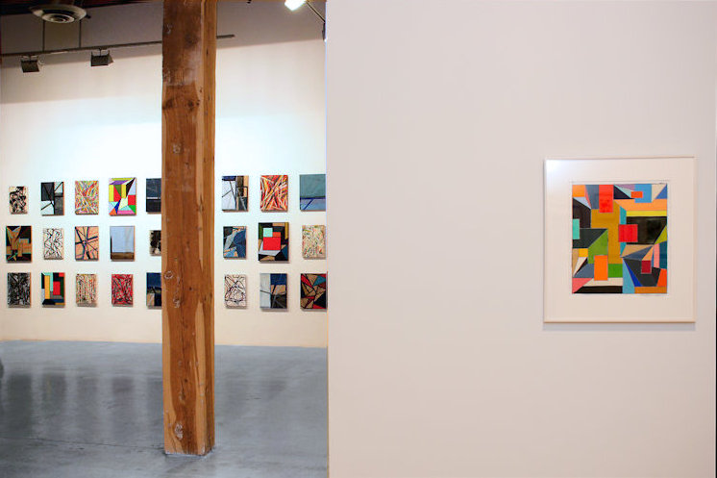

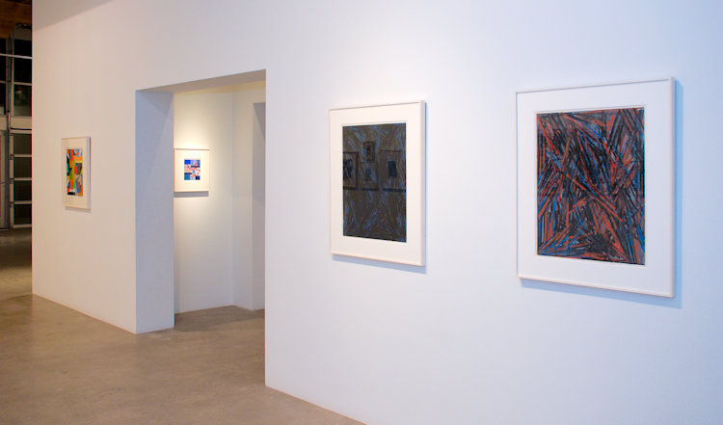

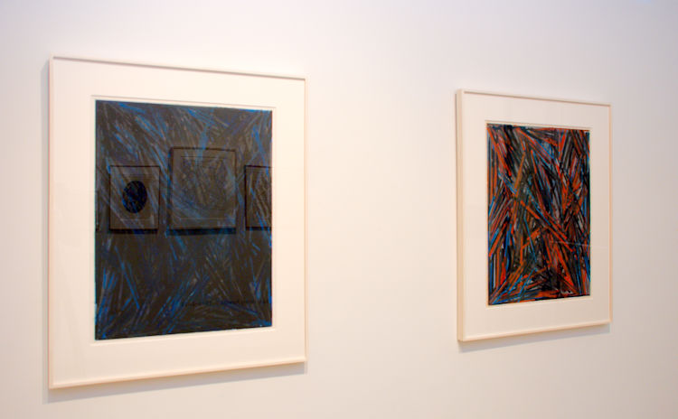

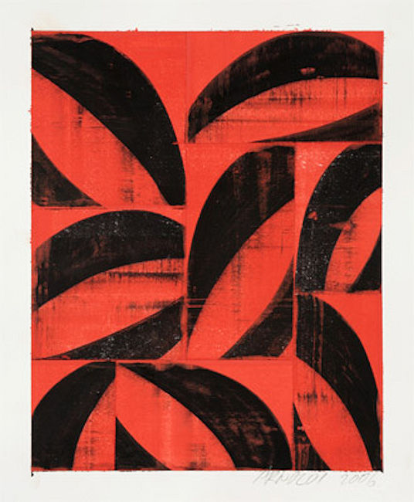

Untitled (06-132), 2006  
Gouache on collaged paper  
14 1/2 x 17 1/4 in. (36.83 x 43.82 cm)  
CA0015

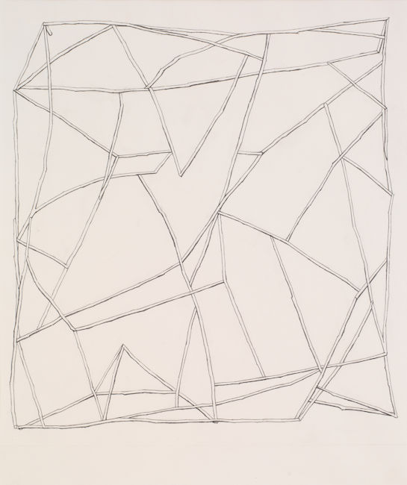

Untitled (#3), 1974 (74.08)  
Pencil on paper  
24 3/4 x 19 3/4 in. (62.87 x 50.17 cm)   
CA158

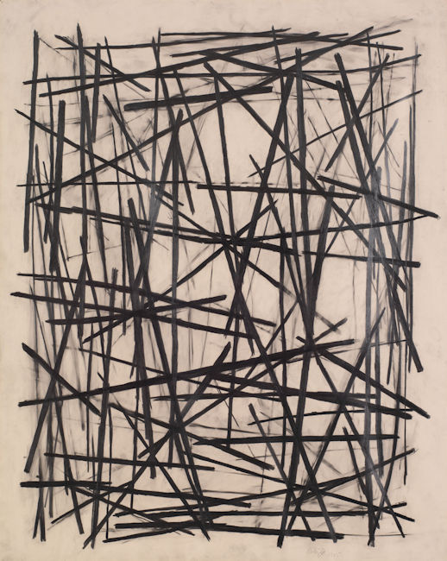

Untitled, 1975 (75.17)  
Graphite on Paper  
29 x 23 in. (73.66 x 58.42 cm)  
CA160

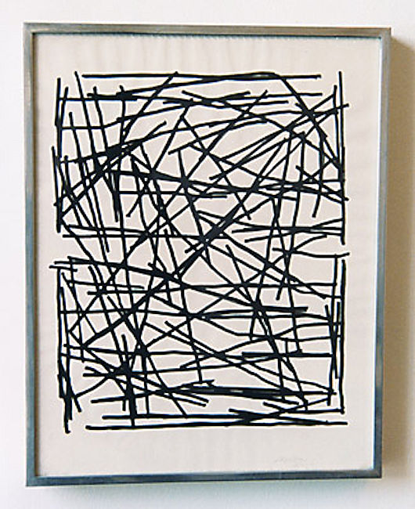

Untitled, 1975 (75.18)  
Ink Drawing on Paper  
14 1/4 x 11 1/4 in. (36.2 x 28.58 cm)   
CA161

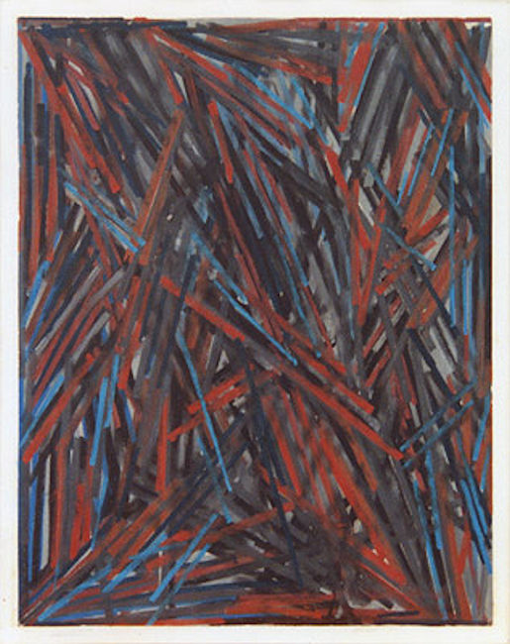

Untitled, 1979 (79.04)  
Oil Pastel on Paper  
15 1/2 x 11 in. (39.37 x 27.94 cm)  
CA163

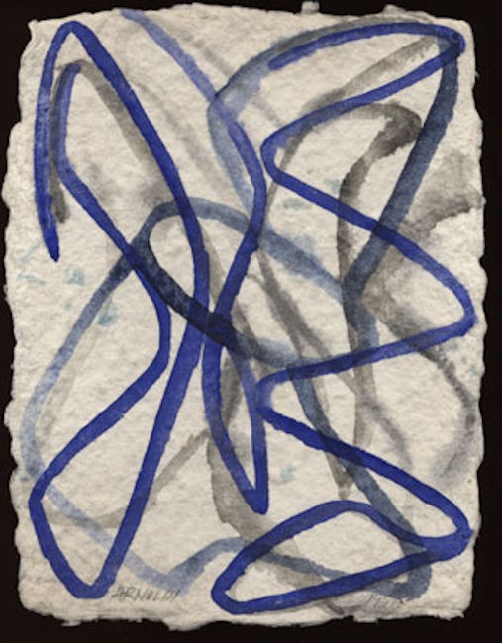

Untitled, 1990 (90.104)  
Gouache on Rag Paper  
15 1/4 x 13 1/2 in. (38.74 x 34.29 cm)  
CA170

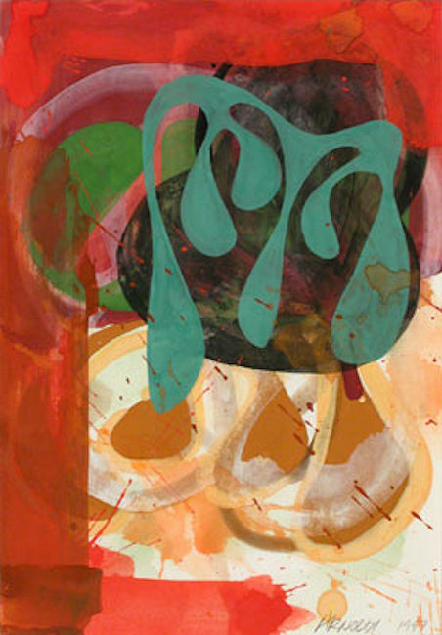

Untitled, 1997 (97.40)  
Gouache on Paper  
10 1/4 x 7 1/8 in. (26.04 x 18.1 cm)  
CA179

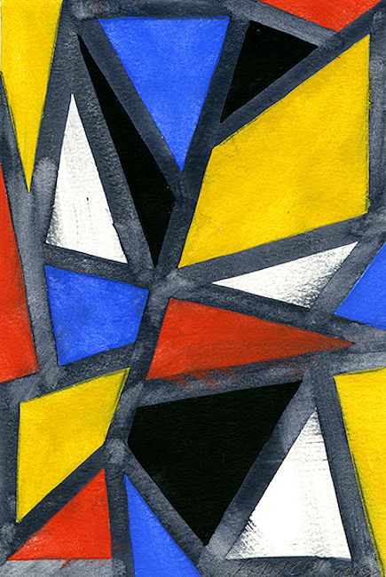

Untitled, 2013 (13.46)  
Gouache on Paper  
9 x 6 in. (22.86 x 15.24 cm)  
CA209

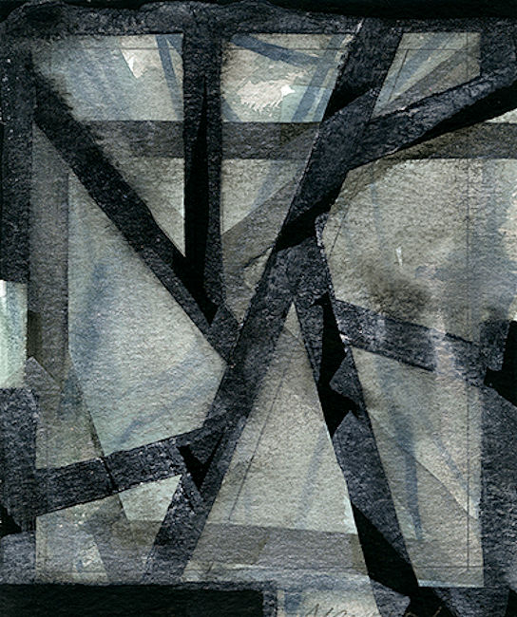

Untitled, 2013 (13.59)  
Gouache on paper  
6 x 5 in. (15.24 x 12.7 cm)  
CA210

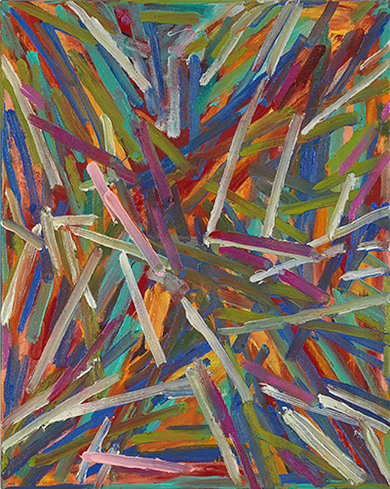

Untitled, 2013 (13.110)  
Oil on Linen  
20 x 16 in. (50.8 x 40.64 cm)   
CA212

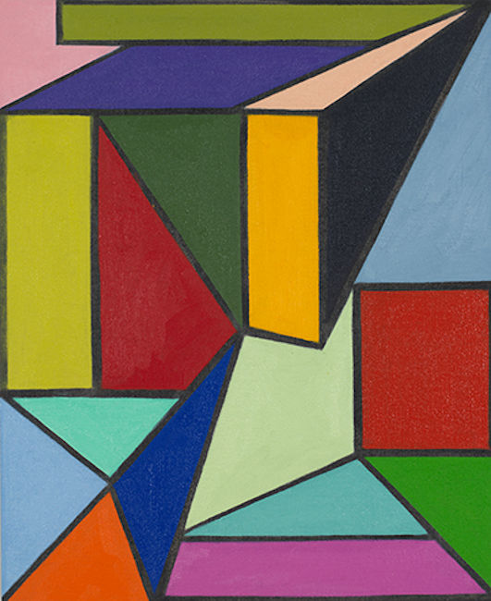

Untitled, 2014 (14.57)  
Oil on Linen  
22 x 18 in. (55.88 x 45.72 cm)   
CA214

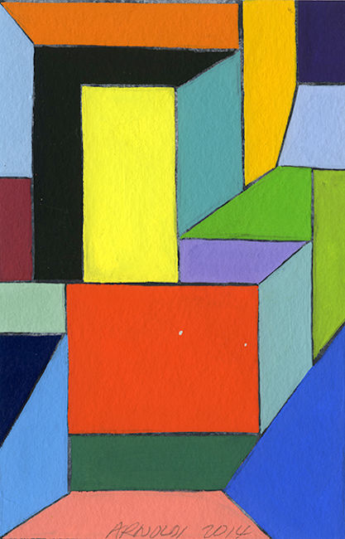

Untitled, 2014 (14.74)  
Gouache on Paper  
6 x 4 in. (15.24 x 10.16 cm)   
CA217

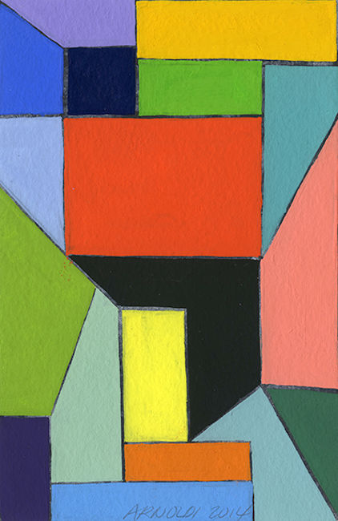

Untitled, 2014 (14.78)  
Gouache on Paper  
6 x 4 in. (15.24 x 10.16 cm)  
CA218

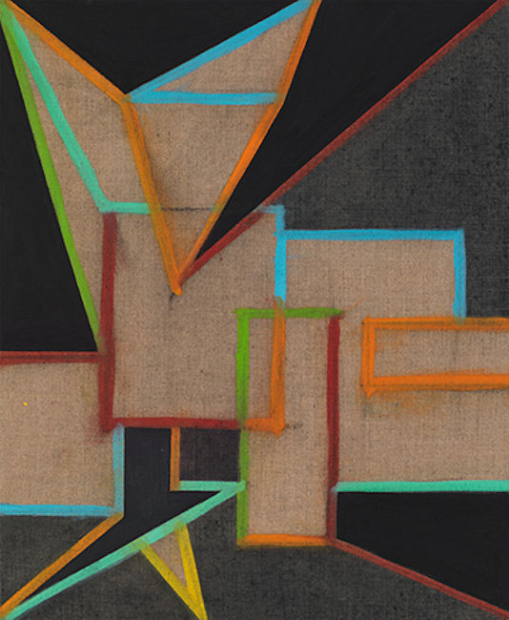

Untitled, 2014 (14.108)  
Oil on Linen  
22 x 18 in. (55.88 x 45.72 cm)   
CA221

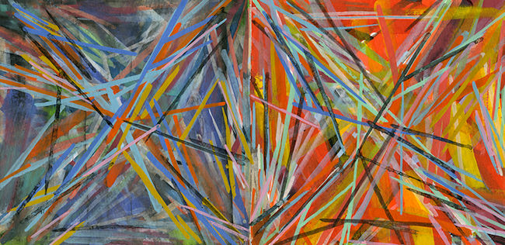

Untitled, 2015 (15.10)  
Gouache on Paper  
4 x 8 in. (10.16 x 20.32 cm)  
CA223

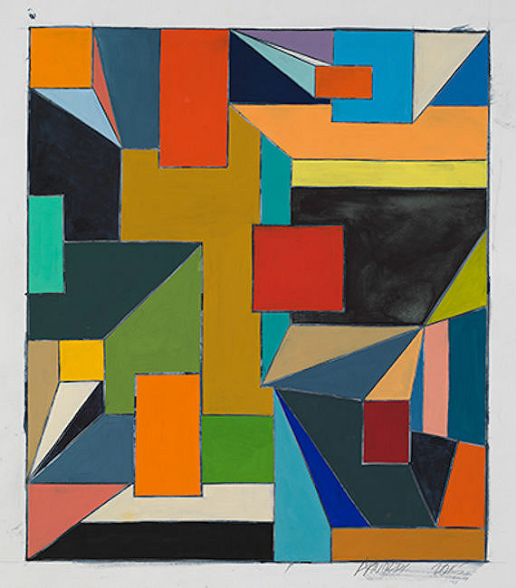

Untitled, 2015 (15.26)  
Gouache on Paper  
20 x 17 in. (50.8 x 43.18 cm)  
CA226

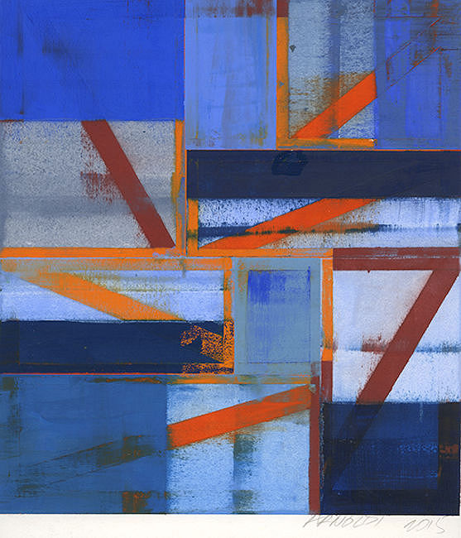

Untitled, 2015 (15.37)  
Gouache on Paper  
9 x 8 in. (22.86 x 20.32 cm)  
CA229

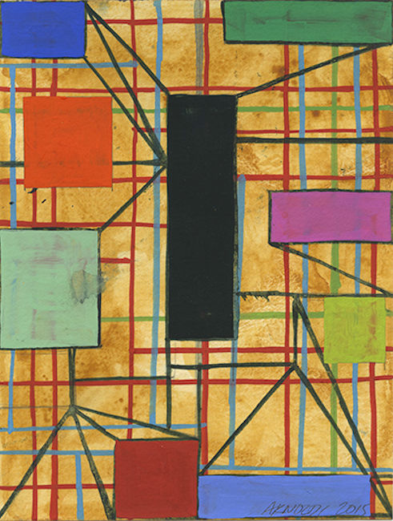

Untitled, 2015 (15.56)  
Gouache on Paper  
8 x 6 in. (20.32 x 15.24 cm)  
CA234

# © 2015

# Charlotte Jackson Fine Art, Inc.

## In the Railyard at:

## 554 S. Guadalupe, Santa Fe, New Mexico 87501

Telephone: 505.989.8688 Fax: 505.989.9898

cjfa@charlottejackson.com - www.charlottejackson.com