CHARLOTTE JACKSON FINE ART PRESENTS:

ALL ABOUT COLOR
A Group Exhibition

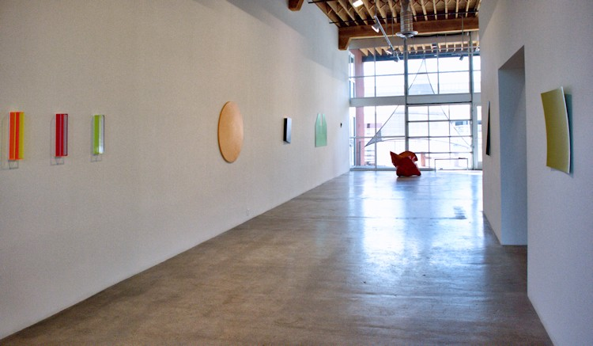

July 30 -August 26, 2013
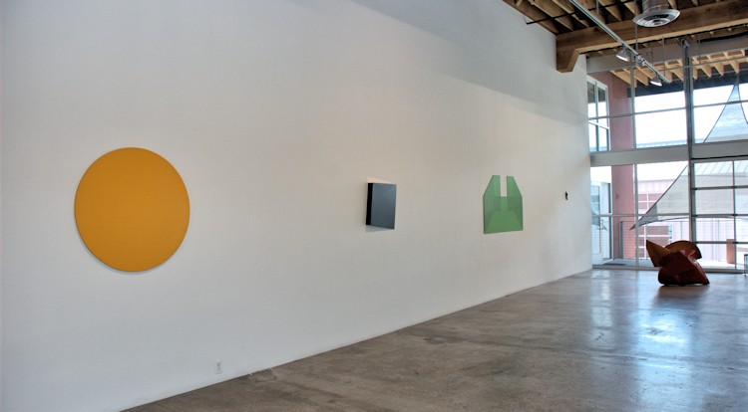

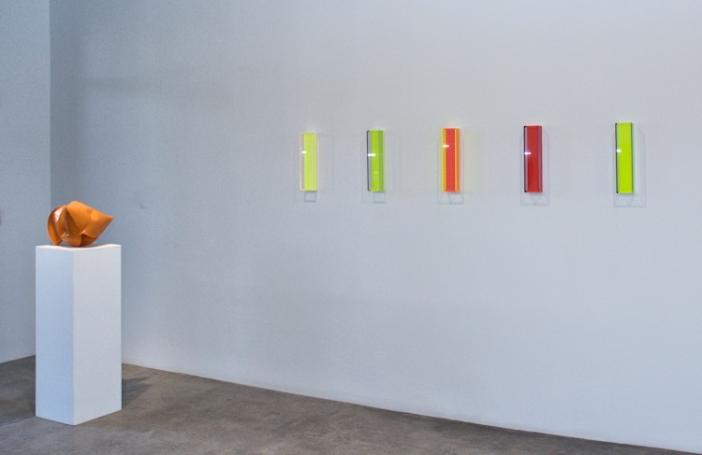
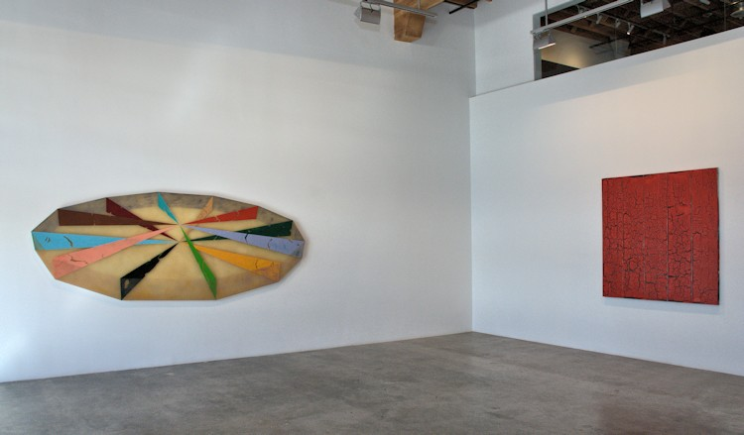

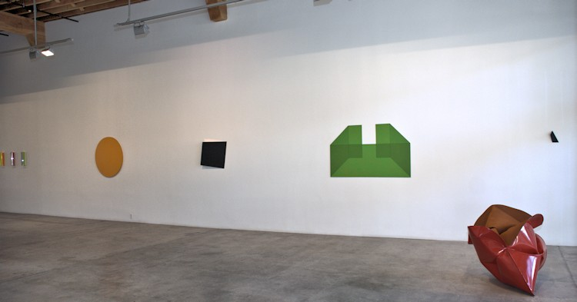
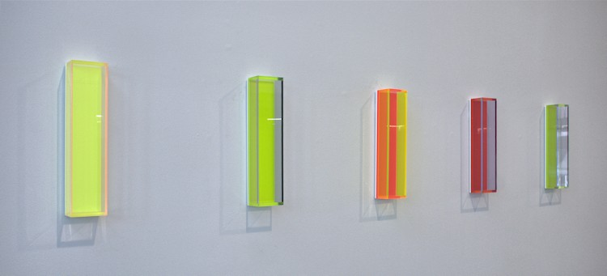

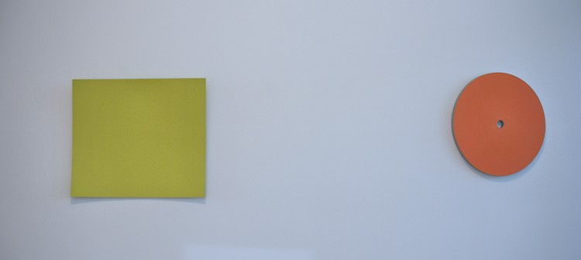
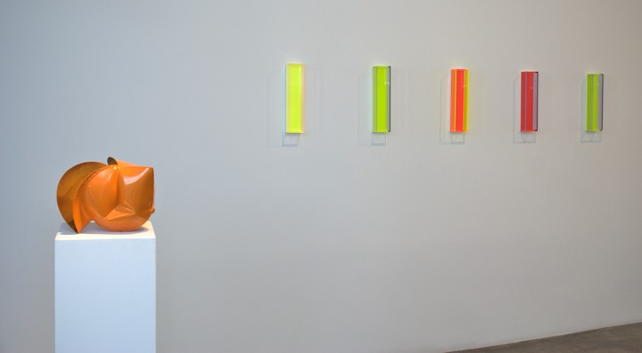

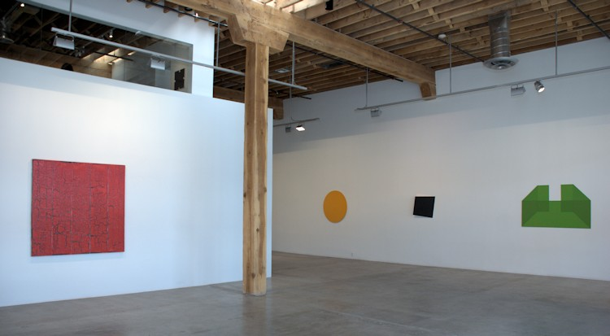
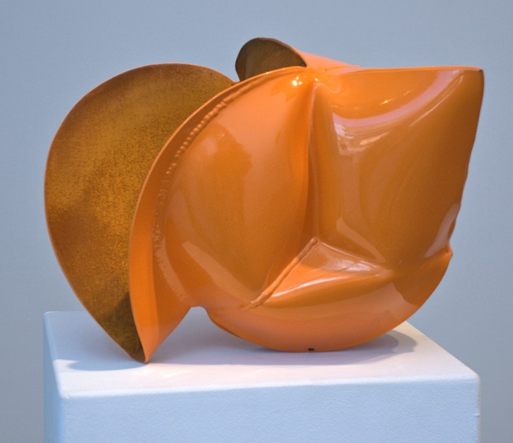

Jeremy Thomas
Allgaier Orange, 2013
forged mild steel and powder coat
11 1/2 x 16 3/4 x 13 3/4 inches
JT262
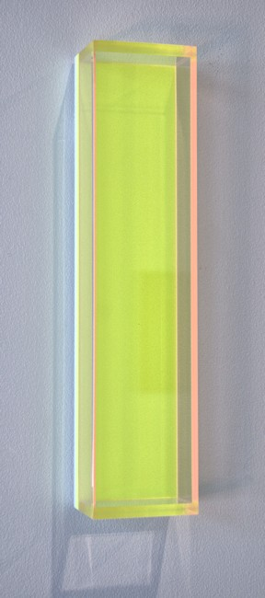

Regine Schumann
Color Mirror Cologne, 2009
Fluorescent Acrylic Glass
15 x 3 1/2 x 2 1/3 inches
RSC012-A

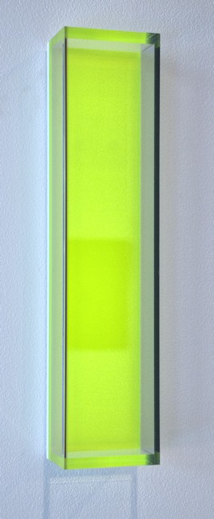

Regine Schumann
Color Mirror Cologne, 2009
Fluorescent Acrylic Glass
15 x 3 1/2 x 2 1/3 inches
RSC012-B
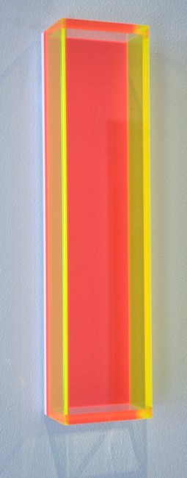
Regine Schumann
Color Mirror Cologne, 2009
Fluorescent Acrylic Glass
15 x 3 1/2 x 2 1/3 inches
RSC012-C
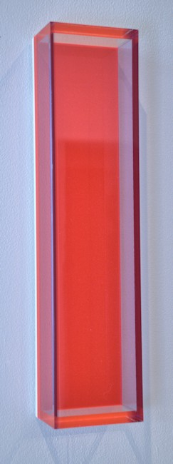
Regine Schumann
Color Mirror Cologne, 2009
Fluorescent Acrylic Glass
15 x 3 1/2 x 2 1/3 inches
RSC012-D
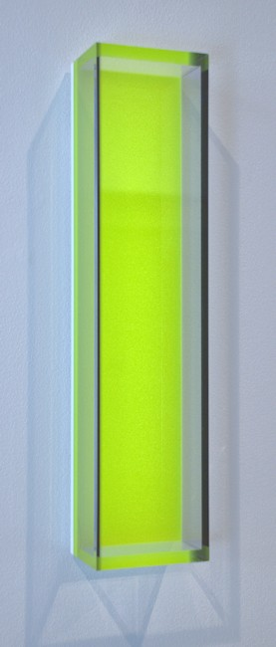
Regine Schumann
Color Mirror Cologne, 2009
Fluorescent Acrylic Glass
15 x 3 1/2 x 2 1/3 inches
RSC012-E
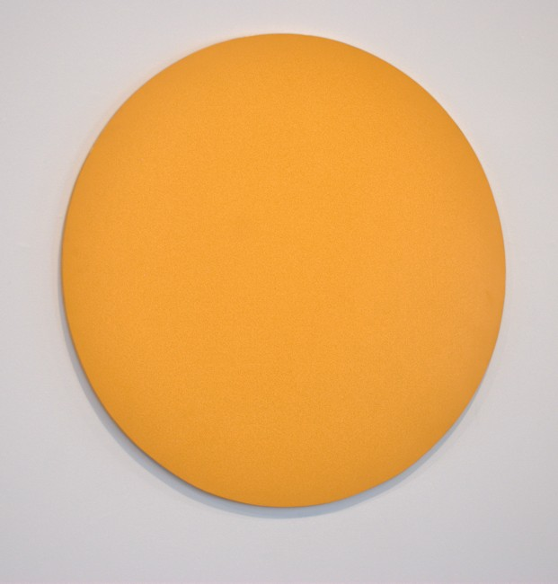

Elliot Norquist
Summer Circle, 2010
Steel and acrylic enamel
40 inches
EN0061
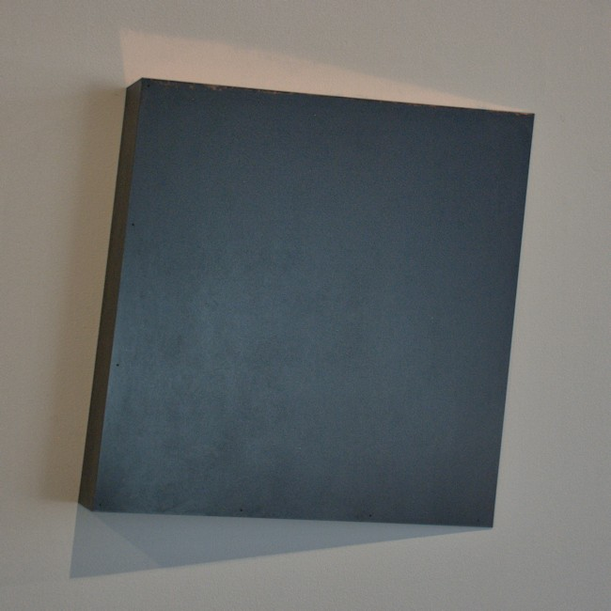

Constance DeJong
Square 23/3, 2012
patinated copper and wood
23 x 23 x 3 inches
CD120
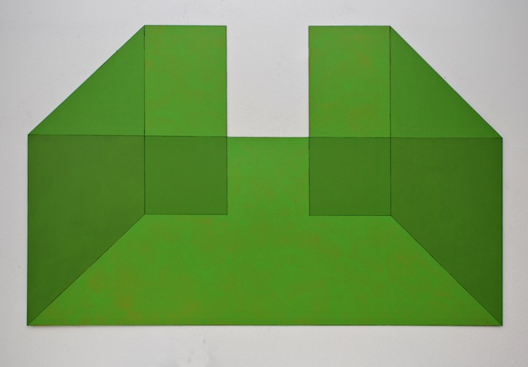

William Metcalf
Mindspace #55, 2013
Acrylic, india ink,on AluPanel
38 x 60 inches
WM304
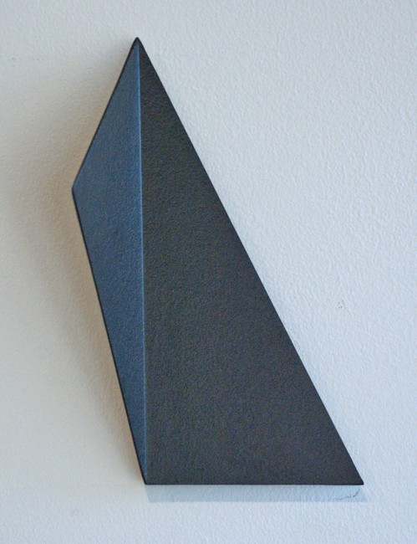

Michael Post
Untitled- wvz33, 2013
acrylic on fiberglass over steel
7.5 x 3.9 x 2 in.
MP010
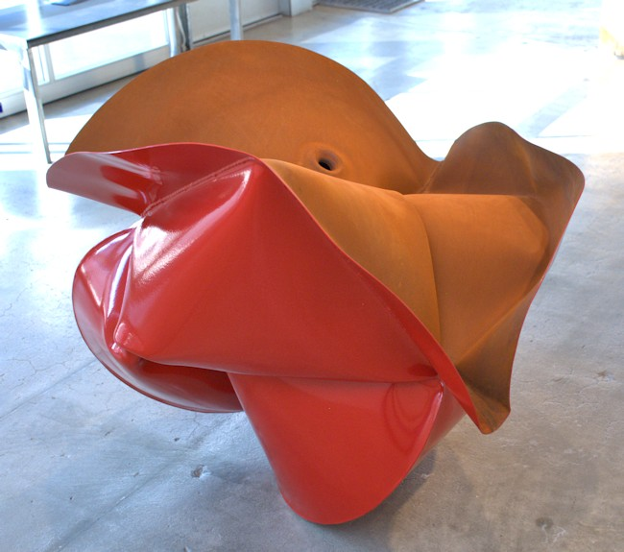

Jeremy Thomas
forged mild steel and powder coat
34 x 44 x 36 inches
JT272
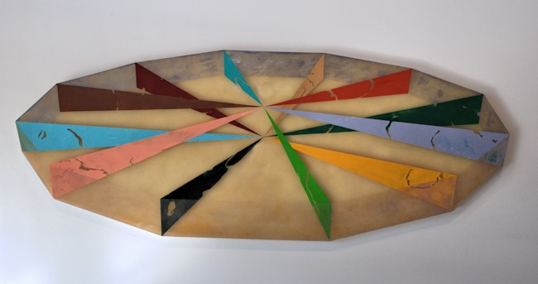

Ronald Davis
Spindle, 1968
Moulded Polyester Resin and Fiberglass
50 1/2 x 132 inches
ROND0052
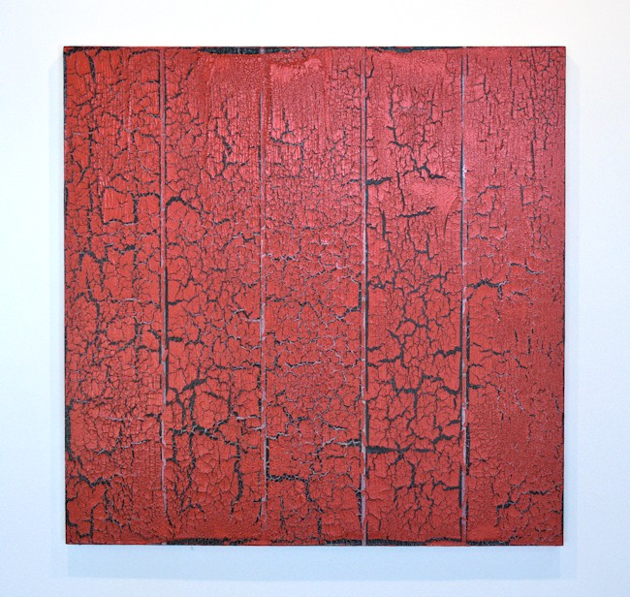

Ed Moses
ACM #2, 2011
acrylic and glue on canvas
60 x 60 inches
EM044
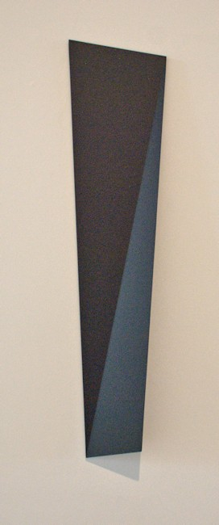

Michael Post
Untitled- wvz36, 2011
acrylic on fiberglass over steel
35.4 x 8.3 x 2.6 in.
MP024

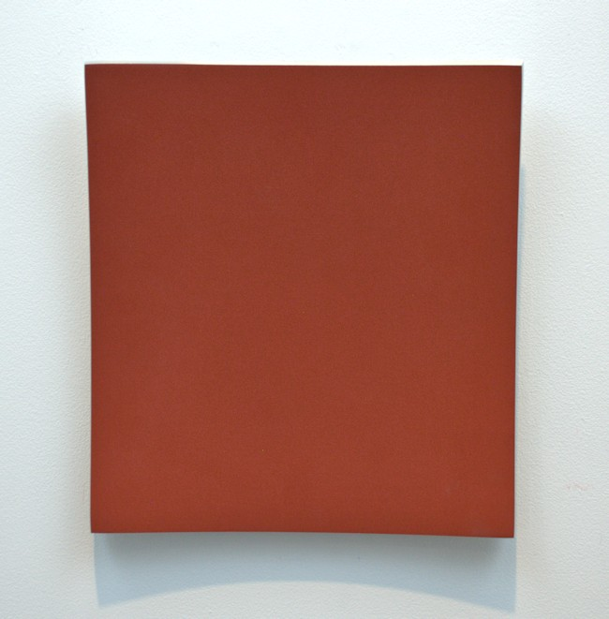

Heiner Thiel
Untitled- WVZ553, 2012
Anodized Aluminum
13 x 12 x 1.9 in.
HT152
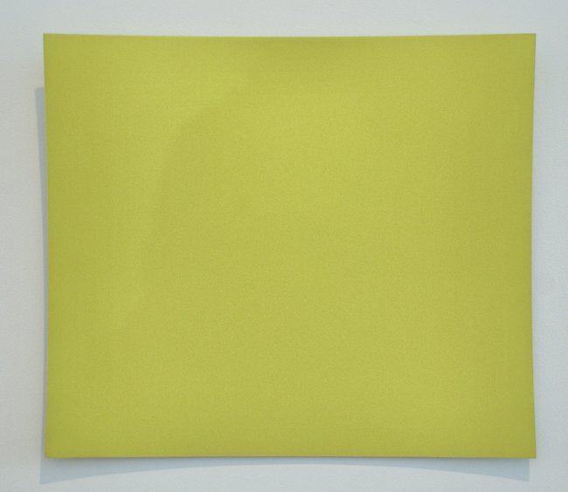

Heiner Thiel
Untitled- WZI/99/308, 1999
Anodized Aluminum
22 x 25 x 4 inches
HT140
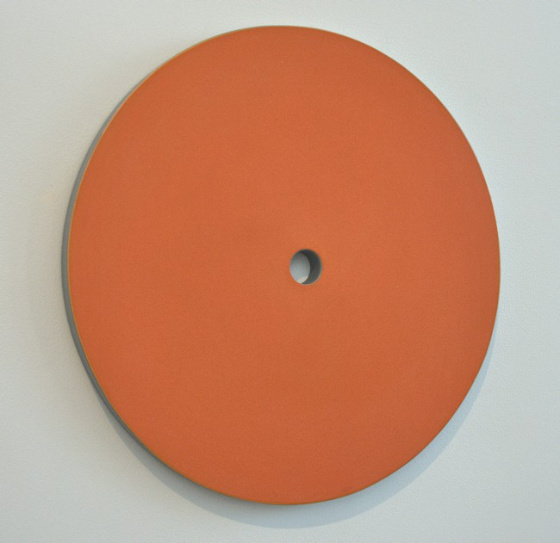

Elliot Norquist
Mango Slice, 2012
painted steel
20" diameter x 1 1/8"
EN0082

© 2013

Charlotte Jackson Fine Art, Inc.

In the Railyard at:

554 S. Guadalupe, Santa Fe, New Mexico 87501
Telephone: 505.989.8688 Fax: 505.989.9898
cjfa@charlottejackson.com - www.charlottejackson.com

