CHARLOTTE JACKSON FINE ART
PRESENTS:

ALFONSO FRATTEGGIANI BIANCHI:
UMBRIAN PAINTINGS
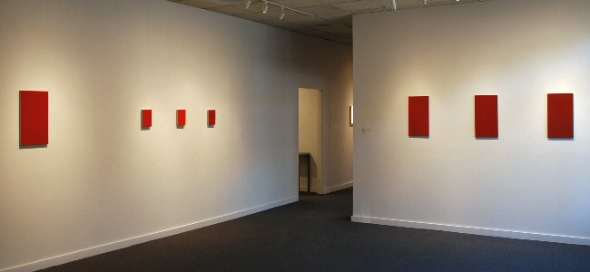
March 21 through April 13, 2008
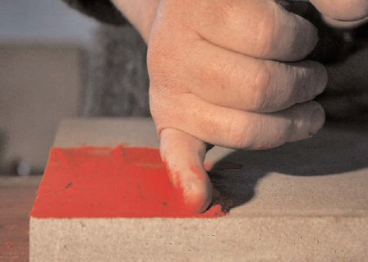Hand, color, stone. In the work of Alfonso Fratteggiani Bianchi we encounter painting, and color, at a level of intensity and purity that is irresistible. Fratteggiani Bianchi’s small scale, monochromatic works are pure powdered pigment applied directly onto pietra serena, the Italian limestone native to the Umbrian district where he lives. Pure in this case means that there are no binders, glues, or mediums used to attach the pigment to the stone, only the porousness of the stone itself and Fratteggiani Bianchi’s hand.
There is a sort of magic here, something that pervades the pieces themselves as well as the man who makes them. Originally doing work with music, founding the Institute for Contemporary Music in Perugia in 1986—a place where contemporary artists, both musicians and painters, from around the world came to study, create, and share—when Fratteggiani Bianchi first began to paint, he mixed his pigments with glue, applying them onto medium density board. The experiment did not satisfy him. As he remarks, “The glue dishonored the pigment,” by arresting it into a time, space, and density. When he looked at the pigment on his hands, it was beautiful, yet mixed with the glue it was “blocked, broken.”
And so he made the leap to applying pigment directly to the pietra serena so common in Umbria, used to make roads, steps, windowsills, even used in his own 10th century farmhouse. As renowned art collector Giuseppe Panza di Biumo comments on his work, “Fratteggiani’s discovery is a real event in the history of art. It is a first time in thousands [of] years.”
Those who have worked with powdered pigment may wonder at Fratteggiani Bianchi’s ability to affix color to stone without a medium. When asked how he does it, he smiled and replied, “How does the moon stay up there, without glue?” Although this answer may not satisfy those wanting to know how to do as he does, one feels it is more appropriate and more gratifying that any methodological reply. Here again is magic: though the answer of his own question might have to do with gravity, centripetal force, and the physics of motion, who hasn’t looked up at the night sky and wondered at the moon? The same wonderment is present in Fratteggiani Bianchi’s paintings where the color itself is so vibrant, so resonant, that they seem to move, to breathe, to speak.
Perhaps it is the romance of the Umbrian country-side that pervades the work. Umbria is a region of rolling hills, vineyards, and lovely clear light and was the home of two great artists, Perugino and Piero della Francesca. The works of these artists are present in the churches and cathedrals throughout the region. Fratteggiani Bianchi recalls that some of his earliest memories are of the frescos in his parents’ home. He grew up in an olive oil producing family (his own family still makes olive oil and wine) and speaks of the care and expression that this enterprise represents, with a similar intensity that he does about making art. He applies a similar principle: just as music and art come from the “same mind,” so all productions of human passion arise from the same realm. We come, he says, from “homo faber” the making man, and it is impossible to divide passion from creation.
But without knowing any of this, these paintings will affect you. Deepest red, shocking blue, flame orange, pulsating green—the surfaces of these works are so textured and rich they often appear wet or like forest moss. So intense are the colors that the pieces seem to give off their own light, something originating wholly from the pigment itself. Although perhaps it is more than that. In his pursuit of color, Fratteggiani Bianchi seeks out pigments whenever he travels. When asked about the amazing effects he achieves he comments, “When one painter buys a color in an art store, the color does not yet know how it will end up.” More magic ... in the hand of an artist the pigment finds itself, comes to be. In the case of Fratteggiani Bianchi’s paintings, color awakens.
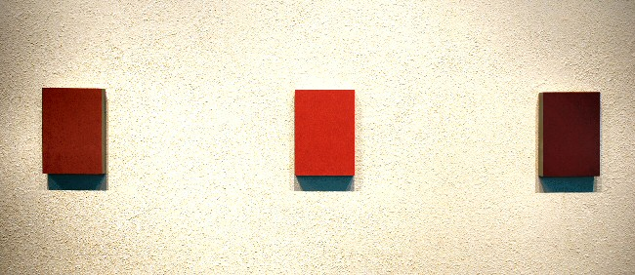
278 Rosso Fi, #277 Rosso, #276 Rosso

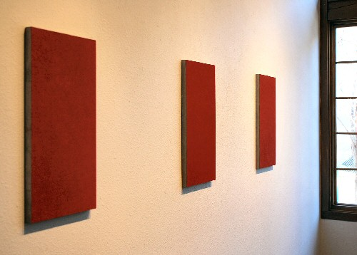
#323 Rosso, #324 Rosso, #325 Rosso
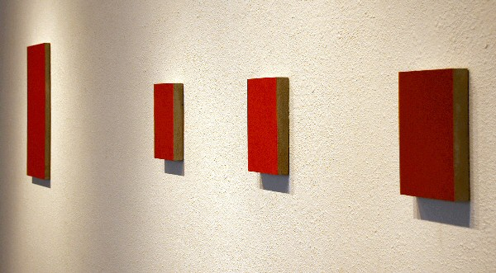
#259 Rosso, 278 Rosso Fi, #277 Rosso, #276 Rosso
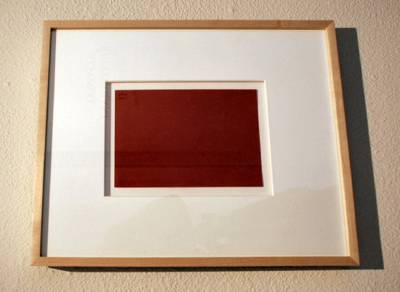
Pigmento su carta (Rosso 23182), 2006
pigment on paper 44.45 x 36.83 cm AFB49
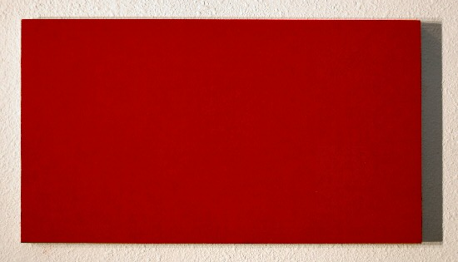
#259 Rosso 23182, 2005
pigment on limestone 54 x 30 cm AFB26
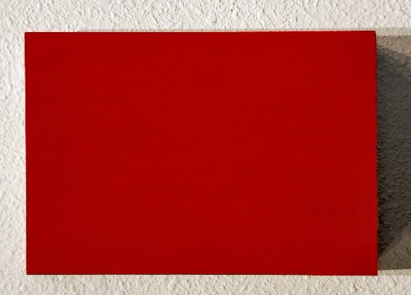
#278 Rosso Fi, 2006
pigment on stone 21 x 14.5 cm AFB56
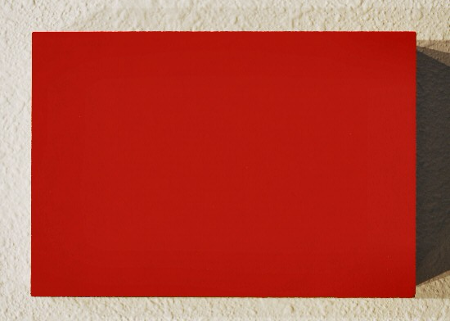
#277 Rosso 23182, 2006
pigment on stone 21 x 14.5 cm AFB55
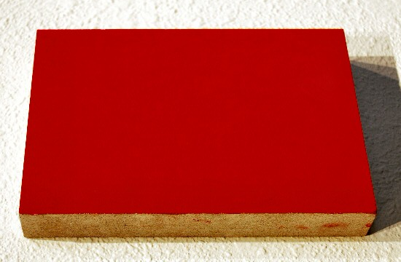
#277 Rosso 23182, 2006
pigment on stone 21 x 14.5 cm AFB55
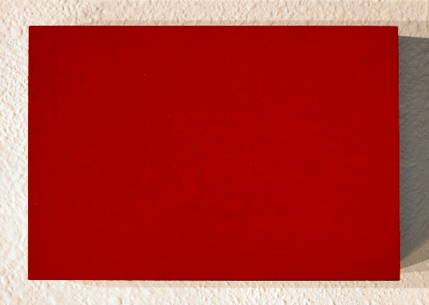
#276 Rosso, 2006
pigment on stone21 x 14.5 cm AFB54
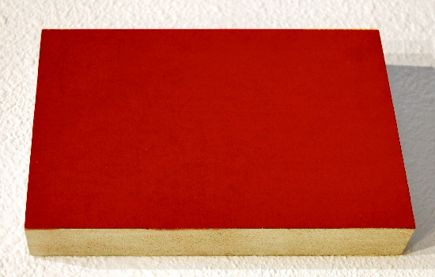
#276 Rosso, 2006
pigment on stone21 x 14.5 cm AFB54
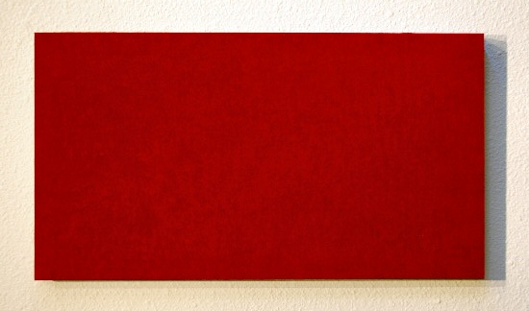
#323 Rosso 23410a, 2007
pigment on stone 54 x 30 cm AFB61
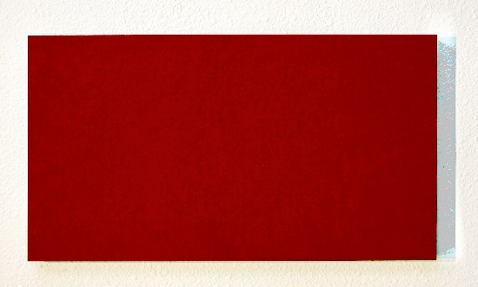
#324 Rosso 23182, 2007
pigment on stone 54 x 30 cm AFB62
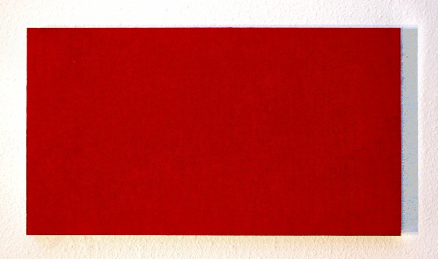
#325 Rosso 23410b, 2007
pigment on stone 54 x 30 cm AFB60
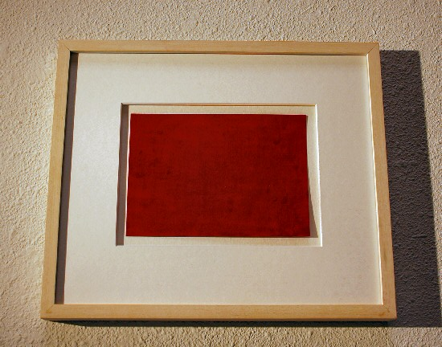
Rosso 23410, 2006
pigment on paper 21 x 14.5 cm AFB58
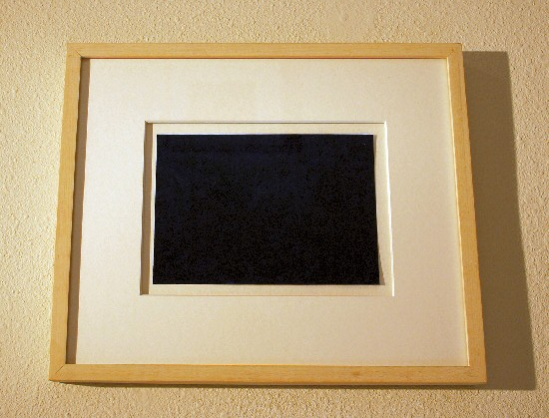
Blu Medio, 2006
pigment on paper 21 x 14.5 cm AFB59
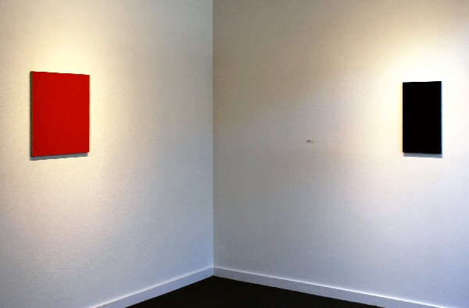

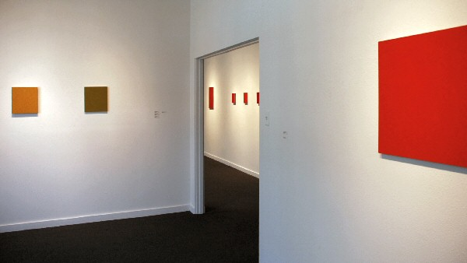
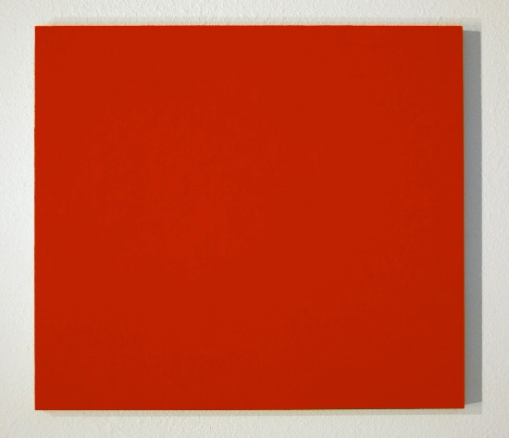
#293 Verde chiaro, 2007
pigment on stone 30.9 x 27.7 cm AFB64

#293 Verde chiaro, 2007
pigment on stone 30.9 x 27.7 cm AFB64
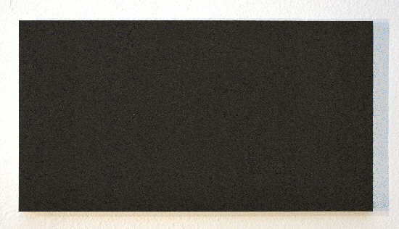
#M18 Giallo senabe, 2001
pigment on stone 30.6 x 27.6 cm AFB65
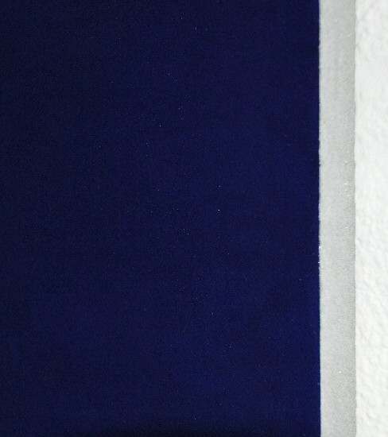
#M18 Giallo senabe, 2001
pigment on stone 30.6 x 27.6 cm AFB65
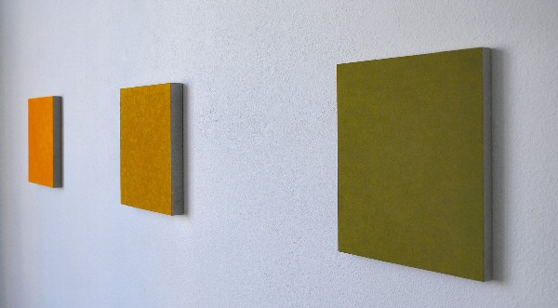
#197 Giallo, #132b Rosso, #124 Blu Scuro
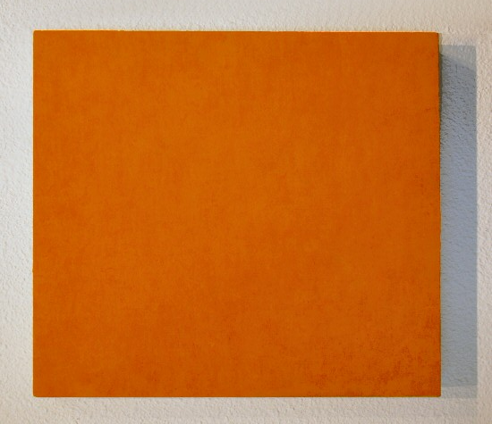
#197 Giallo, 2004
pigment on stone 30.6 x 27.5 cm AFB66
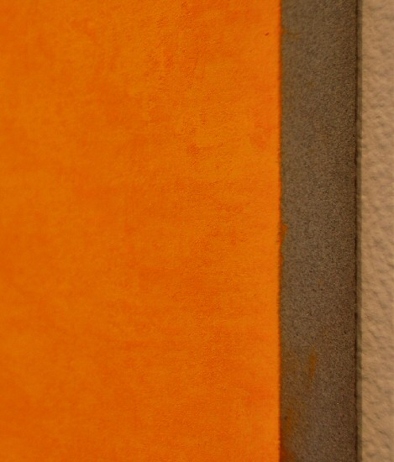
#197 Giallo, 2004
pigment on stone 30.6 x 27.5 cm AFB66

#132b Rosso (K23290), 2002
pigment on limestone 57.1 x 51.2 cm AFB37
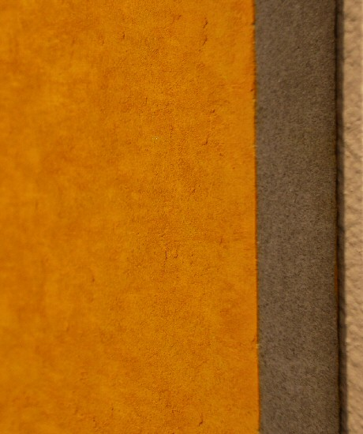
#132b Rosso (K23290), 2002
pigment on limestone 57.1 x 51.2 cm AFB37
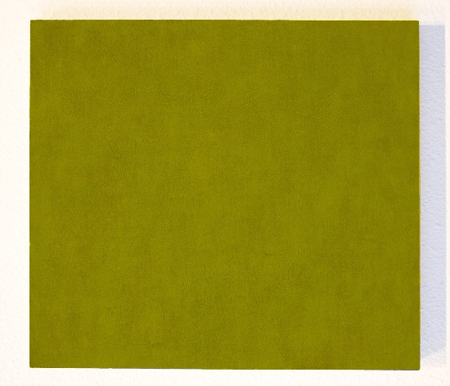
#124 Blu Scuro, 2003
pigment on limestone 54 x 29.8 cm AFB31
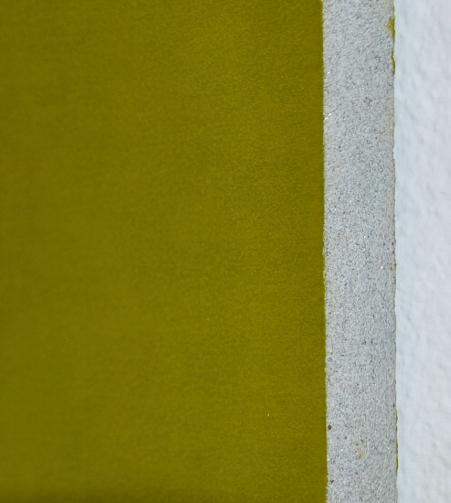
#124 Blu Scuro, 2003
pigment on limestone 54 x 29.8 cm AFB31

© 2008

Charlotte Jackson Fine Art, Inc.

200 West Marcy Street, Suite 101, Santa Fe, New Mexico 87501
Telephone: 505.989.8688 Fax: 505.989.9898
cjfa@charlottejackson.com - www.charlottejackson.com

Photography & CD Production:
William Metcalf

