CHARLOTTE JACKSON FINE ART PRESENTS

Winter Group Exhibition
December 20 - January 15
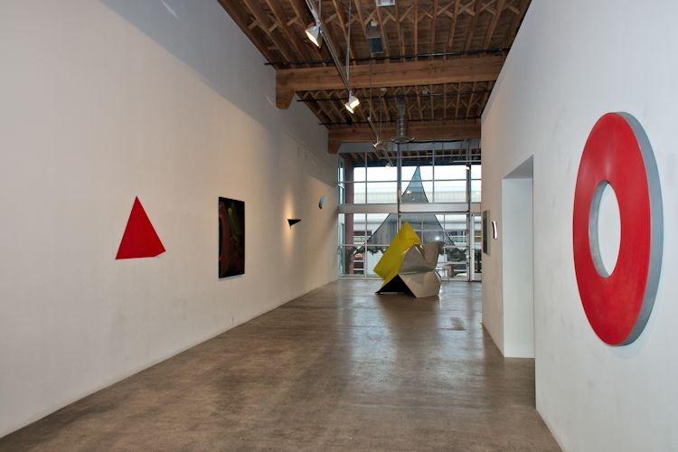

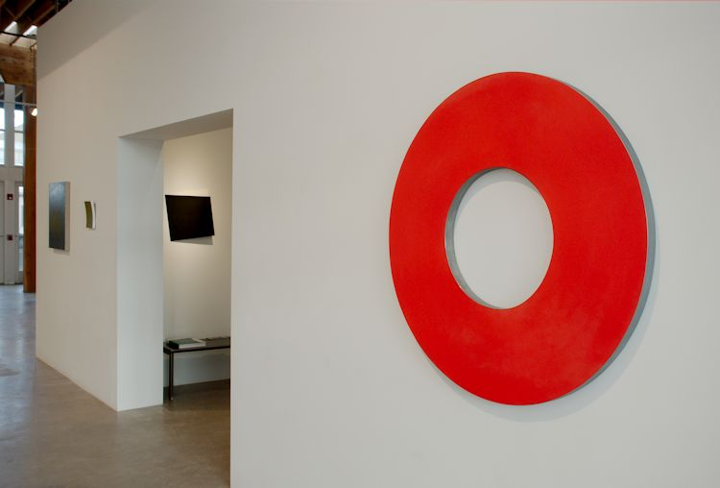
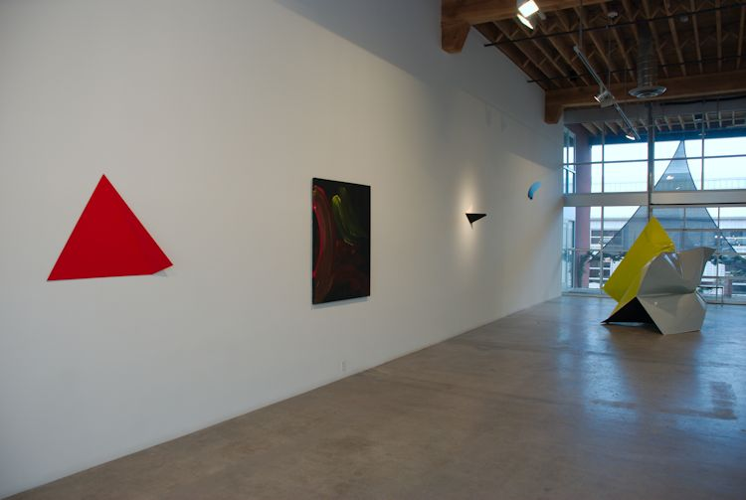
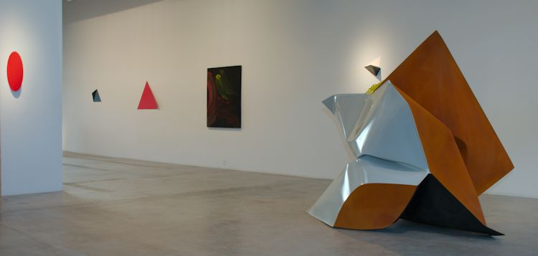

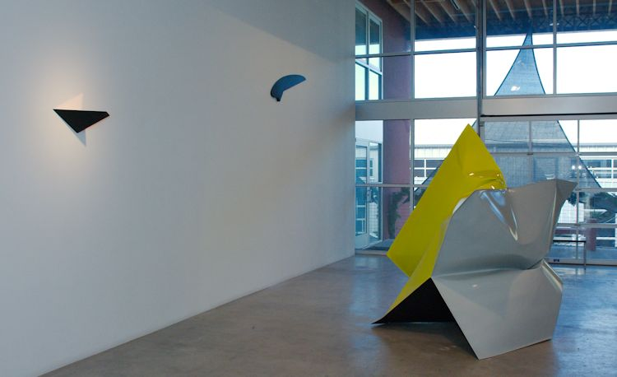
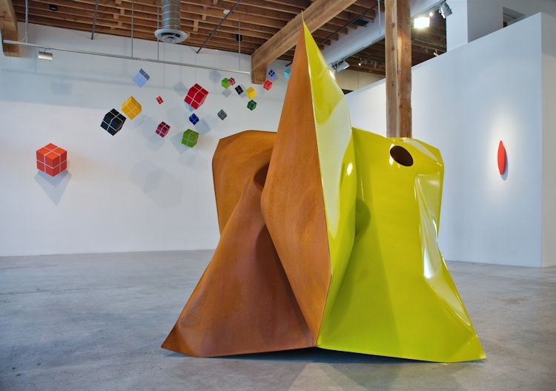
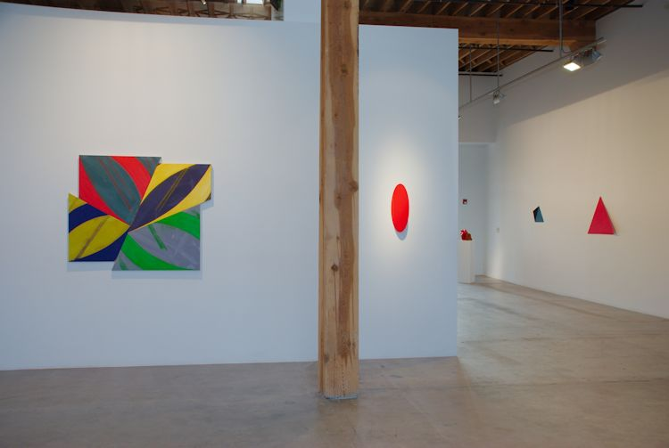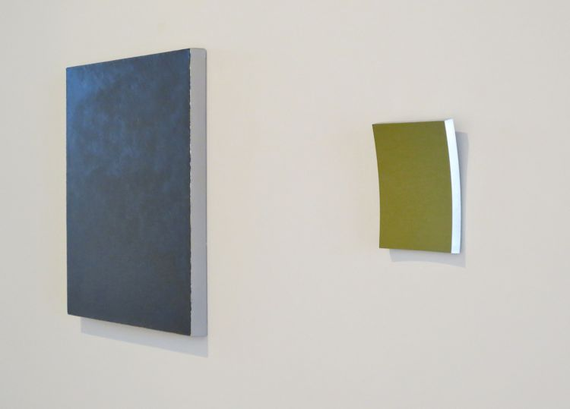
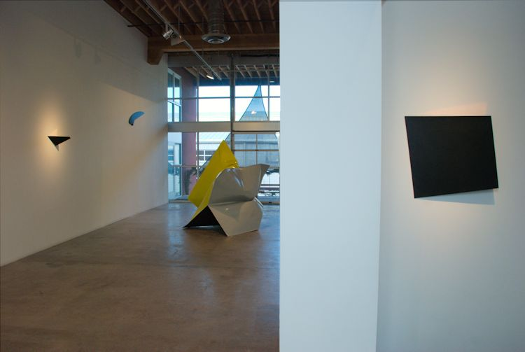
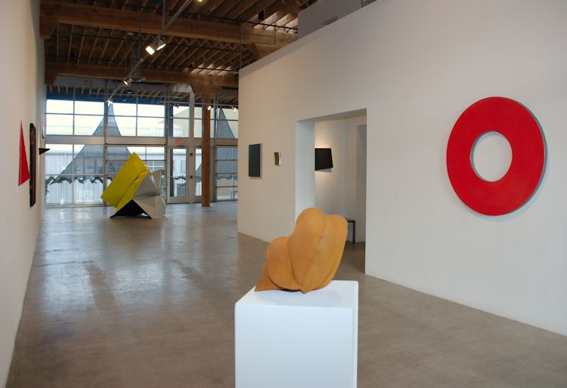
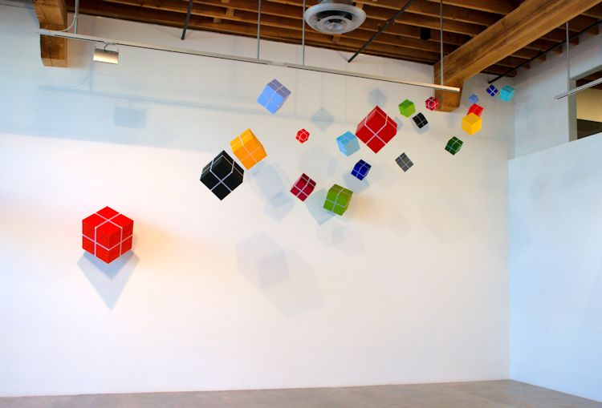
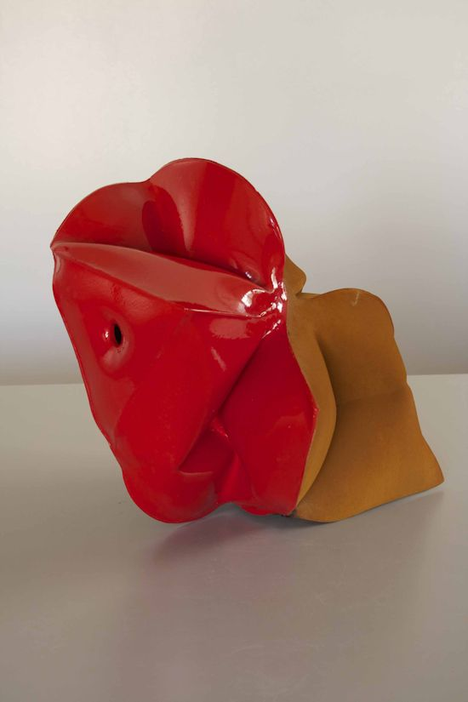
Jeremy Thomas
Race Red, 2014
forged mild steel and nail lacquer
11 3/4 x 11 1/2 x 11 3/4 in
JT300

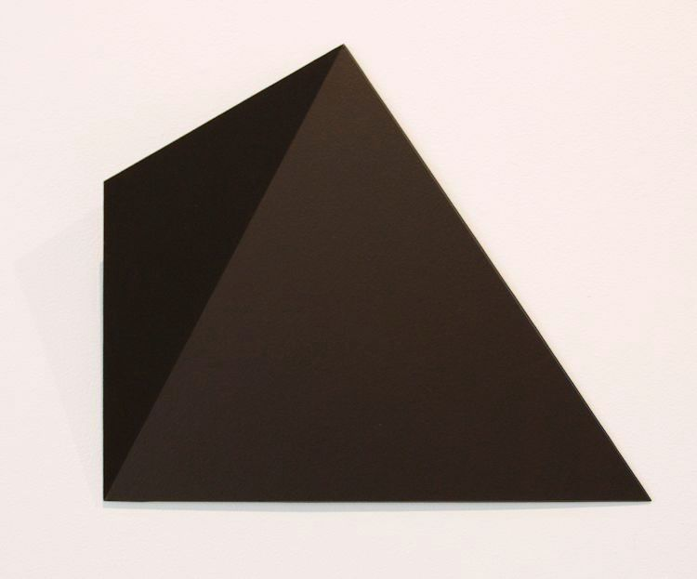
Michael Post
Untitled- wvz32, 2013
acrylic on fiberglass over steel
14 5/8 x 19 5/8 x 2 in
MP019

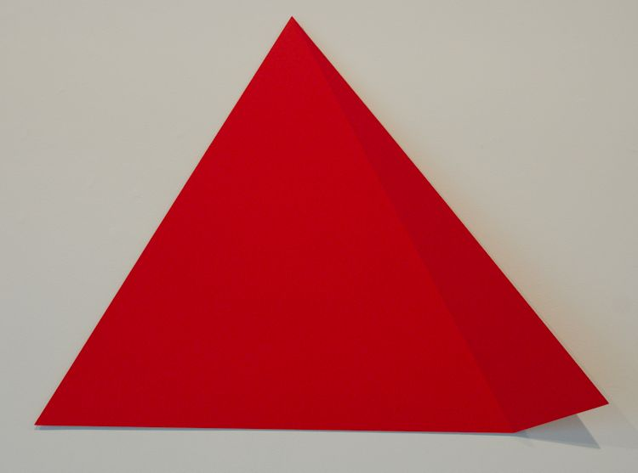
Michael Post
Untitled- wvz19, 2013
acrylic on fiberglass over steel
28 3/4 x 39 3/8 x 3 1/8 in.
MP023

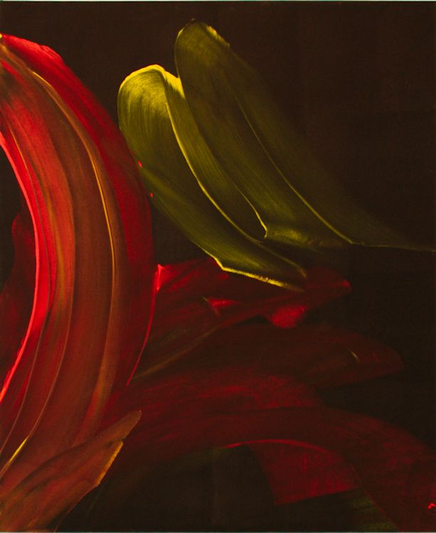
Ed Moses
Axe #1, 2014
acrylic on canvas
52 x 43 inches
EM068

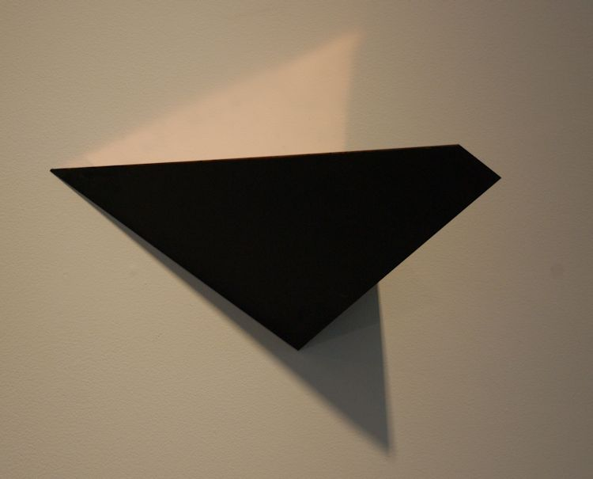
Constance DeJong
Square XVI, 1991
copper and wood
7 x 14 x 10 in.
CD126

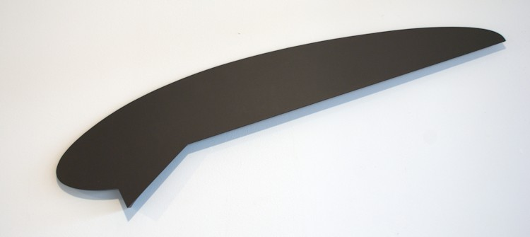
Tony DeLap
Matoon, 1998
Aluminum, wood, acrylic paint
11 x 47 x 2 inches
TD0133

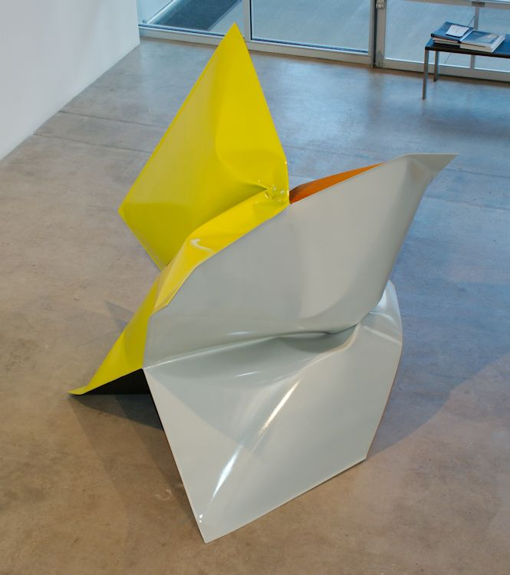
Jeremy Thomas
Hoodie Grey, 2014
forged mild steel, acrylic urethane & urethane rubber
82 x 94 x 84 inches
JT313

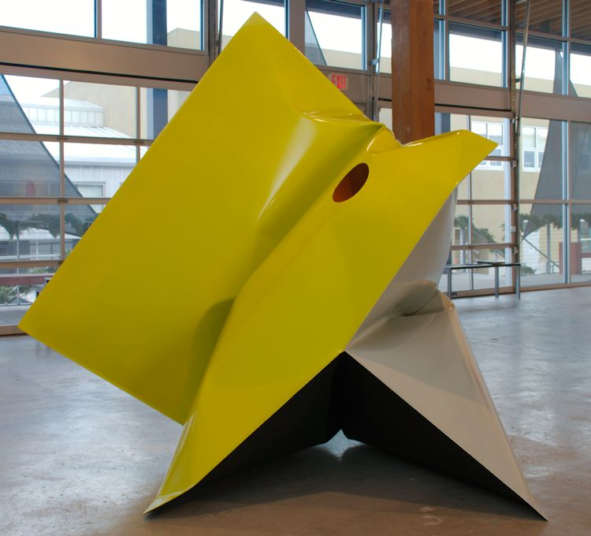
Jeremy Thomas
Hoodie Grey, 2014
forged mild steel, acrylic urethane & urethane rubber
82 x 94 x 84 inches
JT313 (Detail)

William Metcalf
Cube Cluster, Installation
Acrylic on Polyester Fabric, Wood
4 x 4 x 4 in., 6 x 6 x 6 in., 8 x 8 x 8 in., 12 x 12 x 12 in., 16 x 16 x 16 in., 18 x 18 x 18 in.

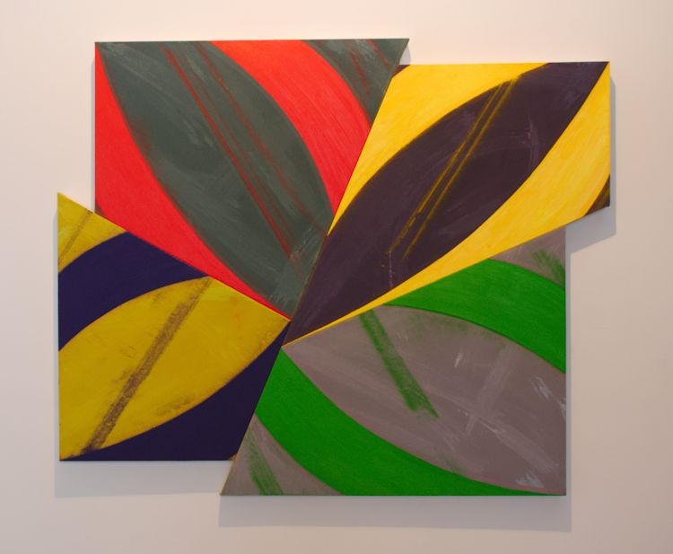
Charles Arnoldi
Four By Four, 2013
acrylic on linen
48 x 58 inches
CA149

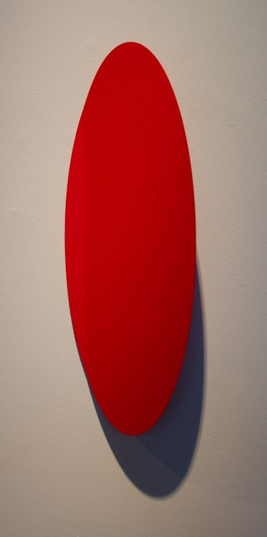
Michael Post
Untitled- WVZ428, 2014
acrylic on fiberglass over steel
21 1/4 x 8 1/3 x 3 1/2 inches
MP046
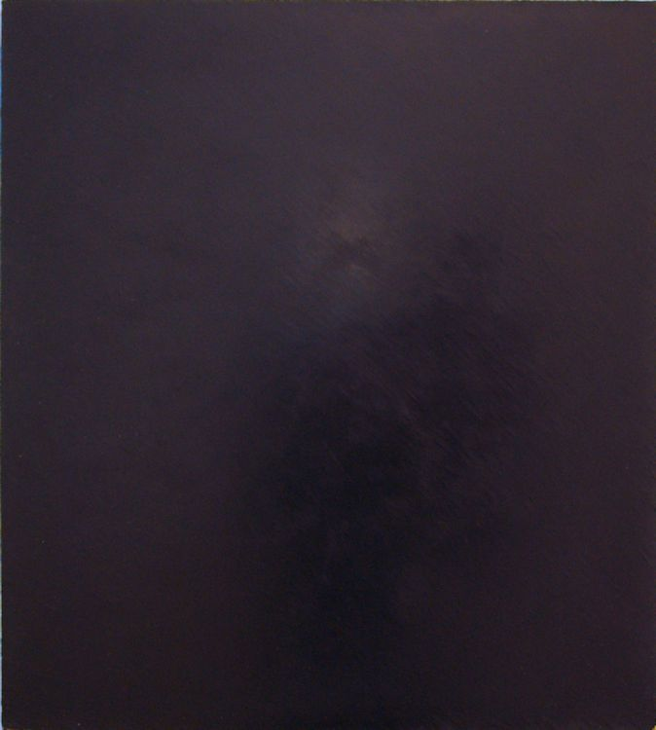
Clark Walding
Thin Ice (2nd Lead), 2005
Oil, wax and alkyd on canvas
28 x 25 inches
CW0036

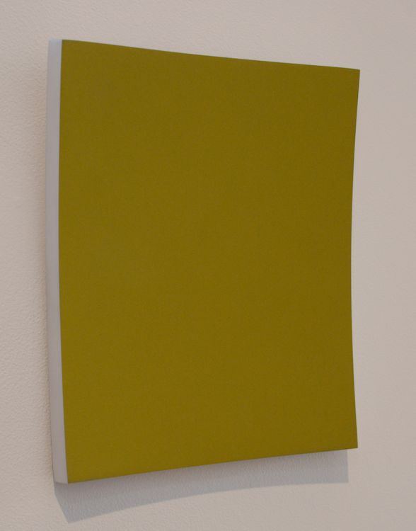
Heiner Thiel
Untitled- WVZ562, 2013
Anodized Aluminum
9 3/4 x 8 3/4 x 1 3/8 inches
HT166
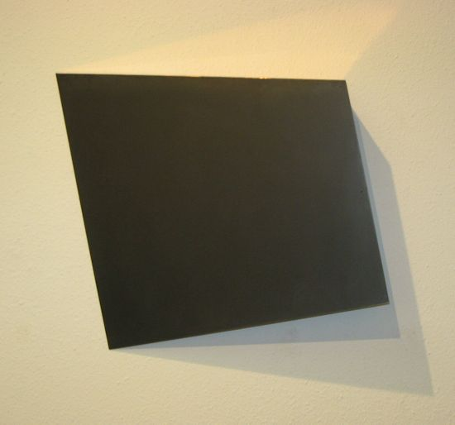
Heiner Thiel
Untitled- WVZ562, 2013
Anodized Aluminum
9 3/4 x 8 3/4 x 1 3/8 inches
HT166

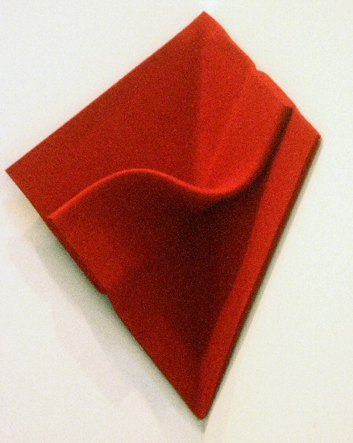
Peter Weber
Corner Folding, 2008
felt
15 3/4 x 15 3/4 in
PW026
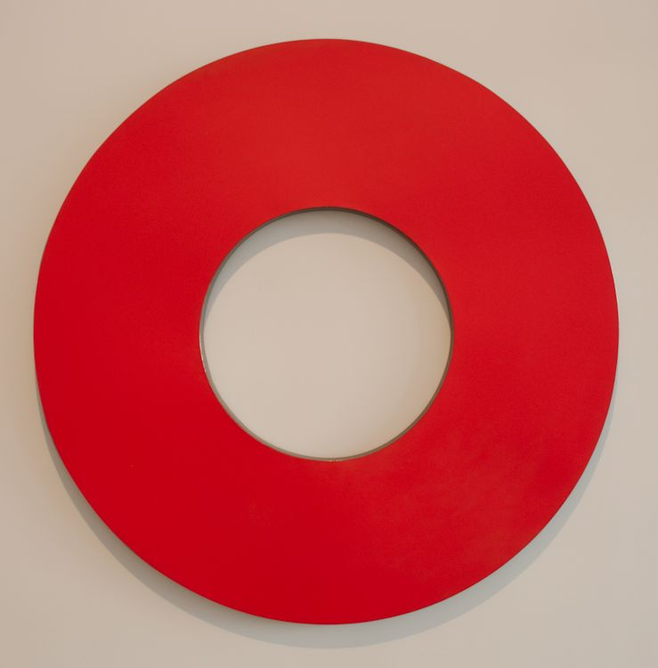
Elliot Norquist
Red Cherry Life Saver, 2012
painted steel
47 x 47 x 1 7/8 in
EN0069

© 2014

Charlotte Jackson Fine Art, Inc.

In the Railyard at:

554 S. Guadalupe, Santa Fe, New Mexico 87501
Telephone: 505.989.8688 Fax: 505.989.9898
cjfa@charlottejackson.com - www.charlottejackson.com

