CHARLOTTE JACKSON FINE ART

PRESENTS

Variations on Yellow
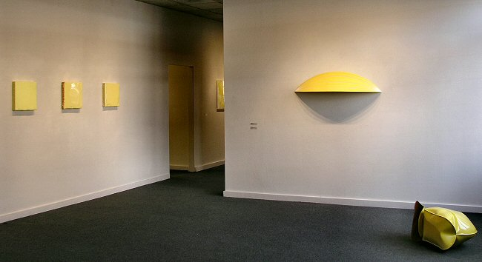

Joseph Barnes, John Beech, Tom Benson, Mark Cole, Danielle Frankenthal, Frederick Hammersley, Joseph Marioni, William Metcalf, Florence Pierce, Jeremy Thomas, Clark Walding
January 7 - January 29, 2005
For those suffering from light deprivation in the depths of winter, Variations on Yellow offers a shot of brightness and cheer. The show features paintings and sculpture in the color yellow, by artists Joseph Barnes, Tom Benson, John Beech, Mark Cole, Danielle Frankenthal, Frederick Hammersley, Joseph Marioni, William Metcalf, Florence Pierce, Jeremy Thomas and Clark Walding.
Variations on Yellow offers the viewer the opportunity to see just how many different ways the color yellow can manifest in works of art. Monochrome painter Joseph Marioni, a member of the Radical Painting Group of New York, applies translucent layers of acrylic to linen, exposing bits of the underlayers to the viewer. New Yorker John Beech, whose work was featured in a solo installation at the prestigious Albright-Knox Art Gallery last year, constructs whimsical rotating paintings and dumpster paintings. Local viewers will be familiar with Florence Pierce's luminous resin reliefs and Frederick Hammersley's hard-edge oils.
William Metcalf's sculptural paintings are constructed from translucent polyester fabric stretched over wooden frames and painted with acrylics. Mark Cole presents paintings that look exactly like traditional stretchers, canvas and paint, but that are really solid pieces of poured polyurethane plastic. Jeremy Thomas's inflated sheet metal sculptures, Danielle Frankethal's painting on glass, Clark Walding's oil with alkyd and wax, and Joe Barne's meditative acrylic painting round out the show.
This lively variety and the vibrant range of yellows are guaranteed to bring energy and verve to the darkest of winter days. Viewers are invited to come into the gallery and enjoy a spot of sunshine.
MAIN GALLERY:
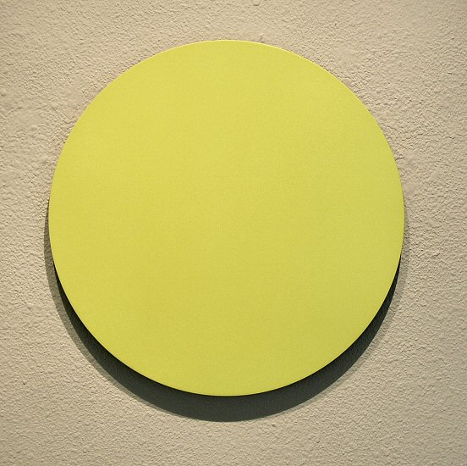
Tom Benson
Circus, 2002
Oil on aluminum, 13" diameter
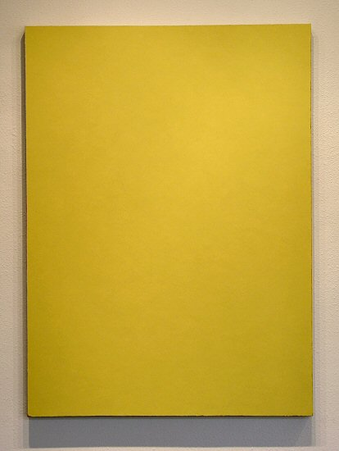
Clark Walding
A Fall, 2002-2004
Oil, alkyd, wax-on-canvas, 52" x 38"
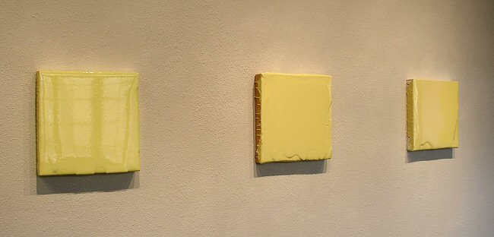
Mark Cole
Untitled, 2004
Polyurethane plastic with pigment, 14" x 14"
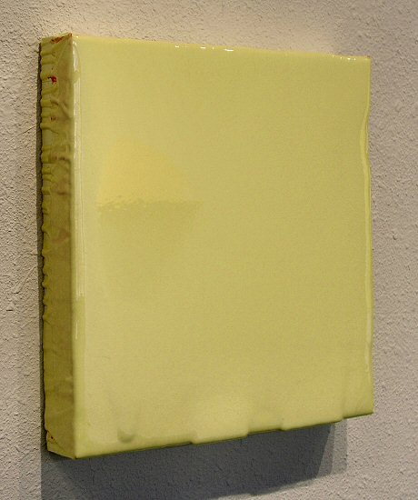
Mark Cole
Untitled, 2004
Polyurethane plastic with pigment, 14" x 14"
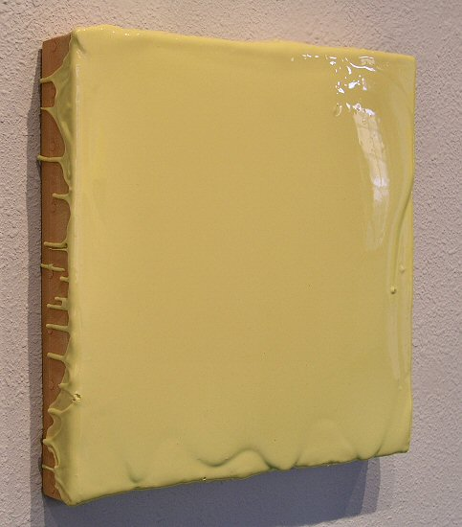
Mark Cole
Untitled, 2004
Polyurethane plastic with pigment, 14" x 14"
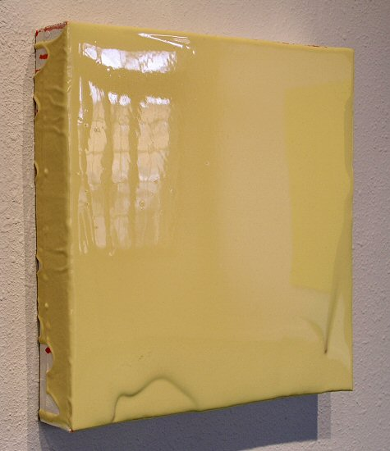
Mark Cole
Untitled, 2004
Polyurethane plastic with pigment, 14" x 14"
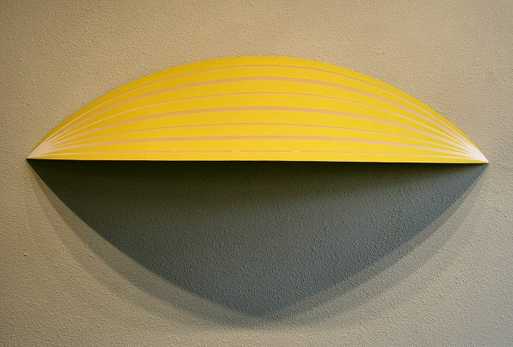
William Metcalf
Folded Yellow Arc, 2004
Acrylic on Polyester fabric on wood, 10 1/2" x 47 1/2" x 10
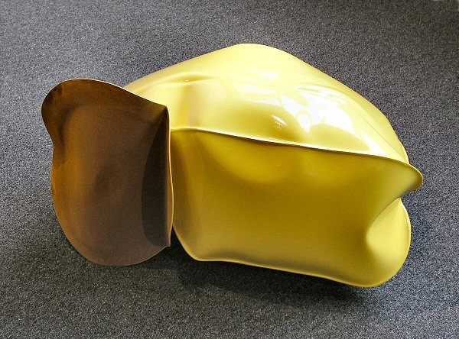
Jeremy Thomas
New Holland Yellow, 2004
Forged mild steel and powder-coated enamel, 30" x 16" x 21"
HALLWAY:
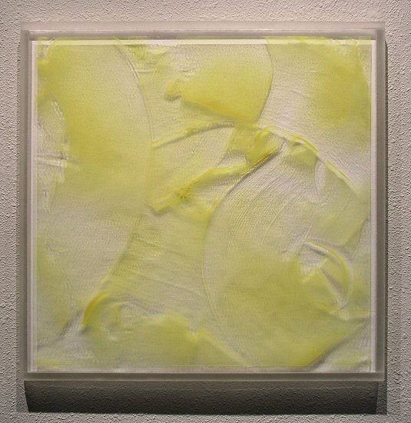
Danielle Frankenthal
Untitled, 2003
Acrylic and gesso on Acrylyte, 24" x 24" x 1/2"
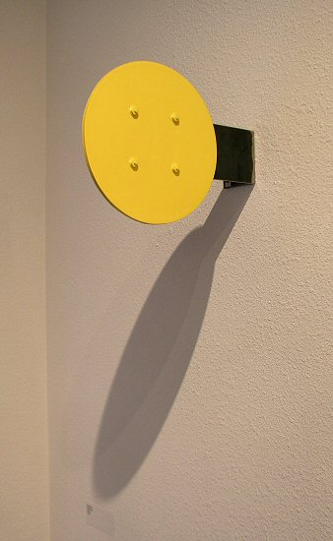
John Beech
RP30, 2000
Plexi, wood, enamel, rotating hardware,12" x 8" x 2"
GALLERY II:
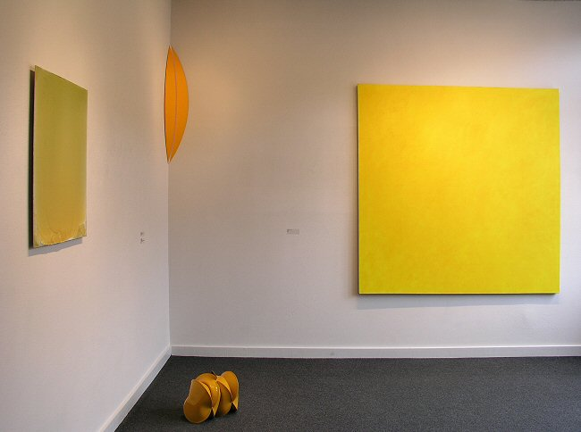
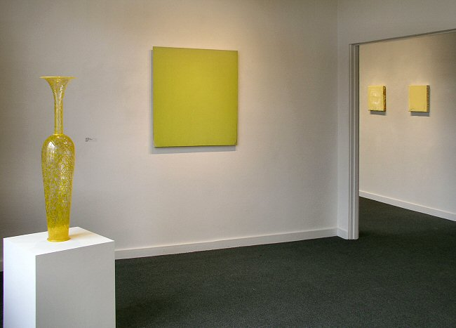
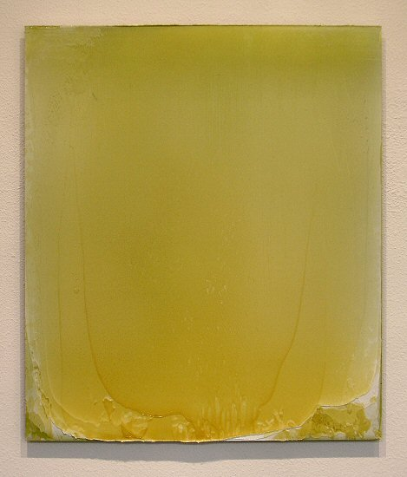
Matt McClune
Green/Yellow Painting, Nov. 2003
Acrylic on aluminum, 29" x 24 1/2"
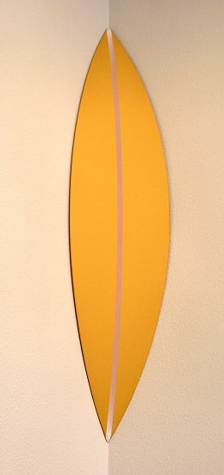
William Metcalf
Folded Corner Arc (Yellow), 2004
Acrylic on Polyester fabric on wood
6 3/4" x 40" x 6 3/4"
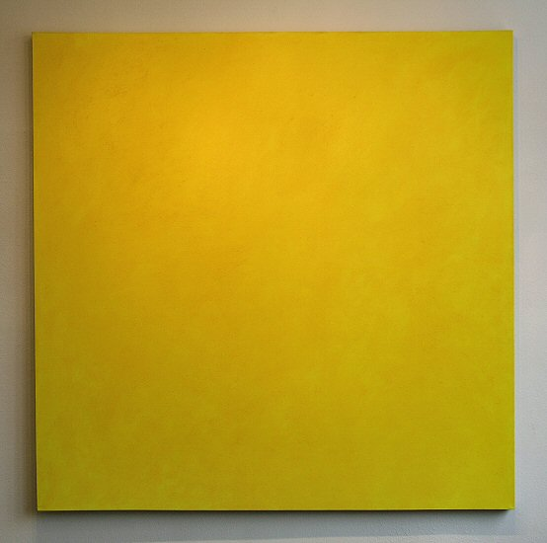
Joe Barnes
Hansa Yellow, 1999
Acrylic on canvas, 68" x 67"
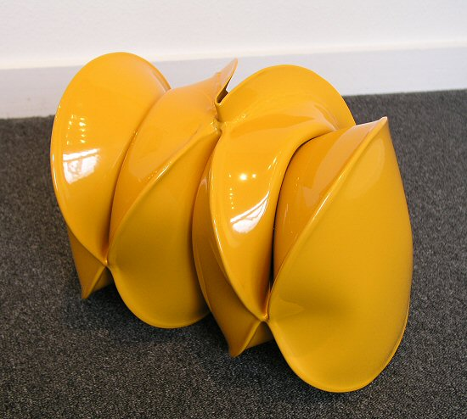
Jeremy Thomas
Cat Yellow, 2004
Forged mild steel and powder-coated enamel, 13 1/2" x 10" x 9"
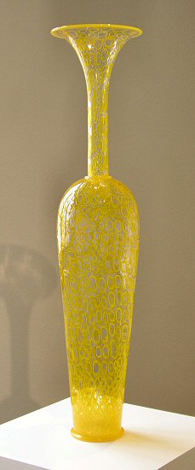
Dante Marioni
Yellow Mosaic, 2004
Blown Glass, 37" x 7" x9"
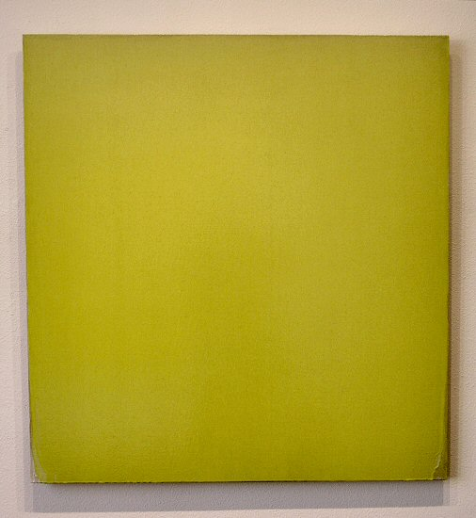
Joseph Marioni
Yellow painting, 2003
Acrylic on linen on stretcher, 36" x 34"
© 2005, Charlotte Jackson Fine Art
All Rights Reserved

Charlotte Jackson Fine Art

200 West Marcy Street, Suite 101

Santa Fe, New Mexico 87501

Phone: 505.989.8688
Fax: 505.989.9898

www.charlottejackson.com

Photography and CD production – William Metcalf

