CHARLOTTE JACKSON FINE ART

PRESENTS:

Tony Delap
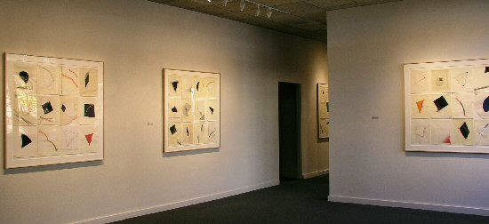
"Paintings and Drawings"
November 4th-November 30th 2005
MAIN GALLERY:
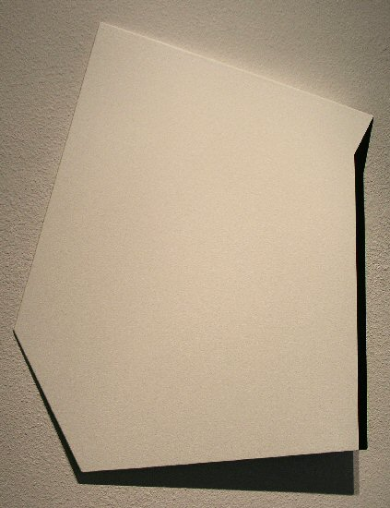
The Missing Card, 2003-2005
Acrylic on aluminum, wood, 26” x 22” x 2 ½”
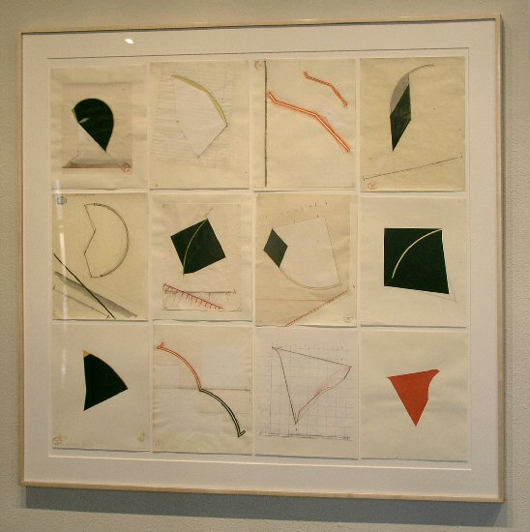
Twelve Drawings IV, 1980-2005
Collage, gouache, graphite, watercolor, colored pencil, ink, paper
50” x 52 ½”
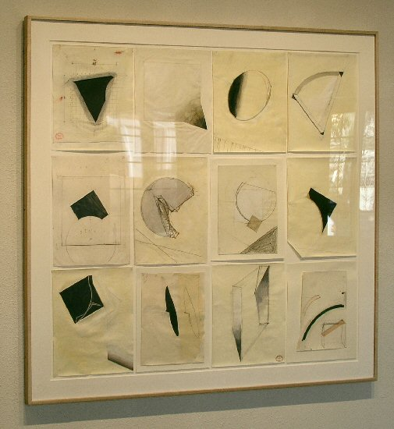
Twelve Drawings II, 1978-2003
Collage, gouache, graphite, watercolor, colored pencil, ink, paper
49” x 51”
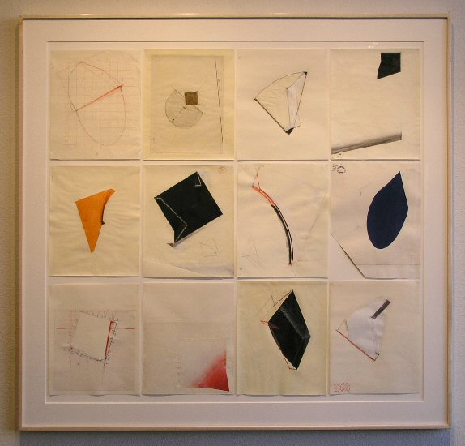
Twelve Drawings V, 1980-2005
Collage, gouache, graphite, watercolor, colored pencil, ink, paper
50” x 52 ½”
Drawing Details:

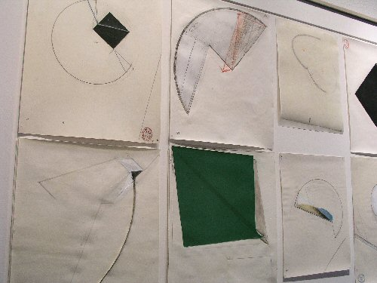

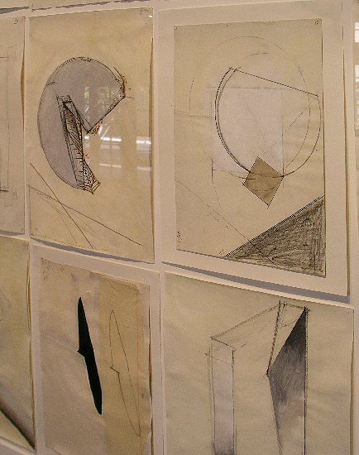

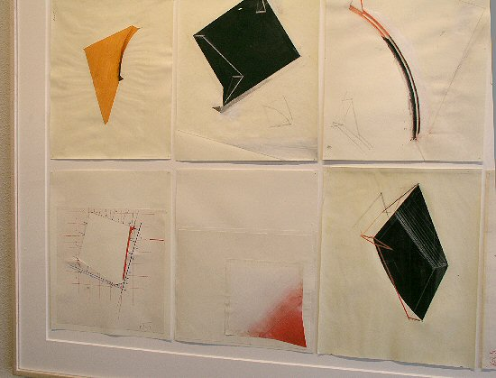
HALLWAY:

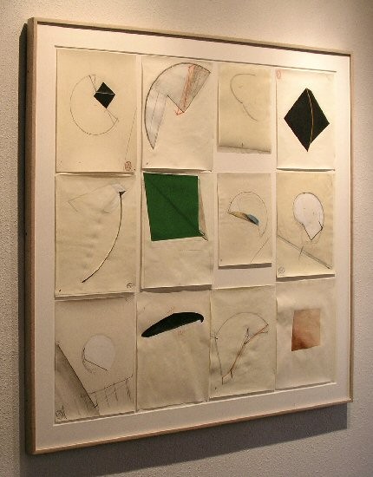
Twelve Drawings III, 1980-2003
Collage, gouache, graphite, watercolor, colored pencil, ink, paper
49” x 51”
GALLERY II:

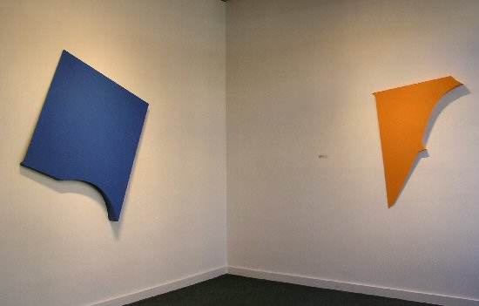

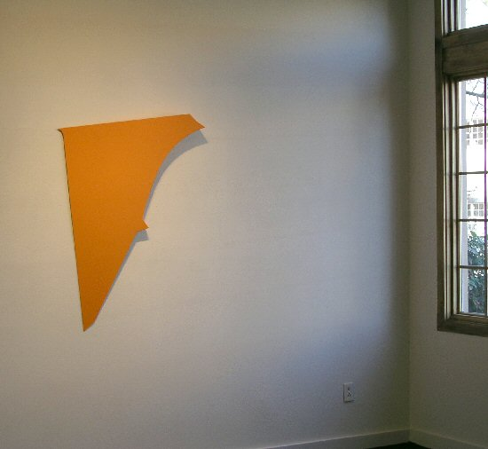
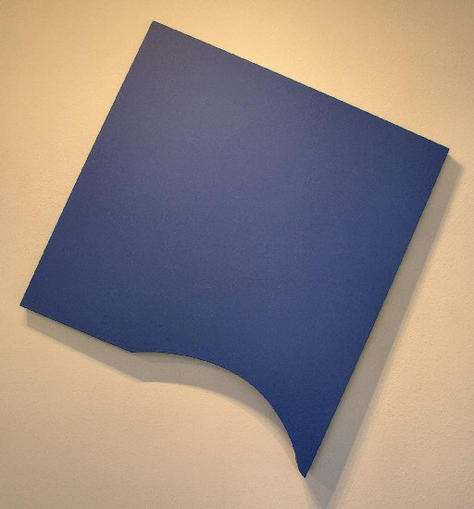
The Thirsty Spirit, 2004
Acrylic on aluminum, wood, 54” x 57” x 4”
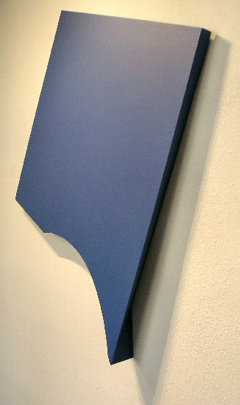
The Thirsty Spirit, 2004
Acrylic on aluminum, wood, 54” x 57” x 4”
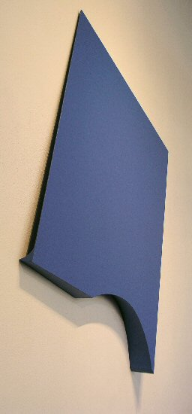
The Thirsty Spirit, 2004
Acrylic on aluminum, wood, 54” x 57” x 4”
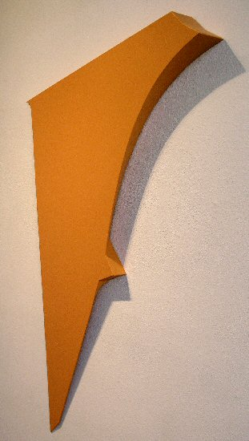
Zinger, 2003
Acrylic on aluminum, wood, 46 ½” x 33 ½” x 4"
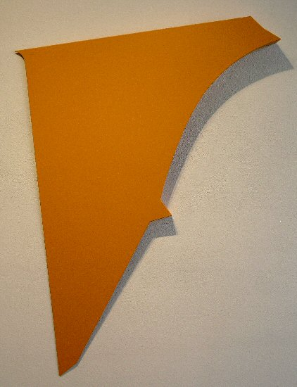
Zinger, 2003
Acrylic on aluminum, wood, 46 ½” x 33 ½” x 4"
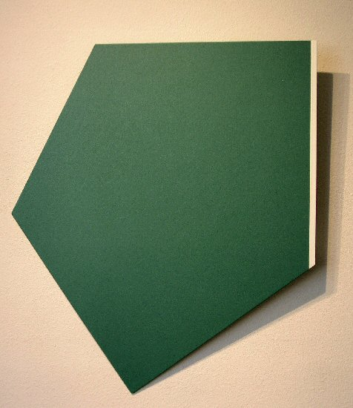
The Eye in the Sky, 2003-2005
Acrylic on aluminum, wood, 35” x 30” x 4"
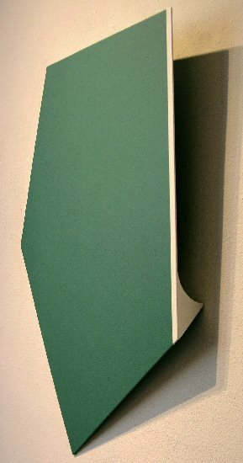
The Eye in the Sky, 2003-2005
Acrylic on aluminum, wood, 35” x 30” x 4"

Tony DeLap
Tony DeLap likes to joke around. Asked why he decided to become an artist, his first reply is, "Well, my father was a lawyer...." Then in a "but seriously folks" tone of voice, he goes on to say that he liked to build things as a kid, and that he has always been interested in drawing. These interests have clearly carried over into his paintings, which can also be seen as sculpture. Their clean lines and interesting configurations suggest the hand of a master draftsman, and the intricacy of their construction speaks of long experience with building things.
DeLap was born and grew up in the Bay Area of Northern California. His family lived near the Richmond/El Cerrito border, in what was then unincorporated cattle country with a view of the Golden Gate bridge. Speaking later in his life about the work of the "finish fetishists" of Southern California (a group in which he was included by some critics), he remarked that he always sort of wanted to see the uprights of the Golden Gate sticking up through the perfect surfaces of some of those works.
This puckish sense of humor also manifested in DeLap's lifelong interest in magic. A 1999 photograph shows five Tonys sitting around a table at the Sixth Los Angeles Conference on Magic History. The idea of magic carries over into his artwork in the intriguing way in which the shape of a given piece appears to change with any shift in the viewer's perspective. This is a much more serious form of magic, however, one which deals with the mysteries of human perception. As Peter Frank wrote in a 1988 article for the Los Angeles Times, "The sleight of hand, or of form, DeLap exercises...is recognized...as the work's payoff. But, like the 'signature' device in work by any serious artist, it is simply a tool, a symptom and/or a result of DeLap's overarching experimentation with perception."
DeLap has exhibited widely in the United States and Europe and in 2001 was honored with a major retrospective exhibition at the Orange County Museum of Art in Newport Beach, California. His work is included in the collections of The Museum of Modern Art in New York, The Whitney Museum of American Art, The Tate Gallery in London, The Guggenheim Museum, The Hirshhorn Museum in Washington, and many other major museums. Awards include grants from the National Endowment for the Arts and the Ford Foundation.
It is no surprise that DeLap's art has garnered so much recognition. The sheer virtuosity of his technique, manifested in a wide variety of works and combined with a fascinating and unique artistic vision, offers the viewer much to see and much to ponder about the nature of human perception itself.
© 2005, Charlotte Jackson Fine Art
All Rights Reserved

Charlotte Jackson Fine Art

200 West Marcy Street, Suite 101

Santa Fe, New Mexico 87501

Phone: 505.989.8688
Fax: 505.989.9898

www.charlottejackson.com

Photography and CD production – William Metcalf

