CHARLOTTE JACKSON FINE ART
PRESENTS:

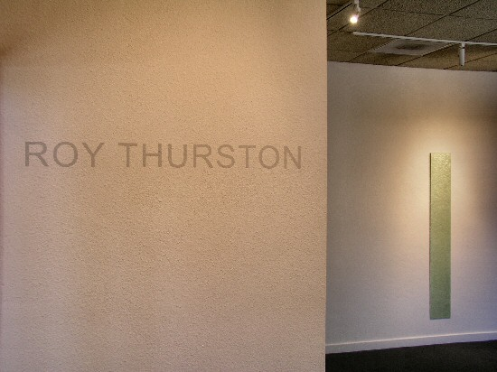

October 13 to Nov. 5, 2006

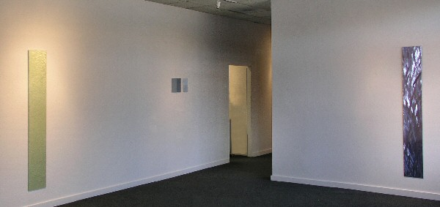

In an era of increasing sensory overload “what do you see” has become a question of profound resonance. The paintings of Roy Thurston encourage exploration of this question. Not that his work is buzzing, busy, or optical illusion, rather the root of Roy Thurston’s work is a reductive impulse to eliminate as many of the variables of painting as possible.
What we are left with is a lesson in attention. Thurston’s works of acrylic polyurethane on aluminum or copper panels engage the viewer and invite participation. The pieces are of a single color, though the idea of them as monochromatic is deceptive. The surface of the metal panels on which the paint is layered are tooled or etched as part of the machining process (which Thurston does himself), in ways that create intricate suggestions of etched lines or patterns, which show through the painting. This texture manipulates illumination so that color, shadow, and light change as the viewer moves around the paintings. The carefully finished surfaces (sometimes velvet smooth and matte, other times highly polished, sometimes textured) add and vary the effects.
In Thurston’s paintings, the “elimination of variables” creates works that are multifaceted. Here, with material, format, color, and surface as the major players it begins to be possible to see just how complex and interconnected even the most straightforward elements of a work of art can be. Surface and color are shown to be interdependent of one another, where the color itself is informed by the shaping of the metal panels beneath or the finished transparent surface above. Finally the other variable that is allowed in this formula is the viewer herself. These works, with their shifting colors and depths, their angles and seductive surfaces, demand participation. The experience of the piece is determined by the viewer’s engagement. What is seen is reliant upon the quality of attention.
Thurston’s work has attracted attention from museums and international collectors like the L.A. County Museum of Art, the Oakland Museum, the Museo Cantonale d'Arte in Lugano, Switzerland, the Panza di Biumo Collection in Milan, and the Berlingieri Collection in Rome.
This exhibition of new works by Roy Thurston at Charlotte Jackson Fine Art promises to be alluring both in the pieces’ luminous play of light and color and in the complexities that arise from slow and careful attention. Plan to take your time and see what you see.

MAIN GALLERY
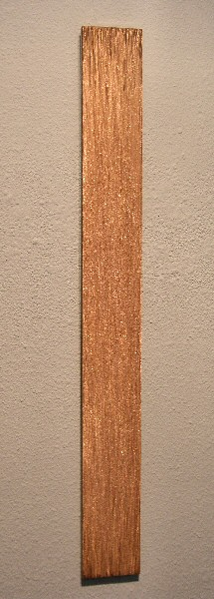
2006-10, 2006
Acrylic polyurethane on scraped copper, 36” x 4” x 3/8”, RT016
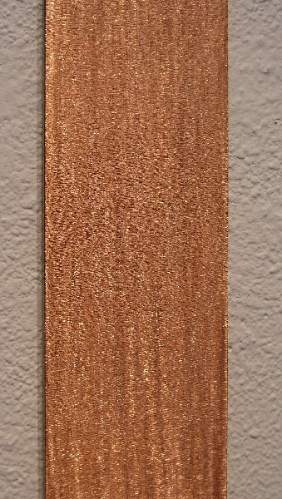
2006-10, 2006 (detail)
Acrylic polyurethane on scraped copper, 36” x 4” x 3/8”, RT016
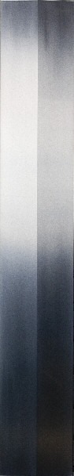
2006-15, 2006
Acrylic polyurethane on bent and sanded aluminum,
48 1/16” x 7 1/2” x 5/8”, RT017
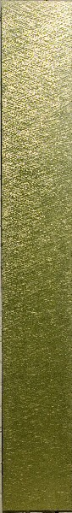
2006-17, 2006
Acrylic polyurethane on scraped aluminum,
72” x 10” x 3/16”, RT018
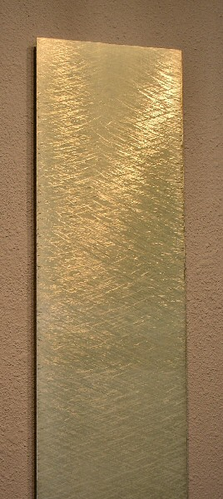
2006-17, 2006
Acrylic polyurethane on scraped aluminum,
72” x 10” x 3/16”, RT018
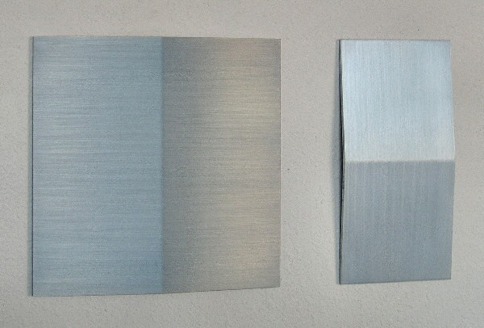
2005-7-1, 2005
Acrylic polyurethane on aluminum, 10” x 10” and 10” x 5”, RT012
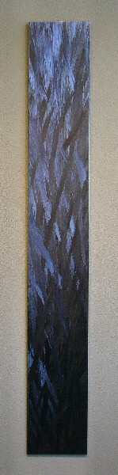
2006-11, 2006
Acrylic polyurethane on scraped aluminum,
72” x 10” x 3/16”, RT019
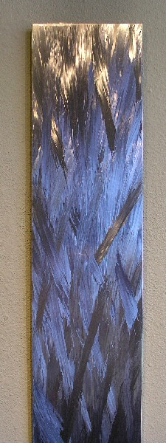
2006-11, 2006 (detail)
Acrylic polyurethane on scraped aluminum,
72” x 10” x 3/16”, RT019
HALLWAY
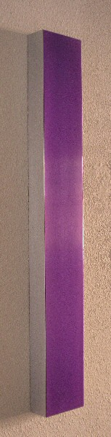
2006-12, 2006
Acrylic polyurethane on milled aluminum,
28 1/16” x 4” x 1 3/4”, RT020
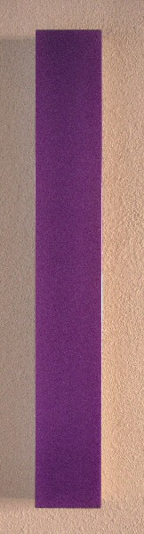
2006-12, 2006 (detail)
Acrylic polyurethane on milled aluminum,
28 1/16” x 4” x 1 3/4”, RT020

GALLERY II

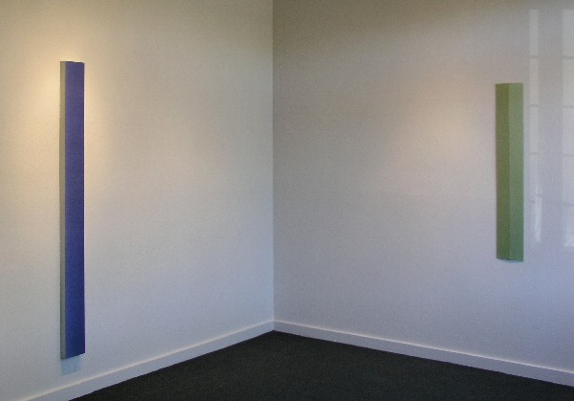
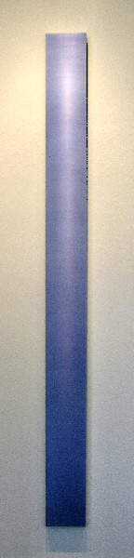
2006-6, 2006
Acrylic polyurethane on aluminum, 72” x 6” x 2”, RT021
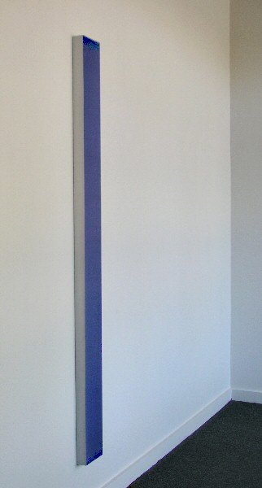
2006-6, 2006 (detail)
Acrylic polyurethane on aluminum, 72” x 6” x 2”, RT021
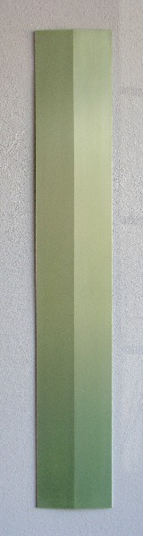
2006-16, 2006
Acrylic polyurethane on bent and sanded aluminum,
48 1/16” x 7 5/8” x 5/8”, RT022
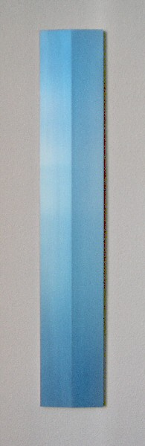
2006-13, 2006
Acrylic polyurethane on milled and sanded aluminum,
32 1/16” x 5 7/16” x 3/4”, RT023
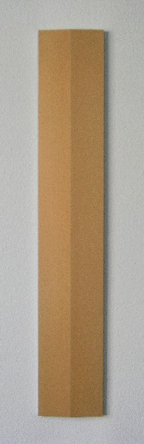
2006-14, 2006
Acrylic polyurethane on milled and sanded aluminum,
32 1/16” x 5 7/16” x 3/4”, RT024

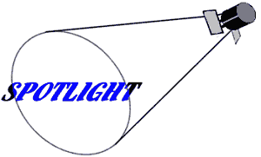 | ROY THURSTON
Even as a child growing up in Maine, Roy Thurston always knew he wanted to be a Westerner. Even as a child, he knew he wanted to be an artist. Today, as an internationally recognized painter active in the L.A. art world, Thurston has achieved both those goals and more.
Thurston's artistic interests and abilities are broad. His paintings reflect the precision and technical virtuosity of an engineer's mind on the one hand, and a pure love of color and its many possibilities for evoking emotion on the other. The son of a famous aircraft designer, Thurston has long been interested in industrial materials and machinery. Besides collecting old trucks, he has also amassed an impressive array of industrial machines, which he uses to manufacture the metal supports for his paintings. Materials for these supports range from shaped or milled aluminum panels to large chunks of honeycomb aluminum. Thurston originally began using honeycomb aluminum after he found sheets of it in the Lockheed salvage yard; he cites the ready availability of a wide variety of materials as one of the reasons he enjoys living in Los Angeles.
Technical expertise and a reputation for meticulous work led to an unusual commission for Thurston this year: he was selected by the Los Angeles County Museum to build and install an exact replica of an interior space (including furnishings) from the Pavillon L'Esprit Nouveau by Le Corbusier for the museum's show, L'Esprit Nouveau: Purism in Paris, 1918-1925. The exhibit opened in April.
But while all of Thurston's work reflects his precision and technical fluency, this is not to say that it appears mechanical or dry. On the contrary, his careful construction and the subtle refinement of his paintings evoke an emotional response that flows naturally out of the contained intensity of his technique. Thurston is in love with color, and his paintings are vivid presences that engage the viewer in an active encounter.
This emotional quality has been recognized and valued by discriminating collectors. Thurston's work is included in two preeminent Italian collections, the Panza di Biumo Collection in Milan and the Berlingieri Collection in Rome. From the Renaissance to the present day, the Italian art world has been particularly appreciative of an artist's ability to combine the best of scientific precision and emotional power. It is fitting that much of Thurston's work has found a home there.

Born 1949, Huntington, NY
EDUCATION
1971 BA, Colorado College, Colorado Springs, Colorado
1974 MFA, Claremont Graduate School, Claremont, California
SOLO EXHIBITIONS
2001 Charlotte Jackson Fine Art, Santa Fe, New Mexico
2000 Tod Hosfelt Gallery, San Francisco, California
Chac-Mool Gallery, Los Angeles, California
1999 Charlotte Jackson Fine Art, Newport Beach, California
1996 Charlotte Jackson Fine Art, Santa Fe, New Mexico
1995 Thomas Solomon=s Garage, Los Angeles, California
1991 Kiyo Higashi Gallery, Los Angeles, California
1989 Kiyo Higashi Gallery, Los Angeles, California
1985 Todd Madigan Gallery, California State College, Bakersfield, California
GROUP EXHIBITIONS
2001 Material Abstraction, Howard Yeserski Gallery, Boston, Massachusetts
Simply Complex: Monochrome Paintings from L.A., Dorsky
Gallery, New York; Howard Yezerski Gallery, Boston; Charlotte Jackson
Fine Art, Santa Fe; Hunsaker/Schlessinger Fine Art, Santa Monica
New Work: L.A. Painting, Tod Hosfelt Gallery, San Francisco
1997 Selections from the Panza acquisition, organized by Museo Cantonale d=Arte
Lugano, Palma di Mallorca, Spain (catalog)
5 Easy Pieces, 5th Annual Invitational Exhibition, Nevada Institute for
Contemporary Art, Las Vegas, Nevada (catalog)
1995 The Panza di Biumo Donation: Euro. and American Art >83- >93, Museo Cantonale d=Arte, Lugano, Switzerland (brochure)
1994 Plane/Structures, curated by David Pagel, Otis Gallery, Otis College of Art and Design, Los Angeles, California (catalog)
1992 Panza di Biumo: The Eighties and Nineties from the Collection, Museo Cantonale d=Arte, Lugano, Switzerland (catalog)
1990 Minimal 1960-1990, Cirrus Gallery, Los Angeles, California
1989 Quiet, curated by Paul Tomidy, Oakland Museum, Oakland, California
1987 Burnett Miller Gallery, Los Angeles, California
1986 Angles Gallery, Santa Monica, California
1975 Selected West Coast Painters, Miami-Dade University, Miami, Florida
BIBLIOGRAPHY
2000 Holly Meyers, "Roy Thurston," Art Issues, Summer
Christopher Knight, "Panza's Two Divergent Worlds," Summer
Christopher Knight, "Panza's Two Divergent Worlds," Los Angeles Times, February 5
1996 Lis Bensley, ARoy Thurston Unlocks a Translucent Realm,@ The Santa Fe New Mexican, September 13
1995 Crockett, Toby, ARoy Thurston at Thomas Solomon=s Garage,@ Art in America, June
Pagel, David, ARoy Thurston at Thomas Solomon's Garage,@ Art Issues, March- April
1994 Wilson, William, APlane/Structures at Otis: Enriching Work,@ Los Angeles Times, September 19, Calendar Section
1991 Colpitt, Frances, APalpable Surface/Elusive Depth,@ Artspace, Summer
1990 Kornblau, Gary, ARoy Thurston at Kiyo Higashi,@ Art Issues, March-April
1990 McKenna, Christine, ACirrus Offers Minimalism with a West Coast Slant,@ Los Angeles Times, Dec. 12, Calendar Section
1989 Geer, Suvan, Los Angeles Times, December 1, Calendar Section
SELECTED PUBLIC and PRIVATE COLLECTIONS
The Berlingieri Collection, Rome, Italy
Jane and Burt Berman, Venice, California
Lester Edelberg, Costa Mesa, California
Natalie and Irving Forman, Santa Fe, New Mexico
Ann Hatch, San Francisco, California
Kiyo and Robert Higashi, Los Angeles, California
Dr. and Mrs. Phyllis Kleinberg, Villa Park, California
Anne Lannan, Los Angeles, California
Museo Cantonale d=Arte, Lugano, Switzerland
Museum of Contemporary Art, Los Angeles, California
Joan and Fred Nicholas, Beverly Hills, California
The Panza Collection, Milan, Italy

© 2006

Charlotte Jackson Fine Art, Inc.

200 West Marcy Street, Suite 101, Santa Fe, New Mexico 87501
Telephone: 505.989.8688 Fax: 505.989.9898
cjfa@charlottejackson.com - www.charlottejackson.com

