CHARLOTTE JACKSON FINE ART
PRESENTS:

Jeremy Thomas
Boll
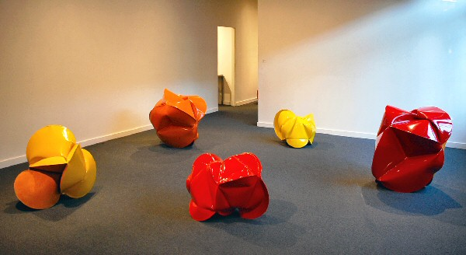
Sept 4 - Sept 30, 2009
Walking through an installation of Jeremy Thomas’ brilliantly colored metal sculptures is a charged experience. Color pummels the eye (greens, oranges, reds, yellows) as slick and intense as any marketing campaign. The shiny force of the color, so clearly industrial, tricks the mind into remembering the other contexts where it has seen these colors on steel before: tractors, combines, farm equipment, bulldozers. But then the forms come clearer, with their burgeoning voluptuousness of curves and dimples, suggesting the sensual forms of nature: bodies, plant-shapes, seed pods.
Although Thomas’ work has always incorporated this play between natural, sensual forms and industrial, assembly-line colors, in the case of his exhibition, Boll, this relationship is even more direct. The forms in this show are inspired by drawings of cotton bolls, the seed pod of the plant from which the fiber is harvested. But it is not only the seed-pod shape that has informed these pieces. After being inspired by the form and shape of the bolls, Thomas began to research the industrial paints used particularly on cotton-cultivating and harvesting equipment. Slowly the forms of this equipment have merged and fused into the forms of the pieces as well.
But there is a larger connection at work here too. Each morning before going to work in his studio Thomas spends working in his organic garden. This year it is a large plot of potatoes, tomatoes, eggplant, beets, corn, onion, garlic, beans, peas, carrots, parsnips, turnips, lettuce, bokchoy, peppers, chilies, melons, and squash. Sustainable agriculture is something he has had a longstanding interest in and his work with soil has influenced his work with steel.
But with Boll the strands of art, history, agriculture, culture, industrialism, and nature achieve a true nexus. With origins as early as five to six thousand B.C., cotton cultivation and the manufacture of cotton cloth tie us back to the very beginnings of both culture and agriculture. Cotton exemplifies the dark costs both to humans and environment of industrial agriculture. Needing huge amounts of water and chemical defoliants to facilitate harvesting, it is one of the most toxic and resource-heavy crops on the planet. Historically its labor-intensity was solved by the use of slaves.
Culture is a word with dozens of variants in meaning. Its earliest meanings are tied to cultivation and thus to the word agriculture. Later it came to be used to describe the cultivation of individuals and peoples through education and the arts. It is used in biology to describe the growth of some biological life-form on a medium. Thomas’ pieces, which seem almost to have been grown in the medium of a 2,000 degree fire, fuse and re-shape the complexities of both agriculture and culture into something which, while it references both, is entirely new.
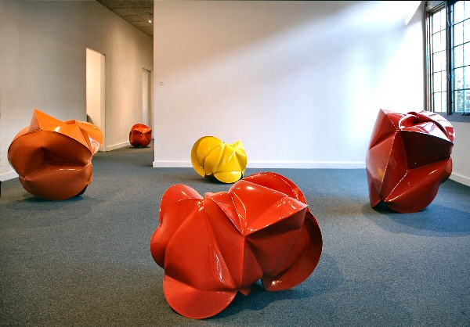
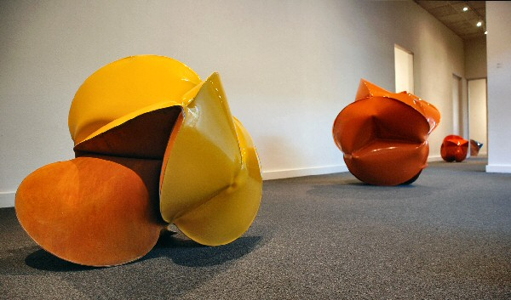
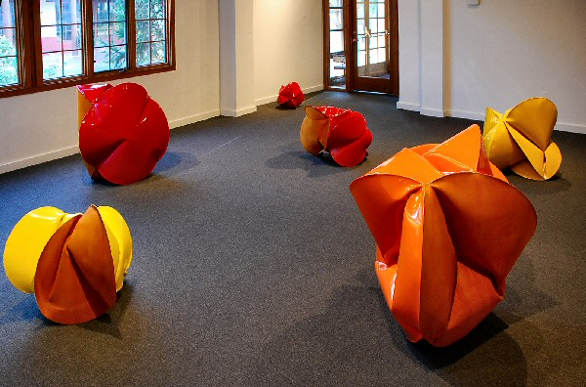
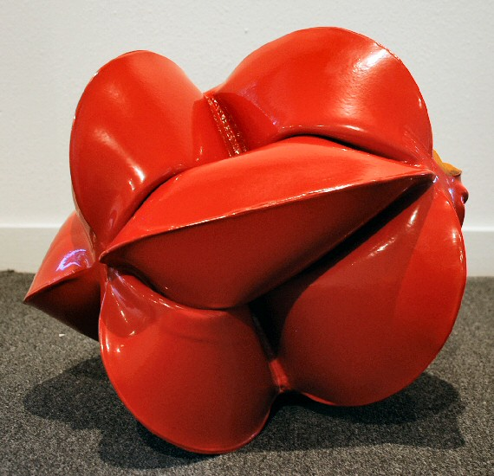
Module Red, 2009
forged mild steel and powder coat
15 x 17 x 16 inches JT177
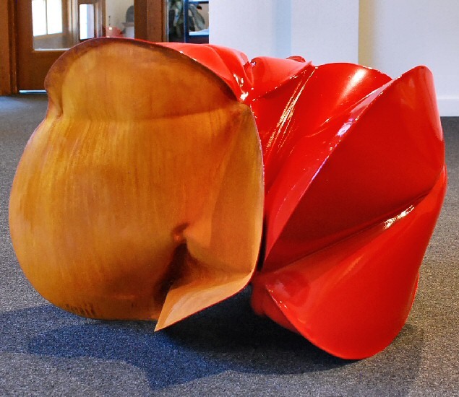
Module Builder Red, 2009
forged mild steel and powder coat
21 x 31 x 20 inches JT189
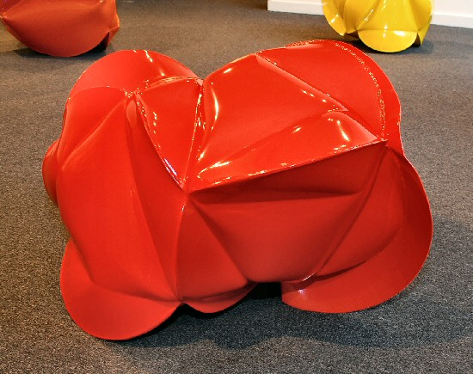
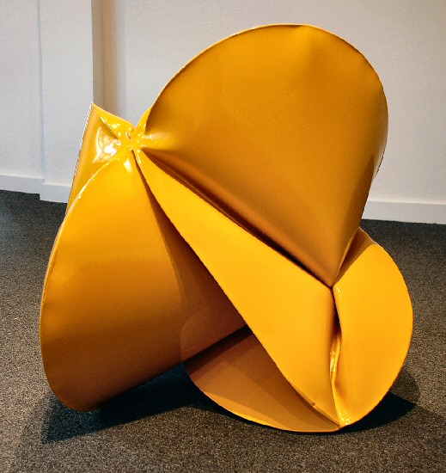
KBH Yellow, 2009
forged mild steel and powder coat
28 ½ x 27 x 24 inches JT192
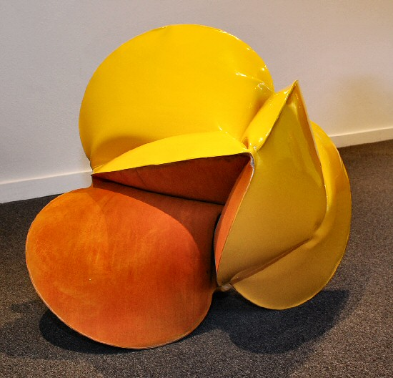
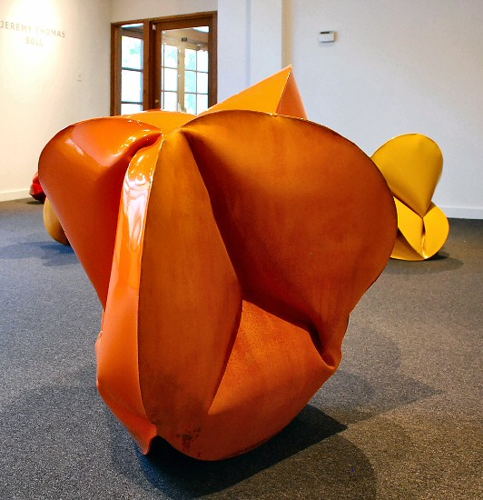
GT Orange, 2009
forged mild steel and powder coat
36 x 37x 36 inches JT186
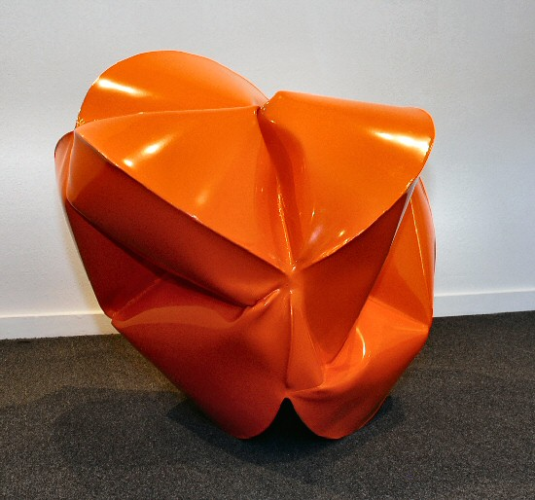
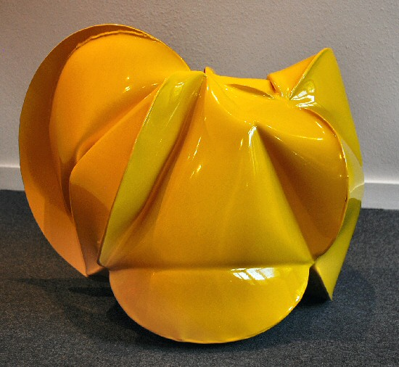
Cotton House Yellow, 2009
forged mild steel and powder coat
21 ½ x 28 ½ x 24 inches JT188
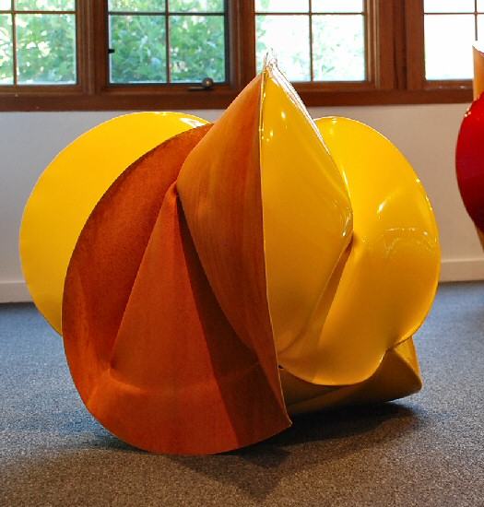
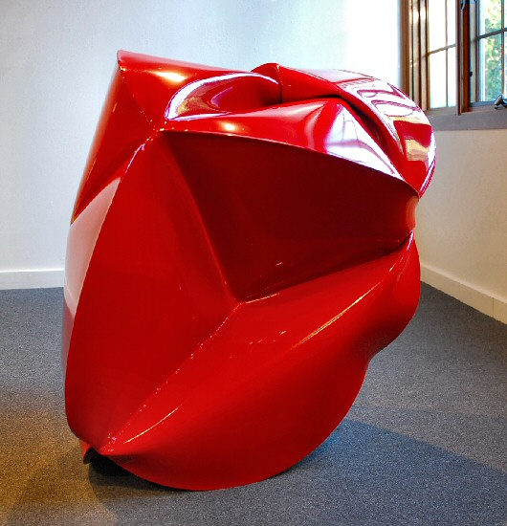
Roda Red, 2009
forged mild steel and powder coat
34 ½ x 32 x 34 inches JT187
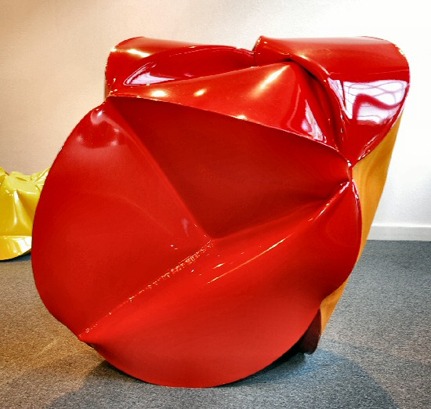
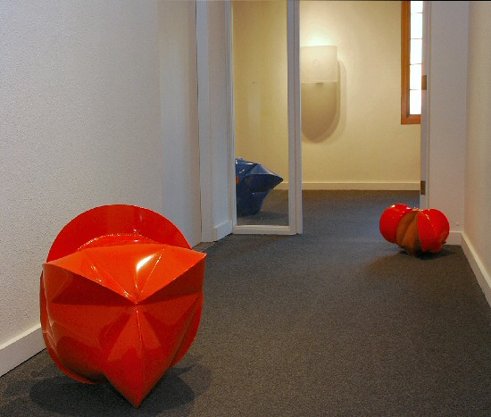
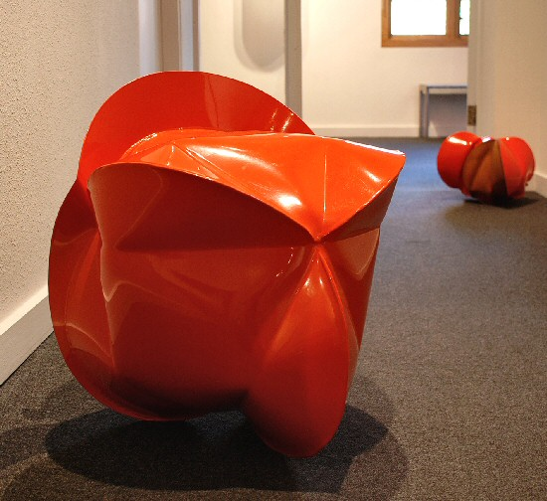
Boll Buggy Orange, 2009
forged mild steel and powder coat
22 x 22 x 24 inches JT172
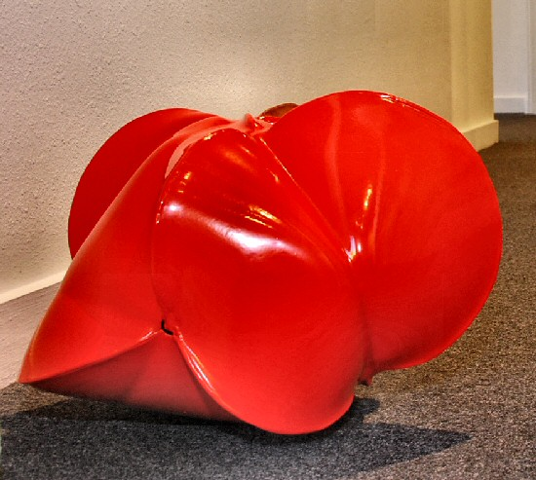
DU-AL Orange, 2009
forged mild steel and powder coat
13 x 15 x 14 ½ inches JT180
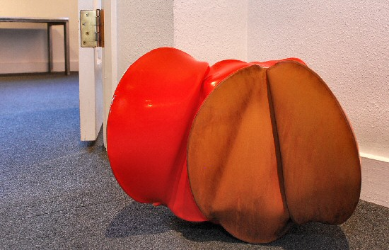
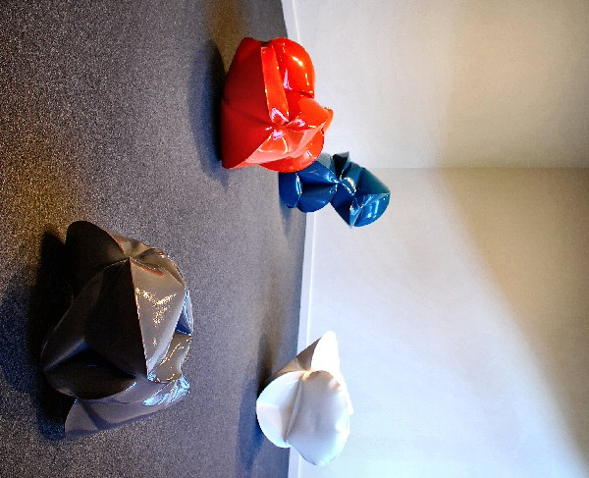
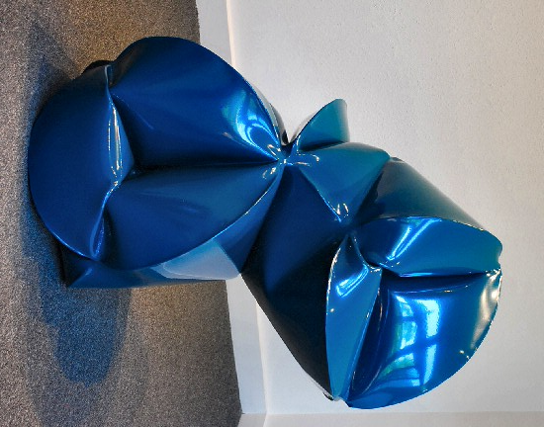
Module Builder Blue, 2009
forged mild steel and powder coat
34 x 24 x 23 inches JT193
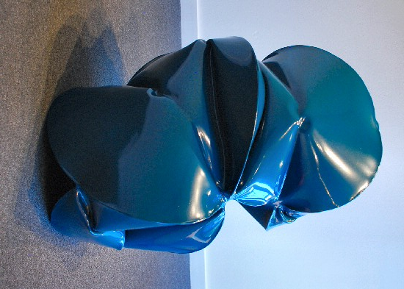

Module White (space shuttle), 2009
forged mild steel and powder coat
23 x 37 x 21 inches JT191
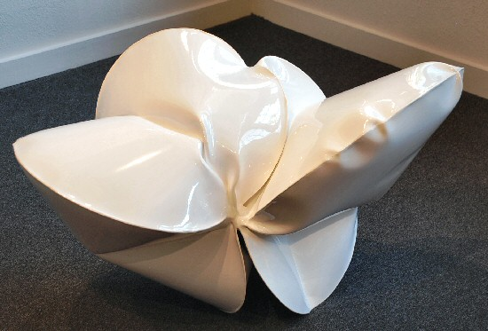
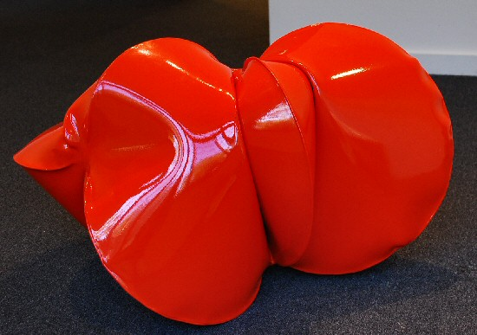
Brush Hog Orange, 2009
forged mild steel and powder coat
20 x 36 x 24 inches JT175
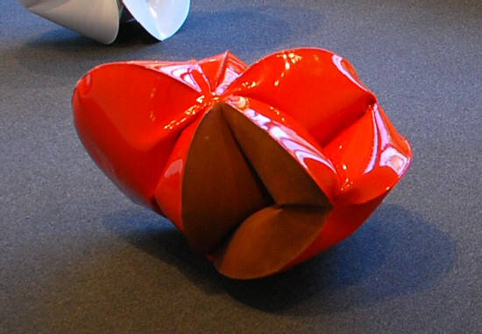
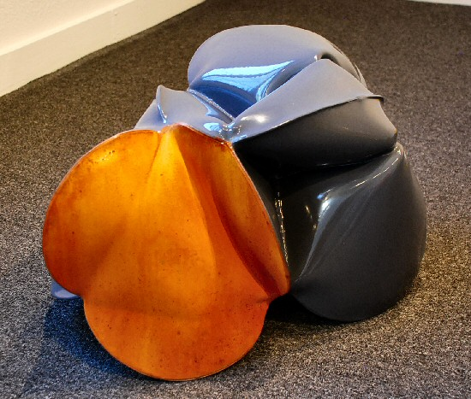
Module Grey, 2009
forged mild steel and powder coat
12 ½ x 20 x 15 ½ inches JT176
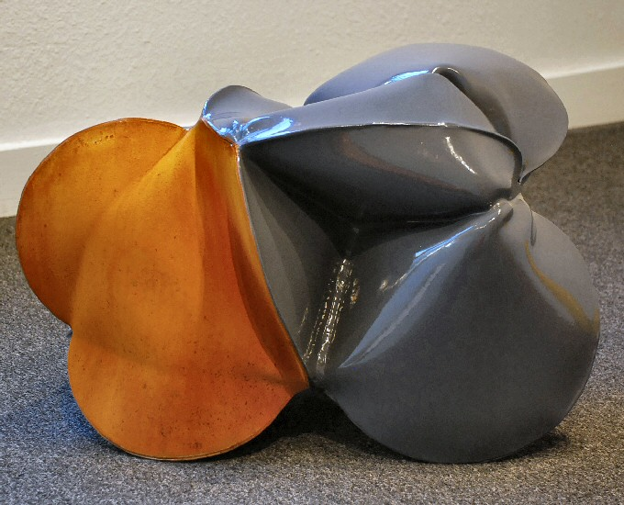
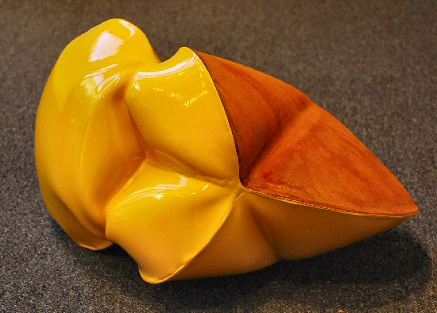
Boll Buggy Deep Yellow, 2009
forged mild steel and powder coat
10 x 19 x 12 inches JT179
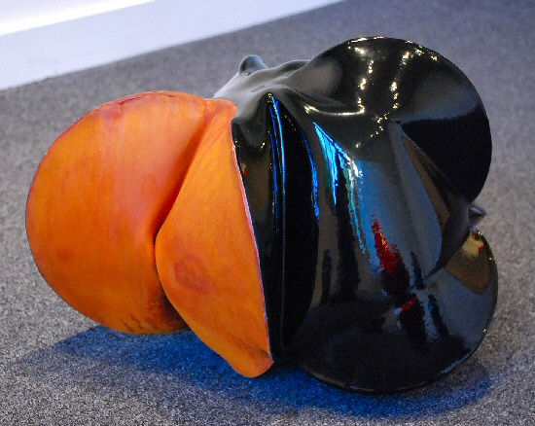
Boll Buggy Black, 2009
forged mild steel and powder coat
17 ½ x 12 13 ½ inches JT184
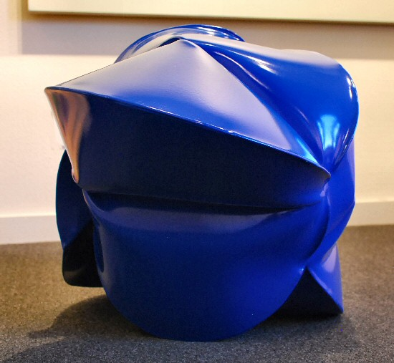
Boll Buggy Blue, 2009
forged mild steel and powder coat
21 x 30 x 21 inches JT190\
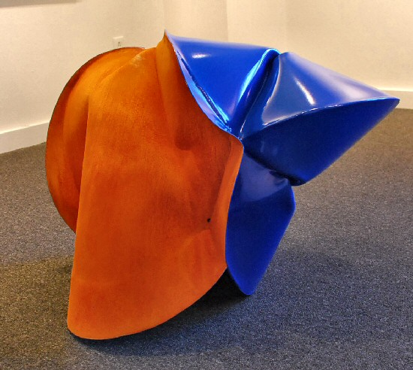

© 2009

Charlotte Jackson Fine Art, Inc.

200 West Marcy Street, Suite 101, Santa Fe, New Mexico 87501
Telephone: 505.989.8688 Fax: 505.989.9898
cjfa@charlottejackson.com - www.charlottejackson.com

