CHARLOTTE JACKSON FINE ART PRESENTS:

TONY DeLAP
Recent Paintings and Magic Drawings

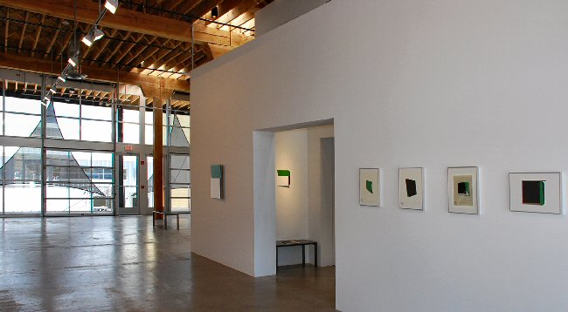

October 1 - 31, 2010

Gallery Talk by art historian Jan Adlmann

An artist leads the viewer along a tricky balancing act: on the one hand challenging their perceptions, disappointing their expectations, but on the other satisfying some part of the viewer’s aesthetic desires. A magician also plays with the perception of his audience, talks them into following him smoothly through his trick, misdirecting their attention from his wily prestidigitations, and satisfying them when the missing coin is finally pulled from the hat. Tony DeLap is an artist. He is also a magician.

If you know this fact about DeLap it seems impossible not to make connections between his art and his study of magic. Looking at a piece from the exhibition Recent Paintings and Magic Drawings like Notario, the relationship between the two begins to come clear. The monochrome green canvas is an almost-square, set cocked at an angle to the wall so that one edge is flush while the others float out into space. The upper right corner of the canvas bursts from its geometry with an arc like a green wave. The effect of the piece disturbs both the viewer’s visual perceptions and their expectations of a canvas hung on a gallery wall. It is impossible to really see Notario without moving around it, investigating the work’s edges, and noting the effect that each view has on the whole. Color (the green shifts in density) and form (what seems floating becomes solid, what seems straight is skewed) become tricky and unreliable. The distortion, or as DeLap puts it, “almost a discomfort” creates the tension that gives the painting its energy and life. The viewer finds herself participating in a playful dance of discovery.

DeLap has been exploring ways of bending perception in his art for many years. A native of Northern California, DeLap studied art at the Claremont Colleges. His work has been aligned by critics with several of the artistic movements of the 20th Century: Hard Edge, Finish Fetish, Op Art, Minimalism, Constructivism, and Art-and-Space to name a few, yet DeLap has managed to remain unfettered by these labels, utilizing techniques and ideas from the movements and in turn contributing to their development while maintaining a playful curiosity and serious artistic exploration that is uniquely his own. His efforts have proven successful; his work is represented in collections from the Hirshhorn, Guggenheim, and Whitney to the Museum of Modern Art and the Tate.

In much of his earlier work (similar to Notario) the edge itself became the content, acting, as he says, “like a Mobius Band” (the unusual circular bands with no inside or outside edge). In some of the more recent work, like Right Guess, the physical surface of the canvas is unaltered, but DeLap skillfully applies planes of color which interact with each other, and with sections of exposed raw linen, to thwart and trick the viewer into seeing a manipulation which is not really there. Some of the pieces from this exhibition, like Melio, combine both physical cutback edges and flat colored form effects.

The drawings included in this exhibition provide an interesting look behind the scenes of DeLap’s working process. The drawings, on paper and mostly about 10 x 16, show sketches of colored planes that echo and reference the finished paintings. For example, in one drawing a black, white and green square is sketched against a gridded background, with a shadow cast below it showing the intended cutback edge. These drawings provide another layer to understanding and appreciating DeLap’s work. As DeLap says, “Unlike the stage magician, I want to expose the trick, show where the edges go, reveal a different surface. But knowing the trick does not finish the art viewer’s experience.”

With this exhibition of new works by a master, Recent Paintings and Magic Drawings, viewers will have an opportunity to engage with a range of DeLap’s challenging and perception-bending works. The experience of the viewer mirrors that of the creator, as DeLap himself says, “The essence of creativity is serious play. I want to find something that I haven’t seen before. But I often find that earlier thoughts appear in the new work.”
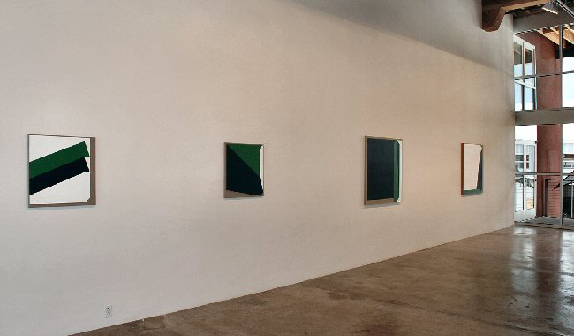

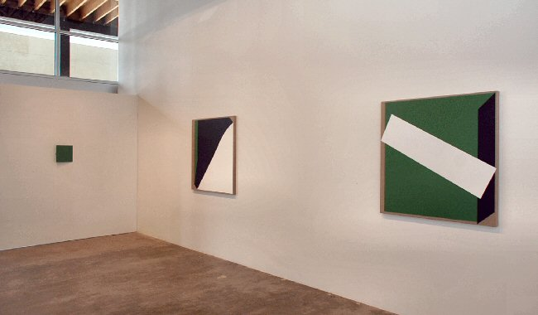
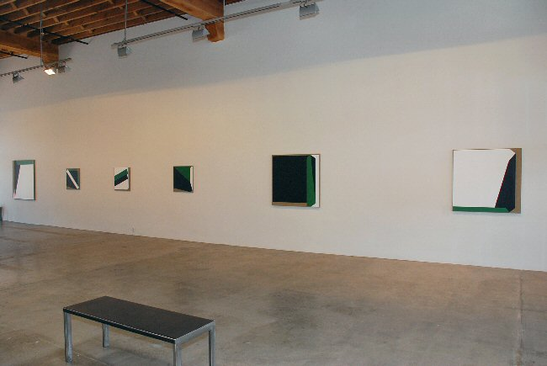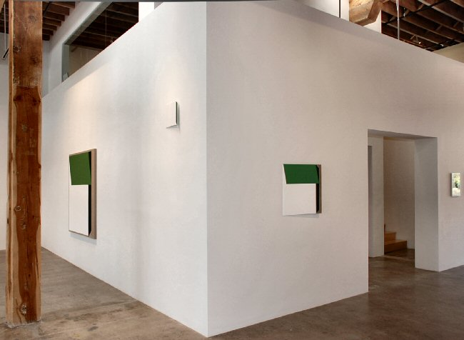

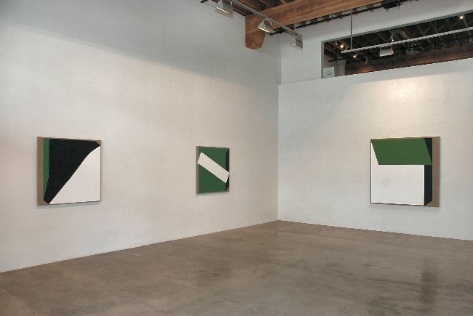

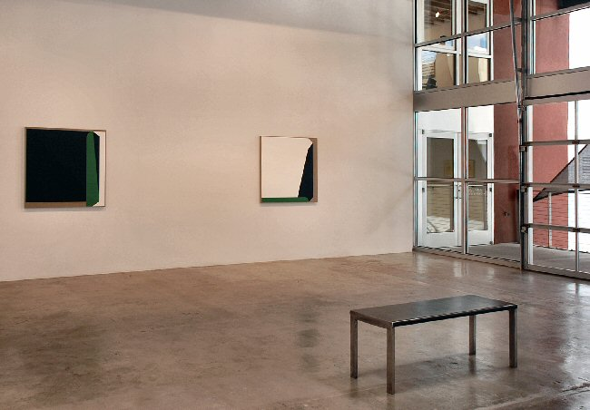
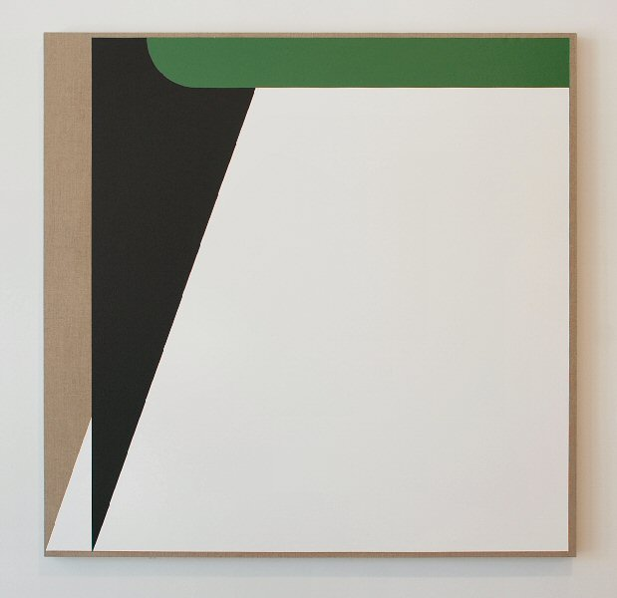

Hypnosthesia, 2010
Acrylic on linen
50 x 51 inches TD0054
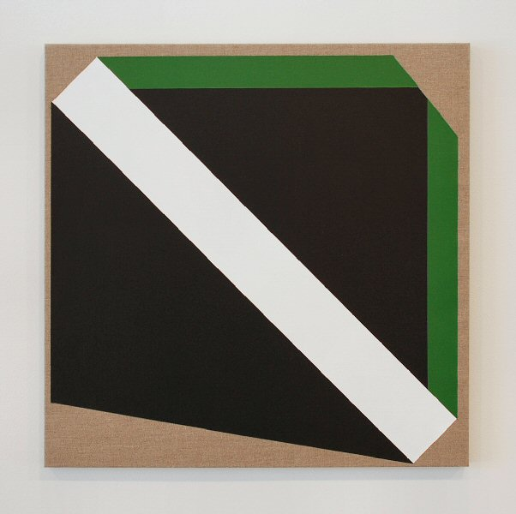

The Courtly Card, 2010
Acrylic on linen
24 x 24 inches TD0064
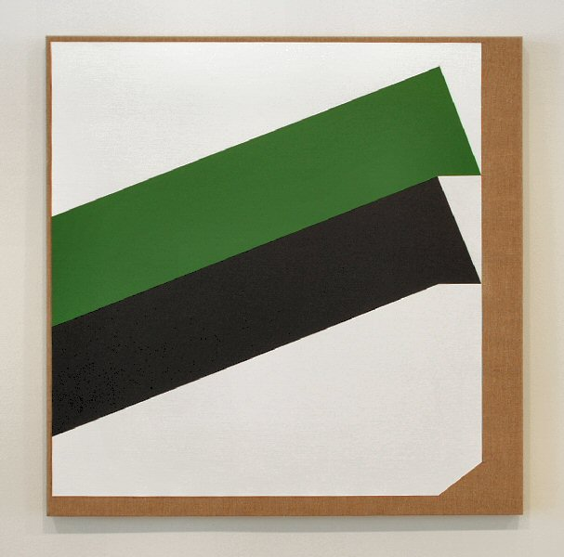

The Escamoteur, 2010
Acrylic on linen
24 x 24 inches TD0063
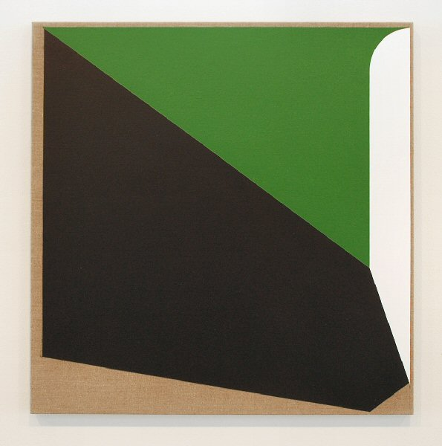

Tannen, 2010
Acrylic on linen
24 x 24 inches TD0062
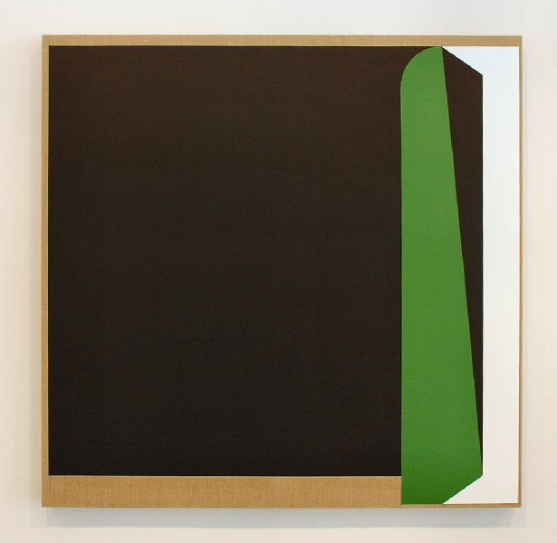

Nufind, 2010
Acrylic on linen
40 x 41 inches TD0055
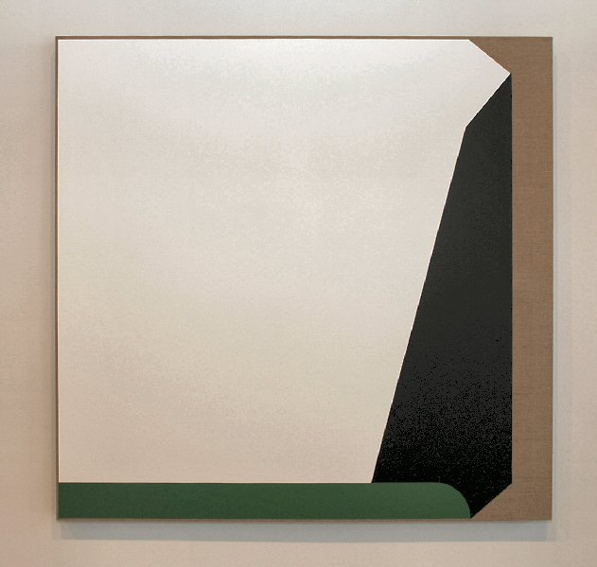

It Goes This Way, 2010
Acrylic on linen
40 x 40 inches TD0060
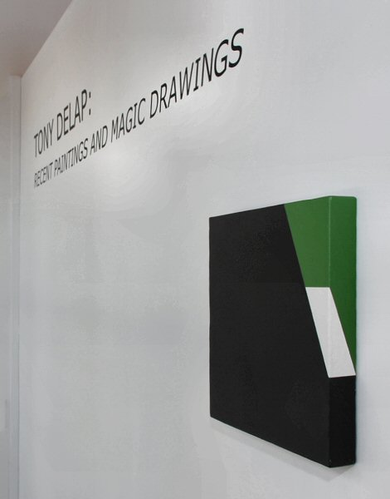

Mystic, 2008
Acrylic on linen
12x 12 x 1 ½ inches TD0068
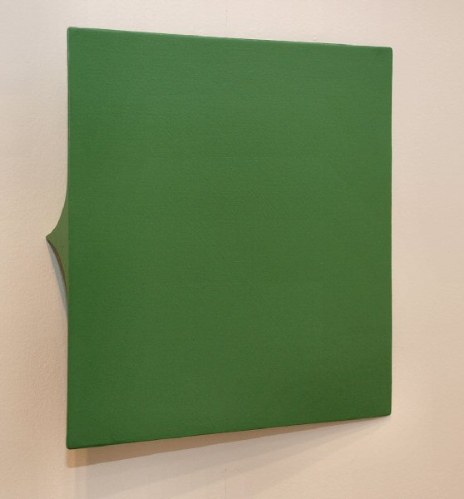

Plenty of Green, 2007
Acrylic on aluminum
10 ½ x 10 ½ x 2 inches TD0066
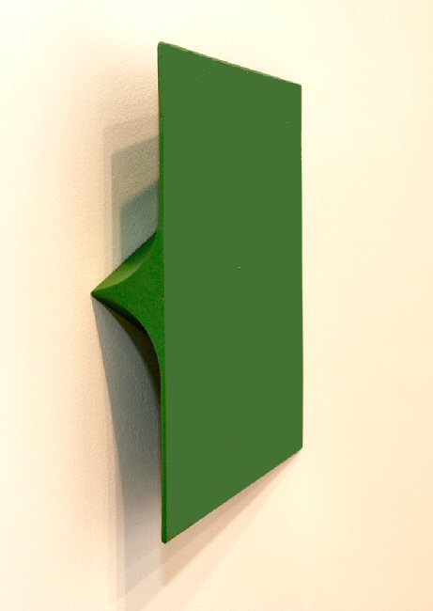

Plenty of Green, 2007 (detail)
Acrylic on aluminum
10 ½ x 10 ½ x 2 inches TD0066
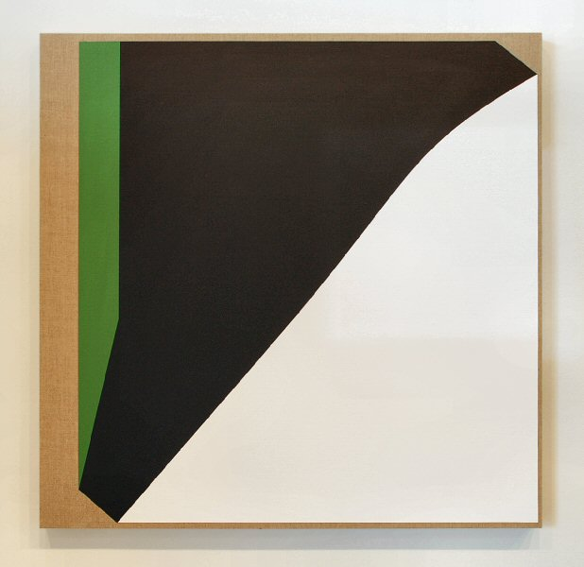

Nyctalopia, 2010
Acrylic on linen
40 x 41 inches TD0056
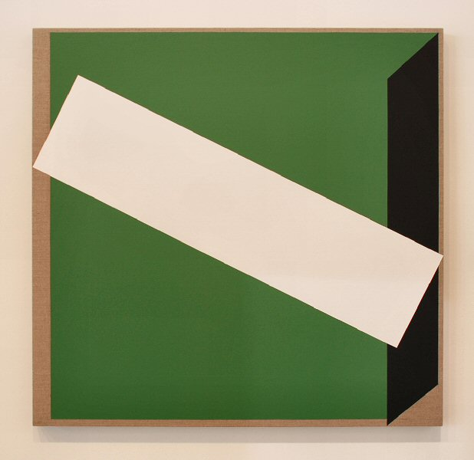

Summer Seance, 2010
Acrylic on linen
40 x 41 inches TD0058
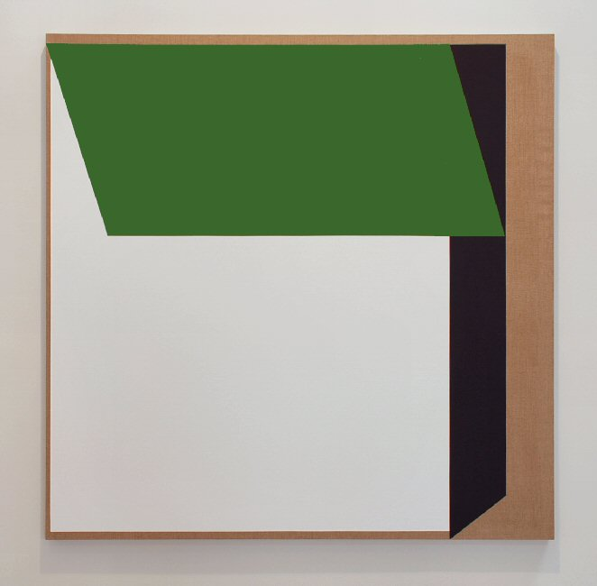

Right Guess, 2009
Acrylic on linen
60 x 62 inches TD0053
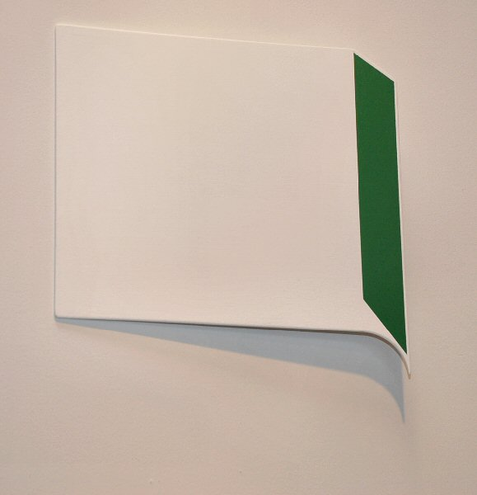

Gabbatha, 2010
Acrylic on linen
12 x 12 x 1 1/8 inches TD0065
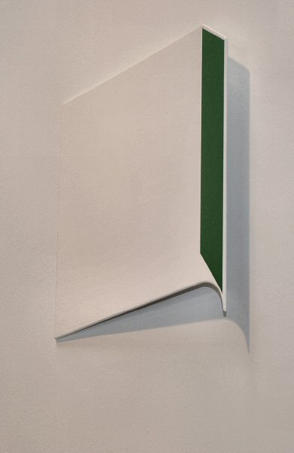

Gabbatha, 2010 (detail)
Acrylic on linen
12 x 12 x 1 1/8 inches TD0065
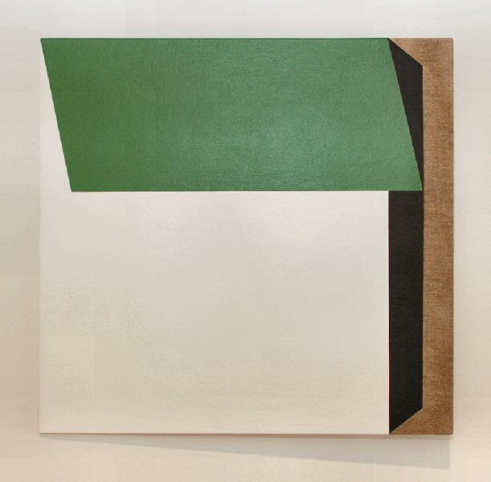

Wrong Guess, 2010
Acrylic on linen
25 x 24 x 2 ½ inches TD0061
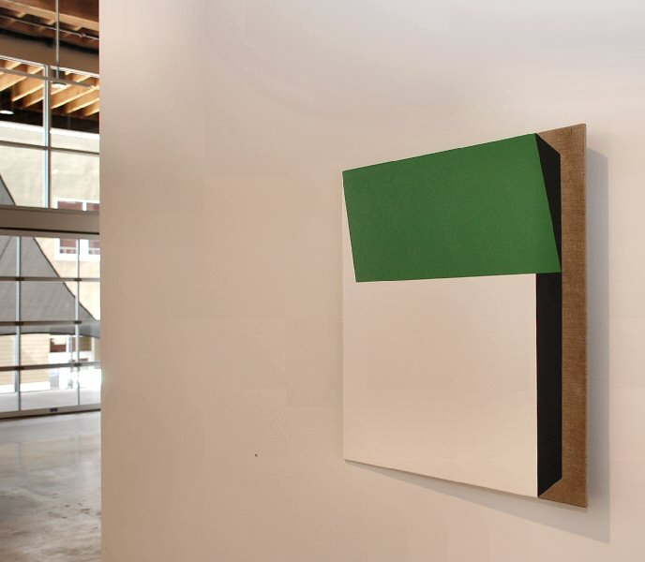

Wrong Guess, 2010 (detail)
Acrylic on linen
25 x 24 x 2 ½ inches TD0061
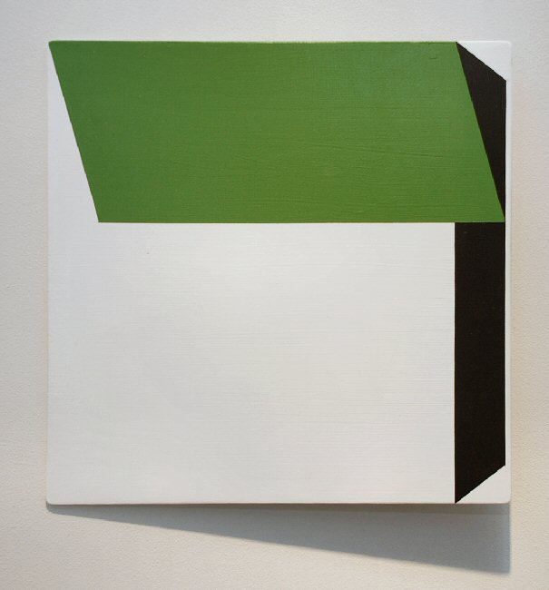

Melio, 2009
Acrylic on aluminum
11 x 11” x 1 1/8 inches TD0051
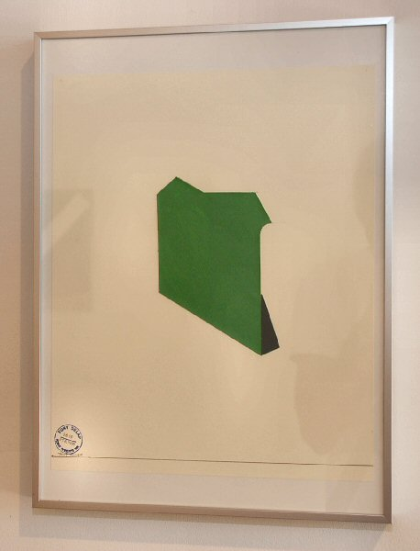

Green with Black Corner, 2010
Acrylic on paper
12 x 16inches TD0069
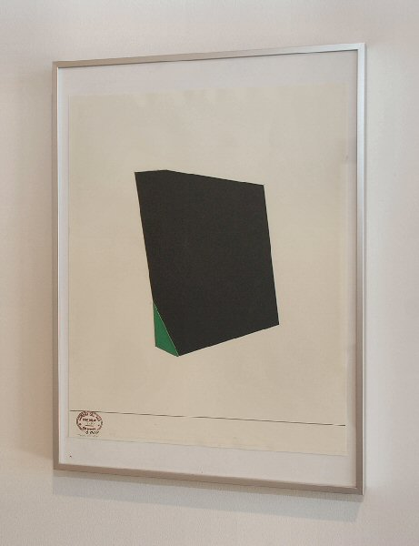

Green with Black Corner, 2010
Acrylic on paper
12 x 16inches TD0069
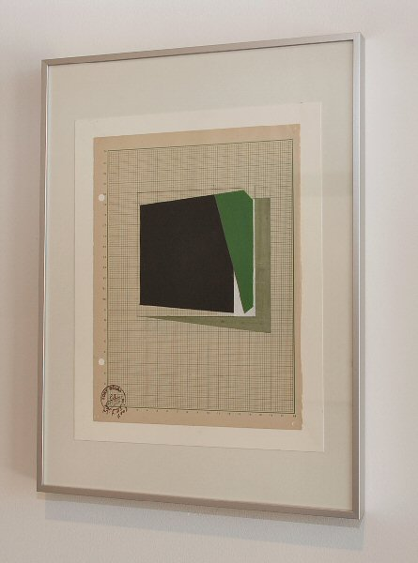

South Beach I
Watercolor, ink, acrylic on graph paper
12 x 16 inches TD0076
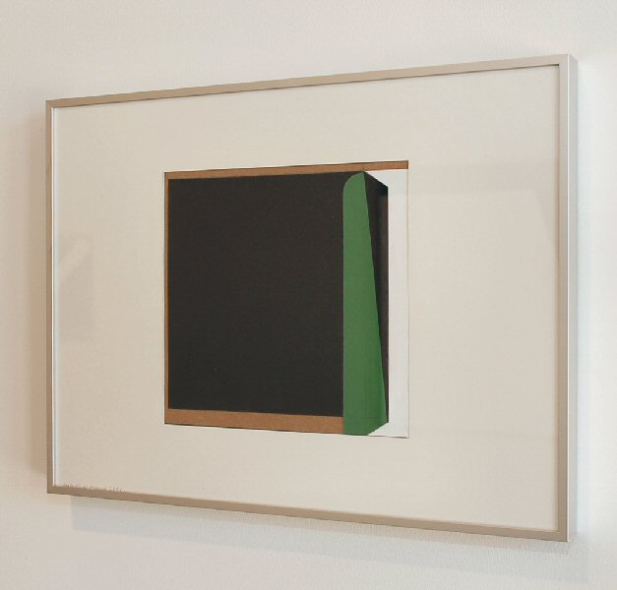

Collage for Nufind
Collage, acrylic on paper
12 x 16 inches TD0072
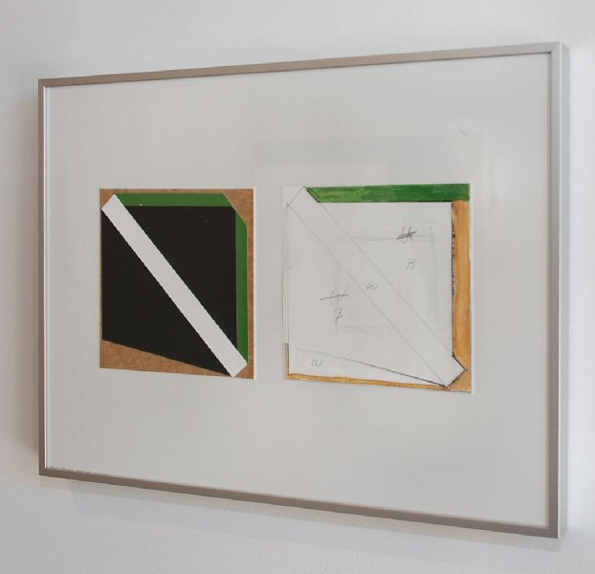

Drawing for the Courtly Card
Collage
12 x 16 inches TD0073
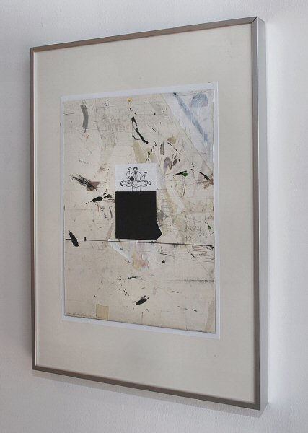

Magic Drawing #IV
Ink, Watercolor, collage on board
16 x 12 inches TD0070

© 2010

Charlotte Jackson Fine Art, Inc.
In the Railyard at:
554 S. Guadalupe, Santa Fe, New Mexico 87501
Telephone: 505.989.8688 Fax: 505.989.9898
cjfa@charlottejackson.com - www.charlottejackson.com

